[Gill Park RTA]
Litter Prevention Action Plan

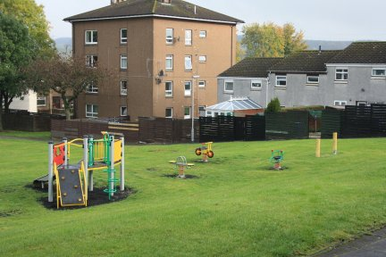

19th June 2021
]Gill Park Play Area
Denny
FK6 6HJ
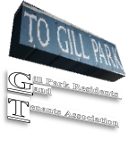

Introduction
We share the Scottish Government’s vision of a litter-free Scotland, laid out in the national litter strategy, Towards a Litter-free Scotland which recognises the social, environmental and economic benefits of a cleaner greener Scotland.
The national strategy outlines three cornerstones of intervention to tackle litter and flytipping:
- Information - ensuring effective and consistent messaging to prevent littering
- Infrastructure - improving the facilities and services needed to reduce litter and promote recycling
- Enforcement - strengthening the deterrent effect of legislation
This plan outlines our actions against each of these cornerstones.
We will publish our plan and review it annually to ensure that we are fulfilling our actions, and to help us identify areas where we can make further progress.
We realise we cannot address this issue alone; we are also committed to contributing to the Community Litter Prevention Action Plan for Falkirk. We will work collectively with the local partners to share resources, deliver objectives, provide knowledge and ideas and influence others.

Our plan
We recommend that your organisation commits to between 3 - 6 litter prevention actions for each intervention. Please refer to our Litter Prevention Action guides for a list of example information, infrastructure and enforcement actions.

Information actions
Action 1 | Celebrate our successes
Description | We will celebrate our accomplishments, reinforce positive behaviours and raise wider awareness through our media channels. We will also share stories with the Take Pride in Your community Facebook Page.

Action 2 | Follow Falkirk Council's litter pick guidance.
Description | We will ensure we follow Falkirk Council's guidance in terms of litter picks regarding waste collection, what land to pick on and what can be picked. We will register our picks with Falkirk Council at www.falkirk.gov.uk/organiseacleanup and if we have any questions we will contact wasteservices@falkirk.gov.uk.

Action 3 | Encourage reporting of local litter and flytipping hotspots to Falkirk Council.
Description | We will report significant or regular build-up of litter or fly-tipping to Falkirk Council. We will try to provide additional information that will help tackle the root causes of such littering and facilitate enforcement action.

Action 4 | Undertake local initiatives to prevent litter and flytipping.
Description | We will work with Falkirk Council, local businesses, schools and others on local initiatives that prevent litter and flytipping. These may include: litter picks that target specific locations or hard-to-reach groups; community-led campaigns focusing on areas of local concern; citizen science projects; the use of incentives; or wider environmental improvement projects. We will contact wasteservices@falkirk.gov.uk if we have any ideas or want to organise local litter picks or campaigns.

Action 5 | Feedback the results from litter picks to staff, volunteers and service users
Description | We will engage the local community around the importance of preventing litter and flytipping by feeding back the results from litter picks (e.g. main types of litter, litter hotspots) through social media and by completing a Falkirk Council litter pick evaluation form.

Infrastructure actions
Action 1 | Develop a litter schedule.
Description | We will develop a litter schedule with planned litter picks. Through our plan, we can ensure we have registered our litter picks with Falkirk Council and have equipment and notice for waste collection in advance.

Action 2 | Ensure correct resources are available for litter picking.
Description | We will provide our staff and volunteers with equipment when carrying out litter picking activities (e.g. high visibility jacket/vest, safety shoes, gloves, litter picker, bin bags, first aid kit). We will also ensure that our staff and volunteers are fully trained and adhere to Health and Safety and Falkirk Council guidance. We will contact Falkirk Council for equipment loan on www.falkirk.gov.uk/organiseacleanup

Action 3 | Partner with neighbouring organisations to carry out joint litter picks.
Description | We will work with neighbouring organisations in our local community to regularly carry out joint litter picks that target specific locations or hard-to-reach groups.

Enforcement actions
Action 1 | Inform members and the wider public users that littering and flytipping are crimes.
Description | We will inform members and the wider public that dropping any waste is a crime, even a cigarette butt or apple core and anyone caught can be issued with a fine starting at £80 for litter and £200 for flytipping. We will do this with awareness campaigns, promotional materials, presentations and in person at events and activities.

Action 2 | Report any intelligence on litter and flytipping offences to enforcement agencies for investigation.
Description | We will report incidents of littering and flytipping within our community, where appropriate, to Falkirk Council through MyFalkirk.

Please email your draft Litter Prevention Action Plan to WasteServices@falkirk.gov.uk for review and feedback. Once finalised, we will upload copy to the Falkirk Council website. Please also upload your Litter Prevention Action Plan to Zero Waste Scotland’s publicly available portal to demonstrate your involvement in this initiative: http://litterplanportal.zerowastescotland.org.uk.

Zero Waste Scotland logo

#LitterFree

