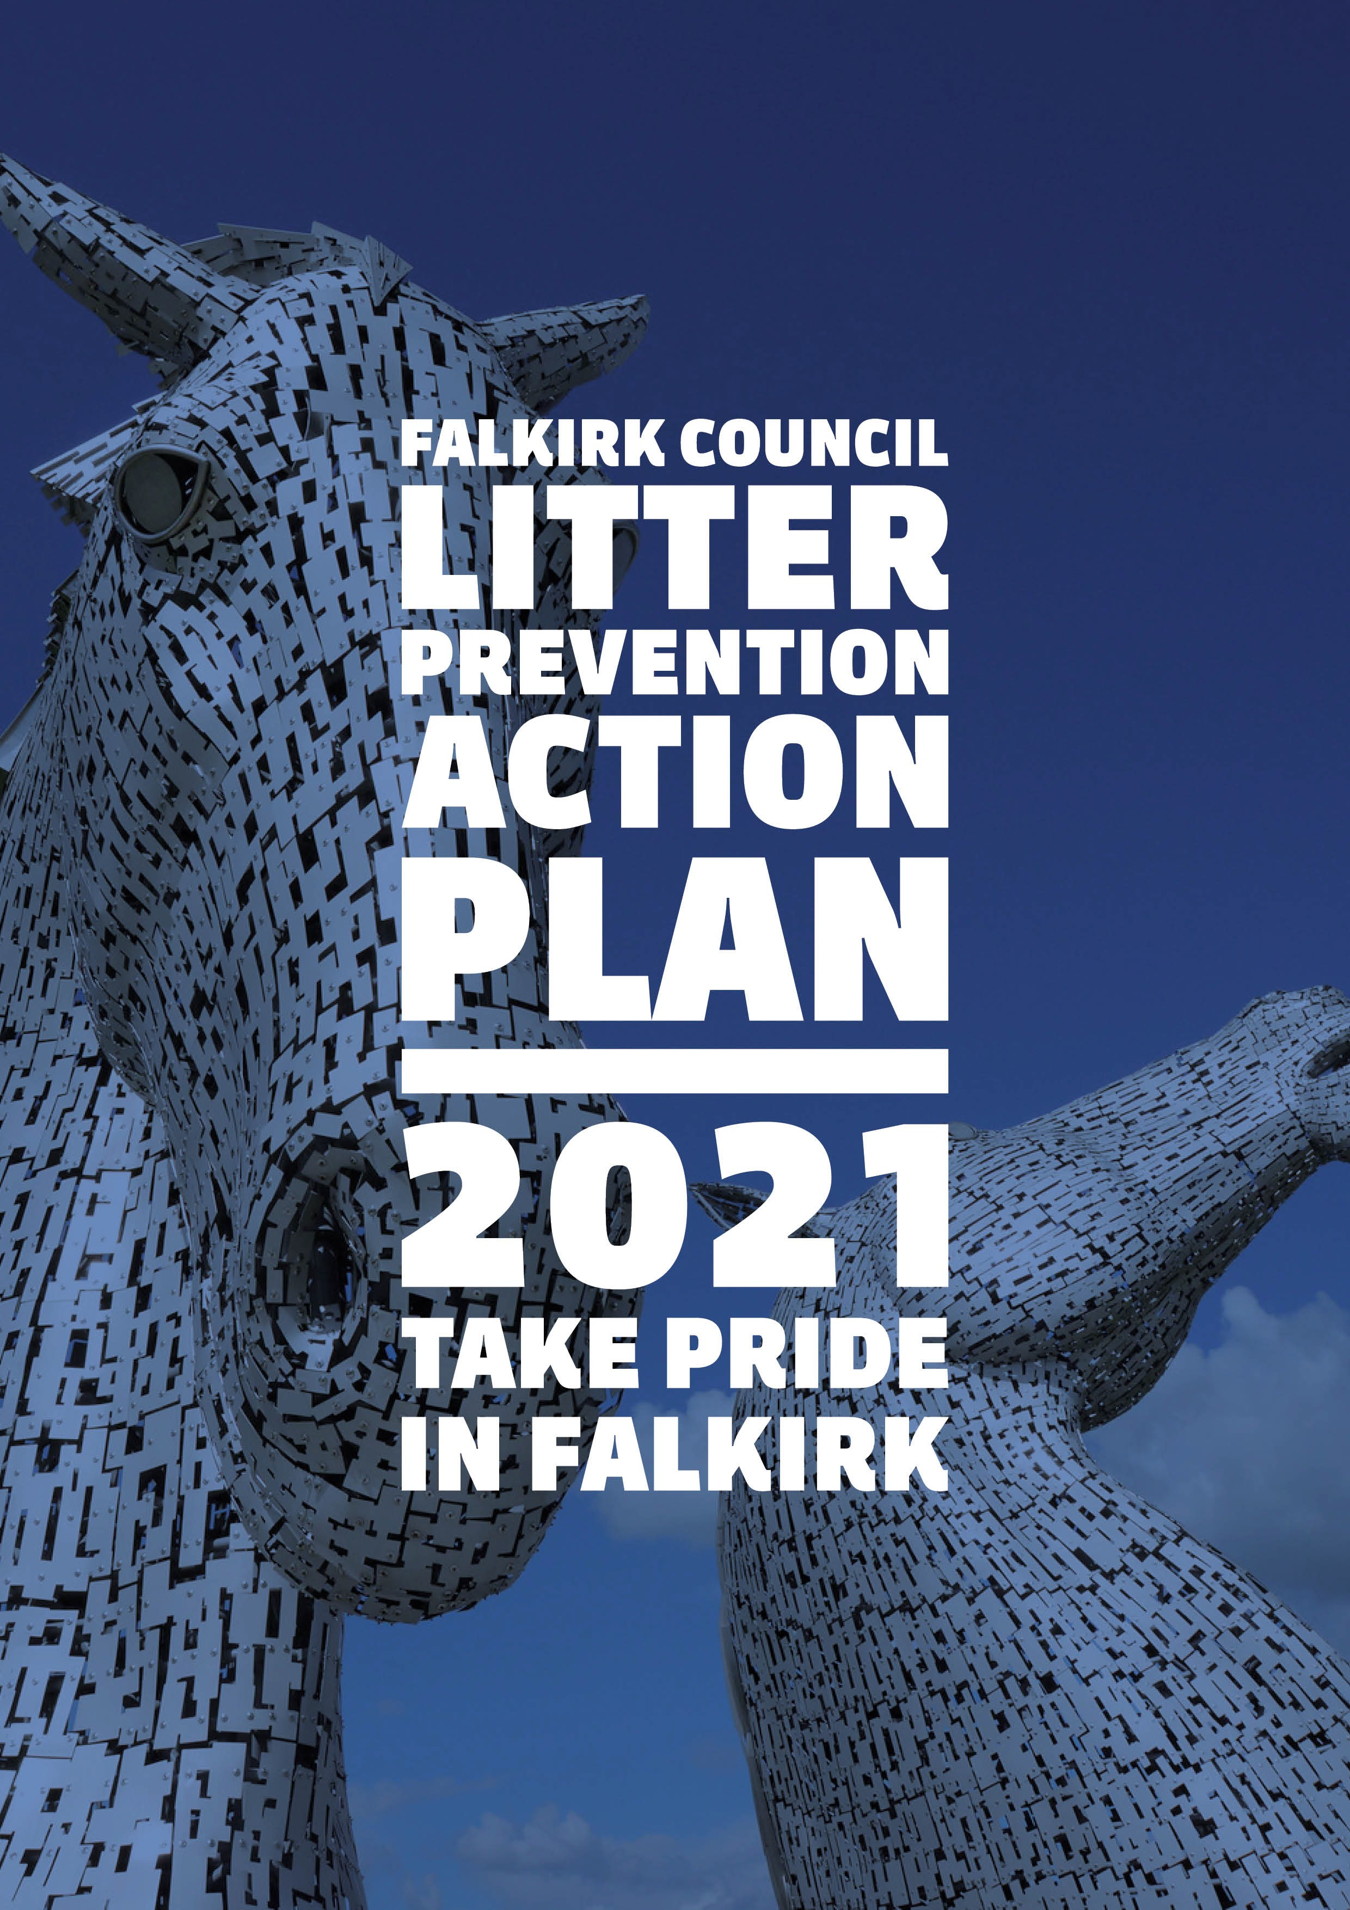

FALKIRK COUNCIL
LITTER PREVENTION ACTION PLAN 2021
“Take Pride in Falkirk”

SUPPORTING THE
FALKIRK COUNCIL LITTER STRATEGY A CLEANER FALKIRK
2021-2026

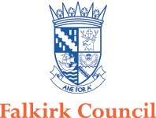

FALKIRK COUNCIL’s LITTER PREVENTION ACTION PLAN:
Falkirk Council share the Scottish Government’s vision of a litter-free Scotland, laid out in the national litter strategy, Towards a Litter-free Scotland which recognises the social, environmental and economic benefits of a cleaner greener Scotland.
The national strategy outlines three cornerstones of intervention to tackle litter and fly-tipping:
- Information - ensuring effective and consistent messaging to prevent littering
- Infrastructure - improving the facilities and services needed to reduce litter and promote recycling
- Enforcement - strengthening the deterrent effect of legislation

This Litter Prevention Action Plan outlines our actions against each of these cornerstones.
We will publish our plan and review it annually to ensure that we are fulfilling our actions, and to help us identify areas where we can make further progress.
We realise we cannot address this issue alone; and a such are committed to working collectively with our local partners to share resources, deliver objectives, provide knowledge and ideas and influence others.
By working with and alongside our communities to achieve our aim of cleaner open spaces we will seek to embed prevention into service delivery, to maximise reach and provide best value.
Falkirk Council in doing so will:
- focus on need
- be honest, open and accountable
- provide equality of opportunity
- develop our employees
- make best use of our resources
- work in partnership.
Actions on infrastructure
Actions on information
Actions on enforcement
Our contribution to creating a litter free Scotland

OUR ACTIONS
As stated we are committed to ensuring we take a collective, partnership approach to tackling fly-tipping and litter, with our Litter Prevention Action Plan establishing our preventative actions in relation to the three main areas of information; infrastructure and enforcement.
This Litter Prevention Action Plan sets out our identified actions that require to be delivered in order to effect a change to the existing culture of littering, and we recognise that a continued reactive cleaning of litter, fly-tipping and dog fouling as well as being not sustainable, is not a service delivery model which is achieving a reduction in littering activity.
Our actions through the duration of the Litter Prevention Action Plan focus in the short term on assessing the level and effectiveness of our reactive service provision and ensuring that available resources are directed to areas of greatest need whilst ensuring adequate attention is given to ensure acceptable standards are maintained. Actions also focus on data gathering which in turn will enable medium and long-term actions to be developed, targeted and measured.
Our Litter Prevention Action Plan seeks to encourage and facilitate the transition from reactive cleaning to proactive prevention and behavioural change, leading to a litter free Falkirk, where we can “Take Pride in Falkirk” whilst engaging and working with Internal and External Partners.
Internal Partners - We will work with internal partners to produce dedicated Litter Prevention Action Plans:
- Development Services
- Corporate & Housing Services
- Children’s Services
- Social Work Adult Services
- Falkirk Community Trust
- Falkirk Health & Social Care Partnership
- Elected members
External Partners: (not exhaustive) - We will work with external partners and encourage them to produce and take ownership of Litter Prevention Action Plans.
- Community Councils
- Gala Committees
- School PTA’s
- Community Managed Assets and Trusts
- Local businesses
- Volunteer groups and individuals
- Housing Associations
- Scottish Canals
- Scottish Woodlands
- Rail operating companies
- SEPA – Emphasis on waste carrier licence issues / fly-tipping / organised crime
- Police Scotland and the justice system
- Zero Waste Scotland
- Keep Scotland Beautiful
- Individual Households – re the presentation of waste and what information to look out for/obtain when employing contractors
- Local Business Associations

INFORMATION ACTIONS:
Across our Council area we shall seek to collect relevant information to highlight where the issues are; identify how we can tackle the issues raised and determine the changes required to allow our available resources, to be most effectively and efficiently used. We aim to be able to provide information to a range of stakeholders including the public, partners and Scottish Government.
- Provide communication on local issues of fly-tipping, litter and dog fouling through the Council’s Communications team – Falkirk 5, and social media, Falkirk Council’s website, and other relevant partner channels, such as Community Council updates, and community engagement events, with the purpose of raising awareness of ongoing and developing initiatives.

- Develop and promote a range of educational resources to meet the needs of the national curriculum and support local community education delivery.

- Maintain and provide continuous support to community groups organising litter picks throughout Falkirk, and to facilitate the development of new groups. This will include the development of a “Litter Group Code of Practice, incorporating Health & Safety considerations and will support the principles of “Adopt My Space, ” including beach cleans – providing a synergy to Take a Pride in Falkirk.

- Encourage the public to make use of reporting channels via the Falkirk Council website such as reporting fly-tipping, litter bin issues and dog fouling via My Falkirk.

- Encourage the public to consider reuse/donation or the re-gifting of unwanted items which are of a condition allowing others to benefit. In aligning to the Council’s Poverty Strategy , this will include, for example furniture reuse such as “Freecycle” initiatives, designed to not only reuse items but to facilitate sustainable tenancies – helping to support “making a house a home.”

- Routinely meet with internal and external stakeholders to encourage the creation of their own Litter Prevention Action Plan, promote joint working and
to seek their involvement/advice in relation to how we best deploy available council resources.

- Create a long term plan for regular campaigns to highlight issues within Falkirk and work along with Keep Scotland Beautiful and Zero Waste Scotland on any local or national campaigns.

- Work with Zero Waste Scotland and Keep Scotland Beautiful to implement the Litter Management System, being the replacement for the current LEAMS reporting system, to ensure our data gathering, Key Performance Indicators (KPI’s) and reporting tools used are comparable and can be readily benchmarked against other local authorities.

- Further engage with partners/stakeholders to assist in developing/maintaining the key objectives or the Litter Strategy and maintaining the alignment of their Litter Prevention Action Plans.

- Work with other local authorities and partners in relation to identifying examples of best practice, to facilitate the sharing of resources and expertise, including publicising success and the provision of physical resources to support developing/realigned aims and initiatives.

- Engage wherever possible to support the principle of litter free Falkirk and Take a Pride in Falkirk by promoting behaviour change – to individuals, groups, businesses etc.

- Encourage local businesses to support and adopt a “Clean My Space” approach – encourages a positive litter free environment in the immediate vicinity of their premise and utilise Street Control Notices as required.

- Through COPLAR 2018 zoning we will establish and highlight awareness of the key litter sources/areas within Falkirk and we will work with those areas/sources to actively reduce the volume of litter occurring. This will include both deliberate and accidental littering and incorporate storage, presentation and use of litter and waste receptacles.

- Continue to engage with the Scottish Government’s Deposit and Return Scheme (DRS), Scheme Administrator on the forthcoming initiative for drinks containers.

- Engage with the Scottish Government on current and developing initiatives to highlight and promote increased environmental awareness and positive
activity such reuse, recycling and the appropriate disposal of waste; and raise awareness of positive activity, such as for example promoting the use of reusable drinks cups and refills whilst out and about across Falkirk.

INFRASTRUCTURE ACTIONS:
We will evaluate and review all aspects of our infrastructure and aim to consult with stakeholders where appropriate to make the required improvements to encourage waste reduction, reuse, recycling and appropriate disposal.
- Complete COPLAR 2018 ZONING requirements in conjunction with Zero Waste Scotland (ZWS).

- Evaluate our vehicles, sweepers, and equipment requirements to provide service required as per Duty 1 and 2 of COPLAR 2018.

- Analyse the captured data on litter and fly-tipping locations to determine any regular sites used with a view to implementing increased patrols and surveillance, whilst utilising the knowledge and expertise of Council staff to highlight known hot spot areas and create “heat maps”.

- Analyse reports of littering and dog fouling to highlight and publicise hot spot areas, and allocate resources accordingly.

- Consult on the introduction of dog off lead areas.

- Consult on the introduction of a local Code of Practice restricting the number of dogs which can be walked simultaneously by professional and non- professional dog walkers.

- Introduce, review and maintain a litter bin policy. To incorporate a review of existing street litter bins to establish suitability of placement, servicing and accurate usage, incorporating the use of bin sensors.

- Review and evaluate the suitability of bin requirements for specific locations, sensors, bin type/size including Recycle on the Go provision in conjunction with the public and wider stakeholders. Ensure litter bins and street bins are maintained to a good condition and be fit for purpose, being replaced as required.

- Engage at the design stage with planning and new developments to ensure adequate provision and space is being considered. Consider storage space for householder and commercial bins, and evaluate future maintenance requirements.
- Consider the introduction of an online booking HWRC access system which manages and restricts bookings to sites in line with a HWRC van and trailer access policy.

- Consider the installation of barriers and other prevention methods such as utilising pan Falkirk fixed and mobile CCTV to prevent access to Council owned land being used for fly-tipping, littering and dog fouling. And, actively engage with private landowners to highlight preventative methods they can employ to deter fly-tipping on their property.

- Review and continually improve as required the process for reporting littering and fly-tipping to Council.

- Use route optimisation software to improve efficiencies and to determine collection and servicing schedules for emptying bins, litter picking and street sweeping activity.

- Keep abreast of market developments to direct and inform council investment to enable street cleansing processes to be an effective and efficient service.

- Continually review and assess data, work practices and procedures and work with other local authorities and stakeholders such as ZWS and KSB to ensure best practice is being maintained and that Falkirk is keeping up to date with any changes.

- Provide householders, businesses and other waste producers with information needed to ensure they are aware of their responsibilities regarding domestic and commercial waste – including presentation, collection, storage and Duty of Care requirements. Promote awareness of reputable business scheme such as Falkirk Council’s Trusted Trader scheme.

- Work with local businesses, schools, community groups, individual and other to support local initiatives to highlight and prevent those antisocial behaviours which are providing local concern.

- Continually review opportunity for, and apply for funding opportunity as they present.

ENFORCEMENT ACTIONS:
- COPLAR 2018 places an emphasis on prevention rather than enforcement. However, we recognise that there does remain a place for enforcement and the deterrent of a fine/prosecution for offenders. Falkirk Council’s Environmental Enforcement Team within Waste Services carry out patrols, investigate reports of fly-tipping, littering and dog fouling and engage with
local communities, individuals and businesses to support preventative actions, and take enforcement actions as required. The Housing Community Estates Team within Housing Services also aim to ensure cleaner and safer communities, by improving the environmental quality of life, and a feeling of well-being through education and enforcement activities within housing owned estates.

- Issue Fixed Penalty Notices where evidence presents and resources allow. Additionally seek to recover the disposal and associated costs of fly-tipping incurred by Council as a direct result.

- We will seek to develop reporting relationships with Police Scotland, the Sheriff’s office and the Procurator Fiscal regarding unpaid Fixed Penalty Notices and fly-tipping offences where systematic and routine behaviours present.

- We will seek to engage with other local authority areas to ensure a consistency of approach is adopted and participate in joint discussions to improve both inter agency and partner understanding and development of existing and future enforcement systems.

- As part of the notification process to private landowners of fly-tipping having occurred, advise of commercial opportunity i.e. provide a clean- up service to landowner.

- Ensure all staff are kept up to date with current legislation.

- Actively participate in Scottish Government and other interested bodies consultations to review enforcement and possible changes in the law to make enforcement easier and relevant.

- Work with other services across the Council to identify, influence and encourage behaviour change to reduce the need for enforcement.

- Engage and support the efforts of Zero Waste Scotland, Keep Scotland Beautiful, and all other interested parties to fulfil the aims of the Scottish National Litter Strategy, that is to convey the message that it is socially unacceptable to litter, fly-tip waste or allow a dog to foul without properly disposing of the waste.

- Highlight through communication channels the disposal costs incurred to the Council resulting from the requirement to react to reports of littering, fly- tipping and dog fouling.

SUMMARY
Our Litter Prevention Action Plan actions are designed to create and facilitate a culture of zero tolerance towards litter, flytipping and dog fouling. By doing this we will not only enhance our local environment for everyone to enjoy, but achieve the switch in public perception from solely the Council’s remit to that of shared responsibility. Embedding the key messages and adopting the principles of sound community engagement will help foster the approach of “Taking Pride in Falkirk”.

