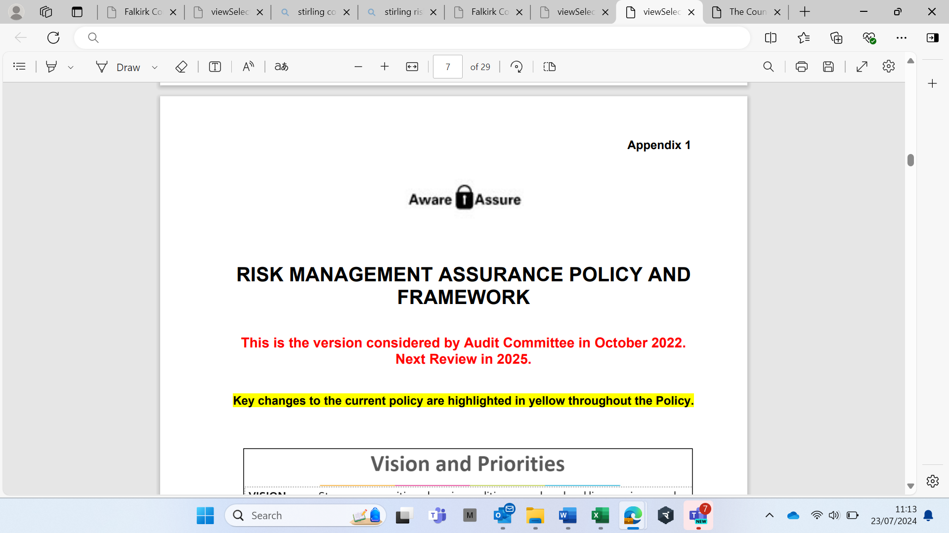

(from 1 April 2023 to 30 September 2024)

Falkirk Council

2023 – 24 Risk Management Assurance Annual Report

**Contents**

Introduction 3

Corporate Risk Priorities 4

Action 1: Policy and Improvement Plan 4

Action 2: CRR: Assess and manage risks to delivering the Council Plan 5

Action 3: Assurance: Implement effective risk assurance and governance. 6

Service Risk Priorities 7

Action 4: Service Risk Assurance Statements 7

Action 5: Risk Training 7

Action 6: Specialist Risks 7

|  |  |
| --- | --- |
|  |  |
| **Scrutinised :** | **Considered by Audit Committee, October 2024** |
| **Published:** | [CRM Pages on Council Website](https://www.falkirk.gov.uk/services/council-democracy/policies-strategies/corporate-risk.aspx) |
| **Key contact:** | Amanda Templeman, Chief Finance Officer |

|  |
| --- |
| Introduction |

The purpose of this report is to enable the Audit Committee to scrutinise progress with implementing the [Risk Management Assurance Policy (Policy)](https://www.falkirk.gov.uk/coins/viewSelectedDocument.asp?c=e%97%9Dc%90q%7D%90), which includes an Improvement Plan (Plan) (agreed by the Executive in January 2023).

This report summarises progress on the Plan to date, and also areas for continuous improvement. Because the Council’s risks, controls, and governance continuously evolve, the actions should be seen as continuous improvements rather than completed ‘task and finish’ actions. Also, all actions continue to be monitored because changes within the Council (e.g. resources and priorities) may mean that the assurance level on specific actions can improve or deteriorate at different points.

This report covers an 18-month period from April 2023 to September 2024, due to the timing of Audit Committee meetings, however, future reports will cover the period from April to March. This report is not, however, intended to duplicate the Executive’s role, which is to scrutinise and agree the [Corporate Risk Register (CRR)](https://www.falkirk.gov.uk/services/council-democracy/policies-strategies/corporate-risk.aspx) (their last review was [June 2024](https://www.falkirk.gov.uk/services/council-democracy/policies-strategies/corporate-risk.aspx), and the next will be January 2025).

The Plan has six core actions, and these are grouped into two priorities as shown below:

|  |  |
| --- | --- |
| **Risk Priorities** | **Actions** |
| Corporate Risk Assurance | 1. Policy: Implement and monitor the Policy and Improvement Plan. 2. CRR: Assess and manage risks to delivering the Council Plan. 3. Assurance: Implement effective risk assurance and governance. |
| Service Risk Assurance | 1. Service Risk Assurance Statements: review quarterly and link to Plans. 2. Risk Training: Staff receive relevant risk training and guidance. 3. Specialist Risk Registers or Assurance Statements are in place, as needed. |

The Council use the following ratings to provide assurance on risk management arrangements:

|  |  |
| --- | --- |
| **Assurance** | **Description** |
| Substantial | Controls are effective and / or measurable action plan is on track. |
| Limited | Some weaknesses in controls and / or actions are overdue or not measurable. |
| None | Controls not effective. There are significant weaknesses and / or actions. |
| Needs Review | Controls need review and / or measurable action plan is required. |

The Corporate Management Team (CMT) can provide **Substantial Assurance** on the effectiveness of Risk Management arrangements from April 2023 to September 2024. This opinion is based on:

* Services’ [most recent CRR updates](https://www.falkirk.gov.uk/services/council-democracy/policies-strategies/corporate-risk.aspx) (reviewed by CMT in October 2024);
* The [CRM update to the Executive in June 2024](https://www.falkirk.gov.uk/coins/submissiondocuments.asp?submissionid=21675) which showed significant progress on the Improvement Plan, and confirmed that all actions will be completed by March 2025;
* the outcomes of an internal audit report on Risk Management Arrangements by West Lothian Council in 2022/23 which provided “Satisfactory Assurance” (defined as “No findings ranked as ‘High’ importance however there are a moderate number of ‘Low’ and ‘Medium’ ranked findings; and most of these findings have been implemented (or substantially progressed);
* the [Annual Governance Statement (AGS) (signed by the Leader and Chief Executive, within the 2023/24 Annual Accounts)](https://www.falkirk.gov.uk/coins/submissiondocuments.asp?submissionid=21768), which included the following assurance opinion from the Chief Executive and Leader of the Council:

“This Statement is an objective appraisal of our governance framework and demonstrates that largely satisfactory risk, control, and governance systems are in place within Falkirk Council. This Statement also demonstrates that we have met our legal and statutory obligations to our residents, and we are committed to completing the actions identified in 2023/24.”

|  |
| --- |
| Corporate Risk Priorities |

## Action 1: Policy and Improvement Plan

|  |
| --- |
| **This action includes:** |

* The Policy will be reviewed three yearly and is supported by guidance and training;
* Guidance and Templates are provided to ensure risks are assessed and reported consistently; and
* Continuous reviews of the Policy (or Risk Maturity), including audits and self-assessments.

|  |
| --- |
| **Progress to Date and Priorities in 2024/25** |

The Policy is broadly well embedded for the monitoring of Corporate and Service Risks, although improvements are needed during 2024/25 on the assessment of risks in Committee Papers. This will be taken forward as part of revised Committee Paper templates in ????.

The effectiveness of the Policy was reviewed by West Lothian Council in 2022/23. A Risk Maturity Self-Assessment will be completed by March 2025 to inform any changes to the Policy in 2025/26.

|  |
| --- |
| **Evidence** |

The Policy sets out the following approach to risk, and this is evidenced in how risks are managed and reviewed by Chief Officers and Elected Members:

* The Council encourages decision makers to be ‘risk aware’ rather than ‘risk averse’. This means that risk is not a bad thing and does not need to be avoided, but informed decisions should be made on risks and benefits;
* The Council supports employees, communities, and partners who take opportunities where the risks are considered, reasonable controls are in place to mitigate risks and maximise opportunities, and decisions are proportionately documented, monitored, and reviewed; and
* The Council’s approach to managing and reporting risk is transparent and consistent with our target risk (appetite) and values (RITA – Responsive, Innovative, Trusted, and Ambitious), which means:

|  |  |
| --- | --- |
| **Council Values** | **Risk Management Behaviours and Culture** |
| Responsive | * Risk assessments are dynamic i.e. are a current assessment of the risks, and they reflect ongoing changes to the internal and external environment. |
| Innovative | * Risk management supports Council transformation, and our approach to assessing and managing risks balances both opportunities and threats. |
| Trusted | * Council Officers are trusted to be transparent when assessing risks, so that Elected Members can make informed decisions on appetite and mitigations. |
| Ambitious | * Council Officers and Elected Members set ambitious (but also achievable) targets on risks and mitigation action plans, and trusted to deliver on them. |

## 

## Action 2: CRR: Assess and manage risks to delivering the Council Plan

|  |
| --- |
| **This action includes:** |

* Target Risk (Appetite) and measurable action plans will be identified in risk registers;
* Corporate Risk reports are provided to the Executive (6 monthly) and Audit Committee (Annually); and
* Risk Horizon Scanning will be undertaken Annually with CMT, Leadership Teams, and Members.

|  |
| --- |
| **Progress to Date and Priorities in 2024/25** |

Significant progress has been made during 2023/24 in confirming the target risk (appetite) and measurable action plans on most high corporate risks as well as simplifying reports. The priority in 2024/25 is to continue to assess risks and deliver on the measurable action plans.

A Horizon Scanning session took place with the Executive in September 2023. In advance the corporate risk team reviewed a wide range of external sources, including e.g. [Audit Scotland’s Local Government Overview 2023](https://www.bing.com/ck/a?!&&p=e28099fe3494c4ecJmltdHM9MTcyMTY5MjgwMCZpZ3VpZD0zOWQxZTVhNy1mYTNmLTY4NmUtM2Y5My1mN2VjZmUzZjZlM2EmaW5zaWQ9NTIwMA&ptn=3&ver=2&hsh=3&fclid=39d1e5a7-fa3f-686e-3f93-f7ecfe3f6e3a&psq=audit+scotland+national+reports+local+government&u=a1aHR0cHM6Ly9hdWRpdC5zY290L3B1YmxpY2F0aW9ucy9sb2NhbC1nb3Zlcm5tZW50LWluLXNjb3RsYW5kLW92ZXJ2aWV3LTIwMjM&ntb=1) and the [Word Economic Forum’s Global Risk Report 2023](https://www.bing.com/ck/a?!&&p=34e90da7728c39e8JmltdHM9MTcyMTY5MjgwMCZpZ3VpZD0zOWQxZTVhNy1mYTNmLTY4NmUtM2Y5My1mN2VjZmUzZjZlM2EmaW5zaWQ9NTIwNg&ptn=3&ver=2&hsh=3&fclid=39d1e5a7-fa3f-686e-3f93-f7ecfe3f6e3a&psq=global+risk+report+2024&u=a1aHR0cHM6Ly93d3cud2Vmb3J1bS5vcmcvcHVibGljYXRpb25zL2dsb2JhbC1yaXNrcy1yZXBvcnQtMjAyNC8&ntb=1). The horizon scanning will be revisited when the Council Plan is updated (date not yet known). More importantly, all Risk Specialists (subject experts) use a range of sources to inform the horizon scanning in their strategies and risk updates, including learning from their professional bodies.

The summary below shows the most significant risks to delivering the Council Plan; and the CRR High Risk Details ([here](https://www.falkirk.gov.uk/services/council-democracy/policies-strategies/corporate-risk.aspx)) details the risks, controls, and action plans:

|  |  |
| --- | --- |
| Priorities | High Corporate Risks to delivering Council Plan priorities |
| Supporting a stronger and more healthy communities | * Counter-Terrorism and Organised Crime * National Care Service * Health and Social Care Transformation * Housing Fire Safety – possible changes in standards * Public Protection: Harm to Adults/Children * Resilience: Business Continuity and Partnerships |
| Promoting opportunities and educational attainment and reducing inequalities | * Equalities Duties * Poverty: impacts on children and families * Services to Asylum Seekers |
| Supporting a thriving economy and green transition | * Climate Change (including Council and Area emissions) * Major Capital Projects (including Growth Deal) * Sustainable Growth (including Economy and Skills) |
| Our Enablers:  Financial Sustainability,  Transformation,  Workforce, and  Quality Services | * Financial Sustainability * Health, Safety, and Wellbeing * Leadership, Governance, and Decision Making |

## Action 3: Assurance: Implement effective risk assurance and governance.

|  |
| --- |
| **This action includes:** |

* Corporate Risk Reports are provided to the Executive (6 monthly) and the Audit Committee (Annually);
* Annual Governance Statements (AGS) are provided to the Audit Committee (Annually); and there are also 6-monthly AGS Action Plan Updates; and
  + Governance Groups (GGs) will complete Annual Self-Assessments including a review of their purpose, strategy / plans, and effectiveness.

|  |
| --- |
| **Progress to Date and Priorities in 2024/25** |

# The [Policy](https://www.falkirk.gov.uk/services/council-democracy/policies-strategies/corporate-risk.aspx) sets out the approach to risk governance, including:

# Roles of Committees, CMT, Service Management Teams, and others e.g. Partnership Boards;

# Risk and Assurance Reporting Framework, including how risks should be escalated;

# Assurance 3 lines of defence, including:

* 1st Line – Management (including Directors and Service Managers): provide Services to clients and manage risks to delivering objectives;
* 2nd Line: Risk Support (including Corporate Risk, Subject Experts, and Governance Groups): provide expertise, support, monitoring, and challenge on managing risk-related matters; and
* 3rd Line: Independent Assurance (including Internal and External Audit, and Inspection Bodies): provide independent and objective assurance and advice on all matters related to achievement of objectives.

To help Elected Members scrutinise risks effectively, the following briefings have been provided:

* June 2023: Audit Committee Introduction (as part of Member Inductions);
* September 2023: Executive Horizon Scanning of risks to delivering the Council Plan; and
* November 2023 and May 2024: Executive Briefing in advance of CRM updates.

In addition, Audit Committee members have received briefings from both Internal and External Audit. Attendance at all risk briefings, however, is low (usually no more than 25%-50%) and e-learning needs to be completed by all Elected Members during 2024/25 so that they fully understand the Policy and their respective roles within it.

# Assurance and governance arrangements are broadly working well, as evidenced by the wide range of assurances that feed into both the CRR and AGS. A key improvement since April 2023 has been that Committee reports now contain clearer assurance levels and action plans. Also, CMT will consider the Governance Groups’ Annual Self-Assessments by December 2025, to ensure that they have clear remits and manage risks effectively. The outcomes from these reviews will feed into the next updates to the Executive and Audit Committee in early 2025.

# There will, however, always be some areas of unknown or limited assurance because the structures, structures, and priorities of Services, Governance Groups, and Partnerships continuously change; and so the approach to risk and assurance also needs to evolve.

|  |
| --- |
| Service Risk Priorities |

## Action 4: Service Risk Assurance Statements

## 

|  |
| --- |
| **This action includes:** |

* Service Risk Assurance Statements are reviewed quarterly and link to Council and Service Directorate Plans, including horizon scanning for new risks and monitoring of risk action plans.

|  |
| --- |
| **Progress to Date and Priorities in 2024/25** |

Service Risk Assurance Statements are maintained and scrutinised by Service Management Teams quarterly. A summary of these feeds into the CRM Updates to both CMT (quarterly) and the Executive (6 monthly). This ensures that there is proper consideration and (where necessary) escalation or de-escalation of risks. This process is working well within most Services, however, a key area improvement area in 2024/25 is to ensure that Education Services and the HSCP improve their approach to the monitoring and escalation of operational risks.

Also, CMT will complete an annual review of Service Operational Risks by December 2025, alongside Governance Group Annual Self-Assessments, to ensure that operational risks are being managed effectively across all Services. This includes the status of improvement plans to manage e.g. business continuity, climate change, and health and safety risks at service (operational) levels.

## Action 5: Risk Training

|  |
| --- |
| **This action includes:** |

* Training and briefings: staff / receive relevant risk training and guidance; and
* Services will complete Risk Training Needs Assessments (TNAs) during 2023/24.

|  |
| --- |
| **Progress to Date and Priorities in 2024/25** |

Risk E-Learning provides an introduction, and it’s targeted (at a minimum) at Team Leaders, Managers, and Elected Members. It has been completed by over 500 employees since the Policy was updated in November 2022, including most of the targeted employees in Place and Transformation, Communities, and Corporate Services. Completion rates are low, however, in Education and Social Care. To address this, Risk E-learning has been added to Social Care Inductions, and a similar approach will be agreed with Education Services. Managers will monitor progress closely.

Service Risk Training Needs Assessments (TNAs) will be taken forward with individual Services during 2024/25. The priority is to work with training leads (including Democratic Services and Organisational Development) to embed risk into the Council’s Development Programmes, including:

* Committee Papers Guidance and Leadership Training for Managers and Elected Members;
* Professional Development Programmes, e.g. Finance, Technology, and Public Protection; and
* Workshops or focussed reviews on specific corporate risks, to review key controls and actions.

## Action 6: Specialist Risks

|  |
| --- |
| **This action includes:** |

* Specialist Risk Registers and / or Assurance Statements are in place and reviewed by Lead Officers / Groups quarterly.

|  |
| --- |
| **Progress to Date and Priorities in 2024/25** |

Focussed reviews will continue on a prioritised basis and feed into the CRR and AGS. The aim is to ensure that all the CRR, AGS, and all Committee Reports (including changes to strategies and plans) provide a reliable assessment of risks, and that processes are in place to assess and monitor Specialist Risks on subjects such as assets, public protection, and resilience.