Falkirk Council

Strategic Surface Water Management Plan (SWMP)

Quality information
Prepared by |  | Checked by |  | Verified by |  | Approved by
Hannah Hopkins  Engineer |  | Aisling McGilloway  Senior Engineer |  | Dylan Huws  Associate Director |  | Hazel MacLeod  Principal

Revision History
Revision | Revision date | Details | Authorized | Name | Position
001 | 11/09/2020 | DRAFT | GH | George Harley | Project Manager
002 | 18/11/2020 | Internal consultation | GH | George Harley | Project Manager
003 | 17/02/2021 | Stakeholder consultation | GH | George Harley | Project Manager
004 | 26/05/2021 | Falkirk Council review following consultation | GH | George Harley | Project Manager
005 | 21/07/2021 | Issue | GH | George Harley | Project Manager

Distribution List
# Hard Copies | PDF Required | Association / Company Name

Prepared for:
Falkirk Council
Abbotsford House
Davids Loan
Falkirk
FK2 7YZ

Prepared by:
‌AECOM Limited
1 Tanfield
Edinburgh EH3 5DA
United Kingdom

T: +44 131 301 8600
aecom.com

© AECOM Limited. All Rights Reserved.
This document has been prepared by AECOM Limited (“AECOM”) for sole use of our client (the “Client”) in accordance with generally accepted consultancy principles, the budget for fees and the terms of reference agreed between AECOM and the Client. Any information provided by third parties and referred to herein has not been checked or verified by AECOM, unless otherwise expressly stated in the document. No third party may rely upon this document without the prior and express written agreement of AECOM.
Table of Contents
1 Introduction 7
1.1 Flood Risk Management planning process 7
1.2 SWMP Process 8
1.3 Level of Assessment 9
1.4 Approach 10
2 Phase 1 & 2 – Prepare, Data Collation & Site Appraisal 12
2.1 Data Collation 12
2.2 Falkirk Council Area 12
2.2.1 Background 12
2.2.2 Strategic Environmental Assessment 12
2.2.3 Landscape and Heritage 13
2.2.4 Local Development Plan 16
2.2.4.1 Green and Blue Network 16
2.2.4.2 Urbanisation/Redevelopment 16
2.2.5 River Basin Management Planning 17
2.2.6 Grangemouth Flood Protection Scheme 18
2.2.7 Geology and Hydrogeology 19
3 Phase 3 - Catchment Assessment & Understanding Flood Risk 20
3.1 Potentially Vulnerable Areas (PVA) 20
3.2 SEPA Flood maps 23
3.3 Scottish Water ICS Model 23
3.3.1 Model runs 24
3.3.2 Model outputs 25
3.3.2.1 Dalderse Catchment 25
3.3.2.2 Kinneil Kerse Catchment 25
3.4 Scottish Water Additional Models; Small Catchments 26
3.4.1 Model outputs 27
3.4.1.1 Denny 27
3.4.1.2 Bonnybridge 27
3.4.1.3 Slamannan 28
3.4.1.4 Bo’ness 28
3.4.1.5 Airth 28
3.5 Catchment Analysis 28
3.6 Future risk 29
3.6.1 Climate Change 29
3.6.2 Development Risk 30
4 Phase 4 - Flood Hotspot Analysis 31
4.1 Flood Hotspot Identification 31
4.1.1 Airth – Airth, Dunmore & Letham 32
4.1.2 Bonnybridge 33
4.1.3 Bo’ness 34
4.1.4 Carronside 35
4.1.5 Denny 36
4.1.6 Dunipace 37
4.1.7 Falkirk Town – North East 38
4.1.8 Falkirk Town – South West 39
4.1.9 Glenburn US 40
4.1.10 Glensburgh 41
4.1.11 Larbert 42
4.1.12 Northfoot 43
4.1.13 Polmonthill 44
4.1.14 Slamannan 45
4.1.15 Zetlands 46
4.2 Flood Hotspot Ranking 47
5 Phase 5 - Objectives 59
6 Phase 6 - Options Appraisal 61
6.1 Identification of Strategic Options 62
6.1.1 Maintenance of Drainage Network 62
6.1.2 Community Engagement 62
6.1.3 Improving Resilience to Flooding 64
6.1.4 Land Management 65
6.1.5 Planning and Development Policies 66
6.1.6 Source Control 68
6.1.7 Daylighting Culvert Opportunities 69
6.1.8 Land Use Planning 70
6.1.9 Detailed Studies 72
6.1.9.1 Prioritised Detailed Study 72
6.2 Hotspot Level Analysis 73
6.2.1 Airth – Airth, Dunmore & Letham 74
6.2.2 Denny 75
6.2.3 Dunipace 76
6.2.4 Glenburn 77
6.2.5 Glensburgh 78
6.2.6 Slamannan 79
6.3 Review of Options and SWMP Objectives 81
7 Consultation 82
7.1 SEPA 82
7.2 Scottish Water 82
7.3 Scottish Canals 83
7.4 Green Action Trust 83
7.5 Forestry and Land Scotland 83
8 Ongoing Monitoring 83
9 Conclusions and Recommendations 85
Appendix A – SEA Screening 87
Appendix B - Mapping 88

Figures
Figure 1-1 Surface water flooding and the flood risk management planning process (from Scottish Government Guidance) 8
Figure 1-2 SWMP Process (from Scottish Government Guidance) 9
Figure 2-1 Environmental Sites as identified by SEPA NFRA 15
Figure 2-2 Heritage Sites as indetified by SEPA NFRA 15
Figure 2-3 Grangemouth Flood Protection Scheme Area 19
Figure 3-1 PVA 10/11 Falkirk, Grangemouth, Lauriston, Denny, Redding, Dunipace, Cumbernauld, Carron and Stenhousemuir (includes SWMP action) (extract from PVA) 21
Figure 3-2 PVA 10/12 Bo’ness (includes SWMP action) (extract from PVA) 22
Figure 3-3 PVA 10/13 Linlithgow Bridge, Bathgate, Whiteside and Slamannan (includes SWMP action) (extract from PVA) 22
Figure 3-4 2018 NFRA PVA's 23
Figure 3-5 Dalderse and Kinneil Kerse Catchments 24
Figure 3-6 Scottish Water Model Areas 27
Figure 3-7 Critical Drainage Areas 29
Figure 4-1 Airth, Dunmore & Letham, CDA and Hotspots 32
Figure 4-2 Bonnybridge CDA and Hotspots 33
Figure 4-3 Bo'ness CDA and Hotspots 34
Figure 4-4 Carronside CDA and Hotspots 35
Figure 4-5 Denny CDA and Hotspots 36
Figure 4-6 Dunipace CDA and Hotspots 37
Figure 4-7 Falkirk Town North East, CDA and Hotspots 38
Figure 4-8 Falkirk Town South West, CDA and Hotspots 39
Figure 4-9 Glenburn, CDA and Hotspots 40
Figure 4-10 Glensburgh, CDA and Hotspots 41
Figure 4-11 Larbert, CDA and Hotspots 42
Figure 4-12 Northfoot, CDA and Hotspots 43
Figure 4-13 Polmonthill, CDA and Hotspots 44
Figure 4-14 Slamannan CDA and Hotspots 45
Figure 4-15 Zetlands, CDA and Hotspots 46
Figure 4-16 Hotspot Map 58
Figure 6-1 Example community engagement adapted from AECOM project 63
Figure 6-2 Locations recommended for land management practices review 66
Figure 6-3 CDA's with opportunity for surface water flood risk management through planning 67
Figure 6-4 Catchment recommended for rainwater harvesting pilot scheme 69
Figure 6-5 Locations for deculverting feasibility assessment 70
Figure 6-6 Vacant Derelict Land Potential Opportunities for SuDS 71
Figure 6-7 Open Green Space Potential Opportunities for SuDS 71
Figure 6-8 Airth Hotspots 74
Figure 6-9 Denny Hotspots 75
Figure 6-10 Dunipace Hotspots 76
Figure 6-11 Glenburn Hotspots 77
Figure 6-12 Glensburgh Hotspots 78
Figure 6-13 Slamannan Hotspots 79

Tables
Table 1-1 Levels of assessment in a SWMP study 10
Table 2-1 Condition Categories 18
Table 3-1 Housing Allocations by Settlement Area 2017 - 2030 (Falkirk LDP 2) 30
Table 4-1 Scoring Methodology 47
Table 4-2 Hotspot ranking table 49
Table 6-1 Analysis of hotspot results 61
Table 6-2 Review of Detailed Study Area Scoring 73
Table 6-3 Overview of Actions and Objectives 81

Introduction
AECOM have been commissioned by Falkirk Council (FC) to develop a Strategic Surface Water Management Plan (SWMP) for the Falkirk Council area. This will allow FC to meet their statutory obligations under the Flood Risk Management (Scotland) Act 2009.
This SWMP is in fulfilment of the following actions from the SEPA national flood risk management strategies: Surface Water Plan/Study Action (ID): (100330018, 101040018, 100420018).
Surface water flooding occurs when the volume of rainwater falling does not drain away through the existing drainage systems or soak into the ground, but instead ponds on the ground or creates flow paths over the ground. This type of flooding is usually of shorter duration than other sources and associated with heavy downpours of rain. Despite the shorter duration, surface water flooding can cause significant impacts on roads, property and infrastructure.
It is therefore important that surface water flood risk be regularly assessed to understand the risk and where possible reduce the impact. The project is being developed using a phased approach as outlined below:
- Phase 1 – Project review and planning
- Phase 2 – Prepare; Data gathering
- Phase 3 – Understanding flood risk; Catchment Assessment
- Phase 4 – Hotspot Identification and Ranking
- Phase 5 – Objective setting
- Phase 6 – Options Appraisal; selection and appraisal of options, and consultation.

Flood Risk Management planning process
The Flood Risk Management (Scotland) Act 2009 (FRM Act) established a six-year cycle for assessing flood risk beginning with the publication of FRM Strategies in December 2015. This has three steps as laid out in Figure 1-1.
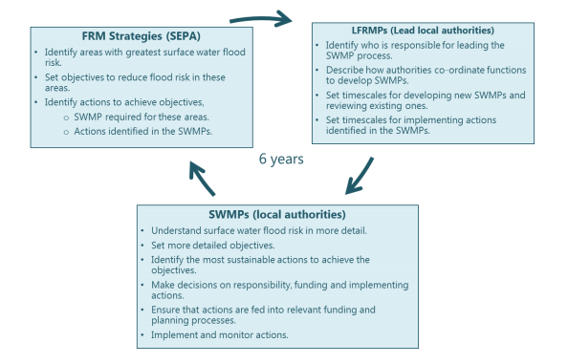
Figure 1-1 Surface water flooding and the flood risk management planning process (from Scottish Government Guidance)
This report delivers Falkirk Council’s local authority level SWMP. This will work towards delivering the actions identified within the FRM Strategies and the Local Flood Risk Management Plans (LFRMP).
The SWMP process should use an iterative and cyclical approach and should be treated as a live tool for partners to better manage resources to tackle surface water flooding. SWMPs should be monitored, reviewed and updated with timescales for reviews and updates that consider the six-year Flood Risk Management planning cycle. This allows long-term sustainability to be built into the plan and creates opportunities to use the most up-to-date available data to get a full picture of current/future flood risk. This approach provides the opportunity to set potential action trigger points, for future interventions, based on a defined set of increasing flood risk criteria or funding availability. Most importantly this approach creates a mechanism to tackle issues in stages. This is necessary for surface water flooding within urban areas where issues are typically fragmented and localised so that in many cases it is not feasible to solve all surface water flooding problems at once.
The purpose of this study is to review the national and regional surface water assessments and then apply and develop the knowledge to a local level. This will allow for a more detailed picture of local risk at a strategic scale focused on the Falkirk Council area which will aid decision making.

SWMP Process
Scottish Government Guidance outlines the process to be followed in developing and implementing a SWMP (Figure 1-2). This report relates to the ‘develop plan’ stage of the cycle.

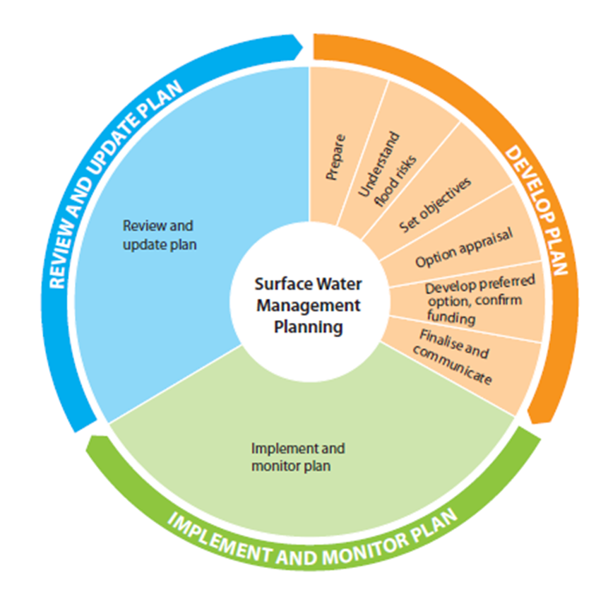
Figure 1-2 SWMP Process (from Scottish Government Guidance)

Level of Assessment
SWMPs can function at different geographical scales and therefore require differing scales of detail as outlined in Table 1-1.
A risk based approach should be adopted to assess surface water flooding. More effort should be focussed in areas of higher risk from surface water flooding to ensure the most cost-effective use of available budgets and resources throughout the SWMP study. Therefore it is generally considered to be most cost-effective to undertake an initial assessment (either through a strategic or intermediate assessment, or both) of surface water flooding at a broad spatial scale (e.g. settlement or county scale) to identify flood hotspots, which may include critical drainage areas (CDAs), and to inform where further assessment may be required. Initial assessments can also help to identify priorities and areas where the risks are highest would normally be addressed first.
As shown in Table 1-1, extracted from DEFRA Technical guidance on SWMPs. In line with Scottish Government guidance, this SWMP has been prepared at the ‘Borough’ scale and fulfils the objectives of a second level assessment covering ‘Large town or city or Borough’. In the light of extensive and severe historical flooding and the results from the SEPA national pluvial modelling suggesting that there are 936 properties at risk across the Falkirk Council area (for a rainfall event with a 1 in 200 probability of occurrence in any given year), it is appropriate to adopt this level of assessment to further quantify the risks.

Table 1-1 Levels of assessment in a SWMP study
Scale of assessment | Outputs | When might this approach be adopted
County or large conurbation - 1st level of assessment creating a base for further work | Broad understanding of locations which are more vulnerable to surface water flooding  Prioritised list for further assessment  Provide outline maps for spatial and emergency planning | Where there is limited current understanding of areas vulnerable to surface water flooding  OR  Where the local authority wants to develop a prioritised list of locations for further assessment
Large town or city or Borough - 2nd level of risk assessment including homing in on priority areas. | Identify flood hotspots which might require further analysis through detailed assessment  Identification of immediate mitigation measures which can be implemented  Provide outline maps for spatial and emergency planning | To enhance understanding of local surface water flooding issues  OR  To identify flood hotspots which require a detailed assessment
Small town or Known flood hotspots (from SFRAs, recent flood incidents, local knowledge etc) - 3rd level or assessment helping to understand the detailed causes and impacts of flooding. At this level solutions can be designed. | Detailed assessment of the causes and consequences of flooding, which can be used to understand the flooding, and to test mitigation measures (this is done through modelling of surface and sub-surface drainage systems) | Where the locations at higher risk of surface water flooding are already known (e.g. through recent flood incidents or level 2 SFRA)  OR  Where second level assessment identifies the need for the detailed assessment

Approach
This SWMP follows a strategic approach. It creates a SWMP action plan to best target and prioritise resources, allowing for more targeted approaches in areas most at need in the future.
The stages for the Strategic SWMP are:
- Start-up Meeting – Project review and planning
- Data Gathering - it is essential that there is an understanding of the existing conditions. The first stage in the development of a SWMP is the preparatory work which will enable the collation of all existing information relating to the priority area. A project data register will be created and updated to formally record the information that is available for the SWMP. Data will be reviewed for its quality and any gaps identified.
- Catchment and Area Characterisation - this stage requires analysis and interpretation of existing data to come to an understanding of the surface water problem. The characterisation includes:
  - Geographic description of each SWMP area including natural drainage characteristics and artificial drainage systems,
  - Identify existing actions/works that are being undertaken for the reduction of flood risk,
  - Identify any future/planned works or developments in the area,
  - Using SEPA regional pluvial data, Scottish Water outputs and historic records to describe the flooding mechanisms and adverse impacts of flooding (i.e. sources, pathway and receptors of flooding where level of detail in data allows),
  - Identify high risk areas (hotspots) and rank these based on likelihood and severity,
  - Assessment of current and future flood risk.
- Objective Setting – this stage aims to build upon the initial objectives set out in the FRM Strategies. These should be specific and related to the high-level flood risk assessment carried out in the characterisation stage. For a strategic SWMP, the objectives should focus on the highest risk areas of flooding and should also consider the different geographical scales (e.g. they should consider areas such as hot spots or high-risk receptors such as hospitals or main communication links).
- Options Appraisal – this stage involves the creation of an action plan for FC, involving further analysis of the catchment area outputs (please note this does not include option design or costing). This plan will identify;
  - Any obvious capital works that could provide improvement,
  - Any monitoring requirements or maintenance regimes that could be improved or formalised,
  - Land use planning or general policy opportunities to manage surface water flood risk,
  - Areas where a detailed SWMP is required to develop a robust option appraisal for FRM works.
- Stakeholder Consultation - Consultation on the Strategic Plan will take place in two stages. Once a draft plan is in place, council departments will be consulted on the outputs of Stage 1. This will enable confirmation of at risk areas and consider the priorities of other stakeholders with regard to option development. The second stage of consultation will be with responsible authorities for FRM including; Scottish Water, SEPA, Scottish Canals, Network Rail and Transport Scotland. This stage will enable opportunities for partnership working to be identified so options recommendations can be prioritised to meet shared objectives. Having a draft plan in place will ensure the process is succinct and produces tangible outcomes.
- Develop preferred options – following consultation with partners AECOM will support FC to;
  - Confirm areas for detailed assessment,
  - Action quick wins/policy changes,
  - Identify funding opportunities.
- Finalise options and areas of further study to communicate – A detailed SWMP report will be prepared that provides sufficient information to guide those implementing the plan. This will include a data pack to help share key information, e.g. key GIS outputs, maps, action plan with stakeholders.

Phase 1 & 2 – Prepare, Data Collation & Site Appraisal

Data Collation
The data gathering process is vital to ensure that the process is robust, includes the best available information and produces effective solutions. The data gathered and reviewed at this strategic stage includes;
- OS Mapping
- LiDAR
- Historic flooding information,
- SEPA flood extents,
- Scottish Water Integrated Catchment Study
- Local Authority historic flood records,
- SEPA historic flood records,
- Scottish Water and FC flooding datasets.
- Landscape and Heritage Designations
- Local Development Plan Report
- Forth River Basin Management Plan
- British Geological Society Geology and Hydrogeology maps
Reviewing the type and quality of the available data has allowed us to develop our methodology for assessing the current flood risk to the area and develop a background understanding of the Falkirk area. It has also supported us in identifying any gaps in knowledge.

Falkirk Council Area

Background
The Falkirk Council area borders North Lanarkshire, Stirling and West Lothian. Across the Firth of Forth is Clackmannanshire and Fife. The Falkirk Council area includes several towns including Falkirk, Grangemouth, Larbert, Polmont, Bo’ness, Denny, Airth, Stenhousemuir and Bonnybridge. The 2011 census recorded a population of 156,800 in the council area. Both the Forth and Clyde and Union Canals cross through the area, historically making it a key area for industry.

Strategic Environmental Assessment
In line with the Environmental Assessment (Scotland) Act 2005, a Strategic Environmental Assessment (SEA) screening was undertaken and submitted to SEA Gateway on 25/03/21. An SEA is the process for the early identification and assessment of the likely significant environmental effects, positive and negative, of activities. Often considered before actions are approved or adopted.

This SWMP is the next step in the FRM planning cycle building on FRM Strategies produced by SEPA in 2015 followed by LFRMPs produced by Responsible Authorities in 2016. The overarching Strategies were subject to a full SEA process that evaluated the likely significant effects on the environment of options that are similar to those being proposed through the SWMP. As the LFRMPs sit below and are consistent with the FRM Strategy it was concluded a screening only assessment was required.

The same conclusion applies to this SWMP. The screening process determined that a full SEA is not required as the environmental effects of the SWMP are unlikely to be significant and the SWMP itself is consistent with the FRM Strategy. The SWMP does not propose any specific schemes or new infrastructure.

It is concluded that the SWMP will not have a likely significant effect on any of the SEA topics. As the six-year cycle for assessing flood risk and developing plans becomes more established and the evidence base improves, it might be possible that more specific schemes/actions will be proposed to reduce flood risk through the lower level plans, such as the LFRMPs and SWMPs. It would be more appropriate at this stage to then evaluate the likely significant effects on the environment unless the measures are still likely to be delivered through other legislative and plan-making processes.
The screening was reviewed by Historic Environment Scotland and NatureScot, who also concluded on 13th April 2021 and 21st April 2021 respectively that there are unlikely to be significant environmental effects and therefore a full SEA was not required. The SEA screening and responses are included in Appendix A.

Landscape and Heritage
There are three Special Landscape Areas (SLA) in the Falkirk Council area:
- Denny Hills Special Landscape Area
- Slamannan Plateau/ Avon Valley Special Landscape Area
- South Bo’ness Special Landscape Area
A Site of Special Scientific Interest (SSSI) is a statutory designation made by Nature Scot under the Nature Conservation (Scotland) Act 2004. There are 7 SSSI’s within the Falkirk Council Area and 3 local nature reserves (LNR) and 1 country park (CP).
- Avon Gorge SSSI
- Bo’mains Meadow SSSI
- Bonnyfield Nature Park LNR
- Carron Dams SSSI
- Carron Dams LNR
- Carron Glen SSSI
- Darnrig Moss SSSI
- Denny Muir SSSI
- Howierig Muir SSSI
- Kinneil Foreshore LNR
- Muiravonside CP
The Falkirk area has a number of cultural heritage sites, of particular note is the Antonine Wall. The Antonine Wall passes through the Falkirk Council area and is a World Heritage Site. The wall originates in West Dunbartonshire, crossing into the Falkirk Council area and ending in Carriden near Bo’ness. The wall is actually a turf embankment built on stone foundations. Parts of the wall can be seen across the FC area, in varying forms.
It is possible that repeated flooding in these areas can damage the existing designation and can have significant environmental and economic impacts. These areas could therefore be considered vulnerable receptors, so awareness is needed to aid understanding of the severity of flood risk during Phase 3.
These areas have been identified so they can be considered during the optioneering stage of the assessment as potential constraints/opportunities to mitigation works. There are always opportunities for environmental enhancement as part of any flood mitigation proposals. These designations can also make certain options non-viable e.g. it would be inappropriate to suggest creating Sustainable urban Drainage System (SuDS) features in a wildlife designation area if this would create a new habitat that would be non-favourable to existing species or would disrupt existing ecological systems. Conversely in the right setting, SuDS options can enhance existing habitats. Awareness of designations will allow this opportunity/constraint to be considered.
Figure 2-1 and Figure 2-2 illustrate the sites of environmental interest and sites of cultural heritage respectively, applied in the SEPA National Flood Risk Assessment (NFRA). It should be noted that not all sites of environmental interest listed above are covered by the SEPA shapefiles shown below. The heritage sites shown in Figure 2-2, includes the buffer zone around the site as well as the site itself.
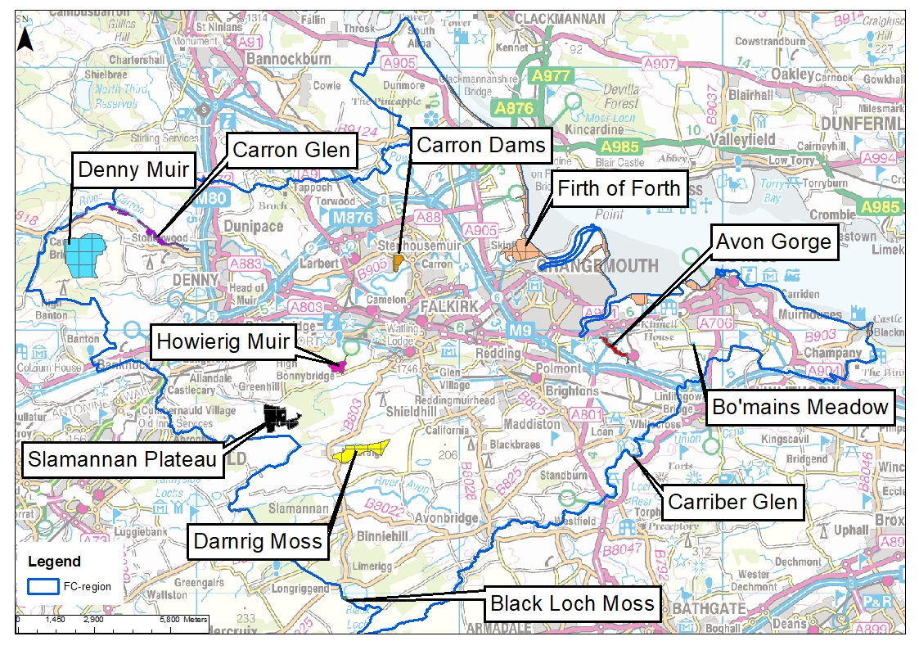
Figure 2-1 Environmental Sites as identified by SEPA NFRA
Contains OS data © Crown Copyright and database right (2020)
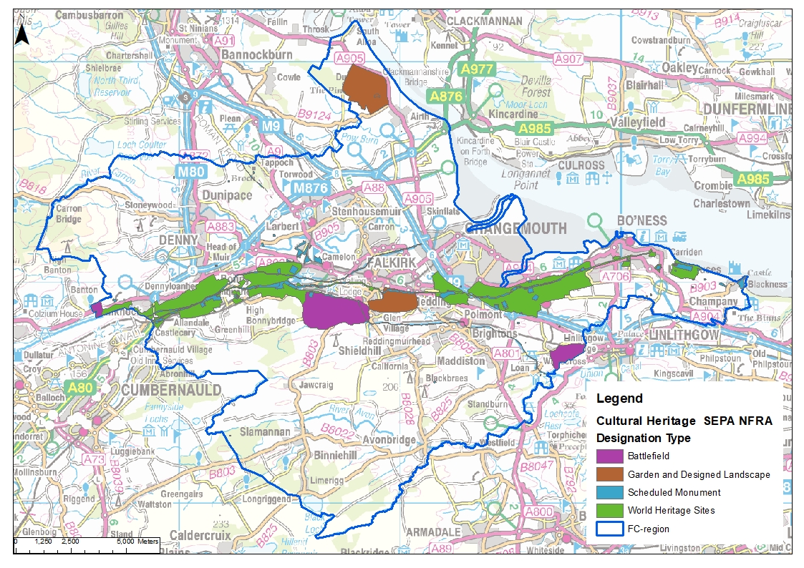
Figure 2-2 Heritage Sites as indetified by SEPA NFRA
Contains OS data © Crown Copyright and database right (2020)

Local Development Plan
The Falkirk Local Development Plan 2 (LDP) is the statutory document which guides FC’s vision and spatial strategy for future development in the Council area over the next 20 years. It was adopted on 07 August 2020. It is important that the SWMP is not viewed as an isolated, stationary document, but one that connects with other strategic and local plans which can adapt as the Falkirk area develops. The LDP has been reviewed to highlight pressure locations for future surface water drainage as well as highlight opportunities for further consideration during the Options Appraisal. The full Local Development Plan can be viewed on the Falkirk Council website. An overview of the LDP is provided below and a high-level map is included in Appendix B

Green and Blue Network
Green Blue networks (GBN) create opportunities for spaces to be better adapted to existing flood risk and a changing climate whilst also creating space for habitats and place making benefits.
The LDP is driving GBNs as part of the Central Scotland Green Network (CSGN). This seeks to transform the landscape of Central Scotland through environmental improvement, creating woodland and other habitats, restoring vacant and derelict land, and developing path networks. The LDP has identified a number of opportunities to meet these objectives. North Larbert and South Bo’ness have significant potential for enhancement of GBN which could also improve surface water flood risk.
As part of the Options Appraisal opportunities to enhance these GBN opportunities for additional surface water flood risk benefit have been identified. It should also be noted GBNs go beyond existing green spaces but can also be retrofitted in existing urban areas or planned in new sites to manage water more sustainably. Development opportunism relating to business, regeneration and housing have also been reviewed as key opportunities to introduce GBNs from the outset to improve drainage from brownfield sites and prevent increased pressure from new sites.

Urbanisation/Redevelopment
Plans for urbanisation and redevelopment present a significant challenge to the existing drainage systems. However, it also affords a crucial opportunity to address long-standing issues and problems relating to surface water flooding and pressure points on the drainage system, through strategic improvements and upgrades to the drainage system.
Housing
By 2039, the population is expected to reach 170,870 compared with the 2016 figure of 159,380. It is estimated that the number of households will rise by 10,641 between 2014 and 2039, therefore, new housing supply is required. A target of 6,894 new homes has been set for the period 2017-2030. Areas within Falkirk under greatest pressure for housing demand include; Bo'ness, Braes rural south, Grangemouth and Larbert which are identified for percentage increases in housing of between 23% and 74%. Surface water drainage in these locations will be sustainably managed in line with SPP and present opportunities to achieve betterment in existing drainage.
Business
The Economic Strategy for Falkirk 2015-2025 is based on growing the local economy, attracting investment to enhance the area’s infrastructure, and inclusion so that all local people can access economic opportunities. Strategic sites have been identified and present an opportunity to improve existing surface water regimes where possible. These include the following:
- Falkirk; Falkirk Gateway/Stadium, Abbotsford Business Park, Caledon Business Park
- Grangemouth; Bo’ness Road/Wholeflats Road (Ineos), Grangemouth Docks, Earls Gate Business Park, Wholeflats Business Park. Glensburgh, South Bridge Street, Earls Road (Chemical Cluster), West Mains/Laurieston Road Gateway Business Park
- Larbert; Glenbervie
- Gilston
- Whitecross/Manuel Works

Town centre regeneration
Town centres form the heart of our communities, providing a sustainable focus for shopping, business, leisure, services and community life, and shaping the area’s sense of place. Within the Falkirk LDP there is a drive to regenerate these areas. This creates opportunity to build back better with GBN and more sustainable drainage systems included as part of placemaking and drainage plans at the following locations:
- Falkirk Town Centre; Grahamston and the East End
- Grangemouth,
- Bo’ness,
- Denny,
- Bonnybridge
- Newcarron.
Infrastructure
It is recognised that infrastructure is required to support any development. It is important that projects summarised below are developed with no increase to surface water flood risk and to create betterment where possible through retrofit/early inclusion of SuDS in designs:
- Local roads Improvements - A904 Corridor Improvements, A803 Corridor Improvements, Grangemouth Access Improvements, Denny Eastern Access Road and Denny Cross Improvement, A904/A993 Junction Improvement, Bo’ness, Waterslap Road Improvement, Carronshore
- Active Travel corridors - Falkirk - Denny/Bonnybridge Path, Bo’ness - Grangemouth Path and A904 Realignment, A88 (Antonshill to A905 Path), Stenhousemuir
- Falkirk Bus Station Improvement
- Education facility enhancement - Secondary School Capacity Enhancement (Braes, Denny, Graeme) and Primary School Capacity Enhancement (Bankier, Denny, Head of Muir, Kinnaird, Maddiston, Whitecross)

River Basin Management Planning
River Basin Management Planning (RBMP) aims to protect and improve the water environment in Scotland. Plans are produced by SEPA on behalf of Scottish Government. The plans establish a range of actions to address impacts to water quality, physical condition of watercourses, water flows and levels, and fish migration. Currently, RBMP is in it’s second cycle which will run from 2015 to 2027. The FC area is set within the Forth catchment. During the first phase, 2009-2015, the Forth advisory group published a management plan and for the second phase data can be found in the Water environment hub, found on the SEPA website. RBMP have been reviewed to identify any opportunities for partnership working and to tie up aspirations to improve surface water flood risk and the water environment, in tandem.
An overview of the overall condition of all surface waters within the FC area is listed below. Some waterbodies are separated into different reaches; however, their category is summarised here.
- Forth and Clyde Canal - Good
- Union Canal - Moderate to Good
- River Avon - Bad to Moderate
- Mains Burn - Poor
- Logie Water/Barbauchlaw Burn - Poor
- Drumtassie Burn - Good
- Pow Burn/Tor Burn - Moderate to Good
- Grange Burn/Westquarter Burn - Moderate
- River Carron - Moderate to Poor
- Bonny Water/ Red Burn - Moderate
- Auchenbowie Burn - Moderate
- North Calder Water - Poor
- Island Farm Lagoon - High
- Island Farm Lagoon - Good
- Lower Forth Estuary - Moderate
- Upper Forth Estuary - Moderate
A breakdown of the categories is provided in Table 2-1. It can be seen that there is opportunity for improvement in a range of categories, in general the majority of waterbodies could benefit from better water quality and physical condition. Specific water bodies could benefit from better access for fish migration and physical condition.
Table 2-1 Condition Categories
Number of surface waters in each condition
Category | High | Good | Moderate | Poor | Bad
Water Quality | 8 | 8 | 9 | 0 | 0
Physical Condition | 8 | 8 | 8 | 0 | 1
Access for Fish Migration | 17 | 0 | 0 | 4 | 0
Water flows and levels | 16 | 3 | 2 | 0 | 0
Freedom from invasive species | 24 | 1 | 0 | 0 | 0
The Forth advisory group are working towards improving these categories within the Falkirk Council Area. The aims of the RBMP to improve these key categories will be considered at the option stage of the SWMP to see if there are opportunities to tie into the existing actions and improve the surface water quality. A more detailed assessment should be undertaken at a detailed SWMP stage.

Grangemouth Flood Protection Scheme
The planned Grangemouth Flood Protection Scheme was identified as high priority in SEPA’s 2015 National Flood Risk Management Strategy. The scheme aims to protect communities in Grangemouth, Wholeflats, Glensburgh, Langlees, Carron, Carronshore and Camelon. The scheme looks to address flood risk from the River Carron, Grange Burn, River Avon and the Forth Estuary. At the time of writing the outline design is being finalised, scheme notification is planned to commence mid 2022 with scheme construction commencing late 2024 over a 10 year period. The development of this scheme presents an opportunity to tie identified works into construction programme to minimise disruption and create cost savings. The Grangemouth Flood Protection Scheme Area is shown in Figure 2-3 and a copy is also included in Appendix B. It should be noted that any secondary flood risk from the scheme itself i.e. new/increased pluvial flooding due to blockage of flow paths by defences would be addressed during detail design.
o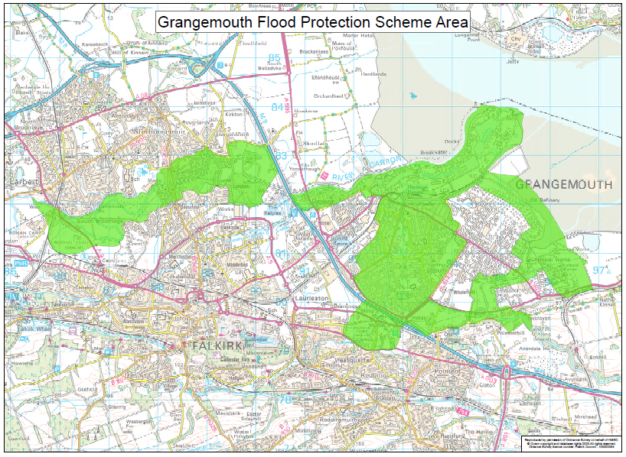
Figure 2-3 Grangemouth Flood Protection Scheme Area

Geology and Hydrogeology
The geological and hydrogeological information for Falkirk has been obtained as part of data gathering to aid understanding of flood mechanisms. Underlying geology can offer an opportunity to use SuDS features to reduce surface water runoff and provide storage/attenuation through infiltration to the ground, where permeable soils are present to allow this pathway. This information will aid the identification of these potential SuDS locations during options appraisal.
The British Geological Survey (BGS) website provides geological maps of the UK as well as locations of existing borehole logs throughout the UK, many of which are freely available. Ground conditions can be a constraint for many civil engineering works if the underlying ground has poor bearing capacity, however given the soft engineering nature of many surface water management interventions this is unlikely to be an issue. A high-level drawing of the Falkirk Council geology is included in Appendix B, full details can be found on the British Geological Survey (BGS) website.
The majority of the study area is underlain by Coal with areas of Passage on the east and west edges of the local authority boundary. Historic mining is present in Falkirk and may require additional ground works and significant additional survey work to gain a clear understanding of surface water flow paths and to de-risk any potential construction sites for mitigation options. This formation is shown to be a moderately productive aquifer in the Hydrogeology maps. This is a constraint when considering infiltration SuDS potential in the catchment as significant infiltration could result in the formation of sink holes. As well as this, contamination risk to the aquifer would need to be carefully considered through treatment levels or lining.
Superficial cover includes till, raised marine deposits and raised tidal flat deposits. Marine and tidal deposits tend to be of low permeability therefore soil is unlikely to be free draining. These factors therefore limit the potential for use of infiltration SuDS measures such as infiltration strips, infiltration basins etc. for mitigation of pluvial flood risk.

Phase 3 - Catchment Assessment & Understanding Flood Risk
The catchment assessment allows the causes and consequences of flooding to be understood. This includes characterising the drainage patterns within the study area, identifying areas at risk of surface water flooding, and identifying any opportunities and constraints. By gaining a better understanding of the catchments and flood risk within the Falkirk area, the next stages of assessment can be targeted, therefore achieving the most beneficial outcomes. This stage will inform the strategic optioneering and provide the overview which can be built upon for future SWMP stages and cycles.
This section of the report reviews the potentially vulnerable areas as outlined by SEPA’s NFRA, the Scottish Water Integrated Catchment Model, catchment analysis and future flood risk.

Potentially Vulnerable Areas (PVA)
The National Flood Risk Assessment (NFRA) established 14 Local Plan Districts (LPD’s). Within every LPD catchments were identified which were at risk of flooding warranting further assessment and appraisal of flood risk management options. These catchments are known as Potentially Vulnerable Areas (PVAs).
The National Flood Risk Assessment (NFRA) was first published in December 2011. It forms the PVA’s and actions and objectives listed here. An update to the NFRA was carried out in 2018. This update reviewed the existing PVA’s and included a public consultation. The updated objectives and actions for the new PVA’s will be applied to the second round of SEPA’s Flood Risk Management Strategies. These are due to be published in December 2021 covering the period of 2022-2027 and are, therefore, not currently available. This assessment, therefore, focuses on the objectives relevant for the current strategy cycle, however the updated PVA areas will be taken into account.
There are 6 PVA areas within the Falkirk Council remit, however some cover multiple local authority areas:
- 09/09 – Stirling (Eastern Villages)
- 10/09 – Airth
- 10/11- Falkirk, Grangemouth, Lauriston, Denny, Redding, Dunipace, Cumbernauld, Carron and Stenhousemuir (includes SWMP action)
- 10/12 – Bo’ness (includes SWMP action)
- 10/13 - Linlithgow Bridge, Bathgate, Whiteside and Slamannan (includes SWMP action)
- 10/14 – Philipstoun
Three of these PVAs have SWMP objectives identified. The resultant objectives are listed below:
- 10033 - Reduce economic damages and number of residential properties at risk of surface water flooding in Falkirk, Stenhousemuir and Carron where practical PVA 10/11.
- 10104 - Reduce economic damages and number of residential properties at risk of surface water flooding in Polmont and Maddiston where practical PVA 10/11 and PVA 10/13.
- 10042 - Reduce economic damages and number of residential properties at risk of surface water flooding in Bo'ness, Carriden and Muirhouses where practical (10042) PVA 10/12.
The annual average damages for surface water flooding for each PVA is set out below, illustrating the need for surface water management planning.
- In PVA 10/11 approximately 21% of the flood risk experienced is surface water flooding with 460 residential properties at risk and Annual Average Damages of £730,000.
- In PVA 10/12 approximately 83% of the flood risk experienced is surface water flooding with 200 residential properties at risk and Annual Average Damages of £510,000.
- In PVA 10/13 approximately 72% of the flood risk experienced is surface water flooding with 400 residential properties at risk and Annual Average Damages of £1,100,000.

The strategy sets actions for surface water for the fulfilment of Falkirk Council within the current LFRMP cycle (2016-2022). The same action was set for all three PVA objectives:
  - Action (ID): SURFACE WATER PLAN/STUDY (100330018, 101040018, 100420018). The area must be covered by a surface water management plan or plans that set objectives for the management of surface water flood risk and identify the most sustainable actions to achieve the objectives.
The objectives will be addressed through the implementation and delivery of the outcomes and recommendations identified and agreed in the SWMP; however, this strategic assessment will not be limited to these priority areas. A full assessment of the Falkirk Council area will be undertaken within this SWMP report in order to deliver a full picture of surface water flood risk specific to the FC area.
Figure 3-1, Figure 3-2 & Figure 3-3 show the existing PVA’s which have SWMP objectives. Figure 3-4 shows the updated PVA areas as part of the 2018 review. It can be seen that the current PVA 10/11 which covers a large area of the FC area is broadly represented by the new PVA 02/10/10, with some boundary changes. PVA 10/12 at Bo’ness is represented by the new 02/10/11. PVA 10/13 at Slamannan and Avonbridge is represented by the new 02/10/16 and just shows the area within the FC boundary. The remaining two new PVAs 02/09/07 and 02/10/08, Stirling East and Airth are reviews of 09/09 and 10/09, neither of which had SWMP objectives.
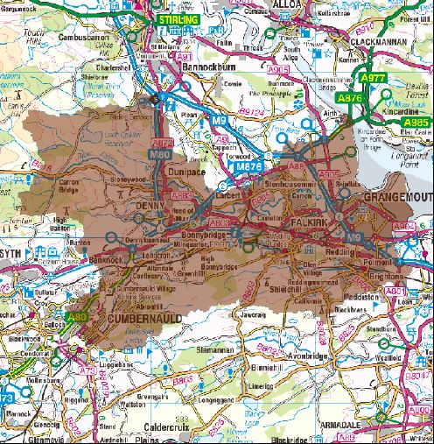
Figure 3-1 PVA 10/11 Falkirk, Grangemouth, Lauriston, Denny, Redding, Dunipace, Cumbernauld, Carron and Stenhousemuir (includes SWMP action) (extract from PVA)
Contains OS data © Crown Copyright and database right (2020)

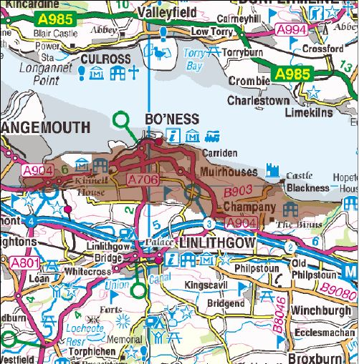
Figure 3-2 PVA 10/12 Bo’ness (includes SWMP action) (extract from PVA)
Contains OS data © Crown Copyright and database right (2020)

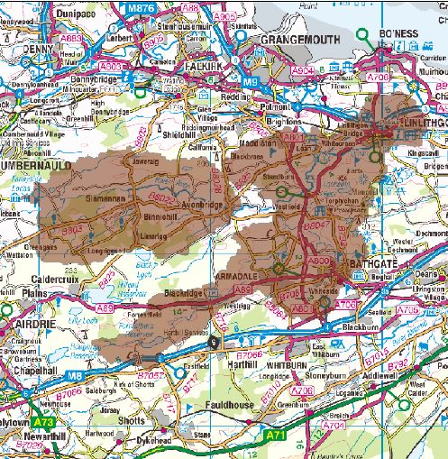
Figure 3-3 PVA 10/13 Linlithgow Bridge, Bathgate, Whiteside and Slamannan (includes SWMP action) (extract from PVA)
Contains OS data © Crown Copyright and database right (2020)

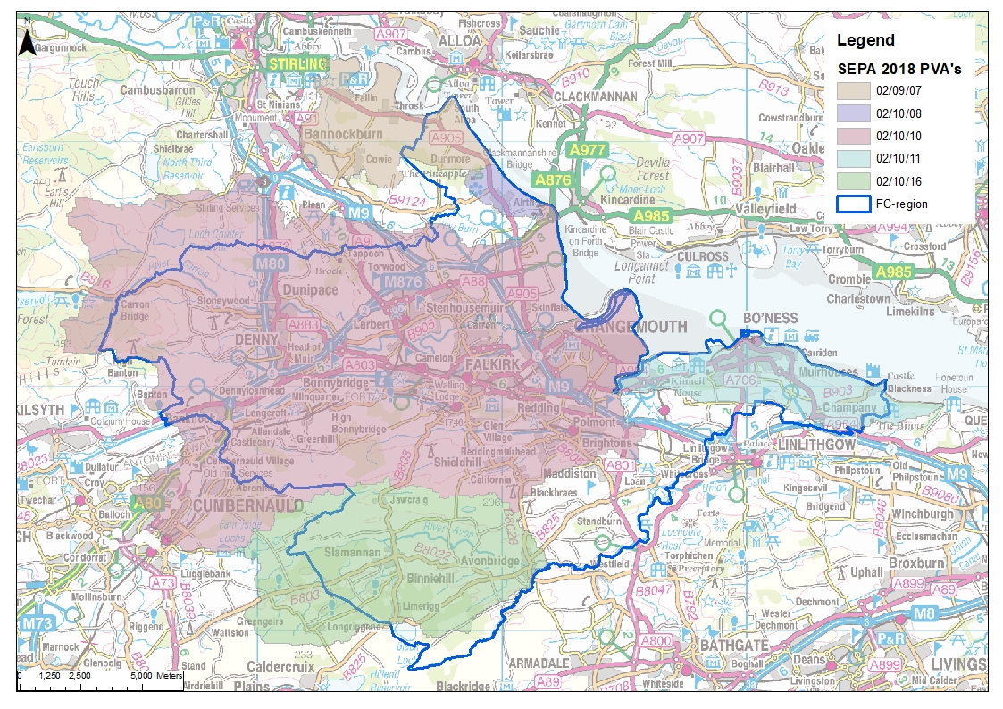
Figure 3-4 2018 NFRA PVA's
Contains OS data © Crown Copyright and database right (2020)

SEPA Flood maps
SEPA flood maps are developed at a national level to help gain understanding of flood risk in Scotland. They show flood risk from coastal, fluvial and surface water flooding. As they are developed on a national scale, they provide a high-level indication of areas at flood risk but should not replace a detailed assessment. SEPA’s flood maps are appropriate at this stage of the SWMP as they can help identify areas which would benefit from a more detailed study. The SEPA flood maps can also be layered with other data sources to enable a greater understanding of the flood sources and impacts. The SEPA flood maps provide three different likelihood maps, low, medium and high, these show the chance of flooding occurring:
- High Likelihood: A flood event is likely to occur in the defined area on average once in every ten years (1:10). Or a 10% chance of happening in any one year.
- Medium Likelihood: A flood event is likely to occur in the defined area on average once in every two hundred years (1:200). Or a 0.5% chance of happening in any one year.
- Low Likelihood: A flood event is likely to occur in the defined area on average once in every thousand years (1:1000). Or a 0.1% chance of happening in any one year.

Scottish Water ICS Model
Scottish Water provided their Integrated Catchment Study (ICS) model for Falkirk as part of the SWMP. The ICS was developed to understand flow interactions between below ground drainage infrastructure and open watercourses. The Falkirk ICS system covers an area of approximately 30km² and is predominantly a gravity system serving approximately 110,000 consumers. The towns of Larbert, Camelon, Falkirk, Grangemouth, Stenhousemuir and Polmont are represented within the ICS. This model has been used to help identify drainage catchments and characteristics as well as highlight areas of sewer flood risk or integrated risks with overland flows.
The Falkirk Integrated Catchment Study (ICS) contains two Wastewater Treatment Works (WwTW), Dalderse WwTW and Kinneil Kerse WwTW.
The Falkirk ICS catchment is predominantly a combined system with some areas of separate systems where redevelopment has occurred. Flows are generally gravity with branches pumped into the network. Dalderse WwTW is served by gravity and pumped flows and Kinneil Kerse WwTW is solely served by pumped flows. The Dalderse and Kinneil Kerse catchments overlap in Grangemouth with Dalgrain Waste Water Pumping Station (WwPS) pumping to Dalderse WwTW, whilst Bowhouse WwPS and Zetland WwPS pump to Kinneil Kerse WwTW. There is no clear boundary between these networks as there are a number of bifurcations along the perimeter that means flows can be spilled either way.
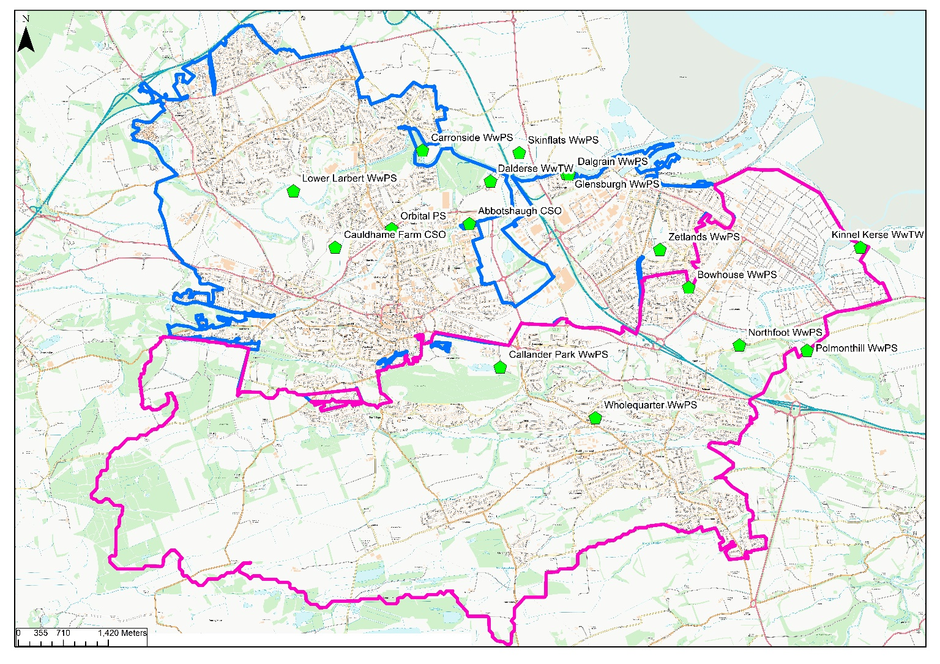
The two main catchments in the network are Dalderse and Kinneil Kerse as shown in Figure 3-5 below, along with key hydraulic controls. These have been subdivided into subcatchments or Critical Drainage Areas (CDA) as part of the Catchment Assessment to create more manageable units for assessment. This is discussed further in Section 4.
Dalderse
Kinneil Kerse
Figure 3-5 Dalderse and Kinneil Kerse Catchments
Contains OS data © Crown Copyright and database right (2020)

Model runs
Hydrology (using FEH 2013 parameters) for 1 in 2-year, 1 in 5-year, 1 in 10-year and 1 in 30-year design storm events (rainfall and fluvial hydrographs) was provided with the model. Trade waste, wastewater and ground infiltration profiles were also provided. In addition, a level hydrograph to set the downstream boundary at Mean High Water Spring Level at outlets was also provided.
Using these different inputs and boundaries, the model was run for the 10 year and 30 year events to represent high and medium likelihood events in order to locate likely sewer flooding locations. The model was run at these return periods for the 60,120,180,240,300,600 min durations for both Winter and Summer storm profiles in order to identify the critical storm i.e. worst-case flooding. Flood volume reports were extracted from the model and analysed. The 600min Summer storm was shown to result in the greatest overall flood volume and was taken as the worst case.
Flood volumes for the 1 in 30 year event were then split into low (<10m³ flood volume), medium (11 - 50m³ flood volume) and high (>50m³ flood volume) severity in order to try and understand the severity of sewer flooding. The 1 in 30 year event was chosen as the maximum standard of service expected from the Scottish Water network. These model results have been used in the identification and ranking of hotspots. It should be noted caution needs to be exercised with these outputs as this model is strategic and, therefore, will contain implications and assumptions which may not be reflective of local conditions. Furthermore, the model only has 1D representation so flood routing and storage above ground is not considered. On this basis, it is important that reported flooding is considered alongside simulated outputs during selection of hotspots.

Model outputs

Dalderse Catchment
The Dalderse network is mainly a combined system with a small number of separate drainage networks (foul and storm water) mainly to the north of the catchment within the Stenhousemuir and Larbert areas.
The majority of the Dalderese WwTW catchment lies to the west of the treatment works. Flows from the Stenhousemuir and Carronshore areas drain by gravity to Carronside Wastewater Pumping Station (WwPS) before transferring to the main sewer in the Bainsford area. Catchment flows from Larbert gravitate south towards the Lower Larbert WwPS where they are then pumped into the Cauldhame Relief Sewer near to Cauldhame Farm CSO and gravitate to Dalderse WwTW. Alternatively, some flows from Larbert do not go via Lower Larbert WwPS. Instead they gravitate via the high level sewer that runs directly to Dalderse WwTW through the area of Bainsford. Flows from South Falkirk and Camelon drain in a north easterly direction towards the Dalderse WwTW. The area to the north of Grangemouth discharges to the Dalderse WwTW via the Dalgrain PS at Glensburgh.
Inlet flows arrive at the Dalderse WwTW via two trunk sewers which merge just upstream of the inlet works. One takes flows from south of Dalderse, which includes Falkirk and Camelon and the other takes flows from Grangemouth. A series of bifurcations are located on Grahams Road which transfer flows between the two main sewers during storm conditions. Skinflats to the north of the WwTW also discharges to the Dalderse WwTW via a transfer WwPS. Treated flows from the WwTW discharge to the River Carron near to Junction 6 of the M9 motorway.
Model results indicated widespread sewer flooding across the Dalderse catchment in a 1 in 30 year event. The Middlefield and Westfield areas are key areas of sewer flood risk in the Falkirk urban area, with large concentrations of flooded manholes particularly in the medium and high flood volume category. Cunningham Road in Carron, Lavery Avenue and Pembroke Street in Larbert as well as South Broomage in Stenhousemuir are other significant clusters of sewer flood risk based on model outputs. The A9 through Bainsford, as well as Westburn Avenue/Majors Loan adjacent to Falkirk Community Hospital also present clusters of predicted sewer flooding towards the north of the Dalderse Catchment. Much of the Grangemouth sewer network is also predicted to flood, likely as a result of tide locking of outfalls. This is particularly noticeable south of Bo’ness Road, Almond Street and Montgomery Street.

Kinneil Kerse Catchment
The Kinneil Kerse network is largely combined, except for the towns of Glen Village and Hallglen which are served by a separated system. Areas within the Polmont area are predominantly served by combined sewers; however surface water sewers also exist within these areas.
Flows from the Polmont, Shieldhill and California catchments drain in a north easterly direction towards the Polmonthill WwPS and flows from here are discharged directly to the Kinneil Kerse WwTW. Two storm tanks are located at Polmonthill WwPS to attenuate catchment flows and provide additional storage.
Catchment flows from Glen Village, Hallglen, Westquarter and north Polmont flow to the east towards Northfoot WwPS. Pumped flows from Northfoot WwPS discharge directly to Kinneil Kerse WwTW.
Flows in south Grangemouth drain to either Bowhouse WwPS or Zetland WwPS which both discharge directly to Kinneil Kerse WwTW. South Grangemouth is predominantly a combined system but there are two surface water culverts running through the catchment that both discharge into the Grange Burn. A storm tank is located within the structure of Zetland WwPS to provide additional storage.
Polmonthill WwPS, Northfoot WwPS, Bowhouse WwPS and Zetland WwPS rising mains all combine and flows are pumped into Kinneil Kerse WwTW Inlet via one rising main.
Model results indicated potential flooding being largely localised to the north east of the Kinneil Kerse catchment at a 1 in 30 year event. A cluster of sewer flooding is predicted in the Rumford and Brighton areas of Falkirk at Carron Terrace and Polwarth Avenue respectively. Langton Road, Westquarter and Station Road, Polmont are potential high risk areas with clusters of medium and high severity flood volumes predicted in a 1 in 30 year event.

Scottish Water Additional Models; Small Catchments
Models covering smaller catchments within Falkirk Council area were also provided by Scottish Water. These included:
- Denny WwTW
- Bonnybridge WwTW
- Slamannan WwTW:
- Bo’ness WwTW
- Airth WwTW
The models were provided with rainfall data as well as trade waste and wastewater profile data. Ground infiltration and tidal level files were also provided where appropriate. The models were run for the 1 in 30 year event to represent the Scottish Water required standard of service and based on the rainfall data available. The models were run for the 60,120,180,240,300,600 min durations for both Winter and Summer storm profiles in order to identify the critical storm i.e. worst-case flooding. This was done by extracting flood volume reports for model manholes and comparing for each storm duration to select the worst case storm duration for each catchment in terms of total flood volume.
Flood volumes were then categorised by severity in the same manner as the Falkirk ICS results. As with the ICS model caution should be exercised with outputs as a strategic representation and results should be read with an awareness of reported events in mind.
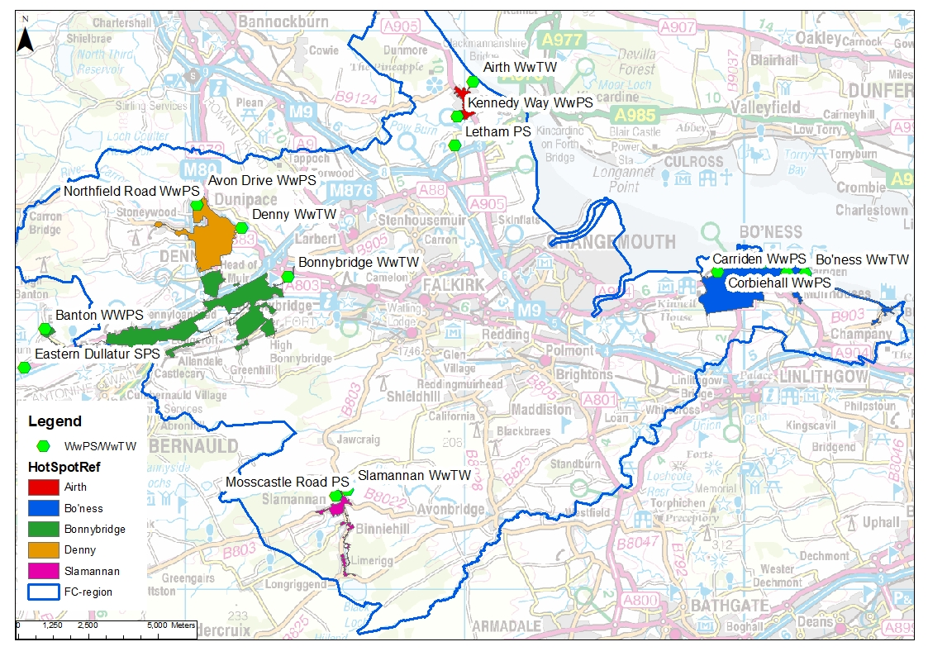
Figure 3-6 Scottish Water Model Areas
Contains OS data © Crown Copyright and database right (2020)

Model outputs

Denny
The Denny catchment is located approximately 9km from Falkirk and includes the settlement of Dunipace. The sewer network is split between combined and separate systems with a slightly higher proportion of separate network. All flow in this catchment flows east to Denny WwTW to the east of Springfield Road. Northfield Road WwPS and Avonside Drive WwPS pump flows from the north to Denny WwTW.
During a 1 in 30 year storm the model predicted manhole flooding is extensive particularly in the medium and high severity category. The highest concentration of flooded manholes are in the Winchester Avenue and Barnego Road areas. The extensive and severe sewer flooding predicted is likely to be linked to high water levels in the River Caron. This is likely to be over-represented as the model does not currently take full cognisance of different response times in rivers and drainage systems or assess the joint probability of extreme rainfall and river flows coincidence. This is further evidenced by the lack of reported flooding to SW with only 3 incidents noted in the Denny catchment.

Bonnybridge
Bonnybridge lies 6.5km west of Falkirk. The sewer network is evenly split between combined and separate sewer systems. The Eastern Dullatur WwPS collects flow from the Dullatur area and pumps flow into the main trunk sewer at Kilsyth Road. The Banton WwPS serves a small area around Main Street which pumps foul flow to the combined system at Mill Road. Combined flow from the Banton area is conveyed by gravity to the main trunk sewer at Kelvinhead Road. Foul and combined flow from Banknock, Haggs, Longcroft, Dennyloanhead, Denny, High Bonnybridge and Bonnybridge areas is conveyed by gravity to the main trunk sewer which follows the route of the Bonny Water. All flows in the catchment are conveyed to the Bonnybridge WwTW, located in the north - east of the catchment.
Model results indicated widespread flooding across Bonnybridge at the 1 in 30 year event with a high number of manholes predicted to flood with flood volumes in the medium and high category. High severity flooding is particularly concentrated around Larbert Road and surrounding residential streets. There is also a high proportion of sewer flooding predicted around Seabeg Road and Roman Road.

Slamannan
The Slamannan catchment is located approximately 6km to the south west of Falkirk. The upper section of the network which includes Limerigg is combined. These flows gravitate to the north discharging to Slamannan WwTW. The downstream network that serves the village of Slamannan is largely separate. Foul flows upstream of Mosscastle Road are collected by a pumping station here and pumped to a main trunk sewer. Mosscastle Road WwPS collects foul flows from the small upstream area of Mosscastle Road and pumps into the main trunk sewer towards the WwTW.
Model results indicated some minor sewer flooding concentrated along Station Road at a 1 in 30 year event. Sewer flooding is also predicted along the right bank of the Culloch Burn in rural land.

Bo’ness
Bo’ness is located approximately 13km east of Falkirk. The sewer network is largely combined but new developments are served by separate systems. The catchment falls from south to north with a drastic drop in level at the coast.
Flows from the east of the Bo’ness catchment drain to the Grangepans WwPS located to north of the catchment. The Corbiehall WwPS, located in the west of the Bo’ness, receives flows from the west of the catchment, then pumps flows to a higher level sewer, after which flows gravitate towards the Grangepans WwPS. Combined catchment flows entering the Grangepans WwPS are subsequently passed to the Bo’ness WwTW located at Carriden. A small section of the network located to the east of the Bo’ness catchment is served by the Carriden WwPS. The Carriden WwPS pumps flows directly to the Bo’ness WwTW.
Medium and high severity flooding is focused in four key areas including; residential streets around Clydesdale Street, the area bounded by Linlithgow Road and Corbiehall, North Street/Main Street and at Bridgeness Road. Based on the location of the most severe flooding it is likely tide locking of outfalls is a major driver to flood risk in Bo’ness.

Airth
Airth is a small village located 7km north of Falkirk. The sewer network is predominately combined however newer developments are served by separate systems. Surface water from the newer developments discharges to the Pow Burn and to the River Forth. Flows travel to Letham Village pumping station, before being pumped to Kennedy Way pumping station within the main catchment of Airth.
The 1 in 30 year model results indicate widespread flooding in Airth. The majority of this predicted flooding is of low severity and likely causes little issue to residents. High severity flooding is predicted around Carse View and Park View whilst medium severity flooding is predicted in the South Green Drive area.

Catchment Analysis
Based on the large scale of the area and volume of data available, the first stage of the catchment analysis was to divide the Falkirk council area into a smaller number of more manageable units for assessment. The overall area was split into “Critical Drainage Areas” (CDA) which are defined as “a discrete geographic area (usually a hydrological catchment) where multiple and interlinked sources of flood risk (surface water, groundwater, sewer, main river and/or tidal) cause flooding in one or more hotspots during severe weather thereby affecting people, property or local infrastructure.”
The CDAs were delineated using a combination of LiDAR data and SW model information on drainage catchments. A total of 37 CDA’s were identified. To tailor the assessment further the catchment analysis is focused on priority areas highlighted by FC during the start up meeting resulting in 15 CDA’s covering the majority of the FC boundary being taken forward for assessment. Each CDA is discussed in more detail in Sections 4.1.1 to 4.1.15. The CDA’s are shown in Figure 3-7 below and are also included in Appendix B.
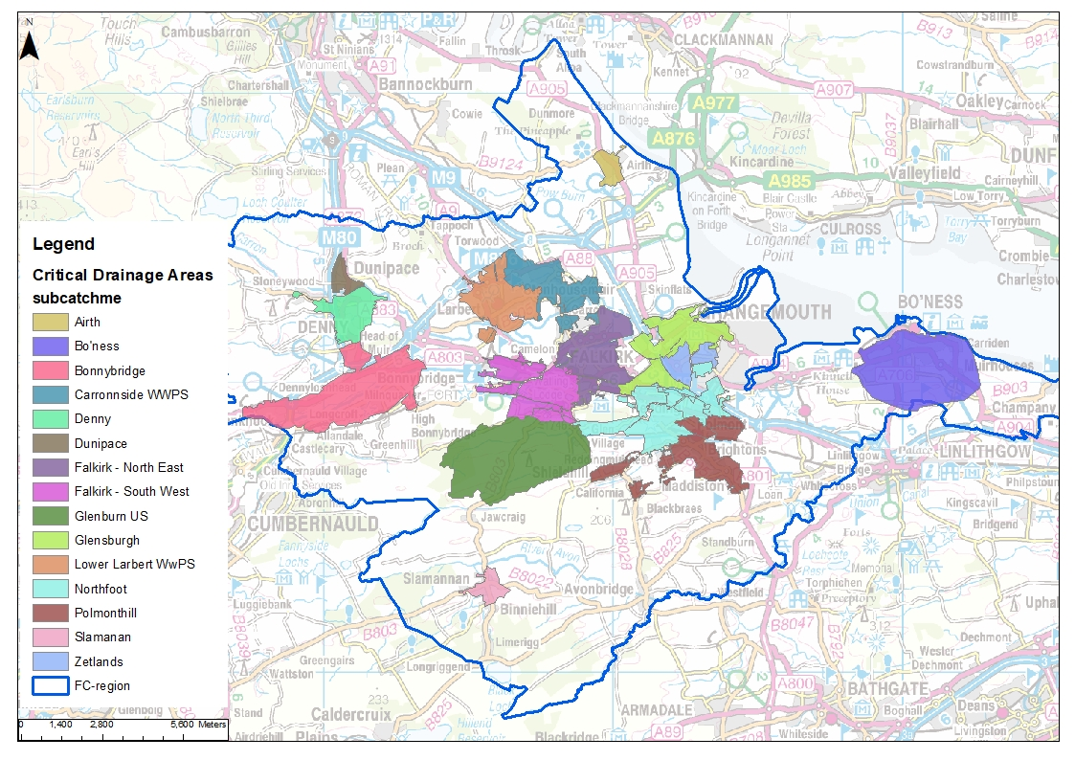
Figure 3-7 Critical Drainage Areas
Contains OS data © Crown Copyright and database right (2020)

Future risk

Climate Change
Climate change is having a significant impact on flood risk, through changing weather patterns, sea level rise and more extreme weather events. In order to understand the consequences of these changes the impacts of climate change must be understood within flood risk assessments, strategic plans and land use planning. This will ensure the resilience and security of communities and businesses for the future. SEPA now recommend applying an increased peak rainfall of 35% in the east of Scotland and 55% in the west, for land use planning.
Climate change is set to increase the frequency of surface water flooding and, therefore, return periods are expected to have increased depths and extents. This SWMP has focused on baseline flood risk, however, it is recommended that the next phases incorporate climate change into their assessments. A high-level review was undertaken of the SEPA flood map ‘Low Likelihood’ event which is equivalent to the current 1000 year return period. Should climate change continue as predicted the extents and depths shown in the 1000 year scenario could become a more frequent occurrence. The review of the 1000 year scenario predominantly showed more severe flooding in the locations already at risk. There was a greater prominence of depths of 0.3-1m and >1m when compared to the medium likelihood scenario. These depths of flooding are significant and at levels where the consequences of flooding are greater, such as increased damages and impacts to way of life.
It is recommended that detailed studies in the following phases review the impacts of climate change at a catchment level, to gain a better understanding of the likelihoods.

Development Risk
Future development has the potential to alter current surface water flood risk through increased pressure on the drainage network, increased impermeable surfaces and changes to topography. Braes rural south and Bo’ness are particular key pressure areas. Key pressure areas are summarised in Table 3-1 below and will be key areas to mitigate against detrimental changes to surface water flood risk through planning powers.
It can be seen that Bo’ness and Braes rural south (including Maddison, Gilston and Whitecross) and Larbert are under significant pressure with a planned 45%, 57% and 23% of total housing to be new allocations. Although this represents a potential increase in surface water management risks, future development plays an important and required role in Falkirk’s future. These can be designed sustainably, and FC planning guidance is well developed to facilitate this. Grangemouth will also be subject to increased housing demand though with smaller baseline numbers of total housing the impacts are likely to be less significant.
Table 3-1 Housing Allocations by Settlement Area 2017 - 2030 (Falkirk LDP 2)
Existing | Planned | Total | % of new allocations | Location
574 | 750 | 1324 | 57 | Bo'ness
911 | 10 | 921 | 1 | Bonnybridge
924 | 750 | 1674 | 45 | Braes rural south
1197 | 130 | 1324 | 10 | Denny and Dunipace
1116 | 230 | 1346 | 17 | Falkirk
14 | 41 | 55 | 74 | Grangemouth
432 | 130 | 562 | 23 | Larbert
228 | 0 | 228 | 0 | Rural north

Phase 4 - Flood Hotspot Analysis

Flood Hotspot Identification
Phase 3 allowed for a good understanding of the catchments and key mechanisms within the Falkirk area. The next stage, Phase 4, identifies surface water ‘hotspots’. These are areas within each catchment that are critical areas at risk for surface water flooding. Each hotspot is identified as having a unique mechanism, although some may have similar flood sources. This identification allows for targeted analysis of the flooding hydraulics and potential options at future analysis stages. This is in line with Scottish Government guidance on SWMPs which recommends looking at surface water flood risk at a “sub-settlement scale” in order to target interventions to areas most likely to receive the greatest benefit. On this basis interventions are focused on areas with greatest concentration of receptors, which are likely to experience the greatest cumulative benefit from an intervention compared to isolated patches of flooding.
Hotspots were identified by layering the following sources of data:
- Scottish Water ICS model outputs
- SEPA national scale flood maps
- Local flood history form FC and SEPA datasets
The hotspot areas were refined and delineated by reviewing localised Scottish Water networks and LiDAR data. This analysis resulted in a total of 130 unique hotspots in the Falkirk local authority area. Due to the scale of the number of the hotspots, further refinement was required to ensure this cycle of the SWMP focuses on the most vulnerable areas. It is recommended that future cycles of the SWMP review the remaining hotspots.
Set out below in Section 4.1.1 to 4.1.15 is a short description of each of the individual CDAs taken forwards and a high level summary of the flood risk within them.

Airth – Airth, Dunmore & Letham
Airth is a village located on the banks of the River Forth. The topography slopes from south west to north east towards the Forth. Airth is impacted by coastal, fluvial and surface water flooding. The Pow Burn is located south of the village. Recent pluvial flood events were due to heavy rainfall and surface water runoff exacerbated by changes to garden surfacing and occasional blockages. Dunmore and Letham are two small communities located north and south of Airth respectively and have been included within this critical drainage area grouping for ease of assessment.
High Level Risk Summary
Flood risk sources | Coastal, fluvial and surface water
Number of flood incidents reported to Falkirk Council | 83
Number of hotspots identified | 5

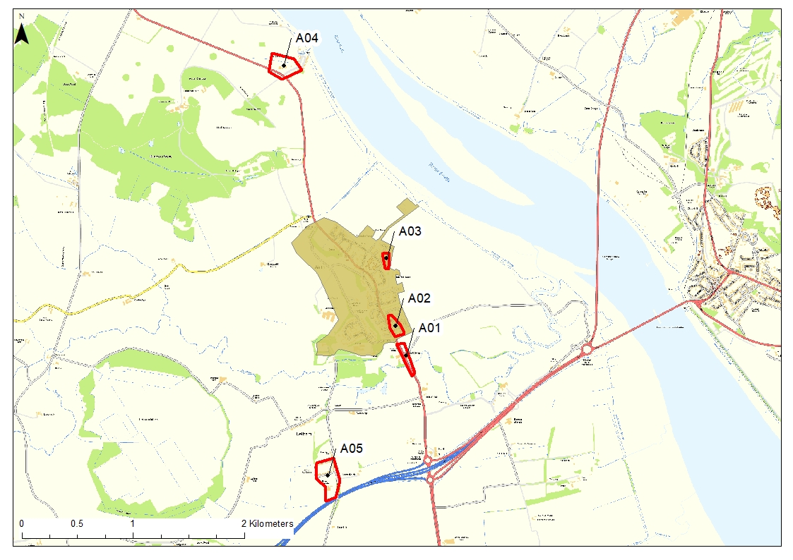
Figure 4-1 Airth, Dunmore & Letham, CDA and Hotspots
Contains OS data © Crown Copyright and database right (2020)

Bonnybridge
Bonnybridge is a village, approximately 4 miles west of Falkirk and is situated on the Bonny Water. The Forth & Clyde Canal runs parallel just south of the Bonny Water. The Bonnybridge catchment includes smaller settlements such as Banknock, Head of Muir and Dennyloanhead. The M876 runs just north of Bonnybridge. A section of the Antonine Wall and a Roman Fort is located to the east of Bonnybridge. Bonnybridge is impacted by fluvial and surface water flood risk.
High Level Risk Summary
Flood risk sources | Fluvial and surface water
Number of flood incidents reported to Falkirk Council | 122
Number of hotspots identified | 14

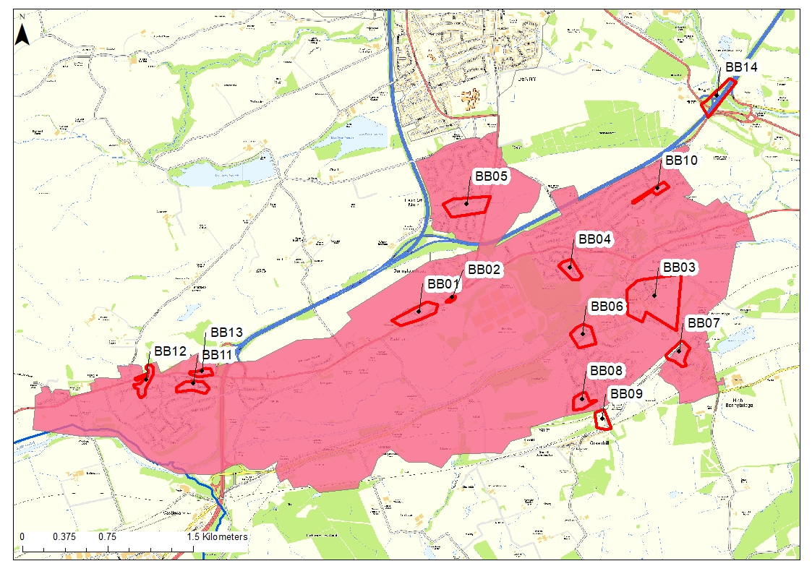
Figure 4-2 Bonnybridge CDA and Hotspots
Contains OS data © Crown Copyright and database right (2020)

Bo’ness
Bo’ness is a coastal town, located approximately 6.7 miles east of Falkirk. Bo’ness is protected from coastal flooding by the Bo’ness Flood Protection Scheme in the form of direct defences. Bo’ness is impacted by surface water flooding, with predominant problems being runoff from agricultural land and surcharging manholes. A large number of roads in the Bo’ness area were subjected to flooding during the August 2020 event.
High Level Risk Summary
Flood risk sources | Coastal and surface water
Number of flood incidents reported to Falkirk Council | 103
Number of hotspots identified | 8

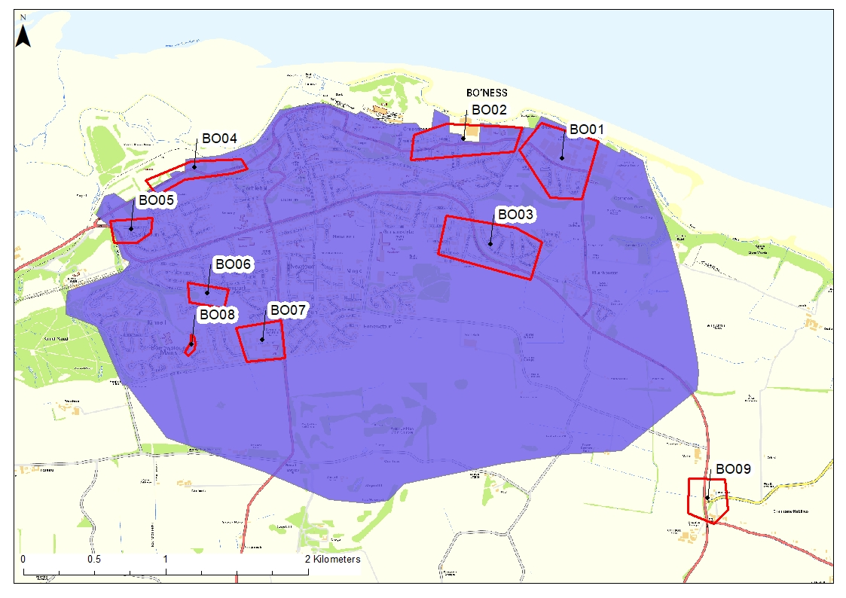
Figure 4-3 Bo'ness CDA and Hotspots
Contains OS data © Crown Copyright and database right (2020)

Carronside
The Carronside catchment is located to the north of the River Carron, to the east of the Lower Larbert catchment. It includes Antonshill and Carronshore. The Chapel Burn runs through the middle of the catchment. The River Carron runs through the south of the catchment and is impacted by mean high water springs. Flood history includes sewer surcharge, surface drainage system issues, flooding from the Chapel Burn and surface water runoff.
High Level Risk Summary
Flood risk sources | Fluvial, surface water and coastal.
Number of flood incidents reported to Falkirk Council | 95
Number of hotspots identified | 11

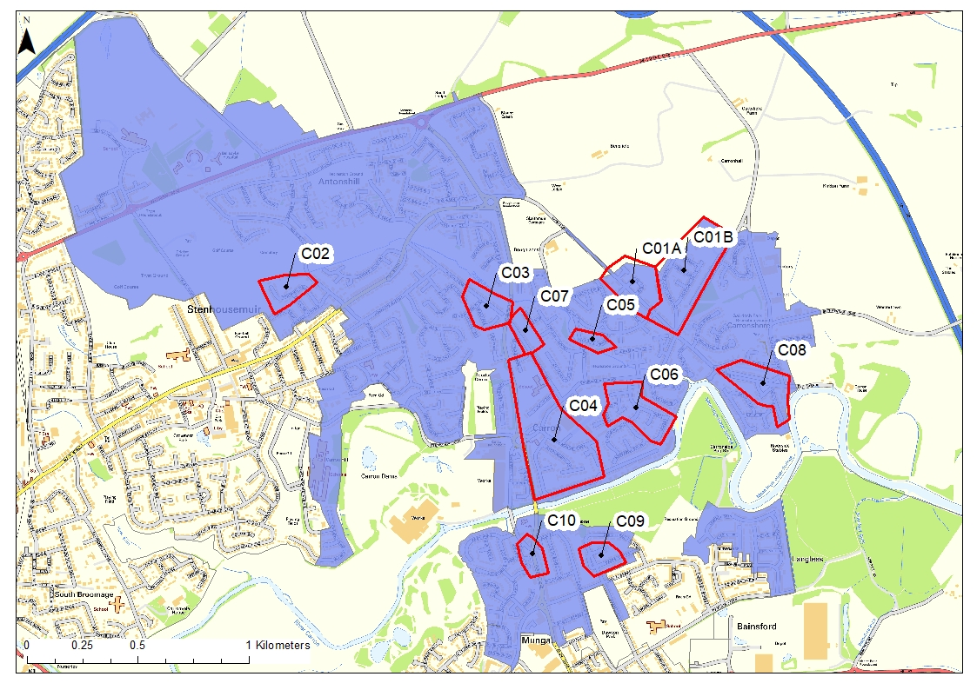
Figure 4-4 Carronside CDA and Hotspots
Contains OS data © Crown Copyright and database right (2020)

Denny
Denny is a town, located 5 miles west of Falkirk. Denny is separated by its neighbouring village Dunipace by the River Carron. Denny is impacted by fluvial and surface water flooding. Two tributaries of the River Carron are located in Denny, the Little Denny Burn and Castlecrankie Burn. Denny is currently undergoing a £7.8m regeneration scheme for the town centre, which is to include the development of shops, community library and a new town square.
High Level Risk Summary
Flood risk sources | Fluvial and surface water
Number of flood incidents reported to Falkirk Council | 40
Number of hotspots identified | 5

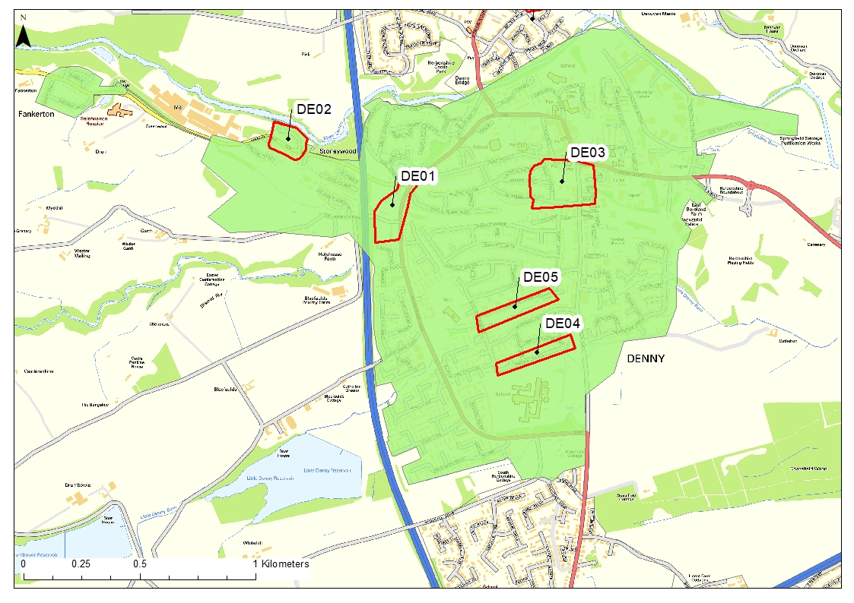
Figure 4-5 Denny CDA and Hotspots
Contains OS data © Crown Copyright and database right (2020)

Dunipace
Dunipace is a village located to the north of Denny, separated by the River Carron. The Avon Burn cuts through the north of Dunipace before joining the River Carron. Dunipace is vulnerable to fluvial and surface water flooding.
High Level Risk Summary
Flood risk sources | Fluvial and surface water
Number of flood incidents reported to Falkirk Council | 28
Number of hotspots identified | 3

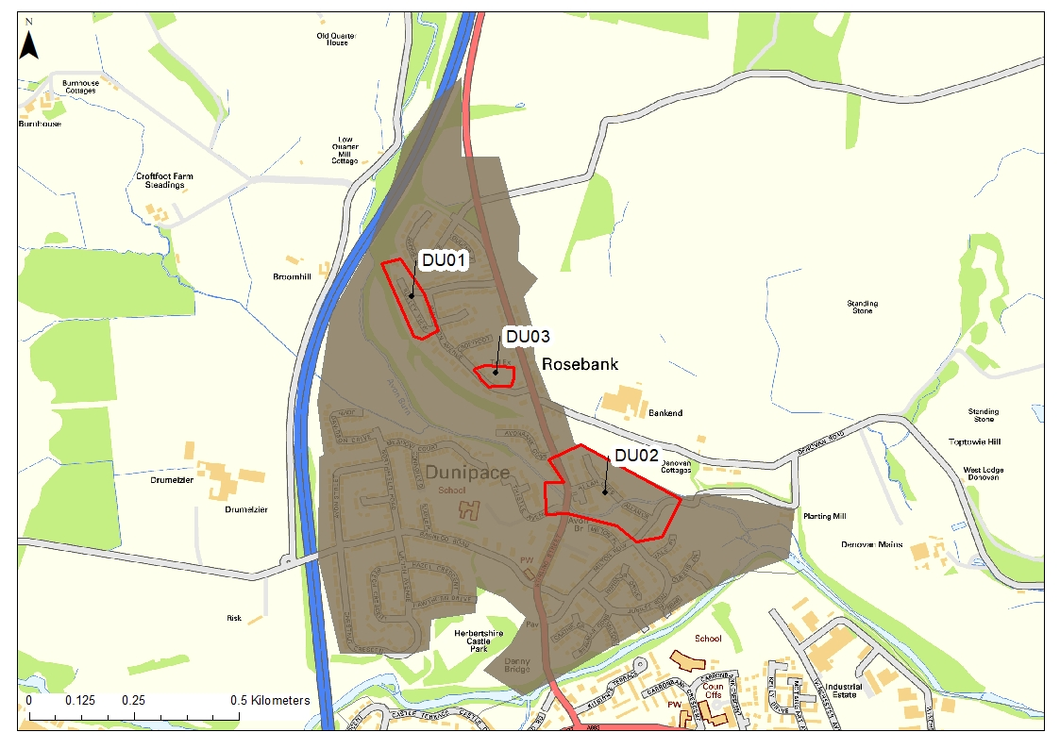
Figure 4-6 Dunipace CDA and Hotspots
Contains OS data © Crown Copyright and database right (2020)

Falkirk Town – North East
This catchment is located in the north east of Falkirk. The very northern section is intersected by the Forth and Clyde Canal separating the Bankside industrial area from the centre of Falkirk. The area is subject to surface water flood risk from overland flow and culvert exceedance.
High Level Risk Summary
Flood risk sources | Surface water
Number of flood incidents reported to Falkirk Council | 47
Number of hotspots | 8

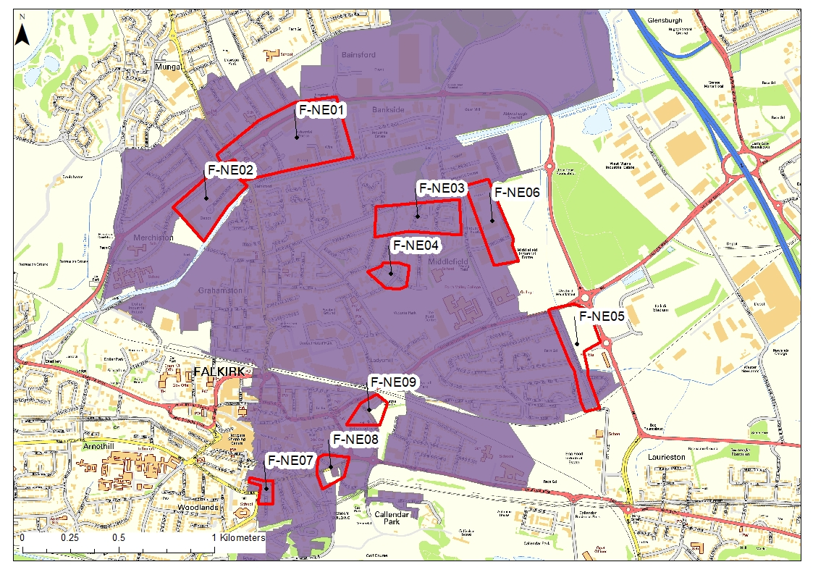
Figure 4-7 Falkirk Town North East, CDA and Hotspots
Contains OS data © Crown Copyright and database right (2020)

Falkirk Town – South West
This catchment covers the south west of Falkirk. It is impacted by surface water runoff, road drainage issues, blocked gullies and surcharging manholes. The catchment is bound by the Forth and Clyde Canal to the north and the Union Canal cuts through the south.
High Level Risk Summary
Flood risk sources | Fluvial, surface water
Number of flood incidents reported to Falkirk Council | 57
Number of hotspots | 19

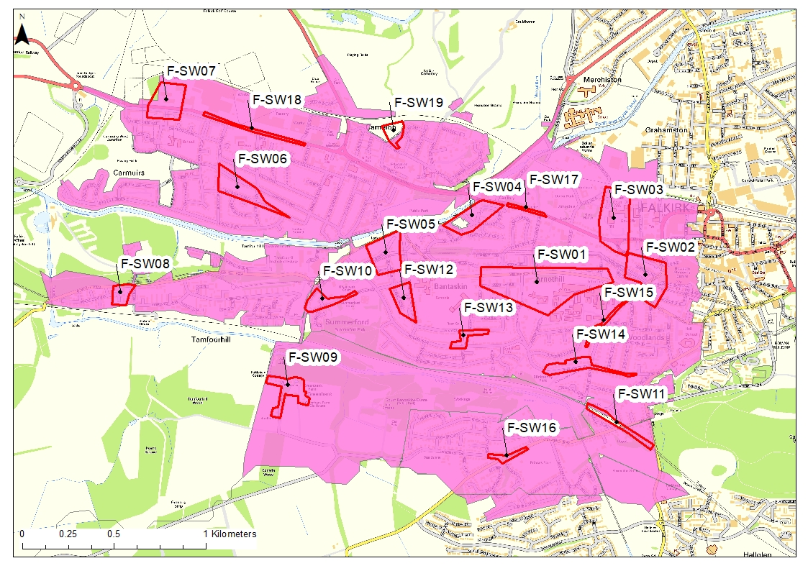
Figure 4-8 Falkirk Town South West, CDA and Hotspots
Contains OS data © Crown Copyright and database right (2020)

Glenburn US
The Glenburn US catchment follows the Glen Burn watercourse and is predominately farmland and some new developments. Flooding issues are identified within the Scottish Water model.
High Level Risk Summary
Flood risk sources | Surface water, fluvial, canal
Number of flood incidents reported to Falkirk Council | 1
Number of hotspots identified | 1

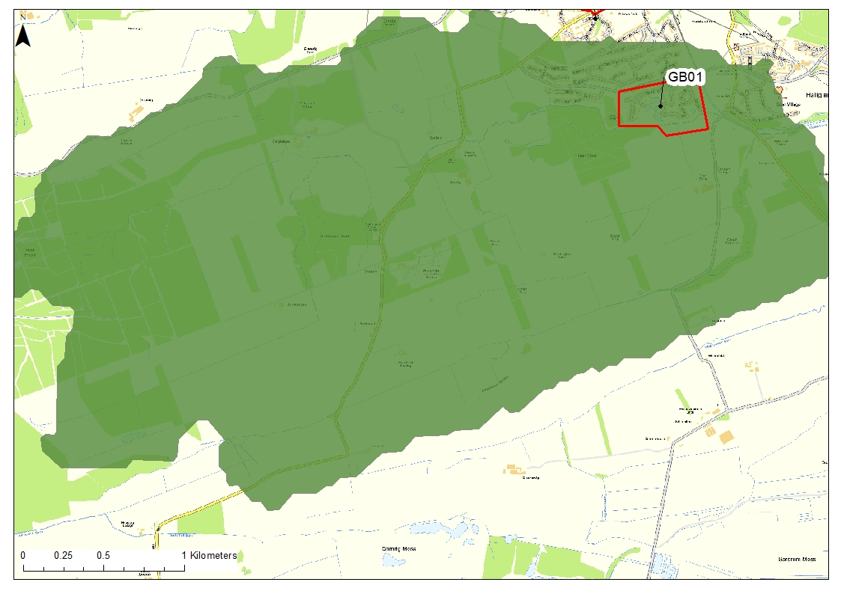
Figure 4-9 Glenburn, CDA and Hotspots
Contains OS data © Crown Copyright and database right (2020)

Glensburgh
The Glensburgh catchment covers north and west Grangemouth, located close to Grangemouth docks. History of flooding includes sewer flooding and tide locking of the network. A large number of roads in the Grangemouth area were subjected to flooding during the August 2020 event.
High Level Risk Summary
Flood risk sources | Surface water, coastal
Number of flood incidents reported to Falkirk Council | 28
Number of hotspots identified | 2

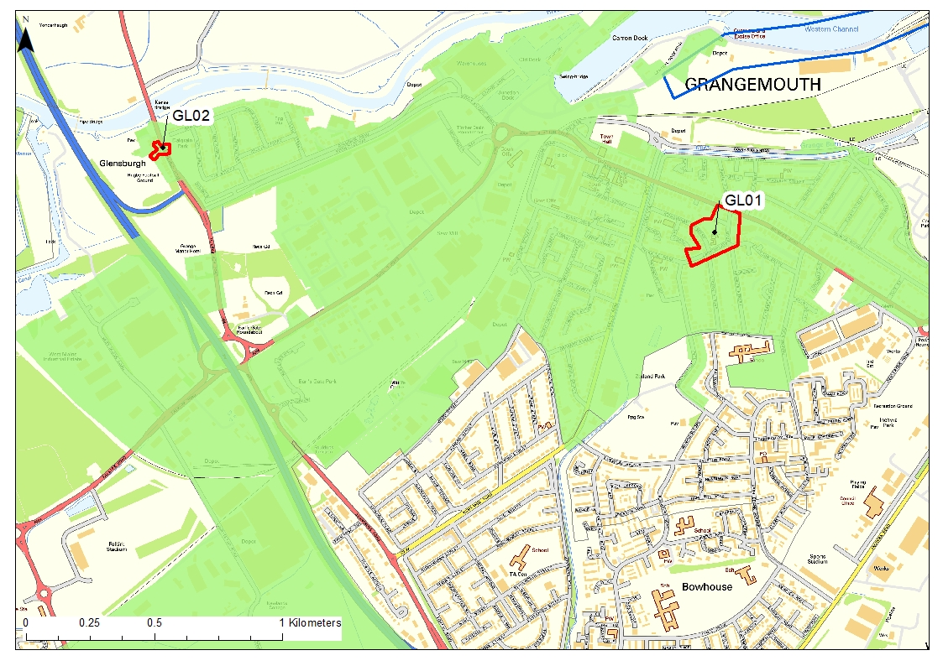
Figure 4-10 Glensburgh, CDA and Hotspots
Contains OS data © Crown Copyright and database right (2020)

Larbert
Larbert is a town which lies to the north of the River Carron, approximately 2.5 miles northwest of Falkirk. Larbert’s topography falls from north to south. Stenhousemuir, which falls under the Carronside catchment is located to the east of Larbert, however, they are joined and share many amenities. Larbert is a growing area including housing developments and redevelopment of brownfield sites. The railway serving links to Stirling, Glasgow and Edinburgh cuts through the middle of Larbert. Larbert is impacted by surface water flooding and flooding of the Chapel Burn culverts.
High Level Risk Summary
Flood risk sources | Surface water, fluvial
Number of flood incidents reported to Falkirk Council | 49
Number of hotspots | 50

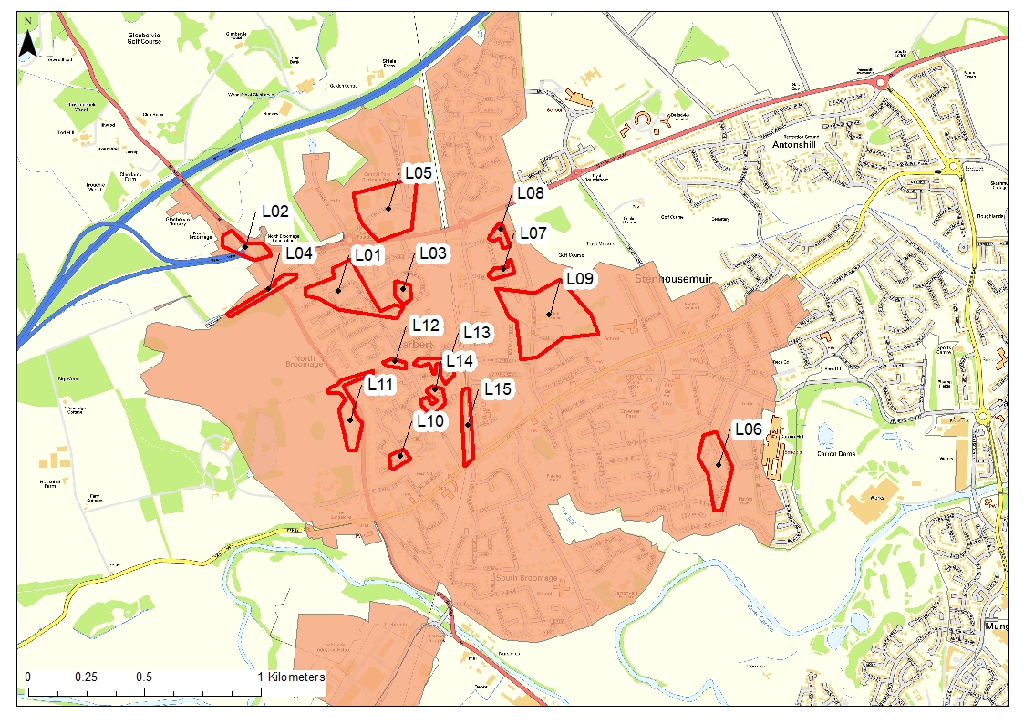
Figure 4-11 Larbert, CDA and Hotspots
Contains OS data © Crown Copyright and database right (2020)

Northfoot
The Northfoot catchment is located south of the M9 and Grangemouth, and east of Falkirk. It includes three settlements Lauriestoun, Westquarter and Redding. The Westquarter Burn flows through the centre of Westquarter. Lauriestoun and Redding are impacted by surface water flooding, and Westquarter by fluvial and surface water. Westquarter was heavily impacted by the flooding on the 12th August 2020, however this was predominantly fluvial in nature.
High Level Risk Summary
Flood risk sources | Fluvial, surface water
Number of flood incidents reported to Falkirk Council | 74
Number of hotspots | 15

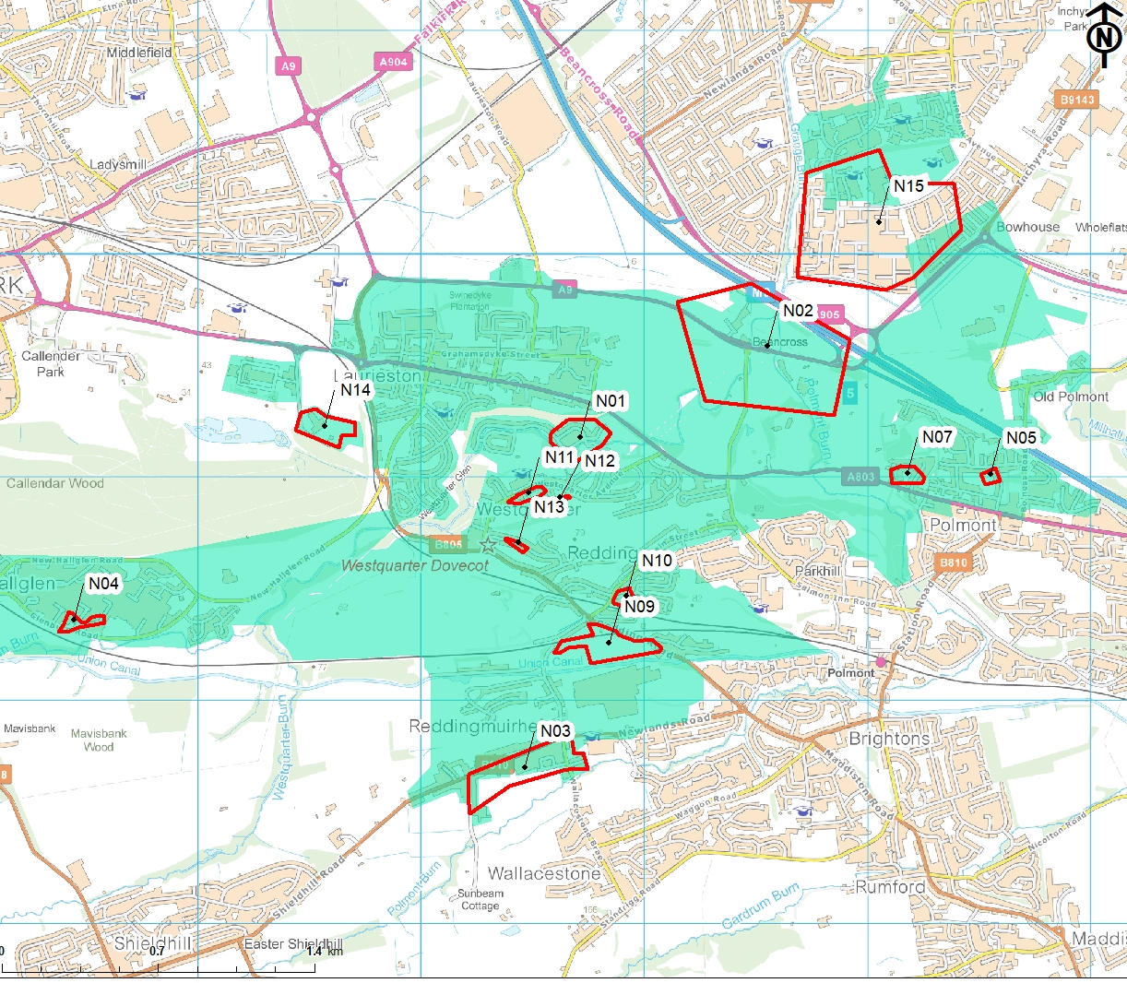
Figure 4-12 Northfoot, CDA and Hotspots
Contains OS data © Crown Copyright and database right (2020)

Polmonthill
The Polmont area is a rapidly growing area with a number of new developments which have changed the natural surface water drainage regime of the area. Polmont is characterised by steep slopes and culverts which contribute significantly to flooding. During most recent flood events, significant surcharging was noted across the sewer network and overtopping of the Polmont Burn reported to SEPA, indicated a likely degree of interaction. exacerbated by high river levels.
High Level Risk Summary
Flood risk sources | Fluvial, surface water
Number of flood incidents reported to Falkirk Council | 126
Number of hotspots | 14

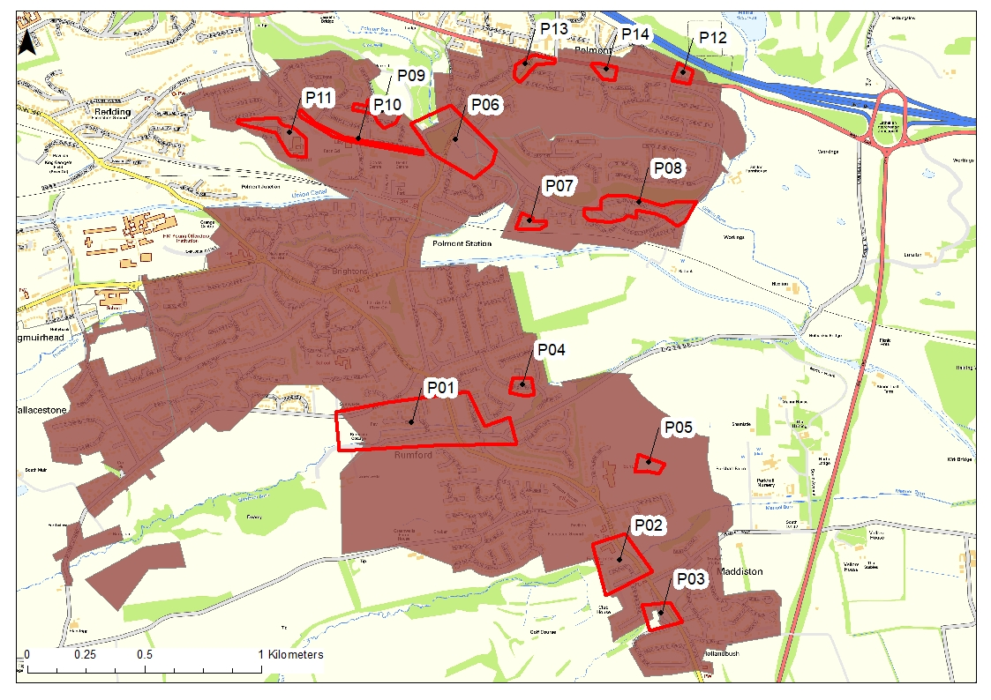
Figure 4-13 Polmonthill, CDA and Hotspots
Contains OS data © Crown Copyright and database right (2020)

Slamannan
Slamannan is a village located in the south of the Falkirk Council area. The Culloch Burn flows through the village, before joining the River Avon. History of flooding includes flooding from the Culloch Burn during high rainfall events, surface water runoff, surcharging manholes and blocked gullies.
High Level Risk Summary
Flood risk sources | Fluvial, surface water
Number of flood incidents reported to Falkirk Council | 59
Number of hotspots | 4

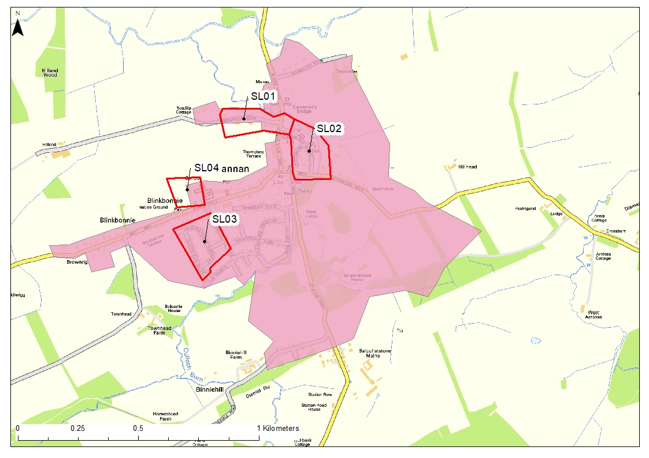
Figure 4-14 Slamannan CDA and Hotspots
Contains OS data © Crown Copyright and database right (2020)

Zetlands
The Zetlands catchment is the south east section of Grangemouth. The Grange Burn passes through the centre of the catchment, which slopes from south to north towards the Forth. The catchment is impacted by fluvial, surface water and coastal influences. A large number of roads in the Grangemouth area were subjected to flooding during the August 2020 event.
High Level Risk Summary
Flood risk sources | Fluvial, surface water, coastal
Number of flood incidents reported to Falkirk Council | 36
Number of hotspots | 6

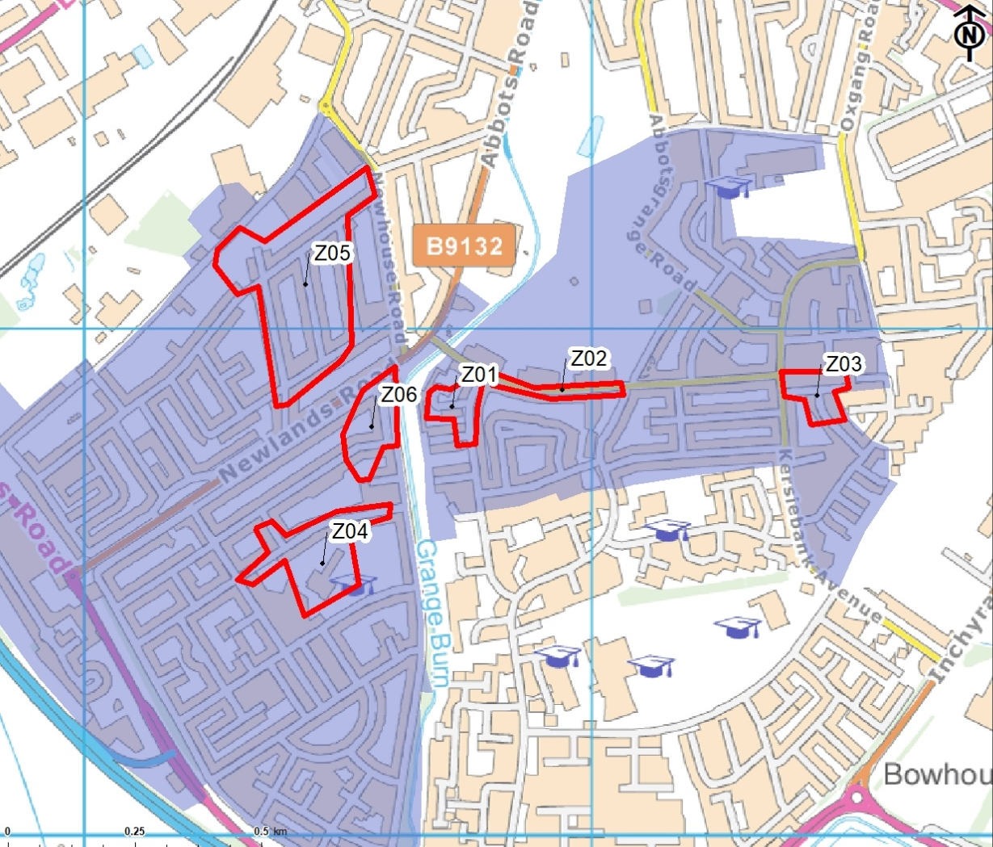
Figure 4-15 Zetlands, CDA and Hotspots
Contains OS data © Crown Copyright and database right (2020)

Flood Hotspot Ranking
To quantify the reasoning behind the selection of the hotspots prioritised for further analysis, a high-level scoring system was developed. Table 4-1 sets out the criteria used for prioritising hotspots. Expert judgement is involved in making these decisions, which creates some elements of subjectivity, however, by considering all relevant data and being transparent in our approach we have been able to appraise each measure fairly. The risk analysis is separated into two categories; likelihood and severity.
Table 4-1 Scoring Methodologys
Type | Category | Scoring
Likelihood | SEPA Maps | Onset of flooding:  10yr(high) = 1c0, 200yr(med) = 5
Likelihood | SW model outputs | Sewer Flooding in 30yr = 10
Likelihood | Validation | Number of records of flooding:  1-5 =3 , 5-10 = 5, >10 = 7, >20 = 10
 | Average Likelihood Score | Total Likelihood/ 3
Severity | Pluvial flood depth (m) | SEPA Maps: <0.3m = 5, >0.3m-1m = 10
Severity | Sewer flood volume (m3) | SW model outputs: low = 2, med = 5, high = 10
Severity | Main receptors affected | Parkland/agricultural land = 1  road = 2,  5 properties = 4  10 properties = 6  11-20 properties = 7  >20 properties = 10  Additional 2 points if majority are residential
Severity | Infrastructure affected | -Essential = 10 e.g. core road/rail link, wastewater treatment works, electricity power station or substation, evacuation routes.  -Highly vulnerable = 8 e.g. Police stations, Ambulance stations, Fire stations, Command Centres and telecommunications  -More vulnerable = 6 e.g. Schools, nurseries, hospitals and health facilities, Landfill, Sewage treatment works, Prisons.  -Community buildings = 4 e.g. churches, town halls.  -Nothing of note = 0
 | Average Severity Score | Total Severity / 4
Total | Total Risk Score | Likelihood x Severity

Likelihood of flooding is the probability of a flood occurring in any one year. This is an important criterion as it demonstrates the frequency at which a hotspot is likely to experience a flood event. Likelihood was established using three data sources: the SEPA flood map extents; the Scottish Water model outputs; and reports of flood history. SEPA flood maps were ranked on the onset of the type of flooding, which is predominant for the hotspot, with scores for each likelihood, high(10), medium(5) and low(0).The Scottish Water model outputs were ranked based on the presence of sewer flooding for the 30yr event, scoring either 0 or 10, the 30yr was selected as this is Scottish Water’s standard of service. Reports of flood history served as a validation criterion so as not to be overly reliant on simulated data. The number of flood events recorded were banded into groups scoring a maximum of 10. The total of these scores was divided by three, allowing for an average total maximum likelihood score of 10.
Severity of a flood indicates how much of a detrimental impact a flood may have. This is an important criterion as it demonstrates the effect a flood event is likely to have in each hotspot. Severity was established using four data sources: the SEPA flood map depths; the Scottish Water model manhole flood volume outputs; the number of receptors affected; and the vulnerability classification of the receptor affected. The greater the depth and volume of flooding predicted, the greater the impacts are likely to be. This includes increased damages to properties and infrastructure and increased social impacts, such as increased health impacts and disruption to the community and way of life. The SEPA flood map depths were ranked based on predominant depths of <0.3m (5) and 0.3-1m (10). The Scottish Water model outputs were ranked based on the 1 in 30 year flood volumes which were banded at low (2) (<10m³), medium (5) (11 - 50m³) and high (10) (>50m³).
Receptors and infrastructure are useful tools in establishing the severity as the impacts of flooding vary with the number of people effected and the type of infrastructure impacted. For example, if a local hospital is flooded this would impact a large portion of the surrounding community, rather than just those with direct property impacts. The main receptors were ranked using a banding system: parkland (1), local residential road (2), 1-5 properties (4), 6-10 properties (6), 11-20 properties (7), >20 properties (10). Areas where properties are majority residential score an additional 2 points, this is to represent the high vulnerability classification as outlined by SEPA land use vulnerability guidance.
Infrastructure effected was ranked based on vulnerability categories as outlined by SEPA: community buildings (4); more vulnerable (6), highly vulnerable (8), and essential (10). Each source was scored out of a maximum score of 10. The total of these scores was divided by four, allowing for an average total maximum severity score of 10. The final risk score for each hotspot was determined by multiplying the likelihood score with the severity score, resulting in a total maximum risk score of 100.
The scoring of the hotspots is set out in Table 4-2. A high level map of all hotspots is shown in Figure 4-16. More detailed mapping is included in the hotspot level analysis in Section 6.2 and in Appendix B. The resultant risk scores for the hotspots ranged from 0.5 to 83.3 out of 100. Analysis of the scores and the optioneering for each hotspot is set out in Section 6.

Table 4-2 Hotspot ranking table
Hotspot | Critical Drainage Area | SEPA Maps | SW model outputs | Validation | Average Likelihood Score | Pluvial flood depth | Sewer flood volume | Main receptors affected | Infrastructure affected | Average Severity Score | Total Risk Score
 |  | onset flooding: 10yr(high) = 10, 200yr(med) = 5 | Sewer Flooding in 30yr = 10 | No of records: 1-5=3, 5-10=5, >10=7, >20=10 |  | SEPA Maps: <0.3=5, 0.3-1=10 | SW model outputs: low=2, med=5, high=10 | Parkland/agricultural land=1, road =2, 5 properties=4  10 properties =6  11-20 properties =7  >20 properties=10, Additional 2 points if majority are residential | Essential=10  Highly vulnerable=8  More vulnerable=6  Community buildings=4  Nothing of note =0
A01 | Airth | 0 | 0 | 5 | 1.7 | 0 | 0 | 4 | 0 | 1.0 | 1.7
A02 | Airth | 5 | 0 | 3 | 2.7 | 5 | 0 | 4 | 0 | 2.2 | 5.9
A03 | Airth | 0 | 10 | 3 | 4.3 | 0 | 10 | 4 | 2 | 4.0 | 17.2
A04 | Airth/Dunmore | 10 | 0 | 3 | 4.3 | 10 | 0 | 6 | 0 | 4.0 | 17.2
A05 | Airth/Letham | 10 | 10 | 3 | 7.7 | 5 | 5 | 4 | 2 | 4.0 | 30.8
BB01 | Bonnybridge | 5 | 10 | 3 | 6.0 | 5 | 10 | 8 | 0 | 5.7 | 34.2
BB02 | Bonnybridge/Dennyloanhead | 10 | 0 | 3 | 4.3 | 10 | 0 | 0 | 10 | 5.0 | 21.5
BB03 | Bonnybridge | 10 | 10 | 5 | 8.3 | 10 | 10 | 4 | 6 | 7.5 | 62.3
BB04 | Bonnybridge | 10 | 0 | 0 | 3.3 | 10 | 0 | 9 | 0 | 4.7 | 15.5
BB05 | Bonnybridge | 5 | 10 | 5 | 6.6 | 10 | 10 | 4 | 4 | 7.0 | 46.2
BB06 | Bonnybridge | 5 | 10 | 3 | 6.0 | 5 | 10 | 6 | 0 | 5.2 | 31.2
BB07 | Bonnybridge | 10 | 10 | 3 | 7.6 | 10 | 5 | 4 | 0 | 4.7 | 35.7
BB08 | Bonnybridge | 10 | 0 | 3 | 4.3 | 10 | 0 | 9 | 0 | 4.7 | 20.2
BB09 | Bonnybridge | 10 | 10 | 3 | 7.6 | 5 | 0 | 1 | 0 | 1.5 | 11.4
BB10 | Bonnybridge | 5 | 10 | 3 | 6.0 | 5 | 5 | 4 | 0 | 3.5 | 21.0
BB11 | Bonnybridge/Longcroft | 5 | 10 | 3 | 6.0 | 5 | 10 | 6 | 0 | 5.2 | 31.2
BB12 | Bonnybridge/Longcroft | 5 | 10 | 5 | 6.6 | 5 | 10 | 6 | 0 | 5.2 | 34.3
BB13 | Bonnybridge/Longcroft | 5 | 0 | 3 | 2.6 | 5 | 0 | 4 | 6 | 3.7 | 9.6
BB14 | Bonnybridge/M876 | 10 | 0 | 10 | 6.6 | 10 | 0 | 0 | 10 | 5.0 | 33.0
BO01 | Bo'ness | 5 | 10 | 0 | 5.0 | 10 | 10 | 10 | 0 | 7.5 | 37.5
BO02 | Bo'ness | 5 | 10 | 3 | 6.0 | 10 | 10 | 10 | 4 | 8.5 | 51.0
BO03 | Bo'ness | 10 | 10 | 3 | 7.6 | 10 | 5 | 10 | 0 | 6.2 | 47.1
BO04 | Bo'ness | 10 | 10 | 3 | 7.6 | 10 | 10 | 4 | 0 | 6.0 | 45.6
BO05 | Bo'ness | 10 | 10 | 0 | 6.6 | 10 | 2 | 8 | 0 | 5.0 | 33.0
BO06 | Bo'ness | 10 | 10 | 3 | 7.6 | 10 | 5 | 8 | 0 | 5.7 | 43.3
BO07 | Bo'ness | 10 | 0 | 0 | 3.3 | 10 | 0 | 4 | 8 | 5.5 | 18.2
BO08 | Bo'ness | 10 | 0 | 3 | 4.3 | 10 | 0 | 6 | 0 | 4.0 | 17.2
BO09 | Bo'ness/Grougfoot | 10 | 0 | 0 | 3.3 | 5 | 0 | 4 | 0 | 2.2 | 7.3
C01A | Carronside WWPS - Stenhouse Muir | 10 | 0 | 3 | 4.3 | 5 | 0 | 9 | 0 | 3.5 | 15.1
C01B | Carronside WWPS - Stenhouse Muir | 10 | 10 | 5 | 8.3 | 10 | 2 | 10 | 6 | 7.0 | 58.1
C02 | Carronside WWPS - Stenhouse Muir | 5 | 10 | 3 | 6.0 | 5 | 10 | 8 | 0 | 5.7 | 34.2
C03 | Carronside WWPS - Carron | 10 | 10 | 3 | 7.6 | 10 | 10 | 8 | 0 | 7.0 | 53.2
C04 | Carronside WWPS - Carron | 10 | 0 | 3 | 4.3 | 10 | 0 | 10 | 6 | 6.5 | 28.0
C05 | Carronside WWPS - Carron | 10 | 10 | 3 | 7.6 | 10 | 2 | 8 | 0 | 5.0 | 38.0
C06 | Carronside WWPS - Carron | 5 | 10 | 3 | 6.0 | 10 | 10 | 8 | 0 | 7.0 | 42.0
C07 | Carronside WWPS - Carron | 5 | 0 | 0 | 1.6 | 10 | 0 | 9 | 0 | 4.7 | 7.5
C08 | Carronside WWPS - Carronshore | 5 | 10 | 3 | 6.0 | 5 | 5 | 6 | 4 | 5.0 | 30.0
C09 | Carronside WWPS - River Carron | 10 | 10 | 0 | 6.6 | 10 | 10 | 9 | 0 | 7.2 | 47.5
C10 | Carronside WWPS - River Carron | 5 | 0 | 0 | 1.6 | 10 | 0 | 8 | 0 | 4.5 | 7.2
DE01 | Denny | 10 | 0 | 3 | 4.3 | 10 | 2 | 0 | 6 | 4.5 | 19.4
DE02 | Denny | 0 | 10 | 3 | 4.3 | 0 | 10 | 4 | 0 | 3.5 | 15.1
DE03 | Denny | 5 | 10 | 3 | 6.0 | 5 | 10 | 8 | 4 | 6.7 | 40.2
DE04 | Denny | 5 | 10 | 3 | 6.0 | 5 | 10 | 6 | 0 | 5.2 | 31.2
DE05 | Denny | 5 | 10 | 3 | 6.0 | 5 | 10 | 6 | 0 | 5.2 | 31.2
DU01 | Dunipace | 10 | 10 | 3 | 7.6 | 10 | 2 | 6 | 0 | 4.5 | 34.2
DU02 | Dunipace | 5 | 10 | 5 | 6.6 | 5 | 2 | 4 | 0 | 2.7 | 17.8
DU03 | Dunipace | 5 | 10 | 5 | 6.6 | 10 | 5 | 4 | 0 | 4.7 | 31.0
F-NE01 | Falkirk Town - North East | 10 | 10 | 3 | 7.6 | 10 | 10 | 6 | 10 | 9.0 | 68.4
F-NE02 | Falkirk Town - North East | 5 | 10 | 3 | 6.0 | 10 | 10 | 10 | 0 | 7.5 | 45.0
F-NE03 | Falkirk Town - North East | 5 | 10 | 3 | 6.0 | 5 | 10 | 10 | 0 | 6.2 | 37.2
F-NE04 | Falkirk Town - North East | 0 | 10 | 3 | 4.3 | 5 | 10 | 6 | 0 | 5.2 | 22.4
F-NE05 | Falkirk Town - North East | 5 | 10 | 3 | 6.0 | 10 | 5 | 4 | 0 | 4.7 | 28.2
F-NE06 | Falkirk Town - North East | 5 | 10 | 7 | 7.3 | 5 | 10 | 9 | 0 | 6.0 | 43.8
F-NE07 | Falkirk Town - North East | 5 | 0 | 0 | 1.6 | 10 | 0 | 4 | 4 | 4.5 | 7.2
F-NE08 | Falkirk Town - North East | 10 | 0 | 0 | 3.3 | 10 | 0 | 6 | 10 | 6.5 | 21.5
F-NE09 | Falkirk Town - North East | 10 | 0 | 3 | 4.3 | 10 | 0 | 6 | 4 | 5.0 | 21.5
F-SW01 | Falkirk Town - South West | 10 | 10 | 3 | 7.6 | 10 | 10 | 10 | 8 | 9.5 | 72.2
F-SW02 | Falkirk Town - South West | 10 | 10 | 5 | 8.3 | 10 | 10 | 7 | 4 | 7.7 | 63.9
F-SW03 | Falkirk Town - South West | 10 | 0 | 3 | 4.3 | 5 | 0 | 6 | 4 | 3.7 | 15.9
F-SW04 | Falkirk Town - South West | 10 | 0 | 3 | 4.3 | 10 | 0 | 9 | 0 | 4.7 | 20.2
F-SW05 | Falkirk Town - South West | 10 | 0 | 0 | 3.3 | 10 | 0 | 9 | 0 | 4.7 | 15.5
F-SW06 | Falkirk Town - South West | 10 | 10 | 0 | 6.6 | 10 | 10 | 9 | 0 | 7.2 | 47.5
F-SW07 | Falkirk Town - South West | 10 | 10 | 3 | 7.6 | 5 | 10 | 6 | 0 | 5.2 | 39.5
F-SW08 | Falkirk Town - South West | 10 | 0 | 0 | 3.3 | 10 | 0 | 4 | 0 | 3.5 | 11.6
F-SW09 | Falkirk Town - South West | 10 | 0 | 3 | 4.3 | 5 | 0 | 4 | 0 | 2.2 | 9.5
F-SW10 | Falkirk Town - South West | 5 | 0 | 3 | 2.6 | 5 | 0 | 9 | 0 | 3.5 | 9.1
F-SW11 | Falkirk Town - South West | 10 | 0 | 0 | 3.3 | 10 | 0 | 0 | 10 | 5.0 | 16.5
F-SW12 | Falkirk Town - South West | 10 | 0 | 5 | 5.0 | 5 | 0 | 8 | 0 | 3.2 | 16.0
F-SW13 | Falkirk Town - South West | 0 | 0 | 3 | 1.0 | 0 | 0 | 4 | 0 | 1.0 | 1.0
F-SW14 | Falkirk Town - South West | 5 | 0 | 5 | 3.3 | 0 | 0 | 4 | 0 | 1.0 | 3.3
F-SW15 | Falkirk Town - South West | 5 | 10 | 0 | 5.0 | 5 | 10 | 2 | 8 | 6.2 | 31.0
F-SW16 | Falkirk Town - South West | 0 | 0 | 3 | 1.0 | 0 | 0 | 2 | 0 | 0.5 | 0.5
F-SW17 | Falkirk Town - South West | 10 | 10 | 0 | 6.6 | 5 | 10 | 2 | 0 | 4.2 | 27.7
F-SW18 | Falkirk Town - South West | 5 | 10 | 0 | 5.0 | 0 | 10 | 2 | 0 | 3.0 | 15.0
F-SW19 | Falkirk Town - South West | 5 | 0 | 3 | 2.6 | 5 | 0 | 6 | 0 | 2.7 | 7.0
GB01 | Glenburn US | 5 | 10 | 0 | 5.0 | 5 | 10 | 8 | 0 | 5.7 | 28.5
GL01 | Glensburgh | 5 | 10 | 3 | 6.0 | 10 | 10 | 8 | 4 | 8.0 | 48.0
GL02 | Glensburgh | 10 | 0 | 7 | 5.6 | 10 | 0 | 4 | 0 | 3.5 | 19.6
L01 | Larbert, lower larbert wwPS | 10 | 10 | 7 | 9.0 | 5 | 10 | 9 | 0 | 6.0 | 54.0
L02 | Larbert, lower larbert wwPS | 5 | 10 | 3 | 6.0 | 10 | 5 | 4 | 10 | 7.2 | 43.2
L03 | Larbert, lower larbert wwPS | 5 | 0 | 0 | 1.6 | 5 | 0 | 9 | 0 | 3.5 | 5.6
L04 | Larbert, lower larbert wwPS | 5 | 0 | 3 | 2.6 | 10 | 0 | 2 | 0 | 3.0 | 7.8
L05 | Larbert, lower larbert wwPS | 10 | 0 | 0 | 3.3 | 5 | 0 | 4 | 0 | 2.2 | 7.3
L06 | Larbert, lower larbert wwPS | 10 | 10 | 3 | 7.6 | 5 | 10 | 9 | 0 | 6.0 | 45.6
L07 | Larbert, lower larbert wwPS | 10 | 10 | 3 | 7.6 | 5 | 10 | 2 | 0 | 4.2 | 31.9
L08 | Larbert, lower larbert wwPS | 5 | 10 | 3 | 6.0 | 5 | 2 | 4 | 0 | 2.7 | 16.2
L09 | Larbert, lower larbert wwPS | 5 | 0 | 5 | 3.3 | 5 | 0 | 4 | 4 | 3.2 | 10.6
L10 | Larbert, lower larbert wwPS | 10 | 10 | 0 | 6.6 | 10 | 10 | 4 | 4 | 7.0 | 46.2
L11 | Larbert, lower larbert wwPS | 5 | 0 | 5 | 3.3 | 5 | 0 | 6 | 0 | 2.7 | 8.9
L12 | Larbert, lower larbert wwPS | 5 | 10 | 3 | 6.0 | 5 | 10 | 4 | 0 | 4.7 | 28.2
L13 | Larbert, lower larbert wwPS | 10 | 0 | 0 | 3.3 | 10 | 0 | 8 | 0 | 4.5 | 14.9
L14 | Larbert, lower larbert wwPS | 10 | 10 | 0 | 6.6 | 5 | 10 | 6 | 0 | 5.2 | 34.3
L15 | Larbert, lower larbert wwPS | 10 | 0 | 3 | 4.3 | 10 | 0 | 4 | 10 | 6.0 | 25.8
N01 | Northfoot | 10 | 10 | 5 | 8.3 | 10 | 10 | 10 | 0 | 7.5 | 62.3
N02 | Northfoot | 10 | 10 | 7 | 9.0 | 10 | 10 | 7 | 10 | 9.2 | 82.8
N03 | Northfoot | 5 | 10 | 3 | 6.0 | 5 | 10 | 6 | 0 | 5.2 | 31.2
N04 | Northfoot | 5 | 0 | 3 | 2.6 | 5 | 0 | 8 | 0 | 3.2 | 8.3
N05 | Northfoot | 5 | 0 | 3 | 2.6 | 5 | 0 | 4 | 0 | 2.2 | 5.7
N07 | Northfoot | 10 | 0 | 3 | 4.3 | 5 | 0 | 8 | 0 | 3.2 | 13.8
N09 | Northfoot | 10 | 10 | 0 | 6.6 | 5 | 10 | 2 | 10 | 6.7 | 44.2
N10 | Northfoot | 10 | 0 | 0 | 3.3 | 10 | 0 | 9 | 0 | 4.7 | 15.5
N11 | Northfoot | 5 | 0 | 3 | 2.6 | 5 | 0 | 8 | 0 | 3.2 | 8.3
N12 | Northfoot | 0 | 0 | 3 | 1.0 | 0 | 0 | 4 | 0 | 1.0 | 1.0
N13 | Northfoot | 5 | 0 | 3 | 2.6 | 5 | 0 | 2 | 0 | 1.7 | 4.4
N14 | Northfoot | 10 | 0 | 0 | 3.3 | 10 | 0 | 4 | 6 | 5.0 | 16.5
N15 | Northfoot | 10 | 0 | 3 | 4.3 | 10 | 0 | 10 | 6 | 6.5 | 28.0
P01 | Polmonthill | 10 | 10 | 3 | 7.6 | 10 | 10 | 10 | 0 | 7.5 | 57.0
P02 | Polmonthill | 10 | 10 | 3 | 7.6 | 10 | 10 | 4 | 0 | 6.0 | 45.6
P03 | Polmonthill | 10 | 0 | 3 | 4.3 | 10 | 0 | 2 | 0 | 3.0 | 12.9
P04 | Polmonthill | 10 | 0 | 3 | 4.3 | 10 | 0 | 6 | 0 | 4.0 | 17.2
P05 | Polmonthill | 5 | 10 | 3 | 6.0 | 5 | 10 | 0 | 0 | 3.7 | 22.2
P06 | Polmonthill | 10 | 10 | 3 | 7.6 | 10 | 10 | 4 | 0 | 6.0 | 45.6
P07 | Polmonthill | 5 | 10 | 5 | 6.6 | 5 | 10 | 6 | 0 | 5.2 | 34.3
P08 | Polmonthill | 10 | 0 | 0 | 3.3 | 10 | 0 | 10 | 0 | 5.0 | 16.5
P09 | Polmonthill | 10 | 0 | 3 | 4.3 | 10 | 0 | 4 | 0 | 3.5 | 15.1
P10 | Polmonthill | 5 | 0 | 3 | 2.6 | 5 | 0 | 2 | 0 | 1.7 | 4.4
P11 | Polmonthill | 10 | 0 | 0 | 3.3 | 10 | 0 | 6 | 6 | 5.5 | 18.2
P12 | Polmonthill | 5 | 0 | 3 | 2.6 | 5 | 0 | 6 | 0 | 2.7 | 7.0
P13 | Polmonthill | 10 | 0 | 3 | 4.3 | 10 | 0 | 6 | 4 | 5.0 | 21.5
P14 | Polmonthill | 10 | 10 | 0 | 6.6 | 10 | 10 | 4 | 0 | 6.0 | 39.6
SL01 | Slamannan | 10 | 10 | 7 | 9.0 | 10 | 10 | 4 | 0 | 6.0 | 54.0
SL02 | Slamannan | 0 | 10 | 5 | 5.0 | 0 | 10 | 0 | 6 | 4.0 | 20.0
SL03 | Slamannan | 0 | 10 | 5 | 5.0 | 0 | 10 | 4 | 0 | 3.5 | 17.5
SL04 | Slamannan | 0 | 0 | 3 | 1.0 | 0 | 0 | 4 | 5 | 2.2 | 2.2
Z01 | Zetlands | 5 | 10 | 0 | 5.0 | 5 | 10 | 4 | 0 | 4.7 | 23.5
Z02 | Zetlands | 5 | 10 | 3 | 6.0 | 5 | 0 | 2 | 0 | 1.7 | 10.2
Z03 | Zetlands | 5 | 0 | 3 | 2.6 | 5 | 0 | 6 | 0 | 2.7 | 7.0
Z04 | Zetlands | 5 | 10 | 3 | 6.0 | 5 | 5 | 6 | 6 | 5.5 | 33.0
Z05 | Zetlands | 5 | 10 | 0 | 5.0 | 5 | 10 | 9 | 0 | 6.0 | 30.0
Z06 | Zetlands | 5 | 10 | 0 | 5.0 | 5 | 5 | 8 | 0 | 4.5 | 22.5

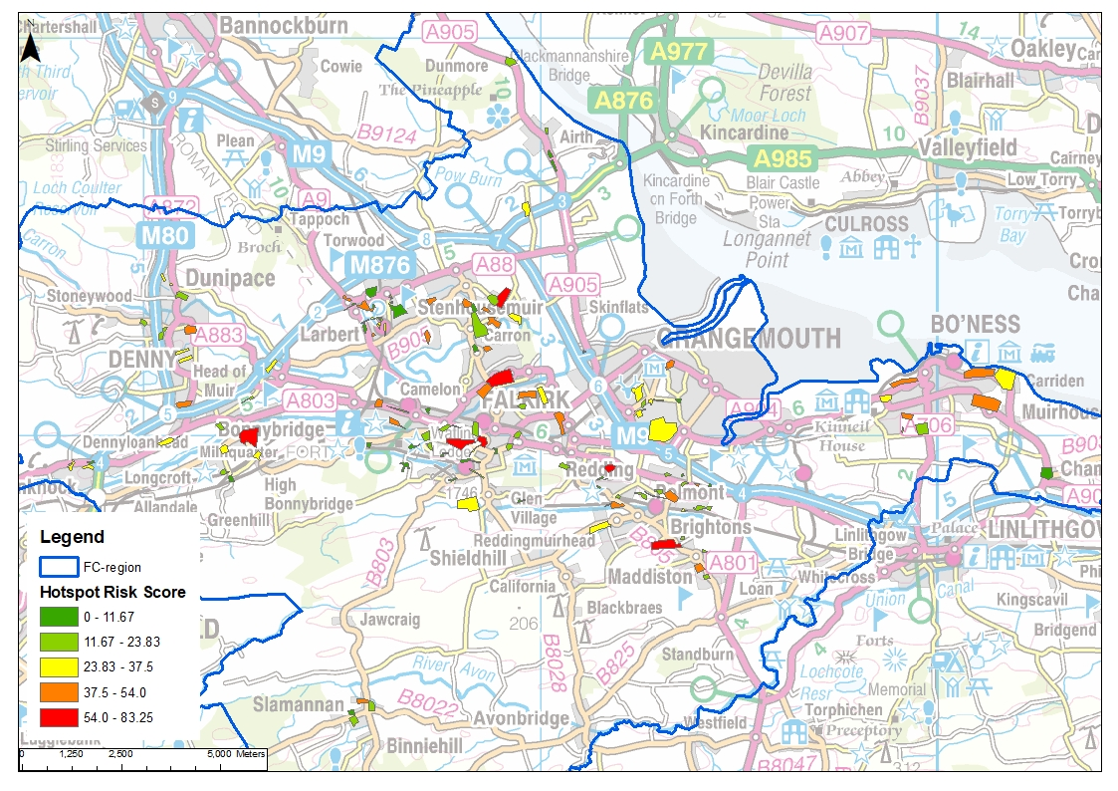
Figure 4-16 Hotspot Map
Contains OS data © Crown Copyright and database right (2020)

Phase 5 - Objectives
Objectives provide a common goal and shared ambition for managing floods. Setting objectives is a key stage in the SWMP process outlined by Scottish Government.
The primary objective of this surface water management plan has been set by SEPA and agreed with flood risk management authorities following consultation. This was identified through an assessment of the underlying evidence of the causes and impacts of flooding during the production of National Flood Strategies (2015) to manage flood risk. These were previously discussed in Section 3.1.
Primary Objectives from the National Flood Strategies:
- 10033 - Reduce economic damages and number of residential properties at risk of surface water flooding in Falkirk, Stenhousemuir and Carron where practical PVA 10/11.
- 10104 - Reduce economic damages and number of residential properties at risk of surface water flooding in Polmont and Maddiston where practical PVA 10/11 and PVA 10/13.
- 10042 - Reduce economic damages and number of residential properties at risk of surface water flooding in Bo'ness, Carriden and Muirhouses where practical (10042) PVA 10/12.
As discussed throughout the report, the aim of this SWMP is to provide a full assessment of the surface water flood risk in the Falkirk Council area in order to deliver a holistic approach. As part of the assessment Critical Drainage Areas (CDAs) were identified, defined and prioritised, including the identification and ranking of flood hotspots to allow investment to be focused on the worst affected areas.
Following the ranking of flooding hotspots, more detailed objectives could be set based on more local aspirations and drivers.
Secondary Objectives
- Develop a robust understanding of surface water flood risk specific to the FC area. Which considers: the challenges of climate change, population and need for development. This will allow FC to make better informed decisions around the surface water policies, investments and maintenance requirements. This transparent approach will allow multiple users to be able to apply the knowledge and ensure surface water is managed appropriately.
- Identify areas which require further data and identify any works, studies and modelling that is required to fill the gaps.
- Make holistic and multifunctional recommendations for surface water management which improve emergency and land use planning and enable better flood risk and drainage infrastructure investments/maintenance planning.
- Renew and consolidate partnerships between key drainage stakeholders to facilitate a collaborative culture of data, skills, resource and learning exchange, and closer coordination to utilise cross boundary working opportunities.
- Undertake engagement workshop with stakeholders to promote knowledge exchange, to raise awareness of surface water flooding, identify flood risks and assets, and agree mitigation measures and actions.
- Make the public more aware of the causes of flood risk in the area, provide education around the standard of service of drainage infrastructure and resilience;
- 'Use surface water flooding reduction as a driver for economic, environmental and social regeneration. Including working with Sustrans and River Basin Management Planning, City Deal, Falkirk-Grangemouth Investment Zone and Green Infrastructure plans to achieve multiple benefits.
- Identify an initial action plan which highlights possible solutions and also define a scope for potential future works.
- Develop local strategies for surface water management which focus on placemaking and landscape led SUDS solutions which treat the four pillars of SUDS as equals: water quantity, water quality amenity and biodiversity.

Phase 6 - Options Appraisal
This phase aims to identify a number of measures that have the potential to alleviate surface water flooding in the Falkirk Council area. It has been informed by the knowledge gained as part of the previous phases, particularly Phases 3 and 4. Phase 6 is focused on each of the Critical Drainage Areas (CDAs) identified in Phase 3.
As outlined in our approach, this phase involves further analysis of the catchment assessment outputs to create a qualitative action plan which identifies the following type of actions at a catchment scale:
- Any catchment level “quick wins” (capital works or maintenance works) obvious from the level of information available that could provide improvement,
- Strategic SWMP opportunities around FC assets,
- Land use planning or strategic opportunities to manage surface water flood risk,
- Areas where a detailed SWMP or further information gathering is required to develop a robust option appraisal for FRM works.
- Hotspot level quick wins for lower risk hotspots
Based on the strategic scale of this SWMP, the options assessment is high level and does not include the calculation of economic damages, engineering design or costing of measures. The options assessment presented here follows that described in the DEFRA SWMP Guidance and is in accordance with Scottish Government guidance. It is focussed on highlighting areas for further detailed analysis and immediate ‘quick win’ actions. Further detailed analysis may occur for high priority Critical Drainage Areas as defined by the Falkirk wide ranking of hotspots.
The hotspot results for each Critical Drainage Area were reviewed. Areas which had 7 hotspots or more were shortlisted for a detailed study, resulting in 9 areas being identified (highlighted in green in Table 6-1 below). These all had an average score of greater than 20. Three of the areas not shortlisted for detailed studies also had average scores of over 20, however due to the low number of hotspots within each area these will be better looked at on an individual basis. Table 6-1 sets out a full summary of the hotspots’ scoring within each CDA.
Table 6-1 Analysis of hotspot results
Critical Drainage Area | No. of hotspots | Average Score | Max Score | Min Score
Airth | 5 | 14.6 | 30.8 | 1.7
Bonnybridge | 14 | 29.1 | 62.3 | 9.6
Bo'ness | 9 | 33.4 | 51.0 | 7.3
Carronside WWPS | 10 | 32.8 | 58.1 | 7.2
Denny | 5 | 27.4 | 40.2 | 15.1
Dunipace | 3 | 27.7 | 34.2 | 17.8
Falkirk Town - North East | 8 | 32.8 | 68.4 | 7.2
Falkirk Town - South West | 19 | 22.3 | 72.2 | 0.5
Glenburn US | 1 | 28.5 | 28.5 | 28.5
Glensburgh | 2 | 33.8 | 48.0 | 19.6
Larbert, lower larbert wwPS | 15 | 25.4 | 54.0 | 5.6
Northfoot | 15 | 24.8 | 82.8 | 1.0
Polmonthill | 14 | 25.5 | 57.0 | 4.4
Slamanan | 4 | 23.4 | 54.0 | 2.2
Zetlands | 6 | 21.0 | 33.0 | 7.0

Identification of Strategic Options
A number of options and policies have been identified that the Council and relevant stakeholders may consider adopting as part of their responsibility for local flood risk management. The preferred Falkirk wide options are listed below and described in more detail in the following sections. As this is a strategic SWMP it should be noted that some options are aspirational, as they are complex to implement and will form longer term aims.

Maintenance of Drainage Network
Effective cleansing of gully pots is essential for effective drainage across the Falkirk council area, particularly at more high likelihood events (< 1 in 30 year) and short intense storms which climate change will exacerbate. FC operates a regular maintenance regime for gully cleansing. Fallen leaves and siltation of grates are the main causes of blockages in the road drainage network. In addition, on roads located on steeper gradients surface water is likely to be flowing too quickly to enter the gully pots and drain away. In these locations flow will have more energy to transport more silt and debris. Historic flood records indicate issues with inadequate field drainage being picked up by gullies which would not be designed to take these flows.
A key quick win to help reduce this issue is to consider opportunities for ongoing improvements to the maintenance of the drainage network. A review of the existing gully maintenance plan should be carried out and the following recommendations included if not already in place:
- Paint yellow circles around gullies that are known to flood to encourage residents to check if they are blocked and to avoid parking directly over them thereby preventing access for gully clearing. This would require education in key hotspot areas to get buy in from communities.
- Focus attention and increase frequency of the maintenance of gully pots in the identified high risk hotspots.
- Educate local community in key hotspots around existing arrangements to report gully blockage and how they can help with this issue. This could be facilitated through letter drops.
- Work with local communities to establish Local Flood Action Groups to develop “a self-help” approach for gully clearance ahead of extreme events where budgets do not permit more intensive gully cleansing work.
- Encourage gully cleansing contractors to use powers to enforce movement of parked cars to ensure all gullies are regularly cleared.
- Time gully cleaning outwith school opening and closing times/other peak traffic times that would prevent gaining access to gullies such as weekends.
- More thorough inspection checks where gully tails are checked as well as grates.
- Develop a GIS database of all gullies to aid planning and develop single database of info (if not already available).

Community Engagement
It is generally accepted that there is less understanding by the public around surface water flooding as there is less of an obvious source compared to coastal or river flooding. A ‘quick win’ action that could be implemented in the short-term is to increase awareness of surface water flooding within CDAs across the Falkirk Council area.
The aim of this action is to improve the understanding of the risks and consequences of surface water flooding amongst local communities and, through this, encourage communities to take up measures to combat flooding. It would reinforce that the first line of defence is self-help and that Falkirk Council are unable to provide sandbags unless absolutely necessary. This may include encouragement to install features such as raingardens/water butts to capture roof runoff or consideration of the extent and materials used for driveways and gardens to educate around the avoidance of replacing permeable surfaces with impermeable paving. By encouraging more sustainable water management there would be reduced pressure on drainage networks across CDAs.
Increased education on the causes and levels of flood risk that communities face could be achieved through;
- Development of Local Flood Action Groups and local emergency plans,
- Social media engagement,
- Newsletters,
- Promotion on FC website,
- Drop-surgeries/door knock meetings/virtual meetings
Engagement would also focus on knowledge sharing and emergency planning for flooding. Comprehensive information is available on the Falkirk Council website to advise people what to do during and after a flood and how to engage with available warning systems such as SEPA Floodline. New engagement material through letter drops or increased social media messaging would help reinforce warnings and inform people if they are at surface water risk. Community Councils will be an important tool to engage with to aid communications particularly where they have an existing strong social media presence. It is recognised flood warning for surface water has less confidence than coastal and river flood warnings but educating the public around the impact of flashy storms for surface water flooding and awareness of weather forecasts and SEPA warnings would help embed resilience.
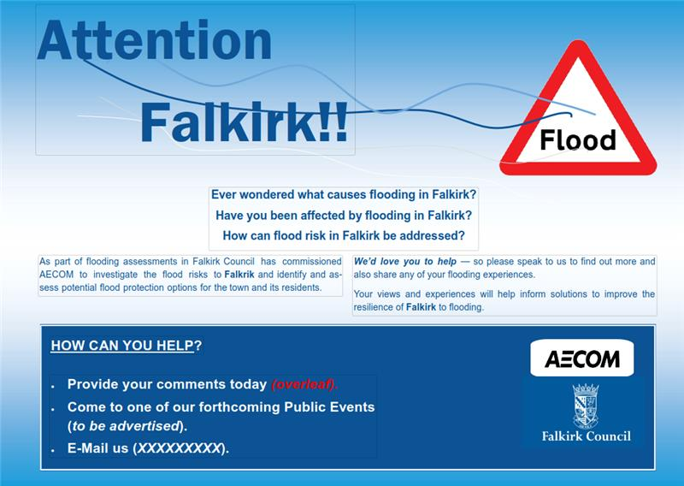
Figure 6-1 Example community engagement adapted from AECOM project
Supporting communities to set up Local Flood Action Groups (LFAG) would also improve understanding. LFAG could essentially disseminate more regional/national flood warning messages from the MET Office and SEPA at a local level through SMS warnings. This could also be used to reinforce advice around simple measures than can be taken to improve readiness i.e. deployment of sandbags/flood sacks, moving valuables to higher areas of the house, moving vehicles, avoiding roads known to flood in surface water incidents, warning against travelling through ponded water. Any telemetry information recorded by FC from trash screens for small watercourses could also be shared with LFAG volunteers as a warning tool.
From the SEPA strategies it appears there is only one LFAG within the FC area, Carronvale Residents and Tenants Association. The experiences of FC engagement with this group should be used to develop and inform the specific engagement strategy. The FC area is large and there cannot be a one size fits all solution in terms of community engagement. For example, a small community such as Airth is likely to be more aware of issues in the community and have stronger connections to circulate information than a large town like Falkirk. On this basis, a community meeting approach would likely generate more engagement from the outset. Engagement would need to be built more slowly through newsletters and social media in larger towns to develop interest and engagement in flood risk activities, to maximise the return of flood officer budget.
It is recognised that budgets are constrained, therefore, priority should be given to those smaller communities where promotion of self-help and resilience is likely to gain traction faster to see more rapid improvement on the ground. These locations are also likely to be lower in priority during national prioritisation for funding of actions through Scottish Government FRM streams given the smaller number of properties at risk compared to more urban locations. On this basis, smaller gains through self-help and resilience are likely to deliver some benefit much sooner in the FRM cycle. It is recommended investment in LFAG is focused around Airth, Denny, Dunipace, Slamannan at first.
The creation of flood resilience pods could also be taken forward by LFAGs and help plan emergency response to floods. These are essentially containers provided within or near a group of hotspots which would contain flood sacks (a lightweight sand bag) which can reduce risk of water entering properties. Pods would be locked but accessible 24 hours a day by pins distributed by the LFAG. Pods would then be restocked once the council is notified of low supply via a dedicated email address/contact. This would require significant community buy in but would be particularly beneficial for surface water flooding which has a rapid response and in rural communities where agency responses may not be rapid enough to deploy sandbags etc. in flash floods. This would again be recommended for Airth, Denny, Dunipace, Slamannan. This would require an upfront budget for engagement and installation of flood pods and sacks with ongoing cost for replenishment, but these are relatively low cost (approx. £8 per flood sack). It is recommended engagement in this approach is trialled in one community first in order to assess long term viability. It is recommended Scottish Flood Forum is engaged to provide support and advice on these measures.
Community engagement around maintenance should also be encouraged. Training could be provided to volunteers as a trial through newly established LFAGs in smaller settlements. Training would focus on monitoring of sediments in burns and gullies and support/advice on how to clear debris safely and identify invasive non-native plant species. This approach has been adopted by other local authorities.
The following recommendations are recommended for consideration by FC:
- Newsletter drops highlighting surface water risk and providing education around paving of surfaces and benefits of features such as rain gardens and water butts to reduce surface water pressure to the wider FC area. Information around authorities’ responsibilities and emergency procedures to be provided.
- Social media campaign specifically around self help on flood risk and harnessing the use of local community social media groups and community councils
- Creation of Local Flood Action Groups in Airth, Denny, Dunipace, Slamannan to create local warning systems and develop local emergency and maintenance planning where possible delivered through flood pods and training on drainage/watercourse maintenance.
- A public meeting should be held to generate the creation of a LFAG. This could include a talk from the key partner organisations – SEPA, Scottish Water and Scottish Flood Forum – on the work that is being undertaken and who is responsible. Such a meeting could also outline how residents can help themselves and highlight their responsibility for maintaining private drainage, soakaways, driveway drainage etc.
- Formalise Community Flood Plans for those communities identified to be at high risk at a local level.

Improving Resilience to Flooding
Where it is accepted that flooding cannot be prevented the impacts/risk can still be reduced. Scottish Government is investing in flood risk protection funding, but this is prioritised at a national scale and not every one of the estimated 240,000 properties at risk in Scotland can be protected. As a ‘quick win’ property owners can reduce the impacts of flooding themselves by investing in Property Flood Resilience (PFR). PFR includes resistance and resilience measures. Resistance approaches prevent water entering properties through routes such as doorways and airbricks e.g. flood doors/barriers, air brick covers etc. Resilience measures reduce the damage associated with water entering a property, decreasing the time it takes to restore property to a suitable standard e.g. replacing carpets with flooring which only requires cleaning after flooding, raising sockets above flood level etc.
PFR can be installed by individual homeowners or by a responsible authority as part of a scheme. The Environment Agency in England has been developing the latter approach over the last couple of years through grant funding as part of The Flood Resilience Community Pathfinder Project. At present FC has no formal policy on PFR schemes and this is something which should be explored. Installation of PFR to affected properties could be delivered as a scheme at a CDA level. Flood depths less than 0.6m are considered the maximum effective depth for PFR installations. On this basis and from the level of detail within current flood extents, Dunipace represents a good opportunity for a pilot PFR scheme where a number of properties in hotspots are affected by flood depths of 0.3m or less. This could be submitted for FRM Act funding within the next national prioritisation cycle (2027) or funded through FC revenue budget where property owners would apply for grant funding of a maximum value (around £5K in similar Environment Agency funded schemes in England) to install PFR measures within properties.
The following actions should be considered by FC:
- It is recommended that the Council aim to raise the awareness of PFR to protect against flooding to encourage individual investment. Information packs from sources such as the Scottish Flood Forum could be provided to properties within CDAs. This could be targeted to properties most likely to benefit from PFR measures i.e. those affected by more shallow depths of flooding up to 0.6m. Initial focus should be placed on the Bonnybridge, Carronside, Zetlands and Larbert catchments. The council website could also be used to highlight potential measures and support from SFF specifically around PFR.
- Explore FC policy on implementation of pilot PFR scheme within Dunipace. This could be submitted for FRM Act funding within national prioritisation or funded through revenue budget where property owners would apply for grant funding of a maximum value (around £5K in similar Environment Agency funded schemes in England) to install PFR measures within properties within CDAs.

Land Management
Falkirk has a high proportion of agricultural land and management of this land can have significant impacts on surface water runoff. Intensive grazing, type and timing of crops and large farm machinery, ploughing up and down slopes and the installation of agricultural drainage has resulted in soil compaction and erosion over many years. This reduces the ability of rainfall to infiltrate into the soil column increasing likelihood and volume of surface water runoff. This also has an impact on watercourses where soil erosion washes off to watercourses, reducing the capacity of the channel to convey water, resulting in less attenuation in flood peaks. Maintenance of drainage ditches also appears to be an issue based on historic reports of overgrown and compacted ditches in some CDAs exacerbating flood risk. It is acknowledged that land management is a complex option which would require significant time to implement effectively. It, therefore, forms part of the strategic plan within Falkirk Council, but resourcing is currently limited. FC are also limited in their powers to enforce best practice land management except where it causes problems in other areas. In the short-term information can be disseminated through community councils, social media and the Falkirk Council website regarding best practise for land management. This can include details of measures and funding to encourage longer term buy in.
The CDAs of Airth, Bonnybridge, Carronside and Slamannan appear to be impacted most by runoff from agricultural land. The following measures should form a long term strategy to help reduce runoff from these areas:
- Engagement with key landowners to educate around best practices for reduced soil erosion and as a reminder of riparian and drainage maintenance responsibilities. An ongoing engagement plan with contact details and frequency of engagement would be useful for high risk locations if and when budget becomes available.
- Review of opportunities for improved land management measures to reduce run off from agricultural land in Airth, Bonnybridge, Carronside and Slamannan. Measures would include adopting contour ploughing to reduce soil compaction, planting of buffer strips (hedgerows/trees) and installation of leaky barriers in drainage ditches to slow flows and reduce sediment run off to watercourses. This will require significant engagement and buy in from landowners but funding streams outwith FRM funding can be accessed by landowners such as Scottish Rural Development Programme support. These are small scale measures, but they are typically low cost and help in the most frequent floods as well as improving water and soil quality which benefits landowners as well as the water environment as noted in the RBMP. This information should be shared on FC website and through community hubs.
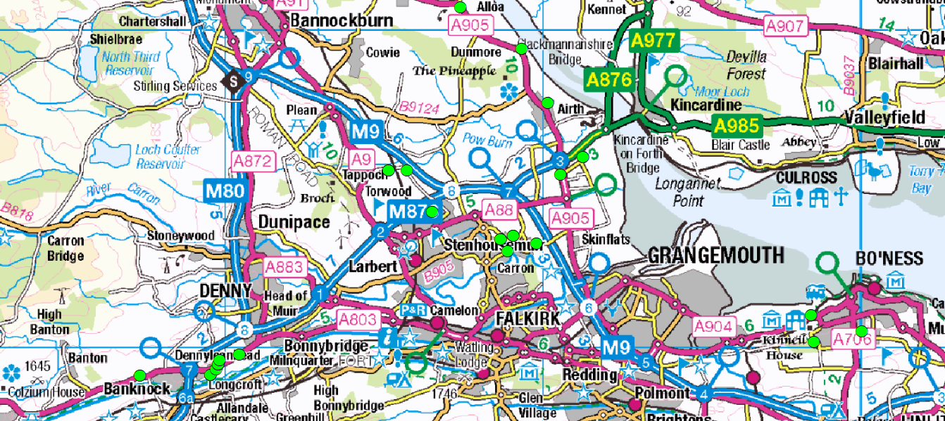
Figure 6-2 Locations recommended for land management practices review
Contains OS data © Crown Copyright and database right (2020)

Planning and Development Policies
Scottish Planning Policy requires a neutral or better impact on flood risk as a result of a development. A number of policies have already been implemented within Falkirk to ensure that new development incorporates Sustainable Drainage Systems (SuDS). Furthermore, planning guidance has recently been updated to include precautionary requirements in terms of allowance for climate change as recommended by SEPA. FC’s planning approach is therefore well structured to manage surface water from new developments.
As discussed previously there is significant pressure for new housing developments in Bo’ness, Maddiston, Gilston and Whitecross and Larbert (Figure 6-3). For these specific locations, planning powers could be used to develop prescriptive design frameworks to which developers must adhere to similar to the Edinburgh Design Guide. This could be used to place more aspirational and precautionary requirements on surface water management in at risk areas so that new developments are pushed to do more than neutral impact required under SPP. This could involve specifying source control measures where possible such as rain gardens, green roofs etc. throughout developments for incremental gain across the catchment rather than traditional, large scale end of pipe SuDS solutions where effectiveness can be significantly reduced by poor maintenance. Design guides for these areas should be considered in consultation with FC planners as a future action. Falkirk Council already apply a more stringent discharge rate than greenfield from new developments in order to provide betterment. This is currently applied across the Falkirk Council area.
Planning guidance could be updated to require a site visit by FC Flooding Officers to determine that SuDS within developments have been constructed in line with what was agreed in Planning Conditions. At present this would be challenging to implement as the majority of SuDS schemes tend to be end of pipe solutions. These are, therefore, adopted by SW and outwith Falkirk Council control once planning permission has been granted.
Section 7 of the Sewerage (Scotland) Act 1968 allows road authorities and Scottish Water to enter into management and maintenance agreements for surface water sewers and drains. Scottish Water have recently updated their Section 7 policy to increase SW site visits during construction to verify construction against plans/specifications. This should increase the likelihood of SuDS operating as planned. There is a mechanism within Section 7 to invite councils to this process as a shared responsibility. FC are not currently signed up to a Section 7 agreement with Scottish Water but these discussions are ongoing. This should continue to be progressed to allow FC to have more control over SuDS in the ground which could pre-empt any potential future issues with SuDS. It should be noted this will need to be a long term action and is dependent on the finalising of a Section 7 agreement and available budget internally to facilitate these visits. Where budget is available this should be focused on developments in the catchments of the highest risk hotspots identified in this report.
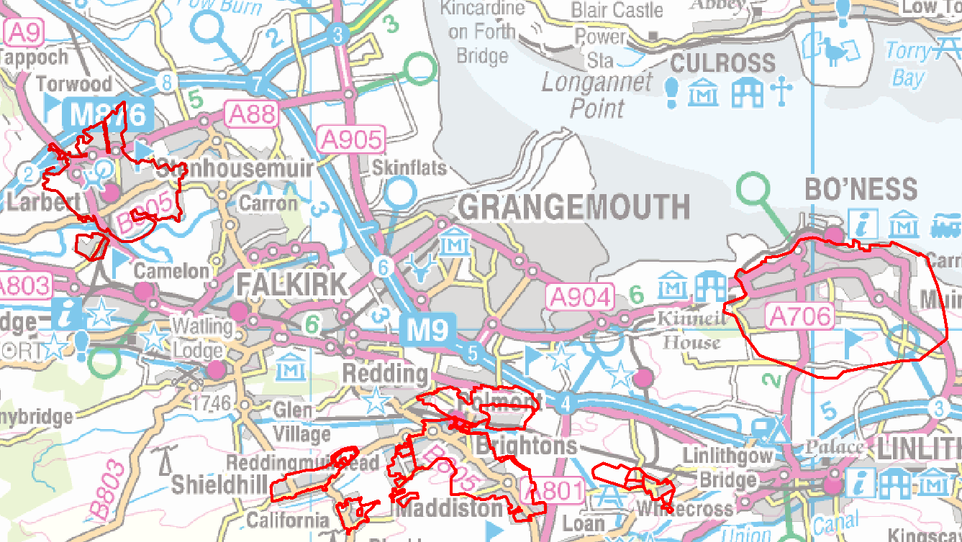
Figure 6-3 CDA's with opportunity for surface water flood risk management through planning
Contains OS data © Crown Copyright and database right (2020)
A number of town centre and business redevelopments have also been included within the LDP. These offer the opportunity to build back better and request installation of SuDS features which would result in a betterment in discharge rather than less than the current brownfield rate. This could be achieved through early dialogue with developers or by updating planning guidance on surface water management to make specific requests for betterment within high risk areas where development is planned within LDP.
Planning policy could also be used to help manage urban creep associated with paving of garden areas. Impermeable paving in gardens can significantly increase surface water runoff entering the local drainage network. Under current SPP permitted development rights, householders can pave their gardens with hard standing without planning permission except where proposed paving is between the house and the road and if the house is in a conversation area or near a listed building. These conditions require planning approval and it must be shown paving is porous or runoff would be routed to a permeable area. This requirement was introduced by the government following a review of extreme floods and may not be widely known. Reiterating these conditions to the public through infrequent social media posts may increase awareness and encourage people to invest in permeable solutions.
The change to National Planning Policy (NPF4), due for publication in 2022, presents an opportunity to better manage urban creep by making the policies around paving gardens more stringent. NFP4 will have a particular focus on climate change, therefore, this is unique opportunity to improve future flood risk policy on a national scale. A draft of NPF4 will be presented in the Scottish Parliament in Autumn 2021 with extensive consultation planned from now until then. It is recognised FC will have no control over the final outcome but engaging with consultations and calls for ideas scheduled throughout the NFP4 timeframe is recommended so issues on the ground can be fed back to be considered in policy.
The following actions are recommended where they are not in place already:
- FC should consider development of prescriptive design guides to encourage exemplar SuDS and betterment in overall surface water flood risk as a result of development pressure in Bo’ness, Maddiston, Gilston and Whitecross and Larbert,
- FC to seek early engagement on redevelopment plans for Falkirk Gateway/Stadium, Abbotsford Business Park, Caledon Business Park and town centre regenerations of Grahamston and the East End, Grangemouth, Bo’ness, Denny, Bonnybridge and Newcarron so retrofit SuDS are considered as early as possible to encourage betterment in the existing surface water flood risk situation,
- FC should continue discussions with SW around Section 7 agreements on SuDS maintenance/adoption and explore potential shared responsibility on verification site visits,
- FC should raise awareness of the options for installation and maintenance of permeable surfaces within property grounds. This could be provided through an information portal on the FC website which can provide ‘best practice’ guidance and examples,
- The Council could aim to refresh training of staff to ensure that planning officers: are aware of the existing planning policy, guidance and best practice; are in a position to educate the public if enquiries are made regarding planning permission to change their drive/garden; and, can identify/enforce for non-compliance or non-permitted conversion. This should be focused around the highest risk hotspots/CDAs where flood risk is already high and additional or increased runoff would likely exacerbate existing issues.
- Engage with statutory and public consultations on NPF4 prior to draft issue in Autumn 2021.

Source Control
With our changing climate water scarcity but also flooding will become more prevalent with wetter winters increasing risk of flooding and prolonged, hotter summers increasing frequency of droughts and intense storms. It is, therefore, important to identify strategic opportunities to treat run off as a more valuable resource whilst reducing downstream flood risk. This can be applied by encouraging the use of rainfall in rainwater harvesting systems and property level use of water butts. Both are described in more detail below.
Rainwater harvesting takes rainwater from roof areas to a filter where it is stored within large underground tanks. When water is required, it is delivered from the storage tank to toilets, washing machines and garden taps for use. If the tank becomes low on stored water, demand is topped up from the mains supply. Any excess water can be discharged via an overflow to a soakaway or the local drainage network. Water butts carry out a similar function on a smaller scale. They are simple, domestic rainwater tanks used to collect and store rain water runoff from downpipes where water is typically reused for domestic gardening.
Green roofs and rain gardens are also SuDS features which can be retrofitted and seek to mimic predevelopment runoff. These features allow processes such as evapotranspiration, interception and/or infiltration to be reintroduced to the system, reducing runoff rates to the drainage network. They would also generate biodiversity and amenity benefit as well as managing urban heating which is likely to become more of an issue in a changing climate.
It is recognised that there are constraints around the long-term maintenance of SUDS. Scottish Water typically adopts end of pipe systems for a minimum of a 1 in 30yr standard of protection. This creates a challenge for the adoption of source control features, which needs to be met by the council or by private developers. For new developments, early dialogue is required with developers to set out an adoption and maintenance plan.
FC should consider retrofit of rainwater harvesting systems or green roofs/rain gardens on FC owned properties such as schools. This would allow large, single runoff contributions from roof curtilage entering the drainage system to be reduced in rate and volume if replicated throughout FC area. Typically focusing this kind of intervention on a single large roof will reduce cost and complexity in managing numerous connections that would be seen in domestic properties. This would be beneficial to the Falkirk Town – North West catchment in particular which has the highest proportion of hotspots impacted by combined sewer flooding including Middlefield, Bankside and the Ladysmill areas. The Polmont, Zetlands, Larbert and Carronside catchments would also benefit from a review of rainwater harvesting opportunities. Focusing on the Falkirk Town – North West catchment first, a pilot scheme could be developed which could be rolled out to these areas. Furthermore, the retrofitting of these measures in FC/education facilities would create an educational benefit to explain how these systems work and show FC leading by example on sustainability and climate change action. The following options are recommended for consideration:
- FC should explore potential opportunities for the installation of rainwater harvesting systems or green roofs in the town centre and business redevelopment areas discussed in Section 2.2.4.2. These offer significant opportunity where there is likely to be high footfall and high demand for water usage.
- Consider installation of rain gardens for all new development roof areas as part of the SuDS management train, focusing on high pressure areas including Bo’ness, Maddiston, Gilston, Whitecross, and Larbert.
- Consider retrofitting raingardens on all existing development. This provides supplementary benefits beyond regeneration and redevelopment sites (volumetric reduction with opportunity for complementary water quality improvements). However, there are currently no available incentives to encourage homeowners to install water butts. The Falkirk Town – North West catchment (Figure 6-4) should be considered for a pilot scheme to incentivise uptake of water butts in residential properties. This could be delivered through grant funding from FC or education and promotion of the benefits within the community.
- It is recommended that the Council promote the use of water butts across the council area and provide information on costs, suppliers, installation and benefits via the FC website and/or targeted letter drop in the Falkirk Town – North West, Polmont, Zetlands, Larbert and Carronside catchments. These areas are at most risk of combined sewer flooding, therefore, any measure to reduce total load on the network is likely to have a flood risk benefit.
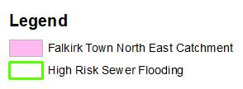
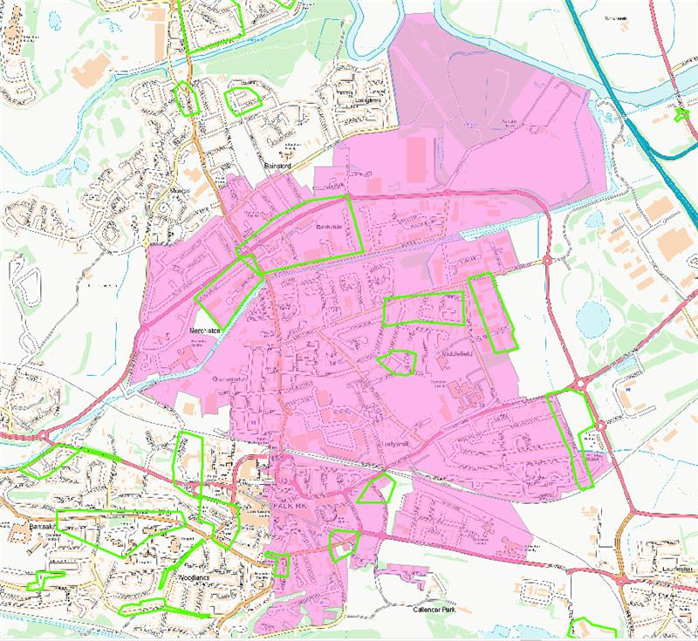

Figure 6-4 Catchment recommended for rainwater harvesting pilot scheme
Contains OS data © Crown Copyright and database right (2020)

Daylighting Culvert Opportunities
The daylighting of historic culverted watercourses can improve surface water flood risk by restoring natural overland flow paths and providing attenuation of flood peaks due to increased capacity and meandering channel sections. Beyond flood risk, daylighted watercourses increase amenity value and community connections with the environment. They can also be used to create valuable wetland / aquatic habitat, aid fish passage and significantly add to the visual attractions of an area. The FC area was reviewed for opportunities to daylight watercourses. This has generally focused on areas of parkland which are likely to be in council ownership and where more open space is available to create a suitable channel section size and meander. Deculverting burns in these locations would also maximise key amenity benefits. It should be noted detailed feasibility assessment has not been carried out for any of the locations. Where there would be obvious topographic constraints no further consideration was given to daylighting for example at Callendar Park and Ladysmill Park in Falkirk. Landowner and community buy in for these proposals will be essential and also need to be reviewed as part of more detailed feasibility assessment. Those watercourses with less than good RBMP classifications highlighted in Section 2.2.5 should be prioritised such as the Pow Burn in Airth.

It is recommended the following locations are explored further in terms of feasibility for deculverting:
- Airth - Cuvlert near Airth Castle and at Forthview Golf course.
- Falkirk - Summerford Road, Falkirk with realignment required into Summerford Park
- Bonnybridge – Parkland at Foundry Road and Industrial Estate at Bonnyside Rd
- Bo’ness - Green space at Douglas Drive and green space at Drum Road
- Maddiston - Craigend Burn - Falkirk Council existing feasibility project
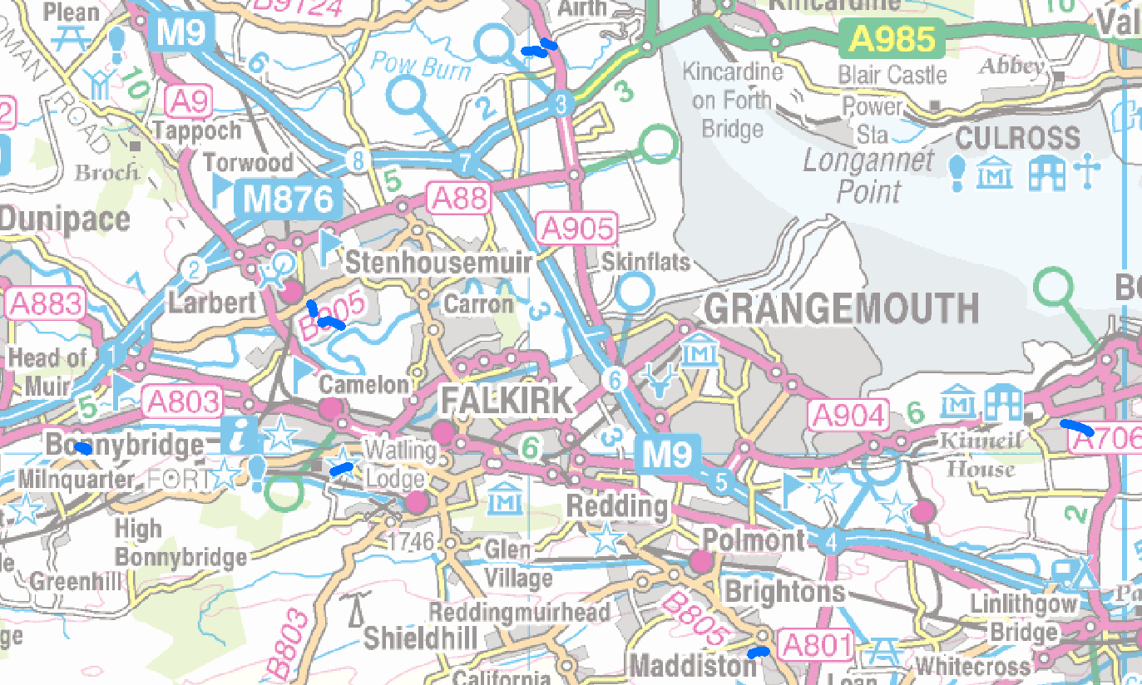
Figure 6-5 Locations for deculverting feasibility assessment
Contains OS data © Crown Copyright and database right (2020)

Land Use Planning
The Scottish Land Commission and SEPA have set up a partnership aimed at reducing the amount of vacant and derelict land and repurposing spaces for new uses. Flood risk management can be part of this drive. Open spaces and green infrastructure can also be repurposed to make a valuable contribution to managing surface water runoff. This is also highlighted within the LDP as an aim of the Central Scotland Green Network, discussed in 2.2.4.1.

Where areas have been determined to be at risk from uncontrolled overland flows or exceedance of local drainage networks, storage areas could help capture and attenuate flows to more manageable levels. Derelict/vacant sites and open green space have the potential to be used for such purposes. A review of the derelict/vacant sites register for the FC area indicates significant opportunity for the repurpose of these sites in the Falkirk Town – North East (south of A9), Falkirk Town – South West and Carronside catchments (Figure 6-6).

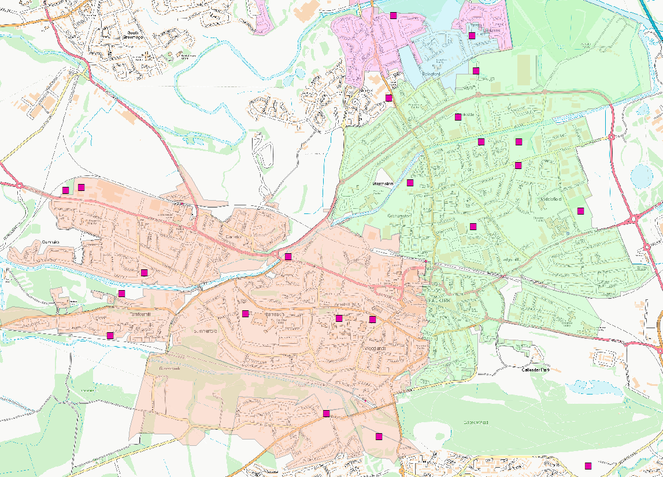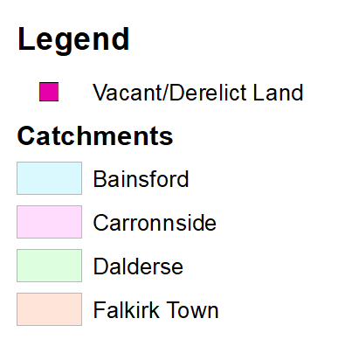
Figure 6-6 Vacant Derelict Land Potential Opportunities for SuDS
Contains OS data © Crown Copyright and database right (2020)
OS Open Greenspace maps were also reviewed to highlight opportunity areas for potential repurposing. Main opportunities are available in Carronside, Falkirk Town - South West and Zetlands catchments (Figure 6-7).

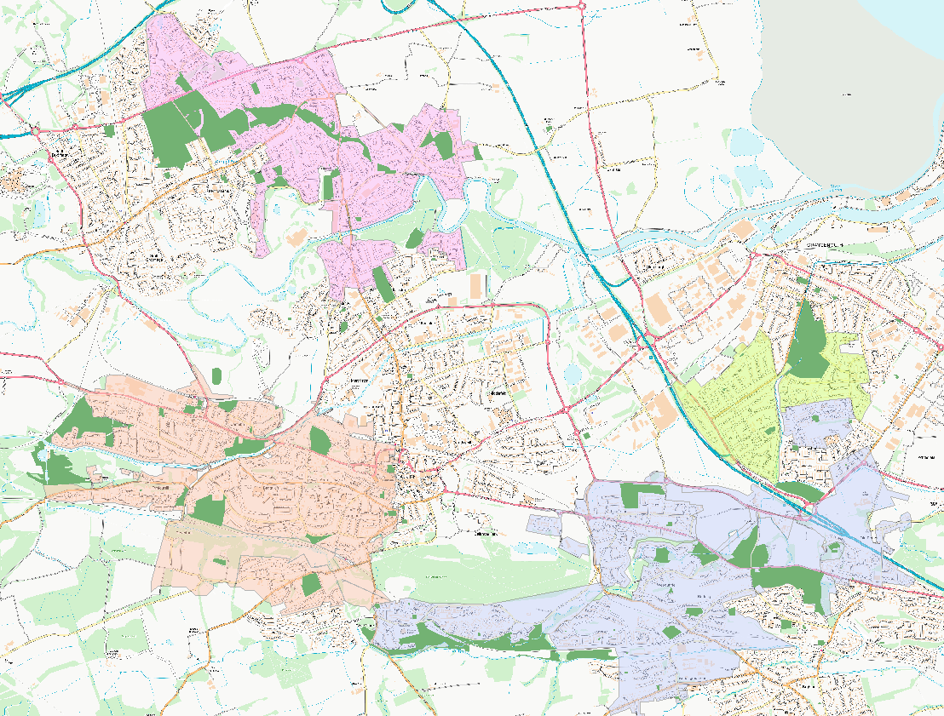
Figure 6-7 Open Green Space Potential Opportunities for SuDS
Contains OS data © Crown Copyright and database right (2020)

No feasibility analysis (hydraulic, topographic or geotechnical) has been carried out on these sites at this stage. However, the following recommendations are suggested:

- It is recommended that feasibility assessments for potential overland flow capture and SuDS retrofit opportunities at these locations are carried out as part of recommended detailed studies.
- It is also recommended these purposes be considered in future phases of Local Development Planning.
- It is noted that different council services will have different aspirations for some open space sites. It is recommended consultation is carried out with internal green space/ecology teams to identify opportunities for partnership working and objective sharing.

Detailed Studies
The hotspot and catchment analysis identified nine areas as potentially benefiting from a detailed study. The reasons they were selected include; areas that were identified as having a high number of hotspots; areas with high average risk score; and those with high ranking hotspots with surrounding linked hotspots. Furthermore, a review of historic flood reports as well as SEPA/SW model outputs create a static picture of flood risk that indicates complex mechanisms in these areas. This cannot be fully assessed without further detail. Furthermore, these high-risk areas are most likely to benefit from a formal surface water management flood scheme, therefore, future investment should be focused on developing a robust optioneering process that can deliver a preferred option for funding. The areas identified for a detailed study are:
- Bonnybridge
- Bo'ness
- Carronside WWPS
- Falkirk Town – North East
- Falkirk Town - South West
- Larbert, lower larbert wwPS
- Northfoot
- Polmonthill
- Zetlands
These detailed studies would take the Catchment Assessment Phase a step further by producing linked 1D-2D hydraulic models of the catchments. This would enable a fuller understanding of flood risk to be developed by gaining dynamic understanding of flood risk from a source, pathway receptor perspective. These detailed assessments will be specific to the local area rather than using regional outputs from SEPA/SW models and can account for local conditions and features which would not be picked up in detail at a regional scale e.g. road kerb heights.
Furthermore, modelling allows the production of local, quantitative outputs on flood risk (depth, velocity etc.). These can be translated to economic assessments of damage at a property level which allows benefit cost analysis of interventions. This would allow a robust options appraisal analysis to be carried out. Options can be represented in the model to test and quantify their impacts in terms of real benefits both monetary and flood risk.

Prioritised Detailed Study
In order for Falkirk Council to move forward with the detailed studies a pilot area is recommended. This is in line with SWMP guidance which highlights that areas with high risk should be a focus. This would allow for an established process to be developed for the Falkirk Council area for SWMPs and allow FC to explore resourcing, budget requirements and make any adjustments for further studies. Table 6-2 shows the scoring for the areas shortlisted for a detailed study. Bo’ness is shown to have the highest average score and also benefits from being hydraulically independent and of moderate size and is, therefore, a good candidate for the FC pilot study. Other CDAs are more linked and, therefore, may benefit from being carried out simultaneously once the pilot study is completed. It is therefore recommended that Bo’ness form the pilot study.
Table 6-2 Review of Detailed Study Area Scoring
Critical Drainage Area | No. of hotspots | Average Score | Max Score | Min Score
Bonnybridge | 14 | 29.1 | 62.3 | 9.6
Bo'ness | 9 | 33.4 | 51.0 | 7.3
Carronside WWPS | 10 | 32.8 | 58.1 | 7.2
Falkirk Town - North East | 8 | 32.8 | 68.4 | 7.2
Falkirk Town - South West | 19 | 22.3 | 72.2 | 0.5
Larbert, lower larbert wwPS | 15 | 25.4 | 54.0 | 5.6
Northfoot | 15 | 24.8 | 82.8 | 1.0
Polmonthill | 14 | 25.5 | 57.0 | 4.4
Zetlands | 6 | 21.0 | 33.0 | 7.0

Hotspot Level Analysis
As discussed in Section 6.1, 7 of the Critical Drainage Areas identified were assessed as lower risk from surface water flooding through hotspot ranking. On this basis these areas have not been recommended for further detailed assessment at this stage. These areas, however, should not be ruled out from further study and should be reassessed during the next phase of the cycle. The areas include:
- Airth – Airth, Dunmore & Letham
- Denny
- Dunipace
- Glenburn
- Glensburgh
- Slamannan
The level of information available from historic flood records and modelled outputs form both Scottish Water and SEPA has enabled the identification of ‘quick wins’ that represent relatively low-cost solutions that could be implemented in the short term compared to a formal surface water management scheme. Identification of quick wins have focused on the following:
- Maintenance
- Review of status of actions in terms of planned alleviation works
- Road kerb heights
- Land management
- Engagement (Community or Stakeholder)

Airth – Airth, Dunmore & Letham
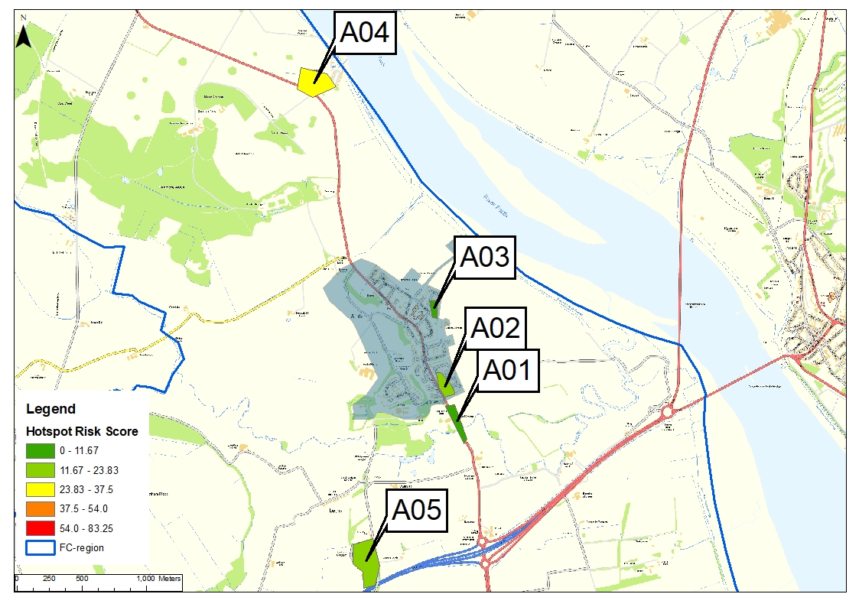
Figure 6-8 Airth Hotspots
Contains OS data © Crown Copyright and database right (2020)
A01 – Flooding on carriageway due to burn
- Regrading farmland to create flood storage or set back defences – potentially a poor business case based on number of receptors.
- Enhanced emergency planning/comms, sandbag hub, improving local knowledge sharing.
A02 – Hotspot has an area of low topography compared to surrounding area
- PLP support for that row of houses
- Scottish Water liaison
- Review maintenance of paving
- Road grading
A03 – Flood risk from ditch on private land
- Ditch – Riparian responsibilities. Flood history recommends work to ditch to improve condition. Check initial ditch work was done. Action to review and touch base with riparian landowner every 6 months.
A04 – Dunmore, coastal village
- Data gap filling – works package already underway to review existing infrastructure and standard of drainage. Coastal village study to be carried out by AECOM.
A05 – Letham, runoff from roads
- Improved road drainage – swale in verge with slight regrade or new gullies/kerb inlet system – doesn’t have much drainage at present. Would require info on local drainage arrangement to develop.

Denny
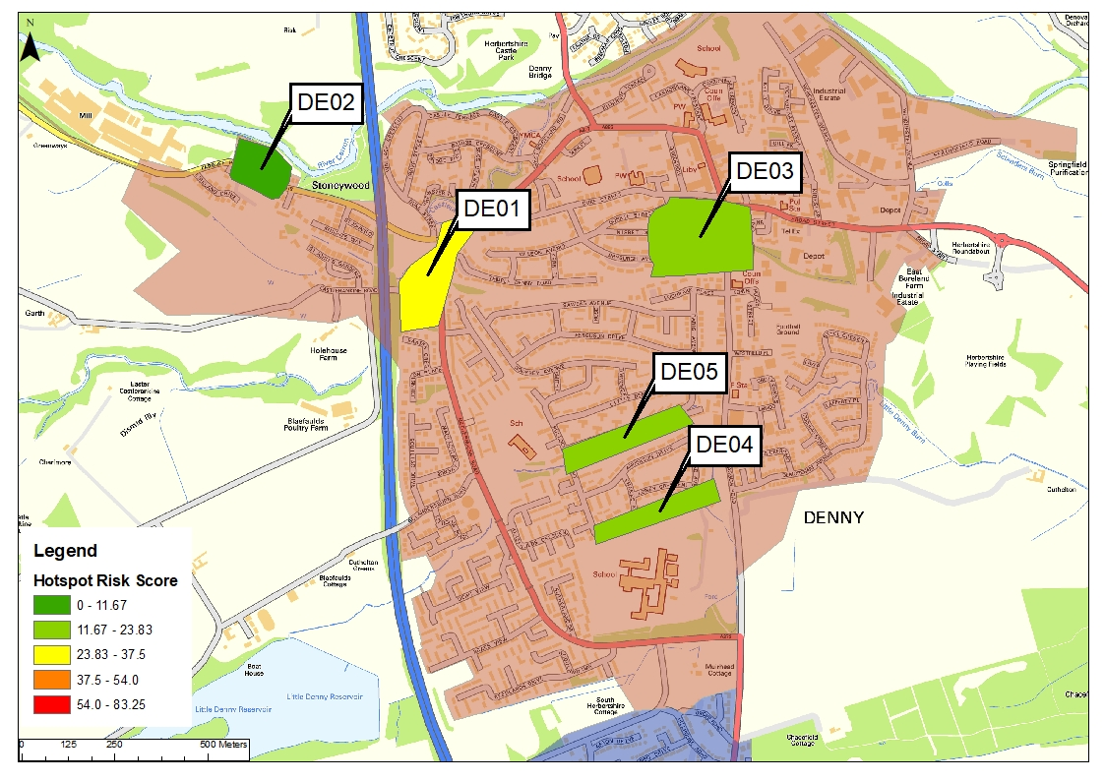
Figure 6-9 Denny Hotspots
Contains OS data © Crown Copyright and database right (2020)
DE01 – Fluvial flooding from Castlerankine Burn and surface water runoff
- Land use planning to not allow redevelopment once life of building is over. FC to promote reconnection to the floodplain
- Property Flood Resilience for Cadet Hall
- Offline storage upstream in playing fields. Would protect road and Cadet Hall.
DE02 - Local drainage network issue
- Liaison with SW
- Review of planning application to determine if construction was in line with plan.
- Maintenance of permeable paving and education for homeowners.
DE03
- Current information not sufficient to determine risk conclusively. Further dialogue with council needed on next steps with potential for further data gathering.
- Regeneration flood risk benefit on Derelict sites.
DE04 – Small watercourse
- Follow up on ownership/maintenance responsibilities for bridge
- SW dialogue
- Tank or oversized pipe to manage surcharge
DE05 – Small watercourse
- Review/creation of maintenance plan for screens
- Replacement of screen/review of sizing
- Speak to landowners about maintenance responsibilities
- Review finished flow level of existing wall

Dunipace
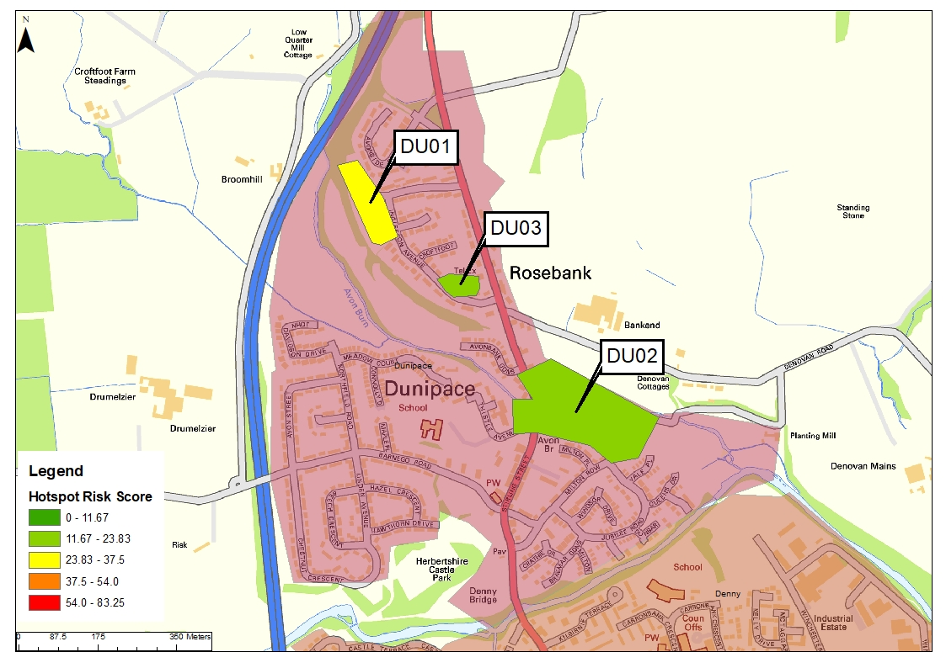
Figure 6-10 Dunipace Hotspots
Contains OS data © Crown Copyright and database right (2020)
DU01 – Culvert capacity
- Follow up on ownership/maintenance responsibilities
- Potential to upgrade but more information required to develop
- Garden wall around affected property but would push flood risk to road likely.
- Property flood resilience
DU02 – Avon Burn Flood Walls
- AECOM undertaking a review of flood walls with option assessment on behalf of Falkirk Council.
DU03 – Drainage issues
- Further understanding of drainage needed and what existing work has been carried out
- Driveways – education and work with public to improve
- Additional gullies

Glenburn
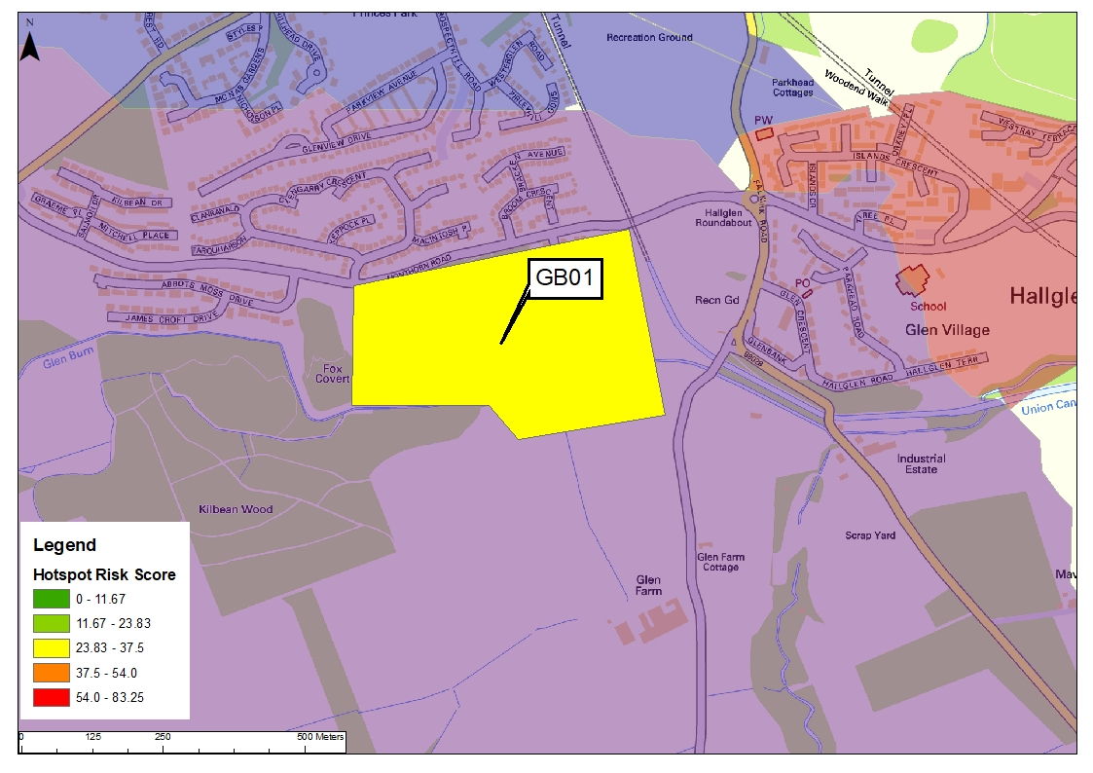
Figure 6-11 Glenburn Hotspots
Contains OS data © Crown Copyright and database right (2020)
GB01 – Scottish water model and SEPA flood maps predicting flooding,
- Review SW issues and model to determine if attenuation is being represented from SuDS ponds – likely high severity flooding being overrepresented without SuDS in place.

Glensburgh
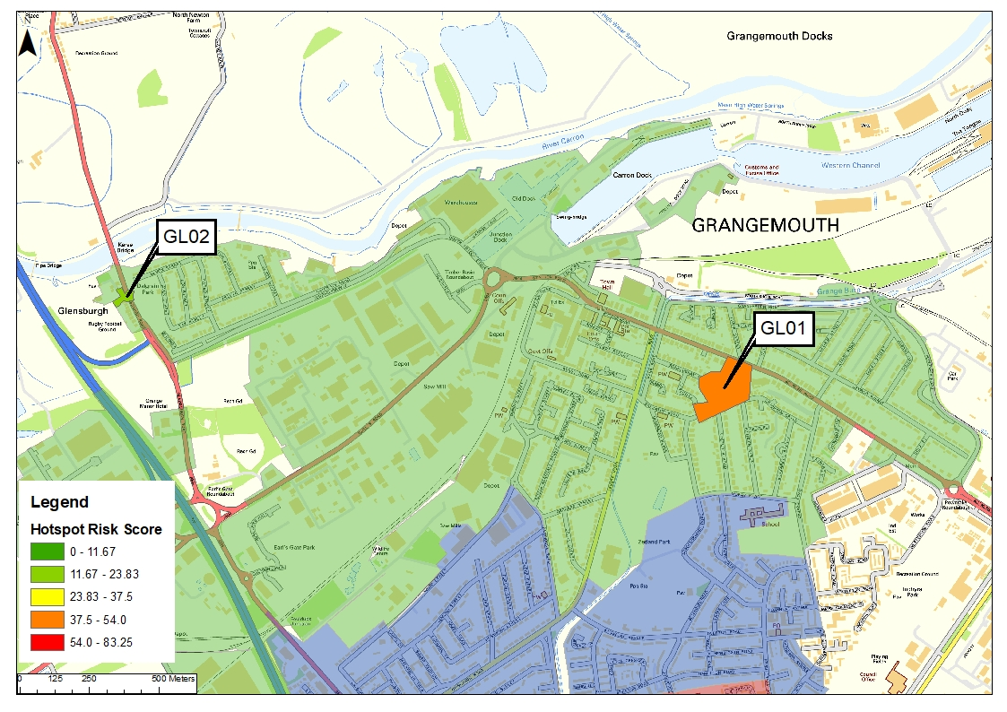
Figure 6-12 Glensburgh Hotspots
Contains OS data © Crown Copyright and database right (2020)
GL01 – Sewer flooding
- Scottish Water liaison
GL02 - Largely driven by tide locking of outfalls
- Grangemouth Flood Protection Scheme related SWMP – looking at opportunities to improve in tandem with scheme works from a quick win approach of improving outfall locations vs tide levels, to SuDS retrofit opportunity to full separation and underground storage potentials to deal with restricted flows with view to reducing pump requirements. Could be done as part of scheme design or as a separate parallel, bit of work.
- Opportunity for smaller hotspots to be tied into this, not quite big enough to be a hotspot on a strategic scale, but as part of a localised scheme could work well.

Slamannan
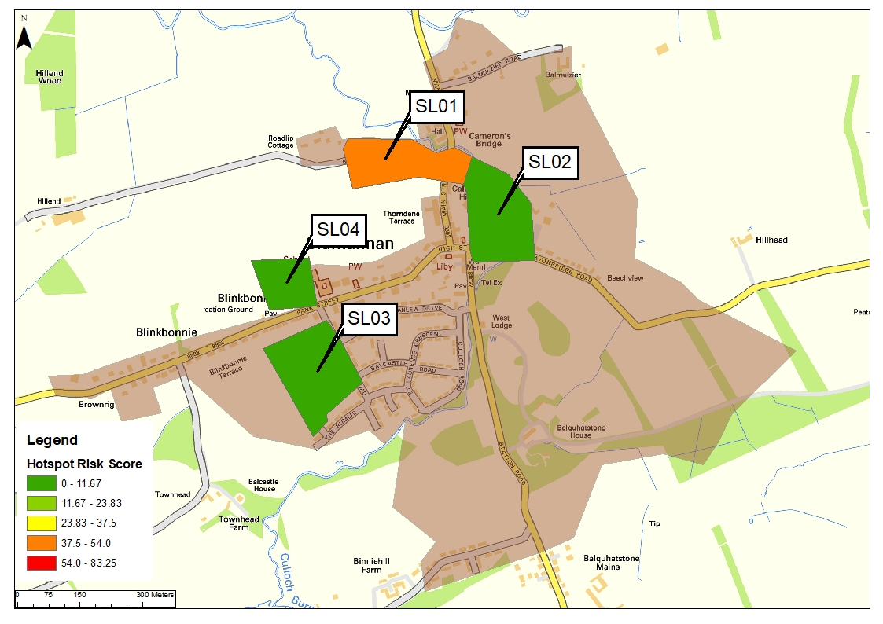
Figure 6-13 Slamannan Hotspots
Contains OS data © Crown Copyright and database right (2020)
SL01 - Runoff from agricultural land
- Review of drainage works from 2016.
- Land management works to slow flow on agricultural land – potential for cross slope planting. Ditch at bottom
SL02 - High river level interacting with drainage network causing backup of flow
- Storage in network
- Flap values
- Review outfall location routes
- NFM through re-meandering or leaky barriers to slow flow and de-sync river levels and peak drainage outflows (no significant fluvial flooding but this may not be fully represented based on small and engineered nature of channel) may be more of an issue.
- Capture and slow run off through SuDS swales high in catchment to again resync peak drainage discharge and river level
- Review blockage of outfalls through vegetation and develop improved maintenance procedures
SL03 - Runoff from fields overwhelming drainage network affecting properties in dip in middle of Southfield Drive.
- Bund
- Filter drain/swale
- Improvement land management/NFM – hillslope planting and buffer streams
- Review ICS outputs and current options and temp works in place to develop final solution
- PFR
SL04
- Further information required to understand flood source.

Review of Options and SWMP Objectives
Objectives for this SWMP were outlined in Section 5. This section provides an overview of the actions recommended for the CDAs and sets them against the objectives of the study provided (see Table 6-3).
This SWMP fulfils the action set out in the SEPA FRM strategy to help meet the primary objectives. The actions that were identified in order to achieve these objectives were: Surface Water Plan/ Study, Action (IDs): (100330018, 101040018, 100420018).
This SWMP process forms the first step in achieving the primary objectives set out in the SEPA FRM Strategies. As SWMPs are cyclical, not all objectives will have been carried through to fruition at this phase. The recommendations and outputs from the plan will enable FC to allocate and prioritise investment towards fulfilling the objectives over this and subsequent FRM planning cycles.
Table 6-3 Overview of Actions and Objectives
Actions | CDA | Objectives
Several quick wins and some small-scale projects requiring data gathering | Airth  Denny  Dunipace  Glenburn  Glensburgh  Slamannan | 10033 - Reduce economic damages and number of residential properties at risk of surface water flooding in Falkirk, Stenhousemuir and Carron where practical PVA 10/11.  10104 - Reduce economic damages and number of residential properties at risk of surface water flooding in Polmont and Maddiston where practical PVA 10/11 and PVA 10/13.  10042 - Reduce economic damages and number of residential properties at risk of surface water flooding in Bo'ness, Carriden and Muirhouses where practical (10042) PVA 10/12.  Develop a robust understanding of surface water flood risk specific to the FC area.  Identify areas which require further data and identify any works, studies and modelling that is required to fill the gaps.
Detailed Study with some quick wins | Bonnybridge  Bo'ness  Carronside WWPS  Falkirk – North East  Falkirk – South West  Larbert, lower larbert wwPS  Northfoot  Polmonthill  Zetlands | Make holistic and multifunctional recommendations for surface water management  Renew and consolidate partnerships  Undertake engagement workshop with stakeholders  Make the public more aware of the causes of flood risk in the area, provide education around the standard of service of drainage infrastructure and resilience.  Reduce surface water flooding as a driver for economic, environmental and social regeneration.  Identify an initial action plan which highlights possible solutions and define a scope for potential future works

Consultation
A draft copy of this report was sent to Stakeholders electronically for comment, on the 18th February 2021. Stakeholders were asked to review the document, give feedback, and provide an opportunity for further data capture and to gain an understanding of stakeholder priorities.
Consultation responses were provided by the following Stakeholders:
- SEPA
- Scottish Water
- Scottish Canals
- Green Action Trust
- Forestry and Land Scotland
Further responses were obtained via the SEA screening from NatureScot and Historic Environment Scotland.
Specific consideration points were provided to stakeholders, these were:
- Data capture – including details of any known operational issues, areas of interaction, ongoing works and details of any additional high priority surface water issues not currently captured.
- Priorities – details of high priority areas for stakeholders, and any drivers for change in the areas e.g. water quality, net carbon zero.
- Schemes and investigations planned, including long term.
- Timescales for any plans or work mentioned.

SEPA
SEPA commented in support of the acknowledgment of the need to update and revise the SWMP over time, as they should be dynamic, taking into account the latest technical and policy guidance data, following Scottish Government advice. They stated that the risk based, borough = scale approach is appropriate for the Falkirk area.
There was general agreement on the hotspots identified, their risk assessment and areas scoped for further detailed study. Further justification of the scoping out of Slamannan was noted given the high incidence of flood records. This is due to the fact most incidents are centred in 1 of 4 hotspots. Although likelihood of flooding here is high the severity and impact of flooding is low, the impact is low with a small number of properties affected, meaning the overall risk level is considered low. At present quick wins are more appropriate than a full detailed study compared to other catchments.
SEPA identified tide locking issues and climate change adaption as priorities. These have been considered within the SWMP as part of the whole assessment, however no detailed analysis was carried out. SEPA recommended consideration of sea level rise predictions; future flood risk data set; and updated short duration rainfall UK climate projections expected in the first half of 2021. It is recommended these are considered in more detail for specific study areas.
It was also noted that SEPA believe a Section 7 agreement for this area regarding SuDS would be beneficial for the future whilst recognising talks are currently ongoing.

Scottish Water
Scottish Water provided details of their current investigations in the area. Scottish Water are investigating Unsatisfactory Intermittent Discharges (UID’s) in the following areas: Dalderse UID, Glensburgh WWPS (Wastewater Pumping Station), Snabb Lane and Furnace Lane. The Glensburgh area is of particular relevance for surface water removal and attenuation. These investigations are at the review stage currently, but partnership working could be established at the optioneering stage.
It is recommended that these areas of Scottish Water interest are considered as part of any detailed study or any other works considered by FC.

Scottish Canals
Scottish Canals stated they are committed to working with Local Authorities to reduce flood risk and towards more integrated water management systems. Scottish Canals datasets are available for use and should be utilised for the detailed SWMPs. Scottish Canals Corporate Plan 2020-2023 is available online and sets out their drivers for change, an Adaption Strategy for the Union Canal is at scoping stage and a number of resilience measures are currently being delivered on the Union Canal. Scottish Canals are aware of the vulnerability of the canal network to unmitigated surface water runoff and are, therefore, supportive of appropriate controls and mitigation being incorporated within the progression of the SWMP.

Green Action Trust
The Green Action Trust stated their support of the SWMP and agree with the methodology used. The Green Action Trust are not aware of any schemes underway or in development within the hotspot areas, or that would have an impact on the plan or the objectives. They are, however, keen to work with FC to investigate, develop and deliver projects in these areas which deliver more than just water management, for example green space creation and improvement, and biodiversity enhancement.
Green Action Trust specifically mentioned their support for a number of the strategic options to manage flood risk including:
- Using engagement to raise public awareness of how successful green infrastructure and nature-based solutions can be, to hopefully reduce public assumptions on pipes and dredging;
- Street scale green infrastructure and retrofit of council owned properties with green roofs and rain gardens;
- Land management considering tree planting/vegetation management particularly in areas prone to soil erosion and associated diffuse pollution, as well as enhancement of riparian habitats in urban areas;
- Planning guidance updates supporting the strengthening of language to require green infrastructure and nature-based solutions to be used for surface water management in new build and redevelopments, and use of prescriptive design guides;
- Daylighting of culverted watercourses, recognising that this can lead to enhanced green networks and biodiversity/amenity value of an area;
- Reuse of derelict land viewed as a potential “resource” for SuDS and surface water management.

Forestry and Land Scotland
Forestry and Land Scotland work on flood mitigation through woodland creation and expressed an interest in any future opportunities for partnership projects.

Ongoing Monitoring
The partnership arrangements established as part of the SWMP process (e.g. SW, SEPA, Scottish Canals etc.) should continue beyond the completion of the SWMP in order to discuss the implementation of the proposed actions, review opportunities for operational efficiency and to review any legislative changes.
The SWMP Strategic Plan should be reviewed and updated once every six years as a minimum, but there may be circumstances which might trigger a review and/or an update of the Plan in the interim, for example:
- Occurrence of a surface water flood event;
- Additional data or modelling becoming available, which may alter the understanding of risk within the study area;
- If the outcome of an investment decision by partners is different to the preferred option, which may require a revision to the Action Plan, and;
- Additional (major) development or other changes in the catchment which may affect the surface water flood risk.

Conclusions and Recommendations
AECOM developed a Strategic SWMP on behalf of and in collaboration with Falkirk Council. This SWMP allows FC to meet their statutory obligations under the Flood Risk Management (Scotland) Act 2009. This SWMP is in fulfilment of the following actions from the SEPA national flood risk management strategies: Surface Water Plan/Study Action (ID): (100330018, 101040018, 100420018).
The project followed a phased approach including project review and planning; prepare and data gathering; understanding flood risk, catchment assessment; hotspot identification and ranking; objective setting; options appraisal and consultation. In line with Scottish Government guidance the SWMP was developed at a strategic ‘Borough’ scale.
Phase 1 and 2, prepare, data collation and site appraisal considered a range of data sources, allowing for the project methodology to be developed, any data gaps to be identified and provided a background understanding of the Falkirk area.
Phase 3, catchment assessment, allowed for the causes and consequences of flooding to be understood. The assessment included a review of SEPAs NFRA PVAs, the Scottish Water Sewer Models, catchment analysis and consideration of future flood risk. This stage informed the strategic optioneering and provided a Falkirk specific overview which can be built upon for future SWMP stages and cycles.
Phase 4, hotspot analysis, identified areas within each catchment that are critically at risk of surface water flooding. The identification allowed for targeted analysis of the flood hydraulics and options at the next stage. The analysis resulted in a total of 130 unique hotspots in the Falkirk local authority area. Due to the large number of hotspots, further refinement was required to ensure this cycle of the SWMP focuses on the most vulnerable areas in line with the risk based approach set out by SEPA and SG. Hotspots were ranked based on likelihood and severity of flooding. It is recommended that future cycles of the SWMP review the remaining hotspots.
Objectives for the SWMP were outlined in Phase 5 of the study. Primary objectives were set from the National Flood Risk Management Strategies and secondary objectives set based on more local aspirations and drivers.
Phase 6 identified several measures that have the potential to alleviate surface water flooding in the Falkirk Council area. Options included any catchment quick wins, strategic SWMP opportunities, land use planning, hotspot level quick wins and areas where a detailed SWMP or further information gathering is recommended.
Strategic options were identified that the Council and relevant stakeholders may consider adopting as part of their responsibility for local flood risk management. As the SWMP is at a strategic level it should be noted that some options are aspirational as they are complex to implement and will form longer term aims. The cyclical nature of surface water management planning will enable these aspirations to develop over time.
In order for Falkirk Council to move forward with the detailed studies a pilot area is recommended. This is in line with SWMP guidance which highlights that areas with high risk should be a focus. This would allow for an established process to be developed for the Falkirk Council area for detailed SWMPs and allow FC to explore resourcing, budget requirements and make any adjustments for further studies. Bo’ness is shown to have the highest average score and also benefits from being hydraulically independent and of moderate size and is, therefore, a good candidate for the FC pilot study. Other CDAs are more linked and therefore may benefit from being carried out simultaneously once the pilot study is completed. It is, therefore, recommended that Bo’ness form the pilot study.
A summary of key next recommendations is provided below:
- Further develop quick wins and small scale studies identified at Airth, Denny, Dunipace, Glenburn, Glensburgh and Slamannan.
- Bo’ness to be progressed as detailed study pilot area commencing 2021.
- Following completion of the Bo’ness SWMP, FC resource planning to be carried out for delivery of remaining detailed studies in order of priority.
- Strategic Options to be progressed within next 6 years subject to availability of funding and resources, including:
  - Take forward drainage maintenance recommendations in consultation with Road Maintenance team.
  - Develop community engagement initiatives
  - PFR pilot in Dunipace where funding is available
  - Continue to enforce planning policy whilst working towards future focused planning such as prescriptive design guides, input to specific planned development and input to NPF4
  - FC should continue discussions with SW around Section 7 agreements on SuDS maintenance/adoption and explore potential shared responsibility on verification site visits
  - Consider source control opportunities in new developments and retrofit of FC assets
  - Review culvert daylighting opportunities in Airth, Falkirk, Bonnybridge, Bo’ness and Maddiston
  - Consider vacant and derelict land for surface water management as part of detailed studies
This SWMP process forms the first step in achieving the primary objectives set out in SEPA FRM Strategies. As SWMP are cyclical, not all objectives will have been carried through to fruition at this phase. The recommendations and outputs from the plan will enable FC to allocate and prioritise investment towards fulfilling the objectives over this and subsequent FRM planning cycles.
Stakeholders were consulted following the draft issue of the SWMP. Stakeholder responses were supportive of the SWMP, identifying opportunities for future partnership and detailed assessments. The SWMP Strategic Plan should be reviewed and updated once every six years or more frequently if required.

- – SEA Screening

- - Mapping
aecom.com

Scottish Government (2018), Surface Water Management Planning: Guidance.
Surface Water Management Plan Technical Guidance, DEFRA, March 2010
SEPA, Water Environment Hub, Webservice, https://www.sepa.org.uk/data-visualisation/water-environment-hub/?riverbasindistrict=Scotland
SEPA, Climate change allowances for flood risk assessment in land use planning, 2019.

