Annual Progress Report (APR)



2020 Air Quality Annual Progress Report (APR) for Falkirk Council
In fulfilment of Part IV of the Environment Act 1995

Local Air Quality Management November 2020

Local Authority Officer | John Millar
Department | Environmental Health
Address | Abbotsford House, Davids Loan, Falkirk, FK2 7YZ
Telephone | 01324 504873
E-mail | JohnA.Millar@falkirk.gov.uk
Report Reference Number | Annual Progress Report 2020
Date | November 2020

Executive Summary: Air Quality in Our Area

Air Quality in Falkirk Council
In 2019, the air quality within the Falkirk Council area continued to be good from 2018.
The Falkirk Council air quality monitoring results for all pollutants measured have shown a slight decrease in National Air Quality Strategy (NAQS) objective exceedances from 2018 for certain pollutants. There were three NAQS objective exceedances in 2018 and there were two recorded in 2019.
Specifically, these were:
Two exceedances of the nitrogen dioxide (NO2) NAQS (annual mean) objective limit (40µg/m3) at (non-automatic) diffusion tube locations:
- NA27 Falkirk West Bridge Street (47µg/m3); and
- NA114 Glasgow Road, Camelon (41µg/m3).
No other NAQS exceedances were recorded throughout the Falkirk Council air quality monitoring network in 2019.
The NA27 NO2 diffusion tube is located on Falkirk West Bridge Street which is within the Falkirk Town Centre Air Quality Management Area (AQMA). This AQMA was declared in 2011 in recognition of the potential to exceed NAQS objectives for NO2 and Particulate Matter (PM10). The NA114 NO2 diffusion tube is located on Glasgow Road in Camelon, Falkirk and is outwith any Falkirk Council declared AQMA. This location will be subject to a local air quality management (LAQM) Detailed Assessment in 2021.
The Falkirk Town Centre Air Quality Management Action Plan (AQAP) was approved in June 2015 and focuses on long-term key point actions to reduce air pollution in the area rather than short-term fixes. Key measures outlined in the plan include:
- Reducing emissions from individual vehicles;
- Promoting the ECOStars Fleet Recognition Scheme;
- Promoting alternative and sustainable modes of transport;
- To educate and inform the public on air quality issues.

In 2019, Falkirk Council made significant progress in implementing these measures. To illustrate, there are now sixty-four electric vehicle (EV) charging bays throughout the Falkirk Council area with more planned in the upcoming year. This action helps to promote alternative, sustainable modes of travel and achieve measures included in Falkirk Council’s Sustainable Development and Climate Change Strategy 2012 - 2017.
On the 10th August 2020, the Falkirk Stadium Vehicle Charging Hub was opened and became operational. The £1.4m facility has capacity for twenty-six electric vehicles - 30% more than the second largest EV facility in Scotland which supports the Scottish Government’s ambition to phase-out the need for new petrol and diesel vehicles by 2032 as outlined in the Renewable and Low Carbon Energy Policy. The Falkirk Stadium Vehicle Charging hub is an integral part of Transport Scotland’s Electric A9 project with the overall aim of improving the electric vehicle charging infrastructure throughout Scotland.
Plans for future upgrades of the EV charge network within the Falkirk Council area include:
- Falkirk Council are installing an additional sixty-seven (7, 22, and 50kW) EV chargers by June 2021 which will be registered on Charge Place Scotland;
- The development of the ‘Plugged in Falkirk’ project funded through the Scottish Government’s Switched on Towns and Cities Challenge Fund.
Falkirk Council’s vehicle fleet currently includes forty electric vehicles (EV). This shows a significant increase from twenty-seven in 2018. There are plans to increase the EV fleet by a further twenty-six in 2020.
The Council also promoted a variety of active and sustainable travel measures in 2019 / 20 to help reduce overall traffic emissions. Full details of the progress Falkirk Council is making towards these measures are outlined in the Air Quality Action Plans (Section 2.2).

In 2019, all seven automatic NO2 analysers within Falkirk Council’s air quality monitoring network met both the NO2 NAQS objectives (1hr + annual mean). The remaining fifty-nine NO2 (non-automatic) diffusion tubes in Falkirk Council’s network met the NAQS objective.
Falkirk Council measured PM10 concentrations at eight locations during 2019. The NAQS objectives (24hr + annual mean) for PM10 were met at all eight locations.
The sites with the highest annual mean PM10 concentrations (but within the NAQS PM10 objective) were A4 Haggs (Roadside, 14µg/m³), A10 Grangemouth Municipal Chambers (Urban Background / Industrial, 14µg/m3) and A15 Main Street, Bainsford (Roadside, 14µg/m3). Over a five-year period (from 2015 to 2019), four of the eight monitoring sites have recorded long-term PM10 (annual mean) concentration reductions.
The A15 Main Street, Bainsford monitoring site recorded the greatest amount of PM10 daily NAQS objective exceedances (five) which is a noticeable increase from none recorded in 2018, however, this is still within the NAQS overall PM10 limit (50µg/m³ not to be exceeded more than seven times per year).
Over a five-year period (from 2015 to 2019), two of the eight montioring sites have recorded PM10 (annual mean) concentration reductions, these were: A7 Falkirk West Bridge Street (Roadside) and A13 Banknock 2 (Roadside). Five sites recorded increased PM10 (24-hr mean) results, these were: A4 Falkirk Haggs (Roadside), A5 Falkirk Hope Street (Roadside), A8 Grangemouth Automatic Urban and Rural Network (AURN - Urban Background / Industrial), A10 Grangemouth Municipal Chambers (Urban Background / Industrial) and A15 Main Street, Bainsford (Roadside). One site, A14 Banknock 3 (Urban Background), recorded the same PM10 (24-hr mean) concentration during this period.
PM2.5 is measured at four locations within the Falkirk Council area, these are: A7 Falkirk West Bridge Street (Roadside), A8 Grangemouth AURN (Urban Background / Industrial), A13 Banknock 2 (Roadside) and A14 Banknock 3 (Urban Background).
During 2019, there were no exceedances of the PM2.5 Scottish NAQS objective (10µg/m3) at any of the aforementioned monitoring sites.
In 2019, the A8 Grangemouth AURN site recorded the highest PM2.5 concentration of 8µg/m³. The PM2.5 concentrations at the Grangemouth AURN site have gradually

reduced from 9.2µg/m3 in 2015 to 6µg/m3 in 2016 and 2017 respectively. 2018 saw a marginal increase to 7µg/m3 then increased further to 8µg/m3 in 2019. These concentrations remain reasonably low and within the NAQS PM2.5 objective limit. This reduction may be attributed to the commisioning of the Tail Gas Treatment (TGT) unit at the INEOS Grangemouth industrial complex in 2013. Since the commissioning of the TGT unit, SO2 concentrations have significantly reduced within the Grangemouth AQMA. As sulphate species are known to contribute towards the formation of secondary PM2.5, a reduction in SO2 could also impact on recorded local PM2.5 concentrations.
In 2018, the PM2.5 concentration estimations showed that two monitoring sites: A5 Falkirk Hope Street (11µg/m3) and A15 Main Street, Bainsford (12µg/m3) exceeded the NAQS PM2.5 objective limit of 10µg/m³. In 2019, all sites with estimated PM2.5 concentrations were within the NAQS objective. The PM2.5 concentrations are estimated using a local correction factor as found in LAQM.TG (16)Ref1 based on continuous PM10 monitoring data. See Appendix C for further details.
In 2019, Falkirk Council monitored sulphur dioxide (SO2) at six locations. Four of the sites are located within the Grangemouth AQMA and two of the sites are located outwith this AQMA. There were no exceedances of the SO2 NAQS objective limits (15-minute, hourly or daily) recorded at any of the Falkirk Council monitoring locations during 2019.
It is worth noting that twelve SO2 15-min NAQS exceedances were recorded at A9 Grangemouth Moray in 2019. This is the sixth consecutive year that no breaches of the SO2 objectives (15-minute, hourly or daily) have been recorded at any site within the Grangemouth AQMA. It is important to stress that although there were exceedances of the 15-min NAQS SO2 objective concentration limit at the Grangemouth Moray and AURN sites, the number of exceedances were below the maximum permitted by the respective NAQS objective.
The Grangemouth Emission Study has been completed by Sweco and is currently being assessed and authorised by the relevant organisations prior to it’s publication in 2020.The study report includes a review and assessment of the Grangemouth AQMA. A Sweco Technical Note summary of the above study can be shown in Appendix D2.

The benzene and 1, 3-butadiene diffusion tube monitoring conducted by Falkirk Council in 2019 met the NAQS (annual running mean) objectives for each pollutant respectively.

Actions to Improve Air Quality
Falkirk Council made significant improvements to its air quality monitoring network during 2019. These improvements included upgrading the Rupprecht and Patashnick (R&P) Tapered Element Oscillating Microbalance (TEOM) particulate (PM10) analyser at the Grangemouth Municipal Chambers site to a combined (PM10+2.5) Palas Fidas 200 analyser.
The Falkirk Council weather station was relocated from the rooftop location on the Grangemouth Municipal Chambers building to the Grangemouth Zetland Park air quality monitoring trailer to improve the quality of the (live polled) local weather data. Falkirk Hope Street and Grangemouth Zetland Park air quality sites had their internal air conditioning systems upgraded.
The Falkirk Council Environmental Health department now own a fully electric van (Renault Kangoo ZE33), this van is used for all routine air quality site work. See photos below for these aforementioned equipment / vehicle upgrades.
Photo 1 Palas Fidas 200 Combined PM10+2.5 Analyser at the Grangemouth Municipal Chambers Site
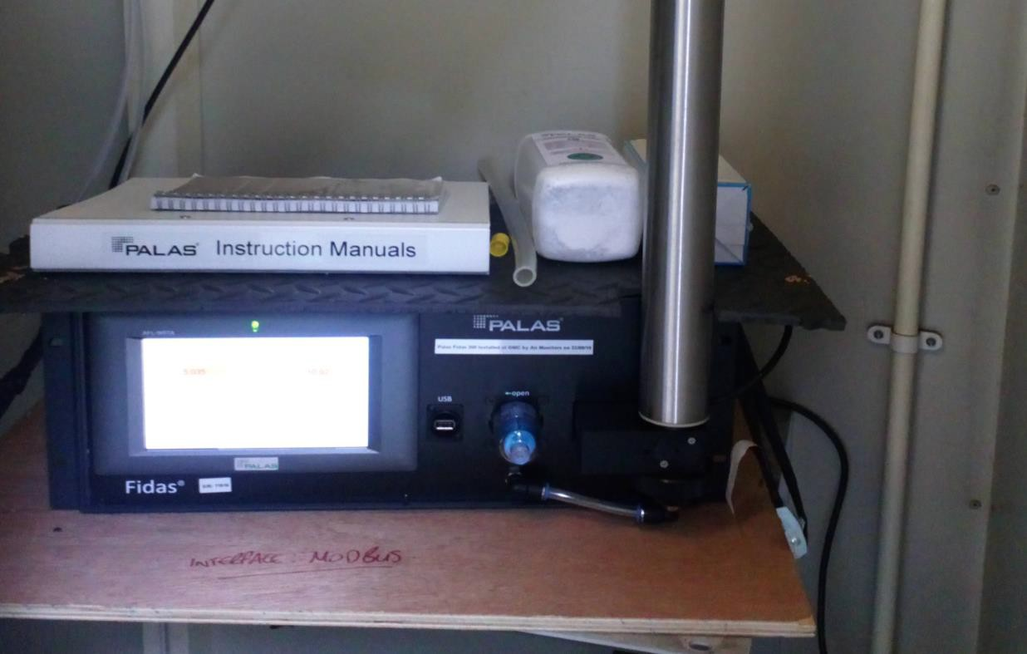

Photo 2 Relocated Falkirk Council Weather Station at Grangemouth Zetland Park Site
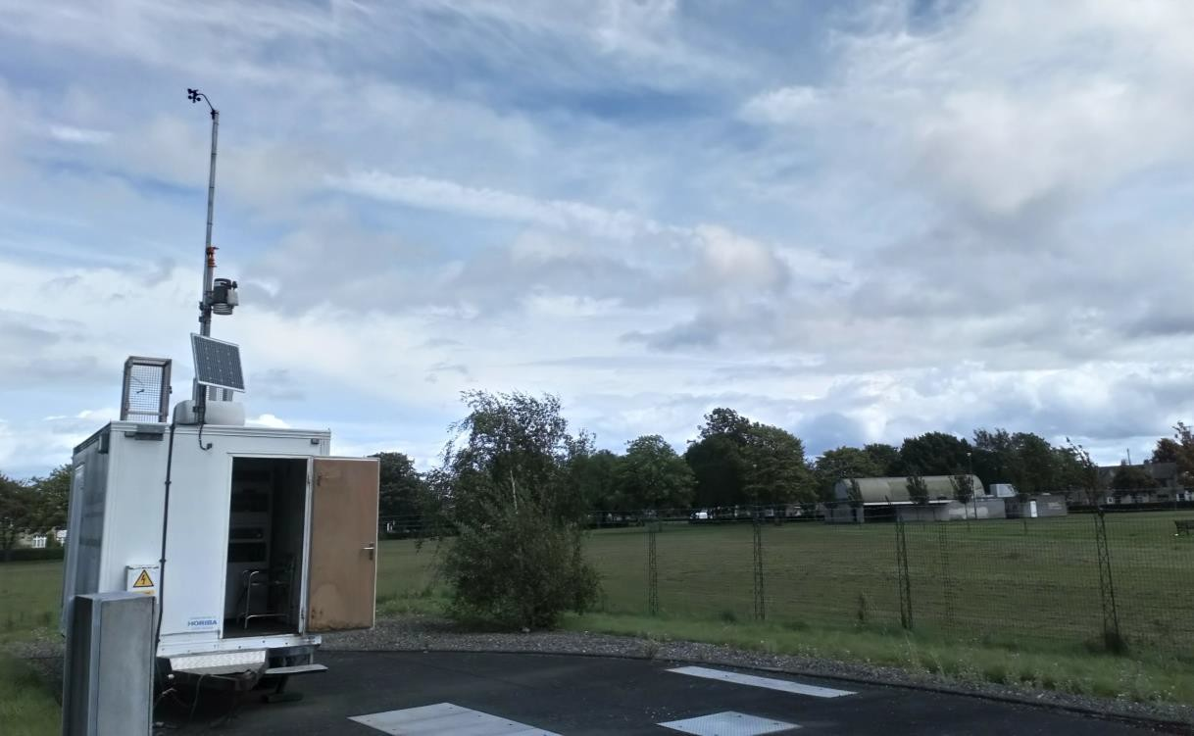
Photo 3 Air Conditioning System Upgrade at Falkirk Hope Street
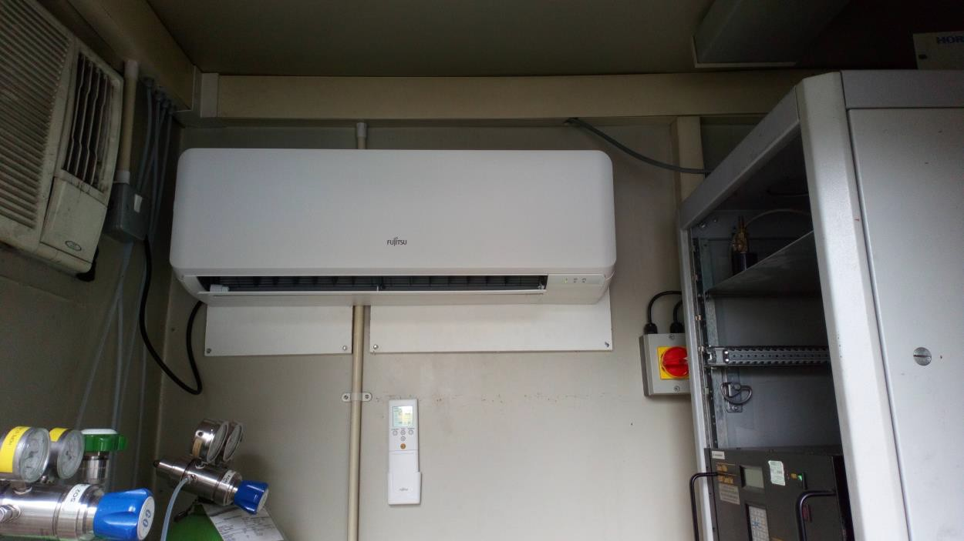

Photo 4 Air Conditioning System Upgrade at Grangemouth Zetland Park Site
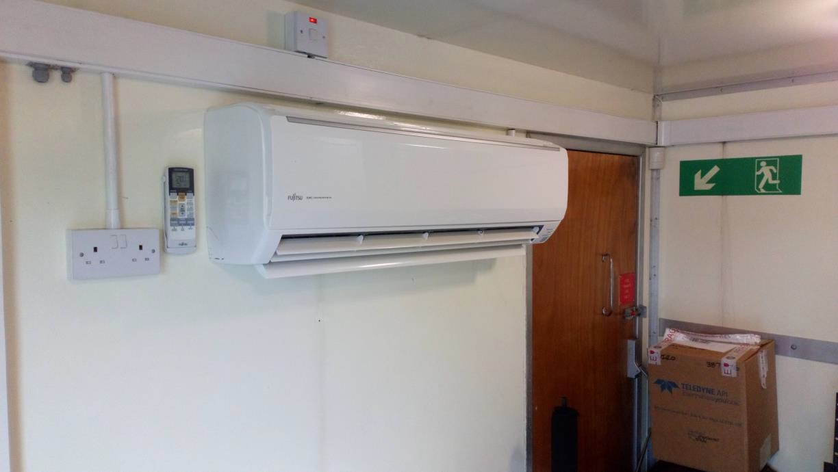
Photo 5 Falkirk Council Environmental Health – Fully Electric Van (Renault Kangoo ZE33)


ECOStars Fleet Recognition Scheme
Throughout 2019 and 2020 Falkirk Council’s ECOStars fleet recognition scheme has grown significantly from two-hundred and eight to two-hundred and twenty-seven members. Falkirk Council’s ECOStars taxi scheme has a small but engaged membership of seven members. ECOStars membership consists of vehicle fleet operators located within the Falkirk Council local authority area as well as those whose depots are located outwith the Council boundary but operate vehicles within that area; all of these operators have an impact on local air quality. In addition, Falkirk Council has been working closely with fellow members of the East Central Scotland Vehicle Emissions Partnership (ECSVEP Switch Off and Breathe) to work to the objectives set out in the Scottish Government’s Cleaner Air for Scotland (CAFS, 2015) strategy. Air Quality Action Plan (AQAP) funding has been provided to continue the operation of the Falkirk ECOStars scheme (for fleet operators and taxis) during 2019 / 20.
Falkirk Council also continues to work closely with its partner organisations to manage local air quality issues. The Council works regularly with organisations such as SEPA, INEOS and Petroineos to help reduce exceedances of the SO2 NAQS objectives within the Grangemouth AQMA.

Local Priorities and Challenges
Education and Awareness of Air Quality Issues
In 2020, Falkirk Council will be developing our engagement with locals through promotion of air quality education resources such as the ‘Learn About Air’ teaching package, promoting the Clean Air Day in Scotland and working closer with the Falkirk Council Transport Planning department on promoting alternative and sustainable local transport solutions.

Low Emission Zones
Low Emission Zones (LEZ) are currently being planned and operated in the four major Scottish cities: Glasgow, Edinburgh, Aberdeen and Dundee over the next few years. There are no current plans for any form of LEZ in the Falkirk Council area.
Falkirk Council has undertaken the ‘Stage 1 Screening Exercise (clause 2.2.25)’ assessment in section 2.3 in accordance with the Scottish Government’s National Low Emissions Framework to inform this process.

How to Get Involved
To obtain further information on air quality within the Falkirk Council area, please visit our air quality policy webpage:
http://www.falkirk.gov.uk/services/environment/environmental-policy/air-quality/
There are eleven automatic air quality monitoring sites across the Falkirk Council area. The air quality data from all the monitoring sites can be viewed on the Scottish Air Quality website at:
http://www.scottishairquality.co.uk/latest/summary?view=la
To learn more about the ECOStars Fleet Recognition Scheme and for details of how to join if you are a commercial fleet operator please visit:
https://www.ecostars-uk.com/eco-stars-schemes/

Table of Contents

Executive Summary: Air Quality in Our Area i
Air Quality in Falkirk Council i
Actions to Improve Air Quality v
Local Priorities and Challenges viv
How to Get Involved ix
- Local Air Quality Management Error! Bookmark not defined.
- Actions to Improve Air Quality 2
  - Air Quality Management Areas 2
  - Cleaner Air for Scotland 4
    - Transport – Avoiding travel – T1 5
    - Climate Change – Effective co-ordination of climate change and air quality
policies to deliver co-benefits – CC2 5
  - National Low Emission Framework (NLEF) Stage 1 Screening Appraisal for
Falkirk Council 6
  - Progress and Impact of Measures to address Air Quality in Falkirk Council 13
- Air Quality Monitoring Data and Comparison with Air Quality
Objectives 22
  - Summary of Monitoring Undertaken 22
    - Automatic Monitoring Sites 22
    - Non-Automatic Monitoring Sites 22
  - Individual pollutants 22
    - Nitrogen Dioxide (NO2) 22
    - Particulate Matter (PM10) 25
    - Particulate Matter (PM2.5) 26
    - Sulphur Dioxide (SO2) 28
    - Carbon Monoxide, Lead, 1,3-Butadiene and Benzene 29
- New Local Developments 32
  - Road Traffic Sources 30
    - Narrow Congested Streets 30
    - Busy Streets 30
    - Roads with High Flow or Buses and / or HGVs 30
    - Junctions 30
    - New Roads Constructed or Proposed 30
    - Roads with Significantly Changes Traffic Flows 30
    - Bus or Coach Stations 31
  - Other Transport Sources 31
    - Airports 31
    - Stationary Trains 31
    - Railways (Diesel and Steam Trains) 31
    - Ports for Shipping 31
  - Industrial Sources 32
  - Commercial and Domestic Sources 33
    - Biomass Combustion Plants 33
    - Biomass Combustion Plants - Combined Sources 33
    - Domestic Solid Fuel Burning 34
    - Combined Heat and Power (CHP) Plant… 34
  - New Developments with Fugitive or Uncontrolled Sources 34
- Planning Applications 35
- Conclusions and Proposed Actions 39
  - Conclusions from New Monitoring Data 39
  - Conclusions relating to New Local Developments 42
  - Proposed Actions 45
Appendix A: Monitoring Results 47
Appendix B: Full Monthly Diffusion Tube Results for 2019 101
Appendix C: Supporting Technical Information / Air Quality Monitoring
Data QA/QC 107
Glossary of Terms 118
References 120
Appendix D1: Supporting Technical Information – Proposal for Revocation of Banknock Air Quality Management Area (AQMA) 121
Appendix D2: Grangemouth Emissions Study – Technical Note 138

List of Tables
Table 1.1 – Summary of Air Quality Objectives in Scotland 1
Table 2.1 – Declared Air Quality Management Areas 4
Table 2.2 – NLEF Appraisal Process 6
Table 2.3 – NLEF Stage 1 Screening Appraisal 8
Table 2.4 – Progress on Measures to Improve Air Quality 14
Table A.1 – Details of Automatic Monitoring Sites 47
Table A.2 – Details of Non-Automatic Monitoring Sites 50
Table A.3 – Annual Mean NO2 Monitoring Results 55
Table A.4 – 1-Hour Mean NO2 Monitoring Results 59
Table A.5 – Annual Mean PM10 Monitoring Results 67
Table A.6 – 24-Hour Mean PM10 Monitoring Results 68
Table A.7 – Annual Mean PM2.5 Monitoring Results 76
Table A.8 – SO2 Monitoring Results 80
Table A.9 - 1,3 Butadiene Annual Mean Diffusion Tube Results… 91
Table A.10 - Benzene Annual Mean Diffusion Tube Results… 92
Table A.11 - Pumped Benzene Annual Mean Results… 93
Table A.12 - Estimated Annual Mean PM2.5 Results… 94
Table B.1 – NO2 Monthly Diffusion Tube Results for 2019 101
Table B.2 - 1,3 Butadiene Monthly Diffusion Tube Results… 105

Table B.3 - Benzene Monthly Diffusion Tube Results… 106
Table C.1 - Comparison of Local vs National Bias Factory Summary 108
Table C.2 – Locally Derived PM2.5 / PM10 Correction Ratio 114
Table C.3 – Details of the QA / QC at the Automatic Monitoring Stations… 115

List of Figures
Figure 1 - A4 Falkirk Haggs Long Term NO2 Concentrations 60
Figure 2 - A5 Falkirk Hope St Long Term NO2 Concentrations 61
Figure 3 – A7 Falkirk West Bridge St Long Term NO2 Concentrations 62
Figure 4 - A8 Grangemouth AURN Long Term NO2 Concentrations 63
Figure 5 - A9 Grangemouth Moray Long Term NO2 Concentrations 64
Figure 6 - A10 Grangemouth Municipal Chambers Long Term NO2 Concentrations.65 Figure 7 - A15 Main St, Bainsford Long Term NO2 Concentrations 66
Figure 8 - A4 Haggs Long Term PM10 (24-hour mean) Concentrations 69
Figure 9 - A5 Falkirk Hope St Long Term PM10 (24-hour mean) Concentrations 70
Figure 10 - A7 Falkirk West Bridge St Long Term PM10 (24-hour mean) Concentrations 71
Figure 11 - A8 Grangemouth AURN Long Term PM10 (24-hour mean) Concentrations 72
Figure 12 - A10 Grangemouth Municipal Chambers Long Term PM10 (24-hour mean) Concentrations 73
Figure 13 – A13 Banknock 2 Long Term PM10 (24-hour mean) Concentrations 74
Figure 14 - A15 Main St, Bainsford Long Term PM10 (24-hour mean) Concentrations 75
Figure 15 - A7 Falkirk West Bridge St Long Term PM2.5 Concentrations 77
Figure 16 - A8 Grangemouth AURN Long Term PM2.5 Concentrations 78
Figure 17 - A13 Banknock 2 Long Term PM2.5 Concentrations 79
Figure 18 - A3 Bo’ness Long Term SO2 Concentrations 81
Figure 19 – A5 Falkirk Hope St Long Term SO2 Concentrations 82
Figure 20 - A8 Grangemouth AURN Long Term SO2 Concentrations 83
Figure 21 - A9 Grangemouth Moray Long Term SO2 Concentrations 84
Figure 22 – A10 Grangemouth Municipal Chambers Long Term SO2 Concentrations 85
Figure 23 – A11 Grangemouth Zetland Park Long Term SO2 Concentrations 86
Figure 24 – Polar Plots of Average SO2 Concentrations Recorded at the Grangemouth Sites 87
Figure 25 – Exceedances of the 15 Minute SO2 NAQS Objective Concentration at the Grangemouth Sites 2015 – 2019 90

Figure 26 – Maps of the AQMA Boundaries in the Falkirk Council Area 95
Figure 27 - Maps Showing Automatic Monitoring Locations 97
Figure 28 - NO2 Locally Derived Bias Adjustment Factor Spreadsheets 109
Figure 29 – NO2 National Derived Bias Adjustment Factor Spreadsheet 112

List of Photos
Photo 1 - Palas Fidas 200 Combined PM10+2.5 Analyser at the Grangemouth Municipal Chambers Site v
Photo 2 - Relocated Falkirk Council Weather Station at Grangemouth Zetland Park Site vi
Photo 3 - Air Conditioning System Upgrade at Falkirk Hope Street vi
Photo 4 - Air Conditioning System Upgrade at Grangemouth Zetland Park Site……vii
Photo 5 Falkirk Council Environmental Health – Fully Electric Van (Renault Kangoo ZE33) vii

1. Local Air Quality Management
This report provides an overview of air quality in Falkirk Council during 2019. It fulfils the requirements of Local Air Quality Management (LAQM) as set out in Part IV of the Environment Act (1995) and the relevant Policy and Technical Guidance documents.
The LAQM process places an obligation on all local authorities to regularly review and assess air quality in their areas, and to determine whether or not the air quality objectives are likely to be achieved. Where an exceedance is considered likely the local authority must declare an Air Quality Management Area (AQMA) and prepare an Air Quality Action Plan (AQAP) setting out the measures it intends to put in place in pursuit of the objectives. This Annual Progress Report (APR) is summarises the work being undertaken by Falkirk Council to improve air quality and any progress that has been made.
Table 1.1 – Summary of Air Quality Objectives in Scotland

Pollutant | Air Quality Objective |  | Date to be achieved by
 | Concentration | Measured as
Nitrogen dioxide (NO2) | 200 µg/m³ not to be exceeded more than 18 times a year | 1-hour mean | 31.12.2005
 | 40 µg/m³ | Annual mean | 31.12.2005
Particulate Matter (PM10) | 50 µg/m³, not to be exceeded more than 7 times a year | 24-hour mean | 31.12.2010
 | 18 µg/m³ | Annual mean | 31.12.2010
Particulate Matter (PM2.5) | 10 µg/m³ | Annual mean | 31.12.2020
Sulphur dioxide (SO2) | 350 µg/m³, not to be exceeded more than 24 times a year | 1-hour mean | 31.12.2004
 | 125 µg/m³, not to be exceeded more than 3 times a year | 24-hour mean | 31.12.2004
 | 266 µg/m³, not to be exceeded more than 35 times a year | 15-minute mean | 31.12.2005
Benzene | 3.25 µg/m³ | Running annual mean | 31.12.2010
1,3 Butadiene | 2.25 µg/m³ | Running annual mean | 31.12.2003
Carbon Monoxide | 10.0 mg/m³ | Running 8-Hour mean | 31.12.2003
Lead | 0.25 µg/m³ | Annual Mean | 31.12.2008

Actions to Improve Air Quality

Air Quality Management Areas
Air Quality Management Areas (AQMAs) are declared when there is an exceedance or likely exceedance of an air quality objective. After declaration, the authority must prepare an Air Quality Action Plan (AQAP) within 12 months, setting out measures it intends to put in place in pursuit of the objectives.
A summary of AQMAs declared by Falkirk Council can be found in Table 2.1.Further information related to declared or revoked AQMAs, including maps of AQMA boundaries are available online at https://uk-air.defra.gov.uk/aqma/local- authorities?la_id=371 – see full list at https://uk-air.defra.gov.uk/aqma/list.
Falkirk Town Centre AQMA
The air quality monitoring data recorded in 2019 shows that two exceedances of the NO2 NAQS (annual mean) objective limit (40µg/m³) were recorded at (non-automatic) diffusion tube locations: NA27 Falkirk West Bridge Street (47µg/m3) and NA114 Glasgow Road, Camelon (41µg/m³). The NA27 NO2 diffusion tube is located on Falkirk West Bridge Street which is within the Falkirk Town Centre Air Quality Management Area (AQMA). This AQMA was declared in 2011 in recognition of the potential to exceed NAQS objectives for NO2 and particulate matter (PM10) it is recommended that the Falkirk Town Centre AQMA is amended so that the NO2 element remains in place and is potentially extended to include the Glasgow Road, Camelon area (pending a LAQM Review and Assessment exercise in 2021) until the (road-traffic related) NO2 results are compliant with the NAQS objective. There have been over five years where PM10 results at both Falkirk Town Centre AQMA automatic monitoring locations (Falkirk Grahams Road, Hope Street and West Bridge Street) have complied with the PM10 NAQS objective. It is anticipated that the PM10 element of the Falkirk Town Centre AQMA will be assessed for revocation eligibility during 2021.
Banknock AQMA
The Banknock AQMA (PM10 24-hr and annual mean) revocation summary report has been completed (see Appendix D1) and approved by the Scottish Government and the Scottish Environment Protection Agency (SEPA). The final stages of this AQMA

revocation are being progressed and will be completed in 2020. The combined (PM10+2.5) particulate analyser (Palas Fidas 200) that was located within the Banknock roadside monitoring site has been relocated to the nearby Haggs site to replace the R&P TEOM PM10 analyser (spare parts are now obsolete for this R&P analyser model).
Haggs AQMA
Monitoring data for 2019 has highlighted that the Haggs AQMA will be reviewed in 2020 / 21 as the site continues to meet the NAQS objectives for traffic-related PM10 emissions.
Grangemouth AQMA
The Grangemouth Emission Study which has been completed by Sweco is currently being assessed and authorised by the relevant organisations prior to it’s publication in 2020. The study report includes an LAQM Review and Assessment of the Grangemouth AQMA. The Sweco Technical Note summary of the study can be shown in Appendix D2.

Table 2.1 – Declared Air Quality Management Areas

AQMA  Name | Pollutants and Air Quality Objectives | City / Town | Description | Action Plan
Falkirk Town Centre | NO2 annual mean  PM10 24-hour mean and annual mean | Falkirk | An area encompassing an area of Falkirk Town Centre | Air Quality Action Management Plan (Falkirk Town Centre and Haggs) 2015  Air Quality Management Action Plan (Falkirk Town Centre and Haggs) June 2015
Banknock | PM10 24-hour mean and annual mean | Banknock | An area encompassing an area within Banknock, Falkirk | Air Quality Action Management Plan (Banknock)
Haggs | NO2 annual mean | Haggs | An area that connects Banknock and Haggs around the road junction of the A803 and M80 | Air Quality Management Plan (Falkirk Town Centre and Haggs) 2015  Air Quality Management Action Plan (Falkirk Town Centre and Haggs) June 2015
Grangemouth | SO2 15-min mean | Grangemouth | An area encompassing the Grangemouth industry areas, shipping port and adjacent residential areas | Air Quality Action Plan Update (Grangemouth) 2009  Available on request

  - Cleaner Air for Scotland
Cleaner Air for Scotland - The Road to a Healthier Future (CAFS) is a national cross- government strategy that sets out how the Scottish Government and its partner organisations propose to reduce air pollution further to protect human health and fulfil Scotland’s legal responsibilities as soon as possible. A series of actions across a range of policy areas are outlined within this strategic document. Progress by Falkirk Council against relevant CAFS actions are demonstrated below.

Transport – Avoiding travel – T1
All local authorities should ensure that they have a corporate travel plan (perhaps within a carbon management plan) which is consistent with any local air quality action plan. Falkirk Council has a local transport strategy published in 2014 entitled Falkirk Council Local Transport Strategy. This strategy sets out the Council’s overall transport vision. This includes objectives directly related to providing sustainable transport options such as encouraging more travel by foot, bicycle, rail, and ensuring new transport infrastructure is delivered to support future sustainable travel choices.
Falkirk Council has an active travel scheme which promotes alternative transport methods to car. Projects completed with local communities in 2019 include:
      - Take the Right Route: utilising online marketing campaigns, extensive local bus / newspaper / business advertising and social media presence incorporating market research feedback;
      - Forth Valley Royal Hospital bus promotion;
      - Free Forth Valley Hospital staff travel;
      - Walk to Westfield (Falkirk Football Club walking group);
      - Walk to School campaigns delivered to fifty primary schools in the Falkirk Council area;
      - The creation of an ‘Active Travel’ officer post for the new Forth Valley College;
      - Falkirk Active Travel Hub (Forth Environment Link) is located in Falkirk town centre (203 High Street, Falkirk, FK1 1DU) and is open to the public to increase awareness of active travel throughout the region.

Climate Change – Effective co-ordination of climate change and air quality policies to deliver co-benefits – CC2
Scottish Government expects any Scottish local authority which has or is currently developing a Sustainable Energy Action Plan to ensure that air quality considerations are covered. Falkirk Council has a dedicated Climate Change and Sustainability team and webpage which outlines what the Council has completed and what they are committed to achieving. The webpage also provides links to:
      - Sustainable Procurement;
      - Sustainable Transport;

      - Sustainable Falkirk
The webpage also provides a link to the Council’s Carbon Management Plan 2015 - 2021

National Low Emission Framework (NLEF) Stage 1 Screening Appraisal for Falkirk Council
The NLEF1, which is now part of the review and assessment process for LAQM reporting in Scotland, contributes to the CAFS strategy by aiming to improve local air quality in areas where air quality objectives are exceeded, or likely to be exceeded, primarily due to emissions from transport.
The NLEF is directly linked to AQAP for local authorities with AQMAs, and will help to identify actions to improve local air quality within AQMAs. The NLEF appraisal takes the form of a two-stage process, as summarised in Table :

Table 2.2 – NLEF Appraisal Process

Stage |  | Outcome | Actions Required
1 | Screening | - decision on whether to proceed to stage two assessment | - screening process to identify actions that will benefit air quality within the AQMA  - screening evidence should form part of the Annual Progress Report, with the decision agreed by Scottish Government and SEPA
2 | Assessment | - decision to proceed with introduction of LEZ or identification of alternative transport-related measures required to improve air quality  - Stage two assessment report agreed by Scottish Government and SEPA | - NMF approach to support assessment of sources of pollution and options  - quantitative impact assessment (based on predicted change in pollutant concentrations)  - consideration of consequential impacts (e.g. congestion, export of pollution)

¹ https://www.gov.scot/publications/national-low-emission-framework/pages/2/

The NLEF Stage 1 Screening Appraisal for Falkirk Council is detailed in Table 2.3. It is the opinion of Falkirk Council that proposed measures in the relevant AQAPs are sufficient and there is therefore no need to proceed to a Stage 2 Assessment.
As one AQMA (Banknock) will be revoked in 2020 and two AQMAs (Falkirk Town Centre PM10 and Haggs) will be under review and may be eligible for revocation in 2021 pending their relevant assessments. The area that requires focus (in relation to emissions from transport) is the Falkirk Town Centre AQMA, and more specifically the West Bridge Street area (due to continued NAQS exceedances of the NA27 diffusion tube) which is relatively limited in geographical size. The historical NO2 results of this diffusion tube location are as follows:

Site ID | Site Type | Monitoring Type | Valid Data Capture 2019 (%) | NO2 Annual Mean Concentration (µg/m³)
 |  |  |  | 2015 | 2016 | 2017 | 2018 | 2019
NA27 | West Bridge St, Falkirk | Diffusion Tube | 91 | 47 | 48 | 38 | 44 | 47
The Falkirk Town Centre AQAPRef2 (Golder Associates Report Number: 115114880001.501/B.2, June 2015) outlines relevant actions to deliver significant air quality improvements within this area, which include:
- Section 7.2.1.1: Increase in volume and use of electric and hybrid Council fleet vehicles;
- Section 7.2.2.1: Review of School Bus Contracts;
- Section 7.2.2.5 Take the Right Route;
- Section 7.2.2.5 (cont.) Infrastructure Projects (such as the Falkirk Stadium Vehicle Charging hub).
In 2020, Falkirk Council has decided to relocate its headquarters at the Municipal Buildings from the West Bridge Street location to an alternative location, which is still to be announced. In theory, this will help reduce the amount of Falkirk Council commuting road

traffic using the West Bridge Street area. Eligible Falkirk Council staff are currently working from home which will also help to reduce commuting trips within this area in the short-term.
Table 2.3 – NLEF Stage 1 Screening Appraisal

No. | NLEF Stage 1 Screening Appraisal Question | Appraisal Response
1 | What is the name of the declared AQMA(s)? | Falkirk Town Centre AQMA Banknock AQMA Grangemouth AQMA  Haggs AQMA
2 | What pollutants are the AQMA(s) declared for? | Falkirk Town Centre AQMA: NO2 annual mean and PM10 24-hour mean and annual mean.  Banknock AQMA: PM10 24-hour mean and annual mean. Grangemouth AQMA: SO2 15-min mean.  Haggs AQMA: NO2 annual mean.

No. | NLEF Stage 1 Screening Appraisal Question | Appraisal Response
3 | What are the main sources of air pollution, or other factors, contributing to the declaration of the AQMA? (If the main source is not transport–related no further screening is required). | Falkirk Town Centre AQMA: The predominant sources of NO2 and PM10 pollution were identified as road traffic emissions within a built-up town centre location.  Banknock AQMA: The predominant sources of PM10 pollution within this area include historic local quarry operations combined with associated site and local road traffic.  Grangemouth AQMA: The predominant source of SO2 pollution within this area are from industrial sources – no further screening required.  Haggs AQMA: The predominant source of NO2 pollution was identified as road traffic emissions.
4 | Are the declared AQMA(s) (and therefore area(s) of exceedance) restricted in nature geographically to a small area for which a Low Emission Zone (LEZ) would not be appropriate or proportionate (e.g. single streets, road junctions, small town centre)? | Falkirk Town Centre AQMA: The AQMA designated area extends to a reasonably large area covering the majority of the town centre road network.  Banknock AQMA: The AQMA designated area extends to a reasonably small semi-rural area covering Banknock and the locations where historic quarrying had operated.  Grangemouth AQMA: The AQMA designated area extends to a large area covering the town centre, shipping port and industrial area.  Haggs AQMA: The AQMA designated area extends to a small area covering a section of the residential area of Haggs and a section of the M80 motorway.

No. | NLEF Stage 1 Screening Appraisal Question | Appraisal Response
5 | Do the monitored concentrations within the AQMA(s) meet the air quality objective(s)? If yes, for how long has compliance been achieved? If not, what are the extent of the exceedances? | Falkirk Town Centre AQMA: All automatic stations have achieved consecutive compliance of the NAQS (PM10 annual mean + NO2 24-hr and annual mean) objective limits for five years (since 2015), one (non- automatic) NO2 diffusion tube continually breaches NAQS objective (NA27 Falkirk West Bridge Street).  Banknock AQMA: Yes, the compliance has been achieved consecutively for six years and the AQMA is planning to be revoked in 2020 (see Appendix D1).  Grangemouth AQMA: Yes, the SO2 NAQS objective limit compliance has been achieved consecutively for six years. An AQMA review is to be published by Sweco in due course (see Appendix D2).  Haggs AQMA: Yes, the NO2 (annual mean) NAQS objective limit been achieved consecutively for five years (since 2019). An AQMA review is to be completed by Falkirk Council in 2020. It is likely this AQMA will be eligible for revocation.

No. | NLEF Stage 1 Screening Appraisal Question | Appraisal Response
6 | What is the current trend for pollutant concentrations within the AQMA(s) (state the trend for each pollutant declared)? | Falkirk Town Centre AQMA: PM10 (annual mean): Increasing , NO2 (annual mean): Decreasing.  Banknock AQMA: PM10 (annual mean): Decreasing.  Grangemouth AQMA: SO2 (15-min mean NAQS objective exceedances): Overall decreasing trend then remaining low within the NAQS objective limit (see Figure 25).  Haggs AQMA: NO2 (annual mean): Decreasing.
7 | Are there any major planned developments which could impact air quality within or surrounding the AQMA(s)? | No. All recent developments have been assessed and included in the relevant APRs.
8 | What are the current trends for vehicle movements within the AQMA and surrounding areas? | Recent Department for Transport road traffic statistics has shown no significant increase or decrease in vehicle miles travelled within the Falkirk Council area. On average, the data trend has been shown to be level since 2016 until present (Approx. range: 1011 – 1015 million vehicle miles travelled)Ref 3.

No. | NLEF Stage 1 Screening Appraisal Question | Appraisal Response
9 | Provide evidence showing how the AQAP (and associated plans, programmes and strategies) will deliver significant improvements towards achieving the air quality objective(s) in as short a timescale as possible? | As one AQMA will be revoked (Banknock) in 2020 and two AQMAs are currently under review (Falkirk Town Centre PM10 and Haggs) and may be eligible for revocation in 2021, the area that requires focus is the Falkirk Town Centre AQMA and more specifically Falkirk West Bridge Street. This street is relatively limited / small in size. The Falkirk Town Centre AQAPRef 4 outlines actions to deliver significant air quality improvements within this street include:  - Increase in volume and use of electric and hybrid Council fleet vehicles;  - Review of school bus contracts;  - Take the Right Route;  - Infrastructure projects (such as the Falkirk Stadium Vehicle Charging hub).

Falkirk Council

  - Progress and Impact of Measures to address Air Quality in Falkirk Council
Falkirk Council has taken forward a number of measures during the current reporting year of 2019 in pursuit of improving local air quality. Details of all measures completed, in progress or planned are set out in Table 2.4. More details on these measures can be found in the AQAP relating to each AQMA. Key completed measures are:
- Measure 4: Monitoring network requirements reviewed and upgraded where necessary (upgrading the R&P TEOM PM10 particulate analyser at the Grangemouth Municipal Chambers site to a combined (PM10+2.5) Palas Fidas 200 analyser and transfer of weather station to the Grangemouth Zetland Park monitoring site);
- Measure 5: New Environmental Health fully electric van (Renault Kangoo ZE33) purchased and now in use for all air quality site work within the Falkirk Council area;
- Measure 16: Continuation and increased members of the ECOStars Fleet Recognition scheme.
Falkirk Council expects the following measures to be completed over the course of the next reporting year:
- Review of Falkirk Town Centre (PM10) and Haggs AQMA and with potential revocation (reduction of Falkirk Council AQMAs from three to two);
- Replacement of older (NOX and SO2) analysers with new models (providing increased accuracy, availability of spares, less breakdowns and expensive maintenance visits etc.);
- Continuation of ECOStars Fleet Recognition Scheme with new members added (Increased fleet efficiency measures / knowledge) – Scottish Government AQAP funding dependant;
- Establishing a new roadside air quality monitoring station (including continuous automatic PM10+NO2 analysers) within the Camelon area of Falkirk.

LAQM Annual Progress Report 2020

Table 2.4 – Progress on Measures to Improve Air Quality

Meas. No. | Measure | Category | Focus | Lead Authority | Planning Phase | Impleme- ntation Phase | Key Performance Indicator | Target Pollution Reduction in  the AQMA | Progress to Date | Estimated Completion Date | Comments
1 | Improving SO2 data access | Public Information | Supplying SO2 monitoring data to SEPA, Petroineos, INEOS and other interested  organisations. | Falkirk Council | 2013 | 2013 | AQ Objectives met in 2013,  2014 and 2015. | Anticipated reduction in SO2 concentration/ breaches of NAQS  objectives. | Data sent after Grangemouth SO2  exceedances- monthly summary  reports sent with ongoing totals. | Completed, and monthly reports ongoing.
2 | Grangemouth Working Group | Policy Guidance and Developmen t Control | Bringing together: Petroineos, INEOS, S.Gov, SEPA  and Falkirk Council. | Falkirk Council | 2013 | 2013 | AQ Objectives met in 2013,  2014 and 2015. | Reduction in SO2 due to cooperative working and agreement of priorities. | Completed. TGU fully commissioned in August 2013, meeting held in November 2013. Further meeting  only if breach of objective occurs. | Completed.
3 | Text Alert System | Public Information | Real-time notification of exceedances by SMS and Email. | Falkirk Council | 2013 | 2013 | Text alerts received by Falkirk Council, SEPA,  Petroineos and INEOS when an NAQS objective exceedance occurs within the Grangemouth AQMA. | Anticipated reduction in SO2 NAQS objective exceedances due to real time alerts of exceedances supplied to SEPA,  Petroineos and INEOS so action to rectify any plant emission / process issues can be addressed. | Completed and on-going. | Completed in 2013 / Upgraded in 2018 | Rather than a text alert system linked to individual analysers this system has been upgraded in 2018 to incorporate the Council’s data collection system and can be used for any measured  pollutant.

4 | Review Monitoring Network | Public Information | Grangemouth Moray SO2 in Scottish Air Quality Network (SAQN).  Monitoring conducted in Grangemouth Zetland Park. | Falkirk Council | Falkirk Park St ceased operation in April 2014.  Zetland Park commen ced operation April 2015. | 2014 and  2015 | All Grangemouth automatic monitoring sites are affiliated with the SAQN. | Affiliation with the SAQN increases data capture allowing better comparison to the NAQS objectives. | Completed.  In addition the Bo’ness, Falkirk Graham’s Rd and Main St, Bainsford stations were affiliated to the SAQN in 2016. | Completed.
5 | Electric Vehicles and Plug-ins | Promoting Low Emission Transport | Cars / Fleet | Falkirk Council | 2012 | 2012 and on-going | Charging points at Falkirk Council depots | Anticipated reduction in NOX and PM emissions due to increased use of electric vehicles. | In 2019, the EV charging point bays increased from 40 to 107. These are located at depots and public places across the Falkirk Council area. Falkirk Council increased its electric vehicle fleet to 40 available for use by Council staff. | Completed and on-going | The air quality team within the Env. Health Department at Falkirk Council have received a new fully electric (Renault Kangoo ZE33) van in June 2019 – further details provided in Section ‘Actions to Improve Air Quality’,  page v

6 | Eco-advanced Driver Training | Promoting Low Emission Transport | All types of vehicle, fuel use and emissions | Falkirk Council | 2014 | 2015 | Offered to Council services by fleet | Anticipated reduction in NOX and PM emissions due to promotion of  efficient driving practices. | Offered to Council services by fleet. | Completed and on-going training offered.
7 | Review of School Bus Contracts with View to Raising EURO Engine Standards | Vehicle Fleet Efficiency | Buses | Falkirk Council | 2017 | 2021 | n/a | Anticipated reduction in NOX and PM emissions from buses operating within the Falkirk Council area. | Meetings to be arranged in 2020/21 with Public Transport Co-ordinator and Procurement Services to discuss the feasibility of raising the EURO  standards for local and school bus contracts from 2021  onwards. | 2020
8 | Improvements of Traffic Lights at Bankside | Transport Planning and Infrastructur e | Congestion | Falkirk Council | 2013 | 2014 | n/a | Anticipated reduction in NOX and PM emissions due to traffic queue reduction at  Bankside traffic lights. | Completed. | Completed.
9 | Feasibility Study of Haggs Infrastructure Changes | Transport Planning and Infrastructur e | Congestion | Falkirk Council | Depende nt on develope r contributi ons and planning  applicatio ns. | Dependent on developer contributio ns and planning application s. | n/a. | Anticipated reduction in NOX and PM emissions. | Dependent on developer contributions and planning applications. | Dependent on developer contributions and planning applications. Future action.

10 | Feasibility study of West Bridge St and Town Centre Traffic Management Changes (speed limits, TROs etc.) | Transport Planning and Infrastructur e | Congestion | Falkirk Council | n/a | n/a | n/a | Anticipated reduction in NOX and PM emissions. | This measure was linked to a planning application to build new council offices at Falkirk Town Centre Municipal Buildings.  However, this project is still being decided upon. However, traffic signals along West Bridge St have been altered to  improve traffic flows. | Completed
11 | Take the Right Route / Walk to School & School Travel Plan Pack | Promote Travel Alternatives | Car travel | Falkirk Council | 2009 | 2013 and ongoing | Scheme in place and publicly advertised on Falkirk Council website. | Anticipated reduction in NOX and PM emissions due to an increase in green travel such as walking and cycling. | In 2019 Take the Right Route continually promoted across the Falkirk Council area with on street interviews, online campaigns, bus and newspaper advertising and leaflets  distributed. | Completed and on- going.

12 | Bike Hire Scheme | Promote Travel Alternatives | Mode transfer | Falkirk Council | 2016 | 2018 | Unknown | Anticipated reduction in NOX and PM emissions due to an increase in green travel alternatives. | Forth Bike (in conjunction with Forth Environment Link) operates an electric bike hire scheme within the Falkirk and Stirling area The Forth Bike system currently includes over one hundred electric pedal assist (Pedelec) bikes spread between their four local stations: the Falkirk Wheel, the Helix, Forth Valley Royal Hospital, and University of  Stirling. | Completed. Forth Bike scheme established and running in 2019.  Expansion of the scheme expected in future years.
13 | Soft Measures  e.g. travel planning (larger employers, schools), journey sharing, changes to mileage, home and mobile working. | Promote Travel Alternatives | Variety | Falkirk Council | 2006 | 2014 | Development of Travel Plans | Anticipated reduction in NOX and PM emissions due to promotion of travel alternatives. | Increased fuel efficient and electric pool car vehicles for staff use as part of Council’s travel plan  Operational car sharing database for Falkirk Council  area. | On-going
14 | Consideration of Air Quality in Local Development  Plan | Policy Guidance and Developmen  t Control | Development | Falkirk Council | 2015 | 2015 | Air quality policy statement in local development  plan | Air Quality Assessment required for developments  within AQMAs. | Air quality policy statement in plan. | Completed

15 | Appropriate Air Quality Monitoring in AQMAs. | Public Information | Improving data capture. | Falkirk Council | 2005 | 2005 | Good data capture (90%) in AQMAs | Good data capture will allow strict comparison of PM10, PM2.5, SO2, NOX  concentrations against the NAQS  objectives. | Monitoring maintained in AQMAs.  Equipment upgrades completed during 2019. | Completed and on-going
16 | Promotion of ECO Stars | Vehicle Fleet Efficiency | Commercial vehicles, taxis and private hire cars. | Falkirk Council | 2013 | 2013 and on-going | The latest Falkirk Eco Stars report shows that recruitment in Falkirk has 227 members. | Anticipated reduction in NOX and PM emissions due to promotion of efficient driving practices. | During 2019, reference to EcoStars is now included in the tender specification for Falkirk Council Adult and Children’s Service passenger transport.  Member meetings were  held regularly during 2019. | On-going
17 | Review of Park and Ride Facilities | Transport Planning and Infrastructur e | Cars | Falkirk Council | 2017 | 2018 | Ongoing. | Anticipated reduction in NOX and PM emissions. | There is currently no progress in taking forward any new bus park and ride facilities.  However, additional parking has been created at Falkirk High and Larbert train stations to help improve park  and ride facilities. | Completed and on-going

18 | Taxi Licensing | Vehicle Fleet Efficiency | Taxis | Falkirk Council | 2013 | 2015 | Increase in taxi services signed up to Eco Stars Scheme. | Anticipated reduction in NOX and PM emissions due to promotion of  efficient driving and vehicles. | Changes to licensing in May 2013 and Eco Stars extended to taxis and private hire cars. | On-going
19 | Vehicle Emissions Partnership (testing and idling) - enforcement and fines rather than raising awareness. | Promoting Low Emission Transport | Cars | Falkirk and other neighbouri ng authorities. | 2012 | 2012 and on-going | Maintain membership of the partnership. | Anticipated reduction in NOX and PM emissions through anti- idling enforcement. | The ESVEP  continues to assist in promoting anti idling in the Falkirk Council area.  Improvements of the associated ‘Switch Off and Breathe’ website have taken  place. | On-going subject to annual funding allocation.

20 | Introduce Quality Bus Corridors | Transport Planning and Infrastructur e | Buses | Falkirk Council | 2017 | On-going depending on funding to complete the scheme. | Unknown | Anticipated reduction in NOX and PM emissions through improved public transport. | The Council has secured areas of land along the A803 Glasgow Road corridor in Camelon. In addition to this the Council has updated the traffic signals on the B902 Grahams Road corridor to “intelligent” traffic signals which better manage the flows of traffic increasing green time along the main corridor, the knock on effect of this improves bus journey times into the town  centre. | 2030

Air Quality Monitoring Data and Comparison with Air Quality Objectives

Summary of Monitoring Undertaken
    - Automatic Monitoring Sites
This section sets out what monitoring has taken place and how local concentrations of the main air pollutants compare with the objectives.
Falkirk Council undertook automatic (continuous) monitoring at eleven sites during 2019. Table A.1 in Appendix A shows the details of the sites. National monitoring results are available at http://www.scottishairquality.scot/.
Maps showing the location of the monitoring sites are provided in Appendix A, Figure 27 A) to G). Further details on how the monitors are calibrated and how the data has been adjusted are included in Appendix C.

Non-Automatic Monitoring Sites
Falkirk Council undertook non-automatic (passive) monitoring of NO2 at sixty-one sites during 2019. Table A.2 in Appendix A shows the details of the sites.
Falkirk Council also undertook non-automatic (passive) monitoring of 1, 3 butadiene at three sites during 2019. Table A.9 in Appendix A shows the details of the 1, 3 butadiene sites.
In addition, Falkirk Council also undertook non-automatic (passive) monitoring of benzene at sixteen sites during 2019. Table A.10 in Appendix A shows the details of the benzene sites.
Further details on Quality Assurance / Quality Control (QA / QC) and bias adjustment for the diffusion tubes are included in Appendix C.

Individual pollutants
The air quality monitoring results presented in this section are, where relevant, adjusted for annualisation and bias. Further details on adjustments are provided in Appendix C.

Nitrogen Dioxide (NO2)
Table A.3 in Appendix A compares the ratified and adjusted monitored NO2 annual mean concentrations for the past five years with the air quality objective of 40µg/m3.

For diffusion tubes, the full 2019 dataset of monthly mean values is provided in Appendix B.
Table A.4 in Appendix A compares the ratified continuous monitored NO2 hourly mean concentrations for the past five years with the NAQS objective of 200µg/m3, not to be exceeded more than eighteen times per year.
NO2 Automatic Analyser Fixed Station Results
The 2019 monitoring results (as displayed in Appendix A Tables A.3 and A.4) show that all seven automatic NO2 analysers in Falkirk Council’s air monitoring network met both NO2 NAQS objectives (1hr and annual mean). The highest NO2 annual mean result in 2019 was recorded at Falkirk West Bridge Street site (38µg/m3) this has decreased from 2018’s result (39µg/m3). The lowest results were recorded at the Grangemouth AURN (15µg/m3) and Moray (15µg/m3) sites. The Grangemouth AURN NO2 annual mean result has increased from 14µg/m³ and Grangemouth Moray’s result has decreased from 17µg/m3 as recorded in 2018. Overall, most fixed automatic site’s NO2 concentrations have remained the same as 2017’s results however, most sites have seen a marginal decrease which is encouraging. The last exceedance in relation to NO2 annual mean concentrations was recorded in 2014 at the Falkirk West Bridge Street site (41µg/m3).
Over a five year period (from 2015 to 2019), three monitoring sites have recorded annual mean NO2 concentration reductions: A4 Haggs, A5 Falkirk Hope Street and A10 Grangemouth Municipal Chambers. Three sites have recorded increased NO2 concentrations: A7 Falkirk West Bridge Street, A8 Grangemouth AURN and A15 Main St, Bainsford. The A9 Grangemouth Moray site’s NO2 annual mean concentrations have remained the same over this period (15µg/m3).
Long term NO2 trend graphs are shown in Appendix A, Figures 1 to 7. There is an overall downward trend in NO2 (annual mean) concentrations at the following monitoring sites: A4 Haggs (Figure 1), A5 Falkirk Hope Street (Figure 2) and A10 Grangemouth Municipal Chambers (Figure 6). A8 Grangemouth AURN (Figure 4), A9 Grangemouth Moray (Figure 5) and A15 Main Street Bainsford (Figure 7) trend has largely remained at the same level. The A7 Falkirk West Bridge Street (Figure 3) site shows an overall upward increase in long-term NO2 (annual mean) concentrations.

Likely contributing factors to the reduction in NO2 concentrations at the above sites include traffic-light timing amendments (on Falkirk West Bridge Street) to minimise congestion and prevent excessive idling (within the Falkirk town centre area), road upgrades (M80 at Haggs) and speed limit enforcement measures (30mph on the A803). Increased ownership of hybrid and electric vehicles may also have contributed to the overall NO2 reduction. Likely contributing factors to the increase in NO2 at A15 Main Street, Bainsford would be frequent localised roadworks (with increased traffic idling) associated with local building developments and renovations with street canyoning to prevent effective air pollution dispersion.
Annual NO2 Diffusion Tube Results
The 2019 annual NO2 diffusion tube monitoring results (as displayed in Appendix A Table A.3) shows that two (non-automatic) NO2 tubes exceeded the NAQS objective of 40µg/m3 at NA27 Falkirk West Bridge Street (47µg/m3) and NA114 Glasgow Road, Camelon (41µg/m3). The remaining fifty-nine tubes in Falkirk Council’s network met the NAQS objective.
Two diffusion tubes were close to the 40µg/m3 annual limit with the highest concentrations recorded at the following sites: NA111 Falkirk West Bridge Street Air Quality Station (38µg/m3) and NA36 Kerrs Crescent, Haggs (35µg/m3). These tubes are located at roadside locations and are within AQMAs (NA111 Falkirk Town Centre AQMA and NA36 Haggs AQMA).
Diffusion tube NA27 is co-located with the Falkirk West Bridge Street fixed automatic monitoring station. This site contains a NO2 reference method (Chemiluminescence) analyser (API Teledyne T200) which has recorded an annual NO2 concentration of 38µg/m3 during 2019 which is comparable, representative and within the NAQS objective limit.
Historically, diffusion tube NA27 Falkirk West Bridge Street records a higher concentration than the automatic analyser despite the close proximity to one another. The most likely reason for a higher concentration at this location is that the automatic site is located further from the road than the NA27 tube location and is therefore less exposed to traffic emissions.

The lowest NO2 annual mean diffusion tube concentrations were recorded at the following locations: NA105 West of Shieldhill (Rural, 8µg/m3) and NA98 Arnothill, Falkirk (Urban Background 13µg/m3).
In addition, the diffusion tubes are affected by several sources of interference which can cause substantial under or overestimation (often referred to as “bias”) compared to the automatic NO2 (chemiluminescence) reference analyser (as defined within the EU as the reference method)^{Ref} ¹. Due to this, NO2 concentrations recorded using diffusion tubes are typically of lower accuracy than that recorded by the reference method using automatic (chemiluminescence) NO2 analysers.

Particulate Matter (PM10)
Table A.5 in Appendix A compares the ratified and adjusted monitored PM10 annual mean concentrations for the past five years with the NAQS objective of 18µg/m3.
Table A.6 in Appendix A compares the ratified, continuously monitored PM10 daily mean concentrations for the past five years with the NAQS objective of 50µg/m3, not to be exceeded more than seven times per year.
Falkirk Council measured PM10 concentrations at eight locations during 2019. The relevant Scottish NAQS objectives for PM10 were met at all eight locations.
The sites with the highest recorded annual mean PM10 concentrations in 2019 (but within the Scottish NAQS PM10 objective) were: A4 Falkirk Haggs (Roadside, 14µg/m3), A10 Grangemouth Municipal Chambers (Urban Background / Industrial, 14µg/m3) and A15 Main Street, Bainsford (Roadside, 14µg/m3). Overall annual data capture was good for two of these sites (A4 Falkirk Haggs and A15 Main Street, Bainsford) at 91%. The Grangemouth Municipal Chambers site achieved 45% PM10 data capture using the R&P TEOM until September 2019 when this analyser was replaced by a Palas Fidas 200 combined PM10+2.5 analyser. The Palas Fidas 200 analyser experienced significant post-installation technical communication issues which resulted in this lower annual data capture rate than other similar sites. This technical issue has since been resolved and the combined PM10+2.5 analyser is polling data as normal.
The two sites with the lowest PM10 (annual mean) concentrations were: A13 Banknock 2 (Roadside, 7µg/m3) and A14 Banknock 3 (Urban Background, 7.9µg/m3). Data capture rates were good for both sites at 97% ad 99% respectively.

Over a five year period (from 2015 to 2019), four sites have recorded PM10 (annual mean) concentration reductions, these were: A4 Falkirk Haggs, A7 Falkirk West Bridge Street, A13 Banknock 2 and A14 Banknock 3. Four sites have recorded concentration increases, these were: A5 Falkirk Hope Street, A8 Grangemouth AURN, A10 Grangemouth Municipal Chambers and A15 Main Street, Bainsford.
In 2019, the A15 Main Street, Bainsford monitoring site recorded the greatest number of daily exceedances (five) which is a significant increase from 2018’s result of none. Further investigation into the daily exceedances of the PM10 (24-hr mean) Scottish NAQS objective indicated that increased local developments with associated increased road traffic and idling from road diversions / roadworks on Main Street, Bainsford were the likely cause. The full results are shown in Appendix A, Table A.6.
Over a five year period (from 2015 to 2019), two sites have recorded PM10 (24-hr mean) concentration reductions: A7 Falkirk West Bridge Street (Roadside) and A13 Banknock 2 (Roadside). Five sites recorded increased concentrations: A4 Falkirk Haggs (Roadside), A5 Falkirk Hope Street (Roadside), A8 Grangemouth AURN (Urban Background / Industrial), A10 Grangemouth Municipal Chambers (Urban Background / Industrial) and A15 Main Street, Bainsford (Roadside). One site, A14 Banknock 3 (Urban Background) remained at the same PM10 (24-hr mean) concentration.

Particulate Matter (PM2.5)
Table A.7 in Appendix A compares the ratified and adjusted monitored PM2.5 annual mean concentrations for the past five years with the NAQS objective of 10µg/m3.
PM2.5 is measured at four locations within the Falkirk Council area, these are: A7 Falkirk West Bridge Street (Roadside), A8 Grangemouth AURN (Urban Background / Industrial), A13 Banknock 2 (Roadside) and A14 Banknock 3 (Urban Background).
During 2019 there were no exceedances of the PM2.5 Scottish NAQS objective (10µg/m3) at any of the four monitoring sites.
The sites with the highest recorded annual mean PM2.5 concentrations in 2019 (within the Scottish NAQS PM10 objective) were: A8 Grangemouth AURN (Urban Background, 8µg/m3) and A13 Banknock 2 (Roadside, 7µg/m3). Annual data capture was good for both sites at 97%.

The two sites with the lowest PM2.5 (annual mean) concentrations were: A14 Banknock 3 (Urban Background, 4.6µg/m3), A7 Falkirk West Bridge Street (Roadside, 6µg/m3) and A14 Banknock 3 (Urban Background, 7.9µg/m3). Data capture rates were good for both sites at 97% and 100% respectively.
Over a five year period (from 2015 to 2019) one site, Grangemouth AURN has recorded a PM2.5 (annual mean) concentration reduction. Two monitoring sites have recorded concentration increases, these were: A13 Banknock 2 and A14 Banknock
- One site, A7 Falkirk West Bridge Street has remained at the same concentration over this period.
The PM2.5 concentrations at the Grangemouth AURN site have gradually reduced from 9.2µg/m3 in 2015 to 6µg/m3 in 2016 and 2017 respectively. 2019 saw a marginal concentration increase to 8µg/m3 however this concentration remains reasonably low and within the Scottish NAQS objective. This reduction may be may be attributed to the commissioning of the Tail Gas Treatment (TGT) unit at the INEOS Grangemouth complex in 2013. Since the commissioning of the TGT unit, SO2 concentrations have reduced within the Grangemouth AQMA. As sulphate species are known to contribute towards the formation of secondary PM2.5, a reduction in SO2 could also impact local PM2.5 concentrations.
Long-term trend analysis has been completed on all four sites for PM2.5 and can be shown in Appendix A, Figures 15 to 17. In general terms, there has been a long-term reduction in PM2.5 concentrations at the Grangemouth AURN site since 2015 however, concentrations have remained the same for the A7 Falkirk West Bridge Street and A13 Banknock 2 sites since they were commissioned (2015 onwards).
To appraise compliance with the PM2.5 NAQS objective at locations that currently do not monitor PM2.5 concentrations, Falkirk Council has applied locally derived correction factors of 0.55 (urban roadside), 0.62 (urban background / industrial) and
0.64 (non-urban roadside) following guidance set out in LAQM TG(16)Ref1. This methodology provides an estimation of PM2.5 data from PM10 data where only one of the two metrics were available. For urban roadside sites the correction factor was derived using PM data from the A7 Falkirk West Bridge Street site, for the background / industrial sites the factor was derived using PM data from the A8 Grangemouth AURN site and for non-urban roadside sites the correction factor was

derived using PM data from the A13 Banknock 2 site. For further details of these factors see Appendix C, Table C.1.
During 2019, the PM2.5 concentration estimations indicate that all four sites where the correction factor was applied met the PM2.5 annual mean NAQS objective. A4 Falkirk Haggs recorded the highest estimated annual PM2.5 concentration of 9µg/m³. A10 Grangemouth Municipal Chambers recorded the second highest estimated annual concentration of 8.6µg/m3. See Appendix A Table A.12 for a full comparison of estimated PM2.5 annual mean concentrations against the NAQS objective.

Sulphur Dioxide (SO2)
Table A.8 in Appendix A compares the ratified, continuously monitored SO2 concentrations for 2019 with the NAQS objectives for SO2.
In 2019, Falkirk Council monitored SO2 at six locations. Four of the sites are located within the Grangemouth (15-minute NAQS objective) AQMA and two of the sites are located outwith this AQMA.
There were no exceedances of the SO2 objectives (15-minute, hourly or daily) recorded at any of the Falkirk Council monitoring locations during 2019.
The sites recording the only exceedances of the 15-minute NAQS objective during 2019 was A9 Grangemouth Moray (twelve) and Grangemouth AURN (two). There was one excedance of the 1-hour NAQS objective which was recorded at Grangemouth Moray. No other SO2 exceedances were recorded at any of the other sites during 2019.
This is the sixth consecutive year that no breaches of the SO2 NAQS objectives (15- minute, hourly or daily) have been recorded at any site in the Grangemouth AQMA. It is important to stress that although there were exceedances of the 15-minute and 1- hour NAQS objectives, the number of exceedances were below the maximum permitted.
The Grangemouth Emission Study which has been completed by Sweco is currently being assessed and authorised by the relevant organisations prior to it’s publication.The study report includes a review and assessment of the Grangemouth AQMA. The Sweco Technical Note summary of the above study can be shown in Appendix D2.

Polar roses displaying average SO2 concentrations for the Grangemouth sites are shown in Appendix A Figure 24, A) to F).

Carbon Monoxide, Lead and 1,3-Butadiene

Carbon Monoxide

No monitoring undertaken.

Lead

No monitoring undertaken.

1, 3-Butadiene

In 2019, Falkirk Council monitored 1, 3-butadiene at three locations using passive diffusion tubes. All the results were within the NAQS objective and are shown in Appendix A, Table A.9. No changes have occurred since the submission of the previous APR.

Benzene

In 2019, Falkirk Council monitored benzene at sixteen locations using passive diffusion tubes. In addition, at the A8 Grangemouth AURN site, a pumped diffusion tube operates as part of the AURN network. The results from the passive diffusion tubes are shown in Appendix A Table A.10 with the pumped diffusion tube results shown in Appendix A Table A.11.
All the benzene concentrations recorded by the passive diffusion tubes were within the NAQS objectives. Eleven of the sixteen benzene diffusion tubes achieved 100% data capture (NA3, NA21, NA27, NA37, NA42, NA44, NA55, NA81, NA94, NA116
and N117), four tubes achieving 91% (NA38, NA41, NA80 and NA105) and one achieving 83% (NA77).
In 2019, the pumped diffusion tube at the A8 Grangemouth AURN site recorded an annual average concentration of 0.78µg/m3. The concentration recorded continues to be within the relevant annual mean NAQS objective (of 3.25µg/m3) and is a slight increase (of 0.04µg/m3) compared to 2018’s result (0.74µg/m3).

New Local Developments

Road Traffic Sources

Narrow Congested Streets
There have been no changes from last year’s APR. There are no new locations that are likely to be considered as congested residential streets that have not been assessed in previous APRs or are not already in AQMAs.

Busy Streets
Falkirk Council has not identified any streets where pedestrians may spend one hour or more in close proximity to road traffic.
For information: the Falkirk Council automatic monitoring network recorded no exceedances of the hourly NO2 NAQS objective concentration and there were two exceedances of the NO2 non-automatic diffusion tube NAQS objective concentration of 40µg/m3 at NA27 Falkirk West Bridge Street (47µg/m3) and NA114 Glasgow Road, Camelon (41µg/m³). The remaining NO2 non-automatic diffusion tubes (across the Falkirk Council network) recorded 2019 annual concentrations of below 40µg/m3.

Roads with a High Flow or Buses and / or HGVs
Since the closure of the Falkirk town centre bus station in August 2018, additional buses are using Upper Newmarket Street. As this road has witnessed an increase in bus traffic, Falkirk Council have kept the additional NO2 (diffusion tube) monitoring location on Glebe Street active and worked with ECSVEP to locate more prominent anti-idling signs on Upper Newmarket Street in Falkirk town centre throughout the year.

Junctions
There were no new road junctions constructed during 2019 within the Falkirk Council area.

New Roads Constructed or Proposed
There were no new roads constructed or proposed during 2019 within the Falkirk Council area.

Roads with Significantly Changed Traffic Flows
There were no roads with significantly changed traffic flows during 2019 within the Falkirk Council area.

Bus or Coach Stations
The Falkirk town centre bus station was located adjacent to Meadow Street as indicated using this weblink, the station closed in August 2018 after many years of operation. Bus routes have subsequently been diverted via the Upper Newmarket Street hub since the closure of the main town centre bus station. There are no new bus or coach stations constructed or planned for the foreseeable future within the Falkirk Council area.

Other Transport Sources

Airports
The nearest major airport to the Falkirk Council area is Edinburgh. Airport passenger movements between January 2018 and 2019 have increased by 9.9% from 836,943 in 2018 to 920,098Ref4 in 2019. This airport does not need considering further as it is greater than 1km from the Falkirk Council boundary.
Falkirk Council is not aware of any significant changes to Cumbernauld airport. This is a small airport situated near to the Falkirk Council boundary.
No other new airports are constructed or planned for the foreseeable future.

Stationary trains
Falkirk Council has not identified any new locations where locomotives or trains are stationary for more than 15-minutes that would not have been assessed in previous APRs.

Railways (diesel and steam trains)
Falkirk Council confirms that there are no new locations with a large number of movements of diesel trains, and potential long-term relevant exposure within 30m.

Ports for Shipping
Falkirk Council confirms that there are no ports or shipping that requires further consideration. The Grangemouth Port is the nearest major port within Falkirk Council area and this has been operating for many years.

Industrial Sources
Industrial Installations – New / Proposed Installations
Proposed Energy from Waste Facility – Avondale Landfill Site, Falkirk
During December 2019, Falkirk Council received a planning application for a proposed development of a new energy from waste (EfW) facility at the Avondale landfill site in Polmont, Falkirk. The proposed EfW facility is designed to process up to 150ktpa of waste to deliver approx. 7.4MW of power. As described within the Isopleth Air Quality Assessment Report, Nov 2019, Ref: 01.0009.017 (v3) section 2.2 ‘Description of Facility’:
The proposed site comprises of the following elements:
- A new access road which links internal Avondale landfill road with the proposed development site to the west;
- A reception building located to the north of the site;
- A process building located to the south of the site;
- Two 45m stacks; and
- Ancillary equipment.
The operation of the EfW facility will fall under the Pollution Prevention and Control (PPC) regulations. SEPA will have overall responsibility for site pollution regulation during operation.
It is noted in section 8.0 ‘Conclusions’:
‘Impacts (based on model assumptions) at human and ecological receptors are predicted to be below limit values at locations where the Air Quality Directive states that they must be applied: residences and locations where the public may reasonably be expected to be present’.
The Isopleth Air Quality Assessment (Ref: 01.0009.017 (v3)) did not include the displacement and subsequent dispersion of dust (and traffic impacts) during the construction, operation and decommissioning phases. All impacts shall be compared to current NAQS objectives. Construction and demolition dust management guidance, such as that published by the Institute of Air Quality Management (IAQM), should be considered within the air quality assessment. Falkirk Council requested

that a section be added to this report that considers the management of dust during these phases.
17/01/2020: The subsequent Enzygo Environmental Statement (CRM0125) was reviewed by Falkirk Council Environmental Health and was deemed satisfactory and in accordance with current and correct dust management guidance such as the stated Institute of Air Quality Management (IAQM).
The Environmental Statement concludes ‘Mitigation against dust impacts should be adopted throughout the construction phase. These are detailed in the Environmental Management System (EMS) for the site.’ It is unlikely that air quality / dust issues should arise if the proposed mitigation measures outlined in EMS are fully implemented with regards to the construction phase of the development.
If any air emission / dust complaints are received during the planned works, Falkirk Council have stated that they would have an obligation to investigate and ensure the stated mitigation measures are being adhered to.

Commercial and Domestic Sources

Biomass Combustion Plants

Falkirk Council did not receive any applications in 2019 for any proposed biomass combustion plants.

Biomass Combustion Plants – Combined Sources
Falkirk Council has assessed domestic biomass or other fuel burning in previous reports. Falkirk Council has received no significant number of complaints about particular areas in relation to or changes to the following:
      - Complaints about nuisance dust or odour relating to burning from domestic biomass appliances;
      - Visual signs of chimney smoke being emitted from several properties in close proximity to each other;
      - Significant odours of burning biomass fuel;
      - Known high levels of sales of biomass or other fuels via home delivery or local outlets;
      - Areas known to have limited or no access to mains gas.

Domestic Solid Fuel Burning
In 2019, Falkirk Council has received eight complaints in relation to smoke and odour from domestic biomass sources such as wood burning stoves and open garden bonfires. These complaints were investigated thoroughly and advice was provided on smoke control area rules, Department for Environment Food and Rural Affairs (DEFRA) approval of stoves including using authorised fuels, guidance on efficient stove use and recommended regular maintenance measures. Relevant and current guidance is now provided by Falkirk Council Environmental Health within the initial planning phase of new residential and commercial developments in relation to installing appliances such as wood burning stoves. This guidance includes adhering to local smoke control area rules, DEFRA approval of stoves, using authorised fuels and providing information on flue height and termination to allow effective smoke dispersal to minimise local smoke / odour nuisance.
A map of the smoke control areas in the Falkirk Council area is available to view via Falkirk Council website at: http://www.falkirk.gov.uk/services/environment/environmental-policy/air- quality/smoke-control-areas.aspx

Combined Heat and Power (CHP) Plant
Falkirk Council did not received any applications in 2019 for any CHP plant.

New Developments with Fugitive or Uncontrolled Sources
Falkirk Council did not received any applications in 2019 for any new developments with fugitive or uncontrolled sources.
Landfill sites are regulated by SEPA licences and no changes with respect to the pollutants covered in this report have been indicated by SEPA.

Planning Applications

Proposed Residential Development – Middlerigg Farm, Falkirk – Air Quality Impact Assessment – January 2019
Falkirk Council received an air quality impact assessment for a proposed residential development at Middlerigg Farm, Falkirk in January 2019. The proposed development is for the erection of one hundred and eighty dwellings of various house types and sizes. The air quality assessment report was completed by PBA Peter Brett (Stantec) on behalf of Taylor Wimpey (Ref: 40626/3005).
A preliminary air quality assessment was completed by PBA in November 2018 (in relation to the Middlerigg Farm site) which concluded that the predicted increase in traffic (generated from the proposed development) on the local road network triggered the requirement for a more detailed air quality assessment to be undertaken. The pollutants of concern that were reported upon in the 2019 report were in relation to road traffic so the pollutants focused on were nitrogen dioxide (NO2) and particulate matter (PM10 and PM2.5).
It is noted that the NO2, PM10 and PM2.5 concentrations in 2022 without and with the proposed development are below the relevant NAQS objective at all existing nearby sensitive receptor locations. The changes in predicted annual mean NO2 concentrations range from 0–2% of the NAQS objective. The changes in PM10 and PM2.5 concentrations are 1% or less at all receptor locations. Using the Environmental Protection UK (EPUK) and Institute of Air Quality Management (IAQM) guidance it is noted that the impacts on annual mean NO2, PM10 and PM2.5 concentrations are described as negligible at all receptor locations.
Falkirk Council recommended some amendments to the PBA January 2019 air quality impact assessment report which were rectified and therefore the report was deemed satisfactory.

Proposed Residential Development – Woodend Farm, Falkirk – Air Quality Assessment – June 2019
Falkirk Council received an air quality impact assessment for a proposed residential development at Woodend Farm, Falkirk in June 2019. The proposed development is for the erection of one hundred and eleven dwellings, ninety-nine of which will be new-build and twelve of which will be incorporated within the existing farmhouse on

the site. The air quality assessment report was completed by ITP Energised on behalf of Falkirk Council (Ref: EDI_1744).
The air quality assessment report was requested to identify the potential impact to local air quality as a result of increased traffic on the local road network due to the proposed development. The pollutants assessed within this air quality assessment were nitrogen dioxide (NO2) and particulate matter (PM10 and PM2.5).
Increased road traffic from the planned development has been fully assessed in section 3.4.7 with impacts at nearest human receptors being stated as ‘negligible’. It is unlikely that air quality / dust issues should arise if the mitigation measures outlined in Appendix F ‘Proposed Dust Mitigation Measures for Inclusion in a Construction Environmental Management Plan (CEMP)’ are fully implemented in relation to the construction phase of the development. All legislation, policies and guidance referenced within the report are current, applicable and correct. The report was deemed satisfactory by Falkirk Council.

Proposed Residential Development – Crawfield Road, Bo’ness, Falkirk - Air Quality Assessment – November 2019
Falkirk Council received an air quality assessment for a proposed residential development at Crawfield Road, Bo’ness in November 2019. The proposed development is for the erection of two hundred and twenty-five dwellings on a vacant field immediately south of Crawfield Road and adjacent to Linlithgow Road in Bo’ness. The air quality assessment report was completed by ITP Energised on behalf of Mactaggart & Mickel (Ref: EDI_2068).
The air quality assessment report was requested to identify the potential impact to local air quality as a result of increased traffic on the local road network due to the proposed development. The pollutants that were assessed within this air quality assessment were nitrogen dioxide (NO2) and particulate matter (PM10 and PM2.5).
Increased road traffic from the planned development has been fully assessed in section 3.4.7 with impacts at nearest human receptors being stated as ‘negligible’. It is unlikely that air quality / dust issues should arise if the mitigation measures outlined in Appendix E ‘Construction Dust Risk Assessment’ are fully implemented with regards to the construction phase of the development. All legislation, policies

and guidance referenced within the report are current, applicable and correct. The report was deemed satisfactory by Falkirk Council.

Proposed Residential Development – Carriden Brae, Muirhouses, Bo’ness - Air Quality Assessment – November 2019
Falkirk Council received an air quality assessment for a proposed residential development at Carriden Brae, Muirhouses, Bo’ness in November 2019. The proposed development is for the erection of one hundred and twenty dwellings, in a variety of house sizes. The air quality assessment report was completed by Envirocentre on behalf of Falkirk Council (Ref: 773187).
The air quality assessment report was requested to identify the potential impact to local air quality as a result of increased traffic on the local road network due to the proposed development. The pollutants that were assessed within this air quality assessment were nitrogen dioxide (NO2) and particulate matter (PM10 and PM2.5).
Increased road traffic from the planned residential development has been fully assessed in Section 6. ‘Air Quality Assessment’ with impacts at nearest human receptors being fully assessed. The report states in Section 6.2 ‘Conclusion’ that ‘the model predicts no significant change in NO2, PM10 or PM2.5 concentrations at all sensitive receptors on comparison of the ‘with and without’ development scenarios. The impact magnitude for all investigated sensitive receptors were categorised as ‘negligible’ for NO2, PM10 and PM2.5. All legislation, policies and guidance referenced within the report are current, applicable and correct.
Falkirk Council recommended some amendments to the November 2019 Envirocentre air quality report which were rectified and therefore the report was deemed satisfactory.

Proposed Residential Development – Former Denny High School, Falkirk - Air Quality Assessment – December 2019
Falkirk Council received an air quality assessment for a proposed residential development at the site of the former Denny High School, Falkirk in December 2019. The proposed development is for the erection of two hundred dwellings, which include a mix of forty-eight flats and fifty-three car parking spaces. The air quality assessment report was completed by ITP Energised on behalf of Falkirk Council (Ref: EDI_1447).

The air quality assessment report was requested to identify the potential impact to local air quality as a result of increased traffic on the local road network due to the proposed development. The pollutants that were assessed within this air quality assessment were nitrogen dioxide (NO2) and particulate matter (PM10).
Increased road traffic pollution (NO2 and PM10) and construction dust emissions from the planned development have been fully assessed in Section 5 ‘Assessment’ with impacts at nearest sensitive receptors being concluded as ‘negligible’. It is stated that the ‘predicted short-term mean concentrations for NO2 and PM10 which are relevant for short-term exposure of members of public, comply with the relevant Air Quality Standards for NO2 and PM10 at all receptors.’
It is unlikely that air quality / dust issues should arise if the proposed mitigation measures outlined in Appendix F ‘Construction Phase Dust Risk Assessment’ are fully implemented with regards to the construction phase of the development.
All legislation, policies and guidance referenced within the report are current, applicable and correct. The report was deemed satisfactory by Falkirk Council.

Proposed Residential Development – Former Manuel Brickworks Site at Whitecross, Falkirk – Air Quality Impact Assessment – January 2020
Falkirk Council received an air quality assessment for a proposed residential development at the Former Manuel Brickworks site in Whitecross, Falkirk in January 2019. The proposed development is for the erection of four-hundred dwellings of various house types, and commercial / industrial land covering a total of 8.9 hectares.
The air quality report was submitted to Falkirk Council to provide an assessment of dust generation during the construction of the development and potential impacts of the development on existing and new residential receptors. The proposed development is not within any Air Quality Management Areas (AQMAs). The air quality assessment report was completed by Surface Property on behalf of CWC Group.
The report demonstrates that the construction dust effect will not exceed the NAQS PM10 objective of 18µg/m³. A risk assessment for construction dust effects was also detailed in accordance with Institute of Air Quality Management (IAQM). No significant effects are predicted if the stated best practice mitigation measures are implemented.

Conclusions and Proposed Actions

Conclusions from New Monitoring Data
Falkirk Council has assessed its automatic and non-automatic 2019 air quality monitoring data and results.
All seven automatic NO2 analysers in Falkirk Council’s network met both NO2 NAQS objectives. Over a five year period (from 2015 to 2019), three sites have recorded annual mean NO2 concentration reductions, these were A4 Haggs, A5 Falkirk Hope Street and A10 Grangemouth Municipal Chambers. Three sites have recorded increased NO2 concentrations, these were A7 Falkirk West Bridge Street, A8 Grangemouth AURN and A15 Main St, Bainsford. The A9 Grangemouth Moray site’s NO2 annual mean concentrations have remained the same over this period (15µg/m3).
The 2019 annual NO2 diffusion tube monitoring results (as displayed in Appendix A Table A.3) show that two (non-automatic) NO2 diffusion tubes exceeded the NAQS objective of 40µg/m3 at NA27 Falkirk West Bridge Street (47µg/m3) and NA114 Glasgow Road, Camelon (41µg/m3). The remaining fifty-nine tubes in the Falkirk Council’s diffusion tube network met the NO2 NAQS objective. This is a slight decline from 2018 as one NO2 diffusion tube in Falkirk Council’s network breached the NO2 (annual mean) NAQS objective (NA27 Falkirk West Bridge Street, 44µg/m3). In 2019, two diffusion tubes were close to the 40µg/m³ NO2 NAQS annual mean objective limit with the highest recorded concentrations at the following sites: NA111 Falkirk West Bridge Street (38µg/m3) and NA36 Kerrs Crescent, Haggs (35µg/m3). These tubes are located at roadside locations and are within AQMAs (NA111 Falkirk Town Centre AQMA and NA36 Haggs AQMA).
The NA27 Falkirk West Bridge Street NO2 diffusion tube has recorded exceedances of the NAQS NO2 (annual mean) objective in 2015, 2016, 2018 and 2019 respectively. The NA114 Glasgow Road, Camelon was a site location created in 2018 and has recorded one exceedance (in 2019) over this two-year period.
Falkirk Council measured PM10 concentrations at eight locations during 2019. The Scottish NAQS objectives for PM10 were met at all eight monitoring locations.
The sites with the highest recorded annual mean PM10 concentrations in 2019 (but within the Scottish NAQS PM10 objective) were: A4 Falkirk Haggs (Roadside,

14µg/m3), A10 Grangemouth Municipal Chambers (Urban Background / Industrial, 14µg/m3) and A15 Main Street, Bainsford (Roadside, 14µg/m3).
During 2019, there were no exceedances of the PM2.5 Scottish NAQS objective (10µg/m3) at any of the four automatic monitoring sites. The sites with the highest recorded annual mean PM2.5 concentrations in 2019 (but within the Scottish NAQS PM2.5 objective) were A8 Grangemouth AURN (Urban Background, 8µg/m³) and A13 Banknock 2 (Roadside, 7µg/m3). Annual data capture was good for both sites at 97%.
The two sites with the lowest PM2.5 (annual mean) concentrations were: A14 Banknock 3 (Urban Background, 4.6µg/m3) and A7 Falkirk West Bridge Street (Roadside, 6µg/m3). Annual data capture rates were good for both sites at 97% and 100% respectively.
Over a five-year period (from 2015 to 2019) one site, Grangemouth AURN has recorded a PM2.5 (annual mean) concentration reduction. Two sites have recorded concentration increases, these were: A13 Banknock 2 and A14 Banknock 3. One site, A7 Falkirk West Bridge Street has remained at the same concentration over this period.
The PM2.5 concentrations at the Grangemouth AURN site have gradually reduced from 9.2µg/m3 in 2015 to 6µg/m3 in 2016 and 2017 respectively. 2019 saw a marginal concentration increase to 8µg/m3 however this concentration remains reasonably low and within the Scottish NAQS objective.
There were no exceedances of the SO2 objectives (15-minute, hourly or daily) recorded at any of the Falkirk Council monitoring locations during 2019.
The sites recording the only exceedances of the 15-minute SO2 NAQS objective during 2019 was A9 Grangemouth Moray (12) and Grangemouth AURN (2). There was one excedance of the 1-hour SO2 NAQS objective which was recorded at Grangemouth Moray. No other SO2 exceedances were recorded at any of the other sites during 2019.
This is the sixth consecutive year that no breaches of the SO2 NAQS objectives (15- minute, hourly or daily) have been recorded at any site in the Grangemouth AQMA. It is important to stress that although there were exceedances of the 15-minute and 1-

hour SO2 NAQS objectives, the number of exceedances were below the maximum permitted.
In 2019, Falkirk Council monitored 1,3-butadiene at three locations using passive diffusion tubes. All the results were within the NAQS objective. Falkirk Council monitored benzene at sixteen locations using passive diffusion tubes. In addition, at the A8 Grangemouth AURN site, a pumped diffusion tube operates as part of the AURN network. All the benzene concentrations recorded by the passive diffusion tubes were within the NAQS objectives. In 2019, the pumped diffusion tube at the A8 Grangemouth AURN site recorded an annual average concentration of 0.78µg/m3. The concentration recorded continues to be within the relevant annual mean benzene NAQS objective (of 3.25µg/m3) and is a minimal increase (of 0.04µg/m3) compared to 2018’s result (0.74µg/m3).
Local Air Quality Policy PG (S) 16Ref5 states that “There are no set criteria on which a revocation decision will be based, and the Scottish Government considers each request on a case by case basis. A minimum requirement however will normally be at least three consecutive years where the objectives of concern are being achieved.”
Although SO2 NAQS objectives have been achieved within the Grangemouth AQMA for six consecutive years; Falkirk Council considers the AQMA remains justified based upon continual exceedances of the 15min SO2 NAQS objective concentration recorded at the A8 Grangemoith AURN, A9 Grangemouth Moray and A10 Grangemouth Municipal Chambers sites for the past five consecutive years. The Grangemouth Emission Study has been completed by Sweco and is currently being assessed and authorised by the relevant organisations prior to it’s publication im 2020.The study report includes a review and assessment of the Grangemouth AQMA.
The Falkirk town centre AQMA remains justified as there was one exceedance of the NO2 (annual mean) NAQS objective recorded at NA27 Falkirk West Bridge Street (within the Falkirk town centre AQMA). The automatic station result for A7 Fallkirk West Bridge recorded 38µg/m³ which is also close to the NO2 NAQS objective limit. An additional (town centre) located diffusion tube was close to the 40µg/m3 limit - this was NA111 Falkirk West Bridge Street (38µg/m³). The PM10 annual mean and 24- hour concentrations continue to be meeting the relevant NAQS objectives.

The Banknock AQMA (PM10 24-hr and annual mean) proposed revocation report has been completed (see Appendix D1) and approved by the Scottish Government and SEPA. The final stages of this AQMA revocation are being progressed and will be completed in due course.
Monitoring data for 2019 has highlighted that the Haggs AQMA will be reviewed in 2020 / 21 as the site continues to meet the NAQS objectives for traffic-related PM10.
Site A15 Main St, Bainsford met all NAQS objectives for NO2 and PM10 in 2019. There was a PM2.5 (annualised-estimation) NAQS (annual mean) exceedance (12 µg/m3) recorded at this site in 2018. Falkirk Council undertook a Detailed Assessment of NO2, PM10 and PM2.5 in Main St, Bainsford in 2016 (DA report contained within the 2016 APR). There is no further requirement to update the Detailed Assessment until NAQS objective breaches are recorded at the roadside automatic site.

Conclusions relating to New Local Developments
During December 2019, Falkirk Council received a planning application for a proposed development of a new energy from waste (EfW) facility at the Avondale landfill site in Polmont, Falkirk.
The operation of the EfW facility will fall under the Pollution Prevention and Control (PPC) regulations. SEPA will have overall responsibility for site pollution regulation during operation.
The Isopleth Air Quality Assessment (Ref: 01.0009.017 (v3)) did not include the displacement and subsequent dispersion of dust (and traffic impacts) during the construction, operation and decommissioning phases. All impacts shall be compared to current NAQS objectives. Construction and demolition dust management guidance, such as that published by the Institute of Air Quality Management (IAQM), should be considered within the air quality assessment. Falkirk Council requested that a section be added to this report that considers the management of dust during these phases. The subsequent Enzygo Environmental Statement (CRM0125) was reviewed by Falkirk Council and was deemed satisfactory and in accordance with current and correct dust management guidance such as the stated Institute of Air Quality Management (IAQM).
In 2019, Falkirk Council has received eight complaints in relation to smoke and odour from domestic biomass sources such as wood burning stoves and open garden

bonfires. These complaints were investigated thoroughly and advice was provided on smoke control area rules, DEFRA approval of stoves including using authorised fuels, guidance on efficient stove use and recommended annual maintenance measures. Relevant and current guidance is now provided by Falkirk Council Environmental Health within the initial planning phase of new residential and commercial developments in relation to installing appliances such as wood burning stoves. This guidance includes adhering to local smoke control area rules, DEFRA approval of stoves, using authorised fuels and providing information on flue height and termination to allow effective smoke dispersal to minimise smoke and odour nuisance.
Falkirk Council received an air quality assessment for a proposed residential development at Middlerigg Farm, Falkirk in January 2019. The proposed development is for the erection of one hundred and eighty dwellings of various house types and sizes.
Falkirk Council recommended some amendments to the PBA January 2019 air quality report which were rectified and therefore the report was deemed satisfactory.
Falkirk Council received an air quality assessment for a proposed residential development at Woodend Farm, Falkirk in June 2019. The proposed development is for the erection of one hundred and eleven dwellings, ninety-nine of which will be new-build and twelve of which will be incorporated within the existing farmhouse on the site.
The air quality assessment report was requested to identify the potential impact to local air quality as a result of increased traffic on the local road network due to the proposed development. The pollutants assessed within this air quality assessment were nitrogen dioxide (NO2) and particulate matter (PM10 and PM2.5). All legislation, policies and guidance referenced within the report are current, applicable and correct. The report was deemed satisfactory by Falkirk Council.
Falkirk Council received an air quality assessment for a proposed residential development at Crawfield Road, Bo’ness in November 2019. The proposed development is for the erection of two hundred and twenty-five dwellings on a vacant field immediately south of Crawfield Road and adjacent to Linlithgow Road in Bo’ness.

The air quality assessment report was requested to identify the potential impact to local air quality as a result of increased traffic on the local road network due to the proposed development. The pollutants that were assessed within this air quality assessment were nitrogen dioxide (NO2) and particulate matter (PM10 and PM2.5).
Increased road traffic from the planned development has been fully assessed in section 3.4.7 with impacts at nearest human receptors being stated as ‘negligible’. The report was deemed satisfactory by Falkirk Council.
Falkirk Council received an air quality assessment for a proposed residential development at Carriden Brae, Muirhouses, Bo’ness in November 2019. The proposed development is for the erection of one hundred and twenty dwellings, in a variety of house sizes. Falkirk Council recommended some amendments to the November 2019 Envirocentre air quality report which were rectified and therefore the report was deemed satisfactory.
Falkirk Council received an air quality assessment for a proposed residential development at the site of the former Denny High School, Falkirk in December 2019. The proposed development is for the erection of two hundred dwellings, which include a mix of forty-eight flats and fifty-three car parking spaces. All legislation, policies and guidance referenced within the report are current, applicable and correct. The report was deemed satisfactory by Falkirk Council Environmental Health.
Falkirk Council received an air quality assessment for a proposed residential development at the former Manuel Brickworks site in Whitecross, Falkirk in January 2019. The proposed development is for the erection of four-hundred dwellings of various house types, and commercial / industrial land covering a total of 8.9 hectares.
The report demonstrates that the construction dust effect will not exceed the NAQS PM10 objective of 18µg/m³. A risk assessment for construction dust effects was also detailed in accordance with Institute of Air Quality Management (IAQM). No significant effects are predicted if the stated best practice mitigation measures are implemented.

Proposed Actions
The Falkirk town centre AQMA remains justified as there was one exceedance of the NO2 (annual mean) NAQS objective recorded at NA27 Falkirk West Bridge Street (within the Falkirk town centre AQMA). The automatic station result for A7 Fallkirk West Bridge recorded 38µg/m³ which is also close to the NO2 NAQS objective limit. An additional (town centre) located diffusion tube was close to the 40µg/m3 limit - this was NA111 Falkirk West Bridge Street (38µg/m³). The PM10 annual mean and 24- hour concentrations continue to be meeting the relevant NAQS objectives. The NA114 NO2 diffusion tube is located on Glasgow Road in Camelon, Falkirk and is outwith any AQMA. This location will be subject to a LAQM Detailed Assessment in 2020 / 21.
Although SO2 NAQS objectives have been achieved within the Grangemouth AQMA for six consecutive years; Falkirk Council considers the AQMA remains justified based upon continual exceedances of the 15min SO2 NAQS objective concentration recorded at the A8 Grangemoith AURN, A9 Grangemouth Moray and A10 Grangemouth Municipal Chambers sites for the past five consecutive years. The Grangemouth Emission Study has been completed by Sweco and is currently being assessed and authorised by the relevant organisations prior to it’s publication im 2020.The study report includes a review and assessment of the Grangemouth AQMA
The Banknock AQMA (PM10 24-hr and annual mean) revocation summary report has been completed (see Appendix D1) and approved by the Scottish Government and SEPA. The final stages of this AQMA revocation are being progressed and will be completed in due course.
Monitoring data for 2019 has highlighted that the Haggs AQMA will be reviewed in 2020 / 21 as the site continues to meet the NAQS objectives for traffic-related PM10.
Site A15 Main St, Bainsford met all NAQS objectives for NO2 and PM10 in 2019. There was a PM2.5 (annualised estimation) NAQS (annual mean) exceedance (12 µg/m3) recorded at this site in 2018. Falkirk Council undertook a Detailed Assessment of NO2, PM10 and PM2.5 in Main St, Bainsford in 2016 (DA report contained within the 2016 APR). There is no further requirement to update the Detailed Assessment until NAQS objective breaches are recorded at the roadside automatic site.

The Air Quality Progress Report (APR) as required by the Scottish Government shall be submitted in June 2021.

Appendix A: Monitoring Results

Table A.1 – Details of Automatic Monitoring Sites

Site ID | Site Name | Site Type | X OS  Grid Ref | Y OS  Grid Ref | Pollutants Monitored | In AQMA? | Monitoring Technique | Distance to Relevant Exposure  (m) (1) | Distance to kerb of nearest road (m)  (2) | Inlet Height (m)
A3 | Bo’ness | Urban Background / Industrial | 299815 | 681481 | SO2 | N | SO2: Horiba, APSA 370,  UV Fluorescence. | 5 | 22 | 1.2
A4 | Falkirk Haggs | Roadside | 278977 | 679271 | NO2, PM10 | Y (NO2) | NO2: API Teledyne T200, Chemiluminescence. PM10: R&P 1400 TEOM,  Gravimetric. | 5 | 2 | 1.2
A5 | Falkirk Hope Street | Roadside | 288688 | 680218 | SO2, NO2, PM10 | Y (NO2  and PM10) | SO2: Horiba APSA 360,  UV Fluorescence.  NO2: Horiba APNA 360,  Chemiluminescence. PM10: R&P 1400 TEOM,  Gravimetric. | 1 | 5 | 1.5
A7 | Falkirk West Bridge Street | Roadside | 288457 | 680064 | NO2, PM10 | Y (NO2  and PM10) | NO2: API Teledyne T200, Chemiluminescence. PM10: Palas Fidas 200  (Optical). | 1 | 2 | 1.2

Site ID | Site Name | Site Type | X OS  Grid Ref | Y OS  Grid Ref | Pollutants Monitored | In AQMA? | Monitoring Technique | Distance to Relevant Exposure  (m) (1) | Distance to kerb of nearest road (m)  (2) | Inlet Height (m)
A8 | Grangemouth Automatic Urban and Rural Network (AURN) | Urban Background / Industrial | 293830 | 681022 | Benzene, SO2, NO2,  PM10 and PM2.5 | Y (SO2) | Benzene: Pumped absorption tube.  SO2: Ecotech Serinus 50, UV Fluorescence.  NO2: API Teledyne T200, Chemiluminescence.  PM10: Met One 1020 Beta Attenuation Monitor (BAM).  PM2.5: Met One 1020 Beta Attenuation Monitor  (BAM). | 5 | 20 | 3.5
A9 | Grangemouth Moray | Urban Background / Industrial | 293469 | 681321 | SO2, NO2 | Y (SO2) | SO2: Horiba APSA 370,  UV Fluorescence.  NO2: API Teledyne T200, Chemiluminescence. | 1 | 25 | 3.5
A10 | Grangemouth Municipal Chambers | Urban Background / Industrial | 292816 | 682009 | SO2, NO2, PM10 | Y (SO2) | SO2: Horiba APSA 370,  UV Fluorescence.  NO2: Horiba APNA 360,  Chemiluminescence. PM10: R&P 1400 TEOM,  Gravimetric until 22/09/19, Palas Fidas 200 (Optical) from 23/09/19 onwards | 1 | 40 | 3.5
A11 | Grangemouth Zetland Park | Urban Background / Industrial | 292969 | 681106 | SO2 | Y (SO2) | SO2: Horiba APSA 360,  UV Fluorescence. | 1 | 135 | 3.5
A13 | Banknock 2 | Roadside | 277247 | 679027 | PM10 | Y (PM10) | Palas Fidas 200 (Optical). | 7 | 3 | 1.2
A14 | Banknock 3 | Urban Background | 277168 | 679254 | PM10 | Y (PM10) | Turnkey Osiris (Optical) | 19 | 17 | 1.3

Site ID | Site Name | Site Type | X OS  Grid Ref | Y OS  Grid Ref | Pollutants Monitored | In AQMA? | Monitoring Technique | Distance to Relevant Exposure  (m) (1) | Distance to kerb of nearest road (m)  (2) | Inlet Height (m)
A15 | Main St, Bainsford | Roadside | 288566 | 681508 | NO2, PM10 | N | NO2: Horiba APNA 360,  Chemiluminescence. PM10: R&P 1400 TEOM,  Gravimetric. | 1 | 2 | 1.2
    - 0 if the monitoring site is at a location of exposure (e.g. installed on the façade of a residential property).
    - N/A if not applicable.

Table A.2 – Details of Non-Automatic Monitoring Sites

Site ID | Site Name | Site Type | X OS  Grid Ref | Y OS  Grid Ref | Pollutants Monitored | In AQMA? | Distance to Relevant Exposure  (m) (1) | Distance to kerb of nearest road (m) (2) | Tube collocated with a Continuous Analyser?
NA3 | Tinto Drive, Grangemouth | Urban Background | 293427 | 680386 | Benzene,  NO2 | N | <5 | 2.6 | N
NA5 | Copper Top pub, Camelon | Roadside | 287332 | 680333 | NO2 | N | <2 | 0.6 (Traffic Island) | N
NA7 | Irving Parish Church, Camelon | Urban Background | 287324 | 680442 | NO2 | N | <5 | 1.4 | N
NA9 | Bellsdyke Rd, Larbert | Roadside | 286048 | 683542 | NO2 | N | <2 | 0.7 | N
NA19 | Kilsyth Rd, Banknock | Roadside | 278779 | 679301 | NO2 | Y | <2 | 2.2 | N
NA20 | Garngrew Rd, Haggs | Urban Background | 278957 | 679172 | NO2 | N | <5 | 1.5 | N
NA21 | Grangemouth Rd, Falkirk College | Roadside | 290112 | 680500 | Benzene,  NO2 | N | <2 | 1.8 | N
NA24 | Kerse Lane, Falkirk | Roadside | 289189 | 680018 | NO2 | Y | <2 | 3 | N
NA26 | Weir St, Falkirk | Urban Background | 289207 | 680123 | NO2 | Y | <5 | 1.7 | N
NA27 | West Bridge St, Falkirk | Roadside | 288490 | 680055 | Benzene,  NO2 | Y | <2 | 0.5 | Y
NA29 | Wellside Place, Falkirk | Urban Background | 288467 | 680220 | NO2 | N | <5 | 1.6 | N
NA36 | Kerr Crescent, Haggs | Roadside | 278985 | 679273 | NO2 | Y | <5 | 2.1 | N
NA37 | Denny Town House | Urban Centre | 281226 | 682526 | Benzene,  NO2 | N | <5 | 8.9 | N
NA38 | Larbert Village Primary School | Urban Background | 285937 | 682309 | Benzene,  NO2 | N | <5 | 2.3 | N

Site ID | Site Name | Site Type | X OS  Grid Ref | Y OS  Grid Ref | Pollutants Monitored | In AQMA? | Distance to Relevant Exposure  (m) (1) | Distance to kerb of nearest road (m) (2) | Tube collocated with a Continuous Analyser?
NA41 | Seaview Place, Bo’ness | Roadside | 299722 | 681594 | Benzene, 1,3 Butadiene,  NO2 | N | <2 | 0.1 | N
NA42 | Municipal Chambers, Grangemouth | Urban Centre / Industrial | 292817 | 682000 | Benzene, NO2 | N | <5 | 37.5 | Y
NA44 | Harvey Avenue, Polmont | Urban Background | 293720 | 678911 | Benzene,  NO2 | N | <5 | 1.6 | N
NA48 | Hayfield, Falkirk | Urban Background | 289197 | 681564 | NO2 | N | <5 | 3.1 | N
NA50 | Upper Newmarket St, Falkirk | Urban Background | 288671 | 680047 | NO2 | Y | <5 | 9 | N
NA51 | Mary St, Laurieston | Roadside | 290965 | 679490 | NO2 | N | 1 | 4.5 | N
NA52 | Main St, Larbert | Roadside | 285866 | 682356 | NO2 | N | <2 | 4.4 | N
NA53 | Denny Cross | Roadside | 281211 | 682727 | NO2 | N | <2 | 0.8 | N
NA58 | Callendar Rd, Falkirk | Roadside | 290194 | 679624 | NO2 | N | <2 | 0.5 | N
NA59 | Carron Rd, Bainsford | Roadside | 288392 | 681931 | NO2 | N | <2 | 1.2 | N
NA60 | Ronades Rd, Carron | Roadside | 288133 | 681587 | NO2 | N | <2 | 1.6 | N
NA61 | Canal Rd, Falkirk | Roadside | 287976 | 680656 | NO2 | Y | <2 | 1.5 | N
NA62 | Arnot St, Falkirk | Roadside | 289125 | 679705 | NO2 | Y | <2 | 1.2 | N
NA63 | Camelon Rd, Falkirk | Urban Background | 288055 | 680134 | NO2 | On FTC AQMA  boundary | <5 | 1.4 | N
NA64 | New Hallglen Rd, Falkirk | Roadside | 288807 | 678422 | NO2 | N | <2 | 1.7 | N

Site ID | Site Name | Site Type | X OS  Grid Ref | Y OS  Grid Ref | Pollutants Monitored | In AQMA? | Distance to Relevant Exposure  (m) (1) | Distance to kerb of nearest road (m) (2) | Tube collocated with a Continuous Analyser?
NA65 | Redding Rd, Redding | Roadside | 291356 | 678644 | NO2 | N | <2 | 0.6 | N
NA67 | Queen St, Falkirk | Urban Background | 289430 | 680433 | NO2 | N | <5 | 1.8 | N
NA69 | Kerse Lane, Falkirk | Roadside | 289025 | 679991 | NO2 | Y | <2 | 2.3 | N
NA71 | Park St, Falkirk | Roadside | 288910 | 680112 | NO2 | Y | <2 | 1.5 | N
NA72 | Vicar St, Falkirk | Roadside | 288824 | 680120 | NO2 | Y | <2 | 1.5 | N
NA73 | West Bridge St RHS, Falkirk | Roadside | 288467 | 680048 | NO2 | Y | <2 | 0.3 | N
NA76 | Tryst Rd, Stenhousemuir | Roadside | 286851 | 683229 | NO2 | N | <2 | 1.8 | N
NA77 | Kinnaird Village | Roadside | 286490 | 683775 | Benzene,  NO2 | N | <2 | 3.9 | N
NA78 | Glen Brae, Falkirk | Roadside | 288525 | 678991 | NO2 | N | <2 | 2.6 | N
NA80 | Cow Wynd, Falkirk | Roadside | 288765 | 679456 | Benzene,  NO2 | N | <2 | 1.8 | N
NA81 | Grahams Rd, Falkirk | Roadside | 288817 | 680911 | Benzene,  NO2 | N | <2 | 0.5 | N
NA82 | Castings Av, Falkirk | Roadside | 288858 | 681036 | NO2 | N | <2 | 1 | N
NA83 | Main St, Bainsford | Roadside | 288614 | 681415 | NO2 | N | <2 | 0.5 | N
NA85 | Auchinloch Dr, Banknock | Roadside | 278752 | 679049 | NO2 | Y | <2 | 0.8 | N
NA86 | Wolfe Rd, Falkirk | Urban Background | 289667 | 679871 | NO2 | N | <2 | 2 | N
NA87 | M80 Slip South, | Roadside | 279017 | 679305 | NO2 | Y | <2 | 1.6 | N

Site ID | Site Name | Site Type | X OS  Grid Ref | Y OS  Grid Ref | Pollutants Monitored | In AQMA? | Distance to Relevant Exposure  (m) (1) | Distance to kerb of nearest road (m) (2) | Tube collocated with a Continuous Analyser?
 | Haggs
NA88 | Ure Crescent, Bonnybridge | Roadside | 282444 | 681074 | NO2 | N | <2 | 1.7 (16 to M876) | N
NA89 | Grahams Rd / Meeks Rd, Falkirk | Roadside | 288856 | 680336 | NO2 | Y | <2 | 2.2 | N
NA98 | Arnothill, Falkirk | Urban Background | 288080 | 680073 | NO2 | N | 23 | 1.6 | N
NA99 | St Crispins Pl, Falkirk | Roadside | 288924 | 679675 | NO2 | Y | 7.6 | 2.7 | N
NA101 | Glensburgh Rd (2), Grangemouth | Roadside | 291127 | 682007 | NO2 | N | 7 | 0.9 | N
NA105 | West of Shieldhill | Rural | 288279 | 676875 | Benzene,  NO2 | N | Background Rural Site | 1.7 | N
NA107 | Main St (East), Bainsford | Roadside | 288640 | 681396 | NO2 | N | 4 | 0.5 | N
NA110 | Banknock 2 Air Quality Station | Roadside | 277247 | 679027 | NO2 | Y | 5.2 | 2.6 | N
NA111 | Falkirk West Bridge  St, Air Quality Station | Urban Centre | 288457 | 680064 | NO2 | Y | 4.3 | 2.3 | Y
NA114 | Glasgow Rd, Camelon | Roadside | 286624 | 680577 | NO2 | N | 2 | 0.5 | N
NA115 | Brown St, Camelon | Urban Background | 286761 | 680413 | NO2 | N | 2 | 1.5 | N
NA116 | Kersiebank Avenue, Grangemouth | Urban Background  / Industrial | 293671 | 680347 | Benzene, NO2 | N | 2 | 2.75 | N
NA117 | Oswald Avenue  (East), Grangemouth | Urban Background  / Industrial | 294101 | 681532 | Benzene, NO2 | Y | 2.5 | 2.2 | N
NA118 | Glebe Street, | Roadside | 288726 | 680096 | NO2 | Y | 2.5 | 1.6 | N

Site ID | Site Name | Site Type | X OS  Grid Ref | Y OS  Grid Ref | Pollutants Monitored | In AQMA? | Distance to Relevant Exposure  (m) (1) | Distance to kerb of nearest road (m) (2) | Tube collocated with a Continuous Analyser?
 | Falkirk
NA119 | Hendry Street, Falkirk | Urban Background | 288728 | 681383 | NO2 | N | 3 | 1.3 | N

- 0 if the monitoring site is at a location of exposure (e.g. installed on/adjacent to the façade of a residential property).
- N/A if not applicable.

Table A.3 – Annual Mean NO2 Monitoring Results

Site ID | Site Type | Monitoring Type | Valid Data Capture for Monitoring Period (%) (1) | Valid Data Capture 2019  (%) (2) | NO2 Annual Mean Concentration (µg/m³) ⁽³⁾
 |  |  |  |  | 2015 | 2016 | 2017 | 2018 | 2019
A4 | Falkirk Haggs | Automatic | 94 | 94 | 30 | 33 | 28 | 28 | 27
A5 | Falkirk Hope St | Automatic | 93 | 93 | 21 | 23 | 19 | 21 | 20
A7 | Falkirk West Bridge St | Automatic | 97 | 97 | 37 | 37 | 36 | 39 | 38
A8 | Grangemouth AURN | Automatic | 88 | 88 | 14 | 16 | 14 | 14 | 15
A9 | Grangemouth Moray | Automatic | 91 | 91 | 15 | 18 | 17 | 17 | 15
A10 | Grangemouth Municipal Chambers | Automatic | 75 | 75 | 18 | 21 | 17 | 18 | 17
A15 | Main St, Bainsford | Automatic | 99 | 99 | 15 | 24 | 23 | 22 | 25
NA3 | Tinto Drive, Grangemouth | Diffusion Tube | 100 | 100 | 20 | 19 | 18 | 18 | 19
NA5 | Copper Top pub, Camelon | Diffusion Tube | 83 | 83 | 27 | 25 | 24 | 24 | 27
NA7 | Irving Parish Church, Camelon | Diffusion Tube | 83 | 83 | 17 | 16 | 15 | 17 | 15
NA9 | Bellsdyke Rd, Larbert | Diffusion Tube | 100 | 100 | 26 | 25 | 24 | 22 | 23
NA19 | Kilsyth Rd, Banknock | Diffusion Tube | 83 | 83 | 26 | 33 | 26 | 28 | 27
NA20 | Garngrew Rd, Haggs | Diffusion Tube | 100 | 100 | 23 | 24 | 22 | 22 | 22
NA21 | Grangemouth Rd, Falkirk College | Diffusion Tube | 91 | 91 | 28 | 28 | 28 | 28 | 26
NA24 | Kerse Lane, Falkirk | Diffusion Tube | 100 | 100 | 38 | 35 | 39 | 34 | 33
NA26 | Weir St, Falkirk | Diffusion Tube | 100 | 100 | 17 | 18 | 17 | 20 | 18
NA27 | West Bridge St, Falkirk | Diffusion Tube | 91 | 91 | 47 | 48 | 38 | 44 | 47
NA29 | Wellside Pl, Falkirk | Diffusion Tube | 91 | 91 | 15 | 17 | 17 | 18 | 17
NA36 | Kerr Crescent, Haggs | Diffusion Tube | 91 | 91 | 37 | 38 | 35 | 37 | 35
NA37 | Denny Town House | Diffusion Tube | 91 | 91 | 18 | 17 | 15 | 17 | 17
 |  |  | 100 | 100 |  |  |  |  | 16
NA38 | Larbert Village | Diffusion Tube |  |  | 16 | 17 | 15 | 17

Site ID | Site Type | Monitoring Type | Valid Data Capture for Monitoring Period (%) (1) | Valid Data Capture 2019  (%) (2) | NO2 Annual Mean Concentration (µg/m³) ⁽³⁾
 |  |  |  |  | 2015 | 2016 | 2017 | 2018 | 2019
 | Primary School
NA41 | Seaview Pl, Bo’ness | Diffusion Tube | 100 | 100 | 21 | 21 | 20 | 22 | 23
NA42 | Municipal Chambers, Grangemouth | Diffusion Tube | 100 | 100 | 20 | 20 | 17 | 19 | 19
NA44 | Harvey Av, Polmont | Diffusion Tube | 100 | 100 | 12 | 12 | 16 | 19 | 18
NA48 | Hayfield, Falkirk | Diffusion Tube | 100 | 100 | 19 | 19 | 16 | 18 | 19
NA50 | Upper Newmarket St, Falkirk | Diffusion Tube | 100 | 100 | 22 | 24 | 20 | 24 | 24
NA51 | Mary St, Laurieston | Diffusion Tube | 100 | 100 | 19 | 25 | 22 | 24 | 24
NA52 | Main St, Larbert | Diffusion Tube | 100 | 100 | 24 | 24 | 21 | 23 | 22
NA53 | Denny Cross | Diffusion Tube | 100 | 100 | 28 | 29 | 23 | 26 | 27
NA58 | Callendar Rd, Falkirk | Diffusion Tube | 91 | 91 | 20 | 23 | 19 | 23 | 21
NA59 | Carron Rd, Bainsford | Diffusion Tube | 91 | 91 | 29 | 26 | 28 | 28 | 29
NA60 | Ronades Rd, Carron | Diffusion Tube | 100 | 100 | 24 | 26 | 23 | 24 | 25
NA61 | Canal Rd, Falkirk | Diffusion Tube | 100 | 100 | 24 | 24 | 20 | 24 | 23
NA62 | Arnot St, Falkirk | Diffusion Tube | 100 | 100 | 39 | 39 | 34 | 34 | 34
NA63 | Camelon Rd, Falkirk | Diffusion Tube | 100 | 100 | 36 | 36 | 33 | 35 | 34
NA64 | New Hallglen Rd, Falkirk | Diffusion Tube | 100 | 100 | 18 | 18 | 14 | 16 | 17
NA65 | Redding Rd, Redding | Diffusion Tube | 100 | 100 | 27 | 26 | 23 | 24 | 24
NA67 | Queen St, Falkirk | Diffusion Tube | 100 | 100 | 25 | 29 | 27 | 27 | 26
NA69 | Kerse Lane, Falkirk | Diffusion Tube | 100 | 100 | 30 | 34 | 30 | 32 | 30
NA71 | Park St, Falkirk | Diffusion Tube | 100 | 100 | 35 | 29 | 30 | 31 | 30
NA72 | Vicar St, Falkirk | Diffusion Tube | 100 | 100 | 30 | 32 | 25 | 26 | 27
NA73 | West Bridge St RHS, Falkirk | Diffusion Tube | 100 | 100 | 31 | 22 | 28 | 31 | 31
NA76 | Tryst Rd, Stenhousemuir | Diffusion Tube | 100 | 100 | 23 | 22 | 19 | 20 | 20
NA77 | Kinnaird Village | Diffusion Tube | 100 | 100 | 23 | 33 | 21 | 22 | 23
NA78 | Glen Brae, Falkirk | Diffusion Tube | 100 | 100 | 32 | 31 | 28 | 30 | 28
NA80 | Cow Wynd, Falkirk | Diffusion Tube | 91 | 91 | 32 | 27 | 29 | 28 | 30
NA81 | Grahams Rd, Falkirk | Diffusion Tube | 100 | 100 | 26 | 19 | 28 | 30 | 32

Site ID | Site Type | Monitoring Type | Valid Data Capture for Monitoring Period (%) (1) | Valid Data Capture 2019  (%) (2) | NO2 Annual Mean Concentration (µg/m³) ⁽³⁾
 |  |  |  |  | 2015 | 2016 | 2017 | 2018 | 2019
NA82 | Castings Av, Falkirk | Diffusion Tube | 100 | 100 | 20 | 38 | 17 | 19 | 18
NA83 | Main St, Bainsford | Diffusion Tube | 83 | 83 | 35 | 21 | 31 | 34 | 34
NA85 | Auchinloch Dr, Banknock | Diffusion Tube | 100 | 100 | 20 | 16 | 17 | 19 | 20
NA86 | Wolfe Rd, Falkirk | Diffusion Tube | 100 | 100 | 18 | 32 | 15 | 16 | 16
NA87 | M80 Slip South, Haggs | Diffusion Tube | 100 | 100 | 32 | 30 | 27 | 28 | 31
NA88 | Ure Crescent, Bonnybridge | Diffusion Tube | 91 | 91 | 29 | 30 | 28 | 27 | 27
NA89 | Grahams Rd / Meeks Rd, Falkirk | Diffusion Tube | 100 | 100 | 31 | 32 | 28 | 30 | 30
NA94 | A905 (Glensburgh Rd), Grangemouth | Diffusion Tube | 100 | 100 | 24 | 21 | 30 | 31 | 30
NA98 | Arnothill, Falkirk | Diffusion Tube | 100 | 100 | 15 | 26 | 19 | 18 | 13
NA99 | St Crispins Pl, Falkirk | Diffusion Tube | 100 | 100 | 22 | 21 | 24 | 25 | 25
NA101 | Glensburgh Rd (2), Grangemouth | Diffusion Tube | 100 | 100 | 22 | 21 | 24 | 23 | 23
NA105 | West of Shieldhill | Diffusion Tube | 100 | 100 | 10 | 8 | 7 | 8 | 8
NA107 | Main St (East), Bainsford | Diffusion Tube | 91 | 91 | 28 | 30 | 26 | 27 | 30
NA110 | Banknock 2 Air Quality Station | Diffusion Tube | 100 | 100 | 19 | 19 | 16 | 16 | 16
NA111 | Falkirk West Bridge St, Air Quality Station | Diffusion Tube | 94 | 94 | 33 | 43 | 36 | 37 | 38
NA114 | Glasgow Rd, Camelon | Diffusion Tube | 100 | 100 | New Location for 2018 |  |  | 39 | 41
NA115 | Brown St, Camelon | Urban Background | 83 | 83 | New Location for 2018 |  |  | 18 | 19
NA116 | Kersiebank Avenue, Grangemouth | Urban Background / Industrial | 100 | 100 | New Location for 2019 |  |  |  | 20
NA117 | Oswald Avenue (East), Grangemouth | Urban Background / Industrial | 100 | 100 | New Location for 2019 |  |  |  | 20
NA118 | Glebe Street, Falkirk | Roadside | 100 | 100 | New Location for 2019 |  |  |  | 23

Site ID | Site Type | Monitoring Type | Valid Data Capture for Monitoring Period (%) (1) | Valid Data Capture 2019  (%) (2) | NO2 Annual Mean Concentration (µg/m³) ⁽³⁾
 |  |  |  |  | 2015 | 2016 | 2017 | 2018 | 2019
NA119 | Hendry Street, Falkirk | Urban Background | 100 | 100 | New Location for 2019 |  |  |  | 22

Notes: Exceedances of the NO2 annual mean objective of 40µg/m³ are shown in bold.
NO2 annual means exceeding 60µg/m³, indicating a potential exceedance of the NO2 1-hour mean objective are shown in bold and underlined.
- data capture for the monitoring period, in cases where monitoring was only carried out for part of the year.
- data capture for the full calendar year (e.g. if monitoring was carried out for 6 months, the maximum data capture for the full calendar year is 50%).
- Means for diffusion tubes have been corrected for bias. All means have been “annualised” as per LAQM.TG(16) if valid data capture for the full calendar year is less than 75%. See Appendix C for details.

Table A.4 – 1-Hour Mean NO2 Monitoring Results

Site ID | Site Type | Monitoring Type | Valid Data Capture for Monitoring Period  (%) (1) | Valid Data Capture 2019  (%) (2) | NO2 1-Hour Means > 200µg/m³ ⁽³⁾
 |  |  |  |  | 2015 | 2016 | 2017 | 2018 | 2019
A4 Falkirk Haggs | Roadside | Automatic | 94 | 94 | 0 | 0 (119) | 0 (107) | 0 | 0
A5 Falkirk Hope St | Urban Background | Automatic | 93 | 93 | 0 | 0 | 0 (82) | 0 | 0
A7 Falkirk West Bridge St | Roadside | Automatic | 97 | 97 | 0 (115) | 0 (107) | 0 | 0 | 0
A8 Grangemouth AURN | Urban Background / Industrial | Automatic | 88 | 88 | 0 | 0 | 0 | 0 | 0
A9 Grangemouth Moray | Urban Background /  Industrial | Automatic | 91 | 91 | 0 | 0 | 0 | 0 | 0
A10  Grangemouth Municipal  Chambers | Urban Background / Industrial | Automatic | 75 | 75 | 0 (86) | 0 (72) | 0 | 0 | 0
A15 Main St, Bainsford | Roadside | Automatic | 99 | 99 | 0 (45) | 0 (94) | 0 | 0 | 0

Notes: Exceedances of the NO2 1-hour mean objective (200µg/m³ not to be exceeded more than 18 times/year) are shown in bold.
- data capture for the monitoring period, in cases where monitoring was only carried out for part of the year.
- data capture for the full calendar year (e.g. if monitoring was carried out for 6 months, the maximum data capture for the full calendar year is 50%).
- If the period of valid data is less than 85%, the 99.8th percentile of 1-hour means is provided in brackets.

Figure 1 – A4 Falkirk Haggs Long Term NO2 Concentrations
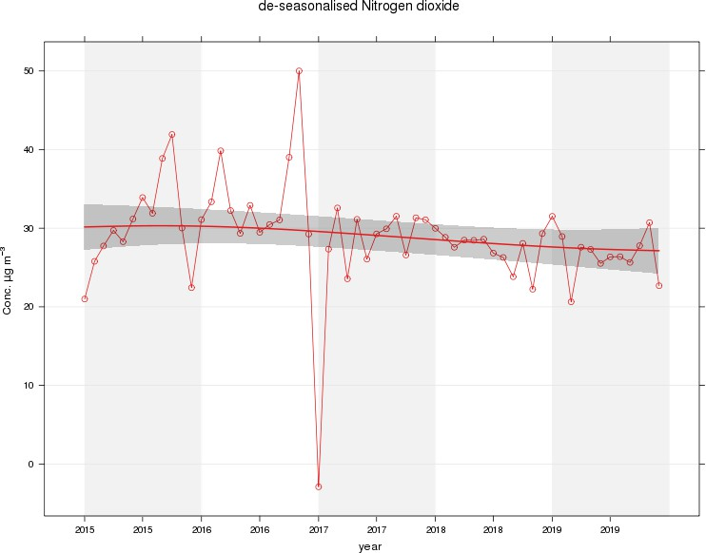

Figure 2 – A5 Falkirk Hope St Long Term NO2 Concentrations
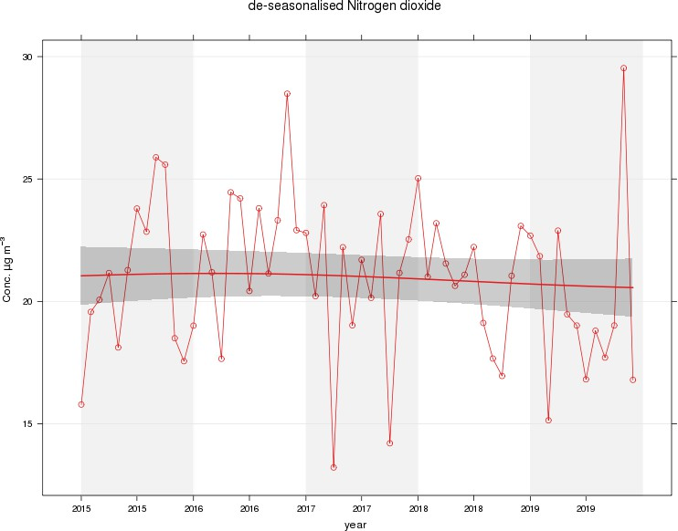

Figure 3 – A7 Falkirk West Bridge St Long Term NO2 Concentrations
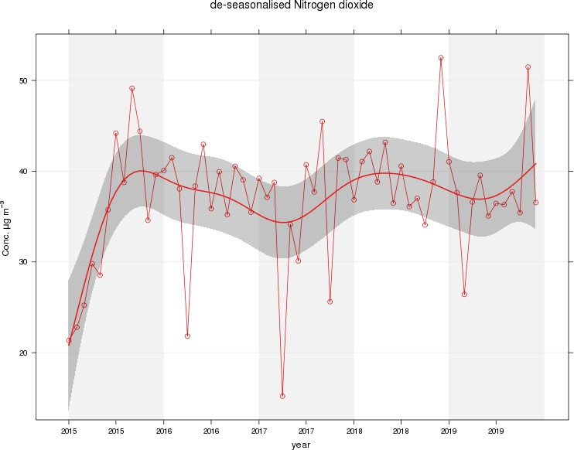

Figure 4 – A8 Grangemouth AURN Long Term NO2 Concentrations
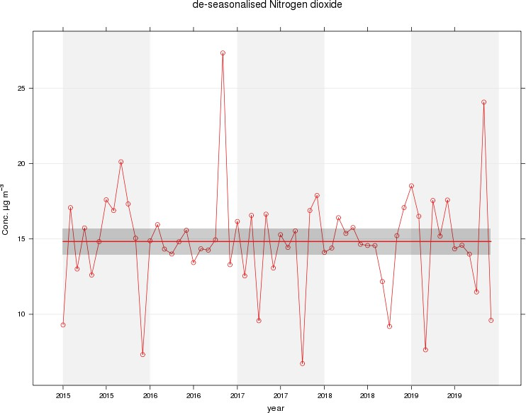

Figure 5 – A9 Grangemouth Moray Long Term NO2 Concentrations
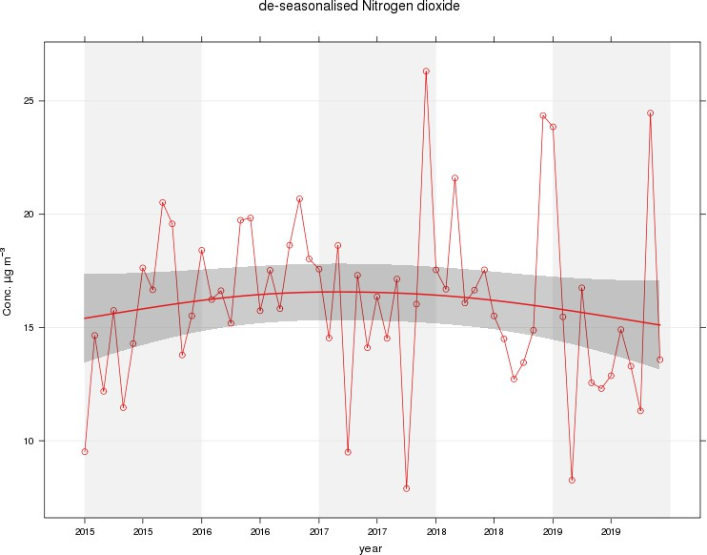

Figure 6 – A10 Grangemouth Municipal Chambers Long Term NO2 Concentrations
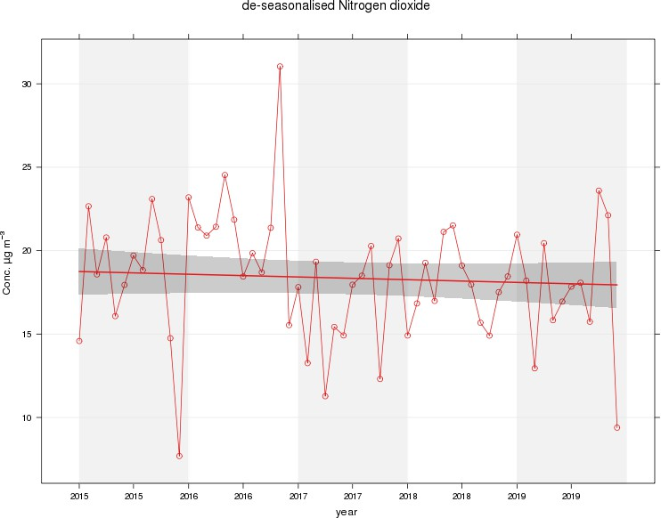

Figure 7 – A15 Main St, Bainsford Long Term NO2 Concentrations

Table A.5 – Annual Mean PM10 Monitoring Results

Site ID | Site Type | Valid Data Capture for Monitoring Period (%) (1) | Valid Data Capture 2019  (%) (2) | PM10 Annual Mean Concentration (µg/m³) ⁽³⁾
 |  |  |  | 2015 | 2016 | 2017 | 2018 | 2019
A4 | Falkirk Haggs | 91 | 91 | 15 | 14 | 12 | 14 | 14
A5 | Falkirk Hope St | 70 | 70 | PM10 analyser transferred from Falkirk Grahams Rd to Hope St  site on 10/10/2018 |  |  | 11 | 13
A7 | Falkirk West Bridge St | 97 | 97 | 15 | 15 | 10 | 6 | 11
A8 | Grangemouth AURN | 93 | 93 | 12.2 | 11 | 9 | 12 | 13
A10 | Grangemouth Municipal Chambers | 45 (1) | 45 (1) | 13 | 13 | 12 | 12 | 14
A13 | Banknock 2 | 97 | 97 | 11 | 11 | 13 | 11 | 7
A14 | Banknock 3 | 99 | 99 | 8.2 | n/n | 7 | 6.9 | 7.9
A15 | Main St, Bainsford | 91 | 91 | 12.8 | 10 | 13 | 12 | 14

Notes: Exceedances of the PM10 annual mean objective of 18µg/m³ are shown in bold.
- data capture for the monitoring period, in cases where monitoring was only carried out for part of the year.
- data capture for the full calendar year (e.g. if monitoring was carried out for 6 months, the maximum data capture for the full calendar year is 50%).
- All means have been “annualised” as per LAQM.TG(16), valid data capture for the full calendar year is less than 75%. See Appendix C for details.

Table A.6 – 24-Hour Mean PM10 Monitoring Results

Site ID | Site Type | Valid Data Capture for Monitoring Period (%)  (1) | Valid Data Capture 2019 (%)  (2) | PM10 24-Hour Means > 50µg/m³ ⁽³⁾
 |  |  |  | 2015 | 2016 | 2017 | 2018 | 2019
A4 | Falkirk Haggs | 91 | 91 | 1 | 0 | 0 | 0 | 4
A5 | Falkirk Hope St | 70 | 70 | PM10 analyser transferred from Grahams Rd to Hope St on  10/10/2018 |  |  | 0 (30) | 1
A7 | Falkirk West Bridge St | 97 | 97 | 2 (29) | 0 | 0 | 0 (47) | 1
A8 | Grangemouth  AURN | 93 | 93 | 1 (21) | 0 | 1 | 0 | 2
A10 | Grangemouth  Municipal Chambers | 45 (1) | 45 (1) | 0 | 0 | 0 | 0 | 2
A13 | Banknock 2 | 97 | 97 | 4 | n/m | 7 | 0 | 3
A14 | Banknock 3 | 99 | 99 | 1 | 3 | 0 | 2 (10) | 1
A15 | Main St, Bainsford | 91 | 91 | 0 (16) | 0 (16) | 0 | 0 (33) | 5

Notes: Exceedances of the PM10 24-hour mean objective (50µg/m³ not to be exceeded more than 7 times/year) are shown in bold.
- data capture for the monitoring period, in cases where monitoring was only carried out for part of the year.
- data capture for the full calendar year (e.g. if monitoring was carried out for 6 months, the maximum data capture for the full calendar year is 50%).
- If the period of valid data is less than 85%, the 98.1st percentile of 24-hour means is provided in brackets.

Figure 8 – A4 Haggs Long Term PM10 (24-hour mean) Concentrations
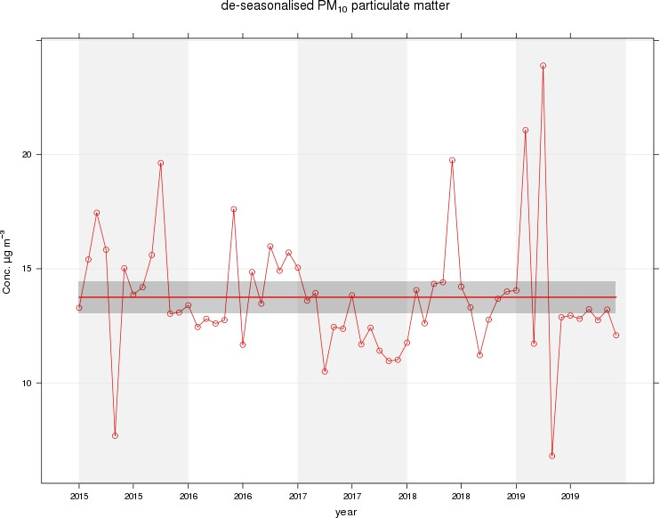

Figure 9 – A5 Falkirk Hope St Long Term PM10 (24-hour mean) Concentrations
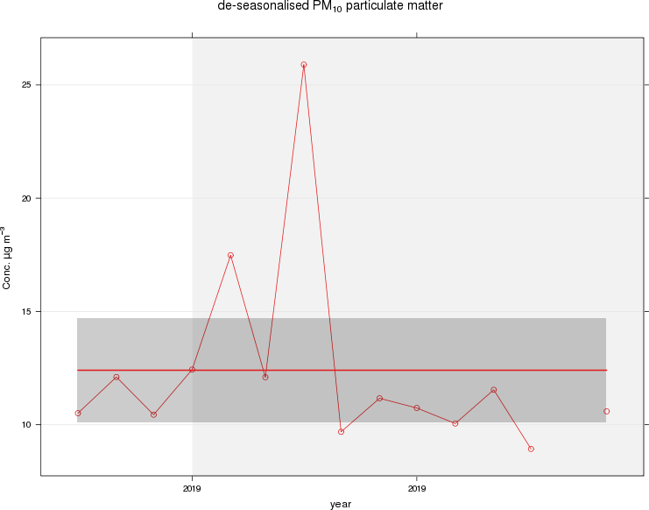

Figure 10 – A7 Falkirk West Bridge St Long Term PM10 (24-hour mean) Concentrations
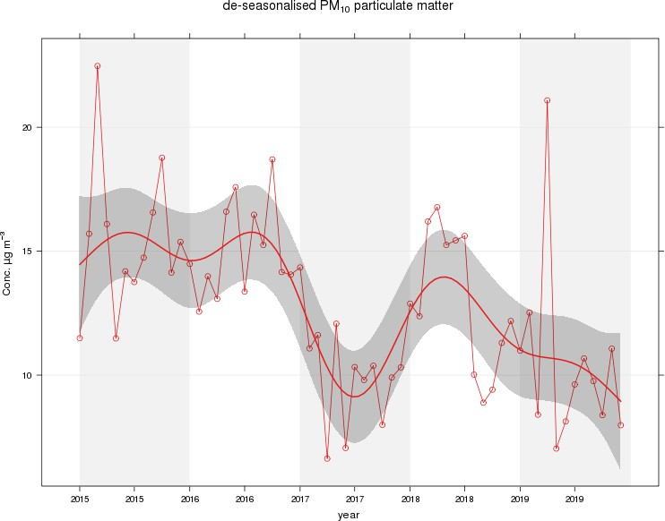

Figure 11 – A8 Grangemouth AURN Long Term PM10 (24-hour mean) Concentrations
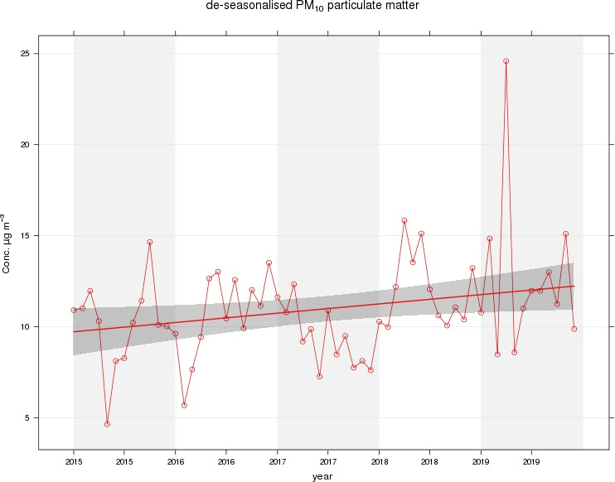

Figure 12 – A10 Grangemouth Municipal Chambers Long Term PM10 (24-hour mean) Concentrations
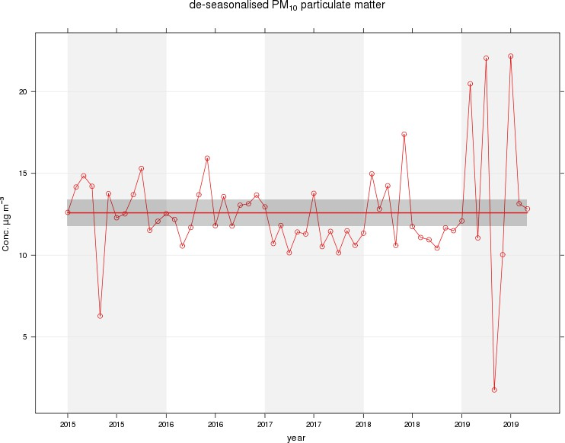

Figure 13 – A13 Banknock 2 Long Term PM10 (24-hour mean) Concentrations
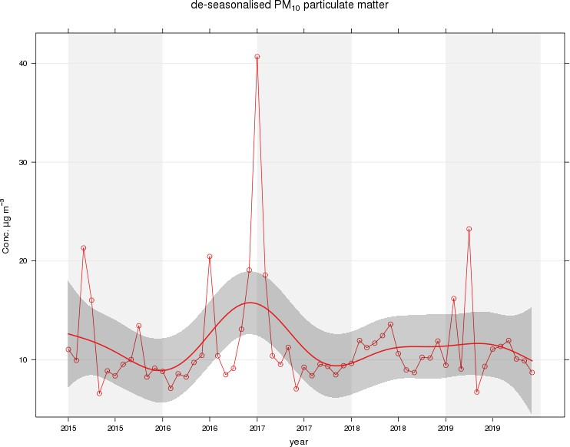

Figure 14 – A15 Main St, Bainsford Long Term PM10 (24-hour mean) Concentrations
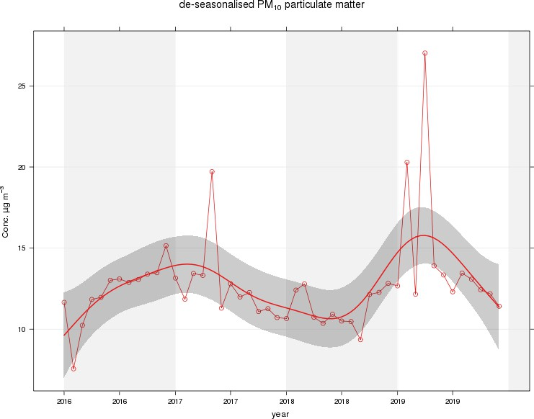

Table A.7 – Annual Mean PM2.5 Monitoring Results

Site ID | Site Type | Valid Data Capture for Monitoring Period (%) (1) | Valid Data Capture 2019  (%) (2) | PM2.5 Annual Mean Concentration (µg/m³) ⁽³⁾
 |  |  |  | 2015 | 2016 | 2017 | 2018 | 2019
A7 | Falkirk West Bridge St | 97 | 97 | Not operating | 6 | 6 | 6 | 6
A8 | Grangemouth AURN | 97 | 97 | 9.2 | 6 | 6 | 7 | 8
A13 | Banknock 2 | 97 | 97 | 6 | 5 | 6 | 6 | 7
A14 | Banknock 3 | 100 | 100 | 3.7 | n/a | 3 | 4 | 4.6

Notes: Exceedances of the PM10 annual mean objective of 10µg/m³ are shown in bold.
- data capture for the monitoring period, in cases where monitoring was only carried out for part of the year.
- data capture for the full calendar year (e.g. if monitoring was carried out for 6 months, the maximum data capture for the full calendar year is 50%).
- All means have been “annualised” as per LAQM.TG(16), valid data capture for the full calendar year is less than 75%. See Appendix C for details.

Figure 15 – A7 Falkirk West Bridge St Long Term PM2.5 Concentrations
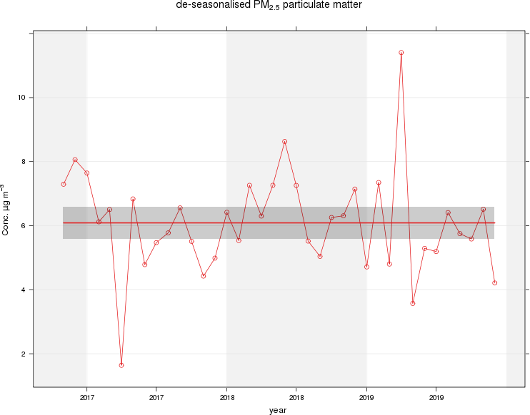

Figure 16 – A8 Grangemouth AURN Long Term PM2.5 Concentrations
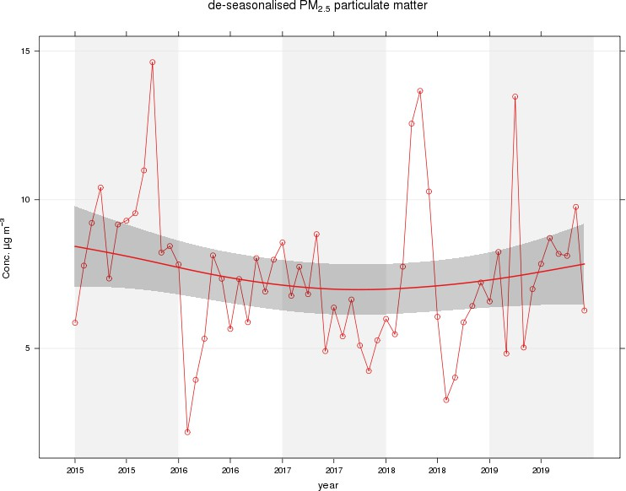

Figure 17 – A13 Banknock 2 Long Term PM2.5 Concentrations
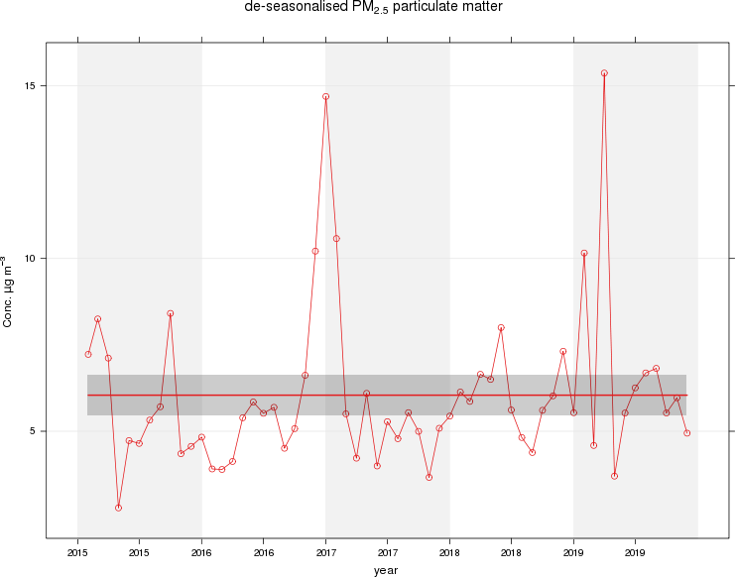

Table A.8 – SO2 Monitoring Results

Site ID | Site Type | Valid Data Capture for monitoring Period (%) (1) | Valid Data Capture 2019 (%) (2) | Number of Exceedances (percentile in bracket) (3)
 |  |  |  | 15-minute Objective (266 µg/m3) | 1-hour Objective (350 µg/m3) | 24-hour Objective (125 µg/m3)
A3 | Bo’ness | 88 | 88 | 0 | 0 | 0
A5 | Falkirk Hope St | 86 | 86 | 0 | 0 | 0
A8 | Grangemouth AURN | 91 | 91 | 2 | 0 | 0
A9 | Grangemouth Moray | 95 | 95 | 12 | 1 | 0
A10 | Grangemouth Municipal  Chambers | 81 | 81 | 0 | 0 | 0
A11 | Grangemouth Zetland Park | 95 | 95 | 0 | 0 | 0

Notes: Exceedances of the SO2 objectives are shown in bold (15-min mean = 35 allowed a year, 1-hour mean = 24 allowed a year, 24-hour mean = 3 allowed a year)
- data capture for the monitoring period, in cases where monitoring was only carried out for part of the year.
- data capture for the full calendar year (e.g. if monitoring was carried out for 6 months, the maximum data capture for the full calendar year is 50%)
- If the period of valid data is less than 85%, the relevant percentiles are provided in brackets.

Figure 18 – A3 Bo’ness Long Term SO2 Concentrations
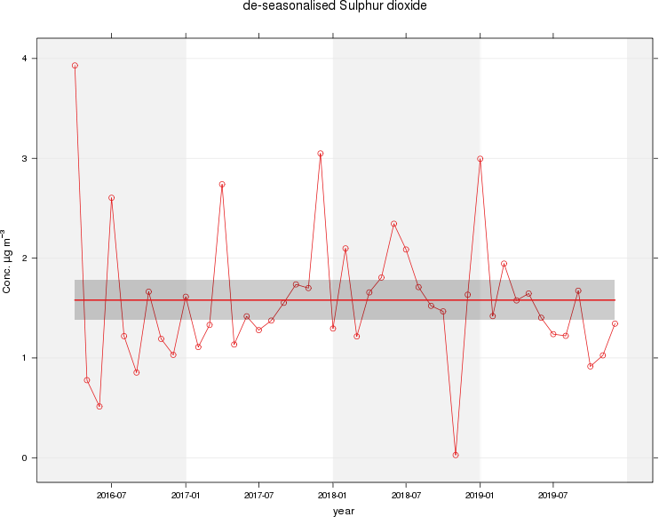

Figure 19 – A5 Falkirk Hope St Long Term SO2 Concentrations
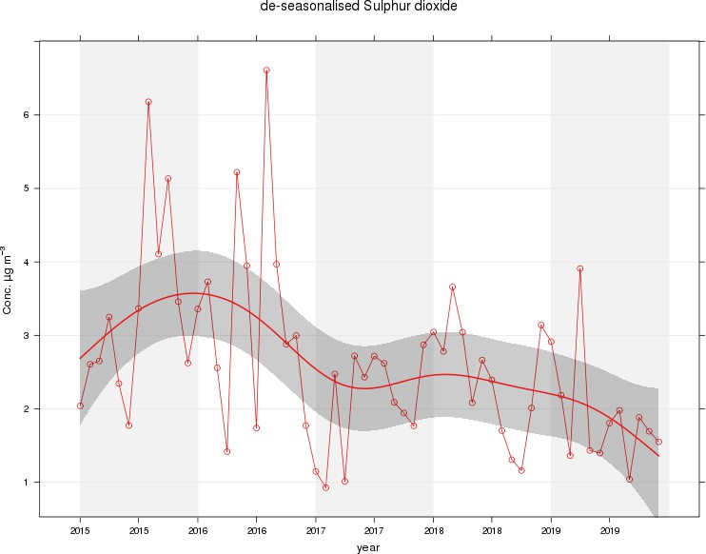

Figure 20 – A8 Grangemouth AURN Long Term SO2 Concentrations
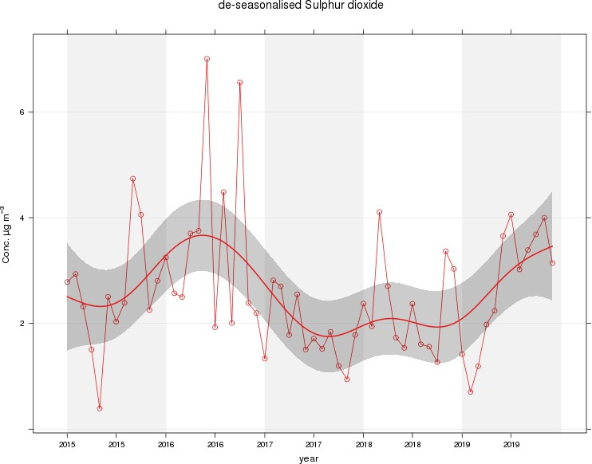

Figure 21 – A9 Grangemouth Moray Long Term SO2 Concentrations
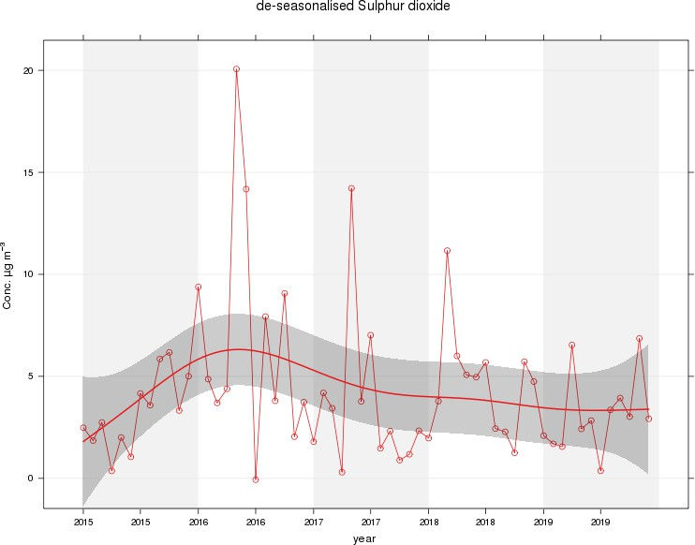

Figure 22 – A10 Grangemouth Municipal Chambers Long Term SO2 Concentrations
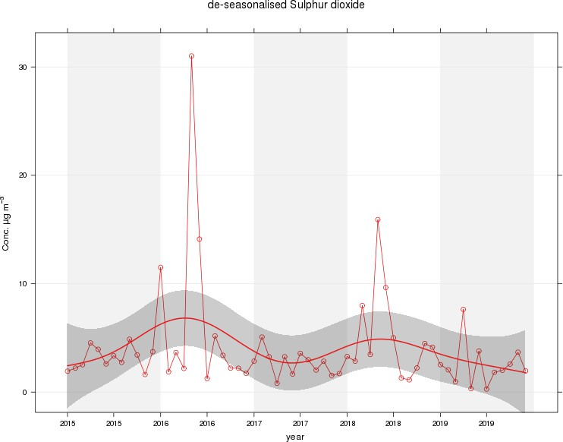

Figure 23 – A11 Grangemouth Zetland Park Long Term SO2 Concentrations
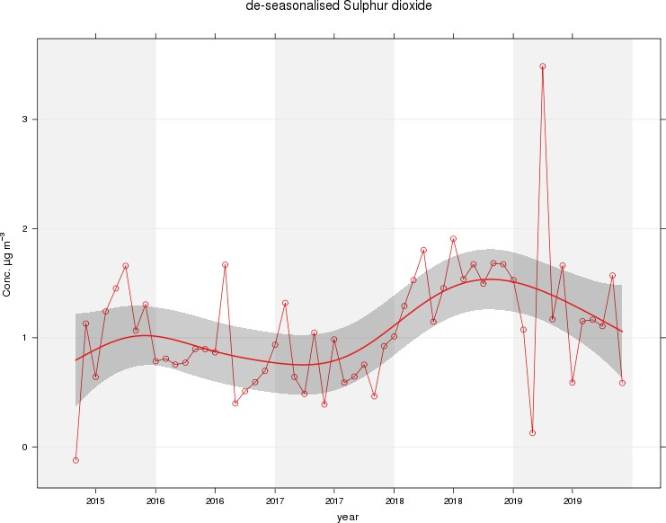

Figure 24 – Polar Plots of Average SO2 Concentrations Recorded at the Grangemouth Sites
A) Grangemouth AURN: 2019 B) Grangemouth AURN: 2015 – 2019
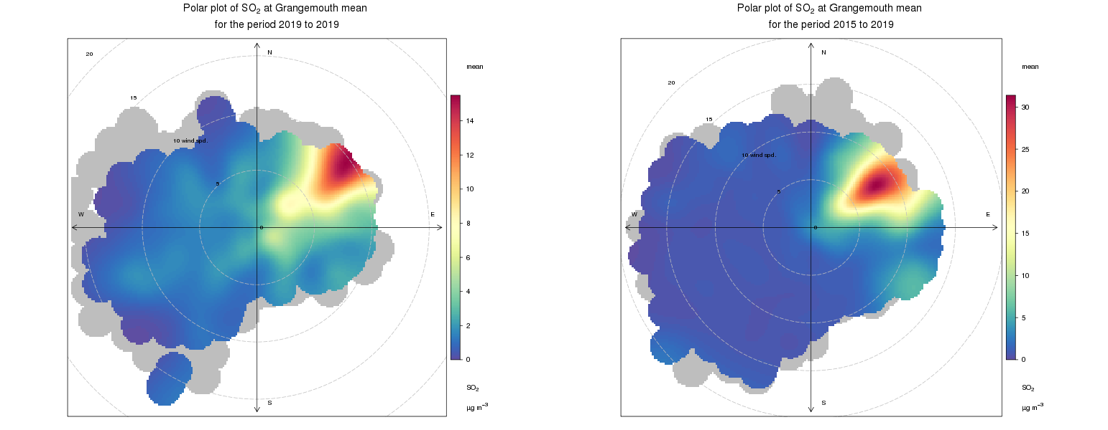

C) Grangemouth Moray: 2019 D) Grangemouth Moray 2015 – 2019
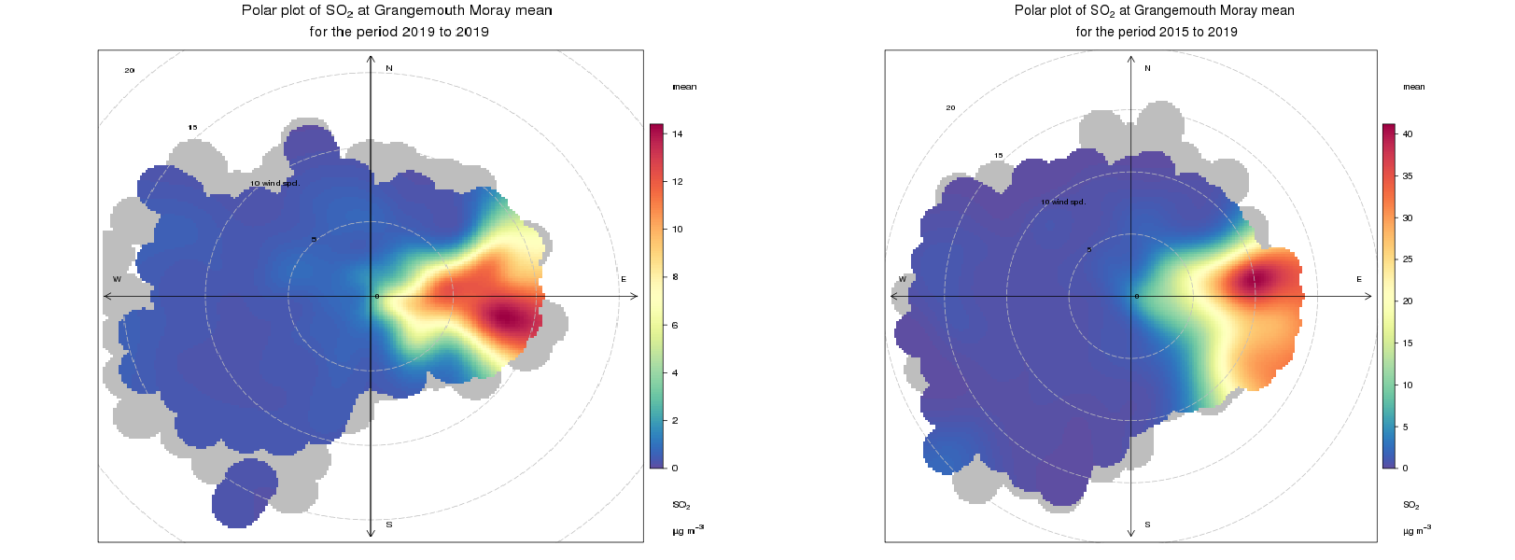

E) Grangemouth Municipal Chambers: 2019 F) Grangemouth Municipal Chambers: 2015 – 2019
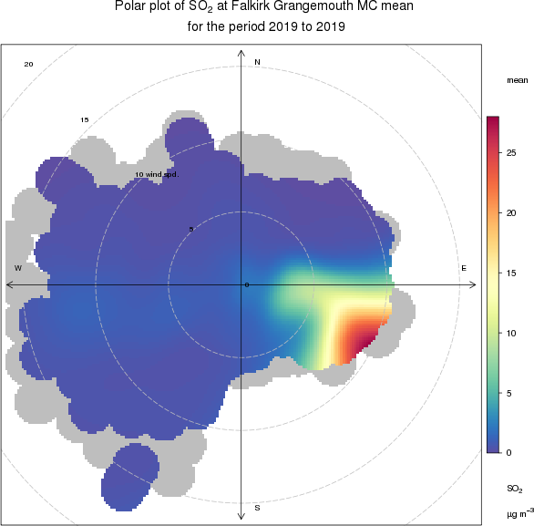
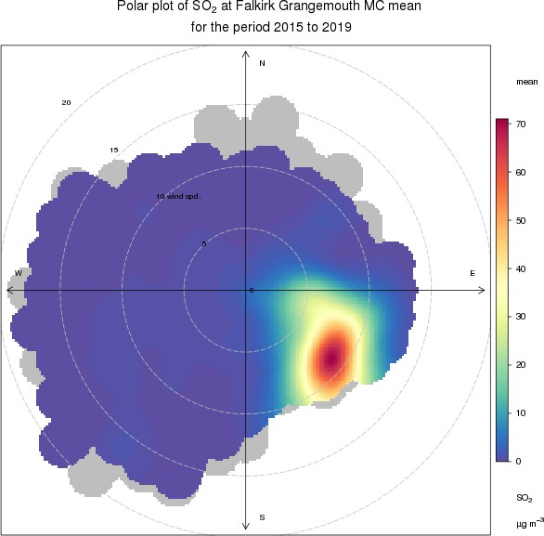

Figure 25 – Exceedances of the 15 Minute SO2 NAQS Objective Concentration at the Grangemouth Sites 2015 – 2019
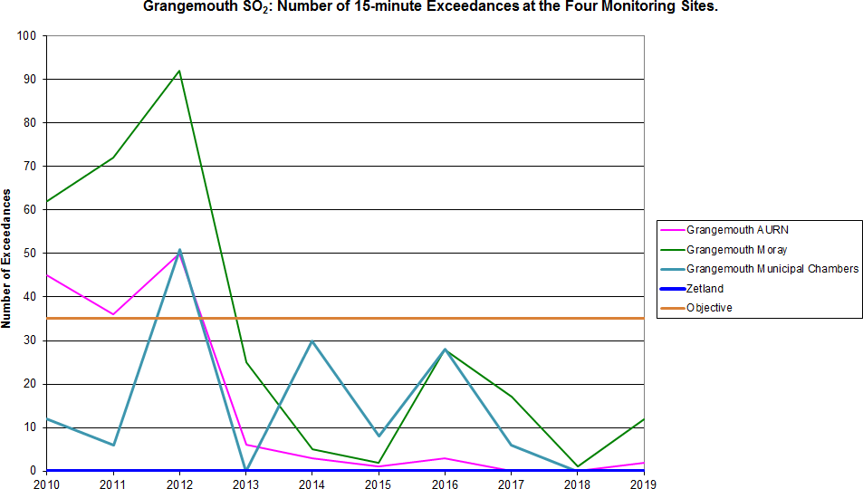

Table A.9 – 1, 3 Butadiene Annual Mean Diffusion Tube Results for 2019

Site ID | Location | Within 1, 3 Butadiene AQMA? | Data Capture in 2019, %.(1) | Annual Mean Concentrations (µg/m³)
 |  |  |  | 2015 | 2016 | 2017 | 2018 | 2019
NA41 | Seaview Place, Bo’ness | N | 100 | 0.11 | 0.10 | 0.1 | 0.06 | 0.05
NA55 | Inchyra Station,  Grangemouth | N | 100 | 0.09 | 0.10 | 0.07 | 0.07 | 0.05
NA104 | Powdrake  Road, Grangemouth | N | 100 | 0.13 | 0.11 | 0.1 | 0.11 | 0.05

Note: Exceedances of the 1, 3 butadiene running annual mean NAQS objective are shown in bold.

Table A.10 – Benzene Annual Mean Diffusion Tube Results for 2019

Site ID | Location | Within AQMA? | Data Capture in 2019, %.(1) | Annual Mean Concentrations (µg/m³)
 |  |  |  | 2015 | 2016 | 2017 | 2018 | 2019
NA3 | Tinto Drive, Grangemouth | N | 100 | 1.16 | 0.51 | 0.58 | 0.66 | 0.8
NA21 | Grangemouth Road, Falkirk College | N | 100 | 0.72 | 0.46 | 0.56 | 0.6 | 0.65
NA27 | West Bridge Street, Falkirk | N | 100 | 0.69 | 0.78 | 0.68 | 0.7 | 1.07
NA37 | Denny Town House | N | 100 | 0.59 | 0.58 | 0.56 | 0.49 | 0.77
NA38 | Larbert Village Primary School | N | 91.7 | 0.55 | 0.51 | 1.01 | 0.5 | 0.51
NA41 | Seaview Place, Bo’ness | N | 91.7 | 0.91 | 1.11 | 0.82 | 0.91 | 0.96
NA42 | Municipal Chambers, Grangemouth | N | 100 | 0.69 | 0.79 | 0.47 | 0.63 | 0.78
NA44 | Harvey Avenue, Polmont | N | 100 | 0.56 | 0.48 | 0.39 | 0.52 | 0.67
NA55 | Inchyra AQ Station, Grangemouth | N | 100 | 0.5 | 0.46 | 0.52 | 0.52 | 0.73
NA77 | Kinnaird Village | N | 83.3 | 0.65 | 0.44 | 0.51 | 0.44 | 0.59
NA80 | Cow Wynd, Falkirk | N | 91.7 | 0.81 | 0.56 | 0.57 | 0.52 | 0.66
NA81 | Grahams Road, Falkirk | N | 100 | 0.88 | 0.95 | 0.7 | 0.81 | 0.97
NA94 | A905 (Glensburgh Rd), Grangemouth | N | 100 | 0.68 | 0.78 | 0.64 | 0.68 | 0.77
NA105 | West of Shieldhill | N | 91.7 | 0.34 | 0.19 | 0.69 | 0.3 | 0.4
NA116 | Kersiebank Avenue, Grangemouth | Y | 100 | New site for 2019 |  |  |  | 0.76
NA117 | Oswald Avenue (East), Grangemouth | Y | 100 | New site for 2019 |  |  |  | 0.99
Note: Exceedances of the Benzene running annual mean objective of 3.25µg/m3 are shown in bold.

Table A.11 – Pumped Benzene Annual Mean Results for 2019

Site ID | Location | Within AQMA? | Data Capture in 2019, % (1) | Annual Mean Concentrations (µg/m³)
 |  |  |  | 2015 | 2016 | 2017 | 2018 | 2019
A8 | Grangemouth AURN | Y | 100 | 0.73 | 0.64 | 0.65 | 0.74 | 0.78
Note: Exceedences of the Benzene running annual mean objective of 3.25µg/m3 are shown in bold.

Table A.12 – Estimated Annual Mean PM2.5 Results for 2019

Site ID | Site Type | Valid Data Capture for Monitoring Period (%)  (1) | Valid Data Capture in 2019 (%)  (2) | Correction Factor | Estimated PM2.5 Annual Mean Concentration (µg/m³) (3)
 |  |  |  |  | 2015 | 2016 | 2017 | 2018 | 2019
A4 Falkirk Haggs | Roadside (Non-urban) | 91 | 91 | 0.64 | 6.92 | 6.46 | 5.54 | 7.7 | 9
A5 Falkirk Hope St | Roadside  (Urban) | 70 | 70 | 0.55 | PM10 analyser not operating at this site |  |  | 11 | 7.1
A10 Grangemouth Municipal Chambers | Urban  Background / Industrial | 45 | 45 | 0.62 | 8.67 | 8.67 | 8.00 | 6.96 | 8.6
A15 Main St, Bainsford | Roadside (Urban) | 91 | 91 | 0.55 | 7.68 | 6.00 | 7.80 | 12 | 7.7

Note: Exceedences of the PM2.5 annual mean objective of 10µg/m³ are shown in bold.
- Data capture for the monitoring period, in cases where monitoring was only carried out for part of the year.
- Data capture for the full calendar year (e.g. if monitoring was carried out for 6 months, the maximum data capture for the full calendar year is 50%)
- All means have been estimated using a local correction factor as per LAQM.TG (16)¹. See Appendix C for details.

Figure 26 – Maps of the AQMA Boundaries in the Falkirk Council Area
- Grangemouth AQMA (SO2, 15min mean), declared November 2005
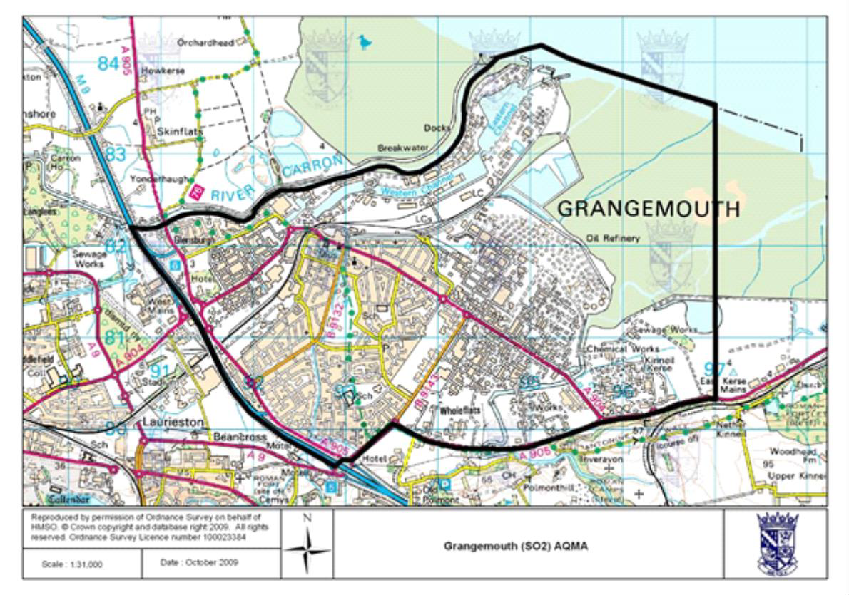
- Falkirk Town Centre AQMA (NO2 Annual Mean, PM10 annual and 24-hour mean), declared March 2010
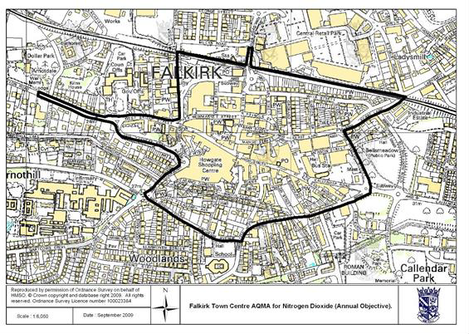

- Haggs AQMA (NO2 annual mean), declared March 2010
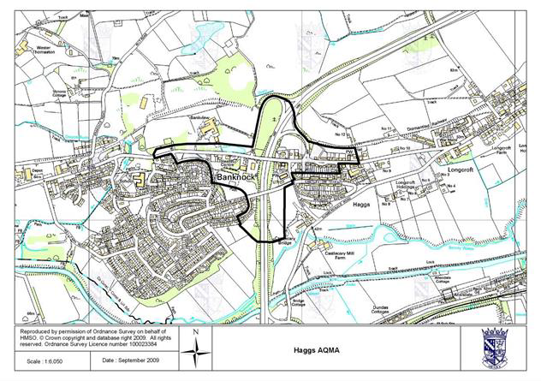
- Banknock AQMA (PM10 24-hour mean), declared August 2011
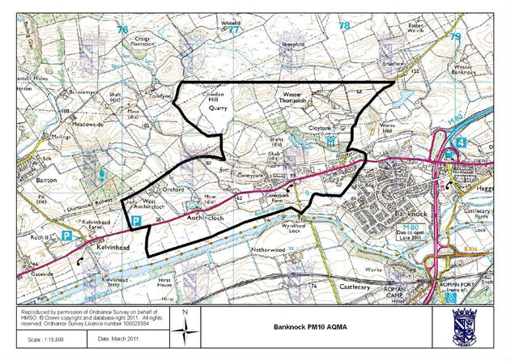

Figure 27 – Maps Showing Automatic Monitoring Locations
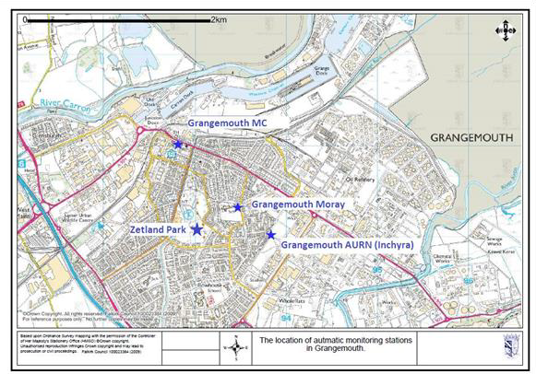
  - Grangemouth Air Quality (AQ) Stations
  - Falkirk Hope St AQ Station
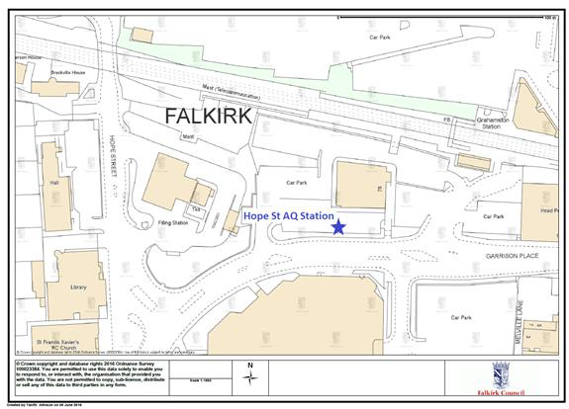

  - Falkirk West Bridge St AQ Station
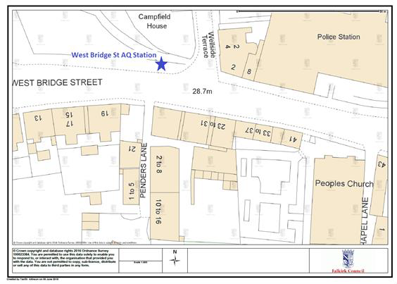

  - Bo’ness AQ Station
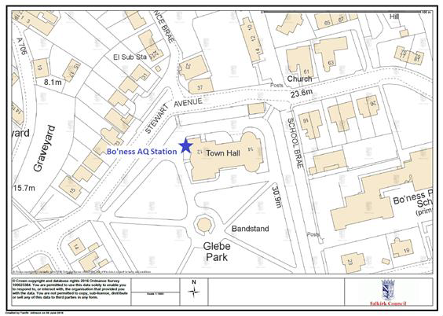

  - Falkirk Haggs AQ Station
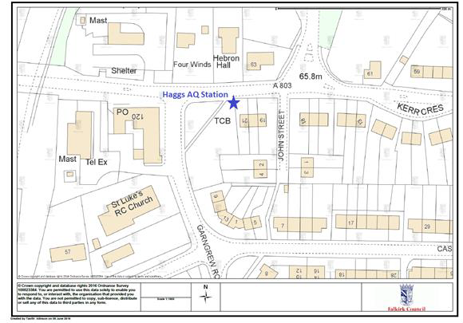

  - Banknock 2 AQ Station
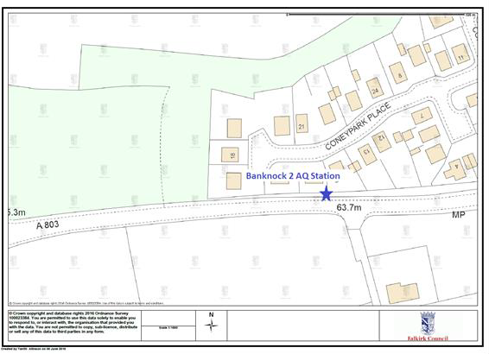

  - Main St, Bainsford, Falkirk AQ Station
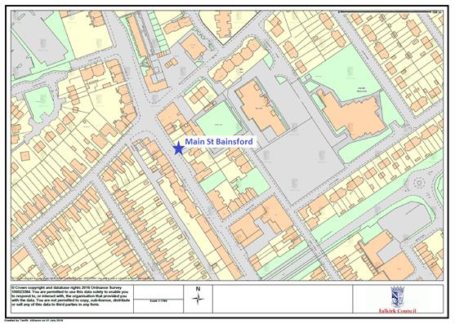

Appendix B: Full Monthly Diffusion Tube Results for 2019

Table B.1 – NO2 Monthly Diffusion Tube Results for 2019

Site ID | NO2 Mean Concentrations (µg/m³)
 | Jan | Feb | Mar | Apr | May | Jun | Jul | Aug | Sep | Oct | Nov | Dec | Annual Mean
 |  |  |  |  |  |  |  |  |  |  |  |  | Raw Data | Bias Adjusted  (1)
NA3 | 27.97 | 26.18 | 17.94 | 22.15 | 17.33 | 13.76 | 12.71 | 10.56 | 16.28 | 25.30 | 31.42 | 22.03 | 20 | 19
NA5 | 43.49 | 34.49 | 24.82 | 26.32 | - | - | 20.27 | 15.16 | 24.19 | 29.26 | 37.65 | 31.79 | 29 | 27
NA7 | 29.67 | 20.40 | 15.20 | 17.80 | 11.98 | 13.17 | 11.48 | 10.61 | 14.83 | 18.09 | - | - | 16 | 15
NA9 | 33.74 | 28.08 | 24.00 | 23.44 | 20.51 | 19.43 | 17.51 | 12.55 | 23.25 | 26.16 | 37.16 | 26.88 | 24 | 23
NA19 | 40.12 | 36.21 | 25.04 | 35.21 | 28.48 | 27.05 | - | 14.99 | 24.46 | 30.70 | - | 28.61 | 29 | 27
NA20 | 39.00 | 30.44 | 22.80 | 17.82 | 11.55 | 17.45 | 15.72 | 16.13 | 21.31 | 25.73 | 35.85 | 27.27 | 23 | 22
NA21 | 35.40 | 33.95 | 24.71 | 36.79 | 26.50 | 22.98 | 23.91 | 13.39 | 27.44 | 30.92 | - | 26.55 | 28 | 26
NA24 | 50.65 | 42.12 | 35.32 | 32.77 | 32.61 | 24.66 | 28.88 | 25.32 | 34.70 | 33.92 | 44.49 | 36.77 | 35 | 33
NA26 | 30.33 | 21.93 | 16.77 | 17.66 | 14.22 | 12.37 | 12.86 | 7.94 | 17.01 | 20.67 | 30.40 | 22.19 | 19 | 18
NA27 | 55.75 | 54.56 | 41.09 | 66.37 | 49.92 | - | 40.28 | 29.89 | 44.62 | 49.86 | 78.20 | 43.67 | 50 | 47
NA29 | 26.72 | 25.08 | 13.60 | 21.77 | 13.50 | 12.29 | 12.51 | 6.84 | - | 19.51 | 30.17 | 18.62 | 18 | 17
NA36 | 52.23 | 49.08 | 36.15 | 44.43 | 34.73 | 32.89 | 33.48 | 20.56 | 26.98 | 37.62 | - | 37.13 | 37 | 35
NA37 | 25.55 | 22.53 | 13.98 | 20.10 | - | 12.04 | 11.88 | 9.95 | 13.92 | 20.16 | 27.17 | 18.90 | 18 | 17
NA38 | 29.16 | 22.20 | 13.48 | 15.80 | 12.53 | 9.26 | 10.17 | 9.97 | 15.03 | 19.76 | 29.02 | 20.02 | 17 | 16
NA41 | 31.90 | 31.78 | 20.95 | 23.26 | 20.00 | 18.29 | 19.20 | 20.62 | 21.48 | 24.46 | 33.32 | 24.01 | 24 | 23

Site ID | NO2 Mean Concentrations (µg/m³)
 | Jan | Feb | Mar | Apr | May | Jun | Jul | Aug | Sep | Oct | Nov | Dec | Annual Mean
 |  |  |  |  |  |  |  |  |  |  |  |  | Raw Data | Bias Adjusted  (1)
NA42 (3 Tubes) | 31.45 | 26.25 | 17.72 | 20.43 | 16.88 | 11.42 | 13.50 | 9.85 | 18.01 | 22.94 | 32.94 | 22.47 | 20 | 19
 | 29.83 | 26.48 | 18.63 | 20.49 | 15.73 | 11.40 | 12.80 | 8.28 | 18.77 | 21.47 | 33.39 | 21.90
 | 30.53 | 25.19 | 16.41 | 22.32 | 16.36 | 11.88 | 12.52 | 8.42 | 18.13 | 20.46 | 29.21 | 18.08
NA44 | 30.75 | 25.98 | 19.39 | 16.93 | 14.05 | 12.63 | 12.44 | 10.59 | 17.46 | 23.14 | 27.23 | 22.90 | 19 | 18
NA48 | 31.74 | 27.43 | 15.94 | 24.87 | 15.73 | 13.31 | 14.23 | 8.83 | 17.18 | 17.96 | 32.91 | 19.17 | 20 | 19
NA50 | 32.78 | 28.22 | 17.81 | 42.45 | 23.91 | 22.60 | 21.62 | 11.45 | 24.00 | 28.28 | 37.64 | 21.03 | 26 | 24
NA51 | 40.44 | 31.54 | 24.20 | 22.91 | 22.77 | 20.32 | 19.41 | 16.01 | 22.58 | 27.80 | 30.43 | 23.32 | 25 | 24
NA52 | 37.08 | 30.17 | 22.08 | 21.97 | 19.68 | 17.90 | 17.53 | 11.81 | 20.55 | 21.34 | 33.61 | 28.27 | 23 | 22
NA53 | 39.58 | 35.95 | 22.36 | 36.13 | 26.99 | 25.62 | 22.72 | 14.66 | 23.69 | 25.09 | 40.05 | 29.89 | 29 | 27
NA58 | 31.53 | 25.37 | - | 25.97 | 20.51 | 16.43 | 14.27 | 11.14 | 21.18 | 25.41 | 34.55 | 22.93 | 23 | 21
NA59 | 45.68 | 39.86 | 29.07 | 27.88 | 26.43 | 24.90 | 23.00 | 16.09 | - | 31.55 | 39.81 | 29.32 | 30 | 29
NA60 | 43.55 | 32.10 | 24.20 | 28.79 | 21.94 | 19.78 | 19.66 | 12.65 | 22.48 | 27.19 | 41.28 | 31.27 | 27 | 25
NA61 | 39.35 | 27.99 | 19.04 | 23.82 | 14.96 | 19.90 | 17.71 | 14.23 | 21.40 | 27.52 | 37.41 | 26.34 | 24 | 23
NA62 | 52.44 | 39.37 | 33.29 | 38.87 | 31.89 | 27.27 | 27.87 | 30.58 | 33.54 | 38.24 | 42.27 | 38.15 | 36 | 34
NA63 | 54.30 | 43.85 | 35.46 | 38.72 | 30.99 | 29.26 | 28.70 | 17.92 | 32.50 | 37.97 | 51.39 | 38.87 | 37 | 34
NA64 | 28.42 | 17.18 | 15.21 | 23.00 | 17.51 | 13.23 | 10.96 | 8.17 | 16.99 | 19.56 | 30.73 | 16.20 | 18 | 17
NA65 | 37.78 | 29.00 | 22.54 | 25.03 | 24.72 | 20.73 | 19.72 | 13.08 | 23.66 | 29.80 | 37.78 | 23.34 | 26 | 24
NA67 | 37.78 | 30.46 | 27.57 | 28.10 | 25.20 | 24.21 | 20.61 | 16.34 | 24.67 | 31.05 | 36.05 | 30.70 | 28 | 26
NA69 | 41.65 | 34.82 | 21.46 | 42.51 | 32.21 | 28.50 | 27.62 | 17.28 | 28.17 | 34.17 | 47.13 | 27.37 | 32 | 30
NA71 | 46.27 | 41.33 | 34.58 | 30.41 | 28.77 | 23.07 | 23.60 | 16.99 | 31.55 | 37.53 | 38.14 | 35.23 | 32 | 30

Site ID | NO2 Mean Concentrations (µg/m³)
 | Jan | Feb | Mar | Apr | May | Jun | Jul | Aug | Sep | Oct | Nov | Dec | Annual Mean
 |  |  |  |  |  |  |  |  |  |  |  |  | Raw Data | Bias Adjusted  (1)
NA72 | 43.26 | 35.93 | 27.83 | 34.16 | 16.01 | 24.02 | 24.93 | 13.68 | 26.70 | 33.41 | 37.95 | 30.53 | 29 | 27
NA73 | 40.40 | 45.08 | 29.20 | 37.28 | 31.98 | 25.73 | 29.32 | 19.18 | 28.82 | 33.84 | 44.71 | 35.18 | 33 | 31
NA76 | 34.95 | 27.77 | 18.35 | 17.75 | 14.47 | 14.38 | 13.61 | 14.70 | 17.77 | 24.10 | 32.20 | 24.93 | 21 | 20
NA77 | 39.80 | 30.68 | 21.15 | 19.61 | 19.01 | 16.05 | 17.56 | 12.76 | 23.38 | 27.16 | 37.92 | 27.07 | 24 | 23
NA78 | 36.73 | 36.27 | 29.61 | 33.32 | 28.03 | 23.62 | 25.50 | 13.86 | 26.36 | 34.14 | 36.49 | 28.37 | 29 | 28
NA80 | 43.96 | 42.44 | 30.18 | 27.56 | 27.52 | - | 25.13 | 22.22 | 26.50 | 33.30 | 35.71 | 34.71 | 32 | 30
NA81 | 38.55 | 40.25 | 31.02 | 40.01 | 31.15 | 26.38 | 26.31 | 23.56 | 31.41 | 36.85 | 46.47 | 30.94 | 34 | 32
NA82 | 28.00 | 28.69 | 15.77 | 20.26 | 14.76 | 13.19 | 12.68 | 11.18 | 15.70 | 22.98 | 29.64 | 20.23 | 19 | 18
NA83 | 53.71 | 40.28 | 38.43 | 34.72 | 32.61 | 29.66 | 27.04 | 19.14 | - | - | 47.86 | 38.21 | 36 | 34
NA85 | 31.00 | 23.74 | 12.94 | 22.51 | 17.48 | 18.54 | 16.04 | 9.97 | 17.30 | 24.07 | 35.33 | 21.49 | 21 | 20
NA86 | 29.95 | 20.54 | 10.36 | 18.10 | 12.32 | 10.96 | 9.78 | 7.27 | 14.31 | 20.26 | 28.21 | 16.59 | 17 | 16
NA87 | 40.56 | 43.28 | 29.74 | 33.58 | 29.68 | 29.29 | 27.85 | 30.77 | 34.99 | 30.37 | 33.62 | 31.27 | 33 | 31
NA88 | 40.46 | - | 31.14 | 26.67 | 30.22 | 22.84 | 21.00 | 13.82 | 28.45 | 33.22 | 38.41 | 28.81 | 29 | 27
NA89 | 46.60 | 41.13 | 30.26 | 34.54 | 26.57 | 24.51 | 26.22 | 16.89 | 29.01 | 33.27 | 38.94 | 33.84 | 32 | 30
NA94 | 46.23 | 44.10 | 34.75 | 28.27 | 27.28 | 22.56 | 26.17 | 16.20 | 32.41 | 35.51 | 40.93 | 34.17 | 32 | 30
NA98 | 1.15 | 25.28 | 3.03 | 22.10 | 16.05 | 14.27 | 13.42 | 0.78 | 17.11 | 0.70 | 31.89 | 19.18 | 14 | 13
NA99 | 39.39 | 30.81 | 26.04 | 30.53 | 23.00 | 14.72 | 19.13 | 19.27 | 24.61 | 29.20 | 37.80 | 30.42 | 27 | 25
NA101 | 30.12 | 33.76 | 18.24 | 31.70 | 19.19 | 18.41 | 16.64 | 16.03 | 21.19 | 26.49 | 35.71 | 23.42 | 24 | 23
NA105 | 12.57 | 9.40 | 6.70 | 5.91 | 7.18 | 5.33 | 5.55 | 4.52 | 7.65 | 9.60 | 18.04 | 7.30 | 8 | 8

Site ID | NO2 Mean Concentrations (µg/m³)
 | Jan | Feb | Mar | Apr | May | Jun | Jul | Aug | Sep | Oct | Nov | Dec | Annual Mean
 |  |  |  |  |  |  |  |  |  |  |  |  | Raw Data | Bias Adjusted  (1)
NA107 | 45.39 | 39.32 | - | 36.15 | 32.28 | 25.42 | 23.03 | 14.95 | 28.14 | 36.07 | 41.79 | 33.29 | 32 | 30
NA110 | 29.42 | 20.20 | 16.46 | 15.25 | 15.24 | 13.78 | 12.86 | 9.99 | 14.33 | 16.46 | 24.95 | 17.53 | 17 | 16
NA111 (3 tubes) | 46.05 | 47.75 | 37.00 | 51.07 | 39.78 | 35.45 | 33.68 | 22.67 | 38.01 | 39.79 | 50.51 | 35.79 | 40 | 38
 | 49.22 | 48.44 | 38.04 | 46.46 | 40.94 | 38.30 | 35.31 | 18.78 | 38.38 | 40.82 | 48.48 | 38.80
 | 42.30 | 46.42 | - | 51.19 | 34.04 | 39.29 |  | 16.36 | 39.13 | 42.91 | 54.93 | 36.08
NA114 | 64.97 | 54.07 | 39.58 | 44.40 | 39.03 | 42.11 | 33.94 | 31.33 | 36.92 | 45.06 | 53.33 | 42.11 | 44 | 41
NA115 | 29.67 | - | 33.09 | 18.33 | 14.88 | - | 12.04 | 7.94 | 15.60 | 21.52 | 30.37 | 19.51 | 20 | 19
NA116 | 25.81 | 30.18 | 17.18 | 27.46 | 18.10 | 17.30 | 15.01 | 11.73 | 18.67 | 23.25 | 27.68 | 21.77 | 21 | 20
NA117 | 29.01 | 26.72 | 16.05 | 28.46 | 19.38 | 13.76 | 14.48 | 13.17 | 18.57 | 22.42 | 30.51 | 21.39 | 21 | 20
NA118 | 32.98 | 32.73 | 20.23 | 29.15 | 19.36 | 19.23 | 19.39 | 12.24 | 22.30 | 29.75 | 35.14 | 24.83 | 25 | 23
NA119 | 37.74 | 24.93 | 18.13 | 26.53 | 19.70 | 17.39 | 17.28 | 11.31 | 21.66 | 23.86 | 33.90 | 24.10 | 23 | 22

(1) See Appendix C for details on bias adjustment

Table B.2 – 1, 3 Butadiene Monthly Diffusion Tube Results for 2019

Site ID | 1,3 Butadiene Mean Concentrations
 | Jan | Feb | Mar | Apr | May | Jun | Jul | Aug | Sep | Oct | Nov | Dec | Annual Mean | Annual Mean
 |  |  |  |  |  |  |  |  |  |  |  |  | Raw Data | Raw Data
 | ppb | ppb | ppb | ppb | ppb | ppb | ppb | ppb | ppb | ppb | ppb | ppb | ppb | µg/m³
41 | 0.04 | 0.04 | 0.02 | 0.02 | 0.02 | 0.02 | 0.02 | 0.02 | 0.02 | 0.02 | 0.02 | 0.02 | 0.02 | 0.05
55 | 0.03 | 0.04 | 0.02 | 0.02 | 0.02 | 0.02 | 0.02 | 0.02 | 0.02 | 0.02 | 0.02 | 0.02 | 0.02 | 0.05
104 | 0.02 | 0.04 | 0.02 | 0.02 | 0.02 | 0.02 | 0.02 | 0.02 | 0.02 | 0.04 | 0.02 | 0.02 | 0.02 | 0.05

Table B.3 – Benzene Monthly Diffusion Tube Results for 2019

Site ID | Benzene Mean Concentrations
 | Jan | Feb | Mar | Apr | May | Jun | Jul | Aug | Sep | Oct | Nov | Dec | Annual Mean | Annual Mean
 |  |  |  |  |  |  |  |  |  |  |  |  | Raw Data | Raw Data
 | ppb | ppb | ppb | ppb | ppb | ppb | ppb | ppb | ppb | ppb | ppb | ppb | ppb | µg/m³
3 | 0.29 | 0.32 | 0.15 | 0.29 | 0.39 | 0.33 | 0.11 | 0.16 | 0.17 | 0.17 | 0.39 | 0.2 | 0.25 | 0.80
21 | 0.07 | 0.29 | 0.13 | 0.24 | 0.34 | 0.41 | 0.12 | 0.1 | 0.14 | 0.1 | 0.33 | 0.14 | 0.20 | 0.65
27 | 0.42 | 0.38 | 0.23 | 0.31 | 0.57 | 0.49 | 0.15 | 0.14 | 0.24 | 0.28 | 0.49 | 0.25 | 0.33 | 1.07
37 | 0.23 | 0.3 | 0.12 | 0.18 | 0.45 | 0.44 | 0.2 | 0.26 | 0.18 | 0.05 | 0.27 | 0.18 | 0.24 | 0.77
38 | 0.07 | 0.27 | - | 0.15 | 0.25 | 0.21 | 0.08 | 0.07 | 0.07 | 0.15 | 0.26 | 0.13 | 0.16 | 0.51
41 | 0.4 | 0.27 | 0.19 | 0.31 | 0.52 | 0.52 | 0.2 | 0.18 | 0.18 | 0.28 | - | 0.21 | 0.30 | 0.96
42 | 0.26 | 0.27 | 0.18 | 0.28 | 0.3 | 0.37 | 0.11 | 0.13 | 0.15 | 0.16 | 0.46 | 0.21 | 0.24 | 0.78
44 | 0.22 | 0.47 | 0.12 | 0.17 | 0.38 | 0.23 | 0.09 | 0.11 | 0.11 | 0.13 | 0.3 | 0.14 | 0.21 | 0.67
55 | 0.21 | 0.28 | 0.14 | 0.3 | 0.34 | 0.37 | 0.05 | 0.15 | 0.14 | 0.16 | 0.38 | 0.19 | 0.23 | 0.73
77 | 0.18 | 0.27 | 0.12 | - | 0.28 | 0.21 | - | 0.11 | 0.11 | 0.18 | 0.22 | 0.12 | 0.18 | 0.59
80 | 0.25 | 0.28 | 0.13 | - | 0.34 | 0.28 | 0.11 | 0.09 | 0.13 | 0.18 | 0.27 | 0.17 | 0.20 | 0.66
81 | 0.38 | 0.41 | 0.21 | 0.27 | 0.54 | 0.41 | 0.18 | 0.07 | 0.22 | 0.24 | 0.42 | 0.23 | 0.30 | 0.97
94 | 0.25 | 0.31 | 0.19 | 0.31 | 0.36 | 0.3 | 0.15 | 0.14 | 0.15 | 0.05 | 0.42 | 0.23 | 0.24 | 0.77
105 | - | 0.23 | 0.12 | 0.15 | 0.2 | 0.21 | 0.05 | 0.07 | 0.07 | 0.08 | 0.13 | 0.05 | 0.12 | 0.40
116 | 0.23 | 0.29 | 0.15 | 0.3 | 0.35 | 0.31 | 0.11 | 0.19 | 0.17 | 0.18 | 0.34 | 0.18 | 0.23 | 0.76
117 | 0.28 | 0.32 | 0.13 | 0.52 | 0.5 | 0.46 | 0.16 | 0.2 | 0.19 | 0.23 | 0.48 | 0.18 | 0.30 | 0.99

Appendix C: Supporting Technical Information / Air Quality Monitoring Data QA/QC

Diffusion Tube Monitoring QA/QC
In 2019 the nitrogen dioxide (NO2), benzene and 1, 3-butadiene ambient air diffusion tubes deployed by Falkirk Council were supplied and analysed by Gradko International Ltd. The analysis method used for the NO2 tubes is 50% tri- ethanolamine (TEA) and 50% acetone. The benzene tube type is Carbograph 1TD (thermal desorption / gas chromatography) and for 1, 3-butadiene the tube type is Carbopack X (ATD) with analysis using TD-GCMS.

Nitrogen Dioxide Diffusion Tubes
In 2019, the NO2 diffusion tube analysis was completed by Gradko International Ltd. Gradko adheres to the DEFRA guidance for the preparation and analysis of the NO2 diffusion tubes. All the results relating to the concentration of NO2 present on the diffusion tube are within the scope of Gradko’s UKAS accreditation
The full set of monthly NO2 diffusion tube results are shown in Table B.1 in Appendix B.

1, 3-Butadiene Diffusion Tubes
Gradko International Ltd. Performed the quantitative analysis of 1, 3-butadiene on diffusion tubes by TD-GCMS. Analysis has been completed in accordance with in- house method GLM 13-6 under UKAS fixed scope accreditation.
The full set of monthly 1, 3-butadiene diffusion tube results are shown in Table B.2 in Appendix B.

Benzene Diffusion Tubes
Gradko International Ltd. Analysed Falkirk Council’s benzene diffusion tubes by ATD- GC-MS. Analysis has been completed in accordance with Gradko’s in-house method ‘GLM 4’ under UKAS fixed scope accreditation. The full set of monthly Benzene diffusion tube results are shown in Table B.3 in Appendix B.

NO2 Diffusion Tube Bias Adjustment Factor (Local and National)
In accordance with LAQM TG16, a locally derived Bias Adjustment Factor has been calculated for the 2019 NO2 diffusion tube results based on the following two co- location sites: NA42 Grangemouth Municipal Chambers and NA111 Falkirk West Bridge Street. The local results have been submitted to the LAQM Helpdesk to contribute to the national bias factor.
The results of the locally derived bias adjustment factor spreadsheets are shown in Figure 27 A) and B)
The national diffusion tube bias adjustment factor spreadsheet is displayed in Figure 28 for comparison purposes. The overall national bias factor in 2019 was 0.87.
A comparison in summary form of the local and national bias factor summary is shown in table C1.

Table C1 – Comparison of Local vs National Bias Factor Summary

L o c a l N O ₂ B ia s A d ju s tm e n t F a c to r | 0 .9 4
N a tio n a l N O ₂ B ia s A d ju s tm e n t F a c to r | 0 .8 7
D iffe re n c e | -0 .0 6 9
In accordance with LAQM TG16 Box 7.11 – data quality checks of the local bias adjustment spreadsheet have been assessed as ‘good’ for both co-location sites. Falkirk Council have a full years’ worth of co-location data at the representative locations (A10 Grangemouth Municipal Chambers: Urban background / Industrial – typical off-street urban location that is likely to measure traffic and industrial emissions. A7 West Bridge Street: roadside – traffic related, elevated NO2 levels at typical daytime peak traffic periods).
Using the above reasons it has been decided to apply the locally derived bias adjustment factor for the 2019 NO2 diffusion tube results.

Figure 28 – NO2 Locally Derived Bias Adjustment Factor Spreadsheets
- A10 Grangemouth Municipal Chambers

C h e c k in g P re c is io n a n d A c c u ra c y o f T r ip l ic a te T u b e s
D iffu s io n T u b e s M e a s u re m e n ts
P e r io d | S ta rt D a te  d d /m m /yyyy | E n d D a te  d d /m m /yyyy | T u b e 1  µg m - 3 | T u b e 2  µg m -3 | T u b e 3  µg m - 3 | T r ip lic a te M e a n | S ta n d a rd D e v ia tio n | C o e ffic ie n t o f V a r ia tio n  (C V ) | 9 5 % C I  o f m e a n
1 | 0 9 / 0 1 / 2 0 1 9 | 0 6 / 0 2 / 2 0 1 9 | 3 1 . 5 | 2 9 . 8 | 3 0 . 5 | 31 | 0 . 8 | 3 | 2 . 0
2 | 0 6 / 0 2 / 2 0 1 9 | 0 6 / 0 3 / 2 0 1 9 | 2 6 . 3 | 2 6 . 5 | 2 5 . 2 | 26 | 0 . 7 | 3 | 1 . 7
3 | 0 6 / 0 3 / 2 0 1 9 | 0 3 / 0 4 / 2 0 1 9 | 1 7 . 7 | 1 8 . 6 | 1 6 . 4 | 18 | 1 . 1 | 6 | 2 . 8
4 | 0 3 / 0 4 / 2 0 1 9 | 0 1 / 0 5 / 2 0 1 9 | 2 0 . 4 | 2 0 . 5 | 2 2 . 3 | 21 | 1 . 1 | 5 | 2 . 7
5 | 0 1 / 0 5 / 2 0 1 9 | 0 5 / 0 6 / 2 0 1 9 | 1 6 . 9 | 1 5 . 7 | 1 6 . 4 | 16 | 0 . 6 | 4 | 1 . 4
6 | 0 5 / 0 6 / 2 0 1 9 | 0 3 / 0 7 / 2 0 1 9 | 1 1 . 4 | 1 1 . 4 | 1 1 . 9 | 12 | 0 . 3 | 2 | 0 . 7
7 | 0 3 / 0 7 / 2 0 1 9 | 0 7 / 0 8 / 2 0 1 9 | 1 3 . 5 | 1 2 . 8 | 1 2 . 5 | 13 | 0 . 5 | 4 | 1 . 3
8 | 0 7 / 0 8 / 2 0 1 9 | 0 4 / 0 9 / 2 0 1 9 | 9 . 9 | 8 . 3 | 8 . 4 | 9 | 0 . 9 | 10 | 2 . 2
9 | 0 4 / 0 9 / 2 0 1 9 | 0 2 / 1 0 / 2 0 1 9 | 1 8 . 0 | 1 8 . 8 | 1 8 . 1 | 18 | 0 . 4 | 2 | 1 . 0
10 | 0 2 / 1 0 / 2 0 1 9 | 0 6 / 1 1 / 2 0 1 9 | 2 2 . 9 | 2 1 . 5 | 2 0 . 5 | 22 | 1 . 2 | 6 | 3 . 1
11 | 0 6 / 1 1 / 2 0 1 9 | 0 4 / 1 2 / 2 0 1 9 | 3 2 . 9 | 3 3 . 4 | 2 9 . 2 | 32 | 2 . 3 | 7 | 5 . 7
12 | 0 4 / 1 2 / 2 0 1 9 | 0 8 / 0 1 / 2 0 1 9 | 2 2 . 5 | 2 1 . 9 | 1 8 . 1 | 21 | 2 . 4 | 11 | 5 . 9
13

It is n e c e s s a r y to h a ve r e s u lts fo r a t le a s t tw o tu b e s in o r d e r to c a lc u la te th e p r e c is i
 | A u to m a tic M e th o d |  | D a ta Q u a lity C h e c k
 | P e r io d M e a n | D a ta  C a p tu re (% D C ) | T u b e s  P re c is io n C h e c k | A u to m a tic M o n ito r  D a ta
 | 25 | 99 | G o o d | G o o d
 | 23 | 96 | G o o d | G o o d
 | 21 | 99 | G o o d | G o o d
 | 16 | 99 | G o o d | G o o d
 | 17 | 99 | G o o d | G o o d
 | 14 | 100 | G o o d | G o o d
 | 10 | 99 | G o o d | G o o d
 | 10 | 99 | G o o d | G o o d
 | 11 | 98 | G o o d | G o o d
 | 17 | 98 | G o o d | G o o d
 | 22 | 98 | G o o d | G o o d
 | 28 | 99 | G o o d | G o o d
o n o f th e m e a s u r e m e n ts  O v e ra ll s u rv e y --> |  |  | G o o d  p re c i si o n | G o o d  O v e ra l l D C
P re c i si o n 1 2 o u t o f 1 2 p e r i o d s h a v e a C V sm a l l e r th a n 2 0 %

S ite N a m e / ID :

A c c u ra c y (w ith 9 5 % c o n fid e n c e in te rv a l)
w ith o u t p e r io d s w ith C V la rg e r th a n 2 0 %
B ia s c a lc u la te d u s in g 1 2 p e r io d s o f d a ta
B ia s fa c to r A 0 .9 (0 .7 7 - 1 .0 8 )
B ia s B 1 1 % (-7 % - 2 9 % )

D iffu s io n T u b e s M e a n : 20 µ g m -3
M e a n C V ( P re c is io n ): 5

A u to m a tic M e a n : 18 µ g m -3
D a ta C a p tu re fo r p e rio d s us e d : 99%
-3
A d ju s te d T u b e s M e a n : 1 8 (1 5 - 2 1 ) µ g m

(C h e c k a ve ra g e C V & D C fro m A c c u ra c y c a lc u la t io n s )
W i tho ut C V > 2 0 W i th a ll d a ta 13% 13%
1 8 .1 % 1 8 .1 %
A c c u ra c y (w ith 9 5 % c o n fid e n c e in te rv a l)
W IT H A L L D A T A
B ia s c a lc u la te d u s in g 1 2 p e r io d s o f d a ta
B ia s fa c to r A 0 .9 (0 .7 7 - 1 .0 8 )
B ia s B 1 1 % (-7 % - 2 9 % )
D iffu s io n T u b e s M e a n :  M e a n C V ( P re c is io n ): | 20 µ g m -3  5
A u to m a tic M e a n : 18 µ g m -3
D a ta C a p tu re fo r p e rio d s us e d : 99%
A d ju s te d T u b e s M e a n : | 1 8 (1 5 - 2 1 ) | µ g m | -3


50%
B
s 25%
ia B
e b u T
0%
W ith o u t C V > 2 0 %
W ith a l l d a ta
n
io - 25 %
s
fu
if
D - 50 %

J a u m e T a rg a , fo r A E A V e rs io n 0 4 - F e b ru a ry 2 0 1 1

- A7 Falkirk West Bridge St
C h e c k in g P re c is io n a n d A c c u ra c y o f T r ip l ic a te T u b e s
D iffu s io n T u b e s M e a s u re m e n ts
P e r io d | S ta rt D a te  d d /m m /yyyy | E n d D a te  d d /m m /yyyy | T u b e 1  µg m - 3 | T u b e 2  µg m -3 | T u b e 3  µg m - 3 | T r ip lic a te M e a n | S ta n d a rd D e v ia tio n | C o e ffic ie n t o f V a r ia tio n  (C V ) | 9 5 % C I  o f m e a n
1 | 0 9 / 0 1 / 2 0 1 9 | 0 6 / 0 2 / 2 0 1 9 | 4 6 . 1 | 4 9 . 2 | 4 2 . 3 | 46 | 3 . 5 | 8 | 8 . 6
2 | 0 6 / 0 2 / 2 0 1 9 | 0 6 / 0 3 / 2 0 1 9 | 4 7 . 8 | 4 8 . 4 | 4 6 . 4 | 48 | 1 . 0 | 2 | 2 . 6
3 | 0 6 / 0 3 / 2 0 1 9 | 0 3 / 0 4 / 2 0 1 9 | 3 7 . 0 | 3 8 . 0 |  | 38 | 0 . 7 | 2 | 6 . 6
4 | 0 3 / 0 4 / 2 0 1 9 | 0 1 / 0 5 / 2 0 1 9 | 5 1 . 1 | 4 6 . 5 | 5 1 . 2 | 50 | 2 . 7 | 5 | 6 . 7
5 | 0 1 / 0 5 / 2 0 1 9 | 0 5 / 0 6 / 2 0 1 9 | 3 9 . 8 | 4 0 . 9 | 3 4 . 0 | 38 | 3 . 7 | 10 | 9 . 2
6 | 0 5 / 0 6 / 2 0 1 9 | 0 3 / 0 7 / 2 0 1 9 | 3 5 . 5 | 3 8 . 3 | 3 9 . 3 | 38 | 2 . 0 | 5 | 5 . 0
7 | 0 3 / 0 7 / 2 0 1 9 | 0 7 / 0 8 / 2 0 1 9 | 3 3 . 7 | 3 5 . 3 |  | 34 | 1 . 2 | 3 | 1 0 . 4
8 | 0 7 / 0 8 / 2 0 1 9 | 0 4 / 0 9 / 2 0 1 9 | 2 2 . 7 | 1 8 . 8 | 1 6 . 4 | 19 | 3 . 2 | 17 | 7 . 9
9 | 0 4 / 0 9 / 2 0 1 9 | 0 2 / 1 0 / 2 0 1 9 | 3 8 . 0 | 3 8 . 4 | 3 9 . 1 | 39 | 0 . 6 | 1 | 1 . 4
10 | 0 2 / 1 0 / 2 0 1 9 | 0 6 / 1 1 / 2 0 1 9 | 3 9 . 8 | 4 0 . 8 | 4 2 . 9 | 41 | 1 . 6 | 4 | 3 . 9
11 | 0 6 / 1 1 / 2 0 1 9 | 0 4 / 1 2 / 2 0 1 9 | 5 0 . 5 | 4 8 . 5 | 5 4 . 9 | 51 | 3 . 3 | 6 | 8 . 2
12 | 0 4 / 1 2 / 2 0 1 9 | 0 8 / 0 1 / 2 0 1 9 | 3 5 . 8 | 3 8 . 8 | 3 6 . 1 | 37 | 1 . 7 | 5 | 4 . 1
13

It is n e c e s s a r y to h a ve r e s u lts fo r a t le a s t tw o tu b e s in o r d e r to c a lc u la te th e p r e c is i
 | A u to m a tic M e th o d |  | D a ta Q u a lity C h e c k
 | P e r io d M e a n | D a ta  C a p tu re (% D C ) | T u b e s  P re c is io n C h e c k | A u to m a tic M o n ito r  D a ta
 | 43 | 97 | G o o d | G o o d
 | 48 | 100 | G o o d | G o o d
 | 48 | 100 | G o o d | G o o d
 | 53 | 48 | G o o d | o r D a ta C a p tu
 |  |  | G o o d
 | 32 | 83 | G o o d | G o o d
 | 27 | 99 | G o o d | G o o d
 | 26 | 100 | G o o d | G o o d
 | 28 | 100 | G o o d | G o o d
 | 38 | 97 | G o o d | G o o d
 | 43 | 100 | G o o d | G o o d
 | 50 | 100 | G o o d | G o o d
o n o f th e m e a s u r e m e n ts  O v e ra ll s u rv e y --> |  |  | G o o d  p re c i si o n | G o o d  O v e ra l l D C
P re c i si o n 1 2 o u t o f 1 2 p e r i o d s h a v e a C V sm a l l e r th a n 2 0 %

A c c u ra c y (w ith 9 5 % c o n fid e n c e in te rv a l)
W IT H A L L D A T A
B ia s c a lc u la te d u s in g 1 0 p e r io d s o f d a ta
B ia s fa c to r A 0 .9 8 (0 .8 5 - 1 .1 7 )
B ia s B 2 % (-1 4 % - 1 8 % )
D iffu s io n T u b e s M e a n :  M e a n C V ( P re c is io n ): | 39 µ g m -3  5
A u to m a tic M e a n : 38 µ g m -3
D a ta C a p tu re fo r p e rio d s us e d : 98%
A d ju s te d T u b e s M e a n : | 3 8 (3 3 - 4 6 ) | µ g m | -3

S ite N a m e / ID :

A c c u ra c y (w ith 9 5 % c o n fid e n c e in te rv a l)
w ith o u t p e r io d s w ith C V la rg e r th a n 2 0 %
B ia s c a lc u la te d u s in g 1 0 p e r io d s o f d a ta
B ia s fa c to r A 0 .9 8 (0 .8 5 - 1 .1 7 )
B ia s B 2 % (-1 4 % - 1 8 % )

D iffu s io n T u b e s M e a n : 39 µ g m -3
M e a n C V ( P re c is io n ): 5

A u to m a tic M e a n : 38 µ g m -3
D a ta C a p tu re fo r p e rio d s us e d : 98%
-3
A d ju s te d T u b e s M e a n : 3 8 (3 3 - 4 6 ) µ g m

(C h e c k a ve ra g e C V & D C fro m A c c u ra c y c a lc u la t io n s )
W i tho ut C V > 2 0 W i th a ll d a ta 4% 4%
1 6 .2 % 1 6 .2 %
50%
B
s 25%
ia B
e b u T
0%
W ith o u t C V > 2 0 %
W ith a l l d a ta
n
io - 25 %
s
fu
if
D - 50 %

J a u m e T a rg a , fo r A E A V e rs io n 0 4 - F e b ru a ry 2 0 1 1

- Calculation of Two Colocation Results: A10 Grangemouth Municipal Chambers and A7 Falkirk West Bridge St

 | F W B S (% ) | G M C (% ) | Av e rag e (% ) | 2 L o catio n s F acto r | In v e rse to g iv e B ias Ad ju stme n t facto r
B ias F acto r B | 2 | 11 | 6 .5 | 1 .065 | 0 .94

Figure 29 – NO2 National Derived Bias Adjustment Factor Spreadsheet
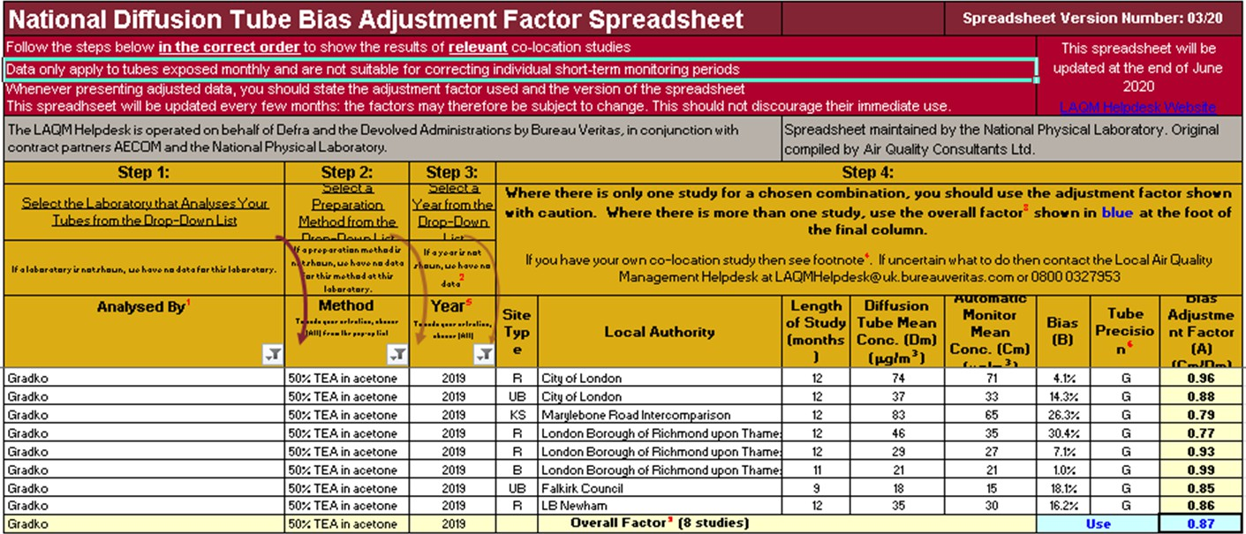

PM10 Monitoring Adjustment
All PM10 R&P TEOM data from 2008 onwards has been adjusted using the King’s College London Volatile Correction Method (VCM). This was carried out by Ricardo for the sites affiliated to the Scottish Air Quality Network in 2015 as part of the Scottish Government’s contract.
The PM10 monitor at the A8 Grangemouth AURN site has been a FDMS since April 2009 and so no correction factor has been applied to the data after this date. The VCM has been applied to the 2008 and 2009 AURN TEOM data by King’s College under contract to DEFRA. A PM10 Met One 1020 BAM analyser has replaced the R&P TEOM FDMS at the A8 Grangemouth AURN site on 06/06/2018 and no correction factor has been applied to this PM10 data since the installation of this analyser.
The PM10 monitor at the A13 Banknock 2 site has been a Palas Fidas 200 analyser since February 2015 so no correction factor has been applied to the data after this date.

Estimating PM2.5 from PM10 Measurements
LAQM TG (16)^{Ref1} describes two methodologies for estimating PM2.5 from PM10 measurements. Method one is to apply a locally-derived correction ratio calculated from local sites measuring both PM10 and PM2.5. The second is to apply a nationally derived correction ratio of 0.7. The national correction ratio should only be used where no appropriate local sites measuring both PM10 and PM2.5 are available. The locally derived correction ratio should only be used at sites of the same classification.
In 2019, Falkirk Council had three local sites monitoring both PM10 and PM2.5 these were the A7 Falkirk West Bridge St, A8 Grangemouth AURN and A13 Banknock 2 sites. The A7 Falkirk West Bridge St automatic station was upgraded to include PM2.5 monitoring capability through the commissioning of a Palas Fidas 200 analyser in November 2016. A sufficient volume of monitoring data has been collected since this installation date.
Using the guidance stated in LAQM TG (16)^{Ref1} the PM2.5 / PM10 ratios were calculated for the A7 Falkirk West Bridge St, A8 Grangemouth AURN and A13 Banknock 2 sites. The ratio derived from the A13 Banknock 2 data was applied to

sites classified as ‘roadside (non-urban)’, the ratio derived from the A8 Grangemouth AURN data was applied to sites classified as ‘urban background / industrial’ and the ratio derived from the A7 Falkirk West Bridge St data was applied to sites classified as ‘roadside (urban)’.
The local correction ratios were used to estimate PM2.5 from PM10 measurements at the following sites: A4 Falkirk Haggs, A5 Falkirk Hope St, A10 Grangemouth Municipal Chambers and A15 Main St Bainsford. Results are shown in Table A12 in Appendix A. Table C. 1 displays how the local ratios have been derived.
Table C.2 – Locally Derived PM2.5 / PM10 Correction Ratio

Site | Site Type | Annual Average PM10 (µg/m³), 2019 | Annual Average PM2.5 (µg/m³),  2019 | Ratio
A7 Falkirk West Bridge St | Roadside (Urban) | 11 | 6 | 0.55
A8 Grangemouth AURN | Urban Background / Industrial | 13 | 8 | 0.62
A13 Banknock 2 | Roadside (Non-urban) | 11 | 7 | 0.64

QA / QC Automatic Monitoring

Table C. 3 – Details of the QA / QC at the Automatic Monitoring Stations in 2019

QA / QC in 2019
Site | Analyser | Network
A3. Bo’ness | SO2 | SAQN
A4. Falkirk Haggs | NOx | SAQN
 | PM10 (TEOM / Fidas)
A5. Falkirk Hope St | NOx | SAQN
 | SO2
 | PM10 (TEOM)
A7. Falkirk West Bridge St | NOx | SAQN
 | PM10, PM2.5 (Fidas)
A8. Grangemouth AURN (Inchyra) | NOx | AURN
 | PM10 (BAM)
 | PM2.5 (BAM)
 | SO2

A9. Grangemouth Moray | NOx | AURN
 | SO2 | SAQN
A10. Grangemouth Municipal Chambers | NOx | SAQN
 | PM10 (TEOM / Fidas)
 | SO2
A11. Grangemouth Zetland Park | SO2 | SAQN
A13. Banknock 2 | PM10, PM2.5 (Fidas) | SAQN
A14. Banknock 3 | PM10 (Osiris) | Local
A15 Main St Bainsford | NOx | SAQN
 | PM10 (TEOM) | SAQN
Local sites:
- Analyser data is downloaded and a flow check is completed on a fortnightly basis.
- A filter change is completed on an approximate four weekly basis, although this is dependent on the weather and filter loading. The filters are retained for analysis.
- As with the other sites all LSO site visits are completed by Falkirk Council staffs that are audited to AURN standards.
- The Turnkey Osiris at Banknock 3 site is serviced on an annual basis and covered by a service agreement for any breakdowns, both are completed off-site.

AURN and Scottish AQ network sites:
- All NOx and SO2 analysers receive fortnightly zero and span checks and filter changes.
- TEOM heads are cleaned and the filter changed on a four weekly basis or more frequently if the filter loading increases above 90%.

- BAM PM10 and PM2.5 nozzles are cleaned and tapes are changed every eight weeks.
- All LSO site visits are carried out by Falkirk Council staffs that are audited to AURN standards.
- Analysers are covered by an emergency callout contract and receive a service every six months.
- QA / QC are conducted to AURN / ‘national’ standards.
- Falkirk Council also checks the data on its internal systems and is in regular communication with Ricardo to ensure the best data quality is collected / presented. Unscaled data is supplied by Falkirk Council to Ricardo for the Scottish AQ Network sites on a six monthly basis to improve data capture

Glossary of Terms

Abbreviation | Description
AADT | Annual Average Daily Traffic – total volume of vehicle traffic on a highway or road for a year divided by 365 days.
AQAP | Air Quality Action Plan – A detailed description of measures, outcomes, achievement dates and implementation methods, showing how the LA intends to achieve air quality limit values’
AQMA | Air Quality Management Area – An area where air pollutant concentrations exceed / are likely to exceed the relevant air quality objectives. AQMAs are declared for specific pollutants and objectives
APR | Annual Progress Report in relation to air quality
AURN | Automatic Urban and Rural Network (UK air quality monitoring network)
BAM | Beta Attenuation Monitor
CAFS | Cleaner Air for Scotland
DEFRA | Department for Environment, Food and Rural Affairs
DMRB | Design Manual for Roads and Bridges – Air quality screening tool produced by Highways England
ECSVEP | East Central Scotland Vehicle Emissions Partnership
EfW | Energy from Waste
EIA | Environmental Impact Assessment
EPUK | Environmental Protection UK
EU | European Union
FEL | Forth Environment Link
FDMS | Filter Dynamics Measurement System
FPS | Flood Prevention Scheme
GCMS | Gas Chromatography–Mass Spectrometry - analysis method
HDV | Heavy Duty Vehicle

IAQM | Institute of Air Quality Management
LAQM | Local Air Quality Management
LDV | Light Duty Vehicle
MCPD | Medium Combustion Plant Directive
NAQS | National Air Quality Strategy
NO2 | Nitrogen Dioxide
NOx | Oxides of Nitrogen
PDU | Public Display Unit
PM10 | Airborne particulate matter with an aerodynamic diameter of 10µm (micrometres or microns) or less
PM2.5 | Airborne particulate matter with an aerodynamic diameter of  2.5µm or less
PV | Photovoltaic (in relation to solar energy)
QA/QC | Quality Assurance and Quality Control
SEA | Supporting Environmental Appraisal
SEPA | Scottish Environment Protection Agency
SO2 | Sulphur Dioxide
TD | Thermal Desorption – Analysis Method
TEOM | Tapered Element Oscillating Microbalance
TGT | Tail Gas Treatment

References
  - Technical Guidance LAQM.TG (16), DEFRA and Devolved Administrations, February 2018.
  - Golder Associates Report Number: 115114880001.501/B.2, June 2015, available on request.
  - https://roadtraffic.dft.gov.uk/local-authorities/30 Road Traffic Statistics for Falkirk Council Area, Department for Transport, Accessed August 2020.
  - Civil Aviation Authority, UK Airport Statistics, CAA, Accessed August 2020.
  - Local Air Quality Policy PG (S) 16 https://www.gov.scot/publications/local-air- quality-management-policy-guidance-pg-s-16/, The Scottish Government, 2018.

Appendix D1: Supporting Technical Information – Proposal for Revocation of Banknock Air Quality Management Area (AQMA)
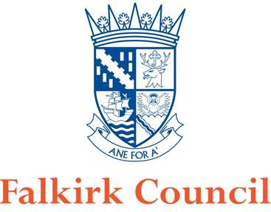

Proposal for Revocation of Banknock Air Quality Management Area (AQMA)
In fulfillment of Part IV of the Environment Act 1995 Local Air Quality Management
2020

Local Authority Officer | Author: John Millar (Air Quality Specialist) Reviewed by: David Gray (Env. Protection Co-ordinator) and  Graeme Webster (Env. Health and Trading Standards Manager)
Department | Environmental Health,  Development Services
Address | Abbotsford House, David’s Loan, Falkirk, FK2 7YZ
Telephone | 01324 504873
E-mail | JohnA.Millar@falkirk.gov.uk
Report Ref: | Revocation Proposal, Banknock AQMA
Status | Final
Date | 07/02/2020

Table of Contents

Introduction… 4

Air Quality Management Area – Particulate Material… 5

Local Quarry Operations… 5

Monitoring Equipment 6

Monitoring Data 7

Conclusion… 8

References 9

Figures 10

- Introduction
The Environment Act 1995 (HM Government, 1995) required the preparation of a national air quality strategy setting Air Quality Objectives (AQOs) for specified pollutants and outlining measures to be adopted by local authorities through the system of Local Air Quality Management (LAQM) and by others to work in pursuit of the achievement of these objectives. A National Air Quality Strategy was published in 1997 and subsequently reviewed and revised in 2000, and an addendum to the Strategy published in 2002. The current Strategy1 was published in July 2007 (Welsh Assembly Government, Scottish Executive, Department for Environment, Department for Environment Food and Rural Affairs, 2007).

The AQOs which are relevant to LAQM in Scotland and have been set into regulations, namely the Air Quality (Scotland) Regulations 20002, the Air Quality (Scotland) Amendment Regulations 20023 and the Air Quality (Scotland) Amendment Regulations 20164 (Scottish Government, 2016).

Falkirk Council has a responsibility to comply with the above regulations when managing local air quality. The Council completes its LAQM duties by managing an extensive air quality monitoring network, assessing results and reporting on areas of existing or anticipated poor air quality - declared via Air Quality Management Areas (AQMA).

One of the areas identified which was subject to historic poor air quality was Banknock, situated on Falkirk Council’s eastern boundary (adjacent to the North Lanarkshire local authority area). This is shown in section 8. Figures - Map 1 Banknock Area within Falkirk Council Boundary.

Air Quality Management Area – Particulate Material (24-hour and Annual Mean)

The Council’s Detailed Assessment⁵ of Particulate Material (PM10) in Banknock (published in December 2010) detailed a high volume of National Air Quality Objective (NAQS) exceedances for PM10 (24-hour and annual mean). This Detailed Assessment led to a declaration of the AQMA on 18th August 2011 following extensive consultation. Table 1 displays the pollutant of relevance for this AQMA revocation proposal, and the Scottish AQSs which must be met for the protection of human health.

Table 1 – AQSs for Scotland applicable for this proposal

Pollutant | Concentration | Measured as
Human Receptors
Particulate material (PM10) | 50 µg/m3, not to be exceeded more than 7 times a year | 24-hour mean
 | 18 µg/m3 | Annual Mean

The Detailed Assessment identified that local quarry operations combined with associated site and local road traffic had been a significant source of dust in this area. The AQMA within Banknock is shown in section 8. Figures – Map 2 – Banknock AQMA.

Local Quarry Operations

There has been an operational quarry at Cowdenhill, Banknock since as early as 1926, and this was operated by Stirlingshire County Council in the 1940's. The site has since been used intermittently for quarrying, with the Skene Group operating the quarry under modern working conditions from 2000 until July 2011. Falkirk Council Application F/99/0026 remains a live permission, allowing for the extraction of aggregate material from the site until 2024.

A nearby quarry called Tomfyne has been planned within the North Lanarkshire area which is awaiting approval. Falkirk Council is a statutory consultee on this.

The above quarries within the Banknock area are shown in section 8. Figures – Map 4 - Locations of Cowdenhill and Tomfyne Quarries in Banknock Area.

At present, there are no plans to extract further aggregate materials from these quarries.

Falkirk Council

- Monitoring Equipment

The following air quality monitoring equipment has been deployed in the Banknock area since 2009 until present: Table 2: Banknock AQMA Air Quality Monitoring Stations and Equipment
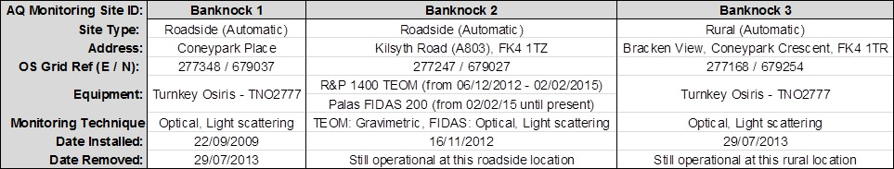

The location of the Banknock 2 and 3 automatic monitoring stations can be shown in section 8. Figures - Map 3 - Monitoring Station Locations.
The current monitoring stations and equipment for Banknock 2 and 3 stations above can be shown in Appendix 1 – Photos.

Monitoring Data

Falkirk Council monitors PM10 and other pollutants at several locations throughout the Council area using both automatic and passive sampling methods. The automatic monitoring data displayed below has been fully ratified in accordance with the Scottish Air Quality Database QA/QC Process6.

The Council currently operates two automatic monitoring stations located within the Banknock AQMA – these are Banknock 2 and 3 (as detailed in Table 2).

The PM10 (24 hour and annual mean) monitoring data (as extracted from the 2019 Falkirk Council APR7) are displayed in Tables 3 and 4.

Table 3: Measured PM10 24-Hour Mean Results 2014 – 2018

Site ID | Site Type | Valid Data Capture for Monitoring Period (%)  (1) | Valid Data Capture 2018 (%)  (2) | PM10 24-Hour Means >50µg/m³ ⁽³⁾
 |  |  |  | 2014 | 2015 | 2016 | 2017 | 2018
A13 | Banknock 2 | 100 | 100 | 3 | 4 | n/a | 7 | 0
A14 | Banknock 3 | 80 | 80 | 0 (24) | 1 | 3 | 0 | 2 (10)
Notes: Exceedances of the PM10 24-hour mean objective (50µg/m³ not to be exceeded more than 7 times/year) are shown in bold.
  - Data capture for the monitoring period, in cases where monitoring was only carried out for part of the year.
  - Data capture for the full calendar year (e.g. if monitoring was carried out for 6 months, the maximum data capture for the full calendar year is 50%).
  - If the period of valid data is less than 85%, the 98.1st percentile of 24-hour means is provided in brackets.

Table 4: Measured PM10 Annual Mean Results 2014 – 2018

Site ID | Site Type | Valid Data Capture for Monitoring Period (%)  (1) | Valid Data Capture 2018 (%)  (2) | PM10 Annual Mean Concentration (µg/m³)
 |  |  |  | 2014 | 2015 | 2016 | 2017 | 2018
A13 | Banknock 2 | 99 | 99 | 13.2 | 11 | 11 | 13 | 11
A14 | Banknock 3 | 80 | 80 | 15 | 8.2 | n/a | 7 | 6.9
Notes: Exceedances of the PM10 annual mean objective of 18µg/m³ are shown in bold.
    - Data capture for the monitoring period, in cases where monitoring was only carried out for part of the year.
    - Data capture for the full calendar year (e.g. if monitoring was carried out for 6 months, the maximum data capture for the full calendar year is 50%).
    - All means have been “annualised” as per LAQM.TG (16); valid data capture for the full calendar year is less than 75%.

Conclusion

The Banknock AQMA was declared on the 18th August 2011 following a high volume of National Air Quality Objective (NAQS) exceedances for PM10 (24-hour and annual mean). Since the AQMA was declared, measured concentrations (using automatic, referenced monitoring methods) of PM10 have complied with the NAQS objectives consistently over the past five years (since 2014).
A previous review and assessment report has identified that local quarry operations combined with associated site and local road traffic had been a significant source of dust in this area.
It is understood that there are no current plans to operate any aggregate quarries within the Banknock area.

As a result of the ongoing automatic air quality monitoring within the Banknock AQMA the Council has demonstrated that the 24-hour and annual mean concentrations of PM10 complies with the NAQS objectives. It is understood that the reduction in quarry operations in this area has led to a reduction in overall PM10 concentrations and thus compliance with the NAQS objectives.

As stated within the Air Quality in Scotland (LAQM) website in relation to AQMA Revocation: ‘Where a local authority feels that it has sufficient evidence to justify the need to amend/revoke an AQMA at any time, it should submit that evidence to the Scottish Government for appraisal. For those authorities that have continuous monitoring, the Scottish Government would expect them to keep the AQMA under regular review, and to take action where necessary, rather than await the next round of reviews and assessments.’

Falkirk Council will continue to have a PM10 monitoring capability within this area until 2024 when the live planning consent of the Cowdenhill quarry expires. It is anticipated that the automatic monitoring equipment within the Banknock area could be used to focus on other areas of poor air quality within the region.

Falkirk Council is requesting the permission of the Scottish Government and Scottish Environment Protection Agency (SEPA) to revoke the Banknock AQMA. Pending permission approval, Falkirk Council will notify all other statutory consultees and publicise the revocation through local / social media, so the public and local businesses are fully aware of the situation.

References

- The Air Quality Strategy for England, Scotland, Wales and Northern Ireland (Volume 1, July 2007, Department for Environment, Food and Rural Affairs in partnership with the Scottish Executive, Welsh Assembly Government and Department of the Environment Norther Ireland)
- The Air Quality (Scotland) Regulations 2000 (31st March 2000, The Scottish Government)
- The Air Quality (Scotland) Amendment Regulations 2002 (11th June 2002, The Scottish Government)
- The Air Quality (Scotland) Amendment Regulations 2016 (1st April 2016, The Scottish Government)

- Detailed Assessment of PM10 in Banknock (December 2010, Falkirk Council)
- The Scottish Air Quality Database QA/QC Process (28th March 2012, AEA Ricardo / The Scottish Government)

- Annual Progress Report (July 2019, Falkirk Council)

- Figures - Map 1 - Banknock Area within Falkirk Council Boundary
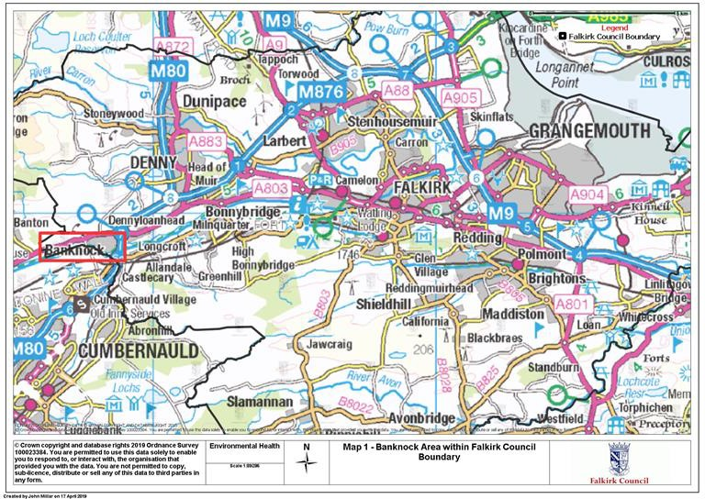

Map 2 - Banknock AQMA
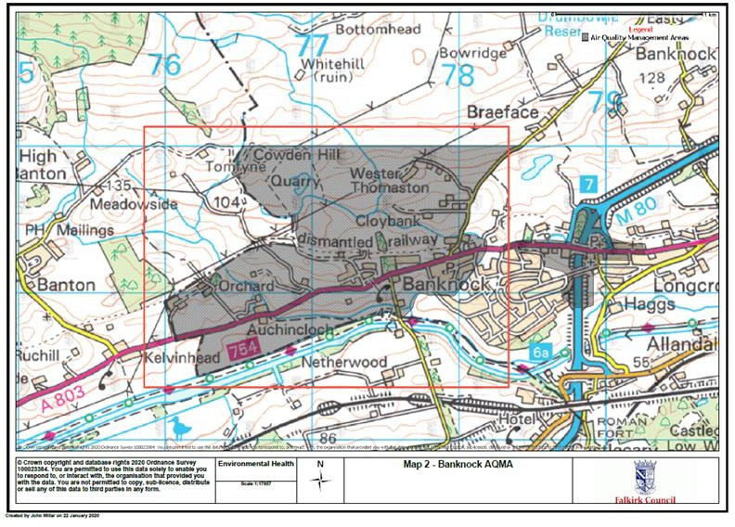

Map 3 - Monitoring Station Locations
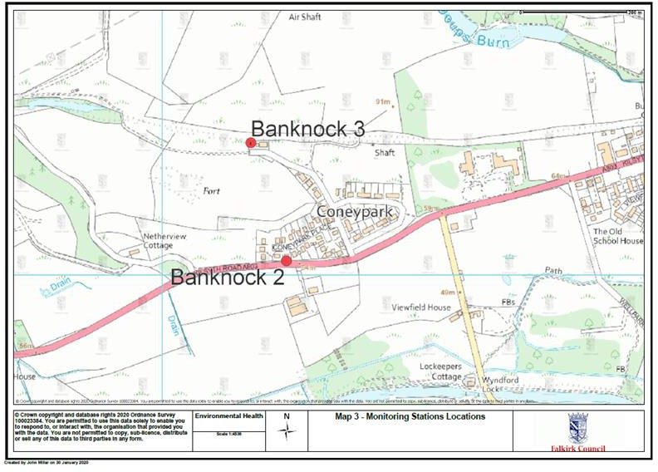

Falkirk Council Map 4 – Locations of Cowdenhill and Tomfyne Quarries in Banknock Area
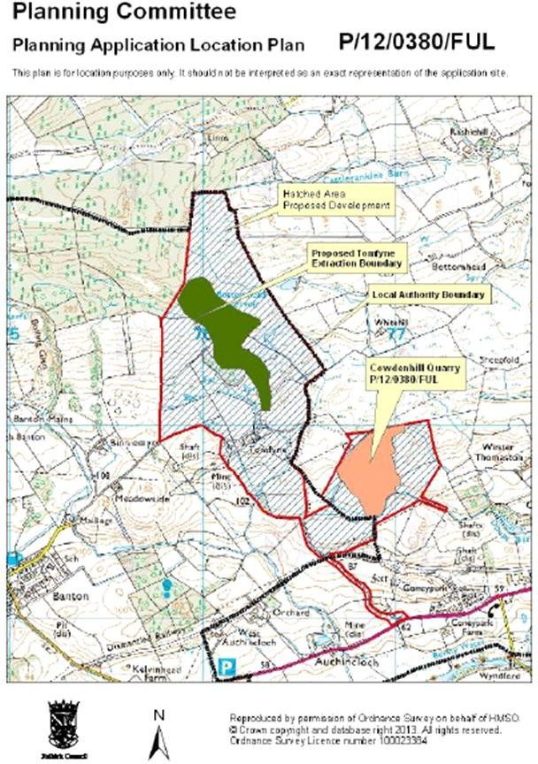

Falkirk Council
Appendix 1: Photo 1 – Banknock 2 Automatic Roadside Station
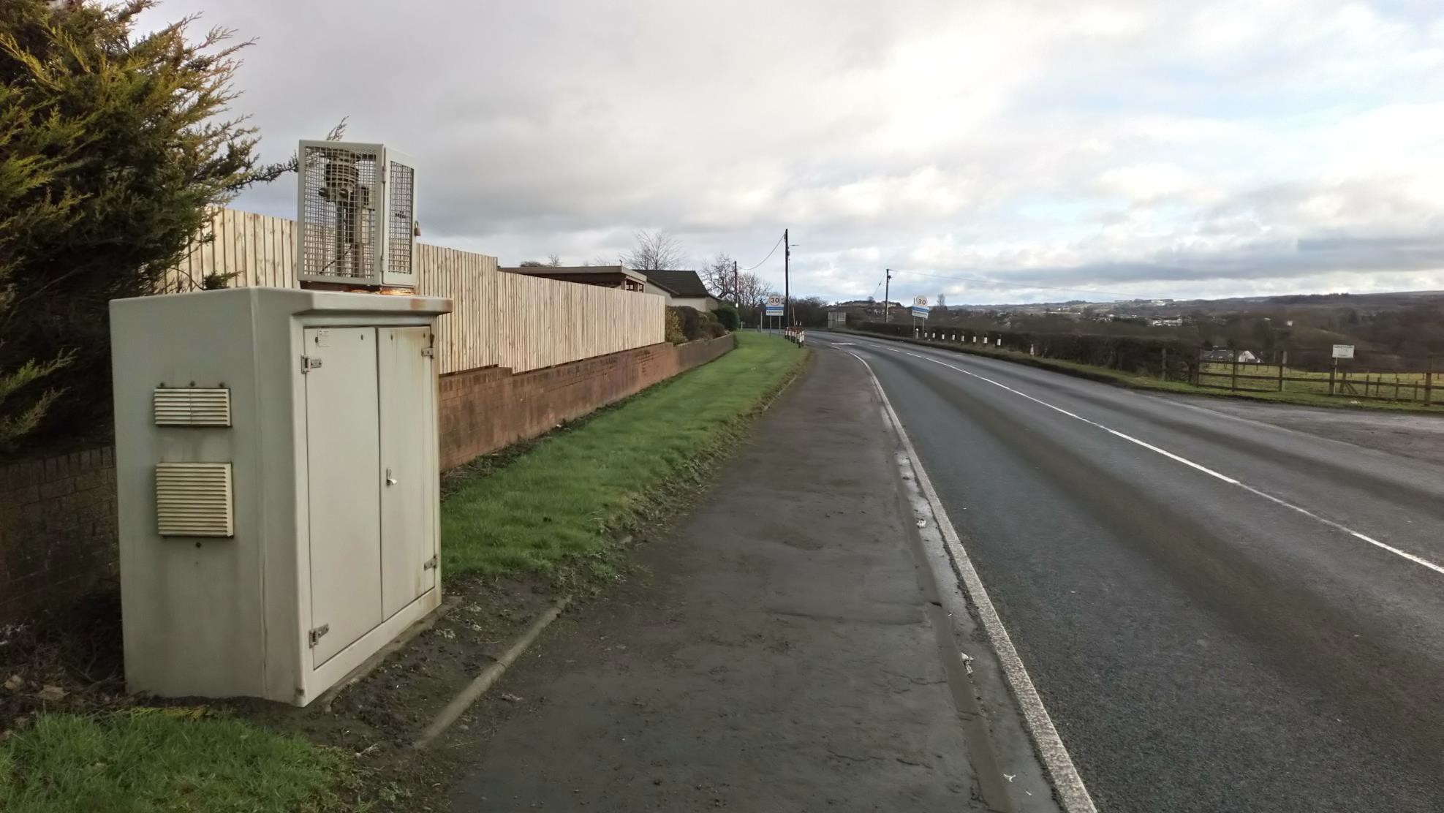

Falkirk Council
Photo 2 – Banknock 2 Automatic Roadside Station
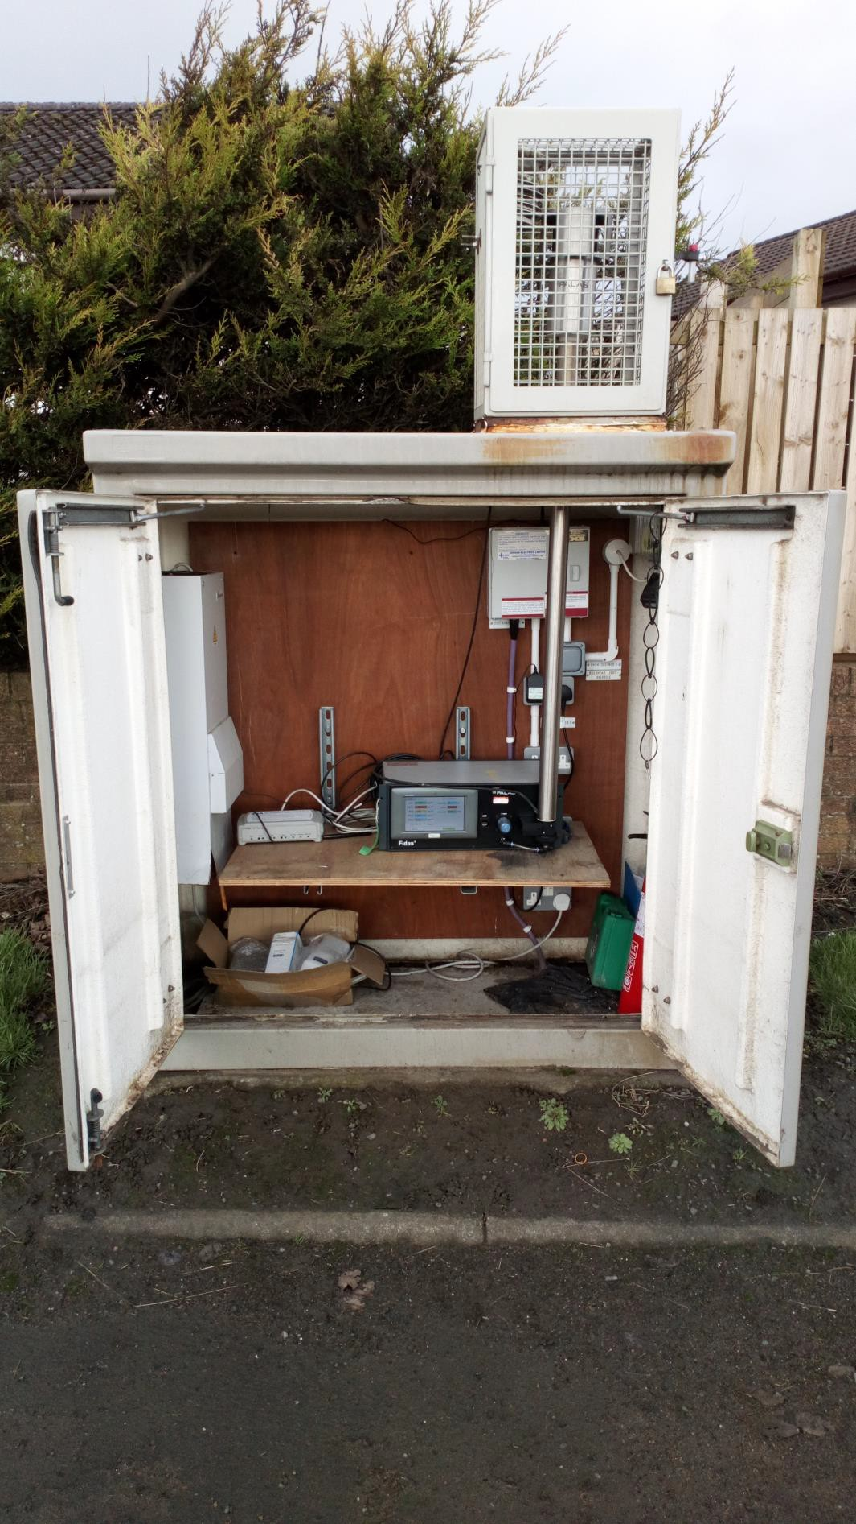

Falkirk Council
Photo 3 – Banknock 3 Automatic Rural Station
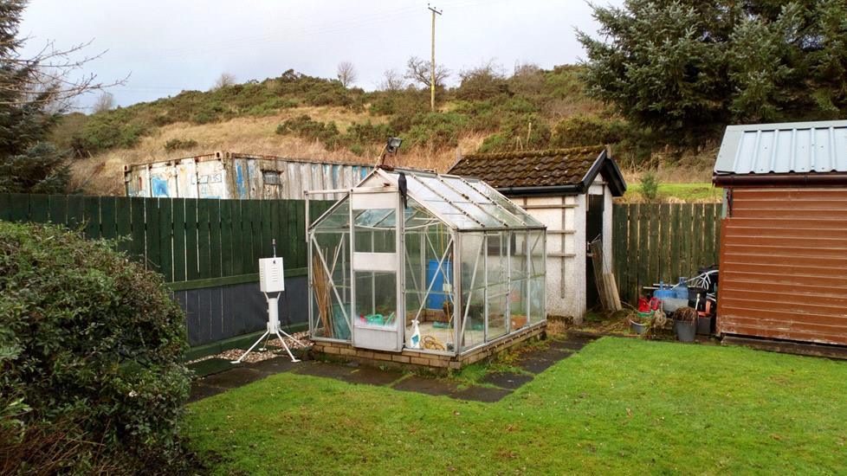

Photo 4 – Banknock 3 Automatic Rural Station
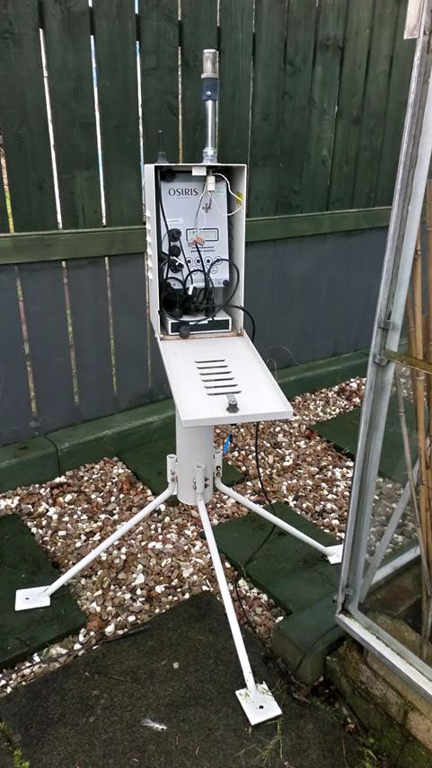

Appendix D2: Sweco – Grangemouth Emissions Study – Technical Note

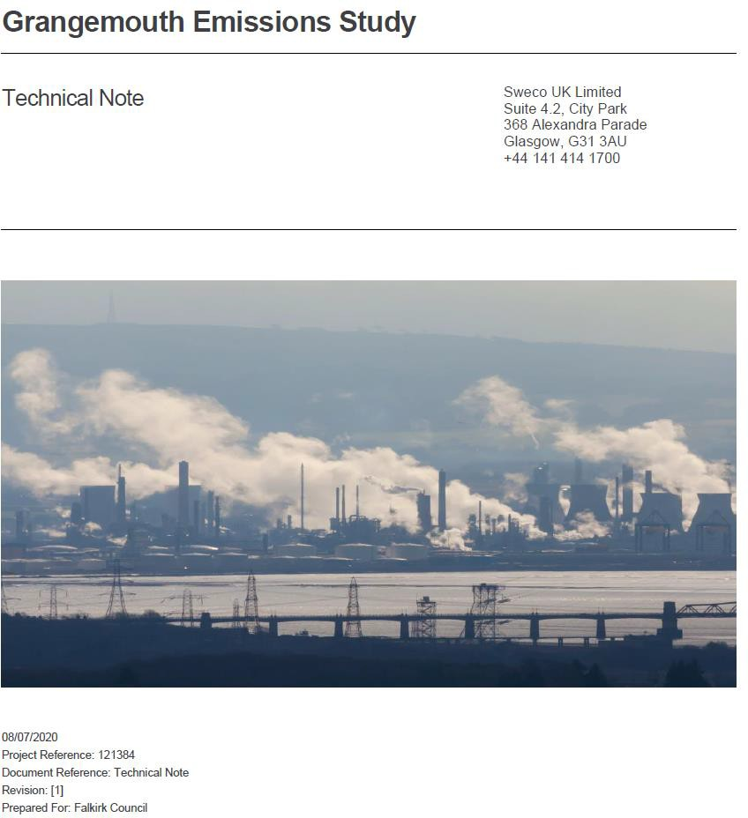

Introduction
Sweco has been appointed by Falkirk Council to provide consultancy support on behalf of them and SEPA for the following studies.
- Produce a Review and Assessment Report of the Grangemouth AQMIA including dispersion modelling of all industrial emissions. (based on 2017 data)
- Produce a Grangemouth traffic emissions modelling study
- Combine the results from both dispersion modelling studies into one combined model/ report.
  - Background
This Technical Note has been prepared for the Couneiil to allow them to submit an overview of the work currently being urndertaken by Sweco, as part of the Councils Annual Progress Report.
Grangemou h is a town within the Falkirk local authority area. Falkirk Council declared an AQMA in Grangemou h for the SO2 15minute mean in 2005 for an area encompassing Grangemouth petrochemical complex and the adjacent area.
Previous assessment work in the AQMA has focussed on the short term SO2 objectives in isolation. This package of work will considerhe following pollutant emissions. NO2, Particulates PM10 and PMl25, SO2 and CO, where data are available.
At the time of commissioning this package of work 2017 emissions data were to be used for both studies. However, while the 2017 emissions inventory was being built and the models developed, new industrial emissions data were provided by SEPA for 2018. These data showed that emissions had reduced during 2018 due to new permits and BAT. Therefore, the Council and SEPA agreed that an updated 2018 emission inventory be built for both the industrial emissions and road traffic emissions.
The studies will through detailed dispersion modelling predict the various pollutant air quality concentrations within Grangemouth and detailed source apportionment modelling for all sources. This will determine which sources have the greatest influence on air quality concentrations within Grangemou h.
Since previous air quality modelling of sources within Grangemouth, there has been considerable changes to sources andheir emissions.
To our knowledge, this assessment is the first assessment where both the road traffic sources and industrial sources within Grangemouth have been modelled together. By combining both the industrial and traffic emissions in a complete assessment, this will give Falkirk Council an overall understanding of all emissions and traffic sources within the Grangemouth area and inform future management of the AQMA.

At the time of preparing the APR the findings of the studies have not yet been finalised and approved by the Council or SEPA. This Technical Note provides an overview of the work currently being undertaken. Full details of the emissions inventory; model input data. model setup and model verification have not been provided as part of this Technical Note but will be provided in full wifhin the final report.
Both studies, once approved by the Council and SEPA will be submitted to the Scottish Government.

Methodology
The modelling undertaken in the studies has followed best practice for both the road source modelling and the industrial source modelling. Modelling and model verification have been undertaken in accordance with LAQM TG.16.
  - Emissions Inventory
    - Road Traffic Emissions
A review ofhe road network within Grangemouth and the surrounding area was undertaken to identify the key road traffic links. As art of identifying which road links the model would include identifying the key model verification locations was key. Initially, the road traffic modelling was undertaken for 2017 using 2017 emissions and monitoring data. This was then updated to 2018 emissions data.
Falkirk Council undertakes automatic traffic counts (ATC) at a number of locations across the Council area. The Council provided Annual Average Daily Traffic (AADT) flows derived fromheir ATC count data for 2018. Unfortunately, not all roads within Grangemouth are curren l,ycovered by the Councils ATCs. Where ATC data were unavailable, traffic data was supplemented with Department for Transport (DfT) traffic data for 2018.
The ATC data and the DfT data provide detailed fleet split. The fleet split information for each modelled road link inclluded where available:
      - Motorcycles
      - Cars
      - LGV
      - HGV
      - Buses

    - Industrial Emissions
Given there has been several studies of SO2 undertaken on behalf of the Council the Council and SEPA were keen that the study focussed on understanding emissions of the other key LAQM pollutants NOx PM10 and CO. Following discussions with Falkirk Council and SEPA, an initial review was undertaken of all permitted sites wi hin the Grangemouth AQMA to determine which ones emitted these pollutants.

This initial screening identified a number of permitted sites. SEPA provided access to their reporting portal¹ which is used by each site to provide annual reporting requirements.
The next stage was to use the emissions inventory to build a dispersion model of all of the point sources identified for each site. For each point source we required all efflux parameters for each stack to allow them to be included in the model and operating in 2018.
While there were a number of point sources identified which did have the key pollutant emissions reported there were no efflux stack parameters reported and therefore these sources could not be modelled at this time.
Based on the information within the SEPA reporting portal we were able to model sources for llhe following sites:
      - Petrolneos
      - Fortrum Grangemouth
      - lneos
      - lneos lnfrastriucture
      - lneos Chemiicals
      - lneos FPS
      - Engie
      - Calachem

  - Modelling
    - Road traffic emissions model
Emissions were calculated using the built-in EFT (EFT v9.0) in the latest version of ADMS ROADS v5. This version of the model allows for traffic induced turbulence to be calculated when the model calculates the emissions based on the numbers of vehicles, speed and the types of vehicle on eac,h road link modelled explicitly in the model.
    - Industrial emission model
ADMS 5.2 was used to model the emissions from the point sources. From our previous experience in modelling the emissions sources in Grangemouth we know the importance of considering calm met conditions. We were also aware from the emissions inventory that there were a number of sources where the flues exited through one stack. The additional input file allowed calm conditions to be selected and for flues to be combined where applicable
  - Receptors
Pollutant concentrations for NOx, PM10 and CO were predicted al sensitive receptors.across the study area where the National Air Quality Objectives (AQOs) are applicable for comparison with the annual mean and the 8 hour mean for CO. The same receptor locations were selected for both the

1 https://beta.sepa.org.uk/publicregister/

road traffic modelling and the industrial modelling to allow for the total pollutant contributions to be summed.

Source Apportionment
Source apportionment is the process that quantifies the contributions of different pollutant sources to pollutant concentrations. This can allow the local authority to target specific sources when attempting to reduce pollutant concentrations in the AQMA.
In local air quality, road transport, local background concentrations, industrial, domestic and commercial sources all contribute to local air quality concentrations.
Withiin the road traffic study, the contributions from the different types of vehicles (e.g. cars, LGVs, IHGVs and buses) have been determined to identify which vehicle types represent the most significant sources of polllution.
The source apportionment analysis was undertaken using air dispersion modelling which modelled the contributions of emissions of NOx and PM10 from various fleet sources. The following vehicle fleet categories were included within the source apportionment:
- Motorcycles
- Cars
- Light Good Vehicles (LGV)
- Heavy Good Vehicles (HGV)
- Buses
The source apportionment analysis was undertaken at a range of receptor locations throughout the study area. This analysis will identify the key source on each road link modelled.
  - Industrial Emissions
The industrial sites oumned above were included within the source apportionment. The sources were grouped within the model for each site/ facility to allow for fhe analysis.
The source apportionment analysis was undertaken at a range of receptor locations throughout the study area. The source apportionment analysis will identify the oontribution to NOx and PMrn pollutant concentrations from each industrial site.

Results
The modellling results for both the road traffic modelling and industrial source modelling are subject to approval! by the Council and SEPA. All results will be reported within the final report.

