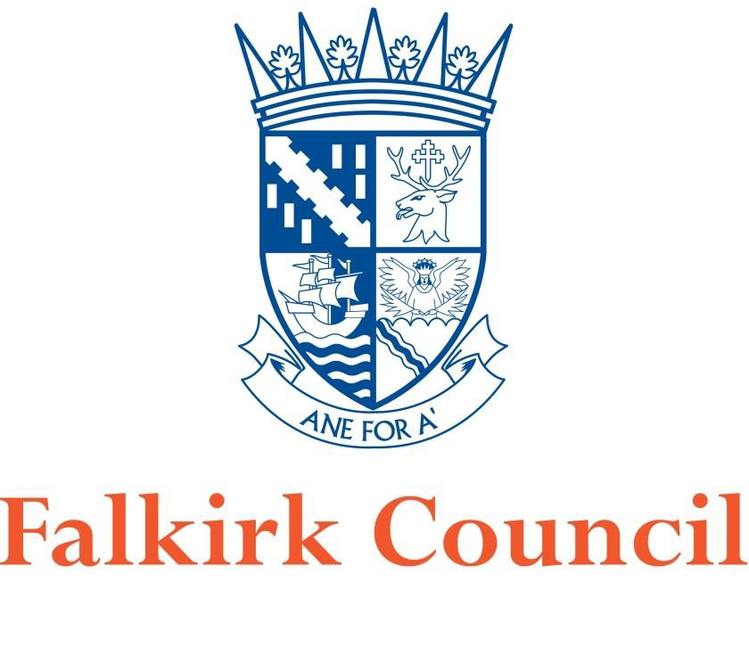


Proposal for Revocation of Haggs Air Quality Management Area (AQMA)
In fulfillment of Part IV of the Environment Act 1995 Local Air Quality Management
2021

Local Authority Officer | Author: John Millar (Air Quality Specialist)  Reviewed by: David Gray (Env. Protection Co-ordinator)
Department | Environmental Health, Development Services
Address | Abbotsford House, David’s Loan, Falkirk, FK2 7YZ
Telephone | 01324 504873
E-mail | JohnA.Millar@falkirk.gov.uk
Report Ref: | Revocation Proposal, Haggs AQMA
Status | Final
Date | 16/04/2021

Table of Contents
- Introduction… 4
- Air Quality Management Area – Nitrogen Dioxide 5
- Local Pollution Sources 5
- Monitoring Equipment 7
- Monitoring Data 9
- Conclusion… 11
- References 12
- Figures 13
- Appendices 17

.

Introduction
The Environment Act 1995 (HM Government) required the preparation of a National Air Quality Strategy (NAQS) setting Air Quality Objectives (AQOs) for specified pollutants and outlining measures to be adopted by local authorities through the system of Local Air Quality Management (LAQM) and by others to work in pursuit of the achievement of these objectives. The NAQS was published in 1997 and subsequently reviewed and revised in 2000, and an addendum to the Strategy published in 2002. The current Strategy1 was published in July 2007 (Welsh Assembly Government, Scottish Executive, Department for Environment, Department for Environment Food and Rural Affairs).

The AQOs which are relevant to LAQM in Scotland and have been set into regulations, namely the Air Quality (Scotland) Regulations 20002, the Air Quality (Scotland) Amendment Regulations 20023 and the Air Quality (Scotland) Amendment Regulations 20164 (Scottish Government).

Falkirk Council has a responsibility to comply with the above regulations when managing local air quality. The Council completes its LAQM duties by managing an extensive air quality monitoring network, assessing results and reporting on areas of existing or anticipated poor air quality - declared via Air Quality Management Areas (AQMA).

One of the areas identified which was subject to historic poor air quality was Haggs, situated on Falkirk Council’s western boundary. This is shown in section 8. Figures - Map 1 Haggs Area within Falkirk Council Boundary.

Air Quality Management Area – Nitrogen Dioxide (Annual Mean)

The Council’s Detailed Assessment5 of air quality in Haggs (published in July 2008) detailed NAQS exceedances for nitrogen dioxide (NO2) (annual mean). This Detailed Assessment and further air quality data analysis led to a declaration of the AQMA on 18th March 2010 following extensive public consultation. Table 1 displays the pollutant of relevance for this AQMA revocation proposal, and the Scottish NAQS objective which must be met for the protection of human health.

Table 1 – Scottish NAQS Objective for Applicable for this Proposal

Pollutant | Concentration | Measured as
Human Receptors
Nitrogen Dioxide (NO2) | 40µg/m3 | Annual Mean

The Detailed Assessment and subsequent Further Assessment6 of local air quality in Haggs identified that road traffic (specifically the upgrade and expansion of the A80 road to M80 motorway) and local quarry site traffic (Cowdenhill quarry located at Banknock) had been significant sources of NO2 which affected relevant receptors. The AQMA within Haggs is shown in section 8. Figures – Map 2 – Haggs AQMA.

Local Pollution Sources
M80 Stepps to Haggs Motorway Expansion

The new 18-kilometre section of motorway was completed in August 2011 which connected the existing M80 at Junction 2 (Robroyston) to the area immediately north of Haggs. The road was partially expanded from an ‘A’ road to motorway.

The Transport Scotland road upgrade scheme included linking the Moodiesburn Bypass (bypassing the communities of Muirhead, Chryston and Moodiesburn) with the previously upgraded Auchenkilns junction in North Lanarkshire. Some of the benefits of this project (as described by Transport Scotland) include delivering significant economic, environmental and safety benefits, by improving road safety and access to the north and south of the country7.

The roadworks during the above major route expansion works led to altered traffic flows both on the A80 and on the A803 Kilsyth Road (the main road through Haggs) which was connected via two (one on, one off) slip roads. During 2009, a 40mph (65 km/hr) speed limit was established on the A80 using average speed cameras for enforcement. The speed limit during normal operation of this section

of the A80 following completion of the roadworks were the national speed limit (112 km/hr).

The M80 (Stepps to Haggs) motorway road upgrade has now been fully completed and has been operational since 2011. There are no current, major motorway roadworks planned in the Haggs area (with any associated speed reduction restrictions) which could adversely affect local air quality through congestion.

Local Quarry Operations

There has been an operational quarry at Cowdenhill, Banknock since as early as 1926, and this was operated by Stirlingshire County Council in the 1940's. The site has since been used intermittently for quarrying, with the Skene Group operating the quarry from 2000 until July 2011. Falkirk Council Application F/99/0026 remains a live permission, allowing for the extraction of aggregate material from the site until 2024.

A nearby quarry called Tomfyne has been planned within the North Lanarkshire area which is awaiting approval. Falkirk Council is a statutory consultee on this.

At present, there are no plans to extract further aggregate materials from these quarries. Further details of these quarries, their operation and effect on local air quality can be found in the Falkirk Council ‘2020 Banknock AQMA Revocation Proposal Report’8

Monitoring Equipment
The following air quality monitoring equipment has been deployed in the Haggs area since 2007 until present: Table 2: Haggs AQMA Automatic Air Quality Monitoring Station and Associated Equipment

AQ Monitoring Site ID: | Falkirk Haggs
Site Type: Address:  OS Grid Ref (X / Y): | Roadside (Automatic)
 | Kerr Crescent, Haggs, FK4 1HN
 | 278977 / 679271
Equipment: | Monitor Labs ML 9041 (NO_{x}) (Operating from 09/11/2007 - 23/10/2018)
 | API Teledyne T200 (NO_{x}) (23/10/2018 - Present)
 | R&P 1400 TEOM (PM₁₀) (09/11/2007 - 04/06/2020 )
 | Palas FIDAS 200 (PM₁₀) (04/06/2020 - Present)
Monitoring Technique: | Monitor Labs ML 9041: Chemiluminescence
 | API Teledyne T200: Chemiluminescence
 | R&P 1400 TEOM: Gravimetric
 | Palas FIDAS 200: Optical, light-scattering
Date Site Installed:  Date Site Removed: | 09/11/2007
 | Roadside station still operational

The location of the Haggs automatic monitoring station can be shown in section 8. Figures - Map 3 – Automatic Monitoring Station Location.
The current Haggs monitoring station and equipment can be shown in Appendix 1 – Photos.

Table 3: Haggs AQMA Non-Automatic Air Quality Monitoring Diffusion Tube Locations

Site ID | Site Name | Site Type | X OS  Grid Ref | Y OS  Grid Ref | Pollutants Monitored | In AQMA? | Distance to Relevant Exposure  (m) (1) | Distance to kerb of nearest road (m) (2) | Tube collocated with a Continuous Analyser?
NA19 | Kilsyth Rd, Banknock | Roadside | 278779 | 679301 | NO2 | Y | <2 | 2.2 | N
NA20 | Garngrew Rd, Haggs | Urban Background | 278957 | 679172 | NO2 | N (On AQMA  boundary) | <5 | 1.5 | N
NA36 | Kerr Crescent, Haggs | Roadside | 278985 | 679273 | NO2 | Y | <5 | 2.1 | N
NA85 | Auchincloch Dr, Banknock | Roadside | 278752 | 679049 | NO2 | Y | <2 | 0.8 | N
NA87 | M80 Slip South, Haggs | Roadside | 279017 | 679305 | NO2 | Y | <2 | 1.6 | N

The locations of the above non-automatic diffusion – Non-Automatic Monitoring Stations

tubes located within the Haggs
AQMA can be shown in section 8. Figures – Map 4

Falkirk Council

Monitoring Data

Falkirk Council monitors NO2 and other pollutants at several locations throughout the Council area using both automatic and passive (non-automatic) sampling methods. The automatic monitoring data displayed below has been fully ratified in accordance with the Scottish Air Quality Database Quality Assurance / Quality Control (QA/QC) process⁹. Non-automatic monitoring (NO2 diffusion tube) analysis displayed below was completed by Gradko International Ltd. Gradko adheres to the Department of Environment Food and Rural Affairs (DEFRA) guidance for the preparation and analysis of the NO2 diffusion tubes. All the results relating to the concentration of NO2 present on the diffusion tube are within the scope of Gradko’s United Kingdom Accreditation Service (UKAS) accreditation. Further details of diffusion tube analysis including local and national NO2 bias adjustment can be found in the most recent Falkirk Council APR: https://www.falkirk.gov.uk/services/environment/environmental-policy/air-quality/

The Council currently operates one automatic monitoring station located within the Haggs AQMA (as detailed in Table 2).

The NO2 (annual mean) monitoring data (as extracted from Falkirk Council’s 2020 APR10) are displayed in Table 4.

Falkirk Council

Table 4: Measured Automatic NO2 Annual Mean Results 2015 – 2019

Site ID | Site Type | Valid Data Capture for Monitoring Period (%) (1) | Valid Data Capture 2019 (%) (2) | NO2 Annual Mean Concentration (µg/m³)
 |  |  |  | 2015 | 2016 | 2017 | 2018 | 2019
A4 | Falkirk Haggs | 94 | 94 | 30 | 33 | 28 | 28 | 27
Notes: Exceedances of the NO2 annual mean objective of 40µg/m³ are shown in bold.
  - Data capture for the monitoring period, in cases where monitoring was only carried out for part of the year.
  - Data capture for the full calendar year (e.g. if monitoring was carried out for 6 months, the maximum data capture for the full calendar year is 50%).

Table 5: Measured Non-Automatic (Diffusion Tube) NO2 Annual Mean Results 2015 – 2019

Site ID | Site Type | Valid Data Capture for Monitoring Period (%) (1) | Valid Data Capture 2019 (%) (2) | NO2 Annual Mean Concentration (µg/m³)⁽³⁾
 |  |  |  | 2015 | 2016 | 2017 | 2018 | 2019
NA19 | Kilsyth Rd, Banknock | 83 | 83 | 26 | 33 | 26 | 28 | 27
NA20 | Garngrew Rd, Haggs | 100 | 100 | 23 | 24 | 22 | 22 | 22
NA36 | Kerr Crescent, Haggs | 91 | 91 | 37 | 38 | 35 | 37 | 35
NA85 | Auchincloch Dr, Banknock | 100 | 100 | 20 | 16 | 17 | 19 | 20
NA87 | M80 Slip South, Haggs | 100 | 100 | 32 | 30 | 27 | 28 | 31
Notes: Exceedances of the NO2 annual mean objective of 40µg/m³ are shown in bold.
- Data capture for the monitoring period, in cases where monitoring was only carried out for part of the year.
- Data capture for the full calendar year (e.g. if monitoring was carried out for 6 months, the maximum data capture for the full calendar year is 50%).
- Means for diffusion tubes have been corrected for bias. All means have been “annualised” as per LAQM.TG(16) if valid data capture for the full calendar year is less than 75%.

Conclusion

The Haggs AQMA was declared on the 18th March 2010 following NAQS exceedances for NO2 (annual mean). Since the AQMA was declared, measured concentrations (using automatic and non-automatic monitoring methods) of NO2 have complied with the NAQS objectives consistently over the past five years (since 2015).
The Detailed5 and Further6 Assessments identified that road traffic (specifically the upgrade expansion of the A80 to M80 Stepps to Haggs motorway) and local quarry site traffic (Cowdenhill quarry at Banknock) had been significant sources of NO2 which affected relevant receptors within the Haggs area. It is understood that the M80 (Stepps to Haggs) road upgrade has now been fully completed and there are no further major motorway roadworks planned in the Haggs area (with any speed reduction restrictions). There are no current plans to operate any aggregate quarries within the Banknock area.

As a result of the ongoing automatic and non-automatic air quality monitoring within the Haggs AQMA, the Council has demonstrated that the annual mean concentrations of NO2 complies with the relevant NAQS objective. It is understood that the opening of the M80 motorway and the reduction in quarry operations in this area has led to a reduction in overall NO2 concentrations and thus compliance with the NAQS objectives.

As stated within the Air Quality in Scotland (LAQM) website in relation to AQMA Revocation: ‘Where a local authority feels that it has sufficient evidence to justify the need to amend/revoke an AQMA at any time, it should submit that evidence to the Scottish Government for appraisal. For those authorities that have continuous monitoring, the Scottish Government would expect them to keep the AQMA under regular review, and to take action where necessary, rather than await the next round of reviews and assessments.’

Falkirk Council will continue to have a NO2 (and PM10) monitoring capability within this area until 2024 when the live planning consent of the Cowdenhill quarry expires. It is anticipated that the automatic monitoring equipment within the Haggs area could be used to focus on other areas of poor air quality within the region.

Falkirk Council is requesting the permission of the Scottish Government and Scottish Environment Protection Agency (SEPA) to revoke the Haggs AQMA (thus reducing Falkirk Council’s AQMAs from three to two). Pending permission approval, Falkirk Council will notify all other statutory consultees and publicise the revocation through local / social media, so the public and local businesses are fully aware of the situation.

References

- The Air Quality Strategy for England, Scotland, Wales and Northern Ireland (Volume 1, July 2007, Department for Environment, Food and Rural Affairs in partnership with the Scottish Executive, Welsh Assembly Government and Department of the Environment Norther Ireland)
- The Air Quality (Scotland) Regulations 2000 (31st March 2000, The Scottish Government)
- The Air Quality (Scotland) Amendment Regulations 2002 (11th June 2002, The Scottish Government)
- The Air Quality (Scotland) Amendment Regulations 2016 (1st April 2016, The Scottish Government)
- Local Air Quality Management Detailed Assessment of NO2 Concentrations at Banknock and Haggs (July 2008, BMT Cordah for Falkirk Council, Report Ref: E_FAL_026 / Report 5, shown in Appendix 2)
- Haggs / Banknock Further Assessment of Air Quality (March 2011, BMT Cordah for Falkirk Council, Report Ref: G.FAL.033.HAGGS, shown in Appendix 3)

- M80 Stepps to Haggs Project (Transport Scotland, https://www.transport.gov.scot/projects/m80- stepps-to-haggs/m80-stepps-to-haggs/)

- Falkirk Council ‘2020 Banknock AQMA Revocation Proposal Report’ (https://www.falkirk.gov.uk/services/environment/environmental-policy/air-quality/docs/air- quality/10%202020%20Banknock%20AQMA%20Revocation%20Proposal%20Report.pdf?v=2020 10220950)
- The Scottish Air Quality Database QA/QC Process (28th March 2012, AEA Ricardo / The Scottish Government)

- 2020 Annual Progress Report (November 2020, Falkirk Council)

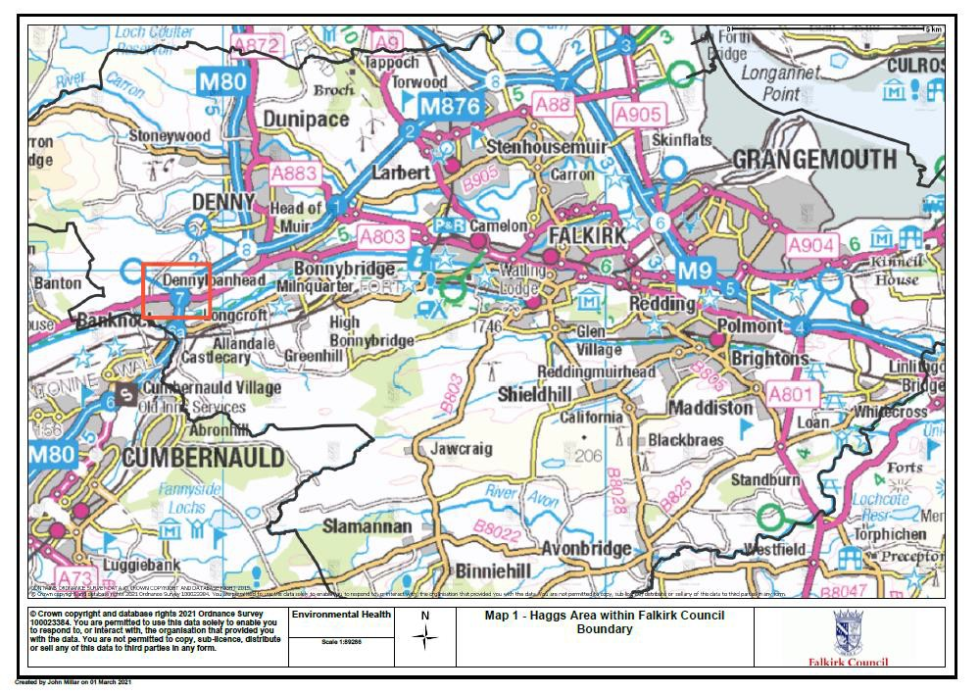
- Figures - Map 1 - Haggs Area within Falkirk Council Boundary

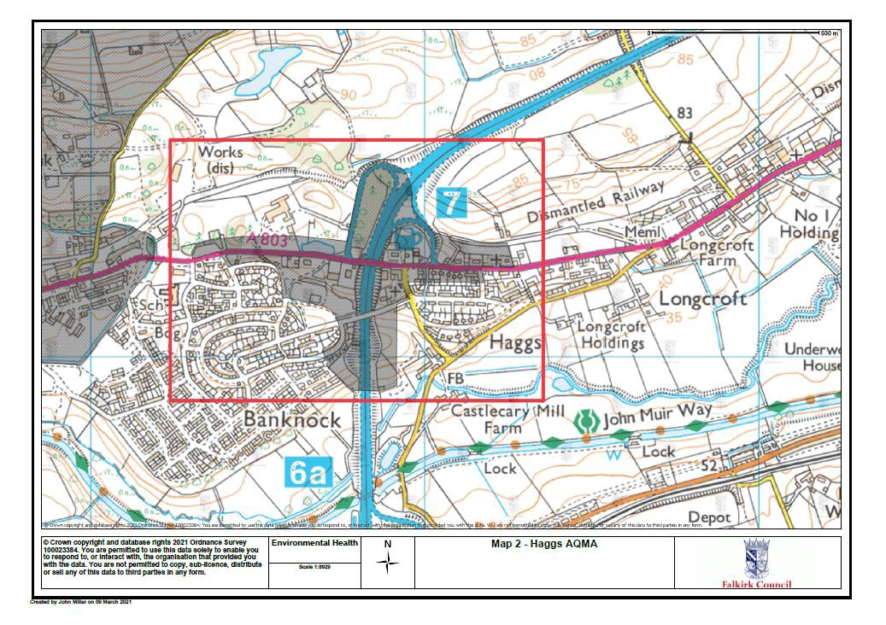
Map 2 - Haggs AQMA

Map 3 – Haggs Automatic Monitoring Station Location
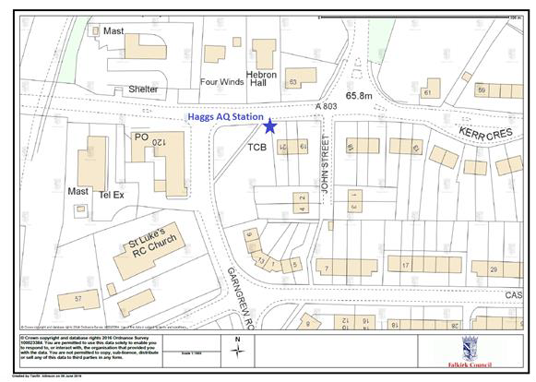

Map 4 – Haggs Non-Automatic Diffusion Tube Monitoring Locations
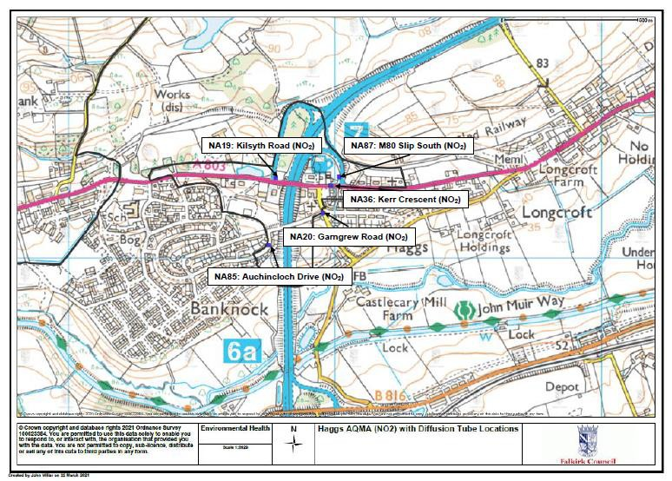

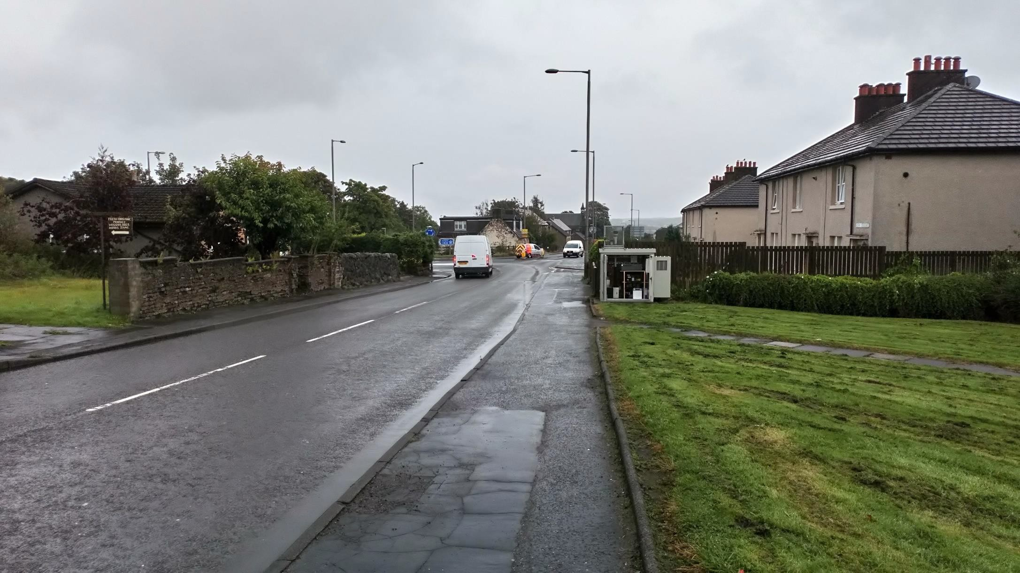
- Appendix 1: Photo 1 – Haggs Automatic Roadside Station

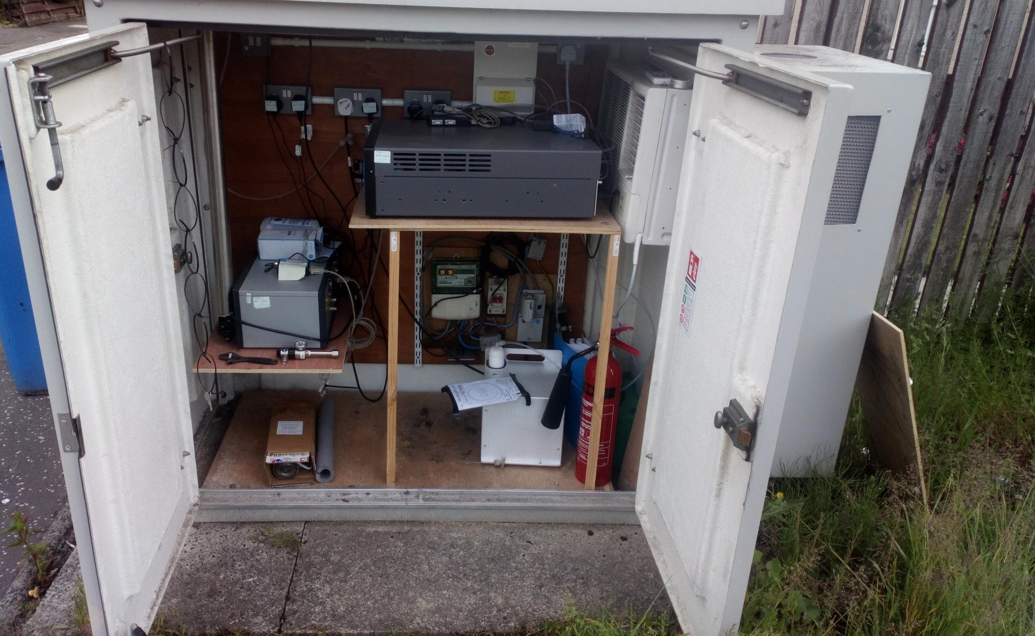
Photo 2 – Haggs Automatic Roadside Station

Appendix 2: Local Air Quality Management Detailed Assessment of NO2 Concentrations at Banknock and Haggs by BMT Cordah for Falkirk Council, July 2008
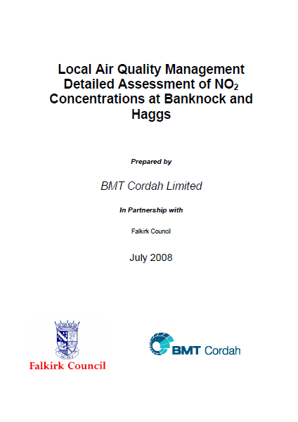

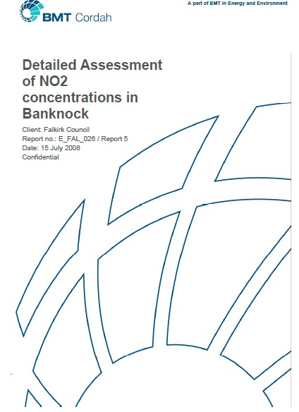



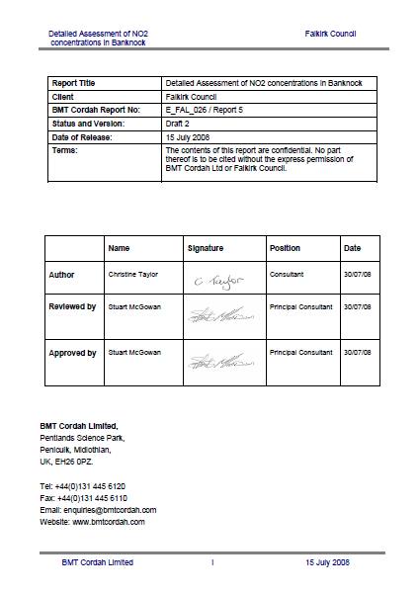

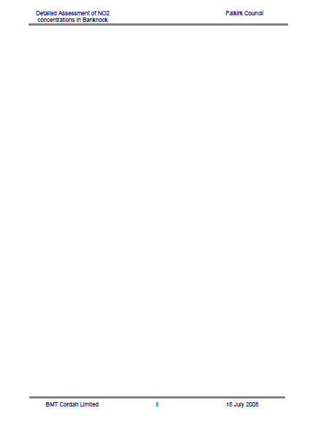

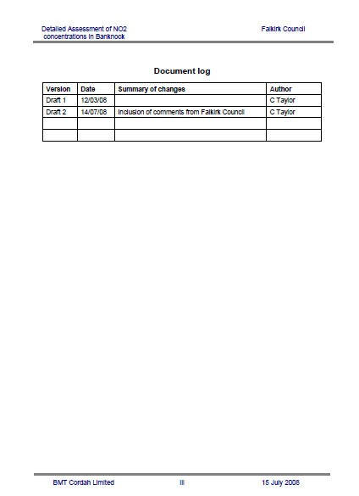

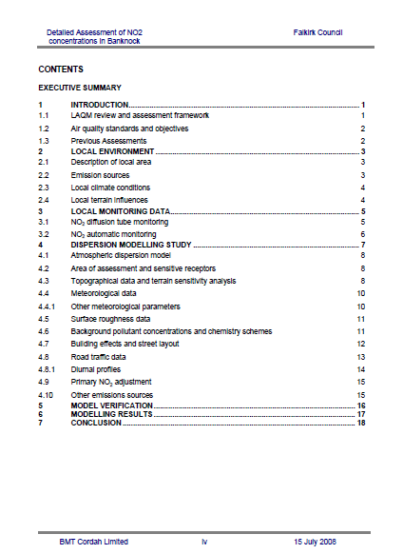

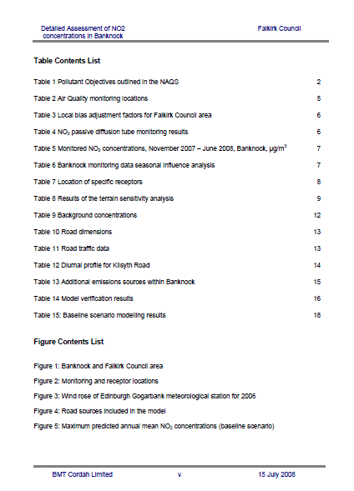

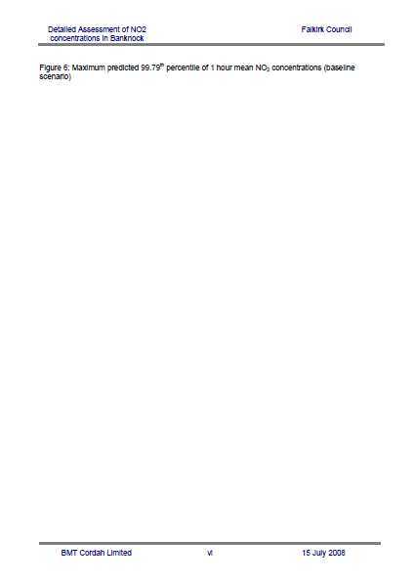

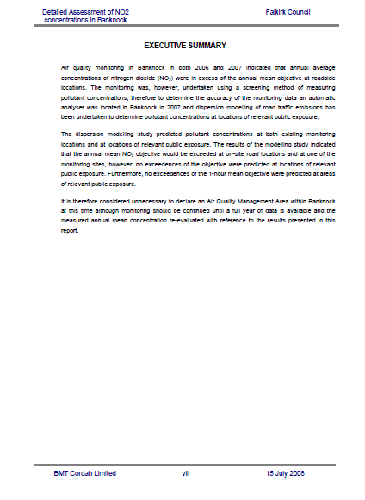

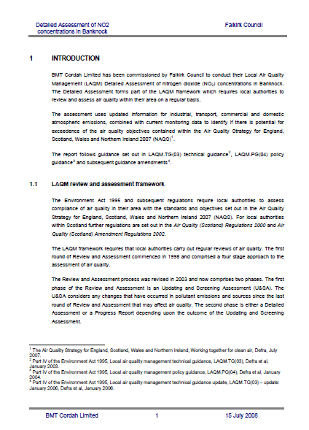

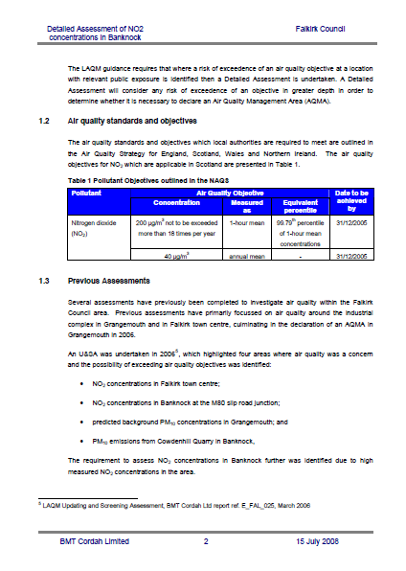

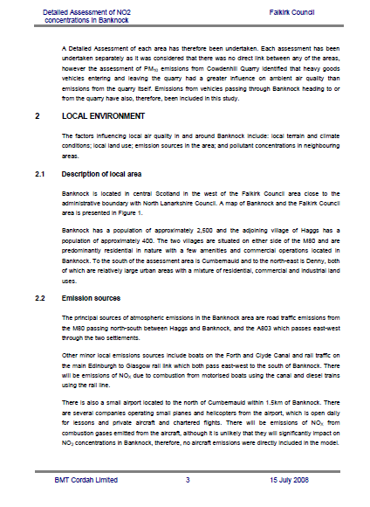

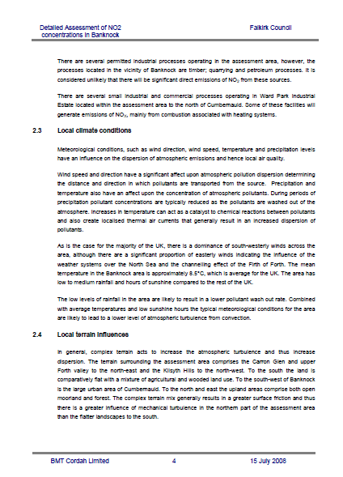

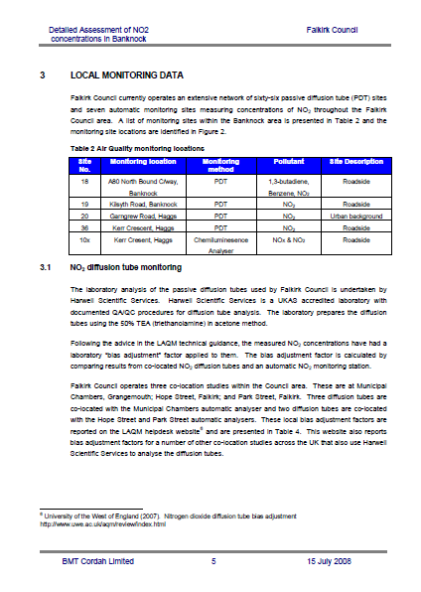

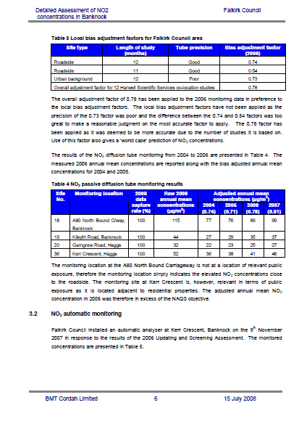

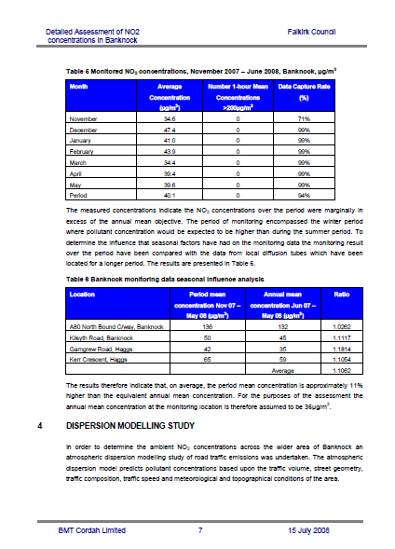

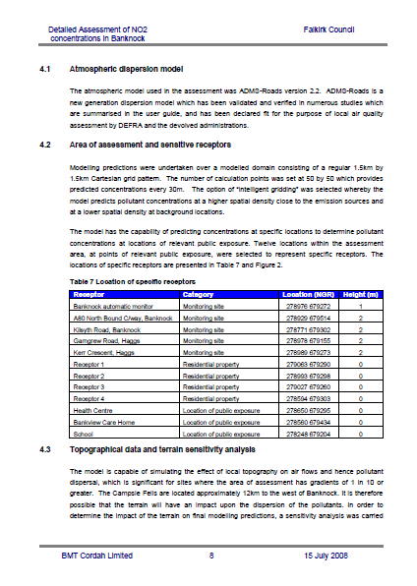

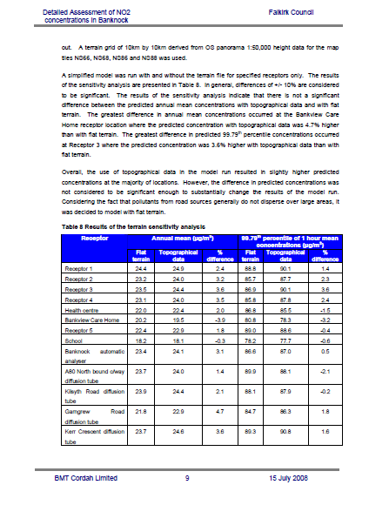

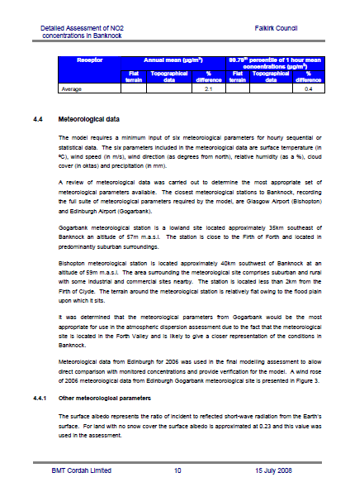

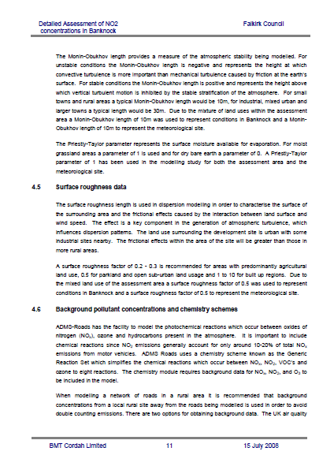

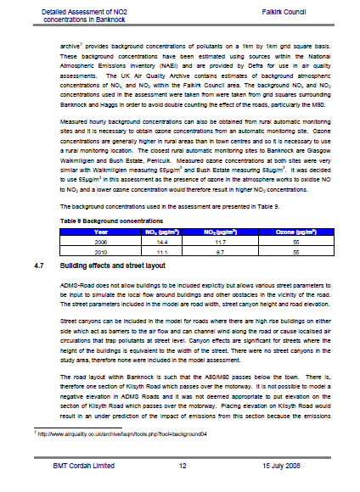

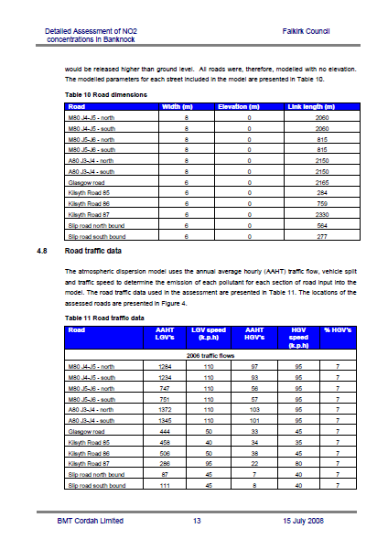

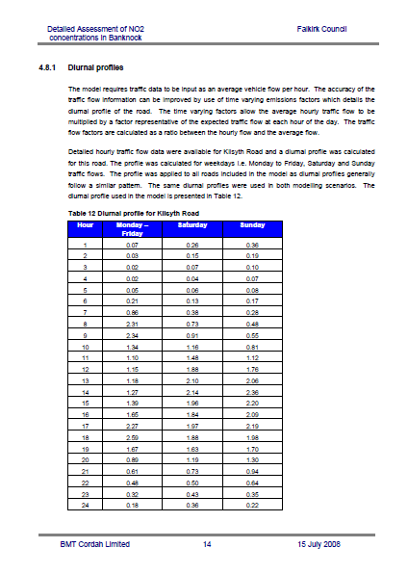

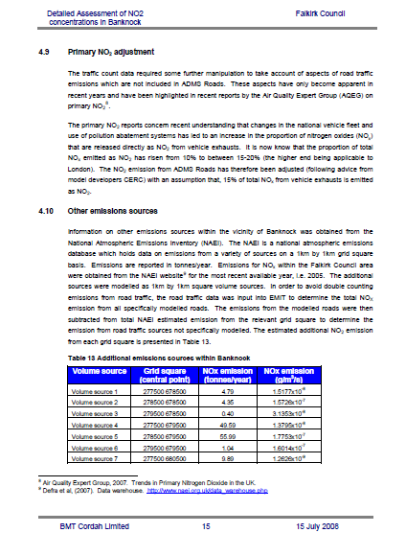

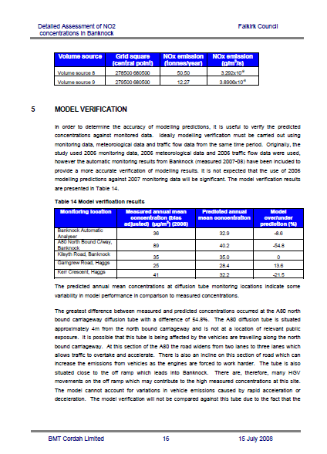

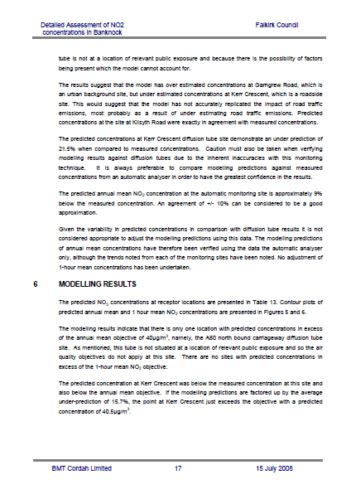

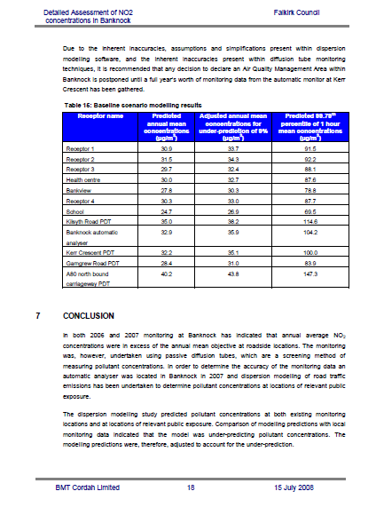

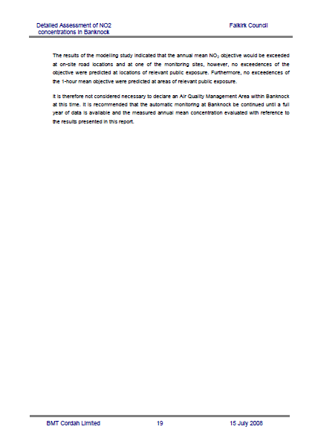

Appendix 3: Haggs/Banknock Further Assessment of Air Quality by BMT Cordah for Falkirk Council
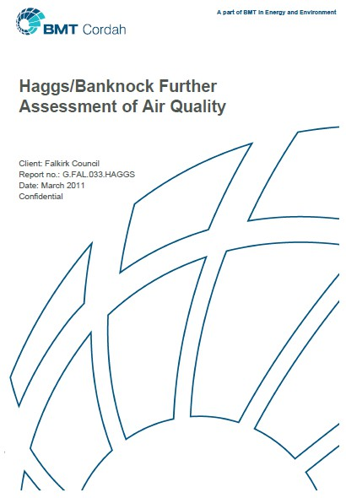



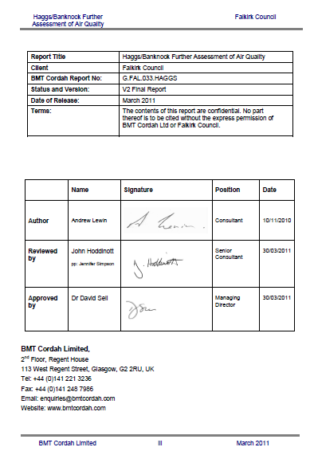

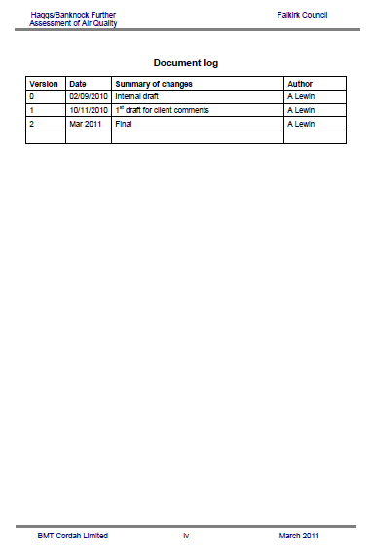

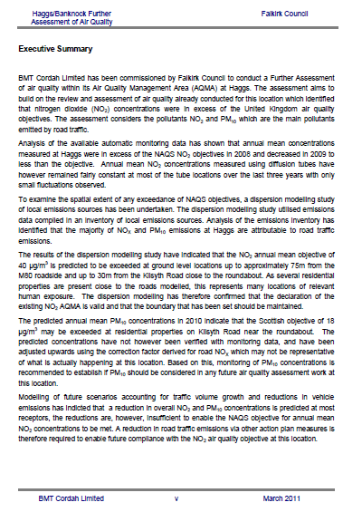

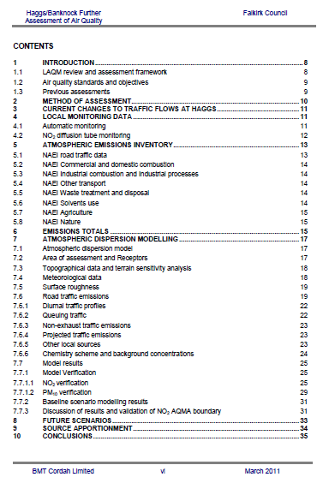

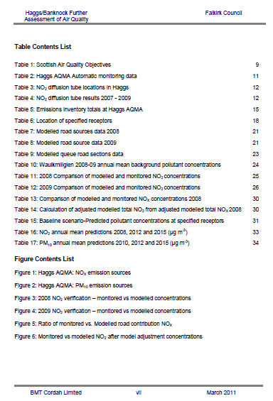

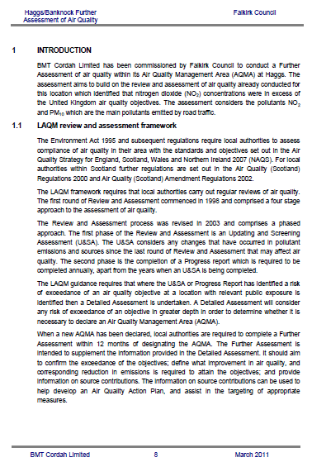

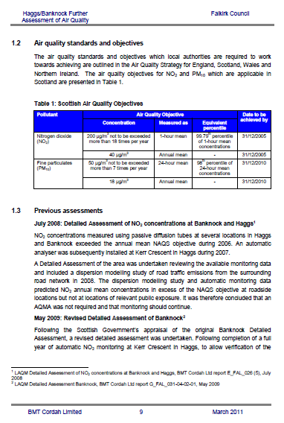

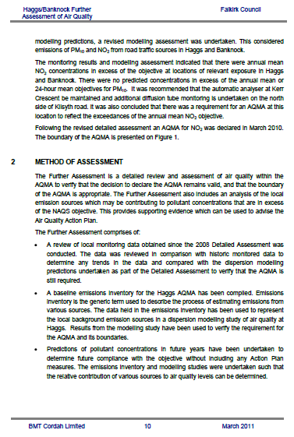

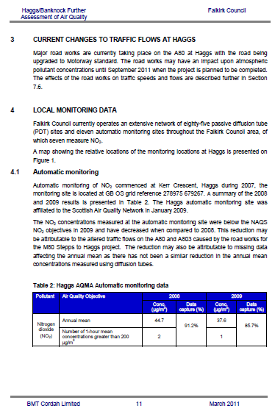

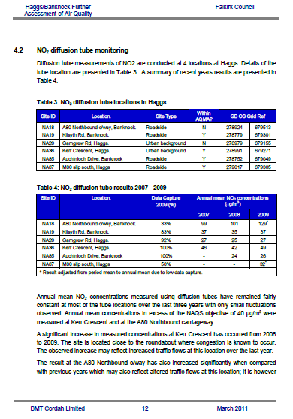

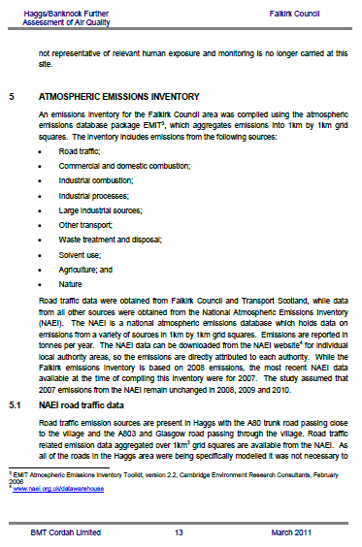

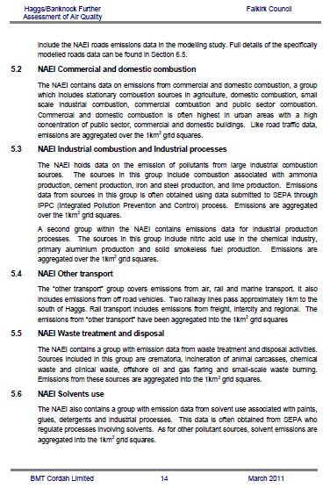

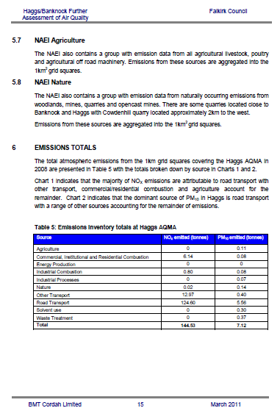

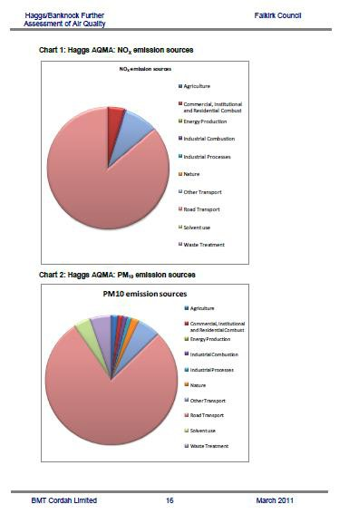

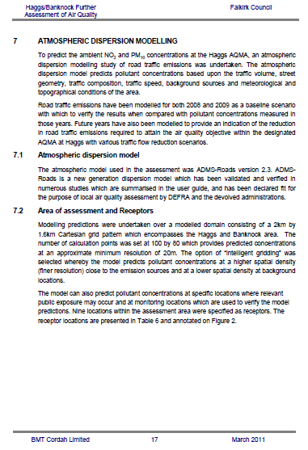

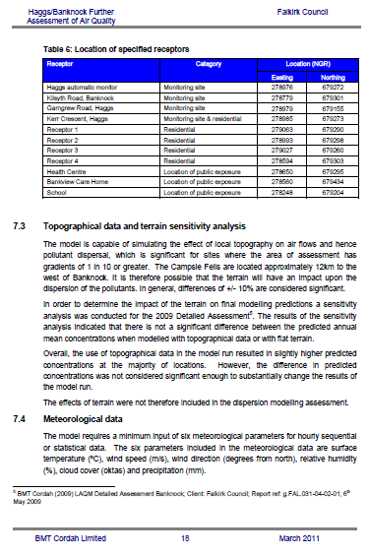

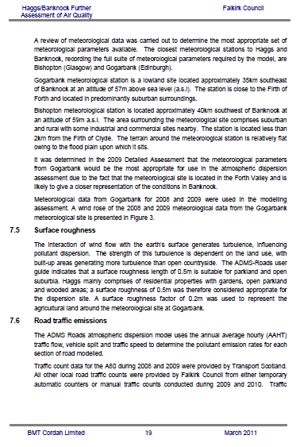

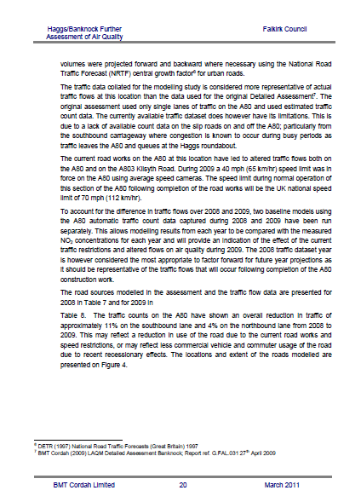

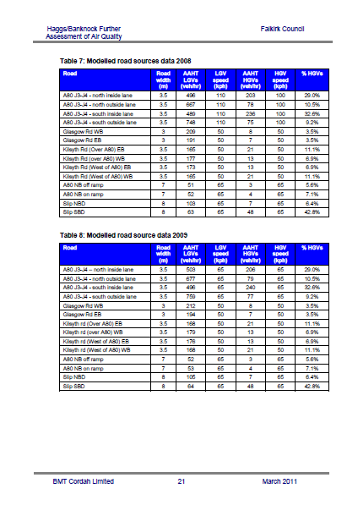

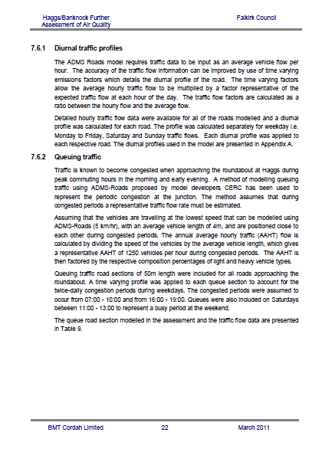

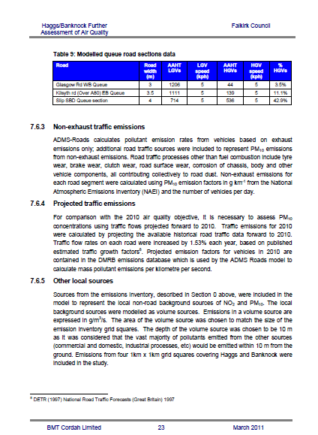

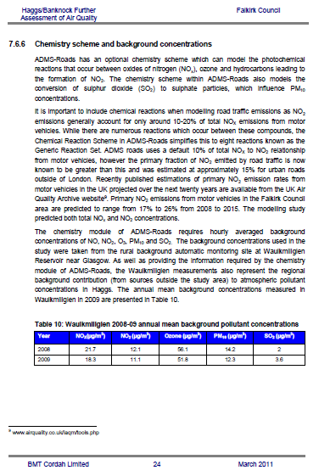

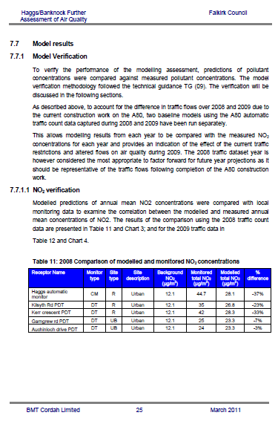

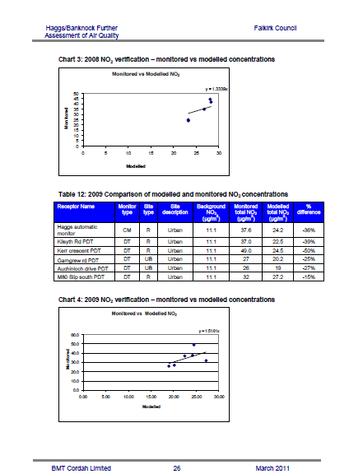

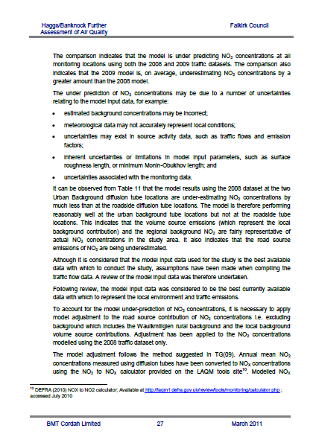

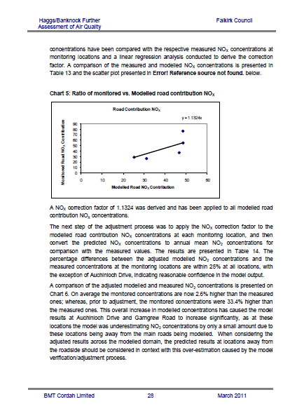

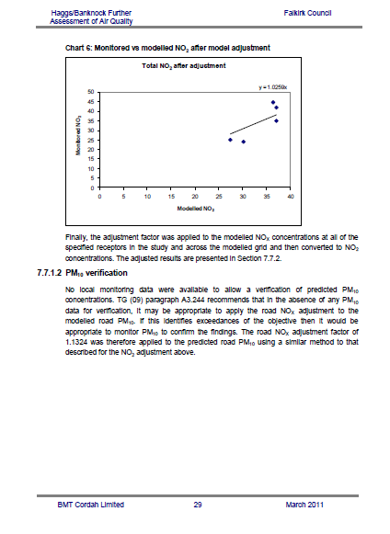

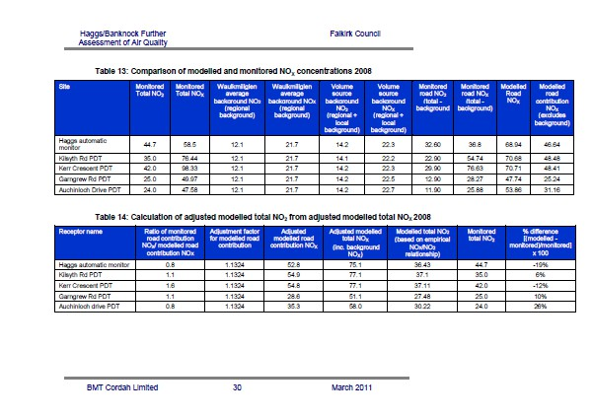
Falkirk Council

