**Larbert High School – October Gas Use (kWh) – 2023 Compared to 2024**

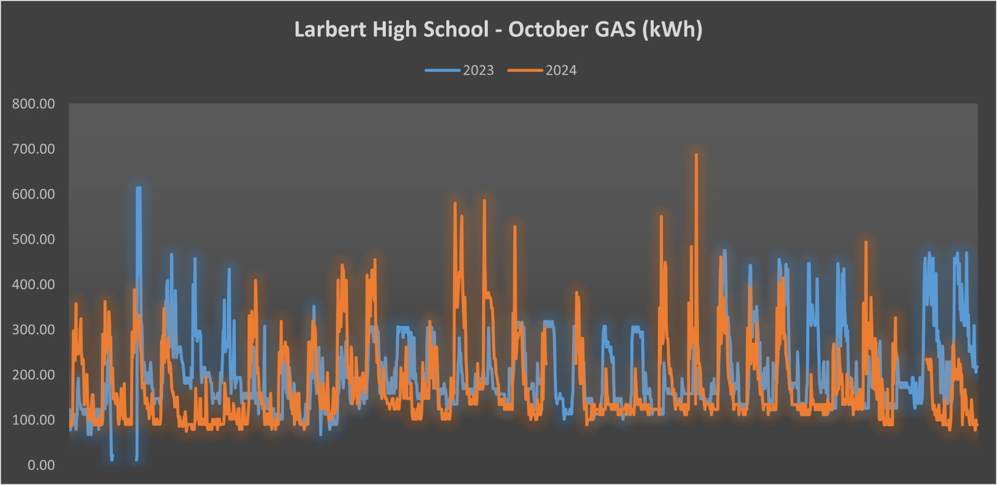

**Larbert High School – October Electricity Use (kWh) – 2023 Compared to 2024**

