Appendix 5 – The Open Space Audit and Fitness for Purpose Assessment

Assessment Criteria

The aim of the open space audit is to undertake an assessment of the nature, type, quality, spatial distribution and use of existing open spaces in the Falkirk Council area.

The seven key criterions used to assess the intrinsic qualities of the sites were, Accessibility, Health and Wellbeing, Cleanliness and Maintenance, Biodiversity and Nature Conservation, Cultural Heritage and Local History, Community Involvement and Design and Aesthetic Qualities. The assessment was carried out by attributing a value on a scale of 1 to 5 in each of the seven above mentioned key criteria, according to the methodology adopted from the previous audit, where 1 is poor, 2 is fair, 3 is good, 4 is very good and 5 is excellent.

1 | 2 | 3 | 4 | 5
Poor | Fair | Good | Very Good | Excellent
Table 1 – Scoring line defined to assess the key criteria, adopted from the previous audit;

The following sub-criteria were considered when assessing the overall quality of each site:

In terms of Accessibility the site had to comply with the following sub criteria:
  - Is the access to the surrounding community good?
  - Are there good footpaths through the site?
  - Does access generally appear safe?
  - Is there equal access for all groups?
  - Does the site seem welcoming?
  - Is there appropriate signage?
  - Is the site well-utilised or under used?

For Health and Wellbeing, the score depended on the sub criteria below:
  - Does it promote good human health and feelings of wellbeing?
  - Is it physically used by the local community for sport & exercise?
  - Is there an appropriate level of facilities for this?
  - Is the greenspace visually connected to the local community?
  - Does it benefit the well-being of the local community?
  - Does it feel safe & secure?

In terms of Cleanliness and Maintenance the site had to comply with the following sub criteria:
  - Does it generally appear clean and well-maintained, or litter-strewn and unattended?
  - How do you rate litter levels and waste management?
  - Is dog fouling obtrusive?

  - How well is it maintained (for the type of space that it is)?
  - How well are any buildings and other infrastructure maintained?

For the scoring of Biodiversity and Nature Conservation the following sub criteria was considered:
  - Is the site designated for its wildlife/ biodiversity value e.g. SINC, Local Wildlife Site, Nature Reserve, SSSI?
  - Are natural heritage features (e.g. wild flora, woodland, streams etc) an important feature of the site, and if so are they being conserved/ protected or neglected?
  - Is there any evidence of rare plant and animal species?
  - Is the site managed appropriately to encourage biodiversity?

In terms of Cultural Heritage and Local History the site had to comply with the following sub criteria:
  - Are there any buildings and structures within the site with cultural heritage value,
e.g. monuments, statues, canals?
  - Are any of these features designated, e.g. Listed Building, Scheduled Monument or World Heritage Sites?
  - Are these features a key characteristic of the site, and if so are they being conserved/ protected or neglected?
  - Does the adjacent townscape setting have cultural heritage value?

For the scoring of Community Involvement the following sub criteria was considered:
  - Is there evidence of community involvement in the site, e.g. events, community woodland, urban farms etc?
  - Does it look like the local community has had any involvement in the management and development of the site?
  - Is there potential for community engagement and involvement?

In terms of Design and Aesthetic Qualities the following sub criteria was considered:
  - Is it fit for purpose?
  - Does it optimise the opportunity?
  - Is it inspiring?
  - Is it a creative response to its environment?
  - What are the design constraints and opportunities at the site?

Hierarchy of Parks and Open Spaces

The audit aims to understand the open space resource and strategic roles and fit between local, regional and national tiers within the open space network, so, each site was assigned a number according to its position in the hierarchy of open spaces. The hierarchy of parks and open spaces, defined for the 2010 open space audit and strategy is based on the size of the sites, their role and function and how far people are willing to travel to visit the site. This designation is divided into National, Regional, Settlement and Neighbourhood levels.

At a National level we find the sites that attract people from further afield than just the Falkirk area. They may be a national or international tourist attraction such as the Falkirk Wheel, a Country Park like that at Muiravonside, a major town park promoted as a tourism attraction such as Callendar Park, or a series of green corridors providing connections across the Central Belt such as the canal network. They are generally large in scale, provide a unique experience, they are varied in character, and provide a high level of facilities appropriate to their typology. They usually have a number of designations (sometimes of national or international importance) relating to their landscape, ecological or cultural value.

At the Regional level we find sites that attract people from across the Falkirk area in the main, differentiated primarily from level 1 sites, by having fewer visitors from further afield. They tend to be medium to large in scale, have characteristics of specific interest, and variety appropriate to its typology, for example the western foreshore of Bo’ness, or the wooded policies of Bantaskine Estate. They may have less variety than Level 1 sites, and associated designations may be fewer or of a lower value.
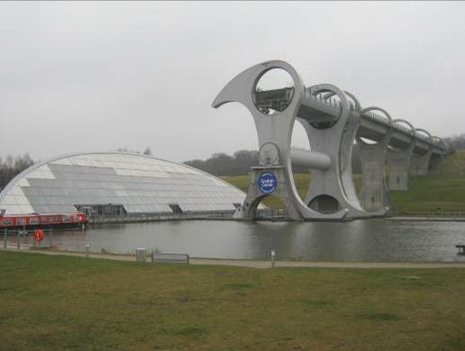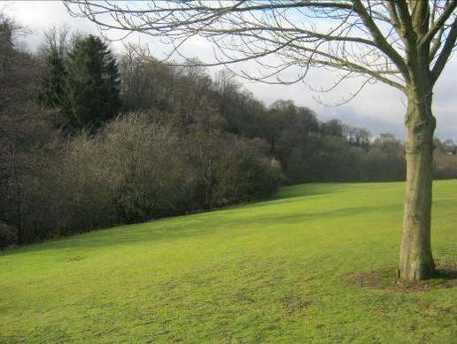
National and Regional Level Sites – Falkirk Wheel in Falkirk and Grey Buchanan Park in Polmont;

At a Settlement level are the sites that generally serve the population of the town or village in which they are located, and which generally do not attract visitors from the rest of the Falkirk region. They tend to be medium in scale, with fewer characteristics of interest, designations or facilities than Level 2 sites. They will generally encompass local parks such as Douglas, Victoria and Zetland Parks, semi-natural spaces such as Airth Castle Woodlands or Limerigg Pond, disconnected green corridors such as the disused railway corridor in The Loan, town playing fields etc. There may be primarily local designations associated with it.

At a Neighbourhood level are the sites whose function relate purely to the neighbourhood immediately around them and are used only by the population living in the immediate vicinity. They are generally smaller pocket spaces such as kickabout areas, amenity open spaces or play areas within and around residential areas, with limited facilities and features of special interest, and are rarely designated in any way.

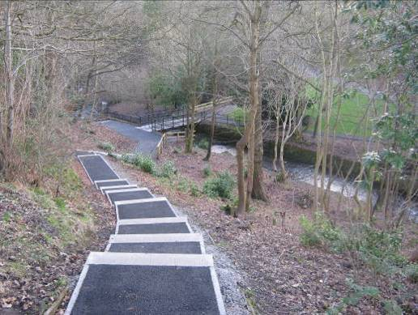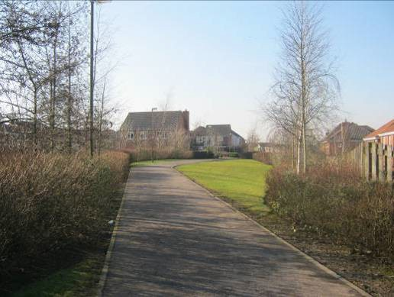
Settlement and Neighbourhood level Sites – Westquarter Glen in Polmont and Sunnyside Amenity Greenspace also in Polmont;

Typology of Sites

Each open space had been assigned a function, and in many cases multiple functions, according to the following typologies:

- Public Park or Garden
- Play Space
- Amenity Open Space
- Sports Area¹
- Natural/Semi Natural/Green Corridor
- Churchyard/Cemetery
- School Grounds/Institutional Grounds
- Allotment

Fitness for Purpose Assessment

Quality open space is defined as open space which is ‘fit for purpose’ meaning it is in the right place, readily accessible, safe, inclusive, welcoming, well maintained, well managed and performing an identified function. ‘Fitness for purpose’ (FFP), by definition, requires the assessment of open space in relation to the intended purpose or need.

The ultimate quality of a site relates to how it serves the needs and aspirations of the community and those needs vary according to the place of the site in the hierarchy and the typologies assigned to it, for example, the criteria that makes a neighbourhood sports area of an acceptable quality in relation to its purpose is not the same as a National level Country Park. Table 2 below illustrates how the primary factors affecting fitness for purpose differ in relation to different typologies and hierarchies of open space. For multi functional open space, the primary factors affecting fitness for purpose are cumulative as illustrated in table 3 below:

¹ Sports Area refers to all types of outdoor sport facilities. Access to open space containing a sports area means specifically sports areas which are free to use.

Open Space Hierarchy | Pan 65 Typology | Accessibility | Health & Wellbeing | Cleanliness & Maintenance | Biodiversity & Nature Conservation | Cultural Heritage & Local History | Community  Involvement | Design & Aesthetic Qualities
National | Public Park or Garden | 1 | 1 | 1 | 1 | 1 | 1 | 1
 | Natural, Semi-Natural,  Green Corridor | 1 | 1 | 2 | 1 | 1 | 1 | 2
Regional | Public Park or Garden | 1 | 1 | 1 | 1 | 1 | 1 | 1
 | Amenity Open Space | 1 | 1 | 1 | 2 | 2 | 1 | 1
 | Sports Area | 1 | 1 | 1 | 2 | 2 | 1 | 2
 | Natural, Semi-Natural,  Green Corridor | 1 | 1 | 2 | 1 | 2 | 1 | 2
Settlement | Public Park or Garden | 1 | 1 | 1 | 2 | 2 | 1 | 1
 | Play Space | 1 | 1 | 1 | 2 | 2 | 1 | 2
 | Amenity Open Space | 1 | 2 | 1 | 2 | 2 | 1 | 1
 | Sports Area | 1 | 1 | 1 | 2 | 2 | 1 | 2
 | Natural, Semi-Natural,  Green Corridor | 1 | 1 | 2 | 1 | 2 | 1 | 2
 | School Grounds,  Institutional Grounds | 1 | 1 | 1 | 2 | 2 | 1 | 2
 | Churchyard, Cemetery | 1 | 1 | 1 | 2 | 2 | 1 | 2
Neighbourhood | Public Park or Garden | 1 | 1 | 1 | 2 | 2 | 1 | 1
 | Play Space | 1 | 1 | 1 | 2 | 2 | 1 | 2
 | Amenity Open Space | 1 | 2 | 1 | 2 | 2 | 1 | 1
 | Sports Area | 1 | 1 | 1 | 2 | 2 | 1 | 2
 | Natural, Semi-Natural,  Green Corridor | 1 | 1 | 2 | 1 | 2 | 1 | 2
 | School Grounds,  Institutional Grounds | 1 | 1 | 1 | 2 | 2 | 1 | 1
 | Allotments | 1 | 2 | 1 | 2 | 2 | 1 | 2
Table 2. Primary (1) and secondary (2) criteria, according to quality and “Fitness for Purpose”
& Local History
PAN 65 Typology | Accessibility | Health & Wellbeing | Cleanliness & Maintenance | Biodiversity & Nature Conservation | Cultural Heritage | Community Involvement | Design & Aesthetic Qualities
Play Space | 1 | 1 | 1 | 2 | 2 | 1 | 2
Natural/Semi Natural | 1 | 1 | 2 | 1 | 2 | 1 | 2
Playspace and Natural/ Semi Natural | 1 | 1 | 1 | 1 | 2 | 1 | 2

Table 3: Primary and Secondary criteria in multi functional open space.

Putting this into practice using the example of Herbertshire Castle Park in Denny (which is a settlement level open space) gives the results below:

Site Quality Scores | Primary Factor (Y/N) | Score (1 to 5)
Accessibility | Yes | 4
Health and Wellbeing | Yes | 3
Cleanliness and Maintenance | Yes | 3
Biodiversity and Nature Conservation | Yes | 3
Cultural Heritage and Local History | Yes | 3
Community Involvement | Yes | 2
Design and Aesthetic Qualities | Yes | 3
Fitness for Purpose Score |  | 3

1 Public Park and Garden | 2 Playspaces | 3 Amenity Open Space | 4 Sports Area
Yes | Yes | No | Yes
5 Natural/Semi-Natural | 6 School Grounds / Institutions | 7 Allotment | 8 Churchyard / Cemetery
Yes | No | No | No

The scores for each of the criteria which are primary factors affecting fitness for purpose are aggregated (A) and then divided by the number of criteria which were primary factors (B) to give the overall fitness for purpose score (C). So for the above example:

A = 21
B = 7
C = 3

