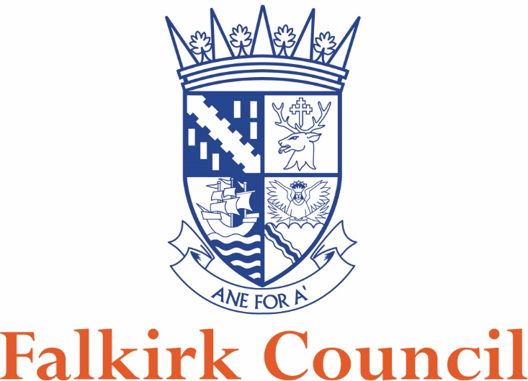

Food & Safety

Sampling Policy

This Policy outlines the Council’s approach to the conduct of food sampling activity by officers within the Food & Safety team.

Suitably qualified and authorised officers of the Council’s Food & Safety team will conduct formal sampling of foodstuffs, where necessary, for analysis and/or examination.

Informal samples, i.e. samples where an adverse report following analysis/examination would not result in formal action, need not be taken by an officer, as determined above. The officer will however be appointed by the Authority.

Due consideration will be given by all officers at all times to compliance with relevant statutory requirements, Food Law Code of Practice or other guidance.

Sampling activity will embrace quality, fitness, composition, labelling, presentation and advertising of food, and of materials or articles in contact with food.

Analysis of samples shall only be undertaken by appropriately qualified and designated food examiners and Public Analysts.

In the interests of best value and service efficiency, the Service shall seek to ensure that the range of analytical and supportive advisory services required in respect of its food safety, food standards activities are supplied by one contractor, who shall have satisfied the Service of their having suitable qualifications, facilities and experience to deliver quality services. The selection of contractor takes cognisance of price and qualitative indicators. The current contract is with Glasgow Scientific Services.

A Sampling Programme will be prepared and targets set annually in collaboration with the food examiner and public analyst. The Sampling Programme will not be published.

The Sampling Programme will allow a capacity for sample submission following complaints, enquiries or any investigations required. The numbers associated with this type of sample cannot be planned but they shall be incorporated into the target number to be achieved.

Sampling activity will be directed to locally identified priorities which may be informed by business numbers and types located in the area, any relevant external survey data, home authority obligations, patterns of local complaints or other reactive reason.

A significant part of food sampling activity will be directed to local surveys and surveillance.

The Service is also committed to participation in national or regional surveys and surveillance exercises organised each year by the Food Standards Scotland, Scottish Food Enforcement Liaison Committee and the East of Scotland Food Liaison Group.

Adequate resources must be provided to allow the Authority to carry out the requirements of the Sampling Programme.

Officers shall ensure that sampling procedures reflect current best practice and comply, where appropriate, with relevant Codes, guidance or defined survey protocols. If necessary, officers will contact the relevant laboratory or analyst to identify and agree appropriate sampling procedures.

Action following an unsatisfactory sample result

Officers will discuss all unsatisfactory sample results with the Food & Safety Co-ordinator.

The most appropriate action will be assessed against individual circumstances, any centrally issued guidance, the Service’s Enforcement Policy, and any other relevant factor. Where appropriate, advice shall be sought from the public analyst or food examiner. Where appropriate, comment shall also be requested of relevant home or originating authorities.

It may be appropriate for informal sample failures to be followed up by formal samples where the Service is satisfied that informal action may have little or no effect in achieving desired improvements.

If formal samples prove unsatisfactory, circumstances should be assessed to determine whether or not it would be appropriate to report the issue to the Procurator Fiscal, having regard to the Enforcement Policy.

The Service shall at all times have due regard to the public interest and protection of health.

