Falkirk Council

Tenant Satisfaction Survey 2021

Research Report

Prepared by: | Prepared for:
Research Resource  10 Lake Avenue  Lanark  ML11 9BQ | Falkirk Council  Municipal Buildings  West Bridge Street  Falkirk  FK1 5RS
Contact: Lorna Shaw | Contact: Alan Christie
Email: lorna.shaw@researchresource.co.uk | E-mail: alan.christie@falkirk.gov.uk

Falkirk Council
Tenant Satisfaction Survey 2021
Contents

1. EXECUTIVE SUMMARY 4

2. INTRODUCTION, OBJECTIVES AND METHODOLOGY 7
2.1 Introduction, Background and Objectives 7
2.2 Research Method 7
2.3 Survey Analysis and Reporting 9

3. OVERALL SATISFACTION 11
3.1 Satisfaction with the overall service provided by the Council (Q1-Q2) 11

4. INFORMATION AND COMMUNICATION 13
4.1 Preferred communications methods (Q3 to Q5) 13
4.2 Keeping tenants informed (Q6-Q7) 15
4.3 Keeping updated during Covid 19 (Q8) 17
4.4 Internet access (Q9) 17

5. TENANT PARTICIPATION 19
5.1 Interest of participation activities (Q10) 19
5.2 Satisfaction with the opportunities to participate (Q11-Q12) 20

6. REPAIRS AND MAINTENANCE 21
6.1 General satisfaction with repairs and maintenance (Q13-Q14) 21
6.2 Satisfaction with the quality of the home (Q15-Q16) 22
6.3 Satisfaction with aspects of the home (Q17) 24
6.4 Moving intentions (Q31-Q32) 25

7. THE NEIGHBOURHOOD 27
7.1 Neighbourhood as a place to live (Q20) 27
7.2 Management of the neighbourhood (Q19-Q20) 27
7.3 Feeling of safety in the community (Q21 – Q23) 29
7.4 Perceptions of problems in the neighbourhood (Q24) 31

8. RENT AND VALUE FOR MONEY 32
8.1 Awareness of Council rents relative to others (Q25) 32
8.2 Priorities for spending rents (Q26) 32
8.3 Value for money (Q28-Q29) 35
8.4 Affordability of rent (Q30) 36

9. OVERVIEW OF LANDLORD SERVICES 38
9.1 Best thing (Q33) 38
9.2 Priority for improvement (Q34) 39

10. ABOUT YOU AND YOUR HOUSEHOLD 40
10.1 Age and gender (Q35 – Q36) 40
10.2 Household composition (Q37-Q38) 41
10.3 Disability (Q39) 42
10.4 Ethnicity (Q40) 42

APPENDIX 1: QUESTIONNAIRE
APPENDIX 2: TECHNICAL REPORT SUMMARY

Report written by: Lorna Shaw

Date: 27/01/2022

Reviewed by: Elaine MacKinnon
Date: 28/01/2022

EXECUTIVE SUMMARY
INTRODUCTION
- Falkirk Council commissioned Research Resource to carry out their Tenant Satisfaction Survey on their behalf.
- A total of 1,000 interviews were carried out with Falkirk Council tenants in order to assess satisfaction with the Council and the services they provide. Interviews took place between 7th December and 25th January 2022.
- 1,000 interviews represents a 40% response rate from the representative sample of 2,500 tenants that was drawn for the research and provides data accurate to +/-2.4% (based upon a 50% estimate at the 95% level of confidence).
- This executive summary highlights the key findings from this programme of research.

SCOTTISH SOCIAL HOUSING CHARTER SATISFACTION INDICATORS
The table below shows the overall satisfaction values for the charter indicator questions that were asked within the Tenant Satisfaction Survey (TSS). The Council carried out three previous large scale tenant satisfaction surveys in December 2013, December 2016 and December 2018. The figures for these surveys are provided in the table below, highlighting that all indicators apart from opportunities to participate have seen a decrease since December 2018.
Scottish Housing Regulator Indicators
 | Dec 2013 | Dec 2016 | Dec 2018 | Dec 2021
Taking everything into account, how satisfied or dissatisfied are you with the overall service provided by Falkirk Council as your landlord? (% very/fairly satisfied) | 75% | 85% | 92% | 75%
How good or poor do you feel your landlord is at keeping you informed about their services and decisions? (% very/ fairly good) | 73% | 91% | 95% | 85%
How satisfied or dissatisfied are you with the opportunities given to you to participate in your landlord's decision making processes? (% very/ fairly satisfied) | 49% | 87% | 93% | 98%
Overall, how satisfied or dissatisfied are you with the quality of your home? (% very/ fairly satisfied) | 76% | 81% | 94% | 77%
Overall, how satisfied or dissatisfied are you with your landlord's contribution to the management of the neighbourhood you live in? (% very/ fairly satisfied) | 74% | 92% | 94% | 84%
Taking into account the accommodation and services your landlord provides, to what extent do you think your rent represents value for money? Is it… (% stating very/ fairly good) | 69% | 80% | 85% | 77%

OVERALL SATISFACTION
- The survey began by asking respondents how satisfied or dissatisfied they were with the overall service provided by Falkirk Council as their landlord. 75% of respondents were very or fairly satisfied in this respect, a decrease from 85% in 2016 and 92% in 2018. This is the same level of satisfaction reported in 2013.
- The key reasons for dissatisfaction were repairs and maintenance related.

INFORMATION AND COMMUNICATION
- Tenants preference for communication from the Council, whether it was about their tenancy specifically or more generally about services was to have a personal letter. It was interesting to note that electronic communications methods had increased in popularity, particularly for younger tenants. They were much more likely to wish to be communicated with by email, text or website than older tenants.
- When it comes to contacting the Council, tenants preference was by telephone (94%), although 11% stated they would be happy to use email to contact the Council about their tenancy.
- 85% of tenants said they believed that Falkirk Council as their landlord was good at keeping them informed about services and decisions. This has decreased from 2018 when 95% rated the Council as good in this respect.
- 63% of respondents said they feel that Falkirk Council’s Housing Service has kept them updated to changes to services available due to Covid 19.
- Just under three quarters of tenants (64%) use the internet, however for tenants aged 16-34, this is almost universal with 97% using the internet. This decreases to just 25% for those aged 65 and over.

TENANT PARTICIPATION
- Respondents expressed a low interest in becoming involved, with 78% stating they were not interested in getting involved. Where tenants were interested in getting involved in helping the Council improve their housing services, they were most interested in answering customer feedback questionnaires (19%) or online questionnaires or discussion forums (13%).
- Over 9 in 10 respondents (98%) were very or fairly satisfied with the opportunities given to them to participate in their landlord’s decision making processes, an increase from 93% in 2018.

REPAIRS AND MAINTENANCE OF THE HOME
- 63% of tenants were satisfied with the way the Council deals with repairs and maintenance. This is a significant decrease from 2018 when 87% were satisfied in this respect. The key issues were the length of time it takes to get repairs done or that repairs are outstanding.
- With regards to the quality of the home 77% were very or fairly satisfied, decreasing from 81% in 2016 and 94% in 2018. This is similar to 2013 when 76% of tenants were satisfied with the quality of their home.
- Tenants were then asked how satisfied or dissatisfied they were with various aspects of their home. Satisfaction had decreased across the board with respect to the home:
  - 83% were satisfied with the general condition of the property overall (down from 93%)
  - 83% were satisfied with the external appearance of the building (down from 93%)
  - 78% were satisfied with the kitchen (down from 93%)
  - 78% were satisfied with the bathroom (down from 93%)
  - 85% were satisfied with the heating system (down from 93%)
  - 67% were satisfied with the windows (down from 88%).

THE NEIGHBOURHOOD
- 85% of respondents were satisfied with their neighbourhood as a place to live.
- 84% were very or fairly satisfied with their landlord’s contribution to the management of the neighbourhood they live in, a decrease from 92% satisfaction in 2016 and 94% in 2018, although it is higher than in 2013 when 74% were satisfied.
- 88% said that they feel safe in their community.
- When asked about perceived issues in the neighbourhood, most likely to be perceived as a problem was excessive noise such as loud music or parties (13%).

RENT AND VALUE FOR MONEY
- In terms of rent levels awareness was low, with 11% of respondents aware that Falkirk Council had the 6th lowest rent and 6% of respondents were aware that Falkirk Council had the 7th lowest level of supervision and management costs.
- Tenant priorities in terms of what they felt the Council should be spending more of their rent on were:
  - Internal improvements such as bathrooms and kitchens (57%)
  - Increasing the supply of housing by building new build houses
  - External improvements such as windows, roofing and roughcasting (50%).
- 77% of tenants said they felt their rent represented very or fairly good value for money, a decrease from 80% in 2016 and 85% in 2018, although this is significantly higher than in 2013 when 69% of tenants rated value for money as good.
- Two thirds of respondents (66%) said they found their rent payments very or fairly easy to afford, compared to 28% who said they found the payments just about affordable and 5% of respondents who said their rent was very or fairly difficult to afford.

INTRODUCTION, OBJECTIVES AND METHODOLOGY

Introduction, Background and Objectives
This report represents and discusses the findings to emerge from Falkirk Council’s Tenant Satisfaction Survey 2021.

The aim of the research was to seek tenants’ views on the services that the Council, as a landlord, provides and how well it performs these services and to help identify areas where the service can be improved. Specifically, the research was designed to provide tenants views on the following:
- The quality of information provided by the Council;
- Feedback on customer care;
- Quality of accommodation;
- Service provision including repairs, maintenance and improvements;
- Tenant involvement/ opportunities for participation;
- Value for money.
It is against this background that Research Resource were commissioned to carry out Falkirk Council Housing Services 2021 Tenant Satisfaction Survey.

Research Method
After consultation with Council representatives, a survey questionnaire was agreed, which fully met the information needs and requirements of the Council. In developing the questionnaire, the following issues were considered:
- The Scottish Social Housing Charter indicators upon which the Council is required to report;
- Current information needs of the Council;
- Research Resource experience in relation to customer satisfaction surveying.

The aim of the survey was to achieve a robust level of data upon which the Council can have confidence making decisions.

A total of 1,000 interviews were completed between the 7th December 2021 and 25th January 2022. This is a 40% response rate from a representative sample of 2,500 tenants that was drawn from the overall Falkirk Council tenant population and provides data accurate to +/- 2.4% accuracy, based upon a 50% estimate and 95% level of confidence. Tenant interviews were spread across the Council’s stock to ensure coverage of all tenants.
Analysis by patch shows good coverage across the Council’s stock.
Patch | No of tenants | % of tenants | No of interviews | % of interviews
CENT1 | 532 | 3.4% | 34 | 3.4%
CENT10 | 357 | 2.3% | 23 | 2.3%
CENT11 | 369 | 2.3% | 23 | 2.3%
CENT12 | 368 | 2.3% | 24 | 2.4%
CENT13 | 354 | 2.2% | 22 | 2.2%
CENT14 | 329 | 2.1% | 22 | 2.2%
CENT15 | 348 | 2.2% | 22 | 2.2%
CENT16 | 299 | 1.9% | 19 | 1.9%
CENT17 | 308 | 1.9% | 19 | 1.9%
CENT2 | 590 | 3.7% | 37 | 3.7%
CENT3 | 364 | 2.3% | 25 | 2.5%
CENT4 | 385 | 2.4% | 24 | 2.4%
CENT5 | 357 | 2.3% | 23 | 2.3%
CENT6 | 350 | 2.2% | 22 | 2.2%
CENT7 | 437 | 2.8% | 28 | 2.8%
CENT8 | 319 | 2.0% | 20 | 2.0%
CENT9 | 252 | 1.6% | 16 | 1.6%
EAST1 | 301 | 1.9% | 19 | 1.9%
EAST10 | 370 | 2.3% | 23 | 2.3%
EAST11 | 354 | 2.2% | 22 | 2.2%
EAST12 | 348 | 2.2% | 22 | 2.2%
EAST13 | 366 | 2.3% | 23 | 2.3%
EAST14 | 339 | 2.1% | 18 | 1.8%
EAST2 | 317 | 2.0% | 18 | 1.8%
EAST3 | 309 | 2.0% | 20 | 2.0%
EAST4 | 310 | 2.0% | 22 | 2.2%
EAST5 | 328 | 2.1% | 21 | 2.1%
EAST6 | 306 | 1.9% | 19 | 1.9%
EAST7 | 384 | 2.4% | 22 | 2.2%
EAST8 | 356 | 2.2% | 22 | 2.2%
EAST9 | 366 | 2.3% | 23 | 2.3%
WEST1 | 411 | 2.6% | 26 | 2.6%
WEST10 | 348 | 2.2% | 21 | 2.1%
WEST11 | 294 | 1.9% | 20 | 2.0%
WEST12 | 281 | 1.8% | 17 | 1.7%
WEST13 | 313 | 2.0% | 21 | 2.1%
WEST14 | 321 | 2.0% | 20 | 2.0%
WEST2 | 420 | 2.7% | 28 | 2.8%
WEST3 | 382 | 2.4% | 23 | 2.3%
WEST4 | 361 | 2.3% | 25 | 2.5%
WEST5 | 373 | 2.4% | 22 | 2.2%
WEST6 | 343 | 2.2% | 22 | 2.2%
WEST7 | 311 | 2.0% | 21 | 2.1%
WEST8 | 319 | 2.0% | 19 | 1.9%
WEST9 | 289 | 1.8% | 18 | 1.8%
Grand Total | 15838 | 100.0% | 1000 | 100.0%

All interviewing was undertaken by Research Resource’s highly trained and experienced researchers, all of whom are experienced in undertaking customer satisfaction surveys for Housing Associations and Local Authorities.

Survey Analysis and Reporting
This report presents the findings of the survey for tenants and focuses on the key findings of the survey.

Throughout this report the figures show the results as percentages and base numbers are also shown where appropriate.

Percentages are rounded up or down from one decimal place to the nearest whole number. For this reason, not all percentages sum to 100% due to rounding.

Rounding can also cause percentages described in the supporting text or summarising ‘overall satisfaction’ (i.e. adding very satisfied and fairly satisfied responses together) to differ from the charts by 1% when two percentages are added together. In some parts of the report percentages may be expressed to one decimal place.

For the key Charter indicator responses, comparison has been drawn to the Council’ previous tenant satisfaction surveys which were completed in December 2013/January 2014, December 2016 and December 2018.

OVERALL SATISFACTION

Satisfaction with the overall service provided by the Council (Q1-Q2)
The survey began by asking respondents how satisfied or dissatisfied they were with the overall service provided by Falkirk Council. As shown in the chart below, 75% of respondents were very or fairly satisfied in this respect compared to 7% who were neither satisfied nor dissatisfied and 18% who were very or fairly dissatisfied.
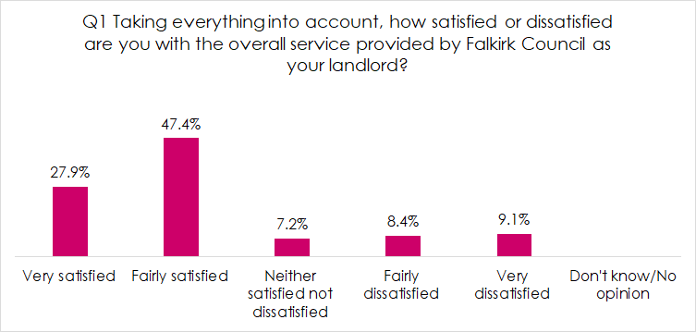

Overall satisfaction is the same as in December 2013 but has decreased from 85% in December 2016 and 92% in 2018.

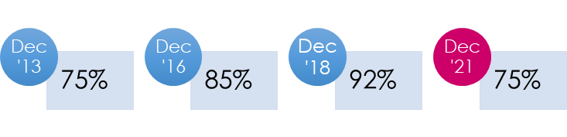

Following on from this, respondents who said they were not satisfied with the overall service provided by Falkirk Council (n=247) were then asked to explain why they felt this way. This was an open-ended question to allow respondents to answer fully. Their answers have subsequently been coded into common themes. The main reasons given for not being satisfied with the overall service provided by Falkirk Council related to:
- The repairs service (67%)
- Homes need upgrading/ improvements e.g. kitchen/ bathroom (13%)
- Poor communication/ not being kept up to date (12%).
Q2 Can you please explain why you said you were not satisfied with the overall service provided by Falkirk Council as your landlord?
Base: not satisfied, n=247 | No | %
Poor repairs service/ not being completed | 166 | 67.2%
Home requires upgrades/ improvements e.g. kitchen, bathroom | 31 | 12.6%
Poor communication/ not kept updated | 30 | 12.1%
Not dealing with issues/ complaints | 26 | 10.5%
Poor customer service | 22 | 8.9%
Other | 13 | 5.3%
Need to deal with ASB/ ASN | 8 | 3.2%
Not had many dealings with them | 6 | 2.4%
Bin issues/ litter problems | 4 | 1.6%

INFORMATION AND COMMUNICATION

Preferred communications methods (Q3 to Q5)
Tenants were then asked their preferences for a range of communications preferences.

Firstly, in terms of the Council communicating with tenants about their tenancy, tenant preference is for the Council contacting them by personal letter (54%) followed by telephone (44%) and then email (28%).
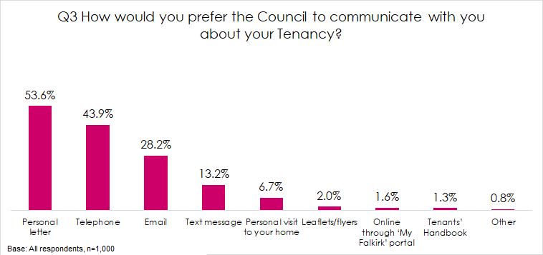
Analysis by age shows that younger respondents are much more likely to prefer communications by email, with 45% of respondents aged 16-34 stating this was their preference compared to 10% of those aged 65+. It is also interesting to note that younger tenants aged 16-34 were more likely to have a preference for personal communication by telephone (54%) than other age groups.
Q3 How would you prefer the Council to communicate with you about your Tenancy?
 | 16-34 | 35-64 | 65+
Base | 148 | 458 | 323
Personal letter | 45.3% | 51.7% | 65.3%
Telephone | 54.1% | 39.7% | 43.7%
Email | 44.6% | 35.4% | 9.6%
Text message | 18.9% | 14.0% | 9.0%
Personal visit to your home | 6.8% | 6.1% | 8.7%
Leaflets/flyers | 2.7% | 2.2% | 1.5%
Online through ‘My Falkirk’ portal | 3.4% | 2.2% | 0.3%
Tenants’ Handbook | 1.4% | 1.3% | 1.5%
Other | - | 0.4% | 0.9%

In terms of tenants communicating with the Council about their tenancy, telephone was the strong preference (94%). The next most common response was email, which was the preference for 11% of respondents

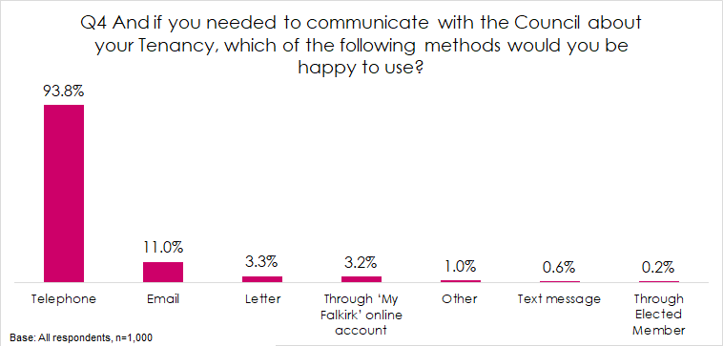

Finally, in terms of being kept informed, personal letter (55%) followed by Tenant Talk magazine were tenants’ preference (47%). This was followed by digital methods of email (22%), text (11%) and website (10%).
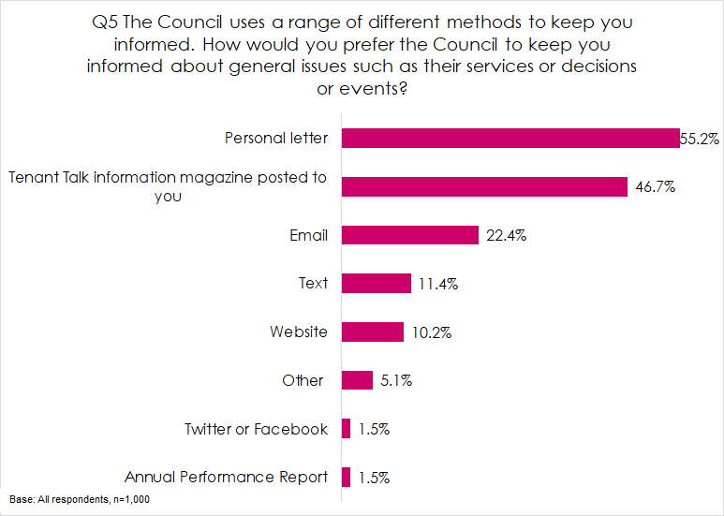

Again, analysis by age shows that younger respondents aged 16-34 and 35-64 were much more likely to prefer digital communications in the form of email, website and text than older respondents aged 65+.

Q5 The Council uses a range of different methods to keep you informed. How would you prefer the Council to keep you informed about general issues such as their services or decisions or events? [ALL THAT APPLY]
 | 16-34 | 35-64 | 65+
Base | 148 | 458 | 323
Personal letter | 50.0% | 48.3% | 68.4%
Tenant Talk information magazine posted to you | 41.2% | 47.6% | 55.7%
Email | 33.1% | 27.7% | 7.7%
Website | 18.9% | 14.8% | 1.9%
Text | 18.2% | 12.4% | 5.3%
Other | 4.1% | 3.3% | 3.7%
Annual Performance Report | 2.0% | 1.5% | 1.5%
Twitter or Facebook | 2.7% | 2.4% | -

Keeping tenants informed (Q6-Q7)
Seventeen out of 20 tenants (85%) were of the opinion that Falkirk Council was very or fairly good at keeping them informed about their services and decisions, compared to 5% who felt they were neither good nor poor and 10% who felt they were very or fairly poor at keeping them informed.

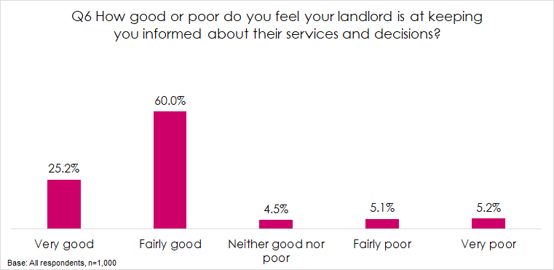

Satisfaction in this respect has decreased since the Council’s last tenant satisfaction survey in 2018 when 95% of respondents rated the Council as their landlord as good at keeping them informed. In 2013 where 73% rated the Council as very or fairly good at keeping them informed and in 2016 ,91% rated the Council as good in this respect.

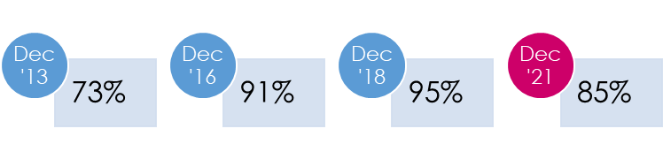

Following on from this, respondents who did not feel the Council were very or fairly good at keeping them informed (n=147) about their services and decisions were then asked to explain why they felt that way. The main reasons given for stating the Council was poor at keeping tenants informed were:
- Don’t get any or very little information/ don’t hear from them (29%)
- Don’t communicate well with tenants (21%)
- Don’t let you know what is going on/ keep you updated (20%)
Q7 Can you please explain why you said that you feel Falkirk Council are poor at keeping you informed about their services and decisions?
Base: did not rate keeping informed as good, n=147 | No | %
Don't get any information/ very little information/ hear from them | 43 | 29.3%
Don't communicate well with tenants | 31 | 21.1%
Don't keep you updated/ let you know what is going on | 30 | 20.4%
They don't get back to you/ You have to chase them up | 27 | 18.4%
Only receive a magazine | 10 | 6.8%
Don't know | 6 | 4.1%
Hard to get to speak to a member of staff | 5 | 3.4%
Don't know what is going on with upgrades | 3 | 2.0%
Other | 3 | 2.0%

Keeping updated during Covid 19 (Q8)
All tenants were asked if they felt that the Council’s Housing Service has kept them updated on the changes to services available due to Covid 19. As shown below, almost two thirds of respondents (63%) said that ‘yes’ they felt that they had been kept informed.

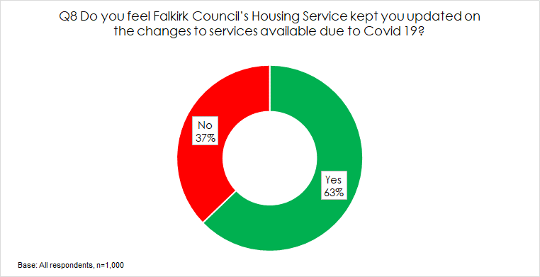

Internet access (Q9)
Overall, 64% of tenants have access to the internet, most commonly using a smartphone (54%). 36% of tenants said they do not use the internet at all.

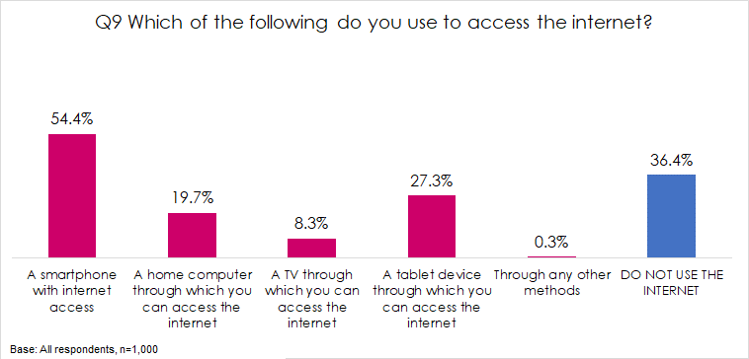

Analysis by age revealed that perhaps unsurprisingly the proportion of respondents with internet access decreases as age increases, for example 97% of tenants aged 16-34 decreasing to 25% of respondents aged 65 and over.

Q9 Which of the following do you use to access the internet?
 | 16-34 | 35-64 | 65+
Base | 148 | 458 | 323
A smartphone with internet access | 91.9% | 67.9% | 15.5%
A home computer through which you can access the internet | 33.1% | 25.1% | 9.6%
A TV through which you can access the internet | 13.5% | 7.0% | 3.4%
A tablet device through which you can access the internet | 43.2% | 37.1% | 9.6%
Through any other methods |  | 0.2% | 0.3%
DO NOT USE THE INTERNET | 2.7% | 21.2% | 74.6%

TENANT PARTICIPATION

Interest of participation activities (Q10)
Respondents were asked about their interest in getting involved in a range of ways they could help the Council improve their housing services..

Respondents expressed a low interest in becoming involved, with 78% stating that they were not interested. Where they were interested, tenants were most likely to be interested in less proactive ways, such as answering customer satisfaction feedback questionnaires (19%) or online questionnaires or discussion forums (13%).
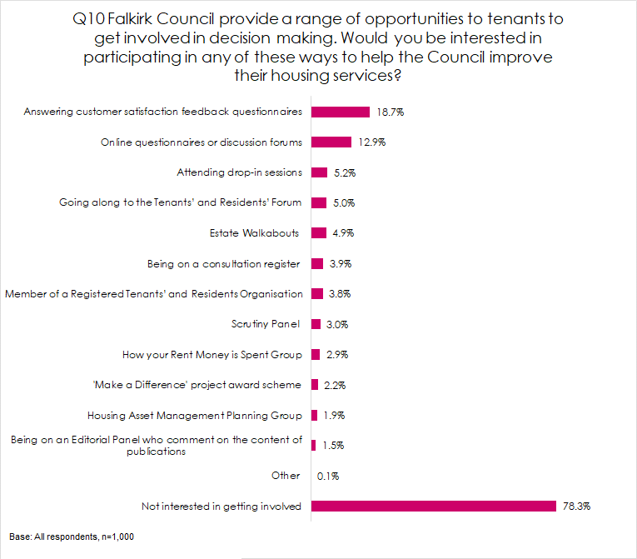

Satisfaction with the opportunities to participate (Q11-Q12)
Tenants were then asked how satisfied or dissatisfied they were with the opportunities given to them to participate in their landlord’s decision making processes. Just over 9 in 10 respondents (98%) were very or fairly satisfied in this respect, compared to 1% who were neither satisfied nor dissatisfied and 1% who were very or fairly dissatisfied.
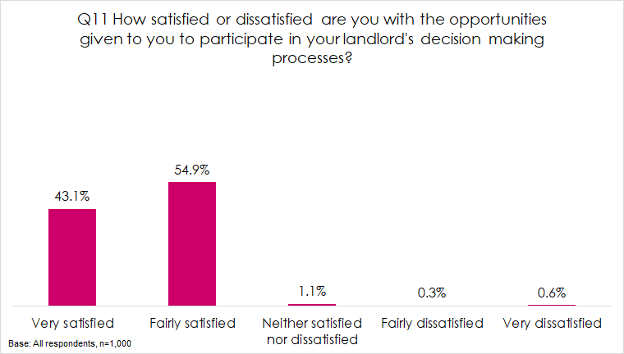
This is a significant increase from the 2013 survey where 49% were satisfied. Satisfaction with participation opportunities has risen year on year to 87% in 2016, 93% in 2018 and 98% in 2021.
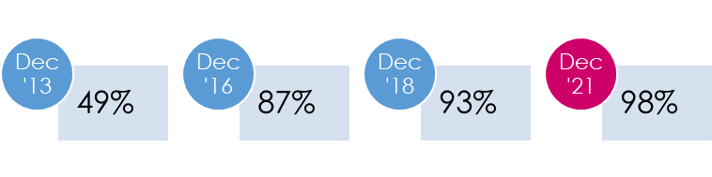
Respondents who were not satisfied with the opportunities given to them to participate in the Council’s decision making processes (n=20) were then asked to explain why they felt this way. The majority of comments related to the fact that tenants were not aware of these opportunities, however two respondents did make comments which may help improve how opportunities are provided:
- ﻿There aren’t many things in my area to get involved in, I would have to travel to Falkirk.
- I feel they have meetings but they just go through the motions as they have made their decision before they even ask tenants their opinion. I used to get involved but there is no point.
- I need things posted as I'm hard of hearing.

REPAIRS AND MAINTENANCE

General satisfaction with repairs and maintenance (Q13-Q14)
All tenants were asked generally how satisfied or dissatisfied they are with the way the Council deals with repairs and maintenance. Overall, 63% of tenants were either very or fairly satisfied in this respect compared to 27% who were dissatisfied. This has decreased significantly from 87% in 2018.
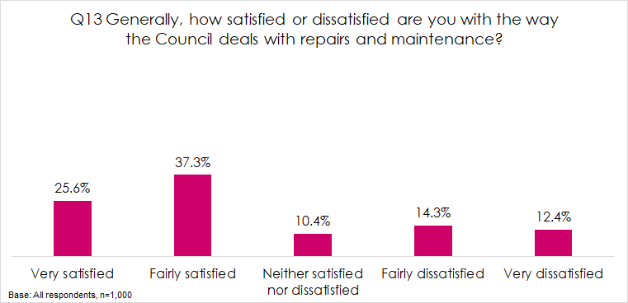
Those who were not satisfied with the repairs and maintenance service provided by Falkirk Council (n=371) were then asked to explain why they felt this way. The main reasons given were:
- Repairs take too long to complete/ issues are ongoing (44%)
- Repairs are outstanding/ still to be completed (23%)
- Repairs are not being done (12%).
Q14 Can you explain why you are not satisfied with the way the Council deals with repairs and maintenance?
Base: not satisfied with repairs, n=371 | No | %
Takes too long to get repairs done/ slow to respond | 162 | 43.7%
Repairs are outstanding/ still to be completed | 86 | 23.2%
Repairs not being done | 46 | 12.4%
Quality of repairs is poor | 38 | 10.2%
Poor communication about repairs | 28 | 7.5%
Recurring repairs issues | 9 | 2.4%
Upgrades required in the home | 9 | 2.4%
Overall repairs service is poor | 9 | 2.4%
Other | 7 | 1.9%
Repairs service is inconsistent - sometimes good sometimes not | 5 | 1.3%
Difficult to get in touch/ report repairs | 5 | 1.3%
Not had any repairs | 5 | 1.3%
There are a lot of repairs required in properties | 3 | 0.8%

Satisfaction with the quality of the home (Q15-Q16)
With regards to the quality of the home, 77% were very or fairly satisfied, compared to 9% who were neither satisfied nor dissatisfied and 14% who were very or fairly dissatisfied.
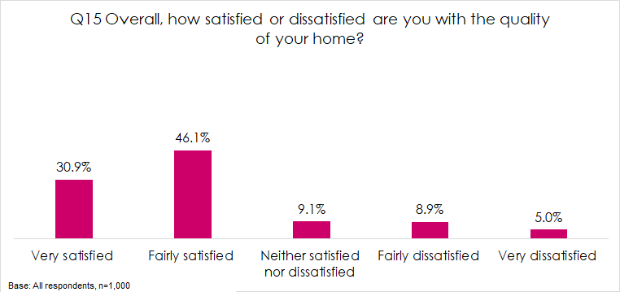

Satisfaction with the quality of the home is very similar to 2013 when 76% of respondents said that they were very or fairly satisfied with the quality of the home. This increased to 81% in 2016 and 94% in 2018 but has now decreased to 77%.
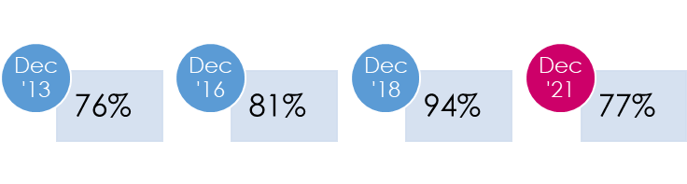

Respondents who were not satisfied with the quality of their home (n=230) were then asked how the Council could improve the quality of their home. The most common responses given were:
- Home requires upgrades e.g. kitchen/ bathroom/ windows/ doors (65%)
- Home is in need of repairs (24%)
- Deal with dampness/ mould issues (11%).

Q16 How could Falkirk Council improve the quality of your home?
Base: not satisfied with quality of the home, n=230 | No | %
Home requires upgrades e.g. kitchen/ bathroom/ windows/ doors | 149 | 64.8%
Home is in need of repairs | 54 | 23.5%
Deal with dampness/ mould issues | 26 | 11.3%
New boiler/ heating system | 18 | 7.8%
Poor quality of house | 15 | 6.5%
Walls need replastered | 14 | 6.1%
Other | 9 | 3.9%
Home is too small | 4 | 1.7%
Fix the floorboards | 3 | 1.3%

Satisfaction with aspects of the home (Q17)
Tenants were then asked how satisfied or dissatisfied they were with various aspects of their home. Satisfaction was greatest with respect to the heating system (85%), the external appearance of the building (83%) and the general condition of the property overall (83%).

On the other hand, satisfaction was lowest with regard to the windows (62%).

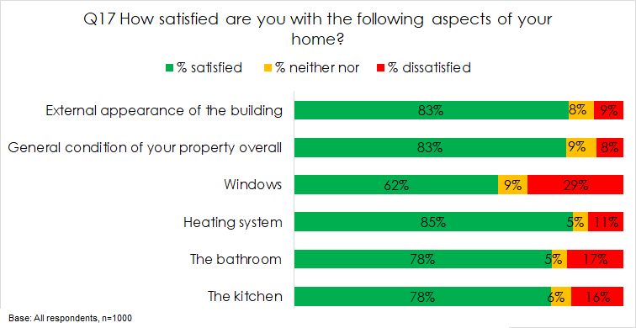

Compared to previous surveys, satisfaction has decreased, most significantly with respect to satisfaction with the windows which was 76% in 2016, rose to 88% in 2018 and has now decreased to 62% in 2021.
How satisfied are you with the following aspects of your home? Year on year analysis
 | % satisfied 2021 | % satisfied 2018 | % satisfied 2016
The kitchen | 78% | 93% | 83%
The bathroom | 78% | 93% | 84%
Heating system | 85% | 93% | 89%
Windows | 62% | 88% | 76%
General condition of your property overall | 83% | 95% | 85%
External appearance of the building | 83% | 95% | 87%

Moving intentions (Q31-Q32)
Just under one in 5 respondents (19%) said that they would like to move from their current property in the next 5 years.
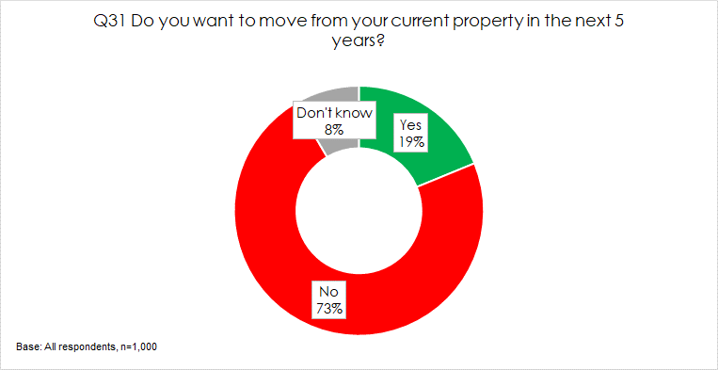

The main reasons given for this were that their current property was either too small (23%) or too big (13%).
Q32 Why do you think you would like to move within the next 5 years?
Base: Respondents, n=188 | No. | %
Too small | 43 | 22.9%
Too big | 24 | 12.8%
Other | 18 | 9.6%
Move to a better area | 17 | 9.0%
Move away from anti social neighbours | 14 | 7.4%
Would like a house/ back and front door/ garden | 14 | 7.4%
I struggle to move about the home e.g. cope with stairs | 12 | 6.4%
I would like to be closer to family or friends | 12 | 6.4%
Would like a ground floor/ level access | 11 | 5.9%
Better condition of property | 10 | 5.3%
Would like to buy a property | 8 | 4.3%
Difficult to maintain the house | 6 | 3.2%
I struggle to get in and out of the property | 4 | 2.1%
Difficult to maintain the garden | 3 | 1.6%
It is too expensive | 3 | 1.6%
I would like to be closer to facilities e.g. shops, doctor, dentist etc. | 1 | 0.5%

Analysis shows that families are most likely to wish to move home with 38% of two parent families and 29% of single parent families stating that they would like to move from their current property in the next 5 years. Their key reason is that their home is too small.

Older respondents aged 65+ are less likely to wish to move (10%) but where they do, their primary reasons tend to be associated with being closer to family/ friends, struggling to move about the house or get in and out of the house or to get a ground floor/ level access property.

THE NEIGHBOURHOOD

Neighbourhood as a place to live (Q20)
All respondents were asked how satisfied they were with their neighbourhood as a place to live. As shown below, 88% stating they were either very or fairly satisfied in this respect compared to 5% who were neither satisfied nor dissatisfied and 7% who were very or fairly dissatisfied.
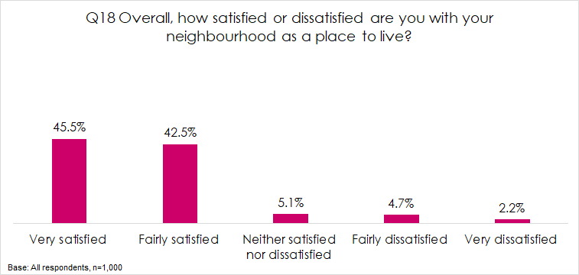

Management of the neighbourhood (Q19-Q20)
Tenants were asked how satisfied or dissatisfied they were with their landlord’s management of the neighbourhood they live in. 84% of respondents were very or fairly satisfied in this respect compared to 8% who were neither satisfied nor dissatisfied and 8% who were very or fairly dissatisfied.
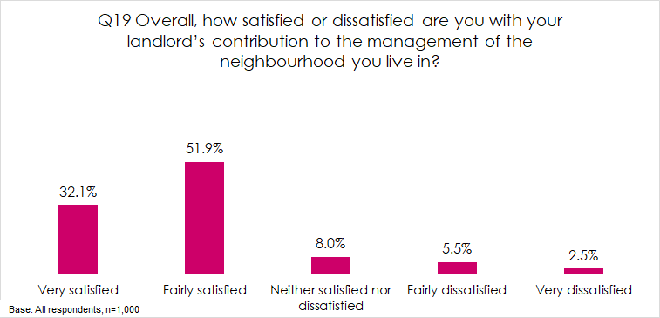

Satisfaction with neighbourhood management has decreased from 94% in 2018 and 92% in 2016 but is higher than it was in 2013 when 74% of respondents said that they were satisfied in this respect.
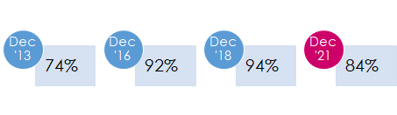

Those who were not satisfied with their landlord’s contribution to the management of the neighbourhood (n=160) were then asked how the housing service could improve their management of the neighbourhood. The most common responses given were:
- You never see them/ need to do more (29%)
- Not dealing with anti-social neighbours (24%)
- Need to vet tenants (17%)
- Tidy up the area (10%).

Q20 You said you were not satisfied with your landlord’s contribution to the management of the neighbourhood you live in. Can you please explain how the housing service could improve their management of the neighbourhood?
Base: not satisfied with contribution to neighbourhood management, n=160 | No | %
Need to do more/ don't see them | 46 | 28.8%
Not dealing with ASB/ ASN | 38 | 23.8%
Need to vet tenants | 27 | 16.9%
Tidy up area | 16 | 10.0%
Gardening maintenance | 14 | 8.8%
Not sure | 10 | 6.2%
Sort the bin area | 8 | 5.0%
Fix roads/ pavements | 7 | 4.4%
Other | 6 | 3.8%
More security/ CCTV | 5 | 3.1%
More for kids | 3 | 1.9%
Parking issues | 2 | 1.2%

Feeling of safety in the community (Q21 – Q23)
All respondents were asked how safe they feel in their community. As shown below, the majority of respondents feel safe, with 88% stating that they feel either very or fairly safe, 6% stating neither safe nor unsafe and 7% saying they feel fairly or very unsafe.
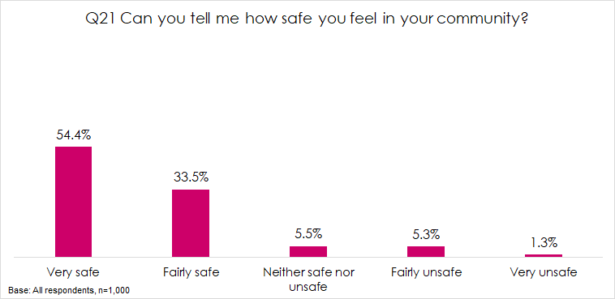

Analysis by housing area shows that those living in the West housing area were most likely to state that they feel very safe (70%) whereas those living in the East Housing area were less likely to state that they feel very safe (41%)
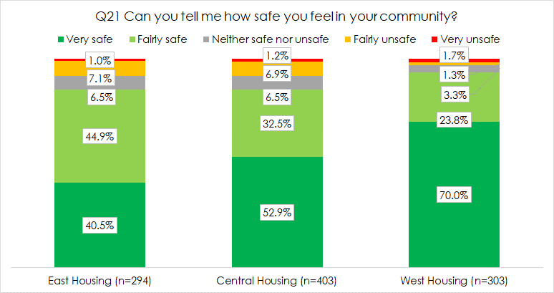

Those who said that they feel unsafe (n=121) were asked what the reasons for this are. The most common response (63%) was that they have witnessed or been the victim of ASB or crime in the area they live. This was followed by they have heard about other people’s experiences of ASB or crime in the area (52%).
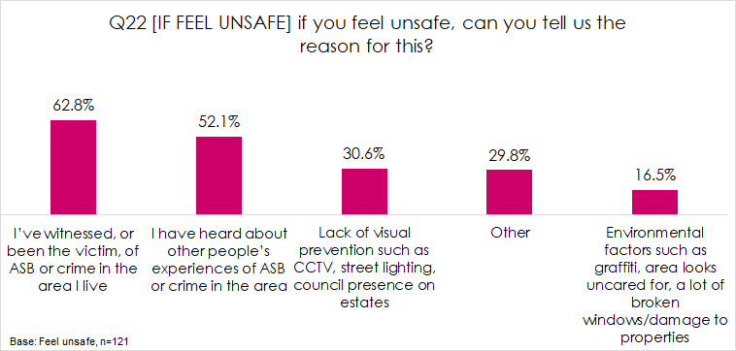

Those who said they feel safe were asked what makes them feel safe. The most common response was nice or friendly neighbours (22%), it is quiet (18%) or that they have lived in their community a long time/ know the area (18%).

Q23 [IF FEEL SAFE] What makes you feel safe?
Base: feel safe, n=879 | No | %
Nice neighbours/ friendly | 195 | 22.2%
It is quiet | 160 | 18.2%
Been here a long time/ know area | 154 | 17.5%
I feel safe | 122 | 13.9%
No issues/ problems | 122 | 13.9%
Home is secure/ safe | 104 | 11.8%
Good area | 64 | 7.3%
Don't go out much/ keep to myself | 24 | 2.7%
It's ok | 21 | 2.4%
Feel comfortable/ fine | 17 | 1.9%
Don't know | 17 | 1.9%
I like it here | 14 | 1.6%
Other | 11 | 1.3%
Close to family/ friends | 6 | 0.7%

Perceptions of problems in the neighbourhood (Q24)
When asked whether a range of potential issues were problems in their neighbourhood. Most likely to be perceived as either a serious or minor problem were:
- Excessive noise such as loud music or parties (13%)
- Vandalism or graffiti (10%)
- Dispute with neighbour (9%).

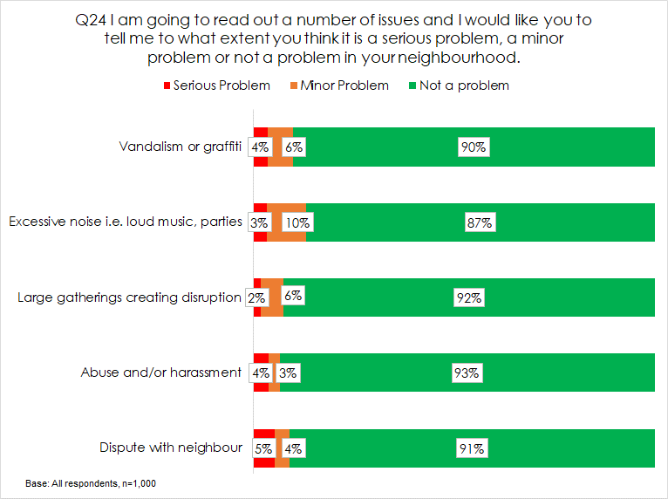

RENT AND VALUE FOR MONEY

Awareness of Council rents relative to others (Q25)
In terms of rent levels awareness was relatively low, with 11% of respondents aware that Falkirk Council had the 6th lowest rent and 5% of respondents aware that Falkirk Council had the 7th lowest level of supervision and management costs.
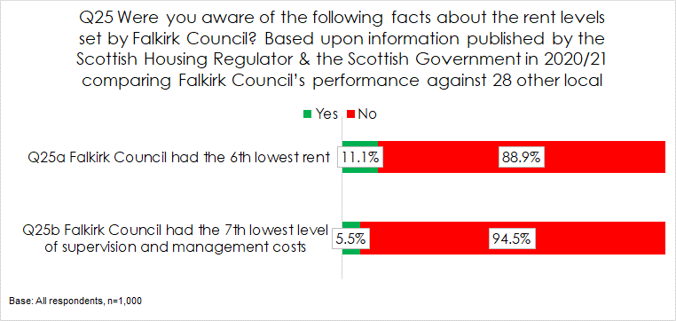

Priorities for spending rents (Q26)
Tenants were asked what they believed the Council should be prioritising spending more of what the income generated from rent is spent on. This shows that tenant’s top 3 priorities were:

The full list of their priorities is shown in the chart below:
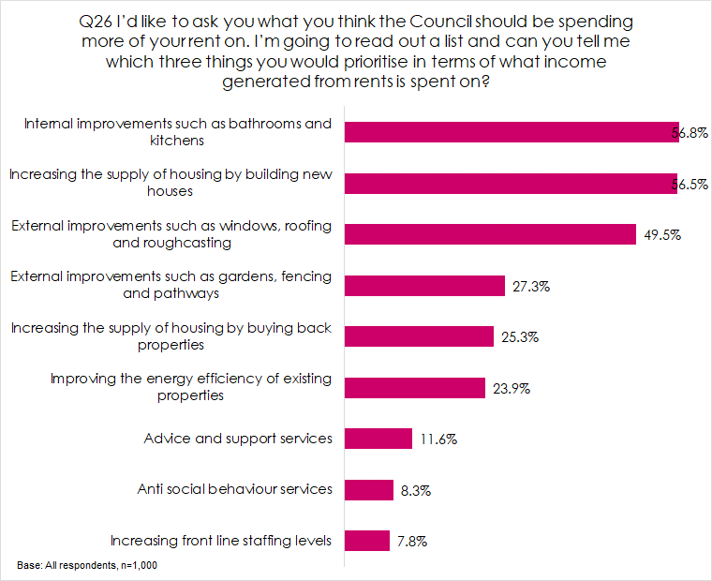

All respondents were then asked if there was anything else they believed the Housing Service should priorities to deliver the best service possible. Many too the opportunity to reinforce aspects noted above, most commonly providing better or more quality housing (27%) and home upgrades or improvements (21%). However, an additional key priority, noted by 20% of respondents was dealing with anti social behaviour.
Q27 Please tell me if there is anything else you believe should be the Housing Services priorities in terms of delivering the best service possible?
Base: all respondents, n=1000 | No | %
Better/ more quality housing | 268 | 26.8%
Home upgrades/ improvements | 214 | 21.4%
Deal with ASB/ ASN | 203 | 20.3%
External improvements | 147 | 14.7%
Communication | 47 | 4.7%
Facilities for children | 32 | 3.2%
Clean up the area | 19 | 1.9%
Better customer service | 18 | 1.8%
Improve repairs | 17 | 1.7%
Better parking | 14 | 1.4%
More affordable housing | 13 | 1.3%
Don't know | 13 | 1.3%
Vetting tenants | 10 | 1.0%
Fix roads/ pavements | 5 | 0.5%
Other | 4 | 0.4%
Sort bin area | 3 | 0.3%
None | 3 | 0.3%

Value for money (Q28-Q29)
Over three quarters of respondents (77%) were of the opinion that their rent represented very or fairly good value for money, compared to 13% who said it was neither good nor poor value and 11% who said it was very or fairly poor value for money.
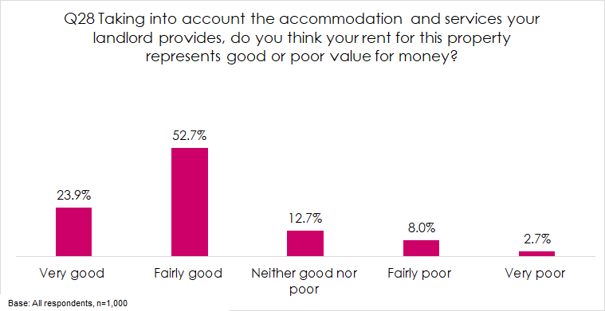

The proportion of respondents who said the rent for their home was very or fairly good value has increased from 69% in 2013 but is slightly lower than 80% in 2016 and 85% in 2018.
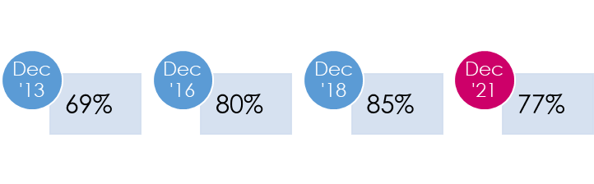
All respondents were then asked why they felt this way in terms of value for money. The most common reasons given for believing that rents were good value were:
- Home is good quality (20%)
- It is fair/ good value (12%)
- It is affordable (10%)
- Services provided are good (9%)
- Rent is cheaper than others/ private landlords (8%)

On the other hand, the most common reason for not rating value for money positively were:
- It is expensive/ keeps increasing (7%)
- Service is poor (6%)
- Home needing upgrades/ improvements (5%)
- Housing is poor quality (3%).

Q29 Can you explain why you say that?
Base: all respondents, n=1000 | No | %
Good quality home | 199 | 19.9%
It is good value | 123 | 12.3%
Affordable/ reasonable/ fair | 97 | 9.7%
Provide good services | 91 | 9.1%
Cheaper than others/ private rent | 84 | 8.4%
It is ok/ fine | 80 | 8.0%
Expensive/ keeps increasing | 73 | 7.3%
Poor services received | 62 | 6.2%
Get help/ housing benefit | 52 | 5.2%
Don't know | 49 | 4.9%
Home needing upgrades/ improvements | 47 | 4.7%
None | 39 | 3.9%
Poor quality housing | 31 | 3.1%
Good for size of property | 27 | 2.7%
Happy/ like it here | 26 | 2.6%
Other | 3 | 0.3%

Analysis also shows strong links to satisfaction with quality of the home and rating of value for money. Where tenants are very satisfied with the quality of the home, their rating of value for money is 92%. This decreases right down to 30% rating of value for money for those who are very dissatisfied with the quality of their home.

Affordability of rent (Q30)
Respondents who did not receive full housing benefit were then asked how easy they find it to afford their rent payments. As shown in the chart below, 66% of respondents said they found their rent payments very or fairly easy to afford, compared to 28% who said they found their rent payments just about affordable and 5% of respondents who said their payments were fairly or very difficult to afford.

This is broadly similar to 2018 when 65% said they find their rent very or fairly easy to afford.

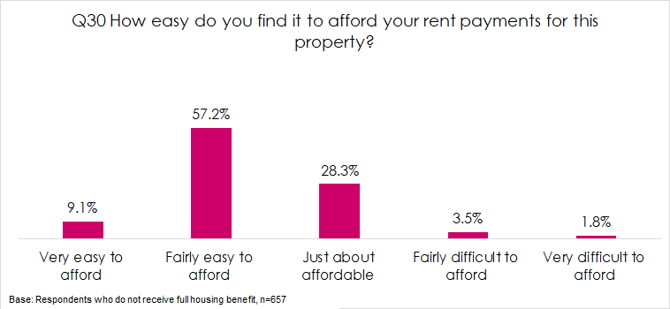

OVERVIEW OF LANDLORD SERVICES

Best thing (Q33)
All respondents were asked an open question relating to what they felt the Council’s housing service did best. They could answer freely in their own words and the responses given have been coded thematically to allow for analysis. Just over half of respondents (54%) said that they didn’t know or couldn’t spontaneously think of an answer. The most common tangible responses were:
- Repairs (11%)
- Communicating with tenants (6%)
- Maintaining homes (6%)
- Customer services/ customer care (5%).

Q33 Thinking about the services provided by your landlord, what do you think Falkirk Council’s Housing Service is best at?
Base: all respondents, n=1000 | No | %
Don't know | 326 | 32.6%
Nothing | 217 | 21.7%
Repairs | 111 | 11.1%
Communicating with tenants | 61 | 6.1%
Maintaining homes | 55 | 5.5%
Customer services/ customer care | 45 | 4.5%
Everything | 35 | 3.5%
Provide good services | 28 | 2.8%
Happy/ satisfied overall | 28 | 2.8%
Responding to tenants/ dealing with issues | 26 | 2.6%
Looking after the area | 21 | 2.1%
Looking after tenants/ vulnerable tenants | 17 | 1.7%
Providing good houses | 15 | 1.5%
Keeping tenants informed | 14 | 1.4%
Other | 10 | 1.0%
Dealing with rents | 7 | 0.7%

Priority for improvement (Q34)
Again, respondents were asked an open question relating to what they would say was the top priority for improvement. Encouragingly, 48% of respondents could not spontaneously provide a response to this stating either ‘nothing’ or don’t know.

In terms of priorities for improvement, the most common responses were:
- Repairs service (20%)
- Maintenance/ upgrading properties (15%)

Q34 And what would you say is top priority for improvement?
Base: all respondents, n=1000 | No | %
Nothing | 268 | 26.8%
Don't know | 214 | 21.4%
Repairs service | 203 | 20.3%
Maintenance/ upgrading properties | 147 | 14.7%
Communications | 47 | 4.7%
Improve the area e.g. gardens, parking, paths, facilities | 32 | 3.2%
Exterior of the building | 19 | 1.9%
Build more homes | 18 | 1.8%
Deal with anti-social behaviour | 17 | 1.7%
Vet tenants | 14 | 1.4%
Clean up the area/ communal cleaning | 13 | 1.3%
Improve ease of contact/ accessibility of staff | 13 | 1.3%
Other | 10 | 1.0%
Everything | 5 | 0.5%
Keep rents affordable | 4 | 0.4%
Grounds/ common area maintenance | 3 | 0.3%
Listen more to tenants | 3 | 0.3%

ABOUT YOU AND YOUR HOUSEHOLD

Age and gender (Q35 – Q36)
With regards to gender, two thirds of respondents (66%) were female and 34% were male.
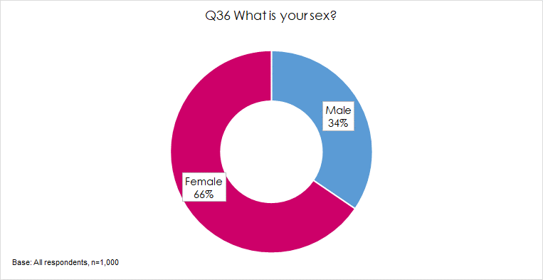

Just under 1 in 5 respondents (16%) were aged under 35, 49% were aged 35 to 64 and 35% were aged 65 and over.

Household composition (Q37-Q38)
The majority of households were single adult households (52%), 20% were two adult households with no children, 7% were couples with at least one child, 12% were lone parents with at least one child and 4% were households with three or more adults.

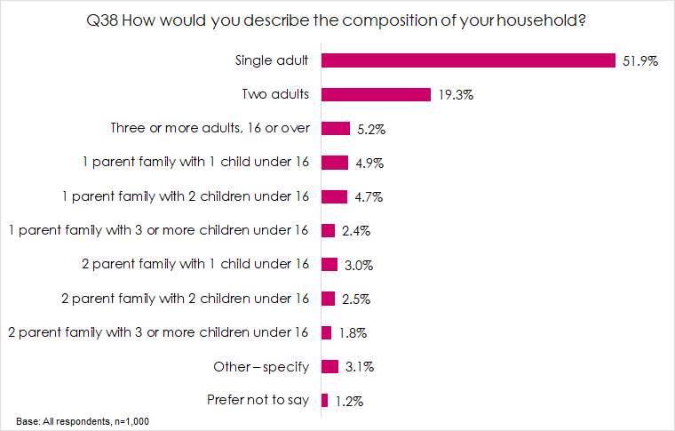

Disability (Q39)
Just under 6 in 10 respondents said they had some form of disability or long-term health condition (57%). This was most commonly a physical disability (29%) followed by a chronic illness (16%) and then a mental health condition (9%).

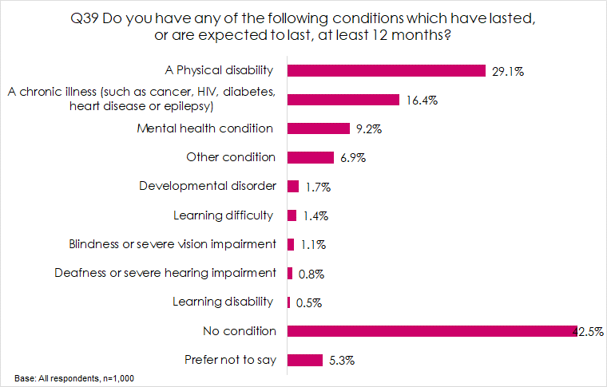

Ethnicity (Q40)
In terms of ethnicity, the vast majority of respondents were White Scottish or Other British (96%).
Q40 What is your ethnic group?
Base: All respondents, n=1,000 | No | %
White Scottish | 932 | 93.2%
White English | 23 | 2.3%
White Irish | 3 | 0.3%
White Polish | 6 | 0.6%
White Roma | 1 | 0.1%
White Other British | 2 | 0.2%
Pakistani, Pakistani Scottish or Pakistani British | 4 | 0.4%
Indian, Indian Scottish or Indian British | 1 | 0.1%
Other Asian, please write in: | 1 | 0.1%
African, African Scottish or African British | 3 | 0.3%
Other | 10 | 1.0%
Prefer not to say | 14 | 1.4%

Appendix 1
Survey Questionnaire

- Overall Service
- Taking everything into account, how satisfied or dissatisfied are you with the overall service provided by Falkirk Council as your landlord?
Very satisfied | 1 | Go to Q3
Fairly satisfied | 2
Neither satisfied nor dissatisfied | 3 | Go to Q2
Fairly dissatisfied | 4
Very dissatisfied | 5
Don’t know/ No opinion | 6 | Go to Q3

- Can you please explain why you said you were not satisfied with the overall service provided by Falkirk Council as your landlord?
- Information and communication
- How would you prefer the Council to communicate with you about your Tenancy? [ALL THAT APPLY]
Email | 1
Telephone | 2
Text message | 3
Personal letter | 4
Personal visit to your home | 5
Tenants’ Handbook | 6
Leaflets/flyers | 7
Online through ‘My Falkirk’ portal | 8
Other (please specify) | 9

- And if you needed to communicate with the Council about your Tenancy, which of the following methods would you be happy to use? [ALL THAT APPLY]
Telephone | 1
Through ‘My Falkirk’ online account | 2
Email | 3
Text message | 4
Letter | 5
Through Elected Member | 6
Social Media | 7
Other (please specify) | 8

- The Council uses a range of different methods to keep you informed. How would you prefer the Council to keep you informed about general issues such as their services or decisions or events? [ALL THAT APPLY]
Tenant Talk information magazine posted to you | 1
Annual Performance Report | 2
Website | 3
Twitter or Facebook | 4
Email | 5
Text | 6
Personal letter | 7
Other (please specify) | 8
- How good or poor do you feel your landlord is at keeping you informed about their services and decisions?
Very good | 1 | Go to Q8
Fairly good | 2
Neither good nor poor | 3 | Go to Q7
Fairly poor | 4
Very poor | 5

- Can you please explain why you said that you feel Falkirk Council are poor at keeping you informed about their services and decisions?

- Do you feel Falkirk Council’s Housing Service kept you updated on the changes to services available due to Covid 19?
Yes | 1
No | 2

- Which of the following do you use to access the internet? CIRCLE ALL THAT APPLY OR ‘DO NOT USE’
A smartphone with internet access | 1
A home computer through which you can access the internet | 2
A TV through which you can access the internet | 3
A tablet device through which you can access the internet | 4
Through any other methods (please describe) | 5
DO NOT USE THE INTERNET | 6
- Tenant Participation
- Falkirk Council provide a range of opportunities to tenants to get involved in decision making.
Would you be interested in participating in any of these ways to help the Council improve their housing services?
Online questionnaires or discussion forums | 1
Scrutiny Panel (a group of tenants who meet to check the Council’s performance and make recommendation for areas for improvement) | 2
Estate Walkabouts where tenants can identify areas of concern on their local estate | 3
Answering customer satisfaction feedback questionnaires | 4
Being on a consultation register of tenants who are happy to be consulted on a range of things | 5
Being on an Editorial Panel who comment on the content and publication of the Tenant Talk magazine and other publications | 6
Going along to the Tenants’ and Residents’ Forum | 7
Becoming a member of a Registered Tenants’ and Residents Organisation | 8
How your Rent Money is Spent Group | 9
Housing Asset Management Planning Group | 10
Attending drop-in sessions | 11
'Make a Difference' project award scheme | 12
Other (please specify) | 13
Not interested in getting involved | 14

- How satisfied or dissatisfied are you with the opportunities given to you to participate in your landlord’s decision making processes?
Very satisfied | 1 | Go to Q13
Fairly satisfied | 2
Neither satisfied nor dissatisfied | 3 | Go to Q12
Fairly dissatisfied | 4
Very dissatisfied | 5

- You said you were neither satisfied nor dissatisfied/ dissatisfied with the opportunities given to you to participate in your landlord’s decision-making processes, can you explain why you gave this response?

- Repairs and maintenance
- Generally, how satisfied or dissatisfied are you with the way the Council deals with repairs and maintenance?
Very satisfied | 1 | Go to Q15
Fairly satisfied | 2
Neither satisfied nor dissatisfied | 3 | Go to Q14
Fairly dissatisfied | 4
Very dissatisfied | 5

- Can you explain why you are not satisfied with the way the Council deals with repairs and maintenance?

- Overall, how satisfied or dissatisfied are you with the quality of your home?
Very satisfied | 1 | Go to Q17
Fairly satisfied | 2
Neither satisfied nor dissatisfied | 3 | Go to Q16
Fairly dissatisfied | 4
Very dissatisfied | 5

- How could Falkirk Council improve the quality of your home?

- How satisfied are you with the following aspects of your home?
 | Very Satisfied | Fairly Satisfied | Neither / Nor | Fairly Dissatisfied | Very Dissatisfied
The kitchen | 1 | 2 | 3 | 4 | 5
The bathroom | 1 | 2 | 3 | 4 | 5
Heating system | 1 | 2 | 3 | 4 | 5
Windows | 1 | 2 | 3 | 4 | 5
General condition of your property overall | 1 | 2 | 3 | 4 | 5
External appearance of the building | 1 | 2 | 3 | 4 | 5

- The neighbourhood
- Overall, how satisfied or dissatisfied are you with your neighbourhood as a place to live? Neighbourhood defined as within 20 min walk from home or if you live outside a town, 20 minute drive from home.
Very satisfied | 1
Fairly satisfied | 2
Neither satisfied nor dissatisfied | 3
Fairly dissatisfied | 4
Very dissatisfied | 5

- Overall, how satisfied or dissatisfied are you with your landlord’s contribution to the management of the neighbourhood you live in?
Very satisfied | 1 | Go to Q21
Fairly satisfied | 2
Neither satisfied nor dissatisfied | 3 | Go to Q20
Fairly dissatisfied | 4
Very dissatisfied | 5

- You said you were not satisfied with your landlord’s contribution to the management of the neighbourhood you live in. Can you please explain how the housing service could improve their management of the neighbourhood?

- Can you tell me how safe you feel in your community?
Very safe | 1 | Go to Q23
Fairly safe | 2
Neither safe nor unsafe | 3 | Go to Q22
Fairly unsafe | 4
Very unsafe | 5

- [IF FEEL UNSAFE] if you feel unsafe, can you tell us the reason for this? ALL THAT APPLY
I’ve witnessed, or been the victim, of ASB or crime in the area I live | 1
Environmental factors such as graffiti, area looks uncared for, a lot of broken windows/damage to properties | 2
Lack of visual prevention such as CCTV, street lighting, council presence on estates | 3
I have heard about other people’s experiences of ASB or crime in the area | 4
Other (please describe) | 5
GO TO Q24

- [IF FEEL SAFE] What makes you feel safe?

- I am going to read out a number of issues and I would like you to tell me to what extent you think it is a serious problem, a minor problem or not a problem in your neighbourhood.
 | Serious Problem | Minor  Problem | Not a  problem
Vandalism or graffiti | 1 | 2 | 3
Excessive noise i.e. loud music, parties | 1 | 2 | 3
Large gatherings creating disruption | 1 | 2 | 3
Abuse and/or harassment | 1 | 2 | 3
Dispute with neighbour | 1 | 2 | 3
Any other ASB you believe to be a problem in your neighbourhood? (please specify) | 1 | 2

Rent and value for money
- Were you aware of the following facts about the rent levels set by Falkirk Council? Based upon information published by the Scottish Housing Regulator & the Scottish Government in 2020/21 comparing Falkirk Council’s performance against 28 other local authorities….
 | Yes | No
Falkirk Council had the 6t^{h} lowest rent | 1 | 2
Falkirk Council had the 7th lowest level of supervision and management costs | 1 | 2

- I’d like to ask you what you think the Council should be spending more of your rent on. I’m going to read out a list and can you tell me which three things you would prioritise in terms of what income generated from rents is spent on?
Increasing the supply of housing by building new houses | 1
Increasing the supply of housing by buying back properties | 2
Internal improvements such as bathrooms and kitchens | 3
External improvements such as windows, roofing and roughcasting | 4
External improvements such as gardens, fencing and pathways | 5
Advice and support services | 6
Anti social behaviour services | 7
Increasing front line staffing levels | 8
Improving the energy efficiency of existing properties | 9

- Please tell me if there is anything else you believe should be the Housing Services priorities in terms of delivering the best service possible?

- Taking into account the accommodation and services your landlord provides, do you think your rent for this property represents good or poor value for money?
Very good | 1
Fairly good | 2
Neither good nor poor | 3
Fairly poor | 4
Very poor | 5

- Can you explain why you say that?

- How easy do you find it to afford your rent payments for this property?
Very easy to afford | 1
Fairly easy to afford | 2
Just about affordable | 3
Fairly difficult to afford | 4
Very difficult to afford | 5
Not applicable – receive full housing benefit | 6

Future plans
- Do you want to move from your current property in the next 5 years?
Yes | 1 | Go to Q32
No | 2 | Go to Q33
Don’t know | 3

- Why do you think you would like to move within the next 5 years? [ALL THAT APPLY]
Too big | 1
Too small | 2
Difficult to maintain the house | 3
Difficult to maintain the garden | 4
I struggle to move about the home e.g. cope with stairs | 5
I struggle to get in and out of the property | 6
I would like to be closer to family or friends | 7
I would like to be closer to facilities e.g. shops, doctor, dentist etc. | 8
It is too expensive | 9
Other (please specify) | 10

- Thinking about the services provided by your landlord, what do you think Falkirk Council’s Housing Service is best at?

- And what would you say is top priority for improvement?
- About you and your household
Finally, I’d like to ask about you and your household. This will only be used for analysis purposes to see if there are differences in the views between different types of tenant household. Please answer these questions as fully as you are willing or able.

- What is your age?

- What is your sex?
Male | 1
Female | 2

- How many people usually live in this house?
- How would you describe the composition of your household?
Single adult | 1
Two adults | 2
Three or more adults, 16 or over | 3
1 parent family with 1 child under 16 | 4
1 parent family with 2 children under 16 | 5
1 parent family with 3 or more children under 16 | 6
2 parent family with 1 child under 16 | 7
2 parent family with 2 children under 16 | 8
2 parent family with 3 or more children under 16 | 9
Other – specify | 10
Prefer not to say | 11

- Do you have any of the following conditions which have lasted, or are expected to last, at least 12 months? [CODE ALL THAT APPLY]
Deafness or severe hearing impairment | 1
Blindness or severe vision impairment | 2
Learning disability (for example Down’s Syndrome) | 3
Learning difficulty (for example dyslexia or dyspraxia) | 4
Developmental disorder (for example, Autistic Spectrum Disorder or Asperger’s Syndrome) | 5
A Physical disability (a condition that substantially limits one or more basic physical activities such as walking, climbing stairs, lifting or carrying) | 6
Mental health condition (such as depression or schizophrenia) | 7
A chronic illness (such as cancer, HIV, diabetes, heart disease or epilepsy) | 8
Other condition, please specify | 9
No condition | 10
Prefer not to say | 11

- What is your ethnic group?
A White
Scottish | 1
English | 2
Welsh | 3
Irish | 4
Polish | 5
Roma | 6
Gypsy / Traveller | 7
Other British | 8
B Mixed or multiple ethnic groups
Any mixed or multiple ethnic groups, please write in: | 9
C Asian, Scottish Asian or British Asian
Pakistani, Pakistani Scottish or Pakistani British | 10
Indian, Indian Scottish or Indian British | 11
Bangladeshi, Bangladeshi Scottish or Bangladeshi British | 12
Chinese, Chinese Scottish or Chinese British | 13
Other Asian, please write in: | 14
D African, Scottish African or British African
African, African Scottish or African British | 15
Other African background, please write in: | 16
E Caribbean or Black
Caribbean, Caribbean Scottish or Caribbean British | 17
Black, Black Scottish or Black British | 18
Other Caribbean or Black background, please write in | 19
F Other ethnic group
Other, please write in: | 20
Prefer not to say | 21
- Thank you very much for completing the questionnaire.
- Would you like to take a note of our website address to learn more about Research Resource and how your data is used? You can find our Privacy Information Notice at www.researchresource.co.uk/privacy-notice

Appendix 2
Technical Report Summary

TECHNICAL REPORT SHEET – QUANTITATIVE RESEARCH
Project number | P1191
Project name | Falkirk Council Satisfaction Survey
Objectives of the research | The aim of the research was to seek tenants’ views on the services that the Council, as a landlord, provides and how well it performs these services and to help identify areas where the service can be improved. Specifically, the research was designed to provide tenants views on the following:  - The quality of information provided by the Council;  - Feedback on customer care;  - Quality of accommodation;  - Service provision including repairs, maintenance and improvements;  - Tenant involvement/ opportunities for participation;  - Value for money.
Target group | Tenants of the Council
Target sample size | 1000 interviews from a representative sample of 2500 Council tenants
Achieved sample size | 1000 interviews
Date of fieldwork | Interviewing took place between 7th December and 25th January 2022
Sampling method | Interviews were spread across the Council’s stock
Data collection method | Interviews were undertaken with the tenant or their partner by telephone. All responses were recorded digitally on tablet into our SNAP survey software package.
Response rate and definition and method of how calculated | 40% (1,000 interviews from 2500 tenants in the scope for research)
Any incentives? | Not applicable
Number of interviewers | 10
Interview validation methods | 10% of each interviewer’s work was back checked to ensure that interviews have been completed accurately and in line with ISO 20252 standards.
Showcards or any other materials used? | Showcards used as per instructions on the questionnaire
Weighting procedures | Not applicable
Estimating and imputation procedures | Not applicable
Reliability of findings | +/- 2.4% based upon a 50% estimate at the 95% confidence level.

