

Falkirk Council

Tenant Satisfaction Survey 2024

Research Report

|  |  |
| --- | --- |
| **Prepared by:** | **Prepared for:** |
| **Research Resource**  10 Lake Avenue  Lanark  ML11 9BQ | **Falkirk Council**  Municipal Buildings  West Bridge Street  Falkirk  FK1 5RS |
| **Contact**: Lorna Shaw | **Contact**: Alan Christie |
| **Email**: lorna.shaw@researchresource.co.uk | **E-mail**: [alan.christie@falkirk.gov.uk](mailto:alan.christie@falkirk.gov.uk) |

Falkirk Council

Tenant Satisfaction Survey 2024

Contents

1. EXECUTIVE SUMMARY 4

2. INTRODUCTION, OBJECTIVES AND METHODOLOGY 8

2.1 Introduction, background and objectives 8

2.2 Research method 8

2.3 Survey Analysis and Reporting 10

3. OVERALL SATISFACTION 11

3.1 Satisfaction with the overall service provided by the Council (Q1-Q2) 11

4. INFORMATION AND COMMUNICATION 13

4.1 Keeping tenants informed (Q3) 13

4.2 Accessibility of information (Q4-Q5) 13

5. TENANT PARTICIPATION 15

5.1 Interest of participation activities (Q6) 15

5.2 Satisfaction with the opportunities to participate (Q7) 16

6. REPAIRS AND MAINTENANCE 17

6.1 General satisfaction with repairs and maintenance (Q8-Q9) 17

6.2 Satisfaction with the quality of the home (Q10-Q11) 18

6.3 Satisfaction with aspects of the home (Q12) 19

6.4 Moving intentions (Q20-Q21) 20

7. THE NEIGHBOURHOOD 21

7.1 Neighbourhood as a place to live (Q13) 21

7.2 Management of the neighbourhood (Q14-Q15) 22

8. RENT AND VALUE FOR MONEY 23

8.1 Priorities for spending rents (Q16-Q17) 23

8.2 Value for money (Q18-Q19) 26

9. OVERVIEW OF LANDLORD SERVICES 28

9.1 Best thing (Q22) 28

9.2 Priority for improvement (Q23) 29

10. UNDERSTANDING THE RESULTS 30

10.1 Introduction 30

10.2 Age 30

10.3 Gender 31

10.4 Disability 32

11. ABOUT YOU AND YOUR HOUSEHOLD 33

11.1 Age and gender (Q24 – Q29/Q31) 33

11.2 Care experienced (Q25) 34

11.3 Disability (Q26) 34

11.4 Ethnicity (Q27) 35

11.5 Religion (Q28) 35

11.6 Sexual orientation (Q30) 35

APPENDIX 1: QUESTIONNAIRE

APPENDIX 2: TECHNICAL REPORT SUMMARY



Report written by: Rosemary Stafford

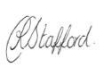

Date: 20/08/2024

Reviewed by: Elaine MacKinnon / Lorna Shaw

 

Date: 20/08/2024

# EXECUTIVE SUMMARY

INTRODUCTION

* Falkirk Council commissioned Research Resource to carry out their Tenant Satisfaction Survey on their behalf.
* A total of 1,002 interviews were carried out with Falkirk Council tenants in order to assess satisfaction with the Council and the services they provide. Interviews took place between 26th of June and the 29th of July 2024.
* 1,002 interviews represent a 40% response rate from the representative sample of 2,500 tenants that was drawn for the research and provides data accurate to +/-2.4% (based upon a 50% estimate at the 95% level of confidence).
* This executive summary highlights the key findings from this programme of research.

SCOTTISH SOCIAL HOUSING CHARTER SATISFACTION INDICATORS

The chart below shows the overall satisfaction values for the charter indicator questions that were asked within the Tenant Satisfaction Survey (TSS). As can be seen below Falkirk Council’s Housing Service is performing to a very high standard with combined satisfaction ranging from 93% in terms of the overall service to 99% for participation opportunities.

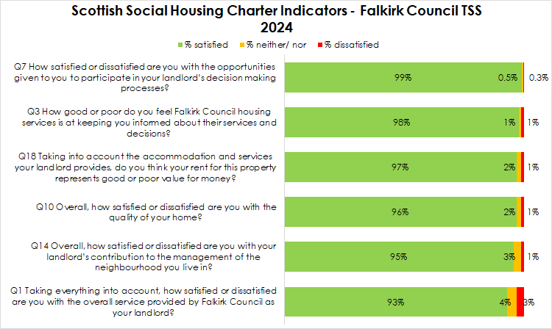

The table below shows that Falkirk Council has seen significant improvements in satisfaction when compared to the 2021 tenant satisfaction survey. This is most notable with regards to value for money (increased by 20 percentage points), the quality of the home (increased by 19 percentage points) and the overall service (increased by 18 percentage points). Furthermore, the 2024 results are higher than the Scottish average reported for all social landlords. This is most evident in terms of value for money with 97% of Falkirk Council tenants stating their rent is good value for money compared to 82% for Scottish social landlords on average.

|  |  |  |  |  |  |
| --- | --- | --- | --- | --- | --- |
| **Scottish Housing Regulator Indicators** | | | | | |
|  | **Dec 2016** | **Dec 2018** | **Dec 2021** | **Aug 2024** | **Scottish average 22/23** |
| Taking everything into account, how satisfied or dissatisfied are you with the overall service provided by Falkirk Council as your landlord? (*% very/fairly satisfied)* | 85% | 92% | 75% | **93%** | 87% |
| How good or poor do you feel your landlord is at keeping you informed about their services and decisions? (*% very/ fairly good)* | 91% | 95% | 85% | **98%** | 90% |
| How satisfied or dissatisfied are you with the opportunities given to you to participate in your landlord's decision making processes? (*% very/ fairly satisfied)* | 87% | 93% | 98% | **99%** | 86% |
| Overall, how satisfied or dissatisfied are you with the quality of your home? (*% very/ fairly satisfied)* | 81% | 94% | 77% | **96%** | 84% |
| Overall, how satisfied or dissatisfied are you with your landlord's contribution to the management of the neighbourhood you live in? (*% very/ fairly satisfied)* | 92% | 94% | 84% | **95%** | 84% |
| Taking into account the accommodation and services your landlord provides, to what extent do you think your rent represents value for money? Is it… (*% stating very/ fairly good)* | 80% | 85% | 77% | **97%** | 82% |

OVERALL SATISFACTION

* The survey began by asking respondents how satisfied or dissatisfied they were with the overall service provided by Falkirk Council as their landlord. 93% of respondents were very or fairly satisfied in this respect, an increase from 75% in 2021.
* The key reasons for dissatisfaction were repairs and maintenance related or where respondents felt their home required upgrades.

INFORMATION AND COMMUNICATION

* 98% of tenants said they believed that Falkirk Council as their landlord was good at keeping them informed about services and decisions. This has increased from 85% in 2021.
* All but 5 tenants (99.5%) were of the opinion the information they receive from Falkirk Council as their landlord is very or fairly accessible. Respondents who did not find information very accessible were asked what improvements could be made to make the information easier to read or understand. Where respondents were able to comment, this was generally where they felt the website could be easier to navigate.

TENANT PARTICIPATION

* Respondents expressed a low interest in becoming involved, with 82% stating they were not interested in getting involved. Where tenants were interested in getting involved in helping the Council improve their housing services, they were most interested in answering customer feedback questionnaires (16%) or online questionnaires or discussion forums (2%).
* Over 9 in 10 respondents (99%) were very or fairly satisfied with the opportunities given to them to participate in their landlord’s decision making processes, which is consistent with the 2021 survey where 98% were satisfied in this respect.

REPAIRS AND MAINTENANCE OF THE HOME

* 94% of tenants were satisfied with the way the Council deals with repairs and maintenance. This is a significant increase from 2018 when 63% were satisfied in this respect. The main reasons given for not being satisfied in this respect were due to the length of time it takes to get repairs done or that repairs are poor quality.
* With regards to the quality of the home 96% were very or fairly satisfied, increasing from 77% in 2021.
* Tenants were then asked how satisfied or dissatisfied they were with various aspects of their home. Satisfaction had increased across the board with respect to the home:
  + 97% were satisfied with the heating system (up from 85%)
  + 96% were satisfied with the general condition of the property overall (up from 83%)
  + 95% were satisfied with the external appearance of the building (up from 83%)
  + 94% were satisfied with the kitchen (up from 78%)
  + 93% were satisfied with the bathroom (up from 78%)
  + 88% were satisfied with the windows (up from 62%).

THE NEIGHBOURHOOD

* 96% of respondents were satisfied with their neighbourhood as a place to live (88% in 2021).
* 95% were very or fairly satisfied with their landlord’s contribution to the management of the neighbourhood they live in, an increase from 84% in 2021.

RENT AND VALUE FOR MONEY

* Tenant priorities in terms of what they felt the Council should be spending more of their rent on were:
  + Internal improvements such as bathrooms and kitchens (56%)
  + External improvements such as windows, roofing and roughcasting (42%).
  + External improvements such as gardens, fencing and pathways (39%)
* 95% of tenants said they felt their rent represented very or fairly good value for money, a significant increase from 77% in 2021.

# INTRODUCTION, OBJECTIVES AND METHODOLOGY

## Introduction, background and objectives

This report represents and discusses the findings to emerge from Falkirk Council’s 2024 Tenant Satisfaction Survey.

The aim of the research was to seek tenants’ views on the services that the Council, as a landlord, provides and how well it performs these services and to help identify areas where the service can be improved. Specifically, the research was designed to provide tenants views on the following:

* The quality of information provided by the Council;
* Feedback on customer care;
* Quality of accommodation;
* Service provision including repairs, maintenance and improvements;
* Tenant involvement/ opportunities for participation;
* Value for money.

It is against this background that Research Resource were commissioned to carry out Falkirk Council Housing Services 2024 Tenant Satisfaction Survey.

## Research method

After consultation with Council representatives, a survey questionnaire was agreed, which fully met the information needs and requirements of the Council. In developing the questionnaire, the following issues were considered:

* The Scottish Social Housing Charter indicators upon which the Council is required to report;
* Current information needs of the Council;
* Research Resource experience in relation to customer satisfaction surveying.

The aim of the survey was to achieve a robust level of data upon which the Council can have confidence making decisions. A total of 1,002 interviews were completed between the 26th of June and the 29th of July 2024. This is a 40% response rate from a representative sample of 2,500 tenants that was drawn from the overall Falkirk Council tenant population and provides data accurate to +/- 2.4% accuracy, based upon a 50% estimate and 95% level of confidence. Tenant interviews were spread across the Council’s stock to ensure coverage of all tenants. Analysis by area shows good coverage across the Council’s stock.

|  |  |  |  |  |
| --- | --- | --- | --- | --- |
|  | **No of tenants** | **% of tenants** | **No of interviews** | **% of interviews** |
| Airth | 141 | 0.9% | 8 | 0.8% |
| Allandale | 43 | 0.3% | 3 | 0.3% |
| Avonbridge | 137 | 0.9% | 10 | 1.0% |
| Bainsford | 51 | 0.3% | 3 | 0.3% |
| Banknock | 282 | 1.8% | 18 | 1.8% |
| Blackness | 5 | 0.0% |  | 0.0% |
| Bo'Ness | 1424 | 8.9% | 904 | 9.4% |
| Bonnybridge | 919 | 5.7% | 57 | 5.7% |
| Brightons | 147 | 0.9% | 6 | 0.6% |
| California | 92 | 0.6% | 6 | 0.6% |
| Carron | 64 | 0.4% | 5 | 0.5% |
| Carronshore | 346 | 2.2% | 21 | 2.1% |
| Castlehill | 5 | 0.0% | 0 | 0.0% |
| Denny | 1006 | 6.3% | 65 | 6.5% |
| Dennyloanhead | 99 | 0.6% | 6 | 0.6% |
| Dunipace | 258 | 1.6% | 17 | 1.7% |
| Falkirk | 4887 | 30.6% | 308 | 30.7% |
| Fankerton | 19 | 0.1% | 1 | 0.1% |
| Glen Village | 55 | 0.3% | 3 | 0.3% |
| Grangemouth | 2252 | 14.1% | 141 | 14.1% |
| Greenhill | 15 | 0.1% | 1 | 0.1% |
| Haggs | 64 | 0.4% | 4 | 0.4% |
| Head Of Muir | 18 | 0.1% | 2 | 0.2% |
| High Bonnybridge | 73 | 0.5% | 5 | 0.5% |
| Larbert | 335 | 2.1% | 21 | 2.1% |
| Laurieston | 347 | 2.2% | 22 | 2.2% |
| Letham | 48 | 0.3% | 3 | 0.3% |
| Limerigg | 37 | 0.2% | 2 | 0.2% |
| Longcroft | 35 | 0.2% | 2 | 0.2% |
| Maddiston | 422 | 2.6% | 26 | 2.6% |
| Polmont | 102 | 0.6% | 6 | 0.6% |
| Redding | 212 | 1.3% | 13 | 1.3% |
| Reddingmuirhead | 18 | 0.1% | 0 | 0.0% |
| Rumford | 37 | 0.2% | 2 | 0.2% |
| Shieldhill | 193 | 1.2% | 11 | 1.1% |
| Skinflats | 44 | 0.3% | 3 | 0.3% |
| Slamannan | 279 | 1.7% | 17 | 1.7% |
| South Alloa | 6 | 0.0% | 1 | 0.1% |
| Standburn | 14 | 0.1% | 0 | 0.0% |
| Stenhousemuir | 1012 | 6.3% | 63 | 6.3% |
| Stoneywood | 26 | 0.2% | 1 | 0.1% |
| Wallacestone | 4 | 0.0% | 0 | 0.0% |
| Westquarter | 256 | 1.6% | 16 | 1.6% |
| Whitecross | 166 | 1.0% | 9 | 0.9% |
| **Grand Total** | **15995** | **100.0%** | **1002** | **100.0%** |

Falkirk Council previously carried out the tenant satisfaction survey using a face to face survey methodology however in 2021, due to the Covid pandemic, the survey was carried out using a telephone methodology. The decision was made to return to the face to face methodology for the 2024 survey. All interviewing was undertaken by Research Resource’s highly trained and experienced researchers, all of whom are experienced in undertaking customer satisfaction surveys for Housing Associations and Local Authorities.

## Survey Analysis and Reporting

This report presents the key findings of the survey for tenants. Throughout this report the figures show the results as percentages and base numbers are also shown where appropriate.

Percentages are rounded up or down from one decimal place to the nearest whole number. For this reason, not all percentages sum to 100% due to rounding.

Rounding can also cause percentages described in the supporting text or summarising ‘overall satisfaction’ (i.e. adding very satisfied and fairly satisfied responses together) to differ from the charts by 1% when two percentages are added together. In some parts of the report percentages may be expressed to one decimal place.

For the key Charter indicator responses, comparison has been drawn to the Council’ previous tenant satisfaction surveys which were completed in December 2016, December 2018 and in December 2021.

Chapter 10 of the report details any variations in satisfaction by equalities groups and geography to understand which respondents are most and least likely to be satisfied with the various services provided by their landlord.

# OVERALL SATISFACTION

## Satisfaction with the overall service provided by the Council (Q1-Q2)

The survey began by asking respondents how satisfied or dissatisfied they were with the overall service provided by Falkirk Council. As shown in the chart below, 93% of respondents were very or fairly satisfied in this respect compared to 4% who were neither satisfied nor dissatisfied and 3% who were very or fairly dissatisfied. Overall satisfaction has seen a significant increase from 75% in 2021 and is in line with the results for 2018 where 92% were satisfied with overall service provided by their landlord.

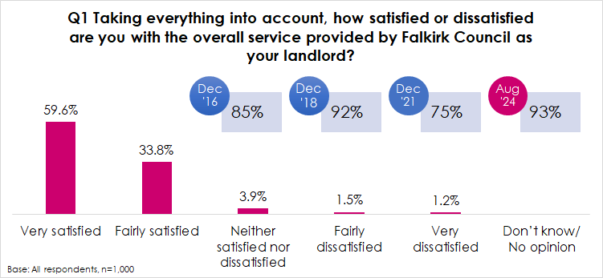

Following on from this, all respondents were then asked to explain why they felt satisfied or dissatisfied with the overall service they receive. This was an open-ended question to allow respondents to answer fully. Their answers have subsequently been coded into common themes. The table below shows that positive themes mentioned by tenants related to being happy overall or complimentary on services (20%), being happy with the home (12%) or happy with the staff who are helpful or friendly (10%). Where respondents provided more negative comments this was most likely to be regarding the repairs service (5%), where respondents believed their home required upgrades such as new kitchens or bathrooms (4%).

|  |  |  |
| --- | --- | --- |
| **Q2 Can you please explain why you said you were not satisfied with the overall service provided by Falkirk Council as your landlord?** | | |
| **Base: All respondents, n=1002** | **No** | % |
| Happy overall/ good services | 204 | 20.4% |
| Happy/ like home | 124 | 12.4% |
| Always helpful/ friendly | 102 | 10.2% |
| Good street/ neighbours | 69 | 6.9% |
| Easy/ good to deal with | 52 | 5.2% |
| Poor repairs service/ not being completed | 49 | 4.9% |
| Good customer service | 40 | 4.0% |
| Home requires upgrades/ improvements e.g. kitchen, bathroom | 37 | 3.7% |
| Not had many dealings with them | 33 | 3.3% |
| Lived here a long time | 28 | 2.8% |
| Need to deal with ASB/ ASN | 19 | 1.9% |
| Poor communication/ not kept updated | 15 | 1.5% |
| Fair rents | 9 | 0.9% |
| Bin issues/ litter problems | 6 | 0.6% |
| Other | 8 | 0.8% |
| Don't know | 34 | 3.4% |
| No issues/ complaints | 229 | 22.9% |

# INFORMATION AND COMMUNICATION

## Keeping tenants informed (Q3)

Almost all tenants (98%) were of the opinion that Falkirk Council was very or fairly good at keeping them informed about their services and decisions, compared to 1% who felt they were neither good nor poor and 1% who felt they were very or fairly poor at keeping them informed.

Satisfaction in this respect has increased from 85% since the Council’s last tenant satisfaction survey in 2021 and is more in line with the 2016 (91%) and 2018 (95%) survey results.

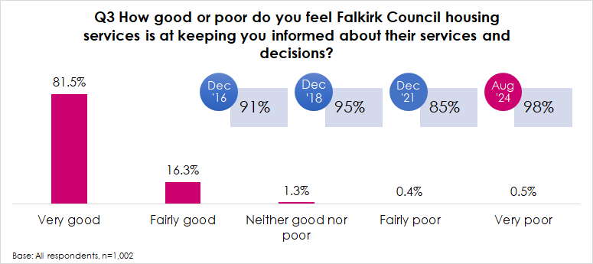

## Accessibility of information (Q4-Q5)

All but 5 tenants (99.5%) were of the opinion the information they receive from Falkirk Council as their landlord is very or fairly accessible.

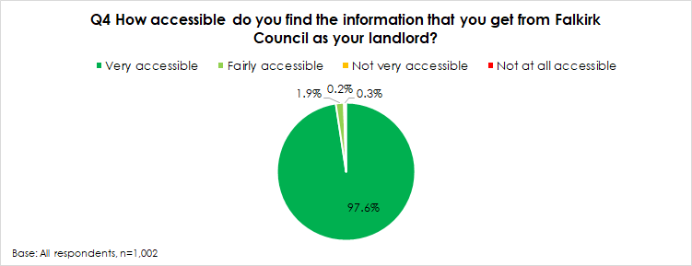

Those who said they did not find information very accessible were asked what would help make the information easier to read and understand for them. The majority of respondents (17 out of 24) were unsure or unable to provide a suggestion. Where respondents provided further comments these are listed below and were generally where they found the website difficult to navigate:

* *Sometimes it’s hard-to-find information on their website, it needs updated.*
* *The website could be easier to find information.*
* *The website is lacking information and not up to date.*
* *Website could be easier to find information.*
* *I don't get any information from them.*
* *It’s a shambles.*
* *It’s hard to find out things.*

# TENANT PARTICIPATION

## Interest of participation activities (Q6)

Respondents were asked about their interest in getting involved in a range of ways they could help the Council improve their housing services. Respondents expressed a low interest in becoming involved, with 82% stating that they were not interested (78% in 2021). Where they were interested, tenants were most likely to be interested in less proactive ways, such as answering customer satisfaction feedback questionnaires (16%) or online questionnaires or discussion forums (2%).

|  |  |  |
| --- | --- | --- |
| **Q6 Falkirk Council provide a range of opportunities to tenants to get involved in decision making. Would you be interested in participating in any of these ways to help the Council improve their housing services?** | | |
| **Base: All respondents, n=1002** | **No** | % |
| Answering customer satisfaction feedback questionnaires | 161 | 16.1% |
| Online questionnaires or discussion forums | 24 | 2.4% |
| Being on a consultation register of tenants who are happy to be consulted on a range of things | 12 | 1.2% |
| Going along to the Tenants’ and Residents’ Forum | 3 | 0.3% |
| How your Rent Money is Spent Group | 2 | 0.2% |
| Estate Walkabouts where tenants can identify areas of concern on their local estate | 1 | 0.1% |
| Attending drop-in sessions | 1 | 0.1% |
| Not interested in getting involved | 826 | 82.4% |

## Satisfaction with the opportunities to participate (Q7)

Tenants were then asked how satisfied or dissatisfied they were with the opportunities given to them to participate in their landlord’s decision making processes. Just over 9 in 10 respondents (99%) were very or fairly satisfied in this respect, compared to less than 1% (5 respondents) who were neither satisfied nor dissatisfied and less than 1% who were very or fairly dissatisfied (3 respondents).

This is consistent with the results from 2021 where 98% expressed satisfaction with participation opportunities.

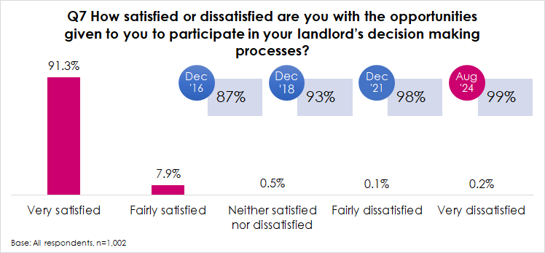

# REPAIRS AND MAINTENANCE

## General satisfaction with repairs and maintenance (Q8-Q9)

All tenants were asked generally how satisfied or dissatisfied they are with the way the Council deals with repairs and maintenance. Overall, 94% of tenants were either very or fairly satisfied in this respect compared to 2% who were dissatisfied. Satisfaction has increased from 63% in 2021.

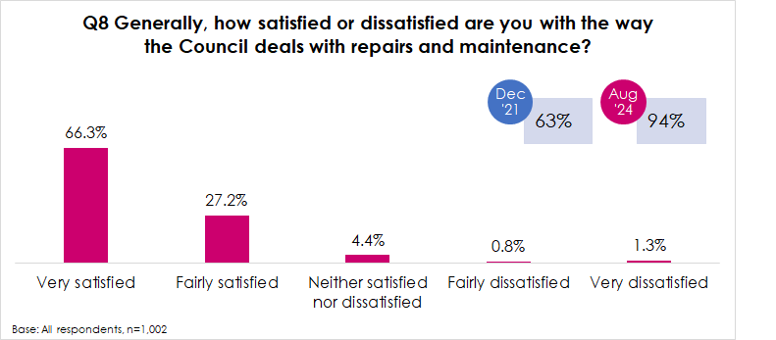

Those who were not satisfied with the repairs and maintenance service provided by Falkirk Council (n=65) were then asked to explain why they felt this way. The main reasons given were:

* Repairs take too long to complete/ issues are ongoing (55%)
* Repairs are poor quality (15%)
* Poor condition (11%).

|  |  |  |
| --- | --- | --- |
| **Q9 Can you explain why you are not satisfied with the way the Council deals with repairs and maintenance?** | | |
| **Base: Not satisfied with repairs, n=65** | **No.** | % |
| Takes too long to get repairs done/ slow to respond | 36 | 55.4% |
| Quality of repairs is poor | 10 | 15.4% |
| Poor communication about repairs | 7 | 10.8% |
| Repairs are outstanding/ still to be completed | 5 | 7.7% |
| Recurring repairs issues | 4 | 6.2% |
| Repairs not being done | 3 | 4.6% |
| Upgrades required in the home | 3 | 4.6% |
| Repairs service is inconsistent - sometimes good sometimes not | 1 | 1.5% |
| Not had any repairs | 1 | 1.5% |
| Other | 2 | 3.1% |

## Satisfaction with the quality of the home (Q10-Q11)

With regards to the quality of the home, 96% were very or fairly satisfied, compared to 2% who were neither satisfied nor dissatisfied and 1% who were very or fairly dissatisfied. Satisfaction with the quality of the home has increased from 77% in 2021 to 96% in 2024.

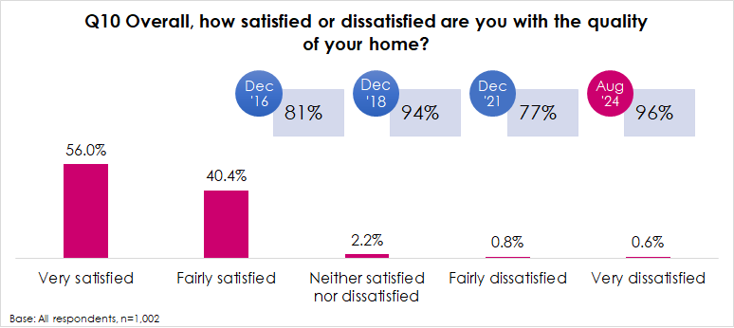

Where respondents were not satisfied this was most likely to be because they felt their home was in need of upgrades such as new kitchens, bathrooms or windows (69%).

|  |  |  |
| --- | --- | --- |
| **Q11 How could Falkirk Council improve the quality of your home?** | | |
| **Base: Not satisfied with quality of the home, n=36** | **No.** | % |
| Home requires upgrades e.g. kitchen/ bathroom/ windows/ doors | 25 | 69.4% |
| Home is in need of repairs | 5 | 13.9% |
| Deal with dampness/ mould issues | 3 | 8.3% |
| Poor quality of house | 1 | 2.8% |
| Home is too small | 1 | 2.8% |
| Walls need replastered | 1 | 2.8% |
| Other | 3 | 8.3% |

## Satisfaction with aspects of the home (Q12)

Tenants were then asked how satisfied or dissatisfied they were with various aspects of their home. Satisfaction was greatest with respect to the heating system (97%) and lowest in terms of windows (88%).

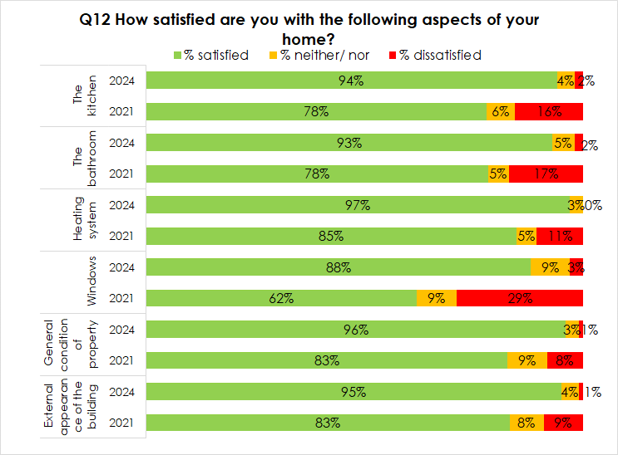

Compared to previous surveys, satisfaction has increased in all respects with the largest increase being seen regarding windows, increasing from 62% in 2021 to 88% in 2024.

## Moving intentions (Q20-Q21)

Only 4% of respondents (19%) said that they would like to move from their current property in the next 5 years, amounting to 44 individuals.

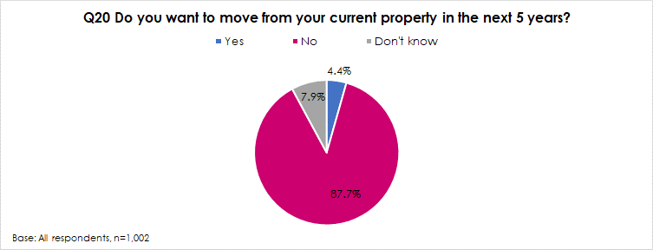

The main reasons given for this were that their current property was too small (48%), where respondents did not like the area (11%) or would like a back and front door with garden (11%).

|  |  |  |
| --- | --- | --- |
| **Q21 Why do you think you would like to move within the next 5 years? [ALL THAT APPLY]** | | |
| **Base: Would like to move, n=44** | **No.** | % |
| Too small | 21 | 47.7% |
| Don't like the area | 5 | 11.4% |
| Like a back and front home with garden | 5 | 11.4% |
| I would like to be closer to family or friends | 4 | 9.1% |
| ASB/ ASN issues | 4 | 9.1% |
| Too big | 2 | 4.5% |
| I struggle to get in and out of the property | 2 | 4.5% |
| Difficult to maintain the garden | 1 | 2.3% |
| I struggle to move about the home e.g. cope with stairs | 1 | 2.3% |
| Other | 5 | 11.4% |

Analysis shows that younger respondents are most likely to wish to move home with 11% of respondents aged under 35 wanting to move. They were most likely to want to move because their home was too small (48%).

# THE NEIGHBOURHOOD

## Neighbourhood as a place to live (Q13)

All respondents were asked how satisfied they were with their neighbourhood as a place to live. As shown below, 96% stating they were either very or fairly satisfied in this respect compared to 3% who were neither satisfied nor dissatisfied and 1% who were very or fairly dissatisfied.

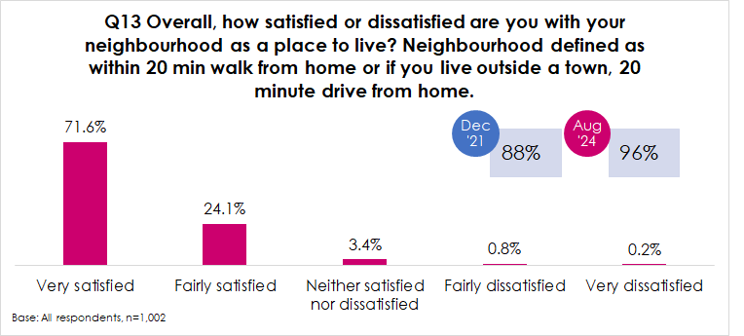

## Management of the neighbourhood (Q14-Q15)

Tenants were asked how satisfied or dissatisfied they were with their landlord’s management of the neighbourhood they live in. 95% of respondents were very or fairly satisfied in this respect compared to 3% who were neither satisfied nor dissatisfied and 1% who were very or fairly dissatisfied. Satisfaction with neighbourhood management has increased from 84% in 2021 and is in line with the 2016 (92%) and 2018 (94%) satisfaction values.

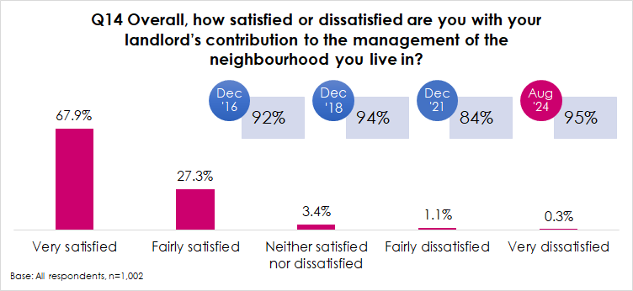

Those who were not satisfied with their landlord’s contribution to the management of the neighbourhood (n=48) were then asked how the housing service could improve their management of the neighbourhood. The most common responses given were where tenants believed their landlord was not dealing with anti-social behaviour or neighbours (27%) or where they were unhappy with gardening maintenance (25%).

|  |  |  |
| --- | --- | --- |
| **Q15 Can you please explain why you say that?** | | |
| **Base: Not satisfied with landlord's contribution to the management of the neighbourhood, n=48** | **No.** | % |
| Not dealing with ASB/ ASN | 13 | 27.1% |
| Gardening maintenance | 12 | 25.0% |
| Need to do more/ don't see them | 10 | 20.8% |
| Need to vet tenants | 4 | 8.3% |
| Sort the bin area | 4 | 8.3% |
| Tidy up area | 3 | 6.3% |
| Parking issues | 1 | 2.1% |
| Other | 3 | 6.3% |

# RENT AND VALUE FOR MONEY

## Priorities for spending rents (Q16-Q17)

Tenants were asked what they believed the Council should be prioritising spending more of what the income generated from rent is spent on. This shows that tenant’s top 3 priorities were:

In 2021 external improvements was not in tenants’ top 3 priorities and instead, increasing the supply of housing by building new build houses was identified as a top priority with 57% selecting this option.

The full list of tenants’ priorities for rents in 2024 is shown in the chart below:

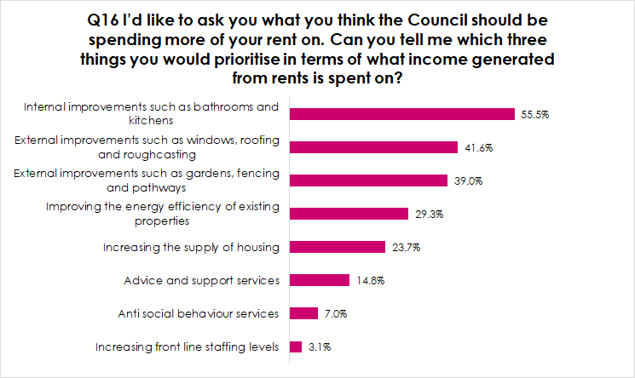

Internal improvements such as new bathrooms and kitchens was tenants’ top priority across all age groups, gender and whether respondents had a disability or not.

All respondents were then asked if there was anything else they believed the Housing Service should prioritise delivering the best service possible. Over a third (35%) said there was nothing else they believed should be a priority and a further 42% said they were unsure. Many took the opportunity to reinforce aspects noted above, most commonly providing home upgrades or improvements (9%) or external improvements (4%).

|  |  |  |
| --- | --- | --- |
| **Q17 Please tell me if there is anything else you believe should be the Housing Services priorities in terms of delivering the best service possible?** | | |
| **Base: All respondents, n=1002** | **No.** | % |
| Home upgrades/ better quality housing | 85 | 8.5% |
| External improvements | 36 | 3.6% |
| Improve repairs | 30 | 3.0% |
| Garden / landscape maintenance e.g. grass cutting, fencing improvements | 25 | 2.5% |
| Deal with ASB/ ASN | 14 | 1.4% |
| Better customer service | 7 | 0.7% |
| Build more housing | 7 | 0.7% |
| Sort bin area | 6 | 0.6% |
| Communication | 6 | 0.6% |
| Vetting tenants | 4 | 0.4% |
| Better parking | 3 | 0.3% |
| Clean up the area | 1 | 0.1% |
| Fix roads/ pavements | 1 | 0.1% |
| Other | 13 | 1.3% |
| Don't know | 417 | 41.6% |
| None | 352 | 35.1% |

## Value for money (Q18-Q19)

The vast majority of respondents (97%) were of the opinion that their rent represented very or fairly good value for money, compared to 2% who said it was neither good nor poor value and 1% who said it was very or fairly poor value for money. The proportion of respondents who said the rent for their home was very or fairly good value has increased to its highest value since 2016, and an increase of 20 percentage points from the 77% reported in 2021.

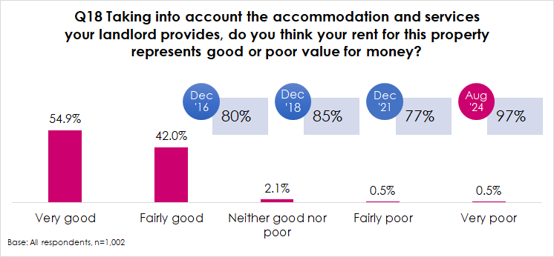

All respondents were then asked why they felt this way in terms of value for money. The most common reasons given for believing that rents were not good value were where tenants believed their rent was too expensive and keeps increasing (42%) or where they felt the rent was high for the quality of services received (29%).

|  |  |  |
| --- | --- | --- |
| **Q19 Can you explain why you say that?** | | |
| **Base: Not satisfied with value for money of rent, n=31** | **No.** | % |
| Expensive/ keeps increasing | 13 | 41.9% |
| Poor services received | 9 | 29.0% |
| Poor quality housing | 4 | 12.9% |
| Home needing upgrades/ improvements | 4 | 12.9% |
| Don't know | 1 | 3.2% |

The chart below shows that perceptions of value for money vary significantly based on whether respondents are satisfied with various service aspects versus those who are dissatisfied. For example, 98% of respondents who were satisfied with the quality of their home said their rent was good value for money compared to 43% of respondents who were dissatisfied with the quality of their home. Care should be taken when reading these results however due to the small numbers of respondents who were dissatisfied with certain service aspects, for example just 3 respondents were dissatisfied with participation opportunities.

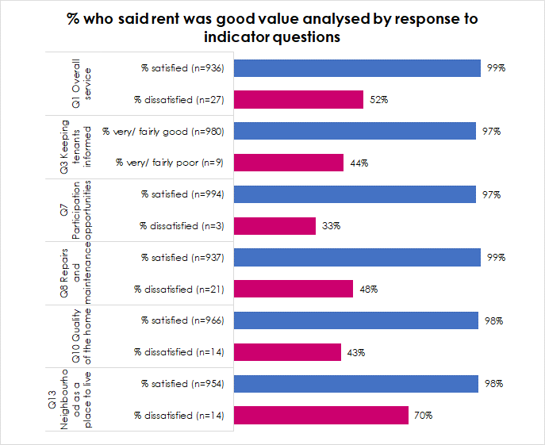

# OVERVIEW OF LANDLORD SERVICES

## Best thing (Q22)

All respondents were asked an open question relating to what they felt the Council’s housing service did best. They could answer freely in their own words and the responses given have been coded thematically to allow for analysis. Just over half of respondents (54%) said that they didn’t know or couldn’t spontaneously think of an answer. The most common tangible responses were:

* Repairs (30%)
* Helpful and friendly staff (9%)
* Customer services (8%)
* Building good or new homes (7%)

|  |  |  |
| --- | --- | --- |
| **Q22 Thinking about the services provided by your landlord, what do you think Falkirk Council’s Housing Service is best at?** | | |
| **Base: All respondents, n=1002** | **No.** | % |
| Repairs service | 304 | 30.3% |
| Staff helpful/ friendly | 89 | 8.9% |
| Customer service | 78 | 7.8% |
| Building good/ new homes | 73 | 7.3% |
| Happy overall | 53 | 5.3% |
| Good communication/ kept informed | 45 | 4.5% |
| Fair rents | 42 | 4.2% |
| All services | 29 | 2.9% |
| Don't know | 247 | 24.7% |
| Nothing | 48 | 4.8% |
| Other | 6 | 0.6% |

## Priority for improvement (Q23)

Again, respondents were asked an open question relating to what they would say was the top priority for improvement. Encouragingly, 43% of respondents could not spontaneously provide a response to this stating ‘don’t know’ and 11% said there was ‘nothing’ they would improve.

In terms of priorities for improvement, the most common responses were:

* General upgrades or improvements (12%)
* New kitchen (10%)
* Repairs service (5%)

|  |  |  |
| --- | --- | --- |
| **Q23 And what would you say is top priority for improvement?** | | |
| **Base: All respondents, n=1002** | **No.** | % |
| General upgrades/ improvements | 122 | 12.2% |
| New kitchen | 104 | 10.4% |
| Repair service | 45 | 4.5% |
| Windows/ doors | 38 | 3.8% |
| Outside maintenance e.g. paths/ fences | 36 | 3.6% |
| New bathroom | 21 | 2.1% |
| Keep rents affordable | 21 | 2.1% |
| Communication/ kept updated | 18 | 1.8% |
| Garden maintenance | 18 | 1.8% |
| Dealing with ASB/ ASN issues | 14 | 1.4% |
| Build more housing | 11 | 1.1% |
| Vet tenants | 8 | 0.8% |
| Everything | 5 | 0.5% |
| Sort the bin area | 4 | 0.4% |
| Clean up litter | 3 | 0.3% |
| Other | 3 | 0.3% |
| Don't know | 435 | 43.4% |
| None | 112 | 11.2% |

# UNDERSTANDING THE RESULTS

## Introduction

To put the results into context, analysis has been undertaken on the basis of age, gender and disability to identify whether any particular groups are more or less likely to be satisfied with the Association’s services than other tenants.

## Age

Analysis by age is shown in the table below. Only significant differences have been highlighted with red cells indicating the lowest levels of satisfaction and green highlighting where respondents are most likely to be satisfied. Our analysis by age indicates that the biggest differences can be seen regarding satisfaction with repairs and maintenance with young people being least satisfied with how well the Council deals with repairs and maintenance generally (89%) and older people aged 65 and over being most likely to be satisfied (97%).

|  |  |  |  |  |  |
| --- | --- | --- | --- | --- | --- |
| **VARIATIONS BY AGE** | | | | | |
|  | **Under 35** | **35 – 54** | **55 – 64** | **65 +** |
| **Base** | **237** | **326** | **186** | **253** |
| Q1 Taking everything into account, how satisfied or dissatisfied are you with the overall service provided by Falkirk Council as your landlord? | 94% | 91% | 94% | 96% |
| Q3 How good or poor do you feel Falkirk Council housing services is at keeping you informed about their services and decisions? | 97% | 99% | 97% | 98% |
| Q7 How satisfied or dissatisfied are you with the opportunities given to you to participate in your landlord’s decision making processes? | 99% | 99% | 99% | 100% |
| Q8 Generally, how satisfied or dissatisfied are you with the way the Council deals with repairs and maintenance? | 89% | 94% | 93% | 97% |
| Q10 Overall, how satisfied or dissatisfied are you with the quality of your home? | 96% | 94% | 98% | 98% |
| Q13 Overall, how satisfied or dissatisfied are you with your neighbourhood as a place to live? | 93% | 95% | 96% | 98% |
| Q14 Overall, how satisfied or dissatisfied are you with your landlord’s contribution to the management of the neighbourhood you live in? | 94% | 96% | 94% | 97% |
| Q18 Taking into account the accommodation and services your landlord provides, do you think your rent for this property represents good or poor value for money? | 100% | 95% | 97% | 96% |

## Gender

Overall satisfaction with the key indicator questions analysed by gender is shown in the table below. As can be seen in this table, there are no significant differences in overall satisfaction for female respondents versus male respondents:

|  |  |  |
| --- | --- | --- |
| **VARIATIONS BY GENDER** | | |
|  | **Female** | **Male** |
| **Base** | **606** | **395** |
| Q1 Taking everything into account, how satisfied or dissatisfied are you with the overall service provided by Falkirk Council as your landlord? | 94% | 93% |
| Q3 How good or poor do you feel Falkirk Council housing services is at keeping you informed about their services and decisions? | 97% | 98% |
| Q7 How satisfied or dissatisfied are you with the opportunities given to you to participate in your landlord’s decision making processes? | 99% | 99% |
| Q8 Generally, how satisfied or dissatisfied are you with the way the Council deals with repairs and maintenance? | 92% | 95% |
| Q10 Overall, how satisfied or dissatisfied are you with the quality of your home? | 96% | 97% |
| Q13 Overall, how satisfied or dissatisfied are you with your neighbourhood as a place to live? | 95% | 96% |
| Q14 Overall, how satisfied or dissatisfied are you with your landlord’s contribution to the management of the neighbourhood you live in? | 95% | 95% |
| Q18 Taking into account the accommodation and services your landlord provides, do you think your rent for this property represents good or poor value for money? | 97% | 97% |

## Disability

With regards to disability the table below shows that in general, respondents who had no long term health conditions or disability were more likely to be satisfied with the overall service, the neighbourhood as a place to live, the Council’s contribution to the management of the neighbourhood and value for money for rents than those who had long term health conditions or disabilities and this was most noticeable in terms of the landlord’s contribution to the management of the neighbourhood and regarding satisfaction with the overall service.

|  |  |  |
| --- | --- | --- |
| **VARIATIONS BY DISABILITY** | | |
|  | **Have long term health condition or disability** | **No condition** |
| **Base** | **355** | **636** |
| Q1 Taking everything into account, how satisfied or dissatisfied are you with the overall service provided by Falkirk Council as your landlord? | 91% | 95% |
| Q3 How good or poor do you feel Falkirk Council housing services is at keeping you informed about their services and decisions? | 97% | 99% |
| Q7 How satisfied or dissatisfied are you with the opportunities given to you to participate in your landlord’s decision making processes? | 99% | 100% |
| Q8 Generally, how satisfied or dissatisfied are you with the way the Council deals with repairs and maintenance? | 92% | 94% |
| Q10 Overall, how satisfied or dissatisfied are you with the quality of your home? | 95% | 97% |
| Q13 Overall, how satisfied or dissatisfied are you with your neighbourhood as a place to live? Neighbourhood defined as within 20 min walk from home or if you live outside a town, 20 minute drive from home. | 94% | 97% |
| Q14 Overall, how satisfied or dissatisfied are you with your landlord’s contribution to the management of the neighbourhood you live in? | 93% | 97% |
| Q18 Taking into account the accommodation and services your landlord provides, do you think your rent for this property represents good or poor value for money? | 95% | 98% |

# ABOUT YOU AND YOUR HOUSEHOLD

## Age and gender (Q24 – Q29/Q31)

With regards to gender, over 6 in 10 respondents (61%) were female and 39% were male.

|  |  |  |
| --- | --- | --- |
| **Q29 What is your sex?** | | |
| **Base: All respondents, n=1002** | **No.** | % |
| Female | 606 | 60.5% |
| Male | 395 | 39.4% |
| Prefer not to say | 1 | 0.1% |

No respondents considered themselves to be trans or have a trans history.

|  |  |  |
| --- | --- | --- |
| **Q31 Do you consider yourself to be trans, or have a trans history?** | | |
| **Base: All respondents, n=1002** | **No.** | % |
| No | 1001 | 99.9% |
| Yes, please describe your trans status (for example, non-binary, trans man, trans woman): | - | - |
| Prefer not to say | 1 | 0.1% |

Just under 1 in 4 respondents (24%) were aged under 35, one third were between 35 and 54, 19% were aged 55-64 and 25% were aged 65 and over.

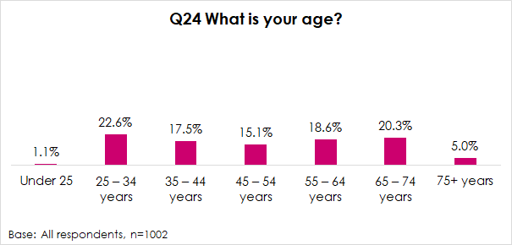

## Care experienced (Q25)

Respondents were asked if they considered themselves to be ‘care experienced’. This refers to anyone who has been or is currently in care or from a looked-after background at any stage in their life, no matter how short, including adopted children who were previously looked-after. This care may have been provided in one of many different settings such as in residential care, foster care, both formal and informal kinship care, or through being looked-after at home with social work support. Just 2% of respondents (18 individuals) considered themselves to be ‘care experienced’.

## Disability (Q26)

Just over 6 in 10 respondents said they did not have any form of disability or long-term health condition (64%) and 1% preferred not to answer. Where respondents did have a long term health condition or disability this was most commonly a physical disability (20%) followed by a chronic illness (15%) and then a mental health condition (7%).

|  |  |  |
| --- | --- | --- |
| **Q26 Do you have any of the following conditions which have lasted, or are expected to last, at least 12 months? [CODE ALL THAT APPLY]** | | |
| **Base: All respondents, n=1002** | **No.** | % |
| Physical disability (a condition that substantially limits one or more basic physical activities such as walking, climbing stairs, lifting or carrying) | 197 | 19.7% |
| Long-term illness, disease or condition (a condition, not listed above, that you may have for life, which may be managed with treatment or medication) | 152 | 15.2% |
| Mental health condition (a condition that affects your emotional, physical and mental wellbeing) | 66 | 6.6% |
| Deafness or severe hearing impairment | 9 | 0.9% |
| Blindness or severe vision impairment | 4 | 0.4% |
| Learning difficulty (a specific learning condition that affects the way you learn and process information) | 1 | 0.1% |
| Other condition, please write in: | - | - |
| No condition | 636 | 63.5% |
| Prefer not to say | 11 | 1.1% |

## Ethnicity (Q27)

In terms of ethnicity, the vast majority of respondents were White Scottish (96%).

|  |  |  |
| --- | --- | --- |
| **Q27 What is your ethnic group?** | | |
| **Base: All respondents, n=1002** | **No.** | % |
| White Scottish | 962 | 96.0% |
| White Other British | 5 | 0.5% |
| White Polish | 31 | 3.1% |
| Asian, Scottish Asian or British Asian | 2 | 0.2% |
| Indian, Scottish Indian or British Indian | 1 | 0.1% |
| Chinese, Scottish Chinese or British Chinese | 1 | 0.1% |

## Religion (Q28)

The majority of respondents (63%) did not belong to any religion, 23% said they were Church of Scotland and 13% were Roman Catholic.

|  |  |  |
| --- | --- | --- |
| **Q28 What religion, religious denomination or body do you belong to?** | | |
| **Base: All respondents, n=1002** | **No.** | % |
| None | 631 | 63.0% |
| Church of Scotland | 230 | 23.0% |
| Roman Catholic | 131 | 13.1% |
| Other Christian, please write in below: | 1 | 0.1% |
| Muslim, write in denomination or school below: | 1 | 0.1% |
| Hindu | 1 | 0.1% |
| Buddhist | 1 | 0.1% |
| Sikh | - | - |
| Jewish | - | - |
| Pagan | - | - |
| Another religion or body, please write in: | - | - |
| Prefer not to say | 6 | 0.6% |

## Sexual orientation (Q30)

All but one respondent described their sexual orientation as straight or heterosexual.

|  |  |  |
| --- | --- | --- |
| **Q30 Which of the following best describes your sexual orientation?** | | |
| **Base: All respondents, n=1002** | **No.** | % |
| Straight / Heterosexual | 1001 | 99.9% |
| Gay | 1 | 0.1% |

**Appendix 1**

**Survey Questionnaire**

|  |  |  |  |  |  |  |  |  |
| --- | --- | --- | --- | --- | --- | --- | --- | --- |
| **Tenant Satisfaction Survey** | **Q1 must be asked first and as a stand alone question** | | |  |  | |  | |
|  |  |  | |  |  | |  | |
| 1.Taking everything into account, how satisfied or dissatisfied are you with the overall service provided by Falkirk Council housing services as your landlord? | | |  | | |  | |
| Very satisfied | Go to Q2 |  | |  |  | |  | |
| Fairly satisfied |  |  | |  | |
| Neither satisfied nor dissatisfied |  | |  |  | |  | |
| Fairly dissatisfied |  |  | |  | |
| Very dissatisfied |  |  | |  | |
|  |  |  | |  |  | |  | |
| 2. Can you please explain why you say that? |  |  | |  |  | |  | |
|  |  |  | |  |  | |  | |
|  |  | |  |  | |  | |
|  |  | |  |  | |  | |
|  |  |  | |  |  | |  | |
|  |  |  | |  |  | |  | |
| 3.    How good or poor do you feel Falkirk Council housing services is at keeping you informed about their services and decisions? | | | |  |  | |  | |
| Very good |  |  | |  |  | |  | |
| Fairly good |  |  |  | |  | |
| Neither good nor poor |  |  | |  |  | |  | |
| Fairly poor |  |  |  | |  | |
| Very poor |  |  | |  |  | |  | |
|  |  |  | |  |  | |  | |
| 4. How accessible do you find the information that you get from Falkirk Council as your landlord? By accessible I mean easy to read and understand | | | |  |  | |  | |
| Very accessible | Go to Q6 |  | |  |  | |  | |
| Fairly accessible | Go to Q5 |  |  | |  | |
| Not very accessible |  | |  |  | |  | |
| Not at all accessible |  |  | |  | |
|  |  |  | |  |  | |  | |
| 5. What would help the information be easier to read and understand for you? [INTERVIEWER: PROBE FULLY] | |  | |  |  | |  | |
|  |  |  | |  |  | |  | |
|  |  | |  |  | |  | |
|  |  | |  |  | |  | |
|  |  |  | |  |  | |  | |

|  |  |  |  |  |  |  |  |  |  |  |  |  |  |  |  |  |  |  |  |  |  |  |  |  |  |  |  |  |  |  |  |  |  |  |
| --- | --- | --- | --- | --- | --- | --- | --- | --- | --- | --- | --- | --- | --- | --- | --- | --- | --- | --- | --- | --- | --- | --- | --- | --- | --- | --- | --- | --- | --- | --- | --- | --- | --- | --- |
| 6.   Falkirk Council housing services provide a range of opportunities to tenants to get involved in decision making. | | | | | | | | | | | | | | | | | | | | | |  | | | |  | | | |  | | | | |
| Would you be interested in participating in any of these ways to help the Council improve their housing services? | | | | | | | | | | | | |  | | | | | | | | |  | | | |  | | | |  | | | | |
| Online questionnaires or discussion forums | | | |  | | | | | | | | |  | | | | | | | | |  | | | |  | | | |  | | | | |
| Scrutiny Panel (a group of tenants who meet to check the Council’s performance and make recommendation for areas for improvement) | | | |  | | | | | | | | |  | | | | | | | | |  | | | |  | | | |  | | | | |
| Estate Walkabouts where tenants can identify areas of concern on their local estate | | | |  | | | | | | | | |  | | | | | | | | |  | | | |  | | | |  | | | | |
| Answering customer satisfaction feedback questionnaires | | | |  | | | | | | | | |  | | | | | | | | |  | | | |  | | | |  | | | | |
| Being on a consultation register of tenants who are happy to be consulted on a range of things | | | |  | | | | | | | | |  | | | | | | | | |  | | | |  | | | |  | | | | |
| Being on an Editorial Panel who comment on the content and publication of the Tenant Talk magazine and other publications | | | |  | | | | | | | | |  | | | | | | | | |  | | | |  | | | |  | | | | |
| Going along to the Tenants’ and Residents’ Forum | | | |  | | | | | | | | |  | | | | | | | | |  | | | |  | | | |  | | | | |
| Becoming a member of a Registered Tenants’ and Residents Organisation | | | |  | | | | | | | | |  | | | | | | | | |  | | | |  | | | |  | | | | |
| How your Rent Money is Spent Group | | | |  | | | | | | | | |  | | | | | | | | |  | | | |  | | | |  | | | | |
| Housing Asset Management Planning Group | | | |  | | | | | | | | |  | | | | | | | | |  | | | |  | | | |  | | | | |
| Attending drop-in sessions | | | |  | | | | | | | | |  | | | | | | | | |  | | | |  | | | |  | | | | |
| Tenants Choice' project award scheme | | | |  | | | | | | | | |  | | | | | | | | |  | | | |  | | | |  | | | | |
| Other (please specify) | | | |  | | | | | | | | |  | | | | | | | | |  | | | |  | | | |  | | | | |
|  | | | | | | | | |  | | | |  | | | |  | | | | |
| Not interested in getting involved | | | |  | | | | | | | | |  | | | | | | | | |  | | | |  | | | |  | | | | |
|  | | | |  | | | | | | | | |  | | | | | | | | |  | | | |  | | | |  | | | | |
| 7. How satisfied or dissatisfied are you with the opportunities given to you to participate in Falkirk Council housing services decision making processes? | | | | | | | | | | | | | | | | | | | | | |  | | | |  | | | |  | | | | |
| Very satisfied | | | |  | | | | | | | | |  | | | | | | | | |  | | | |  | | | |  | | | | |
| Fairly satisfied | | | |  | | | | | | | | |  | | | |  | | | |  | | | | |
| Neither satisfied nor dissatisfied | | | |  | | | | | | | | |  | | | | | | | | |  | | | |  | | | |  | | | | |
| Fairly dissatisfied | | | |  | | | | | | | | |  | | | |  | | | |  | | | | |
| Very dissatisfied | | | |  | | | | | | | | |  | | | |  | | | |  | | | | |
|  | | | |  | | | | | | | | |  | | | | | | | | |  | | | |  | | | |  | | | | |
| 8.   Generally, how satisfied or dissatisfied are you with the way Falkirk Council housing services deals with repairs and maintenance? | | | | | | | | | | | | | | | | | | | | | |  | | | |  | | | |  | | | | |
| Very satisfied | | | | Go to Q10 | | | | | | | | |  | | | | | | | | |  | | | |  | | | |  | | | | |
| Fairly satisfied | | | |  | | | |  | | | |  | | | | |
| Neither satisfied nor dissatisfied | | | | Go to Q9 | | | | | | | | |  | | | | | | | | |  | | | |  | | | |  | | | | |
| Fairly dissatisfied | | | |  | | | |  | | | |  | | | | |
| Very dissatisfied | | | |  | | | |  | | | |  | | | | |
|  |  |
| 9.   Can you explain why you are not satisfied with the way that Falkirk Council housing services deals with repairs and maintenance? | | | | | | | | | | | | | | | | | | | | | |  | | | |  | | | |  | | | | |
|  | | | |  | | | | | | | | |  | | | | | | | | |  | | | |  | | | |  | | | | |
|  | | | | | | | | |  | | | | | | | | |  | | | |  | | | |  | | | | |
|  | | | | | | | | |  | | | | | | | | |  | | | |  | | | |  | | | | |
|  | | | |  | | | | | | | | |  | | | | | | | | |  | | | |  | | | |  | | | | |
| 10. Overall, how satisfied or dissatisfied are you with the quality of your home? | | | | | | | | | | | | |  | | | | | | | | |  | | | |  | | | |  | | | | |
| Very satisfied | | | | Go to Q12 | | | | | | | | |  | | | | | | | | |  | | | |  | | | |  | | | | |
| Fairly satisfied | | | |  | | | |  | | | |  | | | | |
| Neither satisfied nor dissatisfied | | | | Go to Q11 | | | | | | | | |  | | | | | | | | |  | | | |  | | | |  | | | | |
| Fairly dissatisfied | | | |  | | | |  | | | |  | | | | |
| Very dissatisfied | | | |  | | | |  | | | |  | | | | |
|  | | | |  | | | | | | | | |  | | | | | | | | |  | | | |  | | | |  | | | | |
| 11.   How could Falkirk Council housing services improve the quality of your home? | | | | | | | | | | | | |  | | | | | | | | |  | | | |  | | | |  | | | | |
|  | | | |  | | | | | | | | |  | | | | | | | | |  | | | |  | | | |  | | | | |
|  | | | | | | | | |  | | | | | | | | |  | | | |  | | | |  | | | | |
|  | | | | | | | | |  | | | | | | | | |  | | | |  | | | |  | | | | |
|  | | | |  | | | | | | | | |  | | | | | | | | |  | | | |  | | | |  | | | | |
| 13. How satisfied are you with the following aspects of your home? | | | | | | | | | | | | | |  |  | | | | | | |  | | | |  | | | |  | | | | |
|  | | | | Very Satisfied | Fairly Satisfied | | | | Neither satisfied/ nor dissatisfied | | | Unsatisfied | | | | Very Dissatisfied | | | | | | | | | | | |
| The kitchen | | | |  |  | | | |  | | |  | | | |  | | | | | | | | | | | |
| The bathroom | | | |  |  | | | |  | | |  | | | |  | | | | | | | | | | | |
| Heating system | | | |  |  | | | |  | | |  | | | |  | | | | | | | | | | | |
| Windows | | | |  |  | | | |  | | |  | | | |  | | | | | | | | | | | |
| General condition of your property overall | | | |  |  | | | |  | | |  | | | |  | | | | | | | | | | | |
| External appearance of the building | | | |  |  | | | |  | | |  | | | |  | | | | | | | | | | | |
|  | | | |  | | | | | | | | |  | | | | | | | | |  | | | |  | | | |  | | | | |
| 14. Overall, how satisfied or dissatisfied are you with your neighbourhood as a place to live? Neighbourhood defined as within 20 min walk from home or if you live outside a town, 20 minute drive from home. | | | | | | | | | | | | | | | | | | | | | | | | | | |
| Very satisfied | | | |  | | | | | | | | |  | | | | | | | | |  | | | |  | | | |  | | | | |
| Fairly satisfied | | | |  | | | | | | | | |  | | | | | | | | |  | | | |  | | | |  | | | | |
| Neither satisfied nor dissatisfied | | | |  | | | | | | | | |  | | | | | | | | |  | | | |  | | | |  | | | | |
| Fairly dissatisfied | | | |  | | | | | | | | |  | | | | | | | | |  | | | |  | | | |  | | | | |
| Very dissatisfied | | | |  | | | | | | | | |  | | | | | | | | |  | | | |  | | | |  | | | | |
|  | | | |  | | | | | | | | |  | | | | | | | | |  | | | |  | | | |  | | | | |
| 15. Overall, how satisfied or dissatisfied are you with Falkirk Council housing services contribution to the management of the neighbourhood you live in? | | | | | | | | | | | | | | | | | | | | | |  | | | |  | | | |  | | | | |
| Very satisfied | | | | Go to Q15 | | | | | | | | |  | | | | | | | | |  | | | |  | | | |  | | | | |
| Fairly satisfied | | | |  | | | | | | | | |  | | | |  | | | |  | | | | |
| Neither satisfied nor dissatisfied | | | | Go to Q14 | | | | | | | | |  | | | | | | | | |  | | | |  | | | |  | | | | |
| Fairly dissatisfied | | | |  | | | | | | | | |  | | | |  | | | |  | | | | |
| Very dissatisfied | | | |  | | | | | | | | |  | | | |  | | | |  | | | | |
|  | | | |  | | | | | | | | |  | | | | | | | | |  | | | |  | | | |  | | | | |
| 14. Can you explain why you say that? | | | | | | |  | | | | | | | | | | | |  | | | | | |  | | | |  | | | |  | | | | | | | |
|  | | | |  | | | | | | | | |  | | | | | | | | |  | | | |  | | | |  | | | | |
|  | | | | | | | | |  | | | | | | | | |  | | | |  | | | |  | | | | |
|  | | | | | | | | |  | | | | | | | | |  | | | |  | | | |  | | | | |
|  | | | |  | | | | | | | | |  | | | | | | | | |  | | | |  | | | |  | | | | |
| 15. I’d like to ask you what you think Falkirk Council housing services should be spending more of your rent on. I’m going to read out a list and can you tell me which three things you would prioritise in terms of what income generated from rents is spent on? | | | | | | | | | | | | | | | | | | | | | | | | | | |
| Increasing the supply of housing | | | | | |  | | | | | | | | | | | |  | | | | | | | | |  | | | |  | | | | |  | | | | | |
| Internal improvements such as bathrooms and kitchens | | | | | |  | | | | | | | | | | | |  | | | | | | | | |  | | | |  | | | | |  | | | | | |
| External improvements such as windows, roofing and roughcasting | | | | | |  | | | | | | | | | | | |  | | | | | | | | |  | | | |  | | | | |  | | | | | |
| External improvements such as gardens, fencing and pathways | | | | | |  | | | | | | | | | | | |  | | | | | | | | |  | | | |  | | | | |  | | | | | |
| Advice and support services | | | | | |  | | | | | | | | | | | |  | | | | | | | | |  | | | |  | | | | |  | | | | | |
| Anti social behaviour services | | | | | |  | | | | | | | | | | | |  | | | | | | | | |  | | | |  | | | | |  | | | | | |
| Increasing front line staffing levels | | | | | |  | | | | | | | | | | | |  | | | | | | | | |  | | | |  | | | | |  | | | | | |
| Improving the energy efficiency of existing properties | | | | | |  | | | | | | | | | | | |  | | | | | | | | |  | | | |  | | | | |  | | | | | |
|  | | | |  | | | | | | | | |  | | | | | | | | |  | | | |  | | | |  | | | | |
| 16.   Please tell me if there is anything else you believe should be Falkirk Council housing services priorities in terms of delivering the best service possible? | | | | | | | | | | | | | | | | | | | | |  | | | | | | |  | | | |
|  | | | |  | | | | | | | | |  | | | | | | | | |  | | | |  | | | |  | | | | |
|  | | | | | | | | |  | | | | | | | | |  | | | |  | | | |  | | | | |
|  | | | | | | | | |  | | | | | | | | |  | | | |  | | | |  | | | | |
|  | | | |  | | | | | | | | |  | | | | | | | | |  | | | |  | | | |  | | | | |
| 17. Taking into account the accommodation and services your landlord provides, do you think your rent for this property represents good or poor value for money? | | | | | | | | | | | | | | | | | | | | |  | | | | | | |  | | | |
| Very good | | | | Go to Q19 | | | | | | | | |  | | | | | | | | |  | | | |  | | | |  | | | | |
| Fairly good | | | |  | | | | | | | | |  | | | |  | | | |  | | | | |
| Neither good nor poor | | | | Go to Q18 | | | | | | | | |  | | | | | | | | |  | | | |  | | | |  | | | | |
| Fairly poor | | | |  | | | | | | | | |  | | | |  | | | |  | | | | |
| Very poor | | | |  | | | | | | | | |  | | | |  | | | |  | | | | |
|  | | | |  | | | | | | | | |  | | | | | | | | |  | | | |  | | | |  | | | | |
| 18.   Can you explain why you say that? | | | | | | | | | |  | | | | | | | | | | | | |  | | | | |  | | | |  | | | | |  | | | | | | | | | | | | | | | | | | | | | |
|  | | | |  | | | | | | | | |  | | | | | | | | |  | | | |  | | | |  | | | | |
|  | | | | | | | | |  | | | | | | | | |  | | | |  | | | |  | | | | |
|  | | | | | | | | |  | | | | | | | | |  | | | |  | | | |  | | | | |
|  | | | |  | | | | | | | | |  | | | | | | | | |  | | | |  | | | |  | | | | |
| 19. Do you want to move from your current property in the next 5 years? | | | |  | | | | | | | | |  | | | | | | | | |  | | | |  | | | |  | | | | |
| Yes | | | | Go to question 20 | | | | | | | | |  | | | | | | | | |  | | | |  | | | |  | | | | |
| No | | | | Go to question 21 | | | | | | | | |  | | | | | | | | |  | | | |  | | | |  | | | | |
| Don’t know | | | |  | | | | | | | | |  | | | |  | | | |  | | | | |
|  | | | |  | | | | | | | | |  | | | | | | | | |  | | | |  | | | |  | | | | |
| 20. Why do you think you would like to move within the next 5 years? [ALL THAT APPLY] | | | | | | | | | | | | |  | | | | | | | | |  | | | |  | | | |  | | | | |
| Too big | | | |  | | | | | | | | |  | | | | | | | | |  | | | |  | | | |  | | | | |
| Too small | | | |  | | | | | | | | |  | | | | | | | | |  | | | |  | | | |  | | | | |
| Difficult to maintain the house | | | |  | | | | | | | | |  | | | | | | | | |  | | | |  | | | |  | | | | |
| Difficult to maintain the garden | | | |  | | | | | | | | |  | | | | | | | | |  | | | |  | | | |  | | | | |
| I struggle to move about the home e.g. cope with stairs | | | |  | | | | | | | | |  | | | | | | | | |  | | | |  | | | |  | | | | |
| I struggle to get in and out of the property | | | |  | | | | | | | | |  | | | | | | | | |  | | | |  | | | |  | | | | |
| I would like to be closer to family or friends | | | |  | | | | | | | | |  | | | | | | | | |  | | | |  | | | |  | | | | |
| I would like to be closer to facilities e.g. shops, doctor, dentist etc. | | | |  | | | | | | | | |  | | | | | | | | |  | | | |  | | | |  | | | | |
| It is too expensive | | | |  | | | | | | | | |  | | | | | | | | |  | | | |  | | | |  | | | | |
| Other (please specify) | | | |  | | | | | | | | |  | | | | | | | | |  | | | |  | | | |  | | | | |
|  | | | | | | | | |  | | | |  | | | |  | | | | |
|  | | | | | | | | |  | | | |  | | | |  | | | | |
|  | | | |  | | | | | | | | |  | | | | | | | | |  | | | |  | | | |  | | | | |
| 21. Thinking about the services provided by your landlord, what do you think Falkirk Council’s Housing Service is best at? | | | | | | | | | | | | | | | | | | | | | | | | | | |  | | | |  | | | | |  | | | | | |
|  | | | |  | | | | | | | | |  | | | | | | | | |  | | | |  | | | |  | | | | |
|  | | | | | | | | |  | | | | | | | | |  | | | |  | | | |  | | | | |
|  | | | | | | | | |  | | | | | | | | |  | | | |  | | | |  | | | | |
|  | | | | | | | | |  | | | | | | | | |  | | | |  | | | |  | | | | |
|  | | | | | | | | |  | | | | | | | | |  | | | |  | | | |  | | | | |
|  | | | |  | | | | | | | | |  | | | | | | | | |  | | | |  | | | |  | | | | |
| 22. And what would you say is the top priority for improvement? | | | |  | | | | | | | | |  | | | | | | | | |  | | | |  | | | |  | | | | |
|  | | | |  | | | | | | | | |  | | | | | | | | |  | | | |  | | | |  | | | | |
|  | | | | | | | | |  | | | | | | | | |  | | | |  | | | |  | | | | |
|  | | | | | | | | |  | | | | | | | | |  | | | |  | | | |  | | | | |
|  | | | | | | | | |  | | | | | | | | |  | | | |  | | | |  | | | | |
|  | | | | | | | | |  | | | | | | | | |  | | | |  | | | |  | | | | |
|  | | | |  | | | | | | | | |  | | | | | | | | |  | | | |  | | | |  | | | | |
| [INTERVIEWER: READ OUT] The final questions are about you. Please be assured that the questions are completely confidential and will not be passed onto the Council with any reference to your name and address. This information is only used to create an overall picture of the type of tenants housed by the Council.  Equality is not always about treating everyone the same – it is about recognising our differences and treating people accordingly so that the outcome for each person is the same. It is about giving everyone – no matter their gender identity, race, religion, age, disability or sexual orientation – the same chance to get the same opportunities. To help Falkirk Council understand the differences in their tenants, we hope you will complete the following information.  Can I remind you that you do not have to answer anything you do not want to. If you would prefer not to answer any question, please just say and I will move on to the next one | | | | | | | | | | | | | | | | | | | | | | | | | | |
|  | | | |  | | | | | | | | |  | | | | | | | | |  | | | |  | | | |  | | | | |
| **What is your age?** | | | |  | | | | | | | | |  | | | | | | | | |  | | | |  | | | |  | | | | |
| *Tick one box only.* | | | |  | | | | | | | | |  | | | | | | | | |  | | | |  | | | |  | | | | |
| *[INTERVIEWER: IF ASKED] Reasons for asking Age 1. Understand who is applying for and living in Council housing  2. To help plan for the future and to provide the right services, to help us make appropriate allocation of homes e.g. to housing with care 3. Identify the different needs of age groups and understand their challenges and priorities. 4. Understand generational differences in attitudes and behaviour* | | | | | | | | | | | | | | | | | | | | | | | | | | |
| ÿ      Up to and including 24 years | | | | | | | |  | | | | | | | | |  | | | | | | | |  | | | |  | | | | |  | | | | | |
| ÿ      25 – 34 years | | | | | | | |  | | | | | | | | | | | | | |  | | | |  | | | |  | | | | |  | | | | | | | | | | | |
| ÿ      35 – 44 years | | | | | | | |  | | | | | | | | | | | | | |  | | | |  | | | |  | | | | |  | | | | | | | | | | | |
| ÿ      45 – 54 years | | | | | | | |  | | | | | | | | | | | | | |  | | | |  | | | |  | | | | |  | | | | | | | | | | | |
| ÿ      55 – 64 years | | | | | | | |  | | | | | | | | | | | | | |  | | | |  | | | |  | | | | |  | | | | | | | | | | | |
| ÿ      65 – 74 years | | | | | | | |  | | | | | | | | | | | | | |  | | | |  | | | |  | | | | |  | | | | | | | | | | | |
| ÿ      75+ years | | | | | | | |  | | | | | | | | | | | | | |  | | | |  | | | |  | | | | |  | | | | | | | | | | | |
| ÿ      Prefer not to say | | | | | | | |  | | | | | | | | | | | | | |  | | | |  | | | |  | | | | |  | | | | | | | | | | | |
|  | | | |  | | | | | | | | |  | | | | | | | | |  | | | |  | | | |  | | | | |
| **Do you consider yourself to be ‘care experienced’? "This refers to anyone who has been or is currently in care or from a looked-after background at any stage in their life, no matter how short, including adopted children who were previously looked-after. This care may have been provided in one of many different settings such as in residential care, foster care, both formal and informal kinship care, or through being looked-after at home with social work support.** | | | | | | | | | | | | | | | | | | | | | | |
| *Tick one box only.* | | | |  | | | | | | | | |  | | | | | | | | |  | | | |  | | | |  | | | | |
| "This refers to anyone who has been or is currently in care or from a looked-after background at any stage in their life, no matter how short, including adopted children who were previously looked-after. This care may have been provided in one of many different settings such as in residential care, foster care, both formal and informal kinship care, or through being looked-after at home with social work support. The anonymous information provided will help Falkirk Council to ensure that care-experienced people are being able to access and get support in a way that suits them.” | | | | | | | | | | | | | | | | | | | | | | |
| ÿ      Yes | | | |  | | | | | | | | |  | | | | | | | | |  | | | |  | | | |  | | | | |
| ÿ      No | | | |  | | | | | | | | |  | | | | | | | | |  | | | |  | | | |  | | | | |
| ÿ      Unsure | | | |  | | | | | | | | |  | | | | | | | | |  | | | |  | | | |  | | | | |
| ÿ      Prefer not to say | | | |  | | | | | | | | |  | | | | | | | | |  | | | |  | | | |  | | | | |
|  | | | |  | | | | | | | | |  | | | | | | | | |  | | | |  | | | |  | | | | |
|  | | | |  | | | | | | | | |  | | | | | | | | |  | | | |  | | | |  | | | | |
| **Do you have any of the following, which have lasted, or are expected to last, at least 12 months?** | | | | | | | | | | | | | | | | | | | | | |  | | | |  | | | |  | | | | |
| *Tick all that apply.* | | | |  | | | | | | | | |  | | | | | | | | |  | | | |  | | | |  | | | | |
|  | | | |  | | | | | | | | |  | | | | | | | | |  | | | |  | | | |  | | | | |
| ÿ      Deafness or partial hearing loss | | | |  | | | | | | | | |  | | | | | | | | |  | | | |  | | | |  | | | | |
| ÿ      Blindness or partial sight loss | | | |  | | | | | | | | |  | | | | | | | | |  | | | |  | | | |  | | | | |
| ÿ      Full or partial loss of voice or difficulty speaking (a condition that requires you to use equipment to speak) | | | | | | | | | | | | | | | | | | | | | |  | | | |  | | | |  | | | | |
| ÿ      Learning disability (a condition that you have had since childhood that affects the way you learn, understand information and communicate) | | | | | | | | | | | | | | | | | | | | | |  | | | |
| ÿ      Learning difficulty (a specific learning condition that affects the way you learn and process information) | | | | | | | | | | | | | | | | | | | | | |  | | | |  | | | |  | | | | |
| ÿ      Developmental disorder (a condition that you have had since childhood which affects motor, cognitive, social and emotional skills, and speech and language) | | | | | | | | | | | | | | | | | | | | | | | | | | |
| ÿ      Physical disability (a condition that substantially limits one or more basic physical activities such as walking, climbing stairs, lifting or carrying) | | | | | | | | | | | | | | | | | | | | | |  | | | |
| ÿ      Mental health condition (a condition that affects your emotional, physical and mental wellbeing) | | | | | | | | | | | | | | | | | | | | | |  | | | |  | | | |  | | | | |
| ÿ      Long-term illness, disease or condition (a condition, not listed above, that you may have for life, which may be managed with treatment or medication) | | | | | | | | | | | | | | | | | | | |
| ÿ      Other condition, please write in: | | | |  | | | | | | | | |  | | | | | | | | |  | | | |  | | | |  | | | | |
| ÿ      No condition | | | |  | | | | | | | | |  | | | | | | | | |  | | | |  | | | |  | | | | |
| ÿ      Prefer not to say | | | |  | | | | | | | | |  | | | | | | | | |  | | | |  | | | |  | | | | |
|  | | | |  | | | | | | | | |  | | | | | | | | |  | | | |  | | | |  | | | | |
| **What is your ethnic group?** | | | |  | | | | | | | | |  | | | | | | | | |  | | | |  | | | |  | | | | |
| *Choose* ***ONE*** *section from A to F, then tick ONE box which best describes your ethnic group or background.* | | | | | | | | | | | | | | | | | | | | | |  | | | |  | | | |  | | | | |
| [INTERVIEWER: IF ASKED] Reasons for asking ethnicity 1. To help plan and deliver services that are relevant to the different communities served.  2. By analysing data on ethnicity, Falkirk Council can identify areas where certain groups may be facing barriers when accessing services.  3. Asking people about their ethnicity can inform targeted interventions or initiatives aimed at addressing specific needs or challenges experienced by different ethnic communities. For example, not receiving the same quality of service as their white Scottish counterpart. It can also help to inform where further training of staff is required | | | | | | | | | | | | | | | | | | | | | | | | | | |
| Section | | | | Ethnic group or background | | | | | | | | | | | | | | | | | | | |  | | | |  | | | |  | | | | | |  | | | | | | |
| A - White | | | ÿ      Scottish | | | | | | | | | | | | | | | | | | | | | | | | |  | | | |  | | | | | |  | | | | | | |  | | | |
| ÿ      Other British | | | | | | | | | | | | | | | | | | | | | | | | |  | | | |  | | | | | |  | | | | | | |  | | | |
| ÿ      Irish | | | | | | | | | | | | | | | | | | | | | | | | |  | | | |  | | | | | |  | | | | | | |  | | | |
| ÿ      Polish | | | | | | | | | | | | | | | | | | | | | | | | |  | | | |  | | | | | |  | | | | | | |  | | | |
| ÿ      Gypsy / Traveller | | | | | | | | | | | | | | | | | | | | | | | | |  | | | |  | | | | | |  | | | | | | |  | | | |
| ÿ      Roma | | | | | | | | | | | | | | | | | | | | | | | | |  | | | |  | | | | | |  | | | | | | |  | | | |
| ÿ      Showman / Show woman | | | | | | | | | | | | | | | | | | | | | | | | |  | | | |  | | | | | |  | | | | | | |  | | | |
| ÿ      Other white ethnic group, please write in: | | | | | | | | | | | | | | | | | | | | | | | | |  | | | |  | | | | | |  | | | | | | |  | | | |
|  | | | | | | | | | | | | | | | | | | | | | |  | | | |  | | | |  | | | | | |  | | | | | | |
| B – Mixed or multiple ethnic groups | | | ÿ      Mixed or multiple ethnic groups | | | | | | | | | | | | | | | | | | | | | |  | | | |  | | | |  | | | | | |  | | | | | | |
| ÿ      Any mixed or multiple ethnic groups, please write in: | | | | | | | | | | | | | | | | | | | | | |  | | | |  | | | |  | | | | | |  | | | | | | |
|  | | | | | | | | | | | | | | | | | | | | | |  | | | |  | | | |  | | | | | |  | | | | | | |
| C – Asian, Scottish Asian, or British Asian | | | ÿ      Asian, Scottish Asian or British Asian | | | | | | | | | | | | | | | | | | | | | |  | | | |  | | | |  | | | | | |  | | | | | | |
| ÿ      Pakistani, Scottish Pakistani or British Pakistani | | | | | | | | | | | | | | | | | | | | | |  | | | |  | | | |  | | | | | |  | | | | | | |
| ÿ      Indian, Scottish Indian or British Indian | | | | | | | | | | | | | | | | | | | | | |  | | | |  | | | |  | | | | | |  | | | | | | |
| ÿ      Bangladeshi, Scottish Bangladeshi or British Bangladeshi | | | | | | | | | | | | | | | | | | | | | |  | | | |  | | | |  | | | | | |  | | | | | | |
| ÿ      Chinese, Scottish Chinese or British Chinese | | | | | | | | | | | | | | | | | | | | | |  | | | |  | | | |  | | | | | |  | | | | | | |
| ÿ      Other, please write in: | | | | | | | | | | | | | | | | | | | | | |  | | | |  | | | |  | | | | | |  | | | | | | |
|  | | | | | | | | | | | | | | | | | | | | | |  | | | |  | | | |  | | | | | |  | | | | | | |
| D – African, Scottish African, or British African | | | ÿ      African, Scottish African or British African | | | | | | | | | | | | | | | | | | | | | |  | | | |  | | | |  | | | | | |  | | | | | | |
| ÿ      Please write in (for example, Nigerian, Somali): | | | | | | | | | | | | | | | | | | | | | |  | | | |  | | | |  | | | | | |  | | | | | | |
|  | | | | | | | | | | | | | | | | | | | | | |  | | | |  | | | |  | | | | | |  | | | | | | |
| E – Caribbean or Black | | | ÿ      Caribbean or Black | | | | | | | | | | | | | | | | | | | | | |  | | | |  | | | |  | | | | | |  | | | | | | |
| ÿ      Please write in (for example, Scottish Caribbean, Black Scottish): | | | | | | | | | | | | | | | | | | | | | | | | |  | | | |  | | | | | |  | | | | | | |  | | | |
|  | | | | | | | | | | |  | | | | | | | | | | | | | |  | | | |  | | | |  | | | | | |  | | | | | | | | | | | | | | | | | |
| F – Other Ethnic Group | | | | | | | | | | | ÿ      Other ethnic group | | | | | | | | | | | | | |  | | | | | | | | | | | | | | | | | |  | | | |  |  | | | |
| ÿ      Arab, Scottish Arab or British Arab | | | | | | | | | | | | | |  | | | | | | | | | | | | | | | | | |  | | | |  |  | | | |
| ÿ      Other, please write in: | | | | | | | | | | | | | |  | | | | | | | | | | | | | | | | | |  | | | |  |  | | | |
|  | | | | | | | | | | | | | |  | | | | | | | | | | | | | | | | | |  | | | |  |  | | | |
|  | | | | | | | | | | | ÿ      Prefer not to say | | | | | | | | | | | | | |  | | | | | | | | | | | | | | | | | |  | | | |  |  | | | |
|  | | | | | | | | | | |  | | | | | | | | | | |  | | | |  | | | |  | | | | |  | | | | | | | | |
| **What religion, religious denomination or body do you belong to?** | | | | | | | | | | | | | | | | | | | | | |  | | | |  | | | |  | | | | |  | | | | | | | | |
| *Tick one box only.* | | | | | | | | | | |  | | | | | | | | | | |  | | | |  | | | |  | | | | |  | | | | | | | | |
| *Monitoring religious affiliation or belief can help identify patterns of discrimination or harassment based on religion or belief in society. If certain religious groups are disproportionately affected by negative experiences or barriers to services, Falkirk Council can take targeted actions to address these issues.  Understanding the demographic of religious beliefs and practices can inform services to provide appropriate housing and support. For example, being more aware of religious holidays and traditions that dictate a specific lifestyle. It can also help to inform where further training of staff is required.* | | | | | | | | | | | | | | | | | | | | | | | | |
| ÿ      None | | | | | | | | | | | | | | | | | | | | | |  | | | | | | | | | | | | | | | | | | | | | |  | | | | | | | | | |  |  |  | |
| ÿ      Church of Scotland | | | | | | | | | | | | | | | | | | | | | |  | | | | | | | | | | | | | | | | | | | | | |  | | | | | | | | | |  |  |  | |
| ÿ      Roman Catholic | | | | | | | | | | | | | | | | | | | | | |  | | | | | | | | | | | | | | | | | | | | | |  | | | | | | | | | |  |  |  | |
| ÿ      Other Christian, please write in below: | | | | | | | | | | | | | | | | | | | | | |  | | | | | | | | | | | | | | | | | | | | | |  | | | | | | | | | |  |  |  | |
| ÿ      Muslim, write in denomination or school below: | | | | | | | | | | | | | | | | | | | | | |  | | | | | | | | | | | | | | | | | | | | | |  | | | | | | | | | |  |  |  | |
| ÿ      Hindu | | | | | | | | | | | | | | | | | | | | | |  | | | | | | | | | | | | | | | | | | | | | |  | | | | | | | | | |  |  |  | |
| ÿ      Buddhist | | | | | | | | | | | | | | | | | | | | | |  | | | | | | | | | | | | | | | | | | | | | |  | | | | | | | | | |  |  |  | |
| ÿ      Sikh | | | | | | | | | | | | | | | | | | | | | |  | | | | | | | | | | | | | | | | | | | | | |  | | | | | | | | | |  |  |  | |
| ÿ      Jewish | | | | | | | | | | | | | | | | | | | | | |  | | | | | | | | | | | | | | | | | | | | | |  | | | | | | | | | |  |  |  | |
| ÿ      Pagan | | | | | | | | | | | | | | | | | | | | | |  | | | | | | | | | | | | | | | | | | | | | |  | | | | | | | | | |  |  |  | |
| ÿ      Another religion or body, please write in: | | | | | | | | | | | | | | | | | | | | | |  | | | | | | | | | | | | | | | | | | | | | |  | | | | | | | | | |  |  |  | |
| ÿ      Prefer not to say | | | | | | | | | | | | | | | | | | | | | |  | | | | | | | | | | | | | | | | | | | | | |  | | | | | | | | | |  |  |  | |
|  | | | | | | | | | | |  | | | | | | | | | | |  | | | |  | | | |  | | | | |  | | | | | | | | |
| **What is your sex?** | | | | | | | | | | |  | | | | | | | | | | |  | | | |  | | | |  | | | | |  | | | | | | | | |
| *Tick one box only.* | | | | | | | | | | |  | | | | | | | | | | |  | | | |  | | | |  | | | | |  | | | | | | | | |
| This refers to the sex of an individual as they were registered at birth.   By asking this question, we can collect data to identify any disparities or inequalities either sex may experience when accessing or being supported by services. | | | | | | | | | | | | | | | | | | | | | |
| ÿ      Female | | | | | | | | | | |  | | | | | | | | | | |  | | | |  | | | |  | | | | |  | | | | | | | | |
| ÿ      Male | | | | | | | | | | |  | | | | | | | | | | |  | | | |  | | | |  | | | | |  | | | | | | | | |
| ÿ      Prefer to say | | | | | | | | | | |  | | | | | | | | | | |  | | | |  | | | |  | | | | |  | | | | | | | | |
|  | | | | | | | | | | |  | | | | | | | | | | |  | | | |  | | | |  | | | | |  | | | | | | | | |
| **Which of the following best describes your sexual orientation?** | | | | | | | | | | | | | | | | | | | | | |  | | | |  | | | |  | | | | |  | | | | | | | | |
| *Answer only if you are aged 16 or over. Tick one box only.* | | | | | | | | | | |  | | | | | | | | | | |  | | | |  | | | |  | | | | |  | | | | | | | | |
| By asking this question, Falkirk Council are better able to assess if we are effectively engaging with and meeting the needs of LGBTQ+ individuals. If certain groups within the LGBTQ+ community experience discrimination or barriers to accessing housing services as tenants, this information can support us to address them. For example, training staff on LGBTQ+ issues. | | | | | | | | | | | | | | | | | | | | | |
| ÿ      Straight / Heterosexual | | | | | | | | | | |  | | | | | | | | | | | | | | | | | | | | | | | | | | | | | | | | |  | | | | | |  |  | |  | | |
| ÿ      Gay | | | | | | | | | | |  | | | | | | | | | | | | | | | | | | | | | | | | | | | | | | | | |  | | | | | |  |  | |  | | |
| ÿ      Lesbian | | | | | | | | | | |  | | | | | | | | | | | | | | | | | | | | | | | | | | | | | | | | |  | | | | | |  |  | |  | | |
| ÿ      Bisexual | | | | | | | | | | |  | | | | | | | | | | | | | | | | | | | | | | | | | | | | | | | | |  | | | | | |  |  | |  | | |
| ÿ      Other sexual orientation, please write in: | | | | | | | | | | |  | | | | | | | | | | | | | | | | | | | | | | | | | | | | | | | | |  | | | | | |  |  | |  | | |
| ÿ      Prefer not to say | | | | | | | | | | |  | | | | | | | | | | | | | | | | | | | | | | | | | | | | | | | | |  | | | | | |  |  | |  | | |
|  | | | | | | | | | | |  | | | | | | | | | | |  | | | |  | | | |  | | | | |  | | | | | | | | |
| **Do you consider yourself to be trans, or have a trans history?** | | | | | | | | | | | | | | | | | | | | | |  | | | |  | | | |  | | | | |  | | | | | | | | |
| *Trans is a term used to describe people whose gender identity is not the same as the sex they were registered at birth. Answer only if you are aged 16 or over. Tick one box only.* | | | | | | | | | | | | | | | | | | | | | |
| By asking this question, Falkirk Council are better able to assess if we are meeting the needs of trans individuals. If certain groups within the trans community experience discrimination or barriers to accessing housing services as tenants, this information can support us to address them. For example, training staff and identifying if there is any trend in discrimination towards trans individuals. | | | | | | | | | | | | | | | | | | | | | |
| ÿ      No | | | | | | | | | | |  | | | | | | | | | | |  | | | |  | | | |  | | | | |  | | | | | | | | |
| ÿ      Yes, please describe your trans status (for example, non-binary, trans man, trans woman): | | | | | | | | | | | | | | | | | | | | | | | | | |  | | | |  | | | | |  | | | | | | | | |
| ÿ      Prefer not to say | | | | | | | | | | |  | | | | | | | | | | |  | | | |  | | | |  | | | | |  | | | | | | | | |
|  | | | | | | | | | | |  | | | | | | | | | | |  | | | |  | | | |  | | | | |  | | | | | | | | |

**Appendix 2**

**Technical Report Summary**

|  |  |
| --- | --- |
| Final logo (2)TECHNICAL REPORT SHEET – QUANTITATIVE RESEARCH | |
| **Project name** | Falkirk Council TSS 2024 | |
| **Project number** | P1419 | |
| **Objectives of the research** | The aim of the research was to seek tenants’ views on the services that the Council, as a landlord, provides and how well it performs these services and to help identify areas where the service can be improved. Specifically, the research was designed to provide tenants views on the following:   * The quality of information provided by the Council; * Feedback on customer care; * Quality of accommodation; * Service provision including repairs, maintenance and improvements; * Tenant involvement/ opportunities for participation;   Value for money. | |
| **Target population** | Tenants of the Council | |
| **Description of sample frame/ source and validation methods if applicable** | A representative sample of 2500 Council tenants was drawn taking into account proportional representation of geographical area, house type and size profile. | |
| **Sampling method (probability or non probability) and quotas used** | Quotas were set by area to ensure coverage of house type, property type and geography. | |
| **Sample units drawn** | 2500 | |
| **Target sample size** | 1000 | |
| **Achieved sample size and reasons if target not achieved** | 1002 | |
| **Date of fieldwork** | 26th of June 2024 to the 29th of July 2024 | |
| **Data collection method** | Falkirk Council previously carried out the tenant satisfaction survey using a face to face survey methodology however in 2021, due to the Covid pandemic, the survey was carried out using a telephone methodology. The decision was made to return to the face to face methodology for the 2024 survey | |
| **Response rate and definition and method of how calculated** | 40% (1002 interviews from sample of 2500) | |
| **Questionnaire length** | 15 minutes | |
| **Any incentives?** | No | |
| **Number of interviewers** | 5 | |
| **Interview/ self completion validation methods** | 10% of each interviewer’s work was back checked to ensure that interviews have been completed accurately and in line with ISO 20252 standards. | |
| **Showcards or any other materials used?** | Not applicable | |
| **Weighting procedures (if applicable)** | Not applicable | |
| **Estimating and imputation procedures (if applicable)** | Not applicable | |
| **Reliability of findings and methods of statistical analysis if applicable** | +/- 2.4% based upon a 50% estimate at the 95% confidence level. | |

NB If publishing any results please ensure that any conclusions or data reported are adequately supported by the data provided in this report.