

Falkirk’s Strategic Housing Investment Plan

2025-2030

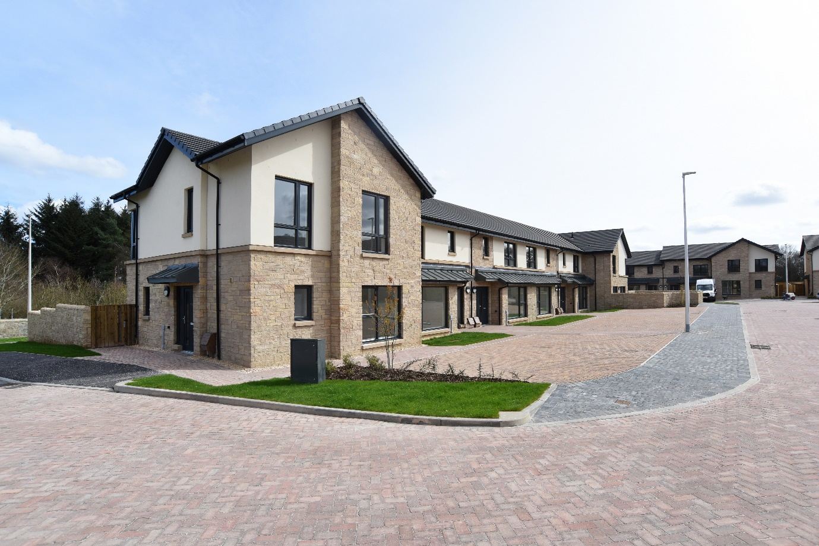

***New houses built by Falkirk Council at Torwood***

**Contents**

# 1. Introduction

# 2. Role of the Strategic Housing Investment Plan

3. Strategic Links

The Falkirk Plan

The Council Plan

Local Housing Strategy

Local Development Plan

Regeneration

# 4. Housing Needs

Housing Needs and Demand Assessment

Housing Supply Target

# 5. Funding

Scottish Government Grant

Council Tax – Second Homes and Empty Homes

Commuted Sums

Affordable Rural Homes for Key Workers Fund

# 6. The SHIP Process

Preparing the SHIP

Summary of Methodology

# 7. Housing Supply

Summary of Previous Programme Delivery 2023-2024

Summary of SHIP Programme 2025-2030

Housing Infrastructure Fund

Specialist Housing

Buy Backs

8. Other Priority Areas

Empty Homes

Climate Change and Carbon Reduction

Homelessness and Rapid Rehousing Transition Plan

Ukrainian Longer-term Resettlement Fund

Gypsy Travellers

Child Poverty

Place Making

Procurement and Alternative Construction Methods

Equalities

Strategic Environment Assessment

9. Consultation and Collaboration

Development Partners

Falkirk Council Planning Team

Scottish Government

Scottish Water

Strategic Housing Group

Housing Contribution Steering Group

Tenants and Residents

# 10. Monitoring

# 11. Appendices

1. Summary ofScottish Government SHIP Guidance

2. SHIP project proforma

3. Scoring framework

4. SHIP 2025-2030 Summary of Projects

5. Map of SHIP Projects

6. List of Abbreviations

1. Introduction

Having a place to call home, that meets you and your family’s needs, and is safe and secure, is a fundamental human right. It is a priority of Falkirk Council’s Local Housing Strategy to increase housing supply to ensure housing is available for our community.

The purpose of the Strategic Housing Investment Plan is to set out Falkirk Council priorities for providing affordable housing, in partnership with the Council new build team and Registered Social Landlords, over the next five years.

These are difficult times financially; therefore, we must ensure strong bonds with our partners to achieve our goals and continue to make Falkirk the place to be.

2. Role of the Strategic Housing Investment Plan

The Strategic Housing Investment Plan (SHIP) sets out the local authority’s strategic investment priorities for affordable housing over the next 5 years. These strategic investment priorities are aligned with the priorities and outcomes set out in the Council’s over-arching Local Housing Strategy (LHS).

The Local Authority, as the Strategic Housing Authority, is responsible for ensuring that all projects proposed by local housing providers are adequately resourced, deliverable and meet the needs of local people.

The Scottish Government requires the Local Authority to publish the SHIP annually setting out projects over the following 5 years. The SHIP is an operational document and is subject to change.

This SHIP:

* Identifies proposed strategic affordable housing projects which require Scottish Government Affordable Housing Supply Programme grant funding, as well as any which are expected to be delivered without Scottish Government funding
* Sets out the estimated resources available and how they will be used, which forms the basis for the Programme Agreement between the Council and the Scottish Government
* Aligns with the outcomes set out in the LHS and planning policy
* Reinforces the role of the Local Authority as the strategic housing authority

The Scottish Government has produced Guidance to assist with the development of the SHIP document and projects, a summary of the guidance can be found in Appendix 1.

There have been numerous challenges facing the housing sector over the last few years. These include the impact of a global pandemic, Brexit and the cost-of-living crisis also more recently a Housing Emergency, as announced by the Scottish Government in May 2024.

Added to the above challenges, the AHSP budget has been reduced by almost £200 million, this is around a 26% cut to the funding for affordable housing delivery and has resulted in some difficult decisions for the Local Authority to make.

Regardless of the challenges, we continue to plan and deliver the affordable housing programme through close joint working with our partners and aim to maintain programme delivery and success.

1. Strategic Links

There are strong links between Falkirk Council’s strategic documents, this is outlined in the Local Housing Strategy 2023-2028 Section 1 and is summarised below.

Housing 2040

The Scottish Government’s first long-term national housing strategy[Housing to 2040](https://www.gov.scot/publications/housing-2040-2/) sets out the vision and route map for homes and communities over the long term within Scotland. Housing is now within a post pandemic context of rebuild and recovery in a fairer and greener way, underpinned by the principles of social justice, equality and human rights.

Housing to 2040 is currently centred on four key themes, which have informed the LHS and the SHIP:

1. More homes at the heart of great places
2. Affordability and choice
3. Affordable warmth and zero emissions
4. Improving the quality of all homes

The Scottish Government are committed on meeting their target of 110,000 affordable homes delivered by 2032 and have brought forward their review of the Housing to 2040 strategy in light of the latest financial challenges. The review is on-going.

The Falkirk Plan 2021-30

The Local Outcomes Improvement Plan (LOIP), known locally as [The Falkirk Plan 2021 - 2030](https://www.falkirk.gov.uk/services/people-communities/community-planning/docs/The%20Falkirk%20Plan.pdf?v=202111100919), sets out priorities for the Community Planning Partnership and describes how it will work together with communities.

The Falkirk Plan emphasis the need for additional and adequate housing within the community. The themes which relate closest to the LHS, and the SHIP are shown in the following table:

*Table 1: Falkirk Plan Themes*

|  |  |
| --- | --- |
| Falkirk Plan Theme | Local Housing Strategy Priority |
| Working in partnership with communities | Priority 2 - Creating sustainable communities |
| Poverty | Priority 1 - Supply of housing is increased.  Priority 5 - Sustainable housing, fuel poverty and climate change |
| Economic recovery | Priority 1 - Supply of housing is increased. |

The Council Plan 2022-27 Falkirk Council

[The Council Plan 2022 - 2027](https://www.falkirk.gov.uk/services/council-democracy/policies-strategies/council-plan.aspx) sets out what we aim to achieve over the next 5 years. The vision for the area is:

*‘Strong communities where inequalities are reduced, and lives are improved’*

The Council Plan has two priorities which link directly with delivering the Strategic Housing Investment Plan:

* Supporting stronger and healthier communities
* Supporting a thriving economy and green transition

Local Housing Strategy 2023-2028

The [Local Housing Strategy 2023-2028](https://www.falkirk.gov.uk/services/homes-property/policies-strategies/local-housing-strategy-2023-28.aspx) underpins the importance of a strong partnership between Housing Services and Planning Services and promotes Housing’s role in building successful and sustainable communities.

The SHIP investment priorities align with the LHS priorities and outcomes. The priorities are:

1. Increasing housing supply
2. Creating sustainable communities
3. Improving access to housing
4. Providing housing and support to vulnerable groups
5. Tackling fuel poverty, energy efficiency and climate change
6. Improving housing conditions
7. Creating a sustainable private rented sector

The LHS is kept under review and is updated annually to take account of any national legislative or local policy changes. The LHS annual update is considered by Council Executive and submitted to Scottish Government.

Local Development Plan

The [Local Development Plan 2](https://indd.adobe.com/view/70cce950-e57c-4daf-a582-ed10e9e34a02) (LDP2) is the statutory document guiding future development locally over 2020-2040. It was adopted on 07 August 2020 and contains a vision for the area. It is the spatial strategy detailing how and where the area will grow and develop, along with detailed policies and proposals indicating where development should or should not take place. The LDP2 provides the criteria used to assess planning applications.

The LDP2 vision is:

“*The Place to be, a dynamic and distinctive area at the heart of central Scotland characterised by a network of thriving communities set in a network of high-quality green spaces and a growing economy which is of strategic importance in the national context, providing an attractive, inclusive and place in which to live, work, visit and invest.*”

The LDP2 aims to deliver sustainable safe communities, to stimulate the local economy and to protect the built, historic, and natural environment by promoting appropriate development and future growth. The LHS and LDP2 are closely linked, particularly through housing supply (LHS priority 1) and creating sustainable communities (LHS Priority 2). The LDP2 looks at projections of future need and ensuring there is adequate land supply available to provide for those needs, this fits with the Housing Need and Demand Assessment (HNDA) in that the HNDA estimates the number of additional housing units required to meet existing and future housing need and demand. Details of the Housing Supply Target are included in the Housing Needs section below.

Falkirk Council’s approach to Place Making for new and existing neighbourhoods is also set out in the LDP2.

National Planning Framework 4

The National Planning Framework (NPF4) sets out a vision for what Scotland, could and should look like in 2050. This includes national planning policies and provides a plan for future development in Scotland. It links to addressing climate change and focuses on achieving outcomes around net-zero emissions, wellbeing economy, resilient communities and better greener places. The Development Plan supports proposals for a range of new homes that improve affordability and choice subject to identified need and a register of people interested in self-build is being developed. NPF4 now forms part of the Development Plan alongside the LDP2.

The LHS has been informed by the concepts and aims set out in the NPF4, such as the 20-minute neighbourhood, use of Place Principle, and appropriate development, prioritising brownfield development over release of greenfield land and support for town centre living.

Both private developers and developing affordable housing landlords are encouraged to consult with Planning colleagues as early as possible. Housing is consulted on new and proposed Planning applications which provides an opportunity at an early stage in the development to advise the developer what is expected as part of the affordable housing provision on the site. Feedback from Registered Social Landlords emphasised the value in developers being given a clear and early message at the outset that a mix of affordable housing units will be sought, including the requirement to deliver full wheelchair standard properties. We have continued to address this with developers over the past year and taking a combined approach with Housing and Planning officers liaising with the developers together. The resulting negotiations/requirements are then fed through to the section 75 legal agreements.

#### Affordable Housing Policy

Affordable housing will be delivered in a number of ways in the Falkirk area. Some will be developed by social rented landlords such as the Council and Registered Social Landlords (RSL) on standalone sites unconnected with any private development. Some affordable housing will be delivered through buying back stock previously sold under the Right to Buy and by reconfiguring existing stock. A significant proportion is expected to be delivered in conjunction with private development through the provisions of the LDP2 Affordable Housing Policy (AHP) which requires a proportion of units on developments with more than 20 units to be affordable. The delivery of such affordable housing will contribute to addressing the priorities set out in the Council’s LHS.

Supplementary Guidance for the AHP provides guidance on affordable housing requirements within private housing sites. This now considers the all-tenure wheelchair accessible housing target contained within the LHS, so the target for new-build wheelchair accessible housing now applies to all tenures and is considered on a site-by-site basis.

The Housing Land Audit estimates the number of houses to be built each year in the council area. The following table highlights the number of sites with more than 20 units which are subject to the affordable housing policy during the timescale of the SHIP and estimates that there are potentially 415 units of affordable housing that could be delivered during this time.

Table 2: Affordable Housing Policy Sites Programmed For 2025-2030

|  |  |  |
| --- | --- | --- |
| Area | Total No. Sites | Potential AH Units |
| Bo’ness | 2 | 66 |
| Falkirk | 1 | 14 |
| Grangemouth | 0 | 0 |
| Bonnybridge and Denny | 2 | 109 |
| Stenhousemuir, Larbert and Rural North | 0 | 0 |
| Braes and Rural South | 2 | 86 |
| Total | **7** | **275** |

There are 7 AHP sites in the 2025-30 SHIP, accounting for 275 of the 586 total newbuild units in the programme (47%). When compared to the total number of Falkirk Council and RSL newbuild and Reconfiguration units in the programme, which is 311, the Affordable Housing Policy sites account for just under half of the units.

Joint working between Housing, Planning and Legal has improved the processes involved in negotiating and agreeing the legal agreement (section 75) required to ensure provision of affordable housing on a specific site. An Affordable Housing Agreement template has been drawn up to ensure there is a clear and detailed record of the Affordable Housing to be delivered. If the developer reneges on that agreement once construction is underway, there is an option to place interdicts/stopping orders on sites.

Developer contributions

LDP2 supplementary guidance [SG13 Developer Contributions](https://www.falkirk.gov.uk/services/planning-building/planning-policy/supplementary-guidance/docs/ldp2/15%20SG13%20Developer%20Contributions.pdf?v=202405301233) , details the contributions required for new developments, the type of contribution and how the amounts payable will be calculated. This allows landowners and developers to consider any cost implications, to ensure the project is financially viable, prior to submitting any planning applications or purchasing land.

The above guidance sets out that it is fair, reasonable and legitimate to seek contributions from all housing developers, including those developing social housing, in order to fund any supporting infrastructure required to make the development acceptable in planning terms.

It has been accepted, however, that for social rented housing, developers’ profit is not relevant, and that viability is dependent on budget and external grant funding. Therefore, through joint working with partners, including Housing, Planning, Link (Curb) and the Wheatley Group, a viability template for social/affordable landlords was developed to allow those providing social housing a mechanism to request a reduction in developer contributions if the site is at risk of not being financially viable, or not require specific types of contribution provision.

Place Making

Place making and 20-minute neighbourhood concepts are considered in relation to SHIP projects. We looked at proximity of SHIP sites to schools, GP surgeries, dentists, shops, frequency of bus service and how near to train stations. The purpose of which is to promote community well-being, and housing regeneration. We have included the following action in LHS 2023-2028:

* We will develop local living and 20-minute neighbourhoods to deliver the healthy, sustainable and resilient places required to support a good quality of life and balance our environmental impact.

We took account of [20 Minute Neighbourhood Tool](https://falkirk.maps.arcgis.com/apps/webappviewer/index.html?id=000db00659164deaac4938f4de991622) developed by Falkirk Council Planning Services for SHIP projects. Appendix 4 details the scores given to each programme through use of the tool.

Regeneration Overview and Vision

The Scottish Index of Multiple Deprivation, looking particularly at areas in the worst 20%, provides evidence for the need for housing regeneration across the Falkirk area. As highlighted in the LHS, we will agree the action needed to set future housing regeneration priorities, taking account of place-making and a range of criteria including:

* Land availability, taking account of constraints set out in the LDP
* Housing demand and turnover
* Environmental considerations
* Energy efficiency
* Community consultation and feedback
* Tenure and options
* Connectivity

This SHIP includes a proposal for regeneration in Grangemouth. Proposals are currently under consideration which allocates £1m from the Greener Grangemouth programme to support the work of the key action to develop a “Grangemouth Housing Masterplan” within the Grangemouth Community Action Plan (2021-2030).

Town Centres

The condition of our town centres is a top priority for the Council. Town centres form the heart of the community shaping the area’s sense of place. Council Planning Policy strongly supports the health and vitality of town centres through the ‘town centre first’ principle, which seeks to prioritise town centres as the first choice for regenerating significant footfall. Falkirk Council is pursuing a programme of [Town centre regeneration | Falkirk Council](https://www.falkirk.gov.uk/services/people-communities/town-centre-regeneration/).

The Council’s Town Centre Development Framework Masterplan was approved at the end of 2023 and shows a vision of Falkirk town centre in 10 to 20 years’ time and the transition from reducing retail dominance to a vibrant mixed use and inhabited town centre that meets the needs of the whole community, and the Municipal Building site project sits well within that Masterplan. The project brings a much-needed boost of affordable housing properties in the area, with a proposed 100 affordable housing units, with a mix of Social Rent and Mid-Market Rent.

The Council has completed several successful town centre regeneration projects across the area in recent years, but further regeneration activity is required over the long-term, involving the Council, private sector and other Partners.

The LHS highlights that town centres face economic and social challenges requiring adaptation and continued investment, reinforcing Planning Policy. It includes actions to prioritise town centre sites for housing and to explore the conversion of empty property above shops, if viable and in areas of housing need. We have taken these into account in the review of the SHIP project scoring methodology and have given increased priority to town centre sites.

Two of the projects in the 2025-30 SHIP lie within town centre boundaries defined within the LDP2, the Municipal Building, Falkirk site and the Kerse Road, Grangemouth site.

Greener Grangemouth

Greener Grangemouth is a community led ‘Just Transition’ programme, [Greener Grangemouth just transition programme](https://www.falkirk.gov.uk/COINS/viewSelectedDocument.asp?c=e%97%9Dc%8Fp%80%8E), which addresses local need by strengthening community wellbeing, quality of place, community wealth, and community capacity and skills to benefit from the transition to a net zero industrial town. Greener Grangemouth will be organised as a local ‘place programme’, supported by an advisory group and a capital investment of £10 million and a revenue budget of £2million over 10 years.

At neighbourhood level, there is an allowance for improving safe routes and spaces and to support community facilities to reach net zero. Using a partnership approach, the project will look at Town Centre Living and Healthy Net Zero Neighbourhoods, considering potential housing models to deliver on specialist housing and sustainable design.

As part of the Community Action Plan, Grangemouth Housing Masterplan, a fact-finding exercise was carried out during 2021/22, and this identified a specific location for development to include demolition of flatted property and build of larger and wheelchair accessible homes. Plans were prepared, however the proposed stalled at the financial viability stage, as when costs were identified they proved to be unaffordable.

A smaller site, which has already been cleared, with lower costs, has been identified within the Town Centre and this is well suited to contribute to the aims for town centre re-development and proposals are under consideration with registered social landlord partners.

1. Housing Needs

Housing Needs and Demand Assessment

The HNDA estimates the number of additional homes that are needed to meet existing and future housing need and demand. It also provides a robust, shared and agreed evidence-base for housing policy and land use to ensure that both the LHS and LDP2 are based upon a shared understanding of existing and future housing requirements. Falkirk Council’s [HNDA](https://www.falkirk.gov.uk/services/homes-property/policies-strategies/housing-need-and-demand-assessment.aspx) was considered to be Robust and Credible by the Scottish Government in December 2022.

The table below shows the estimated annual average number of housing units required over the next 20 years. For the 5 years between 2022 and 2026, there is an estimated annual need for 466 housing units - 224 affordable and 242 market. This equates to 2,328 units in total - 1,120 affordable and 1,208 private units.

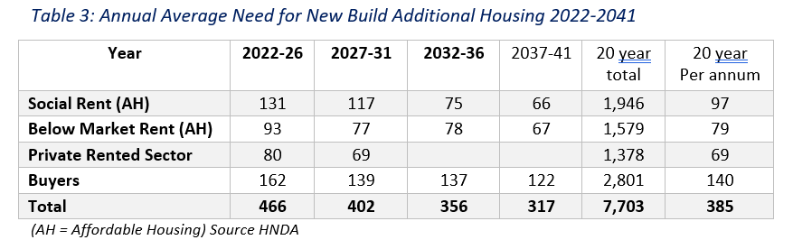

The HNDA identifies a growing need from people with physical disabilities across all age groups, meaning that there is a growing need for disabled adaptations to properties.

The SHIP continues to give a high priority to accessible and wheelchair and accessible housing. There is an acute need for larger accommodation including wheelchair properties for families which impacts significantly on the amount of time homeless households spend in temporary accommodation.

People with complex needs

The HNDA identified that there is a need for housing with support and community care options for people who are under the age of 65, that are currently housed out-with the Falkirk Council area, as there is no suitable accommodation locally.

Housing Services and Falkirk Health and Social Care Partnership have engaged in a partnership with the purpose of identifying opportunities to deliver accommodation and services that will help with the growing pressures and increasing costs of providing support to people in their own homes. The Falkirk Council Oakbank project is a great example of partnership success, the project has delivered specialist housing provision in the Polmont area, with 21 accessible flats and 7 wheelchair accessible bungalows.

We have been working with colleagues in the Health and Social Care Partnership to explore the needs of people with complex needs. The Dynamic Support Register has been established to capture information relating to client needs for housing, care and support.

Recognising the importance of suitable housing and care packages for people with complex needs and the challenges in delivering these, a new multi-disciplinary ‘Coming Home’ team has been set up to help co-ordinate this crucial area. A working group will oversee progress in this initiative.

The Coming Home Team have provided a snapshot of the accommodation required for those placed on the Dynamic Support Register. At the time of writing, there was 71 adults place on the Register, all with differing housing needs. Out of the 71 people, there are 20 individuals suitably placed out with the Falkirk area and are not likely to require a move back into the area with the remaining requiring suitable accommodation in the area.

The 53 adults on the Register who are currently in Falkirk, 37 require 24h care or support. The Coming Home Team also provided details on the types of properties required, this includes ground floor living, full wheelchair accessible, soundproofing, reinforced windows and doors, and high fences within garden areas.

It has been identified by the working group that there is a need for more core and cluster-type accommodation, similar to the successful core and cluster Dunipace project developed by Kingdom and Kingdom Care.

Housing Supply Targets

The Housing Supply Targets (HST) outline the number and type of additional units required in the area to meet need. The HST is a policy-based interpretation of the HNDA outputs. The HST takes account of a range of factors, as set out in Scottish Planning Policy and Scottish Government HNDA Guidance and although there is a clear alignment between the HNDA and the Housing Supply Target, the two are not the same and are not expected to match.  The HST sets out the estimated level of additional housing that will likely be delivered on the ground, over the period of the plan, which considers additional factors, such as the economic downturn.

The LHS targets for Falkirk are detailed in the table below.

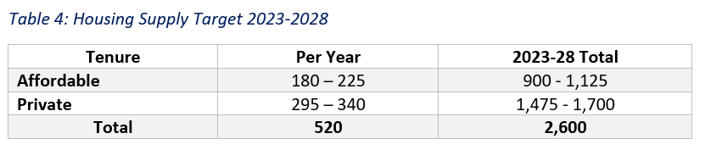

The LHS proposes that the SHIP will look to deliver the following targets:

* 5% of homes to be full wheelchair standard
* 5% of homes to be ambulant/ accessible standard
* 5% of units to be 4 bedrooms or more

Proposals to deliver against these targets are discussed later in section 7. Housing Supply.

1. Funding

Sources of Funding

Funding for SHIP projects come from the following funding sources:

* AHSP Grant provided by the Scottish Government
* Falkirk Council’s Housing Revenue Account, see Housing Investment Programme
* Registered Social Landlord private finance
* Falkirk Council Second Home Council Tax
* Commuted Sums collected from AHP
* Falkirk Council’s Health and Social Care Partnership Contributions for specialist projects. A contribution was made in 2023/4 for a site providing ambulant/wheelchair housing.

Scottish Government Affordable Housing Supply Programme Grant

The purpose of the Scottish Government AHSP Grant is to enable affordable housing providers, local authorities and RSLs, to deliver affordable homes. The Scottish Government allocates a share of grant across the Local Authorities annually, this is known as Resource Planning Assumptions (RPA).

The RPA assigned to a Local Authority must be spent in that financial year, any programme slippage (projects not starting) or underspend cannot be carried forward to the next year. It is important, therefore, that the programme is realistic, and Scottish Government Guidance highlights that SHIP programme should have an emphasis on deliverability.

In previous years Scottish Government allocated RPAs for current and future years. This allowed assurance and certainty for projects, as delivering new housing is not a quick process and sites can take several years before they are delivered. However, in December 2023, the RPA was cut by 26% for 2024-25. Scottish Government have not advised on future years. We have been advised to plan on a similar figure to 2024-25 yet SHIP guidance still requires us to over programme and build in a slippage factor of 25%.

The reason for over programming is to ensure spend; as with the nature of projects, some may slip or not fully draw down their assigned grant allowance, therefore the Scottish Government can move unspent funds between the different local authorities ensuring maximum spend for that year.

Falkirk Council 2023-24 programme spend was £13.601m, the assigned RPA for the financial year was £12.550m, spend was therefore 109%. Falkirk Council were fortunate to have been awarded the additional spend despite the budget cut announced at the end of 2023 and the payment restrictions that followed.

The RPA for 2024-25 was £9.528m, with a programme estimated spend of £9.567m, an over programming of 0.4%, although difference is minimal, we are hopeful that there will be slippage available to cover this amount.

Due to the current financial pressures, we are not presuming receipt of the 25% as in previous years and have therefore identified a project that can be funded if the additional 25% is available as shown in appendix 4.

Affordable Rural Homes for Key Workers Fund

The Scottish Government announced the Key Workers fund to support Local Authorities and RSLs to purchase suitable properties within the local area to meet the need of key workers. The Scottish Government defines a key worker as those who provide an essential public service.

The fund was announced in 2023 and made £25m available from the AHSP fund. The fund is to be used for the acquisition (purchase) of properties within rural areas classified as urban/rural level 4, level 5 or level 6.

Falkirk Council have 16 data zones that fall under the Scottish Government defined areas.

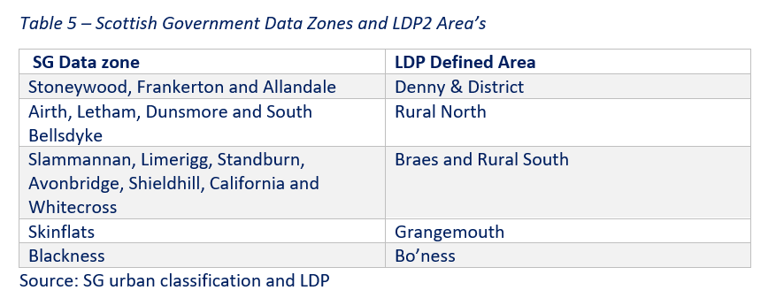

The LDP2 AHP [SG06 Affordable Housing (falkirk.gov.uk)](https://www.falkirk.gov.uk/services/planning-building/planning-policy/supplementary-guidance/docs/ldp2/06%20SG06%20Affordable%20Housing.pdf?v=202107191625), supported by AHSP grant funding, facilitated the delivery of 11 low-cost home ownership houses, targeted at people who would otherwise be unable to afford a new property. Colleagues in Housing and Planning worked closely with partner Kingdom Housing Association and the private developer. All 11 houses were sold on a shared equity basis during 2022-23, to local people, 5 of whom were key workers and 8 of whom were first time buyers. SG06 identifies key workers as a priority group. An affordability assessment is carried out and people purchased between a 60% and 80% share of their property, with the remaining equity share held by the Scottish Government. The review of this project is that it has been successful, and shared equity is an affordable model that we will be including in future developments, particularly as part of AHP sites.

Falkirk Council and local RSL, Paragon, have successful property acquisition schemes, buying back ex social housing within the area, more information will be provided later. We are exploring how best to access and use this fund to enhance our acquisition scheme. We have been networking with other Local Authorities through the Scottish Housing Network on this issue and information has been received from another local authority who have benefitted from this scheme. We aim to develop a Key Worker Policy as required and are hopeful that we can access this fund in future years.

Scottish Government Benchmarks

RPA provide grant support at benchmark rates for each affordable home built. The benchmark and project rates are flexible, so that projects may be eligible for a higher grant award per property following a detailed assessment of project viability and development costs. This is determined by the Scottish Government when the developer submits their project tender.

Any increase to the benchmark grant is met from the Council’s RPA. If there is no increase in the overall RPA, any increase in benchmark will reduce the number of new affordable homes being delivered.

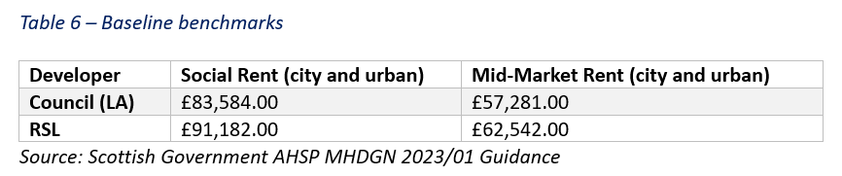

Additional benchmark funding is available to assist with added components such as greener homes, balconies, and fire suppressant systems.

Council Tax Fund – Second Home Council Tax (2HCT) and Empty Homes

The funds generated from the reduction in discount for second homes and empty homes is earmarked for affordable housing. The balance at the start of the financial year 2024-25, as recorded on the Annual Council Tax Local Financial Returns (LFR 12) detail that the ring-fenced amount available for Affordable Housing was £734,000.00. The LFR 12 also detailed the non-ring-fenced amount as £328,000.00

Falkirk Council’s Housing Investment Programme is funded primarily from rents and borrowing. This is repaid over several years by the Housing Revenue Account as loans charges. A sum of £250,000 is transferred from the ring-fenced income generated through Council Tax and used for Council New Build loan Charges annually.

The fund has also been used to assist with other affordable housing projects over the years, most recently a project in William Street, Falkirk Town centre. The Williamson Street project, delivered by Link Housing, was given £188,000.00 from the 2HCT fund. This project generated 36 properties for older people, including 5 fully wheelchair accessible properties.

New powers enabling councils to charge up to double the full rate of council tax on second homes came into force on 1st April 2024. It was agreed at Executive on 22nd August 2024 that a levy of 100% would be applied to second homes in the council area from 1st January 2025. Owners affected by this change have been notified via letter in June 2024, providing a six month notice period.

Commuted Sums

The AHP outlines the forms of affordable housing that are accepted and expects it to be delivered on site, as outlined previously, however, as a last resort, a commuted sum could be accepted in lieu of affordable housing provision. Falkirk Council Housing Service will determine whether a commuted sum is acceptable in place of delivery.

The Scottish Government guidance advises that commuted sums can only be used for the delivery of affordable housing or infrastructure works associated with the delivery of affordable housing. There are also legal restrictions in terms of the commuted sums, in that the sum can only be used within the area the commuted sum originated from and the sum must be spent within a 10-year period from the date received.

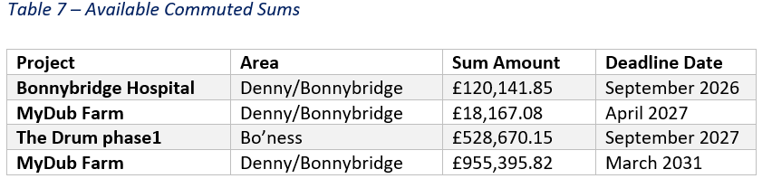

The above funds have been earmarked for project delivery in 2025-26 to support the delivery of projects in Denny/ Bonnybridge and Bo’ness. Given the challenges and pressures faced following the recent AHSP budget cuts, the funds available provide a cushion to allow for sites to progress.

Commuted sums are monitored and managed by the Planning Obligations Group within Falkirk Council’s Place Services. Housing Services and Planning meet regularly to discuss on-going projects as well as legislative and other changes that may impact progress. The regular meetings allow for discussion surrounding the use of the commuted sums available and agree the projects they can be assigned to assist with.

1. The SHIP Process

The purpose of the SHIP is to outlines the affordable housing programme for the local area for the next 5 years. The SHIP is an operational document capturing the current housing development and the priorities that direct the decisions made. Housing development is not a linear process, and it may take years for a project to get to the point of building on site. The SHIP programme is therefore fluid and adaptable in that it can change in response to a range of factors, such as financial resources, economic changes, housing need and demand and market variations. This means that projects might be brought forward, delayed, added or removed when necessary.

There are numerous challenges, and development constraints that may impact on project deliverability, including:

* The increasing price of tender returns
  + *Tenders are well above benchmarks therefore require scrutiny by the Scottish Government to confirm will be approved.*
* Ongoing supply issues due to Covid recovery, Brexit and War in Ukraine
  + *suitable alternatives solutions for resources are sought where possible*
* AHP sites dependent on the wider housing market and developer timescales
  + *an Affordable Housing Agreement template is available to ensure there is a clear record of the AH to be delivered*
* Unrealistic owner expectations of land value and over-paying for land–
  + *we are making developers aware that inflated land costs cannot be recouped via affordable housing. Providers work hard with agents and landowners to raise awareness of the AHSP* *funding process*
* Sites not in the ownership of the developer –
  + *the proforma and scoring for projects has been adjusted to reward sites where ownership is already obtained or very likely to be.*
* Abnormal site ground conditions –
  + *site investigations to be completed upfront and abnormals deducted from land cost. Flexibility in benchmarks to allow for increased grant, if needed.*
* Stricter requirements for surface water drainage from Scottish Water –
  + *Scottish Water is consulted on SHIP sites to ensure any issues are highlighted and scoring adjusted if appropriate. The Council’s flood prevention officer available to offer advice to the providers.*

The most recent challenge to the programme has been the cut in AHSP budget. This has resulted in the majority of projects included in the 2024-25 programme to be moved into future years. Discussions with partners, such as Falkirk Council Planning Services, Scottish Government and developers helped to inform decisions and priority focus for the 2024-25 programme was based on project deliverability and viability.

Falkirk Council, as the Strategic Housing Authority, is committed to working with partners and developers to deliver the projects within the SHIP, to overcome any challenges and constraints that may impact on progress. A tripartite meeting is held quarterly to discuss such matters. This group includes representatives from the Scottish Government, Falkirk Council Strategic Housing and Planning teams and housing providers, such as the Council’s New Build team and developing Registered Social Landlords, the meeting is always well attended. Guest members are also invited to attend Tripartite meetings as necessary, to discuss specific issues which impact on the development process, such as the Climate Change Strategy and LHEES Strategy and Delivery Plan.

Regular SHIP review and project update meetings are held between the Council’s SHIP lead officer and individual housing providers. This is beneficial to all as it allows for more detailed project discussion to ensure projects are progressing and any identified issues or challenges are addressed efficiently. It also allows for any programme adjustments to be made ensuring deliverability and spend.

Preparing the SHIP

We work closely with our partners when preparing the latest SHIP programme, such as Planning Services, and the housing developers in the area, to consider any potential project delivery constraints, this is built into the assessment scoring (see below).

Significant development work has been carried out by all partners involved in the SHIP to identify ‘pipeline’ projects that will be delivered in future years. It is important to identify both future, potential, projects as well as projects that are at an earlier stage, or that may have constraints to be identified/overcome, as highlighted previously, to ensure that they are best placed within the SHIP 5-year programme.

Methodology

Falkirk Council’s Strategy and Development Team invites the affordable housing providers in the area to submit proposals for sites to be included within the latest SHIP programme. This invite is sent out annually and involves the completion of an agreed proforma template (Appendix 2).

It is expected that developers will submit more projects than there is funding available, therefore a scoring matrix has been developed to assist in the decision making (Appendix 3). Both the proforma and scoring matrix has been agreed previously by the partners who attend the Tripartite Meetings, members detailed above.

The scoring methodology reflects the strategic priorities at that point in time as well as project deliverability and viability. Developers have been asked to provide as much information as possible to ensure project can receive maximum points for decision making purposes. This helps to ensure Falkirk Councils programme is strong, will successfully delivering affordable housing and maximise the AHSP funding available.

The Scoring priorities include:

* Location
  + more points for high housing demand areas
* Housing Needs
  + more points for ambulant/ accessible, full wheelchair standard and larger units
* Specialist projects
  + reward for specialist housing e.g., core and cluster and gypsy/traveller projects
* Deliverability
  + Planning status and land ownership position
* Sustainability
  + additional points for silver, silver active and gold standard
* Best value
  + points for projects delivered on or under benchmark, and for additional funding obtained
* Strategic priorities
  + Up to 500 additional points for projects that deliver on particular strategic objectives as outlined in the LHS

AHSP grant spend, and affordable housing completions were low for a period and Council officer targeted efforts to improve both. Over the last few years, there has been an increase in engagement with Planning colleagues and other partners, such as housing developers and this has positively impact on affordable housing delivery. Examples of increased engagement include, becoming more involved in planning consultations, and section 75 site agreements. As part of this approach, we have attended Planning Committee, Planning Pre-Application and Pre-determination hearings, which has allowed advice on housing needs, AHP, AHSP funding and the SHIP processes to be provided if called upon. This has also helped to raise decision makers awareness on what is involved in affordable housing delivery and the differences compared to private development.

The long development process and inevitable delays associated with housing sites mean that programme slippage is common. Previous Scottish Government SHIP guidance requested that a programme be drawn up on the basis of assigned RPA for that financial year with the addition of 25% (RPA+25%). This over-programming, as it is known, helped ensure that the AHSP Grant is spent across the board. If it becomes clear throughout the year that a LA will not fully spend their allocated RPA, the Scottish Government will divert the amount to another LA with the capacity to spend before the end of the financial year.

This year has been slightly different due to the cut in budget and although over-programming has been encouraged by the Scottish Government, it has not been to the level expected previously. Falkirk Councils programme for 2024-25 is £400k, around 0.4%, above RPA.

The proposed projects for the 2025-2030 SHIP programme are detailed in Appendix 4. This programme is based on estimated RPA’s, timescales and likely number and types of property delivered over its life span. The programme has purposely been created to allow flexibility, with the aim of maximising deliverability, therefore there will be capacity to move different projects if able or required.

1. Housing Supply

Summary of 2023-2024 Programme Delivery

Falkirk Council’s 2023-2024 SHIP programme was extremely successful in terms of spend and site completion. The 2023-2024 programme spent an additional £1.091m on top of the allocated £12.550m RPA for the financial year. Spend for 2023-2024 was £13.641m.

Falkirk Council were fortunate to receive additional funds through slippage despite the announcement of budget cut and the spend restrictions that followed. This has allowed for a stronger position moving into 2024-25 than first projected. The additional spend was put towards the Falkirk Council Haugh Gardens project, this allowed a decrease in the project grant award to be drawn down this current financial year, providing a slightly stronger position going forward.

The 2023-24 programme included 5 new build sites completions, a reconfiguration project completion and 70 property acquisitions (purchase of ex local authority properties, known as Buy Backs). This was confirmed by the Scottish Government at the May Tripartite Meeting. The table below provides details on the completions and in order of completion:

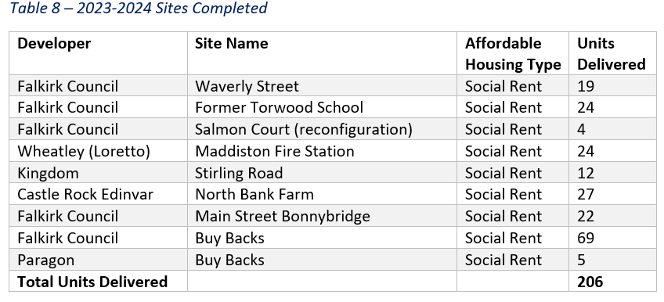

The SHIP priorities align with the LHS goals, therefore the mix of unit types delivered is important to allow goals to be met in terms of housing need. The HNDA expresses the need for both 1 and 2 bedroom properties but also highlights an acute need for larger family homes (4+ bedrooms) and wheelchair accessible homes. The current LHS has set a target goal for delivering 5% larger homes, 5% ambulant/accessible and 5% wheelchair accessible homes. The following tables provide a summary of the type of affordable housing that was delivered on the above sites in 2023-24.

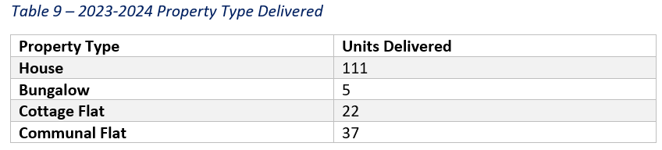

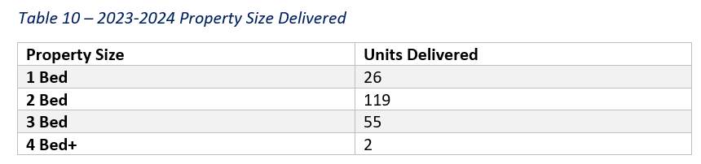

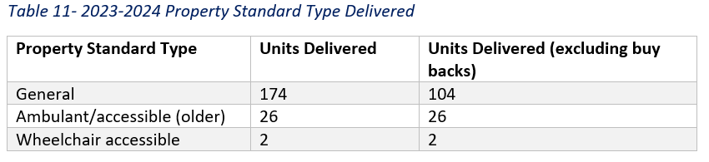

The sites completed in 2023-24 were approved and on site prior to the establishment of the 2023 LHS goal of 5% larger homes, 5% ambulant accessible homes and 5% wheelchair accessible homes. The properties delivered last financial year included:

* 1.9% Larger homes
* 25% Ambulant/accessible homes
* 1.9% Wheelchair homes

The units delivered in 2023-24 were all social rent accommodation. Social rent has been identified as our most pressing need. The LDP2 SG06 Guidance, as outlined previously, details the affordable housing tenure types that qualify for AHSP funding. Mid-Market Rent, Shared Equity and Discounted sale properties had been delivered in previous years and we have included projects with differing tenure types in the 2025-30 SHIP programme.

Summary of 2024-2025 programme

The Scottish Government announced a cut to the AHSP budget in December 2023. The SHIP programme for 2024-2025 had been based on a projected grant income from the Scottish Government, RPA+25%, of £15.873m. The RPA was cut from £12.594m to £9.528m.

The reduction in grant available had a considerable impact and led to decisions being made regarding which project would be assigned grant funding for the 2024-2025 financial year and which projects had to be moved into future years. The decisions taken, following discussions with developing partners, focused on deliverability, i.e. projects that were on site, and housing need in light of the housing emergency.

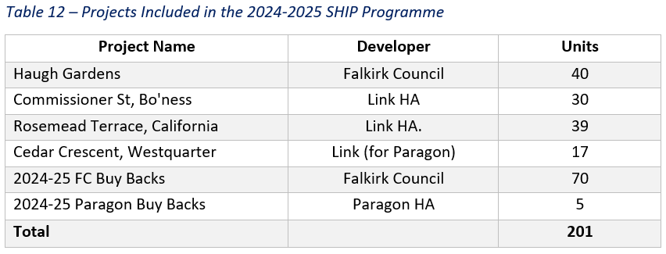

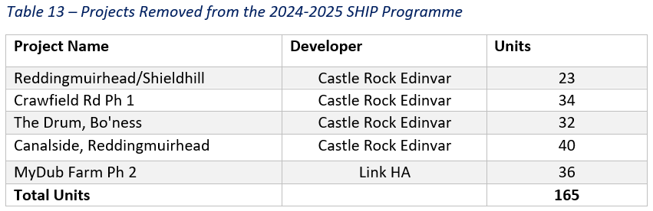

Summary of 2025-2030 programme

The purpose of the SHIP is to set out proposals to deliver a 5-year balanced programme of Council and RSL new build and reconfiguration projects as well as buy backs, through use of the Scottish Government AHSP funding, Council and RSL private financing, Commuted Sums and Second Home Council Tax funds. The 2025-30 programme, which includes over-programming, aims to deliver 539 new homes, 47 reconfigured homes and 375 properties through buy backs. This is an average of 192 units per year.

This is a drop in the average units from the previous 2024-29 SHIP, 269 per year, this is a drop of 28.6% which reflects the cut in AHSP budget and other financial pressures felt by Council and RSL.

As discussed earlier, the LHS 2023-28 has a proposed target of between 180 and 225 additional affordable homes to be provided each year, therefore the programme for 2025-30 fits well within this target.

A summary of projects and the AHSP funding and Commuted Sums earmarked against each one can be seen in Appendix 4, along with a map in Appendix 5, highlighting the distribution of sites across the Council’s housing sub-market areas, as defined by LDP2.

The table below provides a breakdown of tenure. The highest priority of need remains social rent however there are different types of housing that qualify as ‘affordable’ and the SHIP 2025-30 programme is mainly concerned with tenue types that meet our priority need: social rent, mid-market rent and shared equity housing.

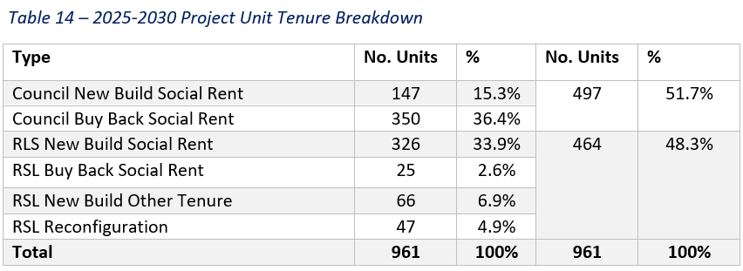

The LHS places emphasis on the delivery of larger family homes, ambulant/accessible properties and fully wheelchair accessible properties. As discussed previously, the goal set by the LHS is 5% and, as outlined in the table below, the goal has been met for new build homes. Projects due to commence later in the programme have not fully confirmed the property types they will deliver, and Falkirk Council will continue to work with the RSLs to encourage the inclusion of more larger style homes.

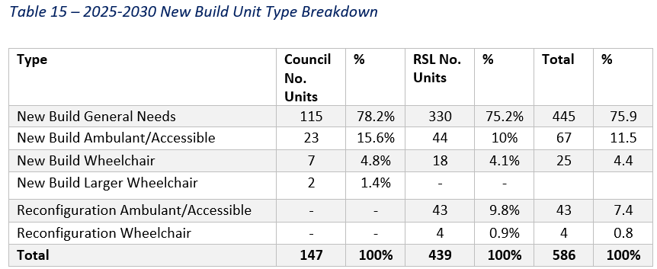

Specialist housing – Accessible Housing and Wheelchair Standard

Housing and Planning officers are working with affordable housing providers to encourage the inclusion of full wheelchair standard properties on future affordable housing sites, and there are a number of projects moving forward including Rosemead, California and Westquarter, although it is proving to be more challenging to persuade housing developer and builders to include these units on private AHP sites. The reason for such resistance is that house builders do not believe that there is a market for them. This is an area officers are continuing to explore.

Falkirk Council New Build Team have delivered specialist housing projects over recent years, such as Salmond Court regeneration, Bonnybridge newbuild and more recently Polmont newbuild. The Health and Social Care Partnership contributed financially to the Council new build site at Oakbank, Polmont, to deliver specialist housing provision including 21 ambulant/accessible flats and 7 wheelchair accessible bungalows. This is a partnership we wish to continue.

We are also working with Falkirk Council’s coming home team, as detailed previously, to gain an insight into type of properties needed to meet the specific needs of their clients. The purpose of this collaboration is to prevent any requirement for people with complex needs to be housed out with the local area in future. The success of the core and cluster model used by RSL Kingdom in Dunipace is encouraging in meeting this aim and is being incorporated into future projects.

The 2025-30 SHIP programme does not include any specific specialist housing projects, however, as mentioned, projects due to commence later within the programme have not confirmed house types and Falkirk Council will encourage additional specialist projects based on success of previous projects.

Buybacks

Buying back ex social housing properties is an excellent way to increase housing supply and provide a steady supply of lets. It can help improve stock condition and enhance local communities, as having a majority ownership of common blocks makes it easier for social landlords to carry out essential repairs and improvements to properties and areas where owners have a shared responsibility.

The SHIP includes Falkirk Council and Paragon Housing Association’s Buy Back Scheme in the AHSP programme.

The Council’s Buy Back scheme, introduced in 2013, was originally set up to purchase one- and two-bedroom ex-Council properties, it was then widened to include 3+ bedroom houses, when an acute need was highlighted for larger family homes and properties suitable for disabled people. The process was adapted again in 2020 when approval was given, due to market pressures, to allow Officers to offer up to 10% above the Home Report/District Valuer valuation for 4+ bedroom houses and properties that had been adapted, or had the potential to be adapted, for a disabled person.

The average price of a Buy Back in 2023-24 was £113,435 this is an increase of 2.4% from the previous financial year. The Office of National Statistics published their analysis for the financial year in May 2024, the information showed an increase in the average Falkirk property, between March 2023 and March 2024, of 8.4%, this is higher than the Scottish average increase of 6.7%[1]. The average price of a Buy Back this financial year, calculated June 2024, is £118,214.00, a further increase of 4.4% from the previous year.

The Scottish Government grant level for Buy Backs is currently set at £45,000 per property. The Council has allocated an annual budget of £8.07m per year over the next 5 year. The target has reduced from 80 per annum to 70 in year 2024-25 in cognisance of market conditions and reduction in grant funding. Paragon Housing Association has an annual target of 5 properties.

The following table highlights the number of ex-LA properties brought back into the public sector over the last 5 years.

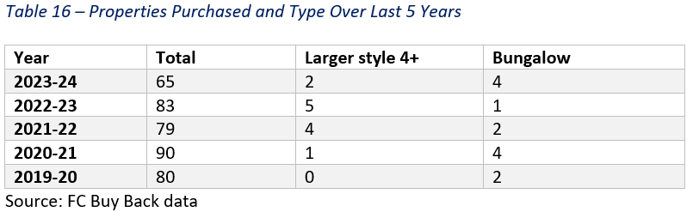

In 2023-2024, the Council were able to claim grant funding for 2 larger properties and 4 bungalows to assist with the need for larger and adapted properties. Such properties are a priority, and an assessment is made on each property when considering purchase, on whether it could be reconfigured to provide a larger or adapted property. 2 additional larger properties were purchased but due to the Scottish Government spending restrictions the Council were unable to draw down grant for all purchased within the financial year. The additional 4 properties have been drawn down years 2024-25.

Housing Investment Fund – progress & projects related to works

The Scottish Government Housing Infrastructure Fund (HIF) is available to deliver housing sites where the scale and nature of infrastructure costs would prevent the site from being supported through the AHSP.

Falkirk Council submitted a funding application for 3 sites within Banknock and Dennyloanhead as the number of units delivered at these sites was constrained due to development works being required at Junction 7 of the M80. To facilitate the junction improvements, the Scottish Government originally offered grant up to £1.543m in May 2018. Following a tender exercise and an increase in costs, in December 2021 the grant was an uplifted to £2.397m.

Conditions of the grant require the completion of the M803/M80 road infrastructure works before the delivery of affordable homes in the Banknock and Dennyloanhead sites can be built. To allow for the infrastructure works to complete, these sites, and the affordable units due to be delivered, have been included in the later years of the SHIP, as highlighted in Appendix 4.

Colleagues in Place Services have prepared the detailed design and legal documentation to allow the project to progress and the tender has been led by the private developers and agencies involved. This project has experienced significant delay however is now making progress. There has been a preliminary price for works submitted and Road Construction Consent is progressing.

**We are aware that HIF funding remains available for suitable sites. We will discuss with the Scottish Government and apply for funding should an opportunity arise, but at present we do not have any projects that would meet the criteria.**

1. Other Priority Areas

Empty Homes

A key priority for Falkirk Council is making best use of existing housing stock and supporting owners of empty properties to bring them back into use helps to achieve that. Falkirk Council Strategy & Development Team has two Empty Home and Buy Back officer who provide owners with a range of practical options and information to support them to bring their properties back into use. An empty home is defined as a property that has been empty for over 6 months.

Falkirk Council took the decision to implement the Council Tax (Variation for Unoccupied Dwellings) (Scotland) Amendments Regulations 2016 (2016 Regulation), meaning that homes that have been empty for over a year, pay additional Council Tax. The purpose of using the 2016 Regulation is encourage owners to bring empty properties back into use, increasing the supply of housing for those who need homes, and also to reduce the blight on communities from some empty homes falling into disrepair. Since April 2017 the Council has applied a 100% levy, doubling the council tax, on these properties.

At present, none of this funding is directly allocated to the affordable housing programme in Falkirk, and Officers are exploring how best to utilise the budget. The Council have used the Empty Homes Framework, developed by the Scottish Empty Home Partnership, to develop an Empty Homes Plan for 2024-2029. The aim of the plan is to work in partnership to bring 70 properties back into use each year, to increase the supply of good quality housing, and raise awareness of the issues surrounding empty properties. One of the actions outlined in the plan is to explore the use of grants for empty homeowners to help get their empty properties back into use.

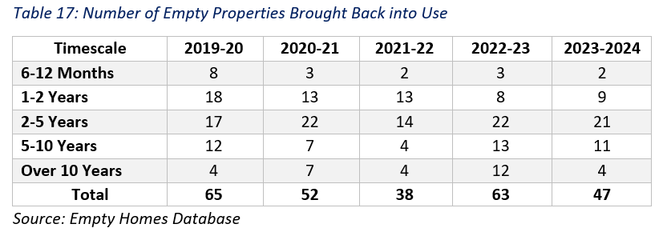

The above table demonstrates the positive impact in the area the Empty Homes and Buy Back officers have had in the area. The Falkirk Council Empty Homes Officer was introduced in 2013 and in the last 5 years alone, they have brought 265 properties, 31 of which had been empty for over 10 years back, into use.

The Enforcement Panel led by the Housing Intervention Coordinator, is a quarterly internal group, comprising colleagues from Building Standards, Environmental Health, Legal Services, Conflict and Private Sector, and the Strategy Team (Empty Homes), who meet to discuss properties, including empty homes that are causing serious issues in the area and come up with actions for owners. The introduction of a revised Empty Homes Plan is a positive step towards tackling the wider issue of an empty home on differing Council Services.

Climate Change and Carbon Reduction

Falkirk Council declared a Climate Emergency in 2019 and published the organisational target of being net zero by 2030. The decision was taken for Grangemouth to be the first net zero town in the Council area. Since this declaration, various actions have been implemented to achieve the targets set, and progress has been made against future targets.

The Scottish Government’s Heat in Buildings Strategy requires any new buildings to use zero direct emissions heating and have high levels of fabric energy efficiency to reduce overall heat demand, preventing any future retrofitting. This requirement applied for new homes Building Warrant applications from 1 April 2024. This was accelerated through the AHSP, as all new build projects applying for grant funding from 1 December 2023 were required to install zero direct emissions heating systems, unless there has a compelling and evidenced reason against it. Additional benchmark grant has been made available for all projects incorporating zero carbon heating systems.

New housing in the SHIP is built to a minimum sustainability standard, as set out in Building Standards legislation, of Bronze Active and the scoring matrix for sites, Appendix 3, prioritises units at Silver Level and above with the purpose of ensuring a high energy efficiency and cost effectiveness for future residents.

The Council and Registered Social Landlord partners continue to work to increase the proportion of their housing stock that meet the equivalent of Energy Performance Certificate (EPC) band B, this is a priority under the LHS. The Council’s Housing Investment Programme 2024-2029 was presented to Council on 31 January 2024, detailing investment to energy efficient heating systems in line with the Council’s capital programme and energy efficiency obligations.

Link Housing are currently progressing the SHIP 24-25 programme project in California, which includes the installation of Air Source Heat Pumps. This project attracted additional grant benchmark funding to assist with the installation of the heat source. This project is due to be completed mid-2025.

Buy Back properties being brought back into the social sector are brought up to the required Scottish Housing Quality and Energy Efficiency Standards for Scottish Social Housing 1 and 2. Reducing the carbon footprint of these properties which prior to upgrades were poor.

Falkirk Councils Climate Change Strategy and LHEES Strategy and Delivery Plan has been developed by The Energy and Climate Change team in partnership with the social housing providers in the area following consultation findings which show social landlords already have set commitments and priorities to reduce their carbon footprint and have targets to achieve net zero emissions. The Strategy and Delivery Plan can be found on the [Climate change | Falkirk Council](https://www.falkirk.gov.uk/services/environment/environmental-policy/climate-change/) webpage. The team have also developed an interactive webpage, [Decarbonise Falkirk](https://decarbonisefalkirk.org/?location=Homeowner) for owners, tenants and businesses which details actions that can be taken to lower carbon emissions and increase energy efficiency.

Homeless and Rapid Rehousing Transition Plan

Falkirk continues to face several challenges in tackling homelessness, and with the announcement earlier this year from the Scottish Government of a Housing Crisis, actions to help tackle homelessness is even more essential.  Homeless presentations are continually increasing, and this increases pressures on temporary accommodation. Therefore, increasing the supply of affordable homes remains vital in meeting Falkirk’s housing needs. Having more properties available enables movement within local housing systems and is essential reducing the homelessness crisis.

The Council’s Rapid Rehousing Transition Plan (RRTP) 2019-20 – 2023-24 has been developed in the context of the wider strategic planning framework including the LHS and is reviewed annually.  The RRTP details actions to provide those who are homeless with settled accommodation more quickly, to reduce the time spent in temporary accommodation, and to provide access to clear support pathways.

The number of households, and household with children, in temporary accommodation is unfortunately increasing. We recognise the detrimental impact of homelessness on a child’s health and are committed to reducing the time children and families spend in temporary accommodation. We know that the increase in families in temporary accommodation is partly due to larger families requiring assistance. There are a limited number of larger properties available for let in the social and private rented sector in the area, with turnover of larger properties being much lower than smaller properties. There have been numerous actions taken over the last few years to increase the number of larger family homes available. Falkirk Council, as detailed previously, been given permission to pay above home report price for Buy Backs to help secure needed properties. Larger family homes are also included in the proposed property mix for new build sites.

There is a reconfiguration project planned by Falkirk Council Housing Needs Team, in future years, to alter homeless supported accommodation for young people within Falkirk. The Seaforth project aims to reconfigure an existing supported accommodation into self-contained flats. The project is at very early stages therefore the number of units that could be delivered is not yet confirmed.

Falkirk Councils Allocations Policy is review regularly with a current review ongoing during the time of writing. The previous Allocations Review was in 2020, and actions were taken to increase the percentage of properties let to homeless applicants from 33% to 45% which meant homeless applicants were housed quicker.

Prevention team

Falkirk Council established the Prevention Team in Summer 2022. The Team provides support and guidance to those facing homelessness with the aim to prevent homelessness or to assist in finding alternative housing prior to becoming homeless. The Team can offer housing options information at an early stage, offer advice regarding financial and family issues, and also engage with housing providers, such as private Landlords, to agree to actions to prevent homelessness.

Ukrainian Longer-term Resettlement Fund

Scotland is welcoming those displaced from Ukraine and the Scottish Government has created a fund for Local Authorities and Registered Social Landlords to increase the number of homes available to support the longer-term resettlement of those who are displaced. The fund is to be used for repairs to void properties to bring them back into use.

Falkirk Council have applied to the fund to assist with the refurbishment of 11 properties in Denny, a mix of 1, 2 and 3 bed flats, which will be initially used for displaced individuals and families. We are currently awaiting confirmation from the Scottish Government as to whether the application to the fund has been successful.

Curb/Link Housing have also confirmed at the time of writing, that they are aiming to apply to the fund. Their proposal is to bring 5 properties currently void within Falkirk and Grangemouth back into use.

Falkirk Council supports and will continue to support Registered Social Landlord applications to the Ukrainian Longer-term Resettlement Fund.

Gypsy Travellers

There is one Gypsy Traveller site in Falkirk and the current HNDA confirmed that there is no need for any additional gypsy traveller pitches within the Falkirk area at this point in time. The LDP2 does however provides guidance for any future site applications if there is a need in the future.

There are currently 10 pitches on the site, reduced from 15 in order to comply with the Fire Safety (Scotland) Regulations, and at the time of writing, 8 of the 10 pitches are let, with the other pitches being used for resident car parking due to limited parking. There is a waiting list and there are ongoing discussions between services looking to maximise site capacity.

The Travelling Persons’ Participation Group and Falkirk Council officers identified several alterations required at the site during the 2021 consultation, including actions to tackle different maintenance issues, such as mould and condensation, and a transit site for visitors. Efforts are already in progress to bring void pitches up to standard alongside scheduled repairs for chalets aimed at enhancing on-site living conditions and a transit site has been established.

Discussions to improve the on-site energy provision are ongoing with consideration being given air to air heat pump systems or solar thermal systems. The options are currently being explored.

The rent charges on site are also being considered as Falkirk Council acknowledges the importance of fair and equal rent. The rent is currently above some Council owned homes rents. Financial assessments will be carried out on site to help maintain and deliver best value for those living on site.

Child Poverty – Falkirk Council Anti- Poverty Strategy

The Child Poverty (Scotland) Act 2017 requires the Local Authority and NHS health boards to produce a report specifying what action is underway and is planned, to tackle child poverty in their area. The Building a Fairer Falkirk Strategy 2024 – 2029 (the 2024-29 Strategy) sets out the ambition for Falkirk Council Community Planning Partnership to understand and address the impact of poverty on individuals, families, and communities in the area.

Scottish Government data shows that 24% of children are living in poverty across Scotland and recent data from [End Child Poverty](https://endchildpoverty.org.uk/homepage/), at time of writing, places 26.2% of children in Falkirk are living in poverty.

The 2024-29 Strategy emphasises that one in four children in Falkirk are living in relative poverty after housing costs, therefore efforts are being focused on reducing the impact of poverty in the communities, and in particular, the impact felt by children and young people.

The Building a Fairer Falkirk Strategy 2024-29 aligns with the LHS 2023-2028, LHS priorities including:

* work in partnership to carry out housing regeneration across Falkirk Council area.
* encourage collaboration and community engagement to improve the impact of resource allocation and investment in community.
* work in partnership to promote community well-being activities.
* work in partnership to tackle poverty and minimise incomes.
* promote digital technology and online services.

The Health Inequalities Impact Assessment for the LHS identified literacy as being a factor leading to poverty. The LHS includes a milestone around developing protocols to ensure people can access services, protocols including plain language and Read Aloud available on documents.

We update the LHS annually and present the update which includes progress towards meeting goals, to elected members for consideration, this is then sent onto the Scottish Government for information.

Placemaking

We have included the following action in the LHS 2023-2028:

* we will develop local living and 20-minute neighbourhoods to deliver the healthy, sustainable and resilient places required to support a good quality of life and balance our environmental impact.

The 20-minute neighbourhoods and placemaking concepts were therefore considered when scoring potential SHIP projects. This is included within Strategic Priorities as outlined in Appendix 3, scoring matrix. We looked at proximity of sites to schools, GP surgeries, dentists, shops, bus services and how near to a train station.

Falkirk Council Planning Service have created a 20-minute neighbourhood tool which is available to all on the Falkirk Council website, [20 Minute Neighbourhoods Tool | Falkirk Council (arcgis.com)](https://falkirk.maps.arcgis.com/apps/webappviewer/index.html?id=000db00659164deaac4938f4de991622)

Procurement and Alternative construction methods

Housing Development Partners are always looking for viable proposals which will offer efficiencies in costings, timescales and energy/carbon savings. This continues to be a discussion topic at the Tripartite meeting and the Falkirk Council New Build Team are exploring potential future projects.

Consideration is being given to the benefits of off-site modular housing for smaller sites to ensure both cost and energy efficient. Sites for consideration include King Street and Queen Street, both in Stenhousemuir.

Equalities

A comprehensive Equality and Poverty Impact Assessment (EPIA) was undertaken for the LHS 2023-29. The assessment identified age, disability, sex, and ethnicity as the main protected characteristics which have an impact on housing need and demand. Priorities, actions, and indicators detailed in the LHS 2023-2029, along with consultation on the needs of these specific groups, has been designed to ensure adequate housing is in place to meet the continuous demand for affordable housing in the area. No significant issues were identified from the EPIA. [Equality and Poverty Impact Assessment](https://www.falkirk.gov.uk/services/homes-property/policies-strategies/local-housing-strategy-2023-28.aspx)

Strategic Environment Assessment

A pre-screening Strategic Environmental Assessment for the new LHS 2023-28 was sent to the Gateway in 2022 and it was confirmed that a full assessment would not be necessary.

[Strategic Environmental Assessment](https://www.falkirk.gov.uk/services/homes-property/policies-strategies/local-housing-strategy-2023-28.aspx)

1. Consultation and Collaboration

Having a good working relationship with partners and the Scottish Government and ensuring that elected members and the local community are aware of and have a say in respect of their communities is important for success. The Strategy & Development Team ensure that they always maintain open communication with all, providing information and opportunities to have a say through consultation and other events. It is important that the SHIP projects being considered and taken forward meet the housing need of the area and is welcomed by all.

Falkirk Council works closely with the Scottish Government and the importance and effectiveness of this partnership can be seen from the success of the affordable housing delivered since the introduction of the AHSP.

Developing Partners

The Strategy & Development Team maintains open communication with developing partners, including house builders delivering on section 75 sites, RSLs and the Council New Build Team, to discuss ongoing and potential projects. The purpose of this is to ensure that all projects considered for affordable housing has been discussed ensuring it is right for the area. It also helps with any issues that arise, as they are flagged up and dealt with at the earliest possible opportunity. This also allows for any future potential sites to be identified, as well as ensuring that sites, included in the programme, are realistic and deliverable within the timescales proposed.

Falkirk Council Planning Team

The Housing Strategy and Development Team meet quarterly with Planning colleagues to discuss SHIP projects and sites which are likely to be developed under the AHP. The Housing and Planning Laison Meeting allows for meaningful discussion and opinions to be heard regarding matters that impact both services.

A viability template for social/affordable landlords was created through collaboration with Falkirk Council and partnering RLS’s Link and Kingdom. It was highlighted that there was a concern regarding the viability of affordable housing projects due to potential developer contributions. This was added to the LDP SG06 Guidance and has been used by developers.

The lead SHIP officer and Planning colleagues maintain an open dialogue and meet on an ad hoc basis to discuss different projects at all stages, whether ongoing SHIP projects, future projects or developer enquiries regarding proposed LDP sites. SHIP projects are also sent to Planning colleagues for comment prior to their inclusion in the final five-year plan. Feedback received from Planning colleagues is invaluable when assessing deliverability and timescales, this is shared with developing landlords where appropriate, to enable them to consider the issues highlighted.

Scottish Water

We have provided details of proposed projects to partners at Scottish Water and planning colleagues who provided comments and information for each site when scoring. This information will be passed to developing landlords for comment and discussion. This consultation will improve future planning for project delivery and take cognisance of site constraints

Strategic Housing Group

The Strategic Housing Group (SHG) is the local equivalent of the housing market partnership. This groups oversees the LHS and its appendices such as the SHIP and the Housing Contribution Statement.

Partnership working is a key priority of the SHG and there is therefore a wide-ranging representation including community planning, the Health and Social Care Partnership, Falkirk Council planning and economic development.

Falkirk Council’s role as the strategic housing authority is steered by the SHG therefore there is also representation from Registered Social Landlords, Homes for Scotland, Falkirk Council homelessness, housing support and economic development services.

Connections are made to the Falkirk Private Tenant and Landlord Forum and Tenant and Customer participation Strategy thorough updates discussed at the SHG on progress delivering LHS actions.

In the past year, partnership working has included Falkirk Council’s new build site at Oakbank Polmont providing 21 ambulant and 7 wheelchair properties. Falkirk Health and Social Care Partnership provided input to this project.

Housing Services are represented on the Coming Home Implementation group and ongoing work to explore a core and cluster model for people with complex needs will be reported to the SHG.

Tenants and Residents

We liaise with Council tenants through different tenant working groups (How Your Rent Money is Spent and Housing Asset Management Plan). Council tenants are also kept informed of the SHIP projects through regular articles in the Tenant Talk newsletter.

We ensure those looking for housing are informed on affordable housing options through the Falkirk Council website [Housing allocations - New build housing webpage](https://www.falkirk.gov.uk/services/homes-property/council-housing/housing-allocations/new-builds.aspx) The webpage provides estimated time scales for projects due to be delivered by Falkirk Council and RSLs.

RSLs keep their tenants informed with regular newsletters, on-line information and regular meetings.

The Council New Build Team and Registered Social Landlords carry out consultation with neighbours and the local community regarding specific new build sites, prior to and during site builds. Site developers are also encouraged by Planning Services, to engage with the local community, prior to submitting plans and during construction. The focus is to ensure new development integrates well into existing communities.

1. Monitoring

The SHIP programme is monitored on an ongoing basis, the Strategy & Development Team encourages regular review and catch-up meetings with individual developing landlords, council services and the Scottish Government. Communication and monitoring are achieved in many forms, face to face meetings, telephone calls, emails and more often than none, online Microsoft Teams calls.

The Scottish Government provide a monthly update to confirm the Grant Funding spend to projects included within the current financial years SHIP programme. This is extremely important as it allows for the programme to be reassessed, and adjustments made when necessary or able.

Progress is closely monitored and the lead SHIP Officer reports to the Tripartite group on a quarterly basis and to elected members when necessary.

1. Appendices
2. *Summary of SG Guidance*
3. *SHIP proforma*
4. *SHIP Scoring Framework*
5. *Summary of SHIP 25-30 projects*
6. *Map of SHIP Projects*
7. *Tables*
8. *Abbreviations*

Appendix 1

**The SHIP should contain the following 2 elements:**

1. A succinct PDF narrative, submitted as a supporting document to the SHIP tables generated in the Scottish Government’s Housing and Regeneration Programmes system (HARP), which explains the context to the SHIP including**:**

* statement on alignment with the LHS demonstrating that investment priorities identified in the SHIP are consistent with what the local authority outlined in its LHS (and updates) and how the SHIP priorities will contribute to delivery of LHS Outcomes
* summary of the methodology used to prioritise projects
* summary of housing investment priorities in terms of house size, including any identified need for larger family housing (see below) and how the local authority (LA) is addressing this
* summary of use of different construction methods in the delivery of affordable housing priorities locally (see below) and any plans within the LA area to facilitate and support efficient delivery of projects through collaboration on (a) design/mass customisation and (b) procurement of all construction methods
* summary of the LA’s investment priorities for housing in town centres
* summary of the LA’s plan to purchase existing properties to bring into the affordable sector and meet immediate housing requirements
* summary of specialist housing that will be delivered of the period of the SHIP including priorities by size, tenure and type including information on which groups this aims to support. This section should also include summary information on the all-tenure wheelchair accessible housing target and what progress the LA has achieved for the delivery of this
* details of development constraints on projects and details of how the LA has responded to and resolved these constraints prior to the site start date
* details on how the LA’s own resources and other funding are supporting the delivery of affordable housing in its area
* details of progress towards the delivery of its Affordable Housing Supply Programme across all tenures by completions
* statement that strategic housing priorities are aligned and are consistent with Rapid Rehousing Transition Plan priorities
* details of affordable housing projects that are aligned with action to tackle child poverty in the LA area including the need for larger family housing, aligned with wider activity captured in the Local Child Poverty Action Report
* details of any empty homes services and actions to bring homes back into use
* details of how Council Tax on Second and Empty Homes has been used to assist affordable housing including support to registered social landlords and communities to bring forward affordable housing
* details of how Developer Contributions have been used to assist affordable housing
* the type and level of consultation undertaken with Registered Social Landlords, communities, developers, and other stakeholders in developing the SHIP and how this has helped with the development ofstrategic investment priorities
* an outline of capital works planned on Gypsy/Traveller sites and whether funding has been sought through the new Scottish Government capital funding programme for Gypsy/Traveller accommodation
* details of the Housing Infrastructure Fund projects where these are linked to affordable housing delivery
* Any specific requirements for key worker housing and the actions that the council or its registered social landlord partners will take forward over the period of the SHIP

2. All affordable housing projects submitted electronically on HARP across all tenures identified as priorities and expected to require Scottish Government funding and/or complete over the five-year period, this should:

* include rolling forward existing projects from the previous SHIP where appropriate
* set out the funding and delivery mechanism, including where funds are being sought/provided through other SG programmes
* demonstrate that the projects and resources will be realistically delivered over the plan period, highlighting any potential risk

LA’s may expand the level of information available to meet individual requirement. However, the SHIP must – as a minimum – contain core information detailed in this guidance and submit on HARP- with appropriate tables in the standard format and the narrative and tables published on the LA’s website

Appendix 2

**Falkirk Council**

**Strategic Housing Investment Plan (SHIP)**

**2025/30 Project Submission Form**

Please complete this form for projects you wish to be considered for inclusion in the SHIP. Provide as much detail as possible, as this will assist in the assessment process. Submitting a form does not mean that the Council will make a commitment to include this project in the SHIP.

The scoring guide is available in Appendix 1.

Please complete a separate form for each site and project to be included within the SHIP (provide as much detail as able) and return to[kate.mcfarlane@falkirk.gov.uk](mailto:kate.mcfarlane@falkirk.gov.uk)by **Friday 21st June 2023**

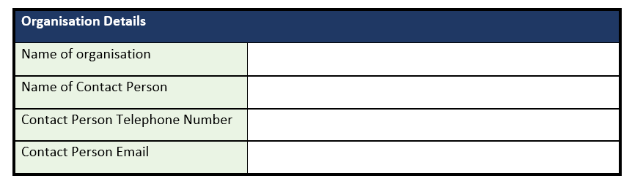

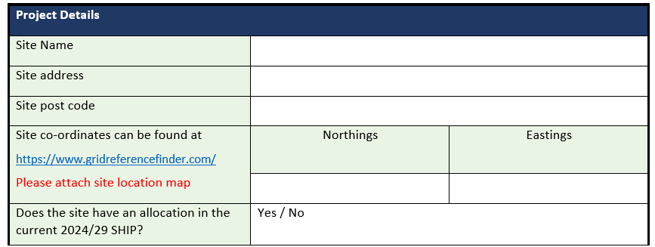

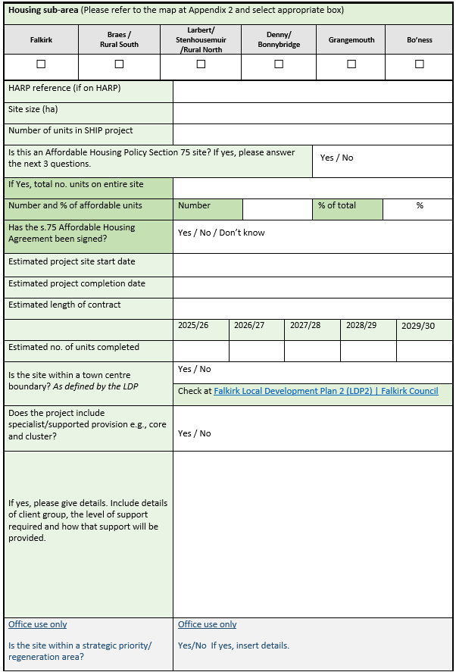

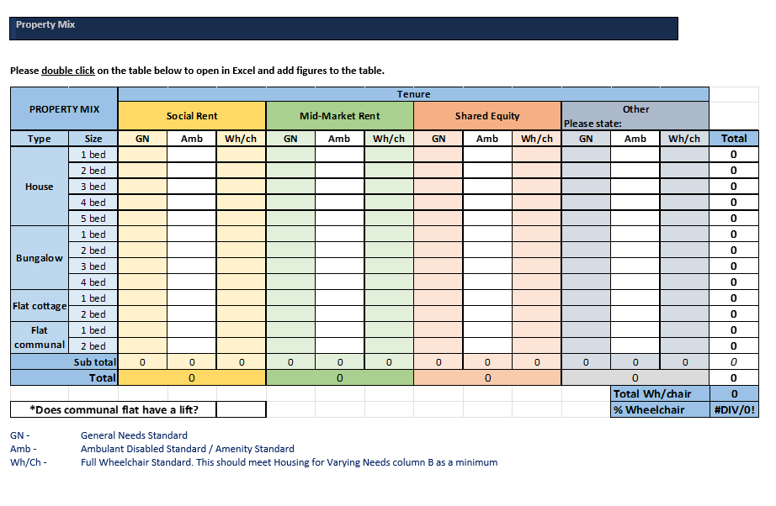

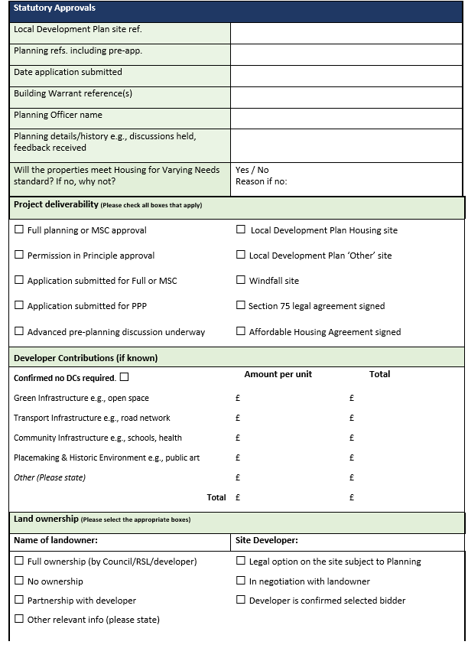

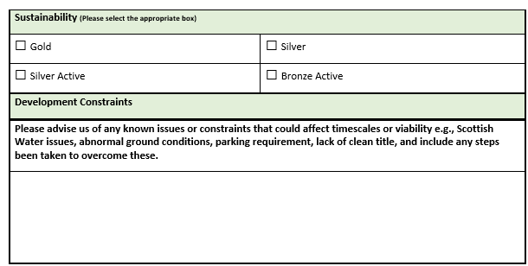

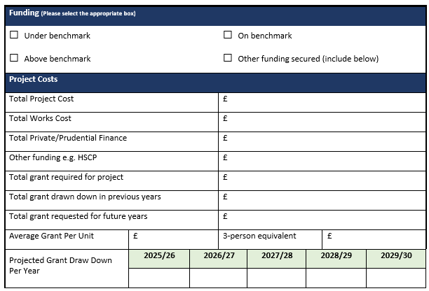

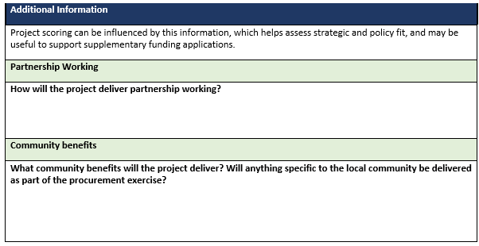

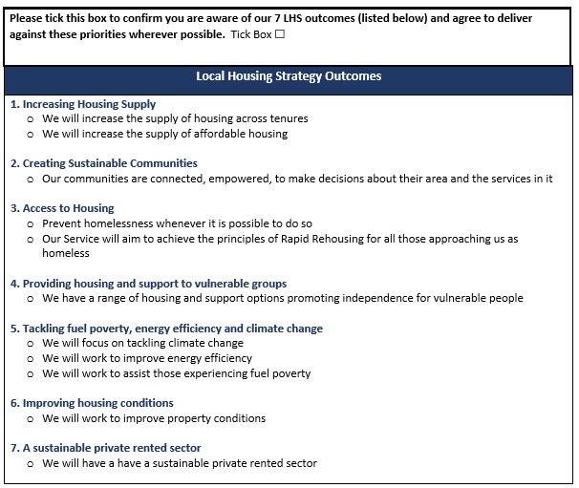

Appendix 3

**SCORING GUIDE**

**FOR INFORMATION ONLY**

Scores achieved will inform the selection of sites for the programme, along with consideration of wider strategic fit and policy decisions, to allow a balanced programme across the Council area and between Council and RSL providers.

Viable sites with an allocation in the current SHIP will normally be given priority over new sites unless they are deemed to be too expensive or cannot be guaranteed to deliver within the next 5-year period.

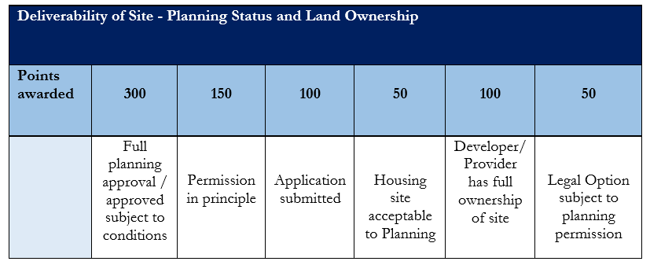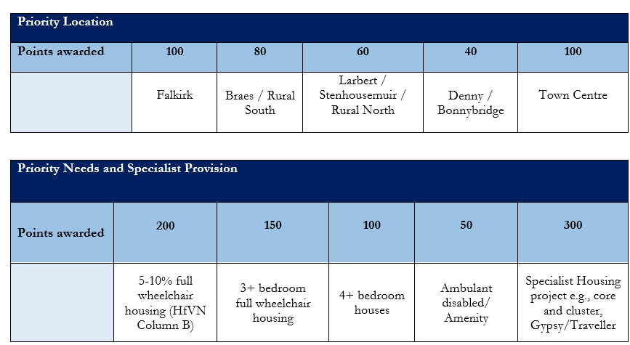

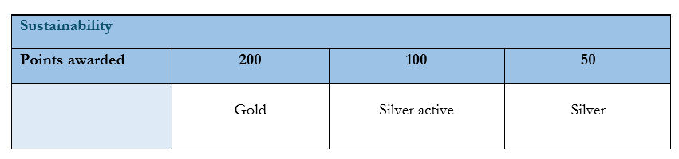

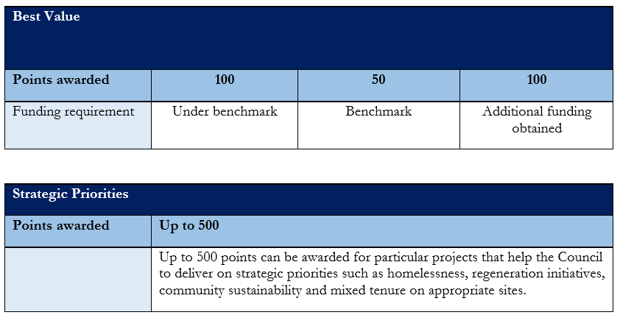

Appendix 4

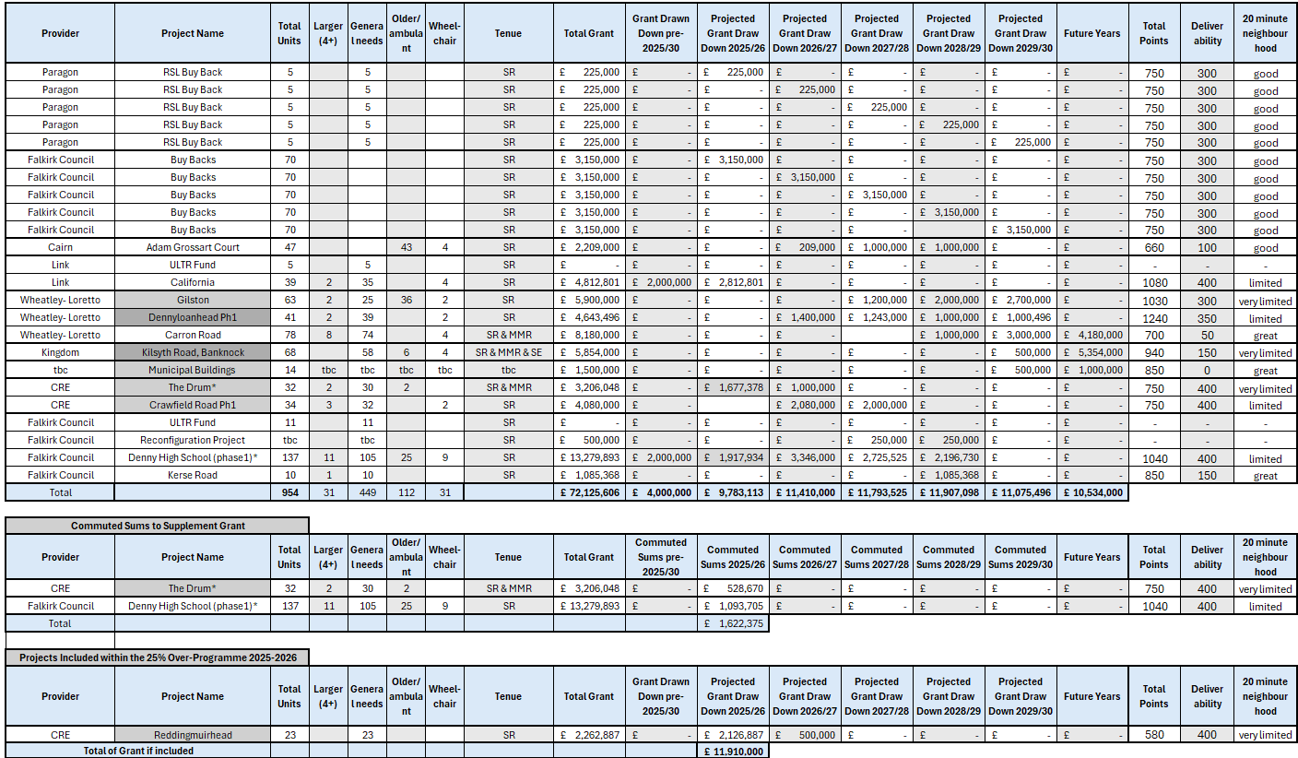

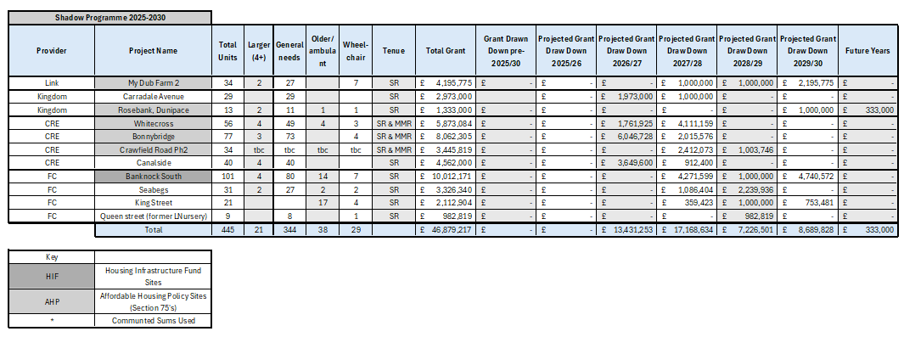

Appendix 5

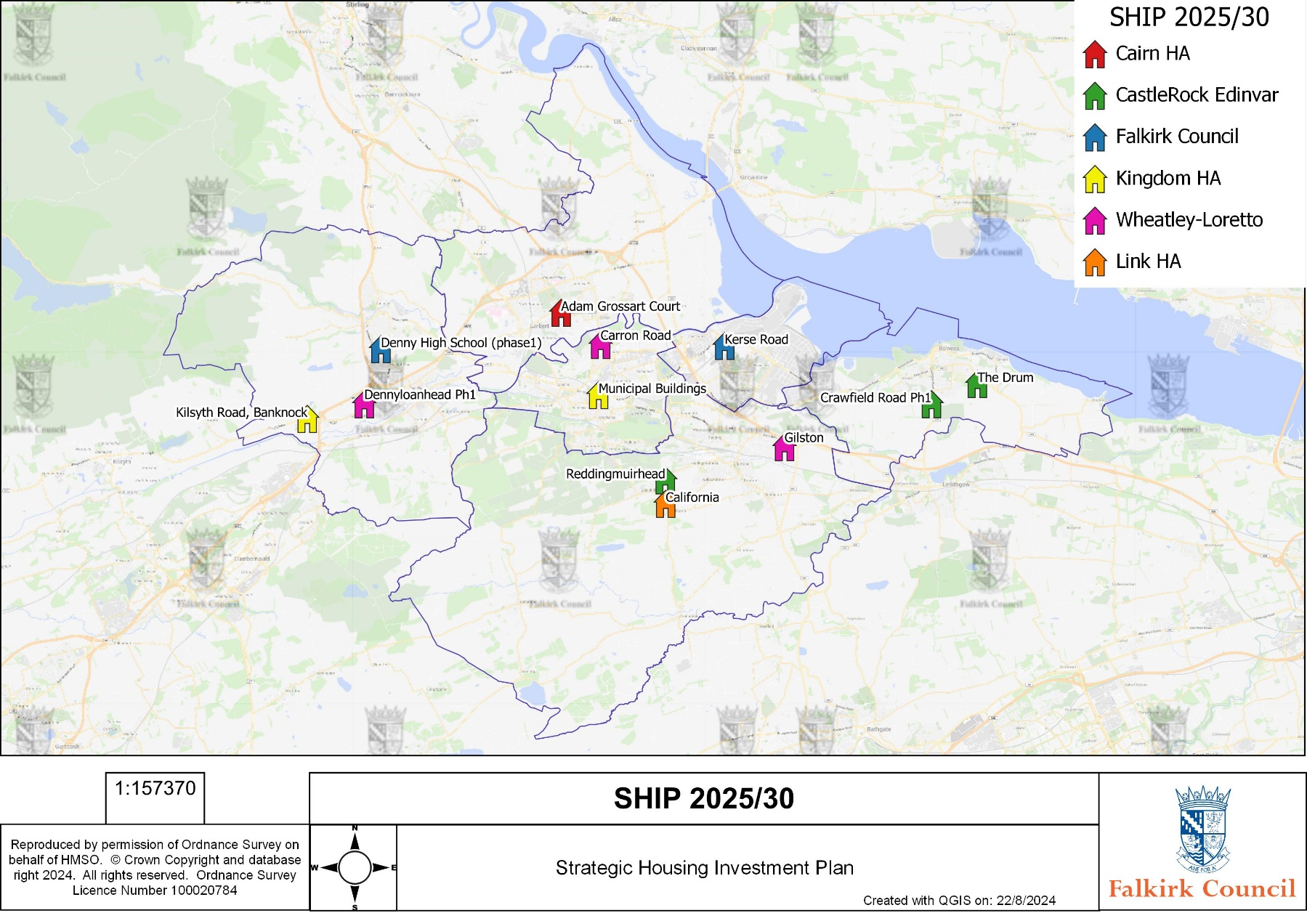

Appendix 6

|  |  |
| --- | --- |
| Table 1 | Falkirk Plan Themes |
| Table 2 | Affordable Housing Policy sites programmed to deliver 2025-2030 |
| Table 3 | Annual average need for new build additional housing 2022-2041 |
| Table 4 | Housing Supply Target 2023-2028 |
| Table 5 | SG data zones and LDP area’s |
| Table 6 | Baseline benchmarks |
| Table 7 | Commuted Sums available |
| Table 8 | 2023-2024 Completed Sites |
| Table 9 | Property Type |
| Table 10 | Property Size |
| Table 11 | Property Standard Type |
| Table 12 | projects included within the 2024-25 SHIP programme |
| Table 13 | Projects removed from the 2024-25 SHIP programme |
| Table 14 | 2025-2030 Project Unit Tenure Breakdown |
| Table 15 | 2025-30 New Build Unit Type Breakdown |
| Table 16 | properties purchased and type over last 5 years |
| Table 17 | Number of empty properties brought back into use by year and timescale empty |

Appendix 7

|  |  |
| --- | --- |
| AHSP | Affordable Housing Supply Programme |
| AHP | Affordable Housing Policy |
| HNDA | Housing Need and Demand Assessment |
| HST | Housing Supply Target |
| LDP | Local Development Plan |
| LDP SG06 | Local Development Plan Statutory Guidance 6 |
| LHS | Local Housing Strategy |
| LOIP | Local Outcomes Improvement Plan |
| NPF | National Planning Framework |
| RSL | Registered Social Landlord |
| SHIP | Strategic Housing Investment Plan |
| RPA | Resource Planning Assumption |

1. Office for National Statistics [Housing prices in Falkirk (ons.gov.uk)](https://www.ons.gov.uk/visualisations/housingpriceslocal/S12000014/)