Falkirk

Empty Homes Plan

2024-2029

Table of Contents

|  |  |  |
| --- | --- | --- |
|  |  |  |
| 1. | Introduction to Falkirk Council Empty Homes Plan | 2 |
| 1.1 | What is meant by Empty Homes? | 4 |
| 2. | The Legislative and Policy Context for Empty Homes | 6 |
| 2.1 | Statutory Requirements | 6 |
| 2.2 | The National Policy Context for Empty Homes | 7 |
| 2.3 | The Local Policy Context for Empty Homes | 9 |
| 3. | Evidencing the Need to Tackle Empty Homes in the Falkirk Council area | 12 |
| 3.1 | Profiling Empty Homes | 12 |
| 3.2 | Long Term Empty Homes | 13 |
| 3.3 | Housing Need and Demand | 17 |
| 3.4 | Affordable Housing Pressures | 17 |
| 3.5 | Homelessness | 18 |
| 3.6 | Private Rented Sector | 20 |
| 4. | Local Action, Challenges & Barriers in Tackling Empty Homes | 23 |
| 4.1 | Empty Homes Projects and Initiatives in the Falkirk Council area | 23 |
| 4.2 | Challenges and Barriers to Tackling Empty Homes | 28 |
| 5. | The Strategic Framework for Tackling Empty Homes in the Falkirk Council area | 30 |
| 6. | Monitoring Progress and Evaluating Impact | 33 |
| 7. | Consultation & Engagement Outcomes: What did Our Partners Say? | 34 |
| 7.1 | What do Residents, Partners and Stakeholders Think? | 34 |
| 8. | Empty Homes SMART Action Plan | 37 |
|  |  |  |

# Introduction

Falkirk Councilis pleased to present this Empty Homes Plan covering the period 2024-2029.

The Empty Homes Plan sets out the direction, policies, plans and activity that will enable Falkirk Counciland partners to bring as many empty homes as possible back into use. The Empty Homes Plan sets out the important contribution that tackling empty homes makes to meeting housing needs, regenerating places and communities, tackling climate change, and supporting the local economy.

The Empty Homes Plan sets out the vision of Falkirk Counciland local partners for tackling empty homes. It aligns to national priorities and housing outcomes and is embedded in the delivery of the Local Housing Strategy (LHS), which builds on the ambitious community planning objectives set out in The Falkirk Plan. The main purpose of this Empty Homes Plan is to:

* set out a shared understanding of the extent and nature of empty homes and their impact on residents, places and communities in the Falkirk Councilarea***.***
* provide clear strategic direction for partnership working and investment to tackle empty homes
* set out actions and targets to bring empty homes back into use
* provide a strong contribution to national, community planning and LHS outcomes
* set the framework to guide and coordinate partnership and delivery activity to achieve strategic aims and objectives for empty homes
* provide a clear basis to direct resources, monitor progress and measure the impact of empty homes activity.

Overall, this Empty Homes Plan seeks to:

* set a clear target for reducing the number of empty homes in the Falkirk Council area over the next 5 years
* support homeowners to bring empty homes back into use, increasing local housing options and meeting housing need
* enable regeneration, placemaking and neighbourhood improvement activity which improves community safety, environmental quality and housing condition
* make a positive contribution to the building reuse and repurposing agenda aligned to the Council’s wider ambitions for tackling climate change
* raise the profile of empty homes across the community planning and housing market partnership to maximise investment, partnership commitment and innovation in tackling empty homes.

Achievements since the last Plan

* We have moved from a part time shared service in 2013 to a full time Empty Homes Officer (EHO) in post in 2016. Since January 2019 there have been two officers in post with empty homes in their remit, as well as the operation of the Council’s buy-back scheme.
* There have been 674 empty homes brought back into use since the project began in 2013 with

£358,380 in Council Tax recovered from empty homeowners

* Elaine Hall won the Outstanding Individual award at the 2022 Scottish Empty Home Awards and the empty homes officers working with collogues nominated for the team award.
* The EHOs (Empty Home Officers) are active members of the Scottish Empty Homes Best Practice Group
* Excellent working relationships have been developed with colleagues in council tax, environmental health, building standards, social work (criminal justice) and planning.
* An Enforcement Panel Working Group has been set up and it meets quarterly. This group is made up of members of Falkirk Council staff from housing, legal, planning, and environmental health services.
* The Empty Homes Officers have a good working relationship with social work (criminal justice). Service users on community payback orders have on occasion helped cut back gardens of empty properties.

## What is meant by Empty Homes?

In developing this Empty Homes Plan, it is important that the meaning of the term ‘empty homes’ is clearly defined. In Falkirk Council area***,*** empty homes have been classified using the following definitions:

* **Long term empty properties**. These are dwellings that have been empty for 6 months or more and are liable for council tax. The most recent figures published by the Scottish Government show that there were 799 long term empty properties in the Falkirk Council area in 2022.
* **Unoccupied exemptions.** These are properties which are empty and exempt from paying council tax. The most recent figures published by the Scottish Government show that there were 1,151 unoccupied exemptions in the Falkirk Council area in 2022. There is no requirement for a property to have been empty for more than 6 months before it can be included in this category.
* **Second Homes.**Homes which are furnished and lived in for at least 25 days in a 12-month period but not as someone’s main residence. The most recent figures published by the Scottish Government show that there were 105, second homes in the Falkirk Council area in 2022.

The Empty Homes Plan focuses on long-term properties, setting out the approaches that the Council and partners will take to bring homes back into use. It should be noted that unoccupied exemptions may include properties where the previous owner has died and/or properties that have been repossessed. The Empty Homes Plan also sets out approaches for bringing properties to use.

Properties can become vacant for a variety of reasons and understanding these and the potential solutions to bring them back into use, is fundamental to tackling the challenges we face in Falkirk Council. Reasons can include:

* inheritance and ownership difficulties
* emotional attachment to a property if it has been a family home
* household ability to manage debts
* investment as an asset or future development
* unwillingness to become a Private Landlord
* need for major repairs or refurbishment and lack of resources
* planning restrictions
* the property forms part of a business

Empty homes can cause significant challenges not only for owners but also for residents, local authorities, and other relevant stakeholders. There can be significant disrepair and blight which has a negative impact on the local environment and quality of life for neighbours. This includes community safety problems, vandalism, fly tipping, arson, antisocial behaviour as well as removing viable homes from the local housing stock where there is housing need. For owners, empty homes can have considerable financial impacts in terms of lost rental income, mortgage payments, council tax, insurance, maintenance, and security. Empty Homes can therefore pose the potential for significant financial loss.

From a wider community perspective, empty homes can cause a negative appearance in terms of place, undermine regeneration efforts, prevent common works from taking place and lower the value of nearby properties. Furthermore, properties which are inactive within the housing market do not contribute to economic activity within communities and do not help with homelessness prevention or meeting housing needs.

To reduce the negative impact of empty homes within our communities, this Empty Homes Plan sets out the practical activity, interventions and partnership approaches needed to bring empty homes back into use, enabling them to become occupied.

The Empty Homes Plan can deliver significant economic and financial benefits to Falkirk Council, communities, local businesses, owners, landlords and residents by contributing to:

* enhancing housing supply to meet housing need
* reducing homelessness by increasing housing options
* achieving New Zero Targets and carbon savings through the retrofitting of existing properties as an alternative to new build
* reducing neighbourhood complaints and the avoidable deployment of public resources
* reducing requirement for Police and Fire Services to attend empty homes
* financial returns for owners realising asset value or generating rental income
* improving aesthetic appearance and sense of place within a community
* progressing common works to improve housing standards across other homes

# The Legislative and Policy Context for Empty Homes

There is a rich and diverse policy context for tackling empty homes in Scotland, which supports the delivery of empty homes activity and influences the contribution that empty homes can make to national, local and community objectives***.***

It is important that this Empty Homes Plan supports and helps deliver national housing outcomes and targets, whilst also reflecting the local needs and priorities set out by community planning and housing market partnerships.

This Strategic Empty Homes Partnership Framework is set within the wider Community Planning and housing strategy framework for the Council and its partners. The Framework defines the contribution that empty homes can make to local strategic priorities and meeting the targets set out in Scotland’s first national Housing Strategy: ‘Housing to 2040’. The national and local strategic framework that supports and enables the delivery of the Empty Homes Plan is set out in more detail below.

## Statutory Requirements

There are several statutory requirements placed on Falkirk Council***,*** with those that relate to bringing empty homes back into use, as follows:

* Local Government Finance (Unoccupied properties etc.) (Scotland) Act 2012. This allows local authorities to charge increased Council Tax on certain homes that have been empty over a year
* The Housing (Scotland) Act 2001 which places a duty on local authorities to develop a Local Housing Strategy (LHS) which set out the local authority’s and local partners’ vision for the supply of housing across all tenures and types of housing provision
* Local authorities’ duties to homeless people including a statutory responsibility to anyone threatened with, or experiencing, homelessness
* House Condition (Housing (Scotland) Act 2006, Section 10) creates duties to have in place a Below Tolerable Standard Strategy, Housing Renewal Area Policy, and Scheme of Assistance Strategy
* Tackling the effects of Climate Change – Section 44 of the Climate Change (Scotland) Act 2009
* Fuel Poverty (Targets, Definition and Strategy) (Scotland) Act 2019 introduces a new statutory target for reducing fuel poverty. The target is that by 2040, as far as reasonably possible, no household, in any Local Authority area, in Scotland is in fuel poverty; and, in any event, no more than 5% of households, in any local authority area in Scotland are in fuel poverty. No more than 1% of households in Scotland should be in extreme fuel poverty.

This legislative framework not only places powers and duties on Falkirk Council but offers mechanisms which can drive empty homes activity and intervention including enforcement action, advice, assistance and investment.

## The National Policy Context for Empty Homes

The national policy context places the empty homes agenda within a framework of strategic ambitions around housing, place, community, net zero and the Scottish economy. Whilst there are currently no statutory requirements for local authorities regarding empty homes, the Scottish Government is keen to encourage empty homeowners to bring properties back into use and, to increase affordable housing supply in Scotland to tackle shortages in this sector.

There are currently eleven National Outcomes describing what the Scottish Government wants to achieve, relating to

* Children and Young People
* Economy
* Fair Work and Business
* International
* Communities
* Education
* Health
* Poverty
* Culture
* Environment
* Human Rights.

By proactively tackling empty homes and bringing them back into use, the Council and partners can contribute to delivery of several National Outcomes in the Falkirk Council area.

**Table 2.1: Empty Homes impact on achieving National Outcomes**

|  |  |
| --- | --- |
| National Outcome | Empty Homes Contribution |
| Communities: We live in communities that are inclusive, empowered, resilient and safe | Tackling empty homes improves community safety, encouraging greater levels of resident occupation to reduce security risks and enhance neighbourhood quality. |
| Fair work and business: We have thriving and innovative businesses, with quality jobs and fair work for everyone | Empty homes can contribute to fair work and local business agendas through job creation, spending on materials and resources, learning and development of a skilled workforce and increasing the number of households accessing services and amenities. |
| Economy: We have a globally competitive, entrepreneurial, inclusive, and sustainable economy | Assisting and enabling empty homeowners to bring their properties back into use, provides greater housing choice, improves the aesthetic appearance of communities, and can contribute to making communities more robust and resilient through investment, job creation and greater local spend. |
| Environment: We value, enjoy, protect, and enhance our environment | Refurbishment and retrofitting have significantly less impact on the environment and carbon emissions than new build housing activity. Empty homes can contribute to increasing housing choice and supply whilst reducing the impact on consumption and production.  Bringing empty homes back into use safeguards properties at risk by allowing works to be carried out not only for that property but others where there are communal repairs. Ensuring properties are protected and lived in increases housing supply and provides a better environment for those who wish to live in communities in the future. |
| Poverty: We tackle poverty by sharing opportunities, wealth, and power more equally | Empty homes that are brought back into use can contribute to increasing the supply of affordable housing and therefore assist in tackling the poverty agenda. |

Empty homes have a significant role to play in helping to deliver the right homes, in the right places for people across Scotland. The Scottish Government’s Housing to 2040 strategy sets an ambitious vision of what housing should look like over the next two decades and a plan on how to achieve this vision. Bringing empty homes back into use will help deliver all priorities set out in the Housing to 2040 strategy as follows:

1. **Tackling empty homes can support delivery of *‘More homes at the heart of great places’* by:**

* Helping to meet demand for affordable housing in areas of most need
* Contributing to the regeneration and revitalising of town centres, villages, and rural communities

1. **Tackling empty homes can support delivery of ‘*Affordability and choice*’ by**

* Contributing to the Scottish Government’s ambitions of delivering 110,000 affordable homes over the ten-year period 2021/22 to 2031/32
* Ensuring as wide a range as possible of property types and tenures across Scotland

1. **Tackling empty homes can support delivery of *‘Affordable warmth and zero emissions homes’* by:**

* Helping to drive down carbon emissions caused by housing and housing construction
* Assisting with reduced heating and operational carbon emissions through retrofitting for improved energy performance

1. **Tackling empty homes can support delivery of *‘Improving the quality of all homes’ by:***

* Supporting the renovation of empty homes and returning them back to use
* Improving the quality of housing stock and the aesthetic appearance of neighbourhoods

Furthermore, the new National Planning Framework 4 (NPF4)[1] Policy 9 ‘Quality Homes’, encourages the delivery of homes across different tenures and by a range of providers. In doing so, it places an emphasis on sustainability and opportunities for tackling climate change, as well as adopting the approach of building reuse. NPF4 therefore promotes the sustainable reuse of buildings such as empty homes.

Within NPF4 Policy 9 ‘Quality Homes’ there is recognition and encouragement for a significant contribution to housing targets to be made by existing empty homes, or buildings not currently used for residential purposes, being returned or converted to use as homes. This provides an opportunity to consider how bringing housing back into effective use through remodeling and rehabilitation of existing properties could be promoted through the Falkirk CouncilLHS and Local Development Plan.

## The Local Policy Context for Empty Homes

Community planning focuses on the collective efforts of partners to target activity and resources to reduce inequalities and add maximum value to each community in the Falkirk Council area***.***

The vision for the Falkirk Plan 2021-2030 follows six themes:

1. Working in Partnership with Communities

2. Poverty

3. Mental Health and Wellbeing

4. Substance Use

5. Gender-Based Violence

6. Economic Recovery

**Working in Partnership with Communities**

Properties that have been empty for many years can have a negative impact on a street and the surrounding community especially if it looks neglected, has an overgrown garden and the owner does not visit the property. In some cases, it can become a target for antisocial behavior and vandalism, and this has been the case for a few empty properties locally. It is important that the empty homes officer engages with the owner of an empty property but also with neighbours, Council Members, and the community in general to keep them updated.

**Poverty**

There are many people who are struggling to find an affordable and secure home to rent or buy in the Falkirk area, while properties that could be their homes are lying empty. Bringing these empty properties back into use can increase the housing options in the area.

**Mental Health and Wellbeing**

Bringing an empty property back into use is important for people who live in the same street as an empty home and whose physical and mental health can be adversely affected as the condition of the house deteriorates and it becomes the focus of ant-social behaviour.

**Economic Recovery**

For each empty home brought back into use there will be a benefit. This means that another household whether they are providing an essential service through their work, going to local shops, cafes, pubs, and leisure facilities, or carrying out work on the property using local builders and contractors they are supporting the local economy. Scottish Government figures show that every £1 spent on renovating property in Scotland generates £1.60 for the economy[2].

**Local Housing Strategy**

The Falkirk Council area Local Housing Strategy (LHS) is at the heart of the arrangements for housing and planning through its links with the Local Development Plan and its strategic role in directing investment in housing and housing related services.

The LHS sets out a strategic vision for the delivery of housing and housing services and the outcomes that partners are seeking to achieve to meet housing needs. The Strategy sets out the approach to increasing housing supply, meeting housing need and demand, preventing and alleviating homelessness, delivering specialist housing, improving private sector housing condition and energy efficiency, addressing fuel poverty, and delivering the housing contribution to meeting net zero targets. More specifically it defines empty homes as a key area for action, partnership and investment.

The vision for the new Strategy is based on the findings from the HNDA, and LHS consultation findings.

***Local Housing Strategy Vision***

*Working in partnership to ensure everyone has access to good quality housing in safe sustainable and connected communities.*

There are 7 outcomes, and they are listed below:

*Priority 1 – Increasing housing supply*

*Priority 2 – Creating sustainable communities*

*Priority 3 – Improving access to housing*

*Priority 4 – Providing housing and support to vulnerable groups*

*Priority 5 – Tackling fuel poverty, energy efficiency and climate change*

*Priority 6 – Improving housing conditions.*

*Priority 7 – Creating a sustainable private rented sector*

Effectively tackling the problem of empty homes impacts on all the outcomes. It can increase the housing supply in the area by bringing properties back into use. It is fundamental to delivering Priority 2 which is looking at creating sustainable communities. One of the outcomes within this theme is to make best use of existing stock and within this outcome are the following actions related to empty homes:

* We will explore grants to improve empty homes property conditions
* Develop procedures for dealing with longer term empty homes or those impacting on the local community
* We will explore a range of methods to promote the empty homes project
* We will explore purchase of homes by Falkirk Council and RSL (Registered Social Landlord) partners homes which are currently empty

In terms of improving access to housing, bringing empty homes back into use as private rented or putting them up for sale increases the housing options for local people looking for accommodation. If the empty property is an ex-council property, the council will consider it for the buyback scheme which will increase the number of affordable properties in the area.

Tackling fuel poverty, energy efficiency and climate change is also a priority for the council. Research has found that by reusing empty homes an initial saving of 35 tonnes of carbon dioxide (CO2) per property could be made by removing the need for the energy locked into new build materials and construction[3].

The LHS also addresses improving housing conditions in the private sector. The Scheme of Assistance has been developed to support owners in improving and repairing their homes. This enables Falkirk Council to offer owners access to a wider range of information and advice to help them meet their responsibilities for the repair and improvement of their homes.

Consultation for the Local Housing Strategy 2023-2028 highlighted that empty homes are a priority for people, with 79% of respondents to the main LHS survey saying they thought it was very important that empty homes are brought back into use.

# Evidencing the Need to Tackle Empty Homes in the Falkirk Council area

This Empty Homes Plan has been informed by a clear understanding of the extent and nature of empty homes across the Falkirk Council area and their impact on neighbourhoods, communities, homeowners, and local residents. To achieve this, a robust evidence base has been developed by the Council and partners detailing the number and types of empty homes across the Falkirk Council area**,** as well as important contextual information on tenure estimates, unmet housing need, the incidence of homelessness, the role of the private rented sector and housing condition and quality issues.

This evidence base provides us with a strong understanding of the scale of empty homes as well as the challenges faced in bringing them back into use. This analysis is crucial to informing our decisions on how partnerships, investment and innovation should guide empty homes activity and interventions. Our analysis of empty homes arising from this evidence, is detailed below:

## Profiling Empty Homes

Table 3.1 details the scale of ineffective housing stock in the Falkirk Council area, providing a helpful measure of the number of homes which are not in use and do not contribute to meeting housing needs on a permanent basis. It shows that empty homes, both “long term empty dwellings” and “dwellings with unoccupied exemptions”, account for 2.4% of all dwellings in the Falkirk Council area, compared to 3.3% nationally.

Table 3.1: In-effective Housing Stock Scotland

|  |  |  |  |  |
| --- | --- | --- | --- | --- |
| Ineffective Housing Stock | Falkirk Council  No. | Falkirk Council % | Scotland  No. | Scotland  % |
| Occupied Dwellings | 74,063 | 97.5% | 2,562,668 | 95.8% |
| Second Homes | 101 | 0.1% | 23,990 | 0.9% |
| Long-term Empty Dwellings | 751 | 1.0% | 43,766 | 1.6% |
| Dwellings with Unoccupied Exemptions | 1,027 | 1.4% | 44,569 | 1.7% |
| Total Dwellings | **75,942** | **100%** | **2,674,993** | **100%** |

Source: NRS (National Records Scotland) Household Estimates published June 2022

Chart 1 shows the tenure estimates for all local authorities in Scotland. It highlights that Falkirk has one of the highest rates of owner occupation at 66%, only three other local authorities have a higher percentage of owner occupation. In terms of the amount of vacant and second homes, Falkirk has a lower rate at 2.4% than the Scottish average of 3.3%, 22 other local authorities have a higher rate than Falkirk.

**Chart 1: Tenure estimates by local authority area 2019**

This is a bar chart which shows the overall stock for each of the 32 local authroities split between local authority, housing Association, Private Rent, Owner Occupier and vacant dwellings


Source: Scottish Government Housing Statistic for Scotland 2020 & 2021

The housing tenure split in the Falkirk Council area in comparison to the national pictureis detailed in Table 3.2. It highlights that compared to the national figure, there is a higher rate of owner occupation in Falkirk and also local authority stock but there is a lower percentage of private rented sector and RSL stock. In terms of empty properties, there is double the percentage of empty properties in Scotland compared to Falkirk.

**Table 3.2: Tenure Split by Local Authority and Housing Market Sub-Area**

|  |  |  |  |  |  |
| --- | --- | --- | --- | --- | --- |
| Geography | % Local Authority Housing Stock | % RSL Housing Stock | % PRS Housing Stock | % Owner Occupied Housing Stock | % Vacant Dwellings & Second Homes |
| Falkirk | 22 | 5 | 9 | 62 | 2 |
| Scotland | 12 | 11 | 14 | 59 | 4 |

Source: NRS Household Estimates published June 2022

## Long Term Empty Homes

Table 3.3 illustrates the number of long-term empty properties in the Falkirk Council area***,*** detailing where long-term empty homes are concentrated. It also highlights the number of empty properties as a percentage of overall stock.

When the number of empty properties is looked at as a percentage of the overall stock, the Bo’ness are has the highest percentage of long term empty properties. The Falkirk area has the second highest percentage of empty properties. This area has the highest number of properties and households and has also a high number of flatted properties.

**Table 3.3: Number and Percentage of Local Authority Long-term Empty Homes by Housing Submarket Area**

|  |  |  |  |
| --- | --- | --- | --- |
| Housing Sub-Market Area | Long Term Empty homes | Total stock | % long-term empty homes |
| Bo’ness | 83 | 7,023 | 1.18% |
| Braes & Rural South | 125 | 12,169 | 1.03% |
| Denny & Bonnybridge | 108 | 11,291 | 0.96% |
| Falkirk | 198 | 18,238 | 1.09% |
| Grangemouth | 90 | 8,474 | 1.06% |
| Stenhousemuir, Larbert & Rural North | 84 | 11,536 | 0.73% |
| Falkirk Total | 688 | 68,731 | 1.00% |
| Scotland | 43,766 | 2,674,993 | 1.64% |

Source: Falkirk Council, Council Tax data (March 2024)

The map below highlights the location of the long-term empty properties by housing submarket area and shows they are found within all six areas but mainly within the larger settlements.

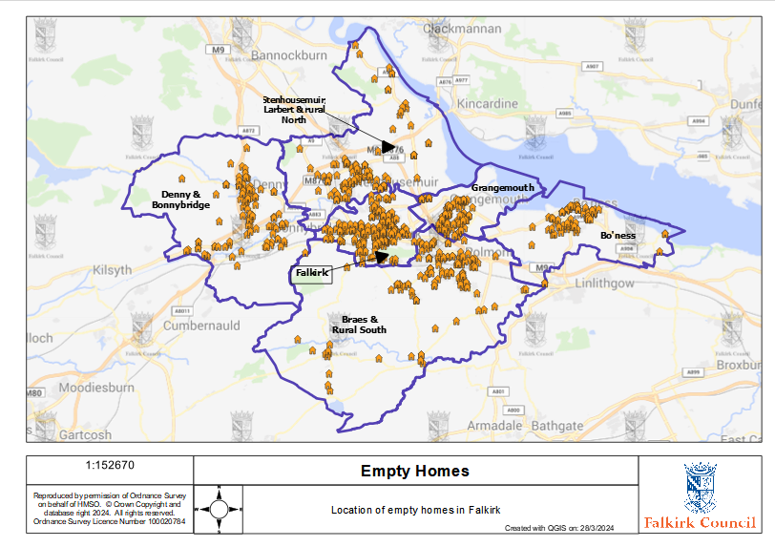

Table 3.4 details the proportion of empty homes within each Council Tax Band in the Falkirk Council area and shows that the lower the band the higher the percentage of empty properties. There may be several reasons for this. It may be that owners think there is little return on spending money on refurbishing empty properties to bring them back into use to either sell or rent. It suggests most empty properties are smaller and more likely to be flatted accommodation. If they are flatted properties, there may also be issues with communal repairs.

**Table 3.4: Percentage of Empty Properties by Council Tax Band**

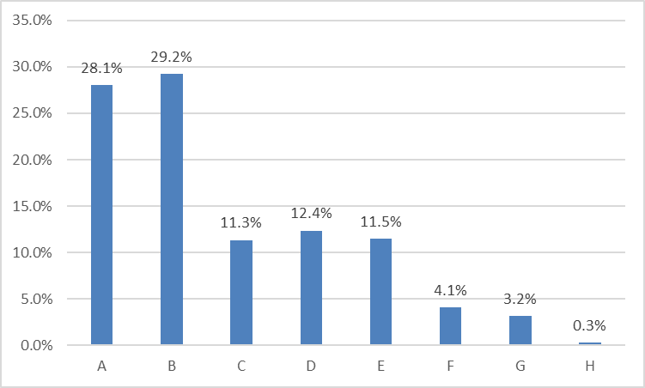

Source: Falkirk Council, Council Tax Data May 2023

Chart 2 shows the timescale for properties being empty and highlights that the majority (64%) of properties have been empty for less than two years. There is a substantial number of properties that have been empty for longer than 5 years at 17%. The longer a property is empty the more difficult it is to get the owner to engage and the more likely it is that the condition of the property has deteriorated, which will mean it needs more work to bring it back into use.

**Chart 2: Empty Property Timescales**

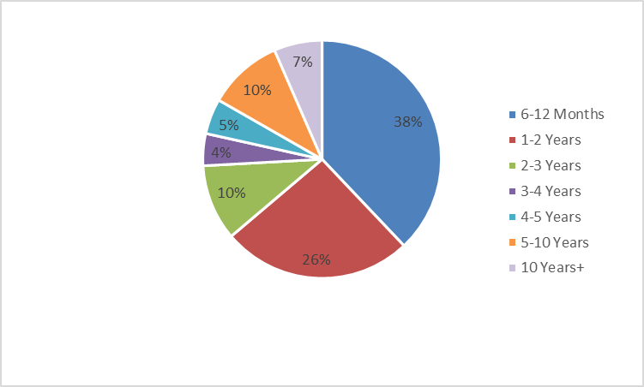

Source: Source: Falkirk Council, Council Tax Data March 2024

While unoccupied exemptions include properties which are empty and unfurnished for less than 6 months, and some other homes empty for less than six months; the term also covers properties that are empty due to the owner being in long term care, the property being repossessed, and the death of a previous owner. A breakdown of the reasons why unoccupied properties is exempt from council tax in the Falkirk Council area provides an indication of the likelihood of the property returning to use or remaining empty without EHO intervention. To explore this, Table 3.5 details the number of empty homes by exemption category in the Falkirk Council area. The main reason for unoccupied exemptions is because of a deceased owner and this makes up just over 81% of all exemptions.

If an owner dies intestate and no executors have been appointed to deal with the estate this can mean a property is empty for a considerable amount of time as in many cases this results in family disputes which can take years to resolve, if at all. In some cases, family members may have an emotional attachment to the property, and it can take them time to first clear the property and then sell the property.

**Table 3.5: Exemption Classifications**

|  |  |  |
| --- | --- | --- |
| Property Description | No. | % |
| Dwellings last occupied by persons living or detained elsewhere | 56 | 14.3% |
| Deceased owners | 320 | 81.6% |
| Dwellings for occupation by ministers | 5 | 1.3% |
| Repossessed dwellings | 5 | 1.3% |
| Dwellings of people in prison | 6 | 1.5% |
| Total | **392** | **100%** |

Source: Falkirk Council, Council Tax Data March 2024

## Housing Need and Demand

Table 3.6 sets out important evidence of the extent and nature of housing pressure in the Falkirk Council areaand emphasises the important role of empty homes activity in increasing housing supply to meet housing need and demand. Information from the latest Housing Need & Demand Assessment (HNDA) sets out the scale of housing estimates for both affordable and market housing as a starting point for the number of new homes needed over the next 20 years in the Falkirk Council area.

It highlights that in the first 5 years of the HNDA, it is estimated that an additional 466 new build properties are needed annually, 224 of them affordable and 242 market housing. This compares with the 700 properties that are empty at any time in the Falkirk area and could help meet the housing need in the area.

**Table 3.6: HNDA Annual Housing Estimates for Market and Affordable Housing**

|  |  |  |
| --- | --- | --- |
| Years | Market Housing Requirements | Affordable Housing Requirements |
| 1-5 | 242 | 224 |
| 5-10 | 208 | 194 |
| 10-15 | 203 | 153 |
| 15.-20 | 183 | 133 |

## Source: HNDA 2022

## Affordable Housing Pressures

Table 3.7 further details the extent of pressure placed on the current supply of affordable housing in the Falkirk Council areaby illustrating the expressed need for housing relative to the number of homes that become available to local households each year. On average in Falkirk there are 8.4 applicants per let. Table 3.7 highlights that the Stenhousemuir, Larbert & Rural north area has the highest pressure with 12.2 applicants per let, whereas Grangemouth has the lowest pressure with 7.3 applicants per let. This highlights the need to bring empty properties back into use particularly in the Stenhousemuir, Larbert and Rural North area. This area has the highest house prices and the highest private rents, which should act as an incentive for owners to bring their properties back into use.

**Table 3.7: Housing Pressures**

|  |  |  |  |  |
| --- | --- | --- | --- | --- |
| Area | No. Social Rented Units | No. Available Lets per Annum | No. Applications on Housing Register | Ratio of housing applicants to annual Lets |
| Bo’ness | 1,481 | 89 | 855 | 9.6 |
| Braes & Rural South | 2,514 | 144 | 1,336 | 9.3 |
| Denny & Bonnybridge | 2,965 | 204 | 1,541 | 7.6 |
| Falkirk | 5,244 | 387 | 3,018 | 7.8 |
| Grangemouth | 2,480 | 204 | 1,485 | 7.3 |
| Stenhousemuir, Larbert & Rural North | 1,974 | 96 | 1,167 | 12.2 |
| Falkirk Total | **16,658** | **1,124** | **9,402** | **8.4** |

Source: Falkirk Council Information Systems

## 

## Homelessness

Falkirk Councilhas a statutory duty to prevent homelessness wherever possible and to mitigate the impact of homelessness where it cannot be prevented. The Council’s Rapid Rehousing Transition Plan (RRTP) sets out a framework for transforming homelessness services in the Falkirk Council area including work around enhancing housing options and the role of empty homes in improving housing access.

Table 3.8 sets out the scale of homeless applications in the last 5 years detailing the extent of households experiencing housing crisis. It highlights that for both Falkirk and nationally the picture is one of fluctuating applications, although the last 3 years in Falkirk has seen a steady increase in presentations. Increasing homeless applications increases the pressure on temporary accommodation and the need for more permanent accommodation.

**Table 3.8: Homeless Applications per annum**

|  |  |  |  |  |  |  |
| --- | --- | --- | --- | --- | --- | --- |
|  | 2017/18 | 2018/19 | 2019/20 | 2020/21 | 2021/22 | 2022/23 |
| Local Authority | 1,116 | 1,010 | 1,164 | 1,073 | 1,142 | 1,201 |
| Scotland | 35,559 | 36,778 | 37,060 | 34,286 | 35,230 | 39,006 |

Source: Scottish Government Homelessness Statistics

As shown in Table 3.9, “Asked to leave” has consistently been one of the main reasons for homeless applications in the last 5 years however, this is closely followed by “dispute within household: violent or abusive” which was the highest presenting reason in 2020/21. This can be partially attributed to Covid-19 pandemic and associated restrictions, leading to more people spending time in their households.

There is a Family Mediation Service available with the aim to prevent homelessness for young

people and ensure that they have the support of their family/ relevant services if they are

moving into their own tenancy to help promote tenancy sustainment and reduce the

number of failed tenancies by young people.

**Table 3.9: Five Main Reasons for Homeless Application 2018-2023**

|  |  |  |  |  |  |  |
| --- | --- | --- | --- | --- | --- | --- |
| **Reason for Homelessness** | **2018/**  **2019** | **2019/**  **2020** | **2020/**  **2021** | **2021/**  **2022** | **2022/**  **2023** | **%** |
|
| Asked to leave | 245 | 379 | 320 | 347 | 348 | 29% |
| Dispute within household: violent or abusive | 241 | 301 | 336 | 330 | 270 | 22% |
| Other reason for loss of accommodation | 153 | 159 | 85 | 81 | 91 | 8% |
| Other reason for leaving accommodation / household | 182 | 194 | 145 | 134 | 132 | 11% |
| Dispute within household / relationship breakdown: non-violent | 114 | 73 | 128 | 139 | 152 | 13% |

Source: Scottish Government Annual Homeless Report 2022-2023

Chart 3 shows the average number of days spent in temporary accommodation over the last 5 years. The average number of days has increased by 73% in Falkirk and 22% nationally. Spending over 200 days in temporary accommodation is putting pressure on the existing temporary accommodation stock as the council tries to reduce it to pre-pandemic levels. The more properties are used for temporary accommodation means the less properties are available for homeless applicants to move on to permanent accommodation. This makes it even more important for empty homes to come back into use, especially if they are private rented accommodation to increase the housing options of homeless applicants.

**Chart 3: Average number of days spent in temporary accommodation in Falkirk compared to Scotland**

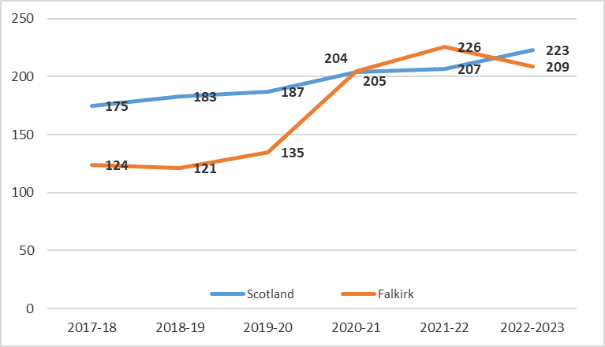

Source – Scottish Government Homelessness Statistics

**Outcomes**

The increase in the quota of lets to homeless applicants at the end of 2021 had an impact on the outcome of homeless applicants in 2021/22 as seen in chart 4. There was a 42% increase from 2020/21 in local authority lets. It also shows an increase in the number of lets by RSLs (Registered Social Landlord) in 2021/22 with a 19% increase and there was also a 28% increase in private rented lets. The increase in RSL lets in 2021/22 may be due in part to the 106 new build RSL completions in the same year. This compares to only 14 lets in 2022/23 due to the lower number of units completed.

**Chart 4: Lets to Homeless Applicants by Type of Tenancy**

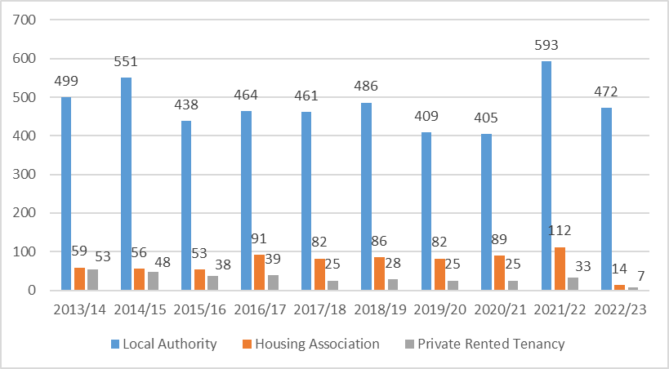

Source: Scottish Government Annual Homeless Report 2021-2022

## Private Rented Sector

Tables 3.10 and 3.11 provide an overview of the Private Rented Sector (PRS) in the Falkirk Council area, illustrating how the affordability of PRS rents compares with rents in the social housing sector. This analysis helps us to understand the role that PRS properties play in meeting housing needs locally. The Falkirk housing submarket area has the highest number of private rented properties, substantially more than any other area at 42%. This area has a higher number of properties and households than other areas and has a high number of flats compared to houses.

**Table 3.10: PRS Properties**

|  |  |  |
| --- | --- | --- |
| Area | No | % |
| Bo’ness | 592 | 9% |
| Denny & Bonnybridge | 777 | 12% |
| Falkirk | 2,663 | 42% |
| Grangemouth | 712 | 11% |
| Stenhousemuir, Larbert & Rural North | 927 | 14% |
| Braes & Rural South | 729 | 11% |
| Falkirk Council Total | **6,400** | **100%** |

Source: Falkirk Council Landlord Registration database

Table 3.11 shows the average rents by tenure and highlights that the private rented sector has the highest average rents at £160.90 a week. This is substantially more than the LHA (Local Housing Allowance) rate, which means that someone on Housing Benefit would need to find almost £30 themselves each week. It also highlights how much rent empty homeowners are losing out on each week by having a property sitting empty.

**Table 3.11: Weekly Rental Comparison**

|  |  |  |  |  |
| --- | --- | --- | --- | --- |
| Rent | PRS | Local Authority | RSL | LHA |
| Local Authority | 160.90 | 74.82 | 100.38 | 129.66 |

Source: Scottish Housing Regulator, Falkirk Council Private Rented Database, Falkirk Council Revenues

Looking at the average rent by the different housing submarket areas highlights that the highest rents can be found in Stenhousemuir, Larbert & Rural North as well as the Braes & Rural South.

**Table 3.12: Average Rent by Housing Submarket Area 2022/23**

|  |  |  |  |  |  |  |
| --- | --- | --- | --- | --- | --- | --- |
| Housing Sub Market Area | 1 Bed | 2 Bed | 3 Bed | 4 Bed | 5 Bed | Total |
| Bo'ness | £501 | £627 | £765 |  |  | £603 |
| Braes & Rural South | £467 | £692 | £865 | £1,163 | £2,200 | £688 |
| Denny & Bonnybridge | £470 | £648 | £811 | £1,417 |  | £723 |
| Falkirk | £487 | £632 | £838 | £1,525 | £1,633 | £628 |
| Grangemouth | £492 | £634 | £735 |  |  | £624 |
| Stenhousemuir, Larbert & Rural North | £499 | £711 | £875 | £955 |  | £681 |
| Total | **£487** | **£646** | **£824** | **£1,324** | **£1,775** | **£644** |

Source: Falkirk private rent database

Table 3.13 shows analysis of the landlord registration database and highlights that there has been a 4.4% fall in the number of properties available for rent in the council area. The biggest fall in properties was seen in the Bo’ness area at 10% and then the Denny & Bonnybridge area at 7%. Empty properties brought back into use could be used to increase the supply of private rented properties.

**Table 3.13: Landlord Registered properties Analysis**

|  |  |  |  |  |  |  |
| --- | --- | --- | --- | --- | --- | --- |
| Area | Aug-21  No. | Aug-21  % | Sep-22 No. | Sep-22 % | Difference 2021-2022 No. | Difference 2021-2022 % |
| Bo'ness | 656 | 10% | 592 | 9% | -64 | -10% |
| Braes & Rural South | 754 | 11% | 729 | 11% | -25 | -3% |
| Denny & Bonnybridge | 838 | 13% | 777 | 12% | -61 | -7% |
| Falkirk | 2,729 | 41% | 2,663 | 42% | -66 | -2% |
| Grangemouth | 741 | 11% | 712 | 11% | -29 | -4% |
| Stenhousemuir, Larbert & Rural North | 966 | 14% | 927 | 14% | -39 | -4% |
| Total | **6,684** | **100%** | **6,400** | **100%** | **-284** | **-4%** |

Source: Landlord Registration Database

# Local Action, Challenges & Barriers in Tackling Empty Homes

As well as evidencing the need to tackle empty homes in the Falkirk Council area, the Empty Homes Plan builds upon the activity and interventions which have succeeded in bringing empty homes back into use; as well as specific local challenges and barriers to tackling empty homes.

The Empty Homes Plan therefore builds on successes that have been achieved by projects and initiatives within the Falkirk Council area**,** as well as innovation in empty homes activity across Scotland, other parts of the UK and elsewhere as the basis of piloting or programming future activity.

## Empty Homes Projects and Initiatives in the Falkirk Council area

The following initiatives have been used to help bring empty properties back into use:

* The council has a buyback scheme for ex-council properties and has bought back 627 empty properties in the last ten years. In 2022/23 two empty properties were bought back through the scheme.
* Registered private landlords may be able to lease a property to us (Falkirk Council) through the Private Sector Leasing Scheme. Properties leased through this scheme will be used to provide temporary accommodation for homeless people. The council is keen to get owners of empty properties to take part in the scheme.
* The council has used CPO powers on two empty properties in the past and will use the powers again on properties that are structurally unsound, unsafe, or are otherwise putting communities at risk and the owner cannot be found.
* The Matchmaker Scheme aims to pair people looking to buy empty homes with owners wishing to sell them. Owners and buyers register their property or interest with the Empty Homes Officers. When a buyer and property ‘match’ both parties will be put in touch to discuss further details of the property and arrange viewings

**Case Studies**

**Case Study 1**

This property had been empty since 2014. The owner had bought the property with the intention to rent or sell it.

The owner returned a survey in 2018 informing us that they were looking for advice on renting and selling as due to family issues, it was no longer viable for them to keep the property. Advice on becoming a landlord, property condition, using accredited letting agents, how to get a home report and using reputable Estate Agents was provided to the owner.

Regular contact was kept with the owner through 2018 and 2019 with phone calls and emails but at the end of 2019 the owner stopped engaging.

By 2020 complaints about the overgrown garden and the condition of the property were being received regularly. Visits were carried out and photos taken, and these were forwarded to the owner to make them aware of the deteriorating condition of the property. The empty homes officer (EHO) continued to email and telephone the owner to advise of complaints and offer advice and assistance on how to move forward.

The owner made contact to advise them that they had been burying their head in the sand and did not want the property to be a nuisance to neighbours. The owner started visiting the property regularly to tidy the gardens and the inside of the property and started to take a keen interest in the property.

We discussed Falkirk Council’s Buy Back Scheme as the property previously belonged to Falkirk Council.

In mid-2021 the property was put on the market for sale with a local Estate Agent. The owner accepted an offer on the property shortly afterwards.

The owner thanked the EHO for their help and guidance and advised that without their support and regular check-ins they would not have got to this stage.

**Case Study 2**

The EHO was made aware of this property by a Local Member. They had received an enquiry from a local constituent advising that the property had flooded.

The EHO visited the property and spoke with the neighbours to gather further details. The owner was then tracked down and the EHO spoke with them at great length. They had gone through an extremely challenging time with a variety of family issues.

The owner was not in a financial position to renovate the property and it was left in a poor condition. This in turn was affecting neighbouring properties. All the options available were discussed with the owner and in particular selling their property at auction, this way the property could be sold in its current condition and many auction houses offer empty homeowners discounted or no upfront rates.

Details of all the auction houses were sent to the owner that works in partnership with EHOs. The owner contacted the auction houses and chose the one that best meet their needs. The property was advertised for auction and an open viewing was arranged.

Shortly before the auction the owner contacted the EHO to advise that they had been made an offer outwith the auction that they were happy to accept.

The property has now been sold and the new owner is currently renovating the property to return it to use.

Contact will be made with the new owner to advise them of available resources e.g., VAT discounts and merchants discounts.

**Case Study 3**

There were several empty properties within a block of traditionally built flats in the centre of Falkirk and they had been empty for around 20 years. The building had deteriorated over the years with part of the roof collapsing which meant several of the flats were uninhabitable and the back area had become a focus for fly tipping.

The owner of the empty properties lived abroad and after searching and using the assistance of a genealogy company, the owner was traced. The EHO worked very closely with colleagues within other services such as Council tax, Building Control, environmental health and planning over the years to monitor the property and try and find the owner.

The properties were eventually sold in 2021 and a local Letting Agent/Developer purchased the properties.

Two of the properties were demolished and the rest of the empty properties were renovated to a high specification. A new roof, windows, doors, kitchens, bathrooms, new heating systems and rewiring took place. The external blockwork was also repointed. The rear of the flats was cleared and is now used for residents parking and an area has been created to store bins. The empty homes visited the site often and was kept up to date by the Developer. The properties have now been let out for private rental.

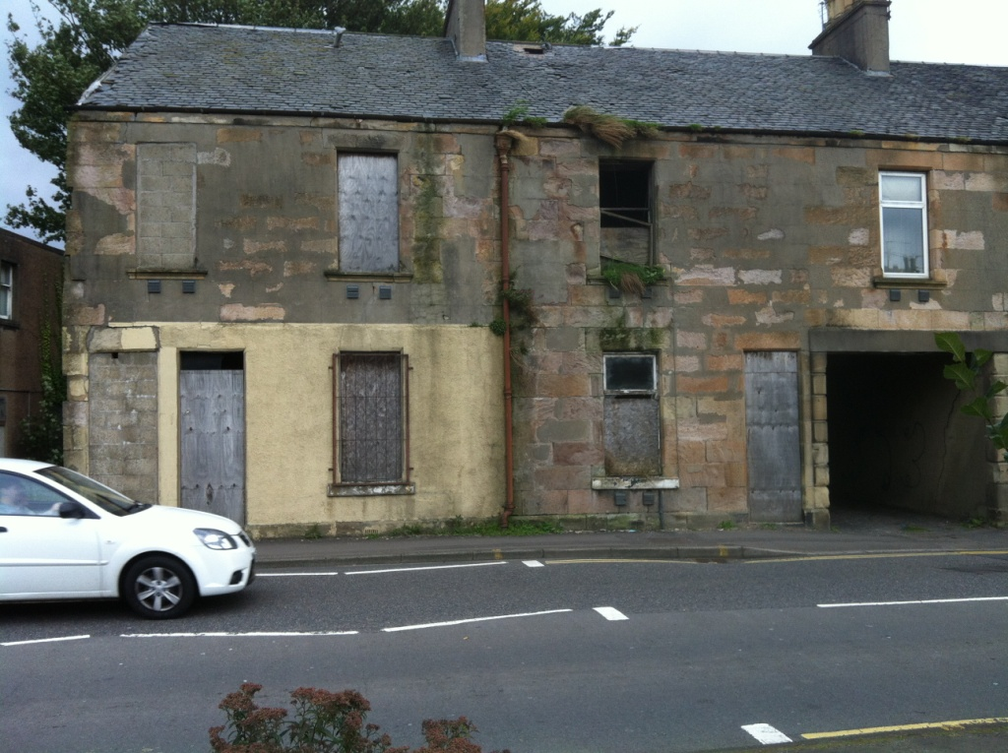

This is a picture taken of an empty block of flats after they have been refurbished with a new roof, windows and doors and new fencing


**Case Study 4**

This detached property had been empty since early 2021. The property was brought to the attention of the EHO by a Local Member. The neighbour had contacted the Local Member to complain about the condition of the property.

## The EHO contacted the owner who was elderly. The EHO worked alongside the owner’s son, providing information and assistance on selling and kept the local member and neighbour up to date with progress on the property.

## The property was sold to a Developer in February 2022 who has completely transformed the property externally and internally. The Developer advised the property would be sold in June 2023.

## This is a picture of an empty property before it's been refurbished and shows an overgrown garden

## This is a picture of an empty property once it's been refurbished

## 4.2 Challenges and Barriers to Tackling Empty Homes

There are several key challenges and barriers to tackling empty homes in the Falkirk Council area which require to be proactively addressed by the development and delivery of this Empty Homes Strategy. The key challenges include:

* **Scale and Extent of Empty Homes**. To try and get an understanding of the scale and extent of empty homes council tax records are used but there are properties that are empty but not showing up as empty on these records. Ensuring people know how to report an empty property and are aware of the team and the work they do is vitally important. There is a reporting tool available on the Council’s website and we aim to promote the service as much as possible.
* **Tracing Owners**. Trying to trace owners where no contact details are available is particularly challenging. There are a number of genealogy companies that the council use to try and find contact details of owners. If an owner moves abroad, this can be extremely challenging.
* **Relevant and Accurate Information**. We try and ensure there is accessible, relevant, and accurate information available to homeowners who want to bring empty homes back into use by mailing specific leaflets out and also having a leaflet on our website to download. A basic leaflet is sent out to all empty homeowners that are subject to the empty homes levy with the contact details of the empty home officers so they can contact them for advice and information. There are several leaflets available for empty homeowners that are sent out to them such as one on VAT discounts and one on retailer's discounts. There is also a comprehensive leaflet available to download from the website which is extensive and covers issues such as renovating a property, selling and renting a property and communal repairs. A leaflet was developed for Council Members, and it was sent to them after the last local election to make them aware of the team and the work they do as well as how to contact them.
* **Vandalism & Antisocial Behavior**. Properties that have been empty for some time are subject to vandalism and can cause neighbourhood blight due to the deterioration of the property and overgrown gardens. These can be subject to numerous complaints from neighbours and Council members and is a particular issue with very long-term empty properties. A priority of the empty home officer is to develop good relationships with council members, environmental health, community police and neighbours in these types of cases and keep them updated.
* **Communal Repairs**. An empty property in a block of flats can cause issues particularly if the condition of the empty property is deteriorating and impacting on other flats in the block. Disputes over common repairs are relatively common for empty properties.
* **Financing Repairs.** The financing of repairs and maintenance work to bring properties back into use is a common issue and this has been exacerbated in recent years due to Covid 19, Brexit etc. and the increase in price of building materials and the shortage of trades people.
* **Lack of Engagement**. Not all empty homes owners wish to engage with Empty Homes Officers despite the offer of assistance which can be very frustrating.

These challenges have been identified through the development of the empty homes evidence base and by engaging with local partners and stakeholders involved in empty homes activity.

Some of the key local barriers to developing and implementing a strategic approach to empty homes includes:

* **Resources**. The council received funding through the Scottish Government’s Empty Homes Loan Fund but returned the funding as there was no interest from empty homeowners. This was mainly due to private rents in the area being higher than LHA rates and owners not wanting to provide the properties for the PSL scheme. The council will explore the use of a grant over the next year.
* **Legal complexities**: Challenging cases where owners cannot be traced, or ownership is in dispute can be extremely time consuming. Properties that have been repossessed can take an enormous amount of the empty home officer’s time.
* **Sharing of information**: There are no issues with sharing information between council services, but this is more of an issue in respect of lenders and solicitors who are unwilling to share information on empty properties.
* **Resource intensive activities for limited outcomes**: There are some empty properties, usually those that have been empty for some time that require a lot of work from the empty homes officer but still remain empty. There are also a number of properties where the owner is not engaging with the empty homes officer, but the property is the subject of complaints due to an overgrown garden etc.
* **Lack of awareness of empty homes work and the opportunities for advice and assistance**: Greater publicity and marketing of the work the empty homes team does is really important so the public know who they can contact and can see the great work that is being done especially if properties that are brought back into use are publicised.

# The Strategic Framework for Tackling Empty Homes in the Falkirk Council area

This Empty Homes Plan sets out how the Council and partners will work together over the next 5 years to proactively tackle the impact of empty homes on communities, neighbourhoods, homeowners, and residents across the Falkirk Council area.

To achieve this, the following aim has been set for the Empty Homes Plan:

**Work in partnership to bring 70 properties back into use each year to increase the supply of good quality housing and raise awareness of the issues surrounding empty properties.**

This aim provides the overarching vision for empty homes in the Falkirk Council area. It sets out what the Council and partners want to achieve in tackling empty homes and reflects the level of ambition agreed with delivery partners. It also reflects the strategic aim of the Scottish Empty Homes Partnership to ‘bring as many privately-owned empty homes back into use as possible’. It also reflects the Council’s priorities to increase the supply of housing, improve access to housing and improve house conditions. Bringing empty homes back into use will increase the supply of housing in the area to hopefully meet the housing needs of local people and by doing so the condition of these properties will also be improved.

The council does have some powers to ensure that private properties meet certain standards and to improve house conditions. In practice, a lot of these powers are used as a last resort, where owners cannot be encouraged to take the necessary action themselves, or where emergency repairs to dangerous buildings are needed. As part of this strategy the council will look at policies and procedures as to when the council needs to intervene to ensure empty homeowners are meeting their responsibilities.

To guide, coordinate and target empty homes activity, a number of main issues have been identified informed by local evidence and aligned to local policy priorities. These key issues also reflect the local initiatives and innovation which provide a solid foundation for future empty homes activity, as well as the specific local challenges and barriers that partners and stakeholders seek to overcome.

These key issues have been used as a basis to define the following strategic objectives, which break down the overarching aim for empty homes and offer more detail on what will be delivered, by whom and when:

**Objective 1: Identify empty properties by collecting relevant and up to date information**

The main source of information on empty properties is from Council Tax data but other sources of information include neighbours, council members and other council services. The Housing (Scotland) Act 2010 allows Local Authorities to use Council Tax information to make direct contact with the owners of empty properties.

The information from council tax is used to send out surveys to owners of empty properties. Once an owner returns the survey and highlights the assistance, they need then a case is opened for that property and contact is made with the owner.

It is important that good working relations are developed with council tax colleagues. On receiving a report of an empty property, the EHO will check council tax records. The EHO works with Council

Tax colleagues to share information and update Council Tax records, which beneﬁts the Council by maximising Council Tax income as well as by tackling empty homes.

**Objective 2: Raise awareness of empty homes in Falkirk**

Owners of empty properties are often not aware of the support available to them to help them bring their empty property back into use. Initial advice is provided on the Council’s website and owners can make further contact with the Council. The advice may be to sell or improve and let their properties and this is done through the provision of information on the cost and consequences of keeping a property empty.

The issue of empty homes will be raised using the council’s social media outlets, local media, the council’s website and through other services in the council and any external partners.

One of the main sources of information for empty homeowners is the council’s website with a dedicated Empty Homes page. There is a comprehensive leaflet for owners available for them to download as well as an empty home reporting tool.

Joint working with other Council services is essential in delivering this strategy. Planning, Environmental Health, Building Control, external agencies and members of the public all have a part to play. An understanding and commitment to tackle the issues associated with empty homes is vital.

**Objective 3: Encourage reuse through information and incentives**

Creating good quality homes is important to meet housing needs within the Falkirk area. Bringing empty homes back into use will assist in increasing housing stock. The main way the council works with owners is by providing information and advice. The council is however looking to explore the use of a grant to encourage owners to bring their property back into use.

Several options are available to owners willing to bring their empty home back into use e.g., sale on the open market, letting, leasing, improvement, conversion or Falkirk Council’s Buy Back Scheme if the property is an ex local authority property.

**Objective 4: Address empty properties which are in a state of disrepair**

The guidance to the Housing (Scotland) Act 2006 requires the Council to address the condition and quality of private housing in their area, benefiting owners and the communities they live in. Empty homes are an area that needs to be considered.

The 2006 Act and continuing powers under the Housing (Scotland) Act 1987 gives the Council a range of options to ensure empty houses are well maintained and in good condition but in all cases, in the first instance, Falkirk Council seek to work with owners to achieve solutions to bringing their properties back into use.

Falkirk Council will only consider enforcement action where all other options have been looked at and as a last resort. The council will look to see if it is appropriate and value for money before it is used. Only where a property is structurally unsound, unsafe, or is otherwise putting communities at risk and the owner cannot be found will a Compulsory Purchase Order (CPO) be considered. There are regular Enforcement Panel meetings which is a multi-agency decision making group. Any enforcement action the Council decides to take will need to be agreed to by this group.

In order to deliver this aim and strategic objectives, a schedule of activities, projects and initiatives has been developed into an Action Plan, enabling partners to bring empty homes back into use over the next 5 years. This Action Plan has been developed in collaboration with local partners and stakeholders who will support implementation, monitoring and evaluation of empty homes activity.

# Monitoring Progress and Evaluating Impact

The actions scheduled under each strategic objective have been developed into the detailed Action Plan in Chapter 7, which sets out specific timescales, resources, and partner responsibilities to guide implementation and delivery. This Action Plan provides a strong basis for monitoring progress in implementing the Empty Homes Plan on a regular basis.

A range of indicators have been developed to measure impact over time aligned to delivery timescales. The Action Plan therefore provides a basis for evaluating the longer-term impact of activity, partnership, and investment in tackling empty homes. These indicators will be reported on through the LHS update which is presented at Executive in October of each year.

Table 7.1 highlights the different indicators that will be measured and reported annually through the LHS update.

**Table 7.1: Indicators, Baselines and Targets**

|  |  |  |
| --- | --- | --- |
| Indicator | Baseline 2022/23 | Target |
| Number of properties brought back into use | 63 | 70 |
| Number of empty homes visits carried out | 200 | 500 |
| Number of owners contacted for action updates annually | 188 | 100% of empty property owners contacted annually for action updates |
| Number of people reporting empty homes through online reporting tool | 20 | 30 |
| Number of leaflets sent out to empty homeowners | 366 | 500 |
| Number of empty homes surveys sent out to owners annually | 0 | 100% of all empty home owners surveyed annually |
| Number of articles and social media posts to promote the empty homes team | 2 | 6 |
| Number of empty homes which have been brought into use as affordable housing | 8 | 10 |

**7. Consultation & Engagement Outcomes: What did Our Partners Say?**

Consultation on developing the Empty Homes Plan was delivered to ensure that residents, partners and stakeholders had an opportunity to influence and have their say on the future strategy for tackling empty homes in Falkirk***.*** As a result, the Empty Homes Plan reflects the local needs and experiences of residents and communities, as well as the views of partners and stakeholders on the development of priorities and actions.

Insert details of consultation activities carried by tailoring the following sample text to detail the

To maximise participation the Council’s new digital engagement platform called Participate+ was used. The platform has been designed to provide a space for people who live, work in, or visit the Falkirk area to be actively involved in local decision making. There are just over 6,500 registered users for the platform. To ensure as many people as possible were aware of the consultation a link was sent to the following groups:

* Current empty home-owners with an email address
* Community Councils
* Citizens Panel, which is a panel made up of local people of all ages who have volunteered to complete regular online questionnaires about Council services and the local issues that affect them and their area
* Internal contacts – Legal, Environmental Health, Revenues and Housing
* Council Members
* Housing Consultation Register participants.

The plan was uploaded on to the platform for 8 weeks and was made public so it appeared on the front page of Participate + so anyone could respond to the 7 questions which are listed below:

1. Is it clear why we should spend time and money on bringing empty houses back into use?
2. Thinking of where you live, are there any empty houses that have been there for a long time (6 months+), and do you know why they are empty?
3. How aware are you of empty homes and the assistance empty homes officers can provide?
4. Do you agree that the best approach is to start with providing information and advice, then if this doesn’t work, start to be more proactive?
5. Do you have any suggestions for other actions we could include in our action plan
6. Which action/s do you think will make the biggest difference?
7. Would you support incentives such as a grant to encourage owners of empty properties to bring their properties back into use?

Two adverts to promote completion of the survey were put on the Council’s Facebook page. Feedback on the plan was also sought from the Scottish Empty Homes Partnership.

**7.1 What do Residents, Partners and Stakeholders Think?**

There were 178 respondents in all to the survey with Table x showing the responses to the closed questions asked in the survey. It highlights that 86% of respondents are clear why the council should spend time and money bringing empty properties back into use, with only 9 respondents (5%) disagreeing.

In terms of respondents who have an empty property near where they live, 35% do and 29% don’t. The majority of respondents at 84% agree that the best approach is to provide advice and information and then be more proactive if that doesn’t work. In terms of providing incentives, 62% agree but 23% disagree with this idea.

|  |  |  |  |  |  |  |  |
| --- | --- | --- | --- | --- | --- | --- | --- |
|  | **Yes** | | **No** | | **Unsure** | | **Total** |
| **No** | **%** | **No** | **%** | **No** | **%** |
| Is it clear from the Draft Empty Homes Plan, why we should spend time and money on bringing empty homes back into use? | 153 | 86% | 9 | 5% | 16 | 9% | 178 |
| Thinking of where you live, are there any empty homes which have been empty for a long time (6 months +)? | 62 | 35% | 51 | 29% | 65 | 37% | 178 |
| Do you agree that the best approach is to start with providing information and advice, then if this doesn't work, start to be more proactive. | 150 | 84% | 17 | 10% | 11 | 6% | 178 |
| Would you support incentives such as a grant to encourage owners of empty properties to bring their properties back into use? | 111 | 62% | 41 | 23% | 26 | 15% | 178 |

Respondents were asked how aware they are of empty homes and the assistance empty homes officers can provide on a scale of 1-5 with 5 being the greatest awareness. The majority at 57% chose 1 which highlights the lack of awareness of the help the team can provide and the need for more publicity on what the team do and the support available.

|  |  |  |
| --- | --- | --- |
| **Scale** | **No.** | **%** |
| 1 | 101 | 57% |
| 2 | 27 | 15% |
| 3 | 32 | 18% |
| 4 | 10 | 6% |
| 5 | 8 | 4% |
| **Total** | **178** | **100%** |

There were two open ended questions asking for suggestions for actions to include in the plan and feedback on what actions would make the most difference. A recurring theme is the need for more public awareness through advertising and social media. Public campaigns and better communication with the public are seen as vital, with proposals for a system allowing residents to report empty homes. There is already a reporting tool on the Empty Homes page of the Council’s website but this obviously needs to be promoted more.

Other suggestions include improving infrastructure and making town centers more attractive to live in with the idea of converting empty spaces above shops into flats mentioned by a number of respondents.

Enforcement measures such as higher business rates for non-compliance were also recommended

as well as fines for owners who leave properties empty. There is also a call for the council to purchase derelict properties at reduced prices to increase their housing portfolio and there are suggestions for making the planning process less restrictive and expensive

In terms of the actions that will make the biggest difference, respondents believe that the most effective actions to address the issue of empty homes include enforcing policies to upgrade and utilize vacant properties. There is also a call for more support and incentives for private landlords to make renting more attractive as well as suggestions for financial penalties or higher rates for those who leave properties empty. Some respondents mention the use of Compulsory Purchase Orders (CPO) to change the flow of housing stock. There is also a suggestion to focus on revitalizing town centers by starting with empty premises there.

There was also a section in the survey which gave respondents the opportunity to add any other comments. Some suggested that legal and bureaucratic delays in settling estates can lead to properties remaining empty for extended periods, indicating a need for council assistance to expedite these processes. There are concerns about potential fire hazards in empty homes and suggestions for mandatory installation of fire alarms linked to emergency services. Financial incentives are a common theme, with some respondents advocating for grants or financial help to reduce redevelopment costs, while others worry that such grants could encourage owners to leave properties empty deliberately.

**7.2 How the findings from the consultation impacted the plan**

One of the main issues highlighted by the survey was the lack of awareness of the empty homes team and the work they do and the ability to report an empty property via the Council’s website. There is an action in the draft plan to promote the work of the team but there needs to be an action on exploring a range of methods to promote the empty homes project.

A number of respondents suggested converting some of the spaces above shops in the town centre to shops. There is an action in the Local Housing Strategy “We will explore conversion of former shops for housing where viable and in areas of housing need”, there needs to be an action in the empty homes plan in relation to EHOs working with other teams in the council on this action.

There are some suggestions respondents have made that the council has no control over but may be able to raise with the Scottish Empty Homes Partnership so they can lobby the Scottish Government. These are in relation to compulsory Sales Orders and also the legal and bureaucratic delays in settling estates. An action will be included in the plan to move this forward.

In terms of financial penalties for empty home owners, owners are charged double council tax if their properties are empty for more than 12 months so there are already financial penalties for leaving a property empty.

Financial incentives were a common theme from respondents to bring empty properties back into use but the use of grants need to be well thought out to ensure that owners aren’t leaving properties empty on purpose to obtain a grant.

# Empty Homes SMART Action Plan

The following Action Plan has been developed to enable the Council and partners to plan, deliver, monitor, and evaluate the impact of empty homes activity over the next 5 years. It sets a framework for partnership working and investment that reflects strategic objectives and creates a route map for delivering the aim of the Empty Homes Plan.

The Action Plan sets out a range of milestones detailing the activity associated with implementation, setting target timescales and details of the lead agency for implementation. The Action Plan, activities and targets will be reviewed annually to ensure partners are able to respond flexibly to changes in need across the Falkirk Council area.

**Objective 1: Identify empty homes by collecting relevant and up to date information**

|  |  |  |  |  |
| --- | --- | --- | --- | --- |
| **Action** | **Milestones** | **Timescale** | **Responsibility** | **Resources** |
| 1.1 Maintain empty homes database and ensure it is as accurate as possible | * Maintain and review empty homes database regularly * Continue joint working with Revenues to improve the level of accurate information collected on empty homes through the Council Tax database | **1st year** | **EHOs** | EHO Post |
| 1.2 Ensure information is gathered from a variety of sources | * Ensure online reporting form is signposted and easily accessible on the Council’s website and updated when necessary * Carry out empty homes survey annually * Continue to develop joint working with different services to identify empty properties e.g., Planning, Environmental Health, Legal Services & Revenues. * Contact the Council’s communication team to ask that they highlight the empty homes reporting function on the website through the council’s social media channels. | **1st year**  **Annually** | **EHOs** | EHO Post  Communications Team |

**Objective 2: Raise awareness of empty homes in Falkirk**

|  |  |  |  |  |
| --- | --- | --- | --- | --- |
| **Action** | **Milestones** | **Timescale** | **Responsibility** | **Resources** |
| 2.1 Increase awareness and understanding of the empty homes' issues and associated activity in the Falkirk area | * Use the Council’s Communications Team and Falkirk Council’s website to promote the empty homes team and properties brought back into use * Regularly review and update Falkirk Council’s website to provide relevant information and comprehensive advice on empty homes * We will explore a range of methods to promote the empty homes project | **1st year** | **EHOs** | EHO Post  Communications Team |
| 2.2 Ensure members of the public are able to engage with us on empty homes issues and have the mechanism to report properties | * Carry out consultation on Empty Homes Plan * Review online reporting form to ensure we are receiving relevant information * Respond to any complaints regarding empty properties | **1st year** | **EHOs** | EHO Post |
| 2.3 Improve engagement  opportunities for empty  homeowners | * Continue to develop relationships and communication with new and existing empty homes owners by telephone, email or via empty home surveys * Review Falkirk Council’s Empty Homes Leaflet and webpage regularly to make sure information is relevant and up to date * Review the Empty Homes Survey * Develop an Empty Homeowner Newsletter/Community Newsletter on Empty Homes | **1st year** | **EHOs** | EHO Post |
| 2.4 Maintain joint working with other services and stakeholders | * Continue to develop joint working relationships with internal services and external agencies to maintain the commitment to tackling empty homes * Continue to attend Enforcement Panel meetings to discuss complicated cases * Lobby the Empty Homes Partnership in relation to Compulsory Sales Orders and the legal and bureaucratic delays in settling estates. | **1st year** | **EHOs** | EHO Post |

**Objective 3: Encourage reuse through Information and Incentives**

|  |  |  |  |  |
| --- | --- | --- | --- | --- |
| **Action** | **Milestones** | **Timescale** | **Responsibility** | **Resources** |
| 3.1 Provide a range of advice, assistance, and  support to enable owners to  bring empty homes back  into use | * Review “Information on Renting” leaflet by liaising with Private Sector Team * Offer advice to empty homeowners on how to sell their property * Promote the Matchmaker Scheme | **1st year** | **EHOs** | EHO Post |
| 3.2 Bring empty homes  back into use to meet  housing need | * Explore using grants to improve empty homes property conditions * Promote the Buy Back Scheme when property is an ex Council property * Promote the Private Sector Leasing Scheme * Promote the new Rent Deposit Guarantee Scheme * Learn from best practice and innovative projects and consider feasibility of adopting pilot project * We will explore purchase of homes by Falkirk Council and RSL partners homes which are currently empty * We will work with other teams to explore the conversion of former shops for housing where viable. | **1st year** | **EHOs** | EHO Post |

**Objective 4: Address empty properties that are in a state of disrepair**

|  |  |  |  |  |
| --- | --- | --- | --- | --- |
| **Action** | **Milestones** | **Timescale** | **Responsibility** | **Resources** |
| 4.1 Ensure effective processes in place to  identify and target empty  properties in serious  disrepair or derelict | * Develop and implement prioritisation matrix for action on empty homes * Develop procedures for dealing with longer term empty homes or those impacting on the local community | **1st year** | **EHOs** | EHO Post |
| 4.2 Improve enforcement  action processes and  procedures for bringing  empty homes back into use | * Review investigation techniques and identify improved ways of working * Review enforcement action processes and procedures to ensure appropriateness and value for money * Identify the full range of enforcement action available and carry out cost benefit analysis of each option | **1st year** | **EHOs** | EHO Post |
| 4.3 Provide targeted advice  and assistance to homeowners whose  property is in serious  disrepair or derelict | * Review existing advice and information * Agree definitions for serious disrepair and derelict | **2nd Year** | **EHOs** | EHO Post |

1. National Planning Framework 4, Scottish Government, 2023

   <https://www.transformingplanning.scot/media/2832/policy-9-quality-homes-pdf-199kb.pdf>
2. Scottish Empty Homes Partnership, Annual Report, May 2022
3. New Tricks with Old Bricks (2008), The Empty Homes Agency