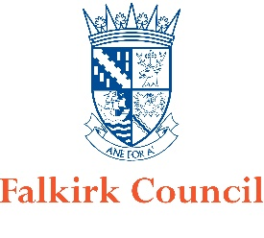
Falkirk Council For help contact
Animal Boarding Establishments Act 1963 envhealth@falkirk.gov.uk
Application to renew the licence Telephone: 01324 504982
Home Boarders

Licence Holders Details
Name

First Name

Family Name

Contact Details

Address

Address

Address

Post Code

E-Mail

Telephone Number

Premises where Animals will be Kept
Name of premises/trading name

Address

Address

Address

Post Code

E-Mail

Telephone Number

Contact Details of Person Responsible for Managing the Premises

Name

E-Mail Address

Telephone Number

Accommodation and Facilities
If there has been any alterations made to the premises or changes in the facilities provided, please enter the details in the box below.

Veterinary Surgeon
Usual veterinary Practice

Name

Address

Address

Address

Post Code

Contact Details

Name

E-Mail Address

Telephone Number

Emergency Key Holder
Name

Address

Address

Address

Post Code

E-Mail

Telephone Number

Disqualifications and Convictions
Has the person who will manage the establishment ever been disqualified from?

(a) Keeping a Riding Establishment? Yes/No
(b) Keeping a Dog? Yes/No
(c) Keeping a Pet Shop? Yes/No
(d) Having the Custody of Animals? Yes/No
(e) Keeping a Boarding Establishment for Animals? Yes/No
(f) Keeping a Breeding Establishment? Yes/No

Has the person who will manage the establishment been convicted of any offences under Animal Welfare of Wildlife Legislation? Yes/No

Has the person who will manage the establishment ever had a licence refused, revoked or cancelled? Yes/No

Authority Postal Address and E-Mail Address
Falkirk Council
Place Services
Suite 1B, Falkirk Stadium
4 Stadium Way
FK2 9EE

envhealth@falkirk.gov.uk

Declaration
I am aware of the provisions of the Animal Boarding Establishment Act 1963. The details contained in this form are correct to the best of my knowledge and belief.

Signed

Print Name

Date

