**COMMUNITY EMPOWERMENT (SCOTLAND) ACT 2015**

**FALKIRK COUNCIL ASSET TRANSFER REQUEST FORM**

**IMPORTANT NOTES:**

**This is an application form which can be used to make an Asset Transfer request to Falkirk Council.**

**Any Community Body interested in making an Asset Transfer Request is advised to contact the Asset Team on** [**strategicpropertyreview@falkirk.gov.uk**](mailto:strategicpropertyreview@falkirk.gov.uk) **before making the request so that we can discuss your proposal.**

**Please complete the asset transfer request form if the property/land is owned/leased/managed by Falkirk Council.**

**It is essential that you read the** [**Asset Transfer guidance**](https://www.gov.scot/binaries/content/documents/govscot/publications/advice-and-guidance/2017/01/asset-transfer-under-community-empowerment-scotland-act-2015-guidance-community-9781786527509/documents/00513211-pdf/00513211-pdf/govscot%3Adocument/00513211.pdf) **provided by the Scottish Government before making a request.**

**When completed, this form should be emailed to** [**strategicpropertyreview@falkirk.gov.uk**](mailto:strategicpropertyreview@falkirk.gov.uk) **or sent to**

**The Asset Team**

**Falkirk Council**

**4 Stadium Way**

**Falkirk**

**FK2 9EE**

## Section 1: Information about the Community Transfer Body (CTB) making the request

* 1. Name of the CTB making the asset transfer request

Bonnybridge Football and Sports Club

* 1. CTB address. This should be the registered address, if you have one.

Postal address: Duncan Stewart Pavilion, High Street, Bonnybridge, Stirlingshire

Postcode: FK1 1BX

* 1. Contact details. Please provide the name and contact address to which correspondence in relation to this asset transfer request should be sent.

Contact name: [REDACTED]

Postal address: [REDACTED]

Postcode: [REDACTED]

Email: byfcvice@gmail.com

Telephone: [REDACTED]

**☐** We agree that correspondence in relation to this asset transfer request may be sent by email to the email address given above. *(Please tick to indicate agreement)*

*You can ask Falkirk Council to stop sending correspondence by email, or change the email address, by telling them at any time, as long as 5 working days’ notice is given.*

* 1. Please mark an “X” in the relevant box to confirm the type of CTB and its official number, if it has one.

|  |  |  |
| --- | --- | --- |
|  | Company and its company number is …………. |  |
|  | Scottish Charitable Incorporated Organisation (SCIO) and its charity number is ……………….. | X  Charity Number SC053733 |
|  | Community Benefit Society (BenCom) and its registered number is ……………………………… |  |
|  | Unincorporated organisation (no number) |  |

**Please attach a copy of the CTB’s constitution, articles of association or registered rules.**

Please note that under The Community Empowerment (Scotland) Act 2015, where a CTB is seeking ownership rather than a lease, the organisation must have at least 20 members. See the Scottish Government’s [Guidance for Community Transfer Bodies.](https://www.gov.scot/binaries/content/documents/govscot/publications/advice-and-guidance/2017/01/asset-transfer-under-community-empowerment-scotland-act-2015-guidance-community-9781786527509/documents/00513211-pdf/00513211-pdf/govscot%3Adocument/00513211.pdf)

* 1. Has the organisation been individually designated as a community transfer body by the Scottish Ministers?

**No ☐**

**Yes ☐**

Please give the title and date of the designation order:

* 1. Does the organisation fall within a class of bodies which has been designated as community transfer bodies by the Scottish Ministers?

**No ☐**

**Yes ☐**

If yes what class of bodies does it fall within?

2 tier SCIO

## Section 2: Information about the land and rights requested

* 1. Please identify the property/land to which this asset transfer request relates.

You should provide a street address or grid reference and any name by which the land or building is known. If you have identified the land on the relevant authority’s register of land, please enter the details listed there.

*It may be helpful to provide one or more maps or drawings to show the boundaries of the land requested. If you are requesting part of a piece of land, you must attach a map and give a full description of the boundaries of the area to which your request relates. If you are requesting part of a building, please make clear what area you require. A drawing may be helpful.*

Details of Property: Duncan Stewart Park pavilion

Address: High Street, Bonnybridge, Stirlingshire

Postcode: FK1 1BX

* 1. Please provide the UPRN (Unique Property Reference Number), if known.

UPRN: 000136076460

## Section 2: Type of request, payment and conditions

* 1. Please tick what type of request is being made:

√

for ownership (under section 79(2)(a)) - go to section 3A

for lease (under section 79(2)(b)(i)) – go to section 3B

for other rights (section 79(2)(b)(ii)) - go to section 3C

3A – Request for Ownership

What price are you prepared to pay for the land requested?

Proposed price: £1.00

Please attach a note setting out any other terms and conditions you wish to apply to the request.

|  |
| --- |
| Not Applicable |

3B – Request for Lease

What is the length of lease you are requesting?

|  |
| --- |
|  |

How much rent are you prepared to pay? Please make clear whether this is per year or per month.

Proposed rent: £ per

Please attach a note setting out any other terms and conditions you wish to be included in the lease, or to apply to the request in any other way.

|  |
| --- |
|  |

3C – Request for other Rights

What are the rights you are requesting?

|  |
| --- |
| Request for additional land at the front of the property. The land will be used to install a ramp to allow disabled access. The building in its present state doesn’t allow disabled access.  Request for additional land on the right-hand side of the property, when facing the front elevation of the property. This is to enable the building to be extended in the future to add storage space for the local community groups to use.  Further details of the additional land requested is detailed in Appendix A |

Do you propose to make any payment for these rights?

**Yes ☐**

**No ☐**

If yes, how much are you prepared to pay? Please make clear what period this would cover, for example per week, per month, per day?

|  |
| --- |
| Proposed payment: £ per |

Please set out any other terms and conditions you wish to apply to the request.

|  |
| --- |
|  |

## Section 2: Community Proposal

* 1. Please set out the reasons for making the request and how the land or building will be used.

This should explain the objectives of your project, why there is a need for it, any development or changes you plan to make to the land or building, and any activities that will take place there.

|  |
| --- |
| 4.1.1 Objectives of Project  Bonnybridge Football and Sports club provides training facilities that enable the local community to enjoy and participate in football. These facilities include changing rooms, football pitches and equipment that the local community have access to. This is to enable Bonnybridge Football and Sports club the provision of recreational facilities, or the organisation of recreational activities, with the object of improving the conditions of life for people in Bonnybridge and the surrounding areas.  Repurpose Duncan Stewart Park pavilion to provide facilities for more of the local community. This will include creating a local hub building for other sporting groups and local groups to meet and socialise.  Bonnybridge Football and Sports Club has held initial discussions with local charity group Roots about using the facilities to provide services for members of the local community. The building will also be provided to the Bonnybridge Gala group to provide food and refreshments during local community events. Bonnybridge Football and Sports Club doesn’t require this as an extra revenue stream and our objective is to make the property multi-use for the wider community. If we are successful in our vision to have more local groups and sports clubs use the property, then the organisation will agree a small donation as part of the lease agreement, to cover the utility costs whilst using the facilities. |
| 4.1.2 Why there is a need for your Project?  Duncan Stewart Park and pavilion allow Bonnybridge Football and Sports Club to provide training facilities and host competitive matches as part of the Scottish Football Association player pathway scheme.  We currently use Duncan Stewart Park pavilion for the local community to use the toilets during training and matches, and for home and away teams to get changed pre and post games. We also use it to host club meetings.  Without the pavilion, we would cease to exist as a football club and the current group of 100+ participants will be without a team to play for since the SYFA does not permit matches to take place where there are no changing / toilet facilities. Further to that, we would not want our children or indeed adult coaches / spectators in a situation where they couldn’t use a toilet if required.  It will also allow us to work with other local groups and charities to offer them a facility to use for their community projects and activities. |
| 4.1.3 Will any Development/changes/modifications to the asset be required?  Bonnybridge Football and Sports Club have worked with an architect to propose a new layout for the building as illustrated in the following figure. The purpose of the new layout is to repurpose the present building footprint to enable multiuse by the wider local community and allow disabled access. The building has fell into disrepair because its only purpose was to provide changing facilities for football teams.  Ground floor layout as proposed |
| 4.1.4 What activities will take place?  Recreational facilities and organisation of recreational activities, with the object of improving the conditions of life for people in Bonnybridge and the surrounding areas; including football teams for people to train and compete in the Scottish Football Association (SFA) competitions; the operation of training grounds and pitches.  Duncan Stewart Park pavilion will offer the following range of services for the organisation, local groups and members of the community.   * Changing facilities. * Showers and toilets. * Storage facilities. * Kitchen and meeting facilities. |
| 4.1.5. If the asset is to be used by the public, please provide details of lettings policy and opening times.  Bonnybridge Football and Sports Club wish to offer the use of Duncan Stewart Park pavilion to the local community. Examples are a local hub building for other sporting groups and local groups to meet and socialise.  Bonnybridge Football and Sports Club will have volunteers that will open and close the facilities for the local community. |
| 4.1.6 What provision will be provided for people with disabilities?  As part of the modifications to the building we would like to install a ramp to allow  disabled access. The building in its present state doesn’t allow disabled access. |
| 4.1.7 Any other relevant information? |

Benefits of the proposal

* 1. Please set out the benefits that you consider will arise if the request is agreed to.

Local Authorities are permitted to dispose of property at less than market value where there are wider public benefits to be gained. This is set out in the Disposal of Land by Local Authorities (Scotland) Regulations 2010. These public benefits are listed below.

In this section, please explain how the project will benefit your community, and others. Please refer to the Scottish Government [guidance](https://www.gov.scot/binaries/content/documents/govscot/publications/advice-and-guidance/2017/01/asset-transfer-under-community-empowerment-scotland-act-2015-guidance-community-9781786527509/documents/00513211-pdf/00513211-pdf/govscot%3Adocument/00513211.pdf) on how the Council will consider the benefits of a request.

|  |
| --- |
| Please explain how the project will benefit your community by detailing how your project will promote or improve:-  4.2.1. Economic development/income generation  ie. Please include details of any job creation or **volunteering and training** opportunities that will be available as a result of the Asset Transfer. Also details of how your organisation will involve the **local community** and of any incentives that may be available to encourage the local community to use the proposed services.  The asset transfer of Duncan Stewart Park pavilion will allow Bonnybridge Football and Sports Club to continue our main objectives of providing football teams for people to train and compete in the Scottish Football Association (SFA) competitions, and the operation of training grounds and pitches.  All of our SFA coaches are volunteers. It is envisaged we will require more volunteer coaches for our future vision of increasing the number of football teams associated with our organisation.  Bonnybridge presently work with schools in the local area to advertise and increase the number of youths who are participants of our club. This will generate extra income for our charitable organisation to fulfil and enhance our services for the local community.  Duncan Stewart Park pavilion is planned to offer the following range of services for the organisation, local groups and members of the community.   * Changing facilities. * Showers and toilets. * Storage facilities. * Kitchen and meeting facilities.   It hasn’t been built into the business plan, but it is envisaged that there will be a small revenue opportunity to rent the facilities to sections of the local community (Eg Local sports clubs wishing to use changing facilities). |
| * + 1. Regeneration   i.e. Please include details of whether your organisation will contribute to the **physical regeneration** of the area, and how your proposal will impact the regeneration of the area, in terms of volunteering or employment, giving examples.  Bonnybridge Football and Sports Club want to repurpose Duncan Stewart Park pavilion to transform the building into a multiuse hub for the local community. This will include adding meeting and kitchen facilities to complement the present changing facilities. The building can then be used as meeting place for groups within the local community.  The building isn’t fit for purpose or used by the local community. The club will actively seek external funding to help regenerate the building and stop it being an eye sore on the local area. We would like the building to be used during local community events such as the yearly Bonnybridge Gala Day celebration. |
| * + 1. Public Health   i.e. How likely is the proposal to improve the Public Health of the Community, in terms of **physical and mental health**, for example through volunteering, training, or taking part in activities, giving examples.  Taking ownership of Duncan Stewart Park pavilions will allow Bonnybridge Football and Sports Club to continue to promote and encourage the advancement of public participation in sport for the local community, especially of football according to the laws approved by the Scottish Football Association (SFA). This will increase the physical and mental wellbeing of members of the local community. |
| * + 1. Social Wellbeing   i.e. How will the proposal improve the Community's Social Well-Being and mental health, or how might it improve the **learning offer and activities** available in the area? Please give brief examples of these activities.  The regeneration of Duncan Stewart Park pavilion to transform the building into a multiuse hub for the local community that will enhance the social and mental wellbeing of the local community by providing facilities for groups to meet. |
| * + 1. Environmental Wellbeing / Environmental Benefits   i.e. Will the proposal bring green / environmental benefits and / or have an impact on the **local environment**? Will it help mitigate the effects of climate change? If so please give details.  Bonnybridge Football and Spots Club want to modernise Duncan Stewart Park pavilion to reduce negative environmental impact of the building. Hopefully this will include the installation and investment in modern solar panel heating and hot water system. Also replacing all the windows with modern double-glazing alternatives. |
| * + 1. Does your project contribute to the reduction of inequalities?   i.e. Will the proposal enable the community to access activities not otherwise available; will these activities be available at an affordable rate; how will your organisation work with other local providers to **reduce inequalities**?  Bonnybridge Football and Sports Club promote and encourage the playing and participation in football by providing inclusive opportunities for all. With no discrimination on age, gender, religion, race, sexuality or football ability.  Families with multiple siblings in Bonnybridge Football and Sports Club are provided concessionary rates.  Families that cannot pay the monthly subscription are not discriminated against. The organisation will endeavour to reach an agreement where such persons can participate in Bonnybridge Football and Sports Club. |
| 4.2.7 Will local people be engaged in the use and management of the Asset?  A “community of interest” may not represent the people living near to the asset. Please provide evidence of how **local people and communities** will be engaged in the use and management of the asset, and how they have been consulted.  Bonnybridge Football and Sports Club has over 20 volunteers that coach and help run our organisation. These volunteers presently manage the pavilion and football pitch at Duncan Stewart Park and will continue after ownership of the building has been transferred to our organisation. |
| 4.2.8 How will you monitor whether the Asset Transfer is benefiting the community?  ie. Will you survey the users / invite feedback / compare user numbers with a baseline etc  We will measure the impact of taking ownership of the building by increased participation from the local community through more participants and new teams being part of the club.  Another measurable impact will be increased engagement and collaboration with other groups within the local community. |
| 4.2.9 Any other relevant information? |

Restrictions on use of the land

* 1. If there are any restrictions on the use or development of the land, please explain how your project will comply with these.

Restrictions might include, amongst others, environmental designations such as a Site of Special Scientific Interest (SSI), heritage designations such as listed building status, controls on contaminated land or planning restrictions.

|  |
| --- |
| Bonnybridge Football and Sports Club has proposed a disabled ramp to increase the access rights of the local community. The organisation will seek any planning permission and building warrants required. |

Negative consequences

* 1. What negative consequences (if any) may occur if your request is agreed to? How you propose to minimise / reduce these?

You should consider any potential negative consequences for the local economy, environment, or any group of people, and explain how you could reduce these.

|  |
| --- |
| Not Applicable |

Capacity to deliver

* 1. Please show how your organisation will be able to manage the project and achieve your objectives.

This could include the skills and experience of members of the organisation, any track record of previous projects, whether you intend to use professional advisers, etc.

4.5.1 Has your organisation or any of its members managed projects or owned / leased property/land prior to this?

Yes ☐

No ☐

Please provide details of:

4.5.2 Skills and experience of the members of the organisation

Bonnybridge Football and Sports Club have the skills and experience to operate and maintain the building in Duncan Stewart Park. Present members have been responsible for maintaining the building in our present long term lease arrangement with Falkirk Council.

We have members with varied professional backgrounds including financial services and the wider business sphere. As well as all trades and business owners well versed in business operations and financial management.

4.5.3 Do you intend to use professional advisors? Please provide details.

Bonnybridge Football and Sports Club has engaged the services of the Cumbernauld Law Practice to conclude the legal aspects of our organisation assuming ownership of the property and land as part of the community asset transfer. The organisation is also going to employ an accountant to audit our yearly accounts to satisfy the requirements of being a SCIO. An architect has been used to generate the plans and building regulations to regenerate the property.

4.5.4 Do you currently lease/manage a property from Falkirk Council? If yes, please provide details.

Bonnybridge Football and Sports Club presently lease the pavilions and pitches at Duncan Stewart Park, Anderson Park, and Loch Park.

4.5.4 Please detail how you plan to manage the building?

For example opening and closing the building / managing lets / will you have staff etc?

Bonnybridge Football and Sports Club plan to manage the building with the network of volunteers we already have in the organisation.

Bonnybridge Football and Sports Club will mainly use the building from 6pm to 8pm during the week and from 9am to 1pm on Saturdays. This will be when training activities and football games are held.

Bonnybridge Football and Sports Club has held initial discussions with local charity group Roots about using the facilities to provide services for members of the local community. The building will also be provided to the Bonnybridge Gala group to provide food and refreshments during local community events. Bonnybridge Football and Sports Club doesn’t require this as an extra revenue stream and our objective is to make the property multi-use for the wider community. Bonnybridge Youths FC will have keyholders for the property that will provide access to groups of the wider community. The organisation will provide an online booking system for groups to book times to use the building. Groups and sports clubs will also be asked to sign a lease agreement with Bonnybridge Youths FC that will cover the dates, length of time, and level of donation to cover utility costs whilst using the facilities.

* + 1. Please provide any other information you think may be relevant.

## Section 2: Level and nature of support

* 1. Please provide details of the level and nature of support for the request, from your community and, if relevant, from others.

This could include information on the proportion of your community who are involved with the request, how you have engaged with your community beyond the members of your organisation and what their response has been. You should also show how you have engaged with any other communities that may be affected by your proposals.

5.1.1. What community engagement has taken place to help develop your business plan? Please provide evidence, for example any completed surveys, questionnaires, letters of support, minutes of public meetings etc.

Bonnybridge Football and Sports Club has held meetings with local community and charitable organisations to validate the need for the building at Duncan Stewart Park to be regenerated. The need for the building will increase with it being developed as a multiuse facility for the local community.

Bonnybridge Football and Sports Club were provided a letter of support from local Councillor Baillie William Buchanon and Jack Redmond. We have also been provided a letter of support from [REDACTED] who operates a successful football coaching organisation. Copy of these letters are detailed in Appendix B.

BYFC also held meetings with ROOTS and Bonnybridge Community Hub to discuss where we can collaborate. Discussions are on-going and we have held positive meetings to brainstorm ideas for the future. BYFC also in the process of creating a survey that will be sent to parents, local schools and wider community.

Bonnybridge Youths FC also conducted a survey of the local community to determine the impact the organisation and the level of support to regenerate the building. Results from the survey are detailed in Appendix C.

5.1.2 Have you consulted with other local stakeholder groups or agencies? Please provide evidence.

Bonnybridge Football and Sports Club have worked with CVS to develop the business plan and CAT application. We also have close links with the local schools to help increase the number of youths participating in football training, games and organised events.

5.1.4 Have you been in contact with any other communities or community groups

that may be affected? Please give details.

Not Applicable

5.1.5 Please provide any other information you think may be relevant.

## Section 6: Financial Viability of Project

Your Business Plan should contain full information about the financial viability of the project, evidencing that the organisation will be able to sustain the project in the long term.

Please submit

* at least 1 year’s audited accounts to evidence your organisations financial stability (if available)
* where audited accounts are not available (for instance for new groups) please provide a bank statement.
* a projected 5 year income and expenditure account
* a cash flow forecast for the proposed asset transfer.

|  |
| --- |
| 6.1 Please outline the Policies and Procedures your organisation has in place to govern the group’s finances  We recognise our organisation’s requirements as a registered SCIO. We will continue to submit audited accounts yearly to OSCR. Our finances are presented and scrutinised at every board meeting. We will follow OSCR’s [Guidance and Good Practice for Charity Trustees (oscr.org.uk)](https://www.oscr.org.uk/media/3621/v10_guidance-and-good-practice-for-charity-trustees.pdf) to ensure we manage our finances correctly.  We have set rates for our subscriptions and will review these yearly at our AGM. |

## Section 7: Funding

* 1. Please outline how you propose to fund the price or rent you are prepared to pay for the land, and your proposed use of the land.

If you intend to apply for grants or loans you should demonstrate that your proposals are eligible for the relevant scheme, according to the guidance available for applicants*.*

7.1.1 Please show your calculations of the costs associated with the transfer of the land or buildings and your future use of it, including any redevelopment, ongoing, maintenance and the costs of your activities. All proposed income and investment should be identified, including volunteering and donations.

We recognise we will require a solicitor to review and negotiate the terms of our transfer of ownership of the building. We are seeking to secure funding to upgrade the building and will continue to seek funding on an ongoing basis.

Please see our Cash Flow for all our planned start up, ongoing, maintenance and planned redevelopment costs. Our Cash Flow also shows all proposed income and investment.

|  |  |  |  |  |  |
| --- | --- | --- | --- | --- | --- |
| **Volunteering Hours** | **Rate** | **Hours** | **Year 1 Benefit** | **Year 2-3 Benefit** | **Year 4-5 Benefit** |
| Board of Trustees | £40 | 1,456 | £58,240 | Yr 2 – £60,278  Yr 3 - £62,388 | Yr 4 - £64,571  Yr 5-  £66,832 |
| Volunteers | £12 | 6,240 | £74,880 | Yr 2 - £77,500  Yr 3 - £80,213 | Yr 4 – £83,020  Yr 5  £85,926 |
|  | **Total** | 7,696 | £127,720 | £280,379 | £300,349 |

7.1.2 Please supply details of what funding you have received so far, and of any conditions attached to it.

Corra Boost Small Grant Fund unrestricted funding of £3,000

UKSPF Capital Equipment Grant funding of £8,000. Restricted funding to purchase the items identified in the application. This money must be spent by 31/1/25

7.1.3 Please supply details of any funding you have applied for but have not yet received a response or decision. Please include timescales if known.

Bonnybridge Youths FC applied to National Lottery Community Fund for £20,000 funding but were declined because the property is still not owned by our organisation, and we weren’t yet a SCIO. We are now a SCIO and have the letter of comfort from Falkirk Council, and therefore our next planned steps are to identify with CVS the appropriate funders to help meet our vision of regenerating the building.

7.1.4 Details of any other funding you will have access to? i.e. voluntary contributions, borrowing etc.

Bonnybridge Football and Sports Club is supported by local businesses that sponsor the different teams within our organisation. Funding has been provided to display their business on football strips worn by our teams. This funding has been used to purchase football kit and training equipment to provide our product and services to the local community.

Bonnybridge Football and Sports Club organises their own fundraising events to generate further revenue streams for the club. These events have been a great success and have been well supported by the local community.

7.1.5 Please outline your funding strategy if you have one, as well as any other relevant information.

Bonnybridge Football and Sports Club has successfully become a SCIO. Our funding strategy is to work with CVS to identify potential funders that we fit the criteria to be successful applicants. This funding will primarily be used to enable us to regenerate Duncan Stewart Park pavilion for multiuse in the wider local community. We have also started applying for smaller funding grants to assist us with the initial costs of taking ownership of Duncan Stewart Park and enhance our organisation whilst we are still a single tire constituted group.

However the revenue stream from our membership allows us to be self sufficient and take ownership of the building at Duncan Stewart Park.

## Section 8: Enablement Fund

Falkirk Council will hand the building over wind and watertight and compliant. However, this is quite light-touch and would involve (for example) patching of a leaky roof. For more significant building works, groups can apply to the Enablement Fund, to pay for capital improvements such as energy efficiency improvements or larger capital renewals which support the viability of the project going forward. **Only capital items are eligible**. Running repairs are revenue costs and are not eligible. You are strongly advised to email [strategicpropertyreview@falkirk.gov.uk](mailto:strategicpropertyreview@falkirk.gov.uk) to confirm eligibility criteria before you submit this application.

Requests to the Fund must be supported by estimates / quotations from professionals which should be provided as supporting documents.

**Please provide details of your request to the Enablement Fund, if applicable.**

|  |  |  |
| --- | --- | --- |
| **Enablement Fund request for larger capital renewals which support the viability of the CAT** | | |
| Item | Estimate Provided By | Amount not more than (including VAT) |
| Preliminary building preparation Work. | 2025 | £7200 |
| Material and Labour | 2025 | £21000 |
| Install new roof | 2025 | £19000 |
| Electrical rewiring | 2025 | £4800 |
| Plumbing | 2025 | £3400 |
| Install new windows and doors | 2025 | £3200 |
| Install disabled access ramp | 2025 | £4000 |
| Total including VAT | | £75,120 |

Bonnybridge Youths FC applied to National Lottery Community Fund for £20,000 funding but were declined because the property is still not owned by our organisation, and we weren’t yet a SCIO. We are now a SCIO and have the letter of comfort from Falkirk Council, and therefore our next planned steps are to apply to funders that we have identified to help meet our vision of regenerating the building. The organisation has applied to the enablement fund to match funding we plan to secure from other funders.

## Appendix A – Request for Additional Land

Blue rectangles indicate the additional land requested in the diagram below.

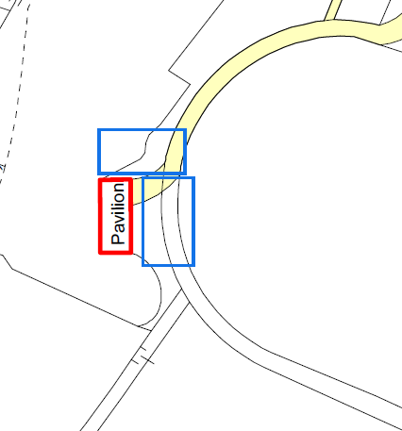

Red rectangles indicate the additional land requested in the diagram below.

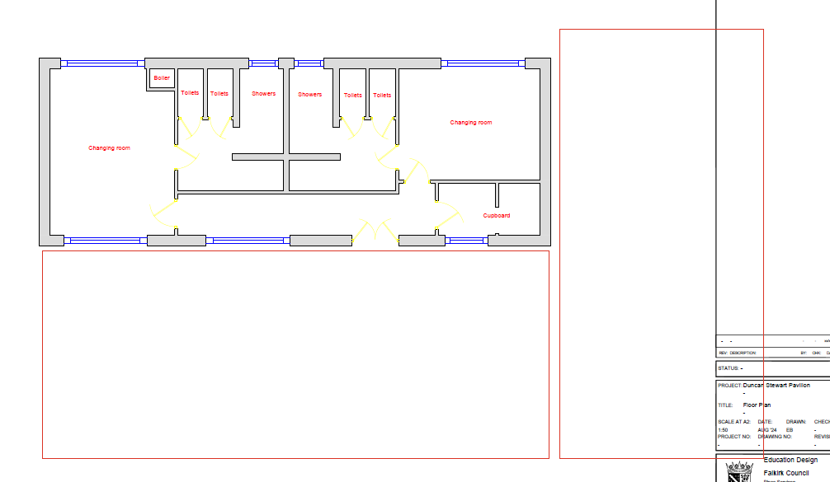

## Appendix B – Letter of Comfort from Baillie Buchanan

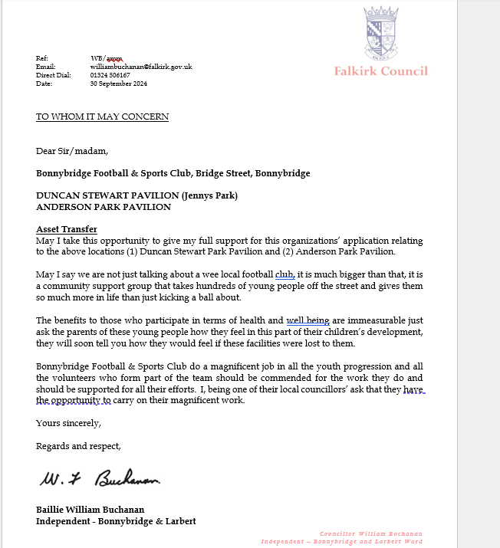

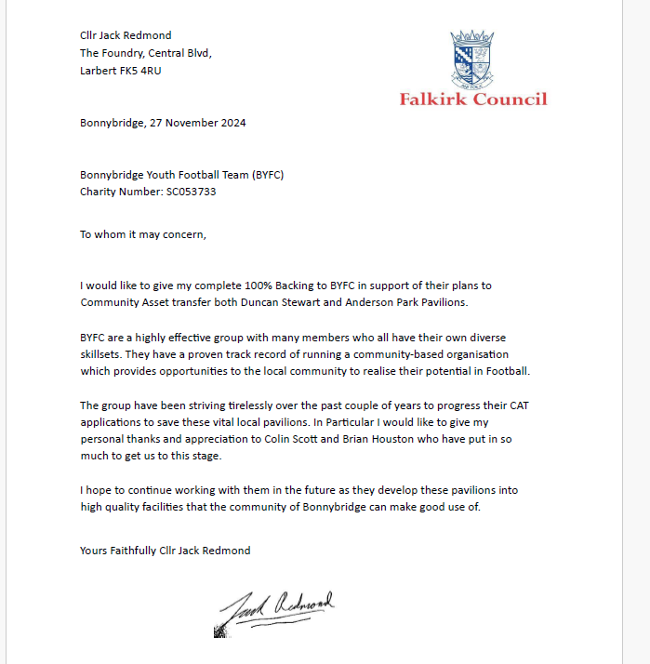

[LETTER REDACTED]

## Appendix C – Survey Results

A summary of the results from a survey [Supporting B.Y.F.C taking community ownership of Duncan Stewart Park Pavilion.](https://docs.google.com/forms/d/e/1FAIpQLSf_YyhxvZVw3FsJJ5-gCDVG_ECUsYmE8rcEgfTqUa-TkXjTzg/viewform?vc=0&c=0&w=1&flr=0) is as follows:

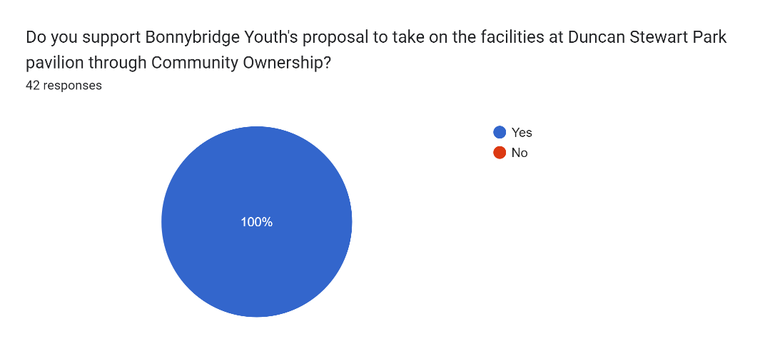

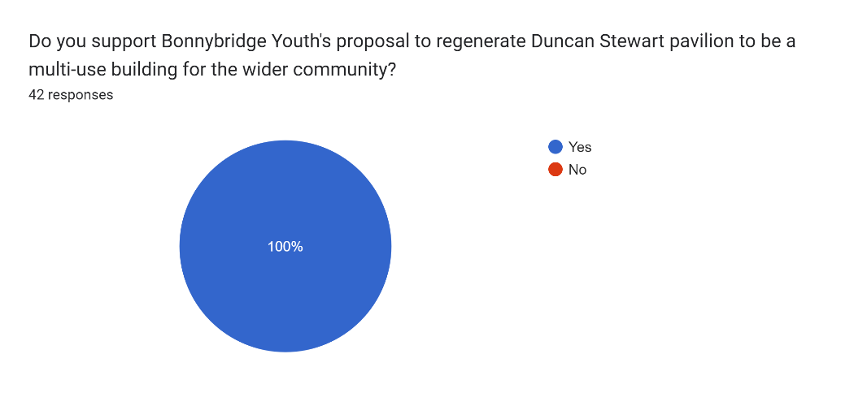

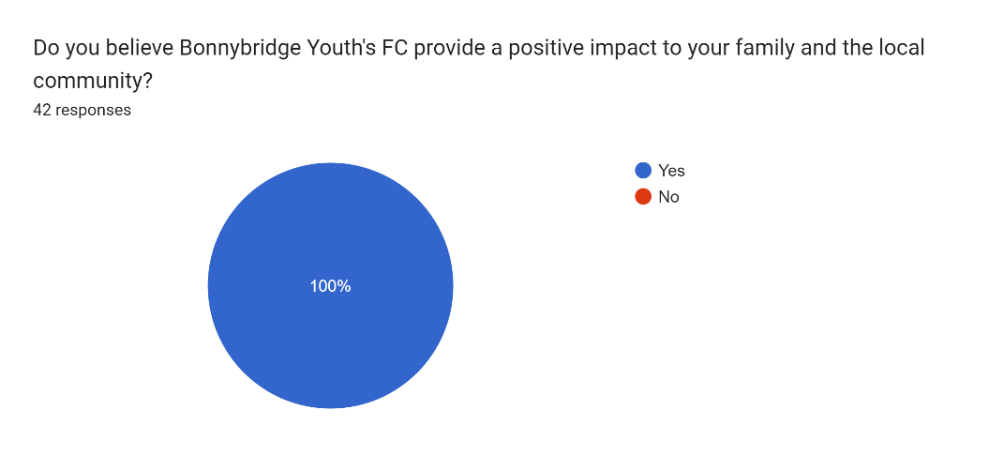

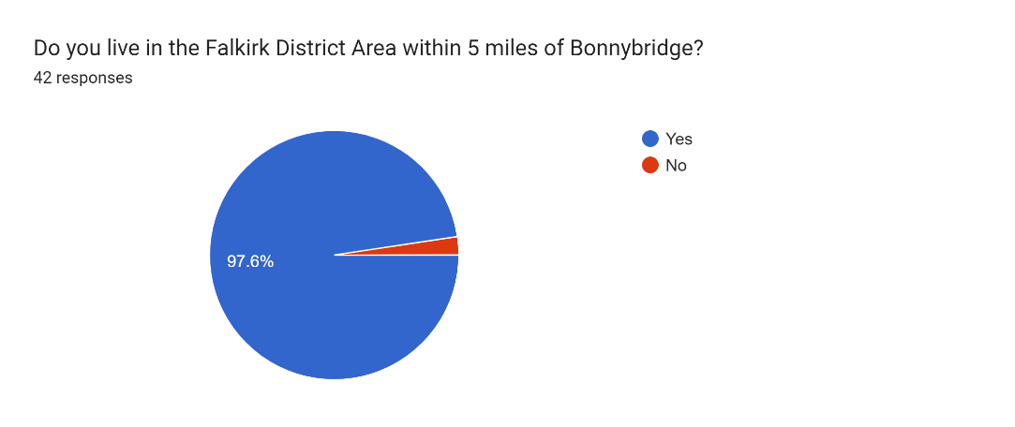

Quotes/Testimonials from current users:

*“My child has been involved with Bonnybridge Football and Sports Club for over 4 years. The club has provided my child a platform to develop and enjoy his football skills.”*

*“The positive impact the volunteers of Bonnybridge Football and Sports Club has had for my child and the local community is immeasurable.”*

*“Yes, the football team is a big part of the community, especially for the children. The facilities would allow the team to strengthen and can be used by the wider community for other events.”*

*“Yes, as this will help facilitate the children on their grassroots football journey. Also strengthening ties with the community having access to the pavilion and supporting other groups. The children will make great use of these facilities using them daily for training and match day purposes. Bringing back the community feel to the club having access to these facilities. I think this will attract more of the community to come and watch games knowing there are toilet facilities that can be accessed and kitchen facilities to provide hot drinks.”*

*“From my experiences and observations, it has had a positive impact on the local community and individuals that are involved. It has created a safe space for children of all ages to socialise and feel part of something - impacting positively on their health and wellbeing.”*

*“The impact of Bonnybridge Youth FC (BYFC) on the local community is truly profound, serving as much more than a football club. BYFC fosters community spirit, personal development, and well-being, while providing young people with opportunities to grow both on and off the pitch.”*

## Appendix D – Corra Foundation Boost Fund Application

|  |
| --- |
| CORRA Foundation and Children's Appeal logos |
|  |
| |  |  | | --- | --- | | |  | | --- | | Dear [REDACTED],  OFFER OF GRANT TO: Bonnybridge Youth Football Club APPLICATION REF NO: Boost-24/247 | | | |  | | --- | | Thank you for your recent application to the Boost Small Grants Fund. We have reviewed your request and we are delighted to be able to offer you a grant.  We would like to offer Bonnybridge Youth Football Club a total grant of £3,000.00 towards running costs including kit and training for coaches.  It was good to hear you have become a registered charity.  Your grant will be paid by bank transfer using the details you provided in your application. It can take up to 7 working days for the transfer to reach your account.  We will email in 12 months to ask you to complete a short report confirming how you spent the money and asking how the work went.  At the time you applied for the grant you accepted a set of Terms and Conditions. These can be reviewed on the copy of your application that you received by email when you applied. If you have any questions please contact us at communitygrants@corra.scot. Payment information will be sent in a separate confirmation email.  Congratulations and we look forward to working alongside you.   Yours sincerely, [REDACTED] Corra Foundation    (The) Corra Foundation is a charity registered in Scotland (No SC009481) and is also a company limited by guarantee (No SC096068).  Corra Foundation, Office Suite 30, Pure Offices, Lochside Way, Edinburgh EH12 9DT | | |

**Checklist of accompanying documents**

To check that nothing is missed, please tick which additional documents are accompanying this form.

Section 1 – You must attach your organisation’s constitution, articles of association or registered rules

Section 2 – Any maps, drawings or description of the land requested

Section 3 – Note of any terms and conditions that are to apply to the request

Section 4 – Any additional evidence regarding your proposals, their benefits, any restrictions on the land or potential negative consequences, and your organisation’s capacity to deliver.

Section 5 – Evidence of community support

Section 6 – Financial – Copies of accounts, forecasts, etc

Section 7 – Funding – Copy of Business Case etc

Section 8 – Enablement Fund – copies of estimates

**Declaration**

Two office-bearers (board members, charity trustees or committee members) of the community transfer body must sign the form. They must provide their full names and home addresses for the purposes of prevention and detection of fraud.

This form and supporting documents will be made available online for any interested person to read and comment on. Personal information will be redacted before the form is made available.

**We, the undersigned on behalf of the community transfer body as noted at Section 1, make an asset transfer request as specified in this form.**

**We declare that the information provided in this form and any accompanying documents is accurate to the best of our knowledge.**

Name [REDACTED]

Address [REDACTED]

Date 20/9/24

Position Chairperson

Signature

Name [REDACTED]

Address [REDACTED]

Date 20/9/24

Position Treasurer

Signature