**Additional Land Requested as part of Community Asset Transfer Request for Duncan Stewart Pavillion by Bonnybridge Youth Football Club.**

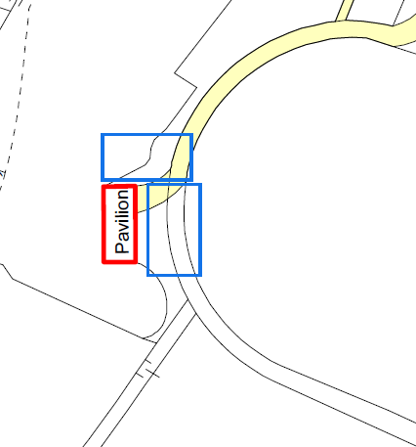

**Blue areas** in the map above show request for additional land

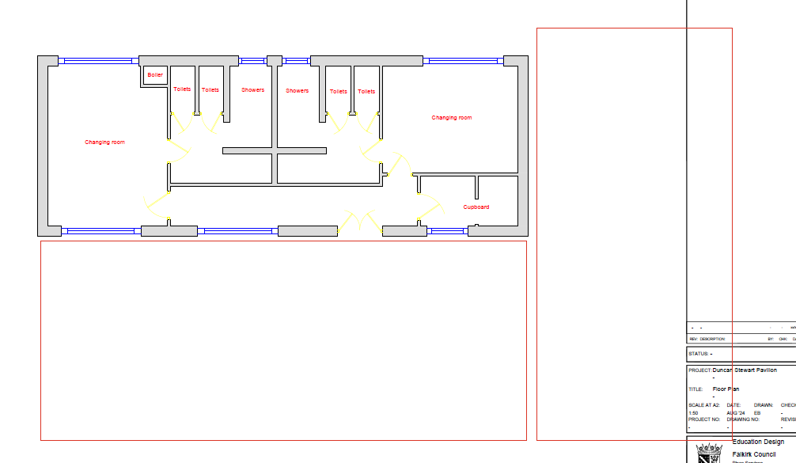

Red areas in the Schematic above show additional land requested