# **COMMUNITY EMPOWERMENT (SCOTLAND) ACT 2015**

# **FALKIRK COUNCIL ASSET TRANSFER REQUEST FORM**

**IMPORTANT NOTES:**

**This is an application form which can be used to make an Asset Transfer request to Falkirk Council.**

**Any Community Body interested in making an Asset Transfer Request is advised to contact the Asset Team on** [**strategicpropertyreview@falkirk.gov.uk**](mailto:strategicpropertyreview@falkirk.gov.uk) **before making the request so that we can discuss your proposal.**

**Please complete the asset transfer request form if the property/land is owned/leased/managed by Falkirk Council.**

**It is essential that you read the** [**Asset Transfer guidance**](https://www.gov.scot/binaries/content/documents/govscot/publications/advice-and-guidance/2017/01/asset-transfer-under-community-empowerment-scotland-act-2015-guidance-community-9781786527509/documents/00513211-pdf/00513211-pdf/govscot%3Adocument/00513211.pdf) **provided by the Scottish Government before making a request.**

**When completed, this form should be emailed to** [**strategicpropertyreview@falkirk.gov.uk**](mailto:strategicpropertyreview@falkirk.gov.uk) **or sent to**

**The Asset Team**

**Falkirk Council**

**4 Stadium Way**

**Falkirk**

**FK2 9EE**

**Section 1: Information about the Community Transfer Body (CTB) making the request**

* 1. Name of the CTB making the asset transfer request

The Ettrick Dochart Community Group

* 1. CTB address. This should be the registered address, if you have one.

Postal address:  
Ettrick Dochart Community Hall,   
Dochart Place  
Hallglen  
Falkirk

Postcode:  
FK1 2QR

* 1. Contact details. Please provide the name and contact address to which correspondence in relation to this asset transfer request should be sent.

Contact name: [REDACTED]

Postal address:  
Ettrick Dochart Community Hall,   
Dochart Place  
Hallglen  
Falkirk

Postcode:  
FK1 2QR

Email:  
at.edch@gmail.com

Telephone:  
[REDACTED]

**☐** We agree that correspondence in relation to this asset transfer request may be sent by email to the email address given above. *(Please tick to indicate agreement)*

*You can ask Falkirk Council to stop sending correspondence by email, or change the email address, by telling them at any time, as long as 5 working days’ notice is given.*

* 1. Please mark an “X” in the relevant box to confirm the type of CTB and its official number, if it has one.

|  |  |  |
| --- | --- | --- |
|  | Company and its company number is …………. |  |
|  | Scottish Charitable Incorporated Organisation (SCIO) and its charity number is SC052605 | X |
|  | Community Benefit Society (BenCom) and its registered number is ……………………………… |  |
|  | Unincorporated organisation (no number) |  |

**Please attach a copy of the CTB’s constitution, articles of association or registered rules.**

Please note that under The Community Empowerment (Scotland) Act 2015, where a CTB is seeking ownership rather than a lease, the organisation must have at least 20 members. See the Scottish Government’s [Guidance for Community Transfer Bodies.](https://www.gov.scot/binaries/content/documents/govscot/publications/advice-and-guidance/2017/01/asset-transfer-under-community-empowerment-scotland-act-2015-guidance-community-9781786527509/documents/00513211-pdf/00513211-pdf/govscot%3Adocument/00513211.pdf)

* 1. Has the organisation been individually designated as a community transfer body by the Scottish Ministers?

**No ☐**

**Yes ☐**

Please give the title and date of the designation order:

* 1. Does the organisation fall within a class of bodies which has been designated as community transfer bodies by the Scottish Ministers?

**No ☐**

**Yes ☐**

If yes, what class of bodies does it fall within?

Section 80(1)(b) ‘it is a Scottish charitable incorporated organisation the constitution of which includes provision that the organisation must have not fewer than 20 members’.

1. **Information about the land and rights requested**
   1. Please identify the property/land to which this asset transfer request relates.

You should provide a street address or grid reference and any name by which the land or building is known. If you have identified the land on the relevant authority’s register of land, please enter the details listed there.

*It may be helpful to provide one or more maps or drawings to show the boundaries of the land requested. If you are requesting part of a piece of land, you must attach a map and give a full description of the boundaries of the area to which your request relates. If you are requesting part of a building, please make clear what area you require. A drawing may be helpful.*

Details of Property:  
All and whole the building known as Ettrick Dochart Community Hall, Falkirk, and the lands as shown above, and bounded as outlined in red.

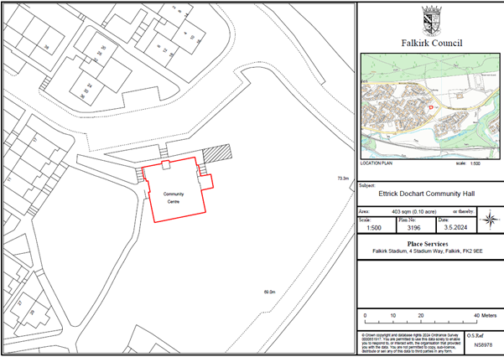

Address:

Ettrick Dochart Community Hall  
Dochart Place  
Hallglen  
Falkirk

Postcode:  
FK1 2QR

* 1. Please provide the UPRN (Unique Property Reference Number), if known.

UPRN: 136071834

1. **Type of request, payment and conditions**
   1. Please tick what type of request is being made:

for ownership (under section 79(2)(a)) - go to section 3A

X

for lease (under section 79(2)(b)(i)) – go to section 3B

for other rights (section 79(2)(b)(ii)) - go to section 3C

3A – Request for Ownership

What price are you prepared to pay for the land requested?

Proposed price: £

Please attach a note setting out any other terms and conditions you wish to apply to the request.

|  |
| --- |
|  |

3B – Request for Lease

What is the length of lease you are requesting?

|  |
| --- |
| 20 Year Lease |

How much rent are you prepared to pay? Please make clear whether this is per year or per month.

Proposed rent: £ 1 per annum

Please attach a note setting out any other terms and conditions you wish to be included in the lease, or to apply to the request in any other way.

|  |
| --- |
|  |

3C – Request for other Rights

What are the rights you are requesting?

|  |
| --- |
|  |

Do you propose to make any payment for these rights?

**Yes ☐**

**No ☐**

If yes, how much are you prepared to pay? Please make clear what period this would cover, for example per week, per month, per day?

|  |
| --- |
| Proposed payment: £ per |

Please set out any other terms and conditions you wish to apply to the request.

|  |
| --- |
| N/A |

1. **Community Proposal** 
   1. Please set out the reasons for making the request and how the land or building will be used.

This should explain the objectives of your project, why there is a need for it, any development or changes you plan to make to the land or building, and any activities that will take place there.

|  |
| --- |
| 4.1.1 Objectives of Project  Our current and future aims are to:  - Ensure the maintenance and improvement of the community hall.  - Ensure the financial viability of the community hall by having a range of income sources, such as hiring out space, donations, grants/3rd sector funding.  - Facilitate events to involve a wide cross section of the community.  - Improve our general marketing and advocacy of the hall, particularly to potential new users.  - Seek ways to use the hall to create employment and help stimulate the local economy.  - Work in partnership with others, for example the local primary school & nursery.    Our charitable purpose is to promote the benefit of the inhabitants of the Hallglen area without distinction of sex or of political, religious or other opinions by associating the local and statutory authorities, voluntary organisations and inhabitants in a common effort to advance education and to provide facilities in the interests of social welfare, for recreation and other leisure time occupations with the object of improving the conditions of life for the said inhabitants. To maintain and manage or to co-operate with any local authority in the maintenance and management of the Ettrick Dochart Community Hall for activities promoted by the committee in the furtherance of the above objects. |
| 4.1.2 Why there is a need for your Project?  We believe that the hall operating under community ownership, will improve the sense of community with many groups, attracting people to come from a wider area, and will be able to pass on information to others. The members of the hall propose to look at holding a variety of activities which will encourage different age groups to mix both socially and in specific classes.  Our key objectives are to offer the people of Hallglen and the surrounding area a quality service, and to build a successful community hub giving it a financially secure future. |
| 4.1.3 Will any Development/changes/modifications to the asset be required?  We intend to update and upgrade the toilets once we take on the lease of the building. |
| 4.1.4 What activities will take place?  The community hall will offer the following range of services:   * Space for party/class bookings * Social gatherings * Space for meetings, business & public * Gym use/membership * Space for counselling services * Soft play area * Community cinema * Help desk area |
| 4.1.5. If the asset is to be used by the public, please provide details of lettings policy and opening times.  All lets are subject to groups/individuals signing our Let Agreement Form, and abiding by the terms and conditions as listed.  The Hall will be open when lets are required. In general, these are between the times of 9am to 9pm, 7 days a week.  The Hall will be closed over the 2 weeks at Christmas. However, the hall will be open if there was a private let during this period. |
| 4.1.6 What provision will be provided for people with disabilities?  There is a ramp in place for disabled access; there are also a number of accessible toilets in the building; our groups and activities are available to all. |
| 4.1.7 Any other relevant information?  The hall is the hub of the community, and the group has spent a large amount of funds to maintain and upgrade the building, through our various endeavours to fundraise, source external funding, and the work of our volunteers, which has produced a modern interior that groups and individuals want to let. This includes a new kitchen; gym area; games room; soft play; toilets; CCTV; door entry system; to name a few. |

Benefits of the proposal

* 1. Please set out the benefits that you consider will arise if the request is agreed to.

Local Authorities are permitted to dispose of property at less than market value where there are wider public benefits to be gained. This is set out in the Disposal of Land by Local Authorities (Scotland) Regulations 2010. These public benefits are listed below.

In this section, please explain how the project will benefit your community, and others. Please refer to the Scottish Government [guidance](https://www.gov.scot/binaries/content/documents/govscot/publications/advice-and-guidance/2017/01/asset-transfer-under-community-empowerment-scotland-act-2015-guidance-community-9781786527509/documents/00513211-pdf/00513211-pdf/govscot%3Adocument/00513211.pdf) on how the Council will consider the benefits of a request.

|  |
| --- |
| Please explain how the project will benefit your community by detailing how your project will promote or improve:  4.2.1. Economic development/income generation  ie. Please include details of any job creation or **volunteering and training** opportunities that will be available as a result of the Asset Transfer. Also details of how your organisation will involve the **local community** and of any incentives that may be available to encourage the local community to use the proposed services.  Our centre provides essential services and spaces that might otherwise be inaccessible due to the financial constraints of our local community. We plan to offer employment opportunities once the asset transfer is complete, in the form of a cleaner, cafe staff, and potentially a centre manager. The centre remaining open and in community ownership, will help to develop the skills and experience of our local community through volunteer places, to build upon an individual’s experience and skills capacity, thus supporting our community’s future employability. |
| * + 1. Regeneration   i.e. Please include details of whether your organisation will contribute to the **physical regeneration** of the area, and how your proposal will impact the regeneration of the area, in terms of volunteering or employment, giving examples.  Unfortunately, due to the economic climate and the cost-of-living crisis, there has been a decline in the number of businesses, venues, and amenities in our community. The closing of a vital community building would be hugely damaging to the local area. We have plans to upgrade our space and our garden area, so that it can be enjoyed by our whole community. We plan to continue our community work to contribute to the local regeneration of the area. Our initiatives of hosting outdoor events, supporting local businesses, and advocating for community needs, means that we are actively engaging with our broader community: our community centre helps create a more vibrant, connected, and resilient local area. |
| * + 1. Public Health   i.e. How likely is the proposal to improve the Public Health of the Community, in terms of **physical and mental health**, for example through volunteering, training, or taking part in activities, giving examples.  By improving the overall health of the community, our group aims to help ease the pressure on public and social services, and on other facilities. Our Positivitea cafe, helps to combat mental health issues in our local area. By engaging in regular social activities, our community can reduce stress, improve mood, and gain a sense of purpose. Physical activities at our centre, such as yoga classes, martial arts classes, and dance classes, help maintain physical health and mobility for all those who attend them. Together, these benefits contribute to a healthier, happier, and more connected community. When individuals have access to programmes that support their social, mental, and physical health, they are less likely to require intervention from public services. This proactive approach to community health not only benefits individuals, but also reduces the burden on public resources, allowing them to be allocated more effectively, to areas where they are needed the most. |
| * + 1. Social Wellbeing   i.e. How will the proposal improve the Community's Social Well-Being and mental health, or how might it improve the **learning offer and activities** available in the area? Please give brief examples of these activities.  The activities and social interactions facilitated at the Ettrick Dochart Community, will contribute significantly to both the mental and social wellbeing of our community. Our centre provides a safe space for the local community to meet and engage with each other, in a vast range of activities and events. Our specialist counsellors who volunteer in our Scott Martin Foundation, Martin’s Room, offer a unique service to our young people, who need that specialist support to tackle mental health issues, suicide ideation, low-mood and general wellbeing. |
| * + 1. Environmental Wellbeing / Environmental Benefits   i.e. Will the proposal bring green / environmental benefits and / or have an impact on the **local environment**? Will it help mitigate the effects of climate change? If so please give details.  We plan to continue to work in an environmentally conscious way, and we have plans to engage with funders to make energy efficiency improvements to reduce our carbon footprint on the environment and local community. These improvements contribute to a healthier, more attractive, and more liveable community, benefiting all who live here. We have recently installed new energy saving windows, which has reduced our heat loss, and decreased our overall energy usage. |
| * + 1. Does your project contribute to the reduction of inequalities?   i.e. Will the proposal enable the community to access activities not otherwise available; will these activities be available at an affordable rate; how will your organisation work with other local providers to **reduce inequalities**?  We run the local food pantry which ensures that the people of Hallglen have access to essential supplies, meaning that no one in our community goes hungry. There is a vast amount of food insecurity in the area due the cost-of-living crisis, and, as with many areas within the district, Hallglen & Glen Village qualify as being among the most deprived 20% in Scotland, under the Scottish Index of Multiple Deprivation (SIMD). Our letting structure is reasonable and affordable for our community. The hall is local, and as such, people do not have to travel far to access the services that we have to offer. |
| 4.2.7 Will local people be engaged in the use and management of the Asset?  A “community of interest” may not represent the people living near to the asset. Please provide evidence of how **local people and communities** will be engaged in the use and management of the asset, and how they have been consulted.    The Ettrick Dochart Community Hall has been a staple within the village of Hallglen since the 1970s. While originally managed by Falkirk council, management and administration duties transferred to the Ettrick Dochart Community Hall Management Committee in 2009 under a tenant-occupiers lease agreement and the management committee has managed the building since.  Under the management committee’s leadership, the hall has developed into a well-used community space that is vital to the people of Hallglen and surrounding areas. Our hall is currently used by The Scott Martin Foundation, Positvitea Cafe, Kint ‘N’ Knatter, Youth Club, 4th Falkirk Boys Brigade, Andy’s Man Club, Love Church as well as private business lets. We have consulted with our user groups to highlight the importance of the centre remaining open and their confidence in The Ettrick Dochart Community Group running it on behalf of the community.  We are a 2-tier membership organisation, run by a board of trustees selected by our members. Membership is open to all residents of Hallglen, Glen Village, Lionthorn and all groups operating from our facilities. They are able to vote at AGMs on matters relating to the SCIO, as well as the running, maintenance, and future of the hall. Application to become an associate member is open to anyone else with an interest in the hall and its success.  As a board of trustees, our effectiveness has been demonstrated over the last 15 years and we will continue to build on the programme of activities we already have in place. We take our responsibilities seriously in relation to good governance and work with various governing bodies to educate ourselves on a regular basis. |
| 4.2.8 How will you monitor whether the Asset Transfer is benefiting the community?  ie. Will you survey the users / invite feedback / compare user numbers with a baseline etc  We will measure the usage of the hall on a monthly, quarterly and yearly basis, against our aims to increase overall usage by 25% in the first 2 years.  We will monitor our social impact by collecting information on the demographics of hall users, gathering feedback in terms of health and social benefits of users, amongst others. |
| 4.2.9 Any other relevant information?  The hall is the hub of the community, and the group has spent a large amount of funds to maintain and upgrade the building, through our various endeavours to fundraise, source external funding, and the work of our volunteers, which has produced a modern interior that groups and individuals want to let. This includes a new kitchen; gym area; games room; soft play; toilets; CCTV; door entry system; to name a few. |

Restrictions on use of the land

* 1. If there are any restrictions on the use or development of the land, please explain how your project will comply with these.

Restrictions might include, amongst others, environmental designations such as a Site of Special Scientific Interest (SSI), heritage designations such as listed building status, controls on contaminated land or planning restrictions.

|  |
| --- |
| There are no known restrictions to the use of the land. We do not have any intention to redevelop the land. |

Negative consequences

* 1. Are there any negative consequences that will affect *other groups or individuals* if your request is agreed to? How you propose to minimise / reduce these?

For example, increased traffic etc. Please consider any potential negative consequences for the local economy, environment, or any group of people, and explain how you could reduce these.

|  |
| --- |
| There are no known negative consequences to the proposal, as we do not intend to change the use of the hall, nor alter the types of let. |

Capacity to deliver

* 1. Please show how your organisation will be able to manage the project and achieve your objectives.

This could include the skills and experience of members of the organisation, any track record of previous projects, whether you intend to use professional advisers, etc.

4.5.1 Has your organisation or any of its members managed projects or owned / leased property/land prior to this?

Yes ☐

No ☐

Please provide details of:

4.5.2 Skills and experience of the members of the organisation

The board of trustees at the Ettrick Dochart Community Hub, has a diverse group of individuals, with each bringing their own unique set of skills and experience. Several of our trustees have served on the management board of the hall for many years, bringing a wealth of experience, and strong relationships with current, past, and future users of the hall, and the wider community. Many trustees have also volunteered extensively with various other charities over the years. Our commitment to our community extends beyond our community hall.

The board have a varied skill mix with a rich blend of skills and experiences, that includes full-time professionals and retired individuals. Our backgrounds span different industries, ensuring a well-rounded perspective in decision-making. Comfortable in public settings, the board actively participates in meetings and engages with the community. We communicate effectively, whether addressing large audiences, or having those one-on-one conversations. The board champion causes that benefit the local area and our local residents. Our trustees bring project experience, enabling us to oversee initiatives efficiently. Our ability to plan, execute, and evaluate projects ensures successful outcomes. Our experience in negotiation, collaboration, and strategic planning enhances the hall’s operations. Our charity trustees handle costings and budgets adeptly. Our financial acumen ensures responsible resource allocation, where several trustees have successfully run their own profitable businesses. Our entrepreneurial insights contribute to sustainable practices and financial stability. The board maintains valuable connections with skilled professionals such as joiners, builders, and electricians – these contacts prove invaluable for maintenance and improvement projects.

Treasurer:   
Our Treasurer has B.A. Degree, Management experience, Quality assurance management, Captain of Girls Brigade, Volunteering for 25yrs, Activities Co-ordinator for people with a learning disability, Certificates in 1st Aid, Moving & Handling, Fire Safety, Computer Safety, Food Safety, PVG Certificate to work with vulnerable adults & children.

Secretary:   
Our secretary has over 17 years' experience as a Senior Administrator, where the role included responsibility for staff training; computer system upgrades; staff rotas; etc. She has also been volunteering for 8 years with the hall, and has certificates in digital marketing, minute taking, amongst others.

Chairperson:   
Our current Chairperson, was a director of her own company; she also has vast catering and retail management experience, which she gained whilst enlisted in the army; she then took these skills to become the head cook within a school; she also gained invaluable management experience during her time in the hospitality business, gaining certificates in food hygiene, health and safety, etc. She has also had her PVG for children and vulnerable adults, for a number of years.

Our wider membership also included tradespeople, local business owners, elected officials, nursing staff, etc, which we can draw upon for support to access their unique skills and abilities.

Collectively we will ensure compliance, ethical behaviour, and accountability. We are able to identify and address issues promptly. By careful financial management, we will manage financial resources, ensuring long-term stability.

4.5.3 Do you intend to use professional advisors? Please provide details.

We intend to instruct a solicitor to negotiate a lease agreement with Falkirk Council.  
We intend to instruct a number of surveyors, architects, etc, as the need arises.

4.5.4 Do you currently lease/manage a property from Falkirk Council? If yes, please provide details.

We currently have a licence to occupy / management lease, of the Ettrick Dochart Community Hall

4.5.4 Please detail how you plan to manage the building?

For example opening and closing the building / managing lets / will you have staff etc?

Collectively we will ensure compliance, ethical behaviour, and accountability. We are able to identify and address issues promptly. By careful financial management, we will manage financial resources, ensuring long-term stability.

The hall will be managed, and staffed, by a dedicated group of volunteers. We already successfully manage the running of the hall, the booking of lets, and the opening and closing of the hall.

The Hall will be open when lets are required.   
In general, these are between the times of 9am to 9pm, 7 days a week.

The Hall will be closed over the 2 weeks at Christmas. However, the hall will be open if there was a private let during this period.

4.5.5 Please provide any other information you think may be relevant.

The hall is the hub of the community, and the group has spent a large amount of funds to maintain and upgrade the building, through our various endeavours to fundraise, source external funding, and the work of our volunteers, which has produced a modern interior that groups and individuals want to let. This includes a new kitchen; gym area; games room; soft play; toilets; CCTV; door entry system; to name a few.

1. **Level and nature of support**
   1. Please provide details of the level and nature of support for the request, from your community and, if relevant, from others.

This could include information on the proportion of your community who are involved with the request, how you have engaged with your community beyond the members of your organisation and what their response has been. You should also show how you have engaged with any other communities that may be affected by your proposals.

5.1.1. What community engagement has taken place to help develop your business plan? Please provide evidence, for example any completed surveys, questionnaires, letters of support, minutes of public meetings etc.

We have held numerous community engagement days including Summer fun days We carried out an online survey (results can be seen below) to gauge the local community’s interest in using the hall, what they would like it to be used for and whether they support us taking over the building through community ownership. We have received impact statements from The Scott Martin Foundation who use the building for counselling sessions. We have received further quotes/testimonials from current users of the building to show how vital it is for them that it remains open.

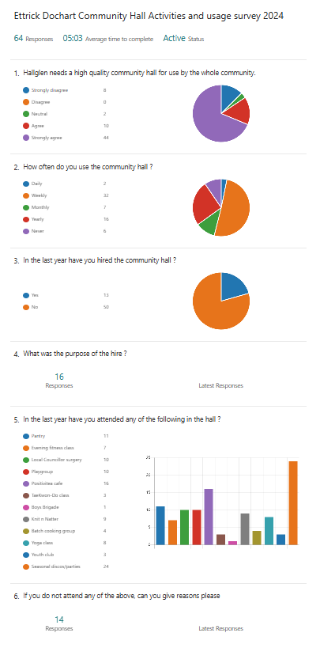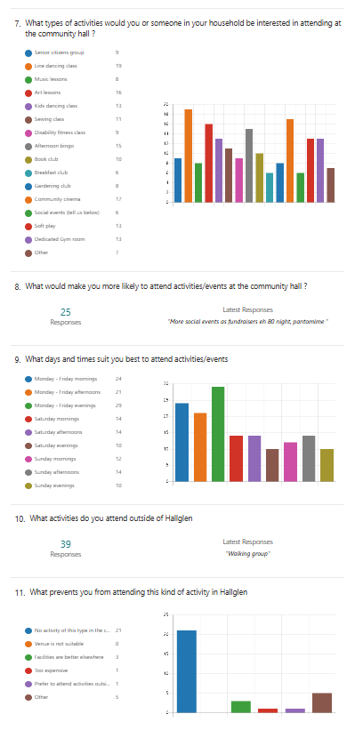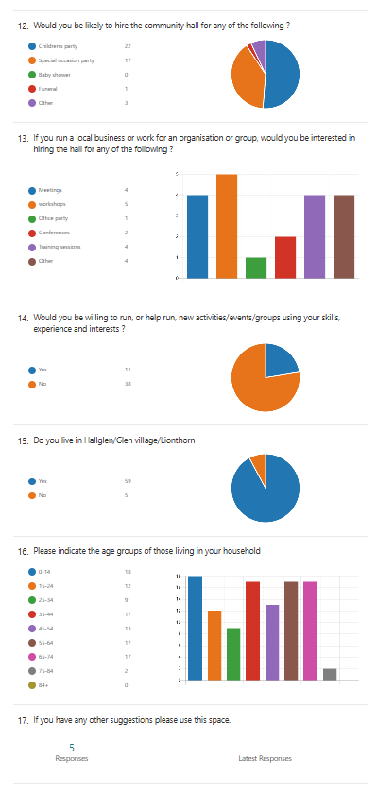

5.1.2 Have you consulted with other local stakeholder groups or agencies? Please provide evidence.

We have worked with CVS to help with our business plan and CAT application. We have collaborated with local schools and ran children’s events at the hall. We have recently received new lets from community groups and businesses for the use of the hall through our community engagement consultation.

5.1.4 Have you been in contact with any other communities or community groups

that may be affected? Please give details.

We have attended CVS’s Community Ownership Group meetings which has put us in contact with other community groups going through the Community Asset Transfer process.

5.1.5 Please provide any other information you think may be relevant.

We have included evidence of community support, surveys, impact statements in our appendices.

**Section 6. Financial Viability of Project**

Your Business Plan should contain full information about the financial viability of the project, evidencing that the organisation will be able to sustain the project in the long term.

Please submit

* at least 1 year’s audited accounts to evidence your organisations financial stability (if available)
* where audited accounts are not available (for instance for new groups) please provide a bank statement.
* a projected 5 year income and expenditure account
* a cash flow forecast for the proposed asset transfer.

|  |
| --- |
| 6.1 Please outline the Policies and Procedures your organisation has in place to govern the group’s finances  We recognise our organisation’s requirements as a registered SCIO. We will continue to submit audited accounts yearly to OSCR. Our finances are presented and scrutinised at every board meeting. We will follow OSCR’s [Guidance and Good Practice for Charity Trustees (oscr.org.uk)](https://www.oscr.org.uk/media/3621/v10_guidance-and-good-practice-for-charity-trustees.pdf) to ensure we manage our finances correctly.  We have set rates for each of our spaces available to let and will review these yearly at our AGM. |

1. **Funding**
   1. Please outline how you propose to fund the price or rent you are prepared to pay for the land, and your proposed use of the land.

If you intend to apply for grants or loans you should demonstrate that your proposals are eligible for the relevant scheme, according to the guidance available for applicants*.*

7.1.1 Please show your calculations of the costs associated with the transfer of the land or buildings and your future use of it, including any redevelopment, ongoing, maintenance and the costs of your activities. All proposed income and investment should be identified, including volunteering and donations.

We recognise we will require a solicitor to review and negotiate the terms of our lease. We have secured funding to upgrade the building and will continue to seek funding in the future.

Please see our Cash Flow for all our planned start up, ongoing, maintenance and planned redevelopment costs. Our Cash Flow also shows all proposed income and investment.

hall lets table

volunteering hours table

Our volunteer contributions can be seen in the table above.

7.1.2 Please supply details of what funding you have received so far, and of any conditions attached to it.

funding table

Evidence of funding received can be found in the appendices.

7.1.3 Please supply details of any funding you have applied for but have not yet received a response or decision. Please include timescales if known.

- Community Empowerment Grant (Small and CAT)  
 - National Lottery Community Led

7.1.4 Details of any other funding you will have access to? i.e. voluntary contributions, borrowing etc.

From our previous years running our group, we have successfully managed to build our reserves to a level we feel comfortable with to take on the building through community ownership.

As a registered SCIO we have access to overdraft and borrowing facilities with our bank.

Our voluntary contributions is evidenced in the table below. General duties can include redecorating and other maintenance duties.

volunteering hours table

7.1.5 Please outline your funding strategy if you have one, as well as any other relevant information.

We recognise that there is a need to continually update and upgrade our facilities, and we keep up to date with the various funding opportunities available to us, thanks to our local third sector interface, CVS Falkirk & District.

We have a good track record of receiving funding and this experience will be valuable to us moving forward.

1. **Enablement Fund**

Falkirk Council will hand the building over wind and watertight and compliant. However, this is quite light-touch and would involve (for example) patching of a leaky roof. For more significant building works, groups can apply to the Enablement Fund, to pay for capital improvements such as energy efficiency improvements or larger capital renewals which support the viability of the project going forward. **Only capital items are eligible**. Running repairs are revenue costs and are not eligible. You are strongly advised to email [strategicpropertyreview@falkirk.gov.uk](mailto:strategicpropertyreview@falkirk.gov.uk) to confirm eligibility criteria before you submit this application.

Requests to the Fund must be supported by estimates / quotations from professionals which should be provided as supporting documents.

**Please provide details of your request to the Enablement Fund, if applicable.**

|  |  |  |
| --- | --- | --- |
| **Enablement Fund request for larger capital renewals which support the viability of the CAT** | | |
| Item | Estimate Provided By | Amount not more than (including VAT) |
| New Heating System Radiators | Awaiting Estimate | £86,400 |
| New Electrical System | Awaiting Estimate | £70,000 |
| Roof Repair | Awaiting Estimate | £51,480 |
| Rough Casting | Awaiting Estimate | £30,000 |
| Upstairs disabled toilet men/women | Awaiting Estimate | £23,000 |
|  |  |  |
| Total including VAT | | £260,880 |

We are applying for the amount of £260,880 to carry out significant capital improvements to the property, which includes the replacement of our heating system; the replacement of our electrical system; significant repairs to the roof; rough casting of external walls; and work carried out for a disabled toilet. The amount indicated in the table above, represents the full cost as provided by professional contractors – quotes have been submitted along with our application.

We will continue in our endeavours to research and apply for various external match-funding to support the costs of these vital works. If we are successful in acquiring this funding, this amount will reduce the amount of funding required via the Enablement Fund, and we would inform Falkirk Council promptly, to allow funds from the Enablement Fund to be reallocated in a timely manner.

**Checklist of accompanying documents**

To check that nothing is missed, please tick which additional documents are accompanying this form.

Section 1 – You must attach your organisation’s constitution, articles of association or registered rules

Section 2 – Any maps, drawings or description of the land requested

Section 3 – Note of any terms and conditions that are to apply to the request

Section 4 – Any additional evidence regarding your proposals, their benefits, any restrictions on the land or potential negative consequences, and your organisation’s capacity to deliver.

Section 5 – Evidence of community support

Section 6 – Financial – Copies of accounts, forecasts, etc

Section 7 – Funding – Copy of Business Case etc

Section 8 – Enablement Fund – copies of estimates

**Declaration**

Two office-bearers (board members, charity trustees or committee members) of the community transfer body must sign the form. They must provide their full names and home addresses for the purposes of prevention and detection of fraud.

This form and supporting documents will be made available online for any interested person to read and comment on. Personal information will be redacted before the form is made available.

**We, the undersigned on behalf of the community transfer body as noted at Section 1, make an asset transfer request as specified in this form.**

**We declare that the information provided in this form and any accompanying documents is accurate to the best of our knowledge.**

Name

Address

Date

Position

Signature

Name

Address

Date

Position

Signature