**COMMUNITY EMPOWERMENT (SCOTLAND) ACT 2015**

**ASSET TRANSFER REQUEST FORM**

**IMPORTANT NOTES:**

**You do not need to use this form to make an asset transfer request, but using a form will help you to make sure you include all the required information.**

**You should read the asset transfer guidance provided by the Scottish Government before making a request.**

**You are strongly advised to contact the authority and discuss your proposals with us before making an asset transfer request.**

**When completed, this form must be sent to Falkirk Council which owns or leases the land your request relates to.**

**This is an asset transfer request made under Part 5 of the Community Empowerment (Scotland) Act 2015.**

1. **Information about the community transfer body (CTB) making the request**
   1. Name of the CTB making the asset transfer request

POLMONT COMMUNITY HUB SCIO

* 1. CTB address. This should be the registered address, if you have one.

Postal address:

GREENPARK COMMUNITY CENTRE, GREENPARK DRIVE, POLMONT, FALKIRK

Postcode:FK2 0PZ

* 1. Contact details. Please provide the name and contact address to which correspondence in relation to this asset transfer request should be sent.

Contact name: [REDACTED]

Postal address: [REDACTED]

Postcode: [REDACTED]

Email: polmontcommunityhub@gmail.com

Telephone: [REDACTED]

**🗹** We agree that correspondence in relation to this asset transfer request may be sent by email to the email address given above. *(Please tick to indicate agreement)*

*You can ask Falkirk Council to stop sending correspondence by email, or change the email address, by telling them at any time, as long as 5 working days’ notice is given.*

* 1. Please mark an “X” in the relevant box to confirm the type of CTB and its official number, if it has one.

|  |  |  |
| --- | --- | --- |
|  | Company, and its company number is …………. |  |
| **🗹** | Scottish Charitable Incorporated Organisation (SCIO), and its charity number is ……………….. | SCO53456 |
|  | Community Benefit Society (BenCom), and its registered number is ……………………………… |  |
|  | Unincorporated organisation (no number) |  |

**Please attach a copy of the CTB’s constitution, articles of association or registered rules.**

* 1. Has the organisation been individually designated as a community transfer body by the Scottish Ministers?

**No 🗹**

**Yes ☐**

Please give the title and date of the designation order:

* 1. Does the organisation fall within a class of bodies which has been designated as community transfer bodies by the Scottish Ministers?

**No ☐**

**Yes 🗹**

If yes what class of bodies does it fall within?

Community Controlled Body

1. **Information about the land and rights requested**
   1. Please identify the land to which this asset transfer request relates.

*You should provide a street address or grid reference and any name by which the land or building is known. If you have identified the land on the relevant authority’s register of land, please enter the details listed there.*

*It may be helpful to provide one or more maps or drawings to show the boundaries of the land requested. If you are requesting part of a piece of land, you must attach a map and full description of the boundaries of the area to which your request relates. If you are requesting part of a building, please make clear what area you require. a drawing may be helpful.*

Greenpark Community Centre, Greenpark Drive, Polmont, Falkirk FK2 0PZ

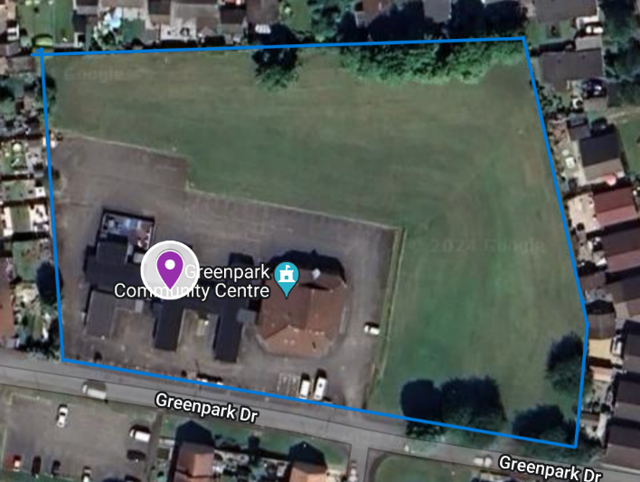

Aerial view of Greenpark Community Centre with boundary

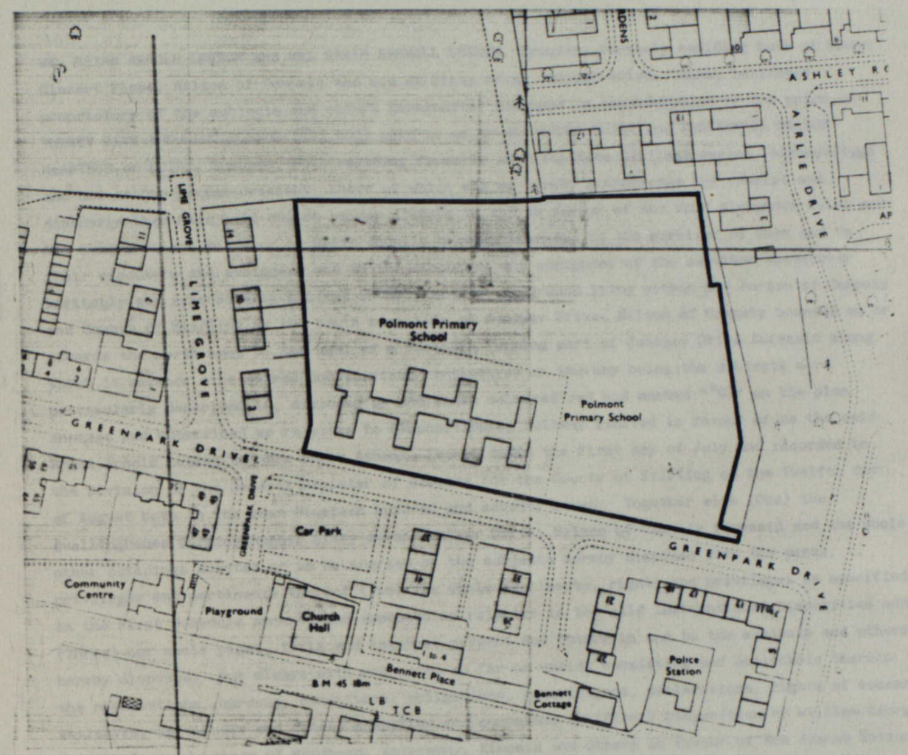

Figure – Map of Greenpark extracted from Notice of Title

* 1. Please provide the UPRN (Unique Property Reference Number), if known.

Please see Falkirk Council’s register of land assets for UPRN

UPRN: 136049060

1. **Type of request, payment and conditions**
   1. Please tick what type of request is being made:

x

for ownership (under section 79(2)(a)) - go to section 3A

for lease (under section 79(2)(b)(i)) – go to section 3B

for other rights (section 79(2)(b)(ii)) - go to section 3C

**3A – Request for ownership**

What price are you prepared to pay for the land requested? :

Proposed price: £1 (Valuation offset by Volunteer Hours)

Please attach a note setting out any other terms and conditions you wish to apply to the request.

**3B – request for lease**

What is the length of lease you are requesting?

How much rent are you prepared to pay? Please make clear whether this is per year or per month.

Proposed rent: £ per

Please attach a note setting out any other terms and conditions you wish to be included in the lease, or to apply to the request in any other way.

**3C – request for other rights**

What are the rights you are requesting?

Do you propose to make any payment for these rights?

**Yes ☐**

**No ☐**

If yes, how much are you prepared to pay? Please make clear what period this would cover, for example per week, per month, per day?

Proposed payment: £ per

Please attach a note setting out any other terms and conditions you wish to apply to the request.

1. **Community Proposal** 
   1. Please set out the reasons for making the request and how the land or building will be used.

*This should explain the objectives of your project, why there is a need for it, any development or changes you plan to make to the land or building, and any activities that will take place there.*

Our key objectives are to offer the community of Polmont a quality service and to build a successful community hub giving it a financially secure and sustainable future.

To further this goal, by enabling and encouraging everyone to work together as a sustainable community, the Hub aims to share knowledge covering carbon accountancy, energy efficiency and climate change via a community film group, showing community beneficial films covering these areas along with the subjects of re-wilding and de-growth. Inspirational speakers providing Q&A sessions are a planned accompaniment, providing not only essential information but also mental well-being and social inclusion.

Waste is a further area intended to be addressed, with the aim to become a zero-waste group, the Hub having amongst its’ membership a Zero-Waste Champion Volunteer, who currently works with an environmental group. Engaging with a local food-growing group, circular economy and active travel initiatives are the current intended means of achieving this ambitious aim. If members of the community with the required skills can be recruited as volunteers, it is planned to start a repair workshop group. This would be aimed at repairing local people’s and businesses’ household items or office equipment, reducing waste by recycling.

It is intended that the local food-growing group utilise an area of the land included in the Community Asset Transfer being applied for, to provide community food producing Community Garden and an outdoor community meeting place, where interested parties of all ages can gain the relative required outdoor skills. A poly-tunnel and planting area with future potential for a food co-operative is also planned.

A further active outdoors group is planned, intended to build community engagement helping others in and around Polmont, with the added benefit of maintaining an active and healthy lifestyle themselves, with both physical and mental benefits.

In order to enhance the appearance of the Centre and provide a welcoming and attractive outdoor area for any member of the community to meet and sit outdoors, particularly those who do not have their own outdoor space, the Hub intends to build planters with community seating around our entrance and in other vacant areas on the site. This will provide outdoor socialising space, assisting mental well-being for members of the community who would otherwise not have the opportunity to just sit outside and chat.

The Hub aims to be inclusive, available to all members of the community. Initially it will be managed by volunteers from our membership group, however, in the future we will be looking at employing an individual to manage the building.

We believe that we have the necessary skills to manage our buildings and get the best for our community

**Benefits of the proposal**

* 1. Please set out the benefits that you consider will arise if the request is agreed to.

*This section should explain how the project will benefit your community, and others. Please refer to the guidance on how the relevant authority will consider the benefits of a request.*

We currently have lets from local community groups covering a wide and varied spectrum of activities giving provision across the full demographic of the area, including:

Polmont Playgroup, Toddlers Music, Child Minding Group, Bridge Club, Carpet Bowls, Barr Dance Dreams, Line Dancing, Tea Dance, Yoga, Aerobics, Tai Chi, Stretch & Tone, Zumba, Hill Walkers, Ramblers, Joggers, Fencing, Karate, Children’s Judo, Writer’s Circle, Poetry Group, Art Club, Crafts (various), Sewing, Model Flying Club, Brownies, Guides, Church Services, Horticultural Groups, Probus Group, S.W.I., local councillor surgeries and Polmont Community Council meetings.

We also have a newly established Tool library, where users can pay a yearly subscription to allow access and return of all tools. Ideally this will also create a part time job in the community as this tool library will need manned, tools maintained and goes towards our net zero targets of reducing waste/landfill.

We work with the community, for the community. We will continue to develop partnerships with local organisations, service providers and community groups in-line with our purpose.

Our vision is to provide a community-led space that helps deliver long-term, social, economic, sustainable and environmental benefits to the local community.

Our values are based on:

* Working in an inclusive and respectful manner, not discriminating against anyone
* Being a not-for-profit organisation and investing any surplus in the advancement of facilities for the local community
* Being community-led
* Intergenerational approach to serving all age ranges in the community
* Provide a space for mental health support services for the local community
* Innovative and proactive approach to local people’s needs

Our objectives are:

* To improve health and wellbeing of the local community
* Provide increased social benefits
* Empower our community and families
* Reduce poverty in the area by providing essential services to help the wellbeing of the community
* Provide a space for children to help alleviate child poverty in the area
* Have an income that is sustainable
* Implement an Environmental Management System
* Have a range of income sources to cover the cost of running the building maintenance such as grants donations hiring it out space delivering contracts and seeking sponsorship
* Make use of good ideas and resources within the community and these can adapt to changing circumstances
* Be a collaborative effort where many people in the community are involved be inclusive All branches of diversity
* Provide a means for alternative approaches to service delivery underpinned by the principles of community involvement and partnership
* Facilitate a place where different local partners in the neighbourhood can come together and address the issues that matter most to them

**Restrictions on use of the land**

* 1. If there are any restrictions on the use or development of the land, please explain how your project will comply with these.

*Restrictions might include, amongst others, environmental designations such as a Site of Special Scientific Interest (SSI), heritage designations such as listed building status, controls on contaminated land or planning restrictions.*

We intend to continue using the land for its existing purpose.

**Negative consequences**

* 1. What negative consequences (if any) may occur if your request is agreed to? How would you propose to minimise these?

*You should consider any potential negative consequences for the local economy, environment, or any group of people, and explain how you could reduce these.*

We believe there will be minimal external negative consequences for the wider community, as we are maintaining the community centre, as a going concern with no planned change of use and we have plenty of parking onsite to support an increased capacity. There may be more late night / weekend lets, however we intend to be a good neighbour and put a reasonable restriction on finishing times in place.

**Capacity to deliver**

* 1. Please show how your organisation will be able to manage the project and achieve your objectives.

*This could include the skills and experience of members of the organisation, any track record of previous projects, whether you intend to use professional advisers, etc.*

[REDACTED] **– CHAIRMAN/TRUSTEE** PCH Chairman and sustainability manager [REDACTED] previously worked in the petrochemical and gas industry for over 30 years. Leaving the industry disillusioned with the environmental damage being done, he hates waste. As an outdoors enthusiast he has sadly seen too much of the damage that has been done and now wants to give back to mother nature, by educating about sustainability net zero, zero-waste initiatives. Involved with Friends of the Earth with their ‘just transition’ movement, as a spokesperson from his health safety and environmental risk assessment industry knowledge, he has now given that up, in order to concentrate on volunteering for PCH. Chairman of Falkirk writers circle and part of Polmont joggers’ group. He not only brings experience of heat and power systems, but he also has the drive and dream of how a just transition from council ownership to community ownership of the hub should be done. On a voluntary basis he is dedicated to drive PCH towards a sustainable future. As a potential conflict of interest, he wishes it to be known he is also on the board of trustees for Scotland’s environmental film festival, held annually in Montrose, also a keen cyclist he is actively involved in the promotion of active travel via Forth environmental link. He now wishes to help his community transition over for the greater good of all, he is seeking to do this by educating and taking part in rewilding initiatives to tackle biodiversity loss, among other actions. He recently qualified as a historical cultural and heritage tour guide, for which he got a silver award from architecture Scotland.

[REDACTED] **(BAcc) – TREASURER/TRUSTEE**. [REDACTED] has a wealth of experience both as a daily user of the centre, having managed Polmont Playgroup for 10 years and a long-term committee member throughout this period, mainly in a Treasurers role – taking on all bookkeeping and account management roles personally and implementing the pay as you earn system. As a part-qualified Accountant, [REDACTED] is perfectly suited to this role and as a resident of Polmont, she really cares about the future of Polmont Community Hub and is willing to pull out all the stops to keep it open. [REDACTED] has sound IT and Social Media management knowledge which she can also bring to the committee.

[REDACTED] **– SECRETARY/TRUSTEE.** Now retired therefore has time available to dedicate to PCH, [REDACTED] has a wealth of transferrable skills and experience to call on from throughout her career from 1968 until 2012 in various roles from an Independent Financial Planning Consultant, Sales Engineer in the Oil & Gas industry, Office Manager/Salesperson in an engineering company, a Book-Keeper and a teller for British Linen Bank in Polmont, which became the Bank of Scotland - All of which she feels are transferrable to the skills required with regard to taking Polmont Community Hub forward to succeed in achieving the CAT.

A glass half full person, enthusiastic, determined and prepared to put in whatever hours and effort it takes to achieve a goal, by utilising any gained experience, knowledge or talent. Deemed to have a talent for letter writing, a touch typist and experienced at problem solving/working out alternative methods of approach. Very much a people person and has no problem with speaking in public.

[REDACTED] **–VICE-CHAIR/TRUSTEE.** [REDACTED] is a friendly outgoing person who enjoys meeting with other people and socialising, bringing organisational skills and a determination to complete any tasks she undertakes. Enjoying crafts and keep fit classes in her retirement - admits that without PCH many people will find their mental health decline. Dedicated to saving PCH for the people of Polmont to enjoy.

[REDACTED] **– VICE TREASURER/TRUSTEE** – [REDACTED] is honest and extremely diligent, willing to go the extra mile to achieve a goal and happy to volunteer in whatever way needed to ensure Polmont Community Hub remains open as an asset to the residents of Polmont and beyond.

[REDACTED]’s working life was office based, commencing as an Office Junior with a book binding company, from which she moved on to the British Linen Bank, which became the Bank of Scotland, a position requiring accuracy, strict confidentiality, the handling of large sums of money, interaction with the public and meticulous ledger maintenance. From this she progressed to a local engineering supplies company, carrying out all clerical aspects of their business, including dealing directly with customers. The latter part of her career covered 20 years spent with a local sweeper manufacturer, where she managed the payroll, covered all other aspects of clerical duties in a busy company and dealt with local authorities as well as other clients National and International. This wide and varied skills and experience are directly transferrable to the operation of PCH. [REDACTED] is also, a committee member for a Scottish Country Dance club which includes taking minutes, organising events and making up dance programmes.

**Capacity to deliver**

We have a dedicated team of Management Trustees as well as a strong team of volunteering/extended family and community committee members supporting us each year.  Each year our Trustees are voted in, and as above you can see we support vice roles to ensure smooth succession planning into each role.

Over the years we have built up relationships with reliable local volunteers and tradespeople who help us with maintenance of our building and the surrounding areas, and we work in close partnership with Polmont Community Council and Polmont Together to make best use of their skills and offerings.

Our highly experienced Treasurer performs our necessary financial record keeping and we use a volunteer Financial Accountant, using our extensive business contacts, to complete our Annual Return to OSCR.

We have over 100 committed members and of those we have 5 volunteers on board to assist with maintenance of the building and a few also willing to help with cleaning. Additionally, a Caretaker who has experience of PCH, initially committing to volunteer hours to help the centre succeed.

Our members are fully appraised through our monthly committee meetings and distributed minutes on our current projects and our achievement path to target.

We believe that we have the necessary skills to manage our buildings and get the best for our community

1. **Level and nature of support**
   1. Please provide details of the level and nature of support for the request, from your community and, if relevant, from others.

*This could include information on the proportion of your community who are involved with the request, how you have engaged with your community beyond the members of your organisation and what their response has been. You should also show how you have engaged with any other communities that may be affected by your proposals.*

We have engaged with the community on multiple occasions through the following means:

**INITIAL ANNOUNCEMENT** - In the first instance, when it was announced in the latter part of 2023 that the Council intended to close Greenpark Centre, we jumped into action to hold open public meetings. As the result of large posters/banners being placed throughout the village, a door-to-door leaflet drop describing the potential issue and inviting the full community to an open meeting, over 200 people attended, all voicing their support for the Community to apply to take over running the Centre. As the result of that meeting sufficient people were elected to become Trustees and Members to allow the eventual formation of the current Polmont Community Hub SCIO.

We have also had considerable support from past and current councillors and invaluable support from Polmont Community Council.

Subsequent meetings, open to members of the community have resulted in others proving their support by volunteering to provide their assistance, which, as time wore on, became apparent was essential in order to succeed in our aim.

**LETTERS OF SUPPORT** – We have received letters of Support from Polmont Community Council, Anne Hannah – Ward 8 councillor, Polmont Playgroup and a motion in Parliament from Michelle Thompson – supported by many MSPs. These are included in attachment ***A05-Letters of Support.pdf***.

**SHOWCASE SATURDAY** – Polmont Community Hub, Polmont Community Council, Greenpark Management Committee & Polmont Playgroup successfully organised a Community Fun and Centre Awareness Day where we liaised with every group using the centre (and some local businesses), invited them along to show-off what they had on offer to the community at the centre. We incorporated a free Family Fun Day at the same time to encourage community involvement, participation and inclusivity. This event was very well attended, and we saw a huge increase in support from the day. The event was documented in the Falkirk Herald and widely shared on social media. In addition, we received a Motion from the Scottish Parliament in recognition of our Community Engagement – See Page 1 in attachment ***A05-Letters of Support.pdf***.

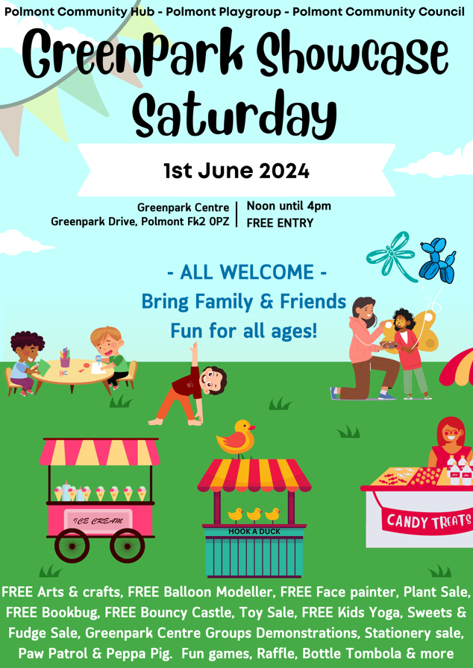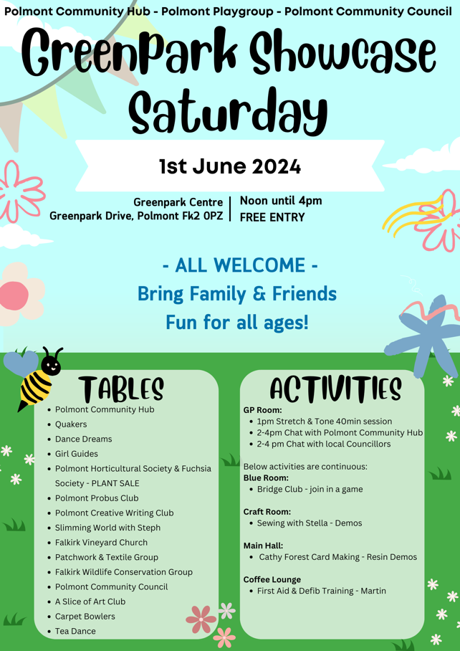

Figure – Greenpark Showcase Flyer

**ONLINE SURVEY** – We utilised a simple Google Form to survey our community on the future of the centre. We have received 188 responses and rising, and a summary of the results to date are as follows (full responses in Attachment ***A01-SAVE Greenpark Centre Questionnaire (Responses).xlsx***):

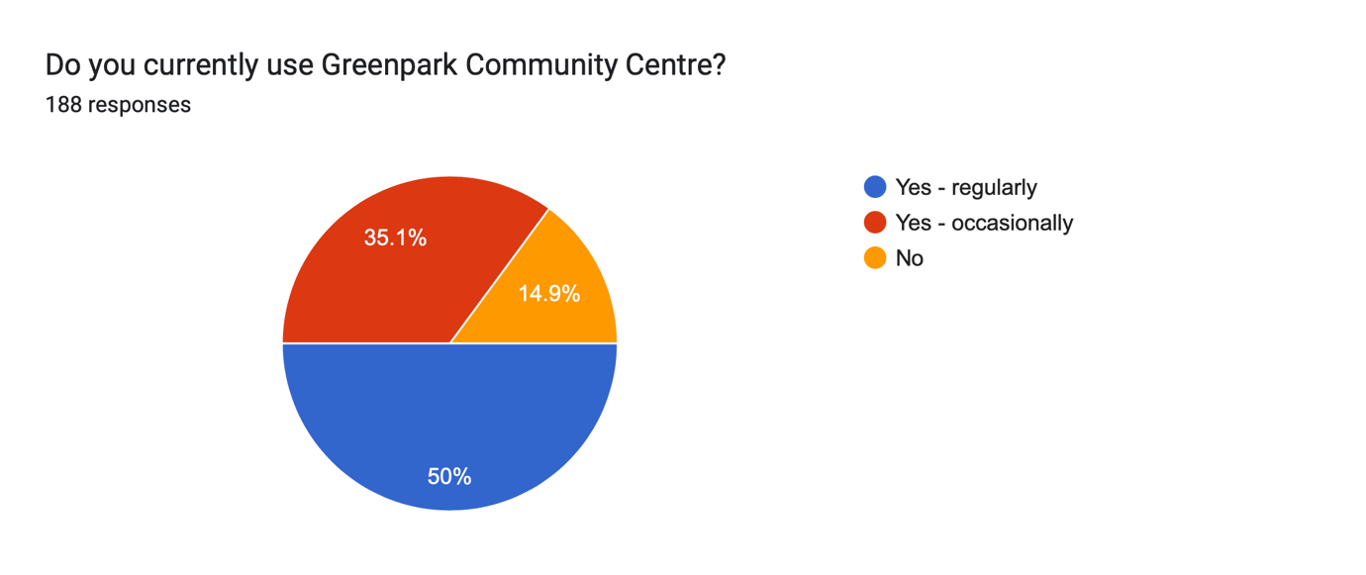

Figure – Survey Result – Usage

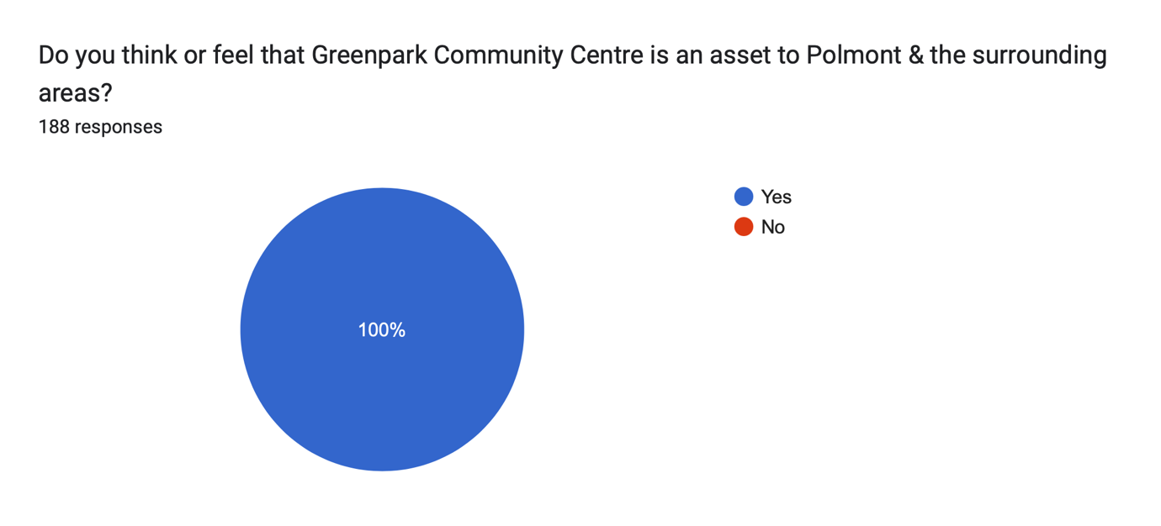

Figure – Survey Result - Deemed Asset

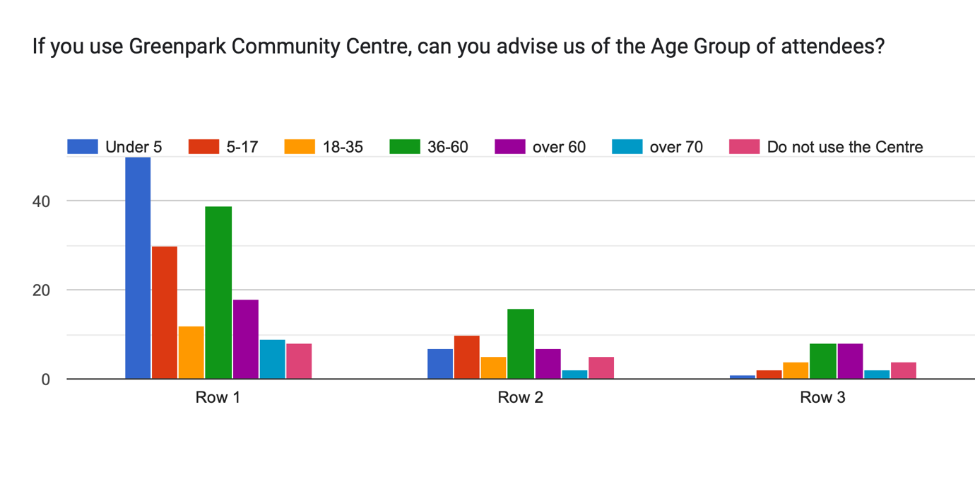

Figure – Survey Result - Usage by Age

## 3.7. Marketing Activities

**FALKIRK HERALD** - We will contact the Falkirk Herald as we have been doing throughout this process to raise the profile of the centre. They recently covered our well-advertised Showcase Saturday:

[IMAGE REDACTED]

Figure – Marketing, Falkirk Herald Excerpt 1

[IMAGE REDACTED]

Figure – Marketing, Falkirk Herald Excerpt 2

**WEBSITE –** We have a consultant volunteer who is currently finalising the design of our website and booking system, tailored to our centre under the domain [www.polmontcommunityhub.co.uk](http://www.polmontcommunityhub.co.uk) We plan to populate this will information about all the groups, a timetable and manage the room bookings to ensure showing real time availability.

**NOTICEBOARDS** – We have large notice boards throughout the Centre, and we will continue to utilise these to advertise as many groups, classes and information as possible. We will also conduct regular advertising via posters in community facilities, community notice boards and local shops: we will ensure that the Centre is advertised and promoted wherever possible.

**INSTAGRAM & FACEBOOK PAGE** – We now have active Instagram and Facebook pages, “Polmont Community Hub”, with growing presence due to regular posting with consistent and increasing interaction. Most of our posts are shared by the local councillors and shared on to local community groups such as ‘Braes Blether’. We use High-quality visuals including photographs, videos and banners and will showcase all our activities.

**WORD OF MOUTH** – In relation to the continued promotion of our community centre, word of mouth through the local community's active engagement will remain a key component. We recognise the value and impact of social media, and we will make strong efforts to promote our services through Facebook to keep people talking about the available services at the Centre. We aim to continue with the established clientele, and benefit from their recommendations to bring in additional opportunities.

**There is a need, genuine desire, and support, for the community asset transfer!**

1. **Funding**
   1. Please outline how you propose to fund the price or rent you are prepared to pay for the land, and your proposed use of the land.

*You should show your calculations of the costs associated with the transfer of the land or building and your future use of it, including any redevelopment, ongoing maintenance and the costs of your activities. All proposed income and investment should be identified, including volunteering and donations. If you intend to apply for grants or loans you should demonstrate that your proposals are eligible for the relevant scheme, according to the guidance available for applicants.*

The current valuation of the building is yet to be communicated by Falkirk Council but for the purpose of this report, we consider it to be no more than £150k.

Essential repairs (as demonstrated in the Conditional Survey – attachment ***A03-Falkirk Council Condition Survey 2023 Greenpark CE Centre.pdf***) to the building are £0, with Falkirk Council required to undertake to ensure that the building is wind and watertight, and statutorily compliant. We expect to have to carry out additional repairs in the value of £424,879, according to the conditional survey, over the next 5 years, to bring the building up to an acceptable standard and fit for purpose. We propose that the community benefit that we can provide is £2.6m over the next 5 years. We propose to pay the value of £1.00.

**We will endeavour to put in place relevant permissions, funding, and partnerships during the asset transfer process.**

(Calculations for Years 2-5 use an inflationary increase of 3.5% per annum).

|  |  |  |  |  |  |
| --- | --- | --- | --- | --- | --- |
| **Volunteering Hours** | **Rate** | **Hours** | **Year 1 Benefit** | **Year 2-3 Benefit** | **Year 4-5 Benefit** |
| Board of Trustees (4) | £40* | 25 p/w | £208,000 | £438,095 | £453,429 |
| Professional Services volunteers (3) | £100 | 6p/w | £30,000 | £63,186 | £65,399 |
| Volunteers (15) | £12** | 4p/m | £8,640 | £18,197 | £18,834 |
|  | **Total** |  | £246,640 | £519,477 | £537,662 |
| *Taken as an average of a Board members salary  **Real Living Wage  **Activities by Board Members, equating 25 hours per week:**   |  |  |  | | --- | --- | --- | | Keyholder management & rota | Email management | Sundries purchases | | Staff governance | Social media content | Equipment purchase | | Staff training | Meeting planning | General maintenance | | Treasurers report | Financial accounts | Chair report | | Statutory compliance | Event planning | Collecting fees | | Paying bills | Applying for funding |  |   **Activities carried out by volunteers, equating to 2 hours per month:**   |  |  | | --- | --- | | Fun Day/Events | Meeting attendance |   **Our plan for Community Asset Transfer will benefit the public health and social wellbeing in the area.**   |  |  |  |  |  | | --- | --- | --- | --- | --- | | **Community Benefit** | | **Year 1** | **Year 2-3** | **Year 4-5** | | Economic development/ income generation | Polmont Community Hub provides essential services and spaces that might otherwise be inaccessible due to the financial constraints of our local community. We plan to offer employment opportunities once the asset transfer is complete, in the form of a cleaner, and a centre manager. The centre remaining open and in community ownership, will help to develop the skills and experience of our local community through volunteer places, to build upon an individual’s experience and skills capacity, thus supporting our community’s future employability.  Our centre hosts regular writing confidence groups for further personal development, which can have a positive impact on an individual's job prospects and education prospects as well as encouraging social inclusion. One particular member is over 100 years old, and this has been a life send to them. Our users are better able to conduct themselves in interviews, within a work setting, and other social settings, meaning that they can make those meaningful and impactful relationships that can help them in their personal, professional, and educational life.  We provide multiple work experience placements to provide experience, permanent & casual employment opportunities. We support local child businesses, providing them with an affordable venue for their services.  We will have a progressive pricing structure, making it affordable to use our centre to allow access for all. | £27,000 | £56,868 | £60,918 | | Regeneration | Unfortunately, due to the economic climate and the cost-of-living crisis, there has been a decline in the number of businesses, venues, and amenities in our community. The closing of a vital community building would be hugely damaging to the local area. We have plans to upgrade our space and our garden area, so that it can be enjoyed by our whole community. We plan to continue our community work to contribute to the local regeneration of the area. Our initiatives of hosting outdoor events, supporting local businesses, and advocating for community needs, means that we are actively engaging with our broader community: our community centre helps create a more vibrant, connected, and resilient local area.  We plan to regenerate the centre, so that it is a modernised, well-equipped and functional hub for our community. | £18,500 | £38,965 | £41,740 | | Public Health | By improving the overall health of the community, our group aims to help ease the pressure on public and social services, and on other facilities. Our LET helps to combat mental health issues in our local area. By engaging in regular social activities, our community can reduce stress, improve mood, and gain a sense of purpose. Physical activities at our centre, such as yoga classes, martial arts classes, and dance classes, help maintain physical health and mobility for all those who attend them. Together, these benefits contribute to a healthier, happier, and more connected community. When individuals have access to programmes that support their social, mental, and physical health, they are less likely to require intervention from public services. This proactive approach to community health not only benefits individuals, but also reduces the burden on public resources, allowing them to be allocated more effectively, to areas where they are needed the most.  Mental Health is improved due to increased social interaction, the reduction of social isolation, and more wealth is retained within the local community.  We know that 1 in 4 people experience some form of poor mental health in their lifetime, and that mental health is an umbrella term which encompasses not only mental health problems/illness and mental health wellbeing. Therefore, it should be highlighted that the Polmont Community Hub could help reduce this by creating some breathing space and balancing out the mental load that those in our community are facing. We plan on opening a wellbeing cafe, which will operate from our centre, allowing individuals to interact in a safe and neutral space.  By way of encouraging physical movement, offering multiple sports and fitness offerings for all ages and abilities. Additionally offering support groups for individuals to engage with, whether that be for mental health support, or physical health support, Polmont Community Hub is always there as a venue for people to come together. There is a definite increase in people being more connected and coming together, people in the local area have an increased level of fitness, thus resulting in less interactions with the NHS.  There will also be an increase in the level of personal fitness and wellbeing overall. | £72,000 | £151,648 | £162,449 | | Social Wellbeing | The activities and social interactions facilitated at Polmont Community Hub will contribute significantly to both the mental and social wellbeing of our community. Our centre provides a safe space for the local community to meet and engage with each other, in a vast range of activities and events.  Attendees to our centre, can form meaningful friendships, build a supportive network, and gain an increased sense of community connectedness. Allowing for better communications between peers in both adults and children. These connections can even last a lifetime, forming in childhood, and continuing into adulthood.  Equality is at the heart of everything that we do, and as a community we recognise that maintaining Polmont Community Hub gives us the opportunity by offering services for young people to attend various classes, events, and activities.  We regularly update information via email, on our social media and notice boards to advertise support available. Our volunteers are friendly and approachable for anyone who needs further support. | £69,500 | £146,382 | £156,808 | | Environmental Wellbeing / Environmental Benefits | We plan to continue to work in an environmentally conscious way, and we have plans to engage with funders to make energy efficiency improvements to reduce our carbon footprint on the environment and local community. These improvements contribute to a healthier, more attractive, and more liveable community, benefiting all who live here.  We regularly update information via email, on our social media and notice boards to advertise support available. Our volunteers are friendly and approachable for anyone who needs further support. | £12,500 | £26,327 | £28,203 | |  | **Total** | £199,500 | £420,191 | £450,120 | | | | | | |

**Signature**

Two office-bearers (board members, charity trustees or committee members) of the community transfer body must sign the form. They must provide their full names and home addresses for the purposes of prevention and detection of fraud.

This form and supporting documents will be made available online for any interested person to read and comment on. Personal information will be redacted before the form is made available.

**We, the undersigned on behalf of the community transfer body as noted at section 1, make an asset transfer request as specified in this form.**

**We declare that the information provided in this form and any accompanying documents is accurate to the best of our knowledge.**

Name [REDACTED]

Address [REDACTED]

Date 11.09.2024

Position Chair

Signature

Name [REDACTED]

Address [REDACTED]

Date 11.09.2024

Position Treasurer

Signature

**Checklist of accompanying documents**

To check that nothing is missed, please list any documents which you are submitting to accompany this form.

**Section 1 – you must attach your organisation’s constitution, articles of association or registered rules**

Title of document attached:

A04-Polmont Community Hub - Constitution (May 2024).pdf

**Section 2 – any maps, drawings or description of the land requested**

Included directly in this application form

**Section 3 – note of any terms and conditions that are to apply to the request**

See attachment A06 – Conditions of Request.pdf

**Section 4 – about your proposals, their benefits, any restrictions on the land or potential negative consequences, and your organisation’s capacity to deliver.**

Included directly in this application form

**Section 5 – evidence of community support**

Documents attached:

A01-SAVE Greenpark Centre Questionnaire (Responses).xlsx

A05-Letters of Support.pdf

**Section 6 – funding**

Documents attached:

A02-Financial Projections & Weekly Planner Greenpark.xlsx