COMMUNITY EMPOWERMENT (SCOTLAND) ACT 2015
FALKIRK COUNCIL ASSET TRANSFER REQUEST FORM
IMPORTANT NOTES:
This is an application form which can be used to make an Asset Transfer request to Falkirk Council.
Any Community Body interested in making an Asset Transfer Request is advised to contact the Asset Team on strategicpropertyreview@falkirk.gov.uk before making the request so that we can discuss your proposal.
Please complete the asset transfer request form if the property/land is owned/leased/managed by Falkirk Council.
It is essential that you read the Asset Transfer guidance provided by the Scottish Government before making a request.
When completed, this form should be emailed to strategicpropertyreview@falkirk.gov.uk or sent to
The Asset Team
Falkirk Council
4 Stadium Way
Falkirk
FK2 9EE

Section 1: Information about the Community Transfer Body (CTB) making the request
  - Name of the CTB making the asset transfer request
Laurieston Community Hall at the Thrums - Charity Number SC053483
  - CTB address. This should be the registered address, if you have one.
Postal address: Laurieston Community Hall at the Thrums,
Park Avenue, The Thrums, Laurieston, Falkirk

Postcode: FK2 9LR

  - Contact details. Please provide the name and contact address to which correspondence in relation to this asset transfer request should be sent.
Contact name: [REDACTED]
Postal address:

Postcode:
Email:
Telephone:
X We agree that correspondence in relation to this asset transfer request may be sent by email to the email address given above. (Please tick to indicate agreement)
You can ask Falkirk Council to stop sending correspondence by email, or change the email address, by telling them at any time, as long as 5 working days’ notice is given.

  - Please mark an “X” in the relevant box to confirm the type of CTB and its official number, if it has one.
 | Company and its company number is ………….
X | Scottish Charitable Incorporated Organisation (SCIO) and its charity number is ……………….. | SC053483
 | Community Benefit Society (BenCom) and its registered number is ………………………………
 | Unincorporated organisation (no number)

Please attach a copy of the CTB’s constitution, articles of association or registered rules.
Please note that under The Community Empowerment (Scotland) Act 2015, where a CTB is seeking ownership rather than a lease, the organisation must have at least 20 members. See the Scottish Government’s Guidance for Community Transfer Bodies.
  - Has the organisation been individually designated as a community transfer body by the Scottish Ministers?
No x
Yes ☐
Please give the title and date of the designation order:

  - Does the organisation fall within a class of bodies which has been designated as community transfer bodies by the Scottish Ministers?
No
Yes ☐
If yes, what class of bodies does it fall within?
SCIO

- Information about the land and rights requested
  - Please identify the property/land to which this asset transfer request relates.
You should provide a street address or grid reference and any name by which the land or building is known. If you have identified the land on the relevant authority’s register of land, please enter the details listed there.
It may be helpful to provide one or more maps or drawings to show the boundaries of the land requested. If you are requesting part of a piece of land, you must attach a map and give a full description of the boundaries of the area to which your request relates. If you are requesting part of a building, please make clear what area you require. A drawing may be helpful.
Details of Property: Laurieston Community Hall
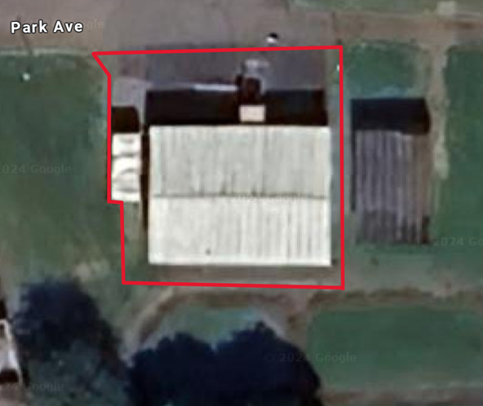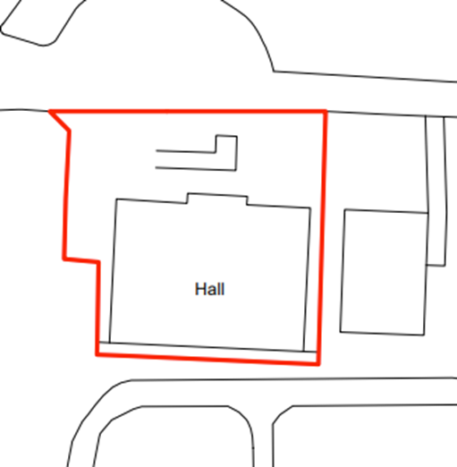

Address: Park Avenue, The Thrums, Laurieston, Falkirk

Postcode: FK2 9LR

  - Please provide the UPRN (Unique Property Reference Number), if known.

UPRN:136071835

- Type of request, payment and conditions
  - Please tick what type of request is being made:

for ownership (under section 79(2)(a)) - go to section 3A
X
for lease (under section 79(2)(b)(i)) – go to section 3B

for other rights (section 79(2)(b)(ii)) - go to section 3C

3A – Request for Ownership
What price are you prepared to pay for the land requested?
Proposed price: £
Please attach a note setting out any other terms and conditions you wish to apply to the request.

3B – Request for Lease

What is the length of lease you are requesting?
20 Years

How much rent are you prepared to pay? Please make clear whether this is per year or per month.

Proposed rent: £ 1 per YEAR

Please attach a note setting out any other terms and conditions you wish to be included in the lease, or to apply to the request in any other way.

3C – Request for other Rights
What are the rights you are requesting?

Do you propose to make any payment for these rights?
Yes
No ☐
If yes, how much are you prepared to pay? Please make clear what period this would cover, for example per week, per month, per day?
Proposed payment: £

Please set out any other terms and conditions you wish to apply to the request.

- Community Proposal
  - Please set out the reasons for making the request and how the land or building will be used.
This should explain the objectives of your project, why there is a need for it, any development or changes you plan to make to the land or building, and any activities that will take place there.
4.1.1 Objectives of Project

We aim to work alongside the community to develop positive well-being, reduce isolation, improve mental health and access to support, community empowerment, a sense of belonging and knowledge. We provide a variety of groups, social events, fundraising and training for all ages from babies to elderly with a vast provision of activities.

We have secured commitment from a number of ‘not for profit’ and established businesses for regular lets including, but not limited to:

- A playgroup which runs from the hall twice per week
- A childminders group which runs from the hall one day a week and weekly during school holidays.
- An exercise and fitness class once a week for older ladies.

We have regular ad-hoc and social events including but not limited to:

- Charity bingo, psychic nights and craft fayres
- Parties for birthdays or other family events for all ages
- Community ‘fun’ days at important times of the year such as Easter, Summertime, Halloween, and Christmas.
- Training and Team Building Events

4.1.2 Why is there a need for your Project?

The Laurieston community is a thriving community with limited resources connecting them with others within their locality. There is very limited capacity for bringing individuals and families together to give a greater sense of community belonging. We feel that our proposal presents an optimum opportunity to build on all the work which our group has successfully implemented since we came on board in March 2024. We have made drastic changes to the way the building is managed, engaging over 500 people across multiple events. We are very proud of this achievement, and it hopefully gives some indication of the hard work and effort which has gone into creating the community space in such a short period of time.

Due to the current status and unknown future of the building and who will be given overall responsibility from the Community Asset Transfer, we are precluded from several funding streams and opportunities for asset growth.

The space provides flexibility to cater for so many people within the community and we are open and experienced in delivering all types of events, social spaces and working with others to provide a full range of much needed social inclusion.
The hall will be a safe space and create lots of little communities from within, including a space to meet new people and connect with others on a similar level to their own experiences including the elderly, new mums, specific health issues such as mental health or obesity, people who are new to the community or just lonely. We will work with locality housing officers as a signpost to inviting new members to our groups (as well as actively engaging on social media, leaflet drops etc.) and are always open to new events or regular groups which it is determined that the community will benefit from.

We have an active booking schedule committed until July 2025 and have been working tirelessly to create a varied schedule continuing existing custom and looking for new things which the community will enjoy and targeting a wide range of hobbies, entertainment and social connection. If our proposal is not progressed, there will be a lot of disappointed business and community persons. This displacement would be devastating to those who have come to the centre and some who have this as their only support.

4.1.3 Will any Development/changes/modifications to the asset be required?

At present, we are not aware of any changes required to modify the building.

4.1.4 What activities will take place?

Playgroup
Childminder's Sessions
Bingo
Craft Fayres
P7 Leavers Parties
Cabaret Nights
Psychic Nights
Keep Fit / Circuits
Crafts
Cycling Proficiency
Concerts for the elderly
Language Classes
Children’s Parties
Fairy Trail
Outdoor BushCraft
Seasonal events
Private Lets
Wacky Races
Pop up tuck shop

4.1.5. If the asset is to be used by the public, please provide details of lettings policy and opening times.

Because of the area as to where the hall is we cannot have the closing time too late
due to neighbours.

Public able to let 09:00-22:00 weekdays, weekends 09:00-23:30.

Please see attached letting policy.

4.1.6 What provision will be provided for people with disabilities?

There is a disabled ramp into the property which is already suitable for use. There
is also a toilet inside, however, this is not DDA compliant and therefore grant funding
or any profits made will be required to be used to refurbish this toilet space.

4.1.7 Any other relevant information?

We would like to have use of the council owned cycle track at the rear of the hall for
our planned events.

Benefits of the proposal
  - Please set out the benefits that you consider will arise if the request is agreed to.
Local Authorities are permitted to dispose of property at less than market value where there are wider public benefits to be gained. This is set out in the Disposal of Land by Local Authorities (Scotland) Regulations 2010. These public benefits are listed below.
In this section, please explain how the project will benefit your community, and others. Please refer to the Scottish Government guidance on how the Council will consider the benefits of a request.
Please explain how the project will benefit your community by detailing how your project will promote or improve:-

4.2.1. Economic development/income generation

ie. Please include details of any job creation or volunteering and training opportunities that will be available as a result of the Asset Transfer. Also details of how your organisation will involve the local community and of any incentives that may be available to encourage the local community to use the proposed services

Previously detailed in the section covering 4.11 and 4.12, our proposals will bring the full community together creating a ‘heart’ of the community with this building.

Our centre provides essential services and spaces that might otherwise be inaccessible due to the financial constraints of our local community. The centre remaining open and in community ownership, will help to develop the skills and experience of our local community through volunteer places, to build upon an individual’s experience and skills capacity, thus supporting our community’s future employability.
By offering volunteer positions, the centre will help residents develop new skills and gain valuable work experience. Volunteering can serve as a stepping stone to future employment, enhancing the employability of individuals and contributing to the overall skill level of the community.
The centre can support local businesses by providing a venue for classes, workshops, and events. This can stimulate local commerce and provide additional income streams for small business owners.
The community centre can host social enterprises, which reinvest profits back into the community. For example, a community café can generate income while providing affordable food options. This not only supports local economic activity but also addresses issues of food insecurity and affordability.
Offering educational and training programs can help bridge the gap for those who are not in full-time education or employment.

A community centre fosters social cohesion and well-being, which are essential for a thriving economy. By providing a space for community activities and support services, the centre can improve the quality of life for residents, making Laurieston a more attractive place to live and work. This can indirectly boost the local economy by attracting new residents and businesses.

We have a number of volunteers on our committee who are dedicated to managing the success of our business plan and the running of the community building.

We will actively encourage the local community to volunteer at the centre and provide employment and education opportunities wherever possible. One of our volunteers has gained so much knowledge and experience with working within our local playgroup, that she has found the confidence to now take forward this as her career. We will work closely with housing officers, DWP and other third sector groups to collaborate on employment and volunteer opportunities.

We will ensure that all volunteer opportunities are, in the first instance, made available to those in the immediate local community. When we are using any external third party for works or services, we will aim to use local SMEs wherever possible. We will have a notice board within the hall where local companies or self-employed persons can advertise their services to help stimulate the local economy.

    - Regeneration

i.e. Please include details of whether your organisation will contribute to the physical regeneration of the area, and how your proposal will impact the regeneration of the area, in terms of volunteering or employment, giving examples.

Unfortunately, due to the economic climate and the cost-of-living crisis, there has been a decline in the number of businesses, venues, and amenities in our community. The closing of a vital community building would be hugely damaging to the local area. We plan to continue our community work to contribute to the local regeneration of the area. Our initiatives of hosting outdoor events, supporting local businesses, and advocating for community needs, means that we are actively engaging with our broader community: our community centre helps create a more vibrant, connected, and resilient local area.
The community centre can act as a hub for local economic activity. By hosting open days, fairs, and other events, it can attract visitors and stimulate spending in the area. Increased foot traffic can benefit local businesses, helping them to thrive and potentially encouraging new businesses to set up in the area.
We will continue to work on the regeneration commenced by Falkirk Council with the cycle path and park, by ensuring that this investment is well used. We will do this by having specific regular events which utilise this asset.

    - Public Health

i.e. How likely is the proposal to improve the Public Health of the Community, in terms of physical and mental health, for example through volunteering, training, or taking part in activities, giving examples.

By improving the overall health of the community, our group aims to help ease the pressure on public and social services, and on other facilities. By engaging in regular social activities, our community can reduce stress, improve mood, and gain a sense of purpose. Physical activities at our centre, such as circuit fitness classes help maintain physical health and mobility for all those who attend them. Together, these benefits contribute to a healthier, happier, and more connected community. When individuals have access to programmes that support their social, mental, and physical health, they are less likely to require intervention from public services. This proactive approach to community health not only benefits individuals, but also reduces the burden on public resources, allowing them to be allocated more effectively, to areas where they are needed the most.
Regular social activities can reduce stress, improve mood, and provide a sense of purpose, which can decrease the reliance on medication and mental health services.
Physical activities such as yoga classes can help maintain physical health and mobility. Regular exercise can prevent chronic diseases, improve mobility, and enhance the overall quality of life for older adults.

By improving the overall health of the community, the centre can help ease the pressure on public and social services. Healthier individuals are less likely to require medical interventions, which can reduce the burden on healthcare facilities. This proactive approach allows public resources to be allocated more effectively to areas where they are needed the most.
Offering educational programs on nutrition, mental health, and preventative care can empower residents to take control of their health. The community centre can collaborate with local health services to provide accessible health screenings, vaccinations, and other essential services. This can be particularly beneficial in ensuring that vulnerable populations receive the care they need

This proposal will drastically improve physical and mental health. We are creating a safe, social space where the local community can come and make friends, share their stories and benefit from training, employment, volunteer opportunities and reduce isolation. As a group, we will take feedback regularly from those who are using the hall – but also from those who aren’t to ensure that we are constantly striving to get as many people on board as possible.

    - Social Wellbeing

i.e. How will the proposal improve the Community's Social Well-Being and mental health, or how might it improve the learning offer and activities available in the area? Please give brief examples of these activities.

The activities and social interactions facilitated at Laurieston Community Hall will contribute significantly to both the mental and social wellbeing of our community. Our centre provides a safe space for the local community to meet and engage with each other, in a vast range of activities and events.
A vibrant community centre can foster social cohesion by providing a space for residents to come together, share experiences, and support one another. Social activities and support groups hosted at the centre can help to reduce social isolation and improve mental health.
The centre can host a wide range of social activities and events, from hobby groups to cultural celebrations. These activities foster a sense of community and belonging, which is essential for social well-being.
Offering volunteer opportunities at the centre can enhance social cohesion and provide residents with a sense of purpose. Volunteering can help individuals develop new skills, gain confidence, and feel more connected to their community.
The community centre can host support groups and services for various needs, such as mental health support, parenting classes, and senior citizen activities. These services can provide essential support to vulnerable populations and improve overall social well-being.
By facilitating intergenerational activities, the centre can bridge the gap between different age groups. Intergenerational activities can foster mutual understanding and respect and provide opportunities for learning and mentorship.
The centre can serve as a hub for community engagement, encouraging residents to participate in local decision-making processes. This can foster a sense of ownership and pride in the community, leading to greater social cohesion and well-being.

Isolation, mental health, depression are all drastically improved by interaction with others. We are offering a full range of low cost/free opportunities for people to get involved in that caters to all ages, hobbies and preferences. We also partake in fun days out such as beach trips, pumpkin picking and zoo trips. These are very well attended including by those who have disabilities and we are very proud of the integration of the local community that we have already achieved.

    - Environmental Well Being / Environmental Benefits

i.e. Will the proposal bring green / environmental benefits and / or have an impact on the local environment? Will it help mitigate the effects of climate change? If so please give details.

We plan to continue to work in an environmentally conscious way, and we have plans to engage with funders to make energy efficiency improvements to reduce our carbon footprint on the environment and local community. These improvements contribute to a healthier, more attractive, and more liveable community, benefiting all who live here.
By engaging with funders to make energy efficiency improvements, the community centre can reduce its carbon footprint.
By implementing energy-efficient technologies and sustainable practices, the community centre can reduce its environmental impact. The centre can engage the community in environmental initiatives, such as clean-up drives, tree planting events, and recycling programs. These activities can foster a sense of community pride and responsibility, encouraging residents to take an active role in protecting their local environment.
We are planning to run a planting and gardening opportunity to plant seeds and flowers to improve the look of the hall and allow people to get involved in gardening under supervision. This will improve the environment aesthetically.

    - Does your project contribute to the reduction of inequalities?

i.e. Will the proposal enable the community to access activities not otherwise available; will these activities be available at an affordable rate; how will your organisation work with other local providers to reduce inequalities?

Many of our trips and days out/activities are funded by the charity so this enables everyone to be included despite their financial situation making it accessible for all. We hope as our ability to secure longer term lets and as our project grows, that more grant funding streams will become available to us to expand these events for the local community as they are very well received.

4.2.7 Will local people be engaged in the use and management of the Asset?

A “community of interest” may not represent the people living near to the asset. Please provide evidence of how local people and communities will be engaged in the use and management of the asset, and how they have been consulted.

Yes, the local school and nursery will be involved in designing the Fairy Trail toadstools and fairy doors which will be part of the trail. We will encourage the children to attend and enjoy the outdoor activity with their family. We will be hosting seasonal activities, such as Halloween parties and Breakfast with Santa so there will be many opportunities for Laurieston children and surrounding areas to enjoy our events.

We will continue to engage with the local community to develop the hall to reflect what the residents of Laurieston would like to see happening at their local facility.

4.2.8 How will you monitor whether the Asset Transfer is benefiting the community?

ie. Will you survey the users / invite feedback / compare user numbers with a baseline etc
We are always looking for feedback and will provide feedback forms after each event. We will monitor the number of attendees at our events as the year progresses and we become bedded into the community and word of mouth spreads on what we can provide and how accommodating we are, providing other events or opportunities based on feedback.
We will also encourage feedback on our web page and social media platforms.

4.2.9 Any other relevant information?

Restrictions on use of the land
  - If there are any restrictions on the use or development of the land, please explain how your project will comply with these.
Restrictions might include, amongst others, environmental designations such as a Site of Special Scientific Interest (SSI), heritage designations such as listed building status, controls on contaminated land or planning restrictions.
We are unaware of any restrictions on the use or development of the land

Negative consequences
  - Are there any negative consequences that will affect other groups or individuals if your request is agreed to? How do you propose to minimise / reduce these?
For example, increased traffic etc. Please consider any potential negative consequences for the local economy, environment, or any group of people, and explain how you could reduce these.
Increased traffic may happen on a popular night or event, we would be considerate and advise the neighbours and make sure everyone at the event has parked considerately. We will ensure that all waste is removed and we will use recyclable products and produce wherever possible.
Capacity to deliver
  - Please show how your organisation will be able to manage the project and achieve your objectives.
This could include the skills and experience of members of the organisation, any track record of previous projects, whether you intend to use professional advisers, etc.
4.5.1 Has your organisation or any of its members managed projects or owned / leased property/land prior to this?
Yes x
No ☐

Please provide details of:
4.5.2 Skills and experience of the members of the organisation
[REDACTED] is an experienced project manager and has worked on multiple projects over most of her adult life. She is also very well established and regarded in the local community and has previously been a Committee member for the Ettrick Dochart Community Hall for 6 years. (2018-2024)
[REDACTED] has been on the Ettrick Dochart Community Hall Committee for the last 16 yrs and brings a wealth of knowledge and experience on the management of community leases, events and marketing.
4.5.3 Do you intend to use professional advisors? Please provide details.
We will use an accountant for our annual submission of our accounts to OSCR and will seek legal advice for our lease.
4.5.4 Do you currently lease/manage a property from Falkirk Council? If yes, please provide details.
No
4.5.4 Please detail how you plan to manage the building?
For example opening and closing the building / managing lets / will you have staff etc?

[REDECTED] is the key holder and we have 21 members on our newly established Committee who all volunteer their time to make this a success. [REDECTED] is the secretary and manages the diary on a daily basis. We all work together to ensure that lets are appropriately manned as required.

We hope in the future we will gain funding for a door access entry system to enhance security.
4.5.5 Please provide any other information you think may be relevant.

- Level and nature of support
  - Please provide details of the level and nature of support for the request, from your community and, if relevant, from others.
This could include information on the proportion of your community who are involved with the request, how you have engaged with your community beyond the members of your organisation and what their response has been. You should also show how you have engaged with any other communities that may be affected by your proposals.
5.1.1. What community engagement has taken place to help develop your business plan? Please provide evidence, for example any completed surveys, questionnaires, letters of support, minutes of public meetings etc.
We have engaged with the community on multiple occasions through social media and open days, we have a web page, have opened a new Facebook page as well as using the local community page “Laurieston Folks” to let people know we are here. We are constantly speaking with local residents using the hall and park whilst we are in session with the various events.
The hall has had low usage and our intention is to increase this to support the aspirations of the community. We now have 90-100 people using the hall on a weekly basis and aim to increase this using the feedback we have gained from the local community for what they would like to see at the hall.
The hall usage has increased as we encouraged a new group with a register of 120 kids and 42 adults to join our hall.
By allowing the Childminders that attend the playgroup to use the toys and equipment on a different day, the group "Childminder's Sessions" joined the hall in May. They advertise weekly and have to restrict the users due to the hall capacity and therefore may open a second day.
We have had several successful events which brought in increased footfall. Midweek bingo was a sell out with no more available seats and tables.
The Open Day for the regenerated cycle track brought large crowds all day, where we took the time to speak to the community regarding our intentions of opening up the hall with events to the community. The Falkirk Herald printed a huge story with photos on August 8th 24.
The Psychic Nights and weekend bingo nights are very well attended and we have a lot of the community come in that didn't know the hall was open. We have 30-40 people attend these events.
We created a poll asking the community on FB pages "Laurieston Folks", some questions.
Do you want the hall to stay open? – 144 people answered yes
Have you used the hall for any events- 5 people answered yes
Have you used the hall for any group activities- 44 people answered yes
10 people would like to be involved in helping with fundraisers and 6 people would like to become volunteers.
Events the community would like to see in the future include Slimming World, Kids Parties. Charity & Religious Events.

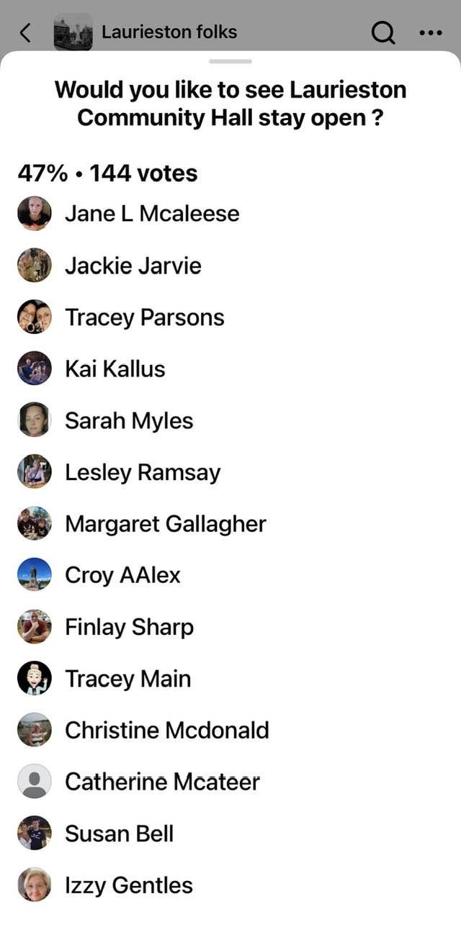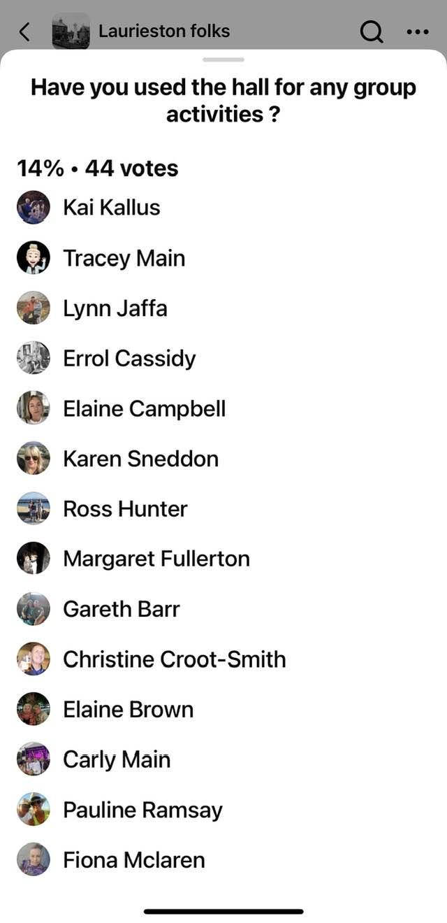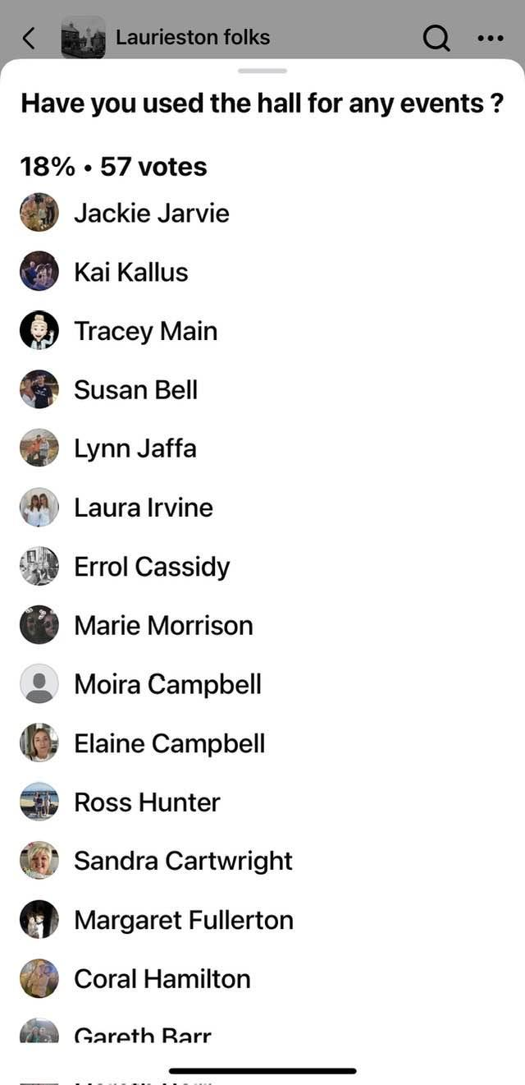

We conducted the same poll on Cradle to Crayons Playgroup albeit a smaller number of members-
46 votes said yes to wanting the hall to stay open.
24 votes said yes to using the hall for events.
32 votes said yes to using the hall for any group activities.
11 votes would like to help with fundraisers.
7 votes would like to volunteer.

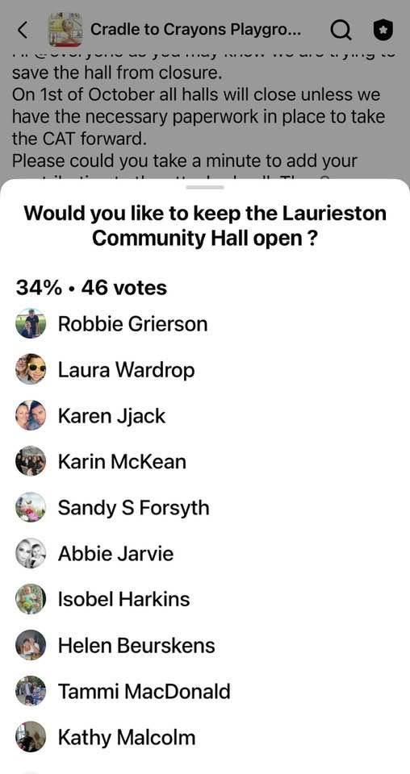

There is a need, genuine desire, and support, for the community asset transfer.

5.1.2 Have you consulted with other local stakeholder groups or agencies? Please provide evidence.
We have spoken to other halls in the area and other establishments eg, bowling club for help and support in obtaining the transfer asset, they are fully onboard and willing to help and support. We are getting support from CVS and CLD workers from the Council in relation to our plans.
5.1.4 Have you been in contact with any other communities or community groups
that may be affected? Please give details.
We have attended other community hall public meetings to ensure they are aware of our plans.
5.1.5 Please provide any other information you think may be relevant.
- Financial Viability of Project
Your Business Plan should contain full information about the financial viability of the project, evidencing that the organisation will be able to sustain the project in the long term.
Please submit
- at least 1 year’s audited accounts to evidence your organisations financial stability (if available)
- where audited accounts are not available (for instance for new groups) please provide a bank statement.
- a projected 5 year income and expenditure account
- a cash flow forecast for the proposed asset transfer.
6.1 Please outline the Policies and Procedures your organisation has in place to govern the group’s finances
We shall clarify each of the roles,authority of the committee members and responsibilities for essential financial management activities and decisions.
We shall implement double-counting of cash deposits,account reconciliation, rotate staff responsibilities, conduct frequent risk assessments, conduct internal and external audits.
We shall have clear authority to spend funds, including approval, and cheque signing.
We shall have clear authority to enter into contracts and for maintaining accurate financial records.
These financial controls shall prevent or detect accounting errors and fraud.

There are no audited accounts available as we are only newly established and to date, don’t have ownership of the hall.

- Funding
  - Please outline how you propose to fund the price or rent you are prepared to pay for the land, and your proposed use of the land.
If you intend to apply for grants or loans you should demonstrate that your proposals are eligible for the relevant scheme, according to the guidance available for applicants.
7.1.1 Please show your calculations of the costs associated with the transfer of the land or buildings and your future use of it, including any redevelopment, ongoing maintenance and the costs of your activities. All proposed income and investment should be identified, including volunteering and donations.
We recognise we will require a solicitor to review and negotiate the terms of our lease. We have secured funding to upgrade the building and will continue to seek funding in the future.
Please see our Cash Flow for all our planned start up, ongoing, maintenance and planned redevelopment costs. Our Cash Flow also shows all proposed income and investment.
Main Hall Lets | Selling Price £/Hour
Charity Rate | £10
Regular Business Rate | £20
Parties/One Off Bookings | £15
BB,Guides, Playgroup,Schools,Nurseries | £10
7.1.2 Please supply details of what funding you have received so far, and of any conditions attached to it.
No funding currently, however, we have applied for several. The National Lottery Funding have asked us to apply once the CAT has been established.
7.1.3 Please supply details of any funding you have applied for but have not yet received a response or decision. Please include timescales if known.
No funding so far, but we have applied for the Falkirk Community Schools 2008 and we hope that our application is successful.
We also have the potential for a national lottery fund, however, we do not yet meet their requirements and criteria with the community asset transfer pending.
We have applied for Falkirk Council’s Capital Equipment Fund.

7.1.4 Details of any other funding you will have access to? i.e. voluntary contributions, borrowing etc.
We will be applying for the Enablement Fund.
7.1.5 Please outline your funding strategy if you have one, as well as any other relevant information.
We will use the resources within our committee to identify the needs of the community, coming together monthly to analyse and implement our long term goals with available funding opportunities.

- Enablement Fund
Falkirk Council will hand the building over wind and watertight and compliant. However, this is quite light-touch and would involve (for example) patching of a leaky roof. For more significant building works, groups can apply to the Enablement Fund, to pay for capital improvements such as energy efficiency improvements or larger capital renewals which support the viability of the project going forward. Only capital items are eligible. Running repairs are revenue costs and are not eligible. You are strongly advised to email strategicpropertyreview@falkirk.gov.uk to confirm eligibility criteria before you submit this application.
Requests to the Fund must be supported by estimates / quotations from professionals which should be provided as supporting documents.
Please provide details of your request to the Enablement Fund, if applicable.
Enablement Fund request for larger capital renewals which support the viability of the CAT
Item | Estimate Provided By | Amount not more than (including VAT)
Disabled Toilets | Sourcing Quotes
Kitchen | Sourcing Quotes
Lighting LED replacement | Sourcing Quotes
Meeting Room refurbished | Sourcing Quotes
Plumbing Water Tank Replaced | Sourcing Quotes
Solar Panels | Sourcing Quotes
Door Entry System | Sourcing Quotes
TOTAL

Checklist of accompanying documents
To check that nothing is missed, please tick which additional documents are accompanying this form.
☐Section 1 – You must attach your organisation’s constitution, articles of association or registered rules
☐Section 2 – Any maps, drawings or description of the land requested
☐Section 3 – Note of any terms and conditions that are to apply to the request
☐Section 4 – Any additional evidence regarding your proposals, their benefits, any restrictions on the land or potential negative consequences, and your organisation’s capacity to deliver.
☐Section 5 – Evidence of community support
☐Section 6 – Financial – Copies of accounts, forecasts, etc
☐Section 7 – Funding – Copy of Business Case etc
☐Section 8 – Enablement Fund – copies of estimates

Declaration
Two office-bearers (board members, charity trustees or committee members) of the community transfer body must sign the form. They must provide their full names and home addresses for the purposes of prevention and detection of fraud.
This form and supporting documents will be made available online for any interested person to read and comment on. Personal information will be redacted before the form is made available.

We, the undersigned on behalf of the community transfer body as noted at Section 1, make an asset transfer request as specified in this form.
We declare that the information provided in this form and any accompanying documents is accurate to the best of our knowledge.
Name [REDECTED]
Address

Date 25.09.24
Position Secretary
Signature

Name [REDECTED]
Address

Date 25.09.24
Position Vice-Chair
Signature

