# **COMMUNITY EMPOWERMENT (SCOTLAND) ACT 2015**

# **ASSET TRANSFER REQUEST FORM**

**IMPORTANT NOTES:**

**This is a standard asset transfer request form which can be used to make a request to any relevant authority. Relevant authorities may also provide their own forms in their own style.**

**You do not need to use this form or a relevant authority’s form to make an asset transfer request, but using a form will help you to make sure you include all the required information.**

**You should read the asset transfer guidance provided by the Scottish Government before making a request. Relevant authorities may also provide additional guidance on their schemes.**

**You are strongly advised to contact the relevant authority and discuss your proposals with them before making an asset transfer request.**

**When completed, this form must be sent to the relevant authority which owns or leases the land your request relates to.**

**This is an asset transfer request made under Part 5 of the Community Empowerment (Scotland) Act 2015.**

1. **Information about the community transfer body (CTB) making the request**
   1. Name of the CTB making the asset transfer request

Limerigg Action Group SCIO SC052145

* 1. CTB address. This should be the registered address, if you have one.

Postal address:  
Limerigg Community Hall  
Slamannan Road  
Limerigg  
Falkirk

Postcode:  
FK1 3BN

* 1. Contact details. Please provide the name and contact address to which correspondence in relation to this asset transfer request should be sent.

Contact name:  
[REDACTED]

Postal address:  
Limerigg Community Hall  
Slamannan Road  
Limerigg  
Falkirk

Postcode:  
FK1 3BN

Email:  
limeriggvillage@gmail.com

Telephone:

**☐** We agree that correspondence in relation to this asset transfer request may be sent by email to the email address given above.

*You can ask the relevant authority to stop sending correspondence by email, or change the email address, by telling them at any time, as long as 5 working days’ notice is given.*

* 1. Please mark an “X” in the relevant box to confirm the type of CTB and its official number, if it has one.

|  |  |  |
| --- | --- | --- |
|  | Company, and its company number is …………. |  |
|  | Scottish Charitable Incorporated Organisation (SCIO), and its charity number is SC052145 | X |
|  | Community Benefit Society (BenCom), and its registered number is ……………………………… |  |
|  | Unincorporated organisation (no number) |  |

**Please attach a copy of the CTB’s constitution, articles of association or registered rules.**

* 1. Has the organisation been individually designated as a community transfer body by the Scottish Ministers?

**No ☐**

**Yes ☐**

Please give the title and date of the designation order:

* 1. Does the organisation fall within a class of bodies which has been designated as community transfer bodies by the Scottish Ministers?

**No ☐**

**Yes ☐**

If yes, what class of bodies does it fall within?

Section 80(1)(b) ‘it is a Scottish charitable incorporated organisation the constitution of which includes provision that the organisation must have not fewer than 20 members’.

1. **Information about the land and rights requested**
   1. Please identify the land to which this asset transfer request relates.

*You should provide a street address or grid reference and any name by which the land or building is known. If you have identified the land on the relevant authority’s register of land, please enter the details listed there.*

*It may be helpful to provide one or more maps or drawings to show the boundaries of the land requested. If you are requesting part of a piece of land, you must give a full description of the boundaries of the area to which your request relates. If you are requesting part of a building, please make clear what area you require. A drawing may be helpful.*

Limerigg Community Hall  
Slamannan Road  
Limerigg  
Falkirk

FK1 3BN

Grid Reference – NS 85600 71157

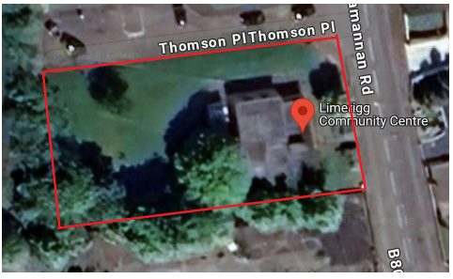

All and whole the building known as Limerigg Village Hall, Limerigg, Falkirk, and the lands as shown above, and bounded as outlined in red.

* 1. Please provide the UPRN (Unique Property Reference Number), if known.

*If the property has a UPRN you will find it in the relevant authority’s register of land.*

UPRN: 136077753

1. **Type of request, payment and conditions**
   1. Please tick what type of request is being made:

for ownership (under section 79(2)(a)) - go to section 3A

X

for lease (under section 79(2)(b)(i)) – go to section 3B

for other rights (section 79(2)(b)(ii)) – go to section 3C

**3A – Request for ownership**

What price are you prepared to pay for the land requested?:

Proposed price: £1

Please attach a note setting out any other terms and conditions you wish to apply to the request.

**3B – request for lease**

What is the length of lease you are requesting?

How much rent are you prepared to pay? Please make clear whether this is per year or per month.

Proposed rent: £

Please attach a note setting out any other terms and conditions you wish to be included in the lease, or to apply to the request in any other way.

**3C – request for other rights**

What are the rights you are requesting?

Do you propose to make any payment for these rights?

**Yes ☐**

**No ☐**

If yes, how much are you prepared to pay? Please make clear what period this would cover, for example per week, per month, per day?

Proposed payment: £ per

Please attach a note setting out any other terms and conditions you wish to apply to the request.

1. **Community Proposal** 
   1. Please set out the reasons for making the request and how the land or building will be used.

*This should explain the objectives of your project, why there is a need for it, any development or changes you plan to make to the land or building, and any activities that will take place there.*

The charity is called Limerigg Action Group and has the legal status of a Scottish Charitable Incorporated Organisation, SCIO number SCO52145. The Hall Working Group forms part of the charity, which was created to support the development, and ongoing needs, of the community hall project.

Limerigg is a tiny village 8 miles south of Falkirk, situated at the top of the Slamannan Plateau at 900 feet above sea level, and was a thriving community in the 40’s and 50’s when the Forestry Commission planted the area with trees and the old miners’ rows were replaced with new council houses. In 1950 the water ski club was opened on the Black Loch.

The Group’s charitable purpose is for the provision of recreational facilities, or the organisation of recreational activities, with the object of improving the conditions of life for the persons for whom the facilities or activities are primarily intended.

Our current and future aims are:     
To obtain funding to renovate the village hall to bring it up to a modern, energy efficient, and ecofriendly standard. The kitchen and toilets within the hall are very dated. Our heating and electricity system is not currently up to standard, and we are working to reduce our environmental impact, our costs, and go greener.   
We aim to use the village hall as a vibrant, inclusive, sustainable space for all people and age groups within the community, to combat loneliness and isolation.   
We aim to host a continuous stream of community engagement events as well as advertising the ability to rent different spaces within the hall for parties, corporate meetings, fitness classes, etc.

MISSION STATEMENT   
**“Working together to create a vibrant village hub that is safe, warm, and inclusive of all. Reducing isolation and loneliness by providing a community space that is sustainable and run by the community, for the community.”**   
**‘Making Limerigg a Designated Destination for training, active workshops and a hub for eco-sustainability, maximising the unique surroundings that Limerigg has to offer.’**

**Benefits of the proposal**

* 1. Please set out the benefits that you consider will arise if the request is agreed to.

*This section should explain how the project will benefit your community, and others. Please refer to the guidance on how the relevant authority will consider the benefits of a request.*

The hall will offer a full range of letting arrangements for groups, businesses and individuals. Initially it will be managed by volunteers from our membership group, however, we may in the future look at employing an individual to manage the building. The hall operating under community ownership will improve the sense of community within Limerigg and will provide a vital ‘Hub’ for the community, due to the rural nature of the village, and lack of access to facilities.

We plan to target all ages and have something for everyone. We want to target loneliness and isolation which can happen to anyone of any age. From our research, we have found that there are more adults within the village than children.

With the community hall as our base, we have plans to upgrade the Play Park and develope the surrounding areas within the village: we have secured funding to upgrade the park, planters added throughout the village, Christmas tree and lights have also been installed.

Some of the events that have taken place in Limerigg village hall so far; Macmillan coffee morning; Christmas arts & craft session; Christmas Ceilidh Dance; Christmas Lights Switch on event; Fitness Taster Sessions. Our village community hall has lacked any programme to develop and drive usage, we believe that we have the necessary skills to manage our building and get the best for our community. We want to create a stronger community and ensure that we are promoting opportunities for all to get involved to help reduce inequality and isolation. We plan on continuing these types of events in order to better serve the community.

The group will carry out all its activities with the Falkirk Plan 2021 – 2030, at the forefront of our minds when our strategic priorities are agreed upon, wherever practicable, with reference to page 21, ‘outcome 12: fewer people struggle with feeling socially isolated or lonely.’

We have hosted a number of different events for the benefit of our local community. These events have included a number of children’s Fun Days; regular Ceilidhs; wreath making classes; working in conjunction with the Forestry and Land Scotland; hosted community consultations (including local business development plans); MacMillan Coffee Mornings; etc.

We work with the community, for the community. We will continue to develop partnerships with local organisations, service providers and community groups.

Our vision is to provide a community led space that helps deliver long-term, social, economic, sustainable and environmental benefits to the local community. The hall will be maintained ongoing, so that it will be there as a place of refuge for our community, in case of emergency, as was the case during the forest fire in recent years.

Our values are based on:   
 - Working in an inclusive and respectful manner, not discriminating against anyone   
 - Being a not-for-profit organisation and investing any surplus in the advancement of facilities for the local community   
 - Being community led   
 - Intergenerational approach to serving all age ranges in the community   
 - Working for the benefit of our community, with the unique challenges that a rural location has

Our objectives are:   
 - To improve health and wellbeing of the local community   
 - Provide increased social benefits   
 - Empower our community and families   
 - Rural connections to improve social isolation and community cohesion

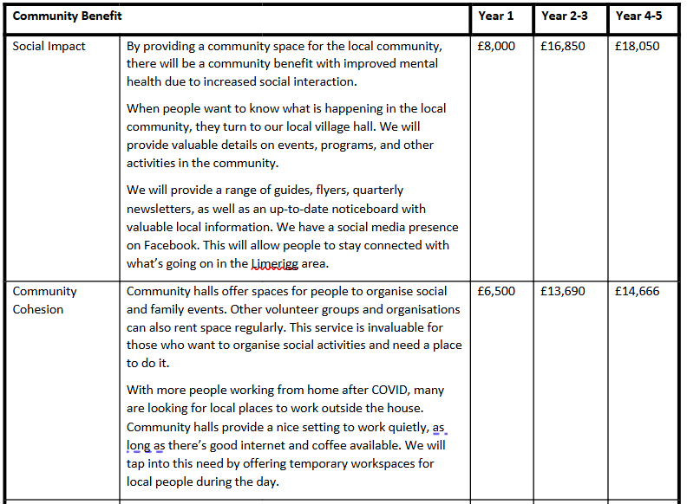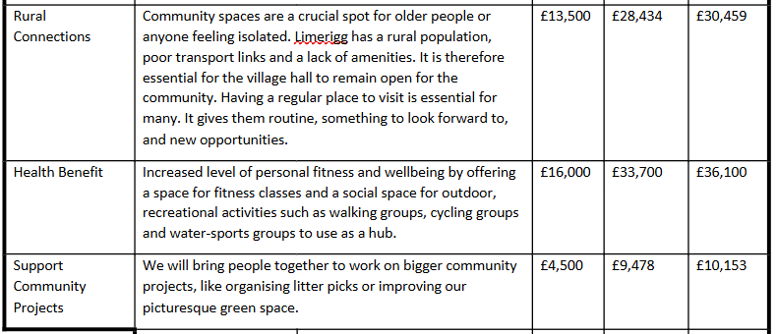

**Restrictions on use of the land**

* 1. If there are any restrictions on the use or development of the land, please explain how your project will comply with these.

*Restrictions might include, amongst others, environmental designations such as a Site of Special Scientific Interest (SSI), heritage designations such as listed building status, controls on contaminated land or planning restrictions.*

There are no known restrictions on the use or development of the land.

*THERE IS NO INTENTION TO DEVELOP THE LAND OR THE BUILDING BEYOND SIMPLE REPAIR, MAINTENANCE, AND MODERNISATION.*

**Negative consequences**

* 1. What negative consequences (if any) may occur if your request is agreed to? How would you propose to minimise these?

*You should consider any potential negative consequences for the local economy, environment, or any group of people, and explain how you could reduce these.*

We have considered potential negative consequences of the group taking over the building through Community Asset Transfer as:

Costly repair work is required for the building we will need to fund

Utility costs are high for the building and we understand the risk of these increasing

There is a risk of us not being able to attract enough business to ensure the hall is able to continue

We understand there is a lot of volunteering work required for our proposal to work and are reliant on there being a continued involvement from the community to help with this

**Capacity to deliver**

* 1. Please show how your organisation will be able to manage the project and achieve your objectives.

*This could include the skills and experience of members of the organisation, any track record of previous projects, whether you intend to use professional advisers, etc.*

The charity is called Limerigg Action Group and has the legal status of a Scottish Charitable Incorporated Organisation, SCIO number SCO52145. The Hall Working Group forms part of the charity, which was created to support the development, and ongoing needs, of the community hall project.

The group is a 2-Tier membership organisation and will be run by a board of trustees and a membership, these will be drawn from a range of local people and organisations who have an interest in the building.

As a Board of trustees, we are aware of our role and responsibilities in relation to good governance and take these seriously. We have already demonstrated our effectiveness as a Board and will continue to build on this.

We have confirmed the roles of Chairperson, Treasurer and Secretary. All members are volunteers, and we plan to keep it like this for the first year of running the hall with the aim to look to employ someone locally to support the maintenance of hall.

The hall committee comprises a diverse group of individuals, each possessing their own unique set of skills, and bringing their own lived experience. Our backgrounds span different industries, ensuring a well-rounded perspective in decision-making.

Our village community hall has lacked any programme to develop and drive usage, we believe that we have the necessary skills to manage our building and get the best for our community. We have hosted several different events for the benefit of our local community. These events have included a number of children’s Fun Days; regular Ceilidhs; wreath making classes; working in conjunction with the Forestry and Land Scotland; hosted community consultations (including local business development plans); MacMillan Coffee Mornings; etc. Hosting events for the local community has given us invaluable experience going forward and given us the skills required to manage the building.

Collectively we will ensure compliance, ethical behaviour, and accountability. We are able to identify and address issues promptly. By careful financial management, we will manage financial resources, ensuring long-term stability.

The committee members understand how to enhance organisational processes, streamline workflows, and drive efficiency, by utilising process improvement methodologies. Several of our committee members, have experience with project management, and we can draw upon this experience to be adept at planning, executing, and overseeing projects, ensuring successful outcomes, for our funders, partners, and our community. Our experience with process mapping enables us to visualise and document existing processes, identifying bottlenecks and areas for improvement. We are also skilled at data analysis, using insights to inform our strategic decision-making. The committee can develop strategic plans and ensure effective execution of these plans. We excel in analysing complex issues, identifying solutions, and making informed decisions, allocating resources to critical initiatives.

We have the knowledge to gather feedback and insights through surveys and assessments, to help us build up a strategic picture of our local community. We can communicate effectively through reports, policies, and other documents. We can mentor and develop staff, enhancing skills and knowledge. The committee understands how to engage and communicate effectively with various stakeholders, and we can prioritise creating positive interactions for beneficiaries and stakeholders. The committee understands the procurement process, and we are able to negotiate effectively with all stakeholders. The committee understands the importance of supporting staff and volunteer development, and we will ensure all policies are in place to help our volunteers.

We will carry out the necessary record keeping from home and engage the services of an accountant to complete our annual Return to OSCR.

We will look to undertake a full survey of the building and work with the council on a list of changes that are required prior to any Community Asset Transfer agreement, the council will also provide their own survey and all details of building works planned etc.

For year 1 our plan is to have a weekly Rota where each committee member will be responsible for the maintenance to ensure it is evenly spread across all volunteers. The Rota will include any admin, bookings, advertisement, cleaning, etc.

Once the Community Asset Transfer is complete, we will seek further professional advice for our redevelopment plan.

1. **Level and nature of support**
   1. Please provide details of the level and nature of support for the request, from your community and, if relevant, from others.

*This could include information on the proportion of your community who are involved with the request, how you have engaged with your community beyond the members of your organisation and what their response has been. You should also show how you have engaged with any other communities that may be affected by your proposals.*

We’ve spoken to the community by completing a door-to-door survey and gathered information during our community fun day to understand what the villagers would like to see in the hall.  Some of the feedback above along with additional services which we will be able to offer within the hall.

The Limerigg Action Group have been working together to form a plan of action, which has covered a variety of improvements to support the overall community:

Play Park & developing the surrounding areas within the village: we have secured funding to upgrade the park, planters added throughout the village, Christmas tree and lights have also been installed.

Working to secure funding to upgrade our paths and complete a feasibility study to understand the possibility of adding a walkway between Limerigg & Slamannan.

Community engagement events, such as a summer fun day, village litter picking opportunities and wildflower planting to bring the wider community together.

*Figure Below*

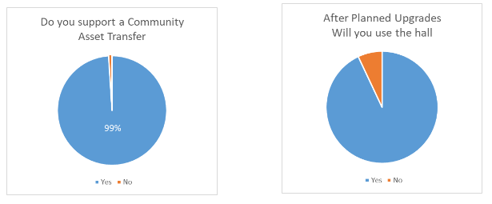

We have engaged with the community on multiple occasions through door-to-door surveys, community fun day events, and a cheese and wine evening. The feedback from the majority has been to save our hall from closure and start to use this as a community hub for our village. During our community fun day, we asked the attendees what events they would like to see happening within the village hall. We did this by completing a post-it note voting exercise engaging with people arriving to the events and providing them with a list of different activities and events which were gathered previous via a door-to-door survey. By doing this we were able to count the votes to understand what the activities the community want to see next at the hall, from arts and crafts, fitness classes, dances & discos, prize bingos. Since this event at the end of July, we have begun to plan some of the events for the upcoming months.

Some of the events that have taken place in Limerigg village hall so far; Macmillan coffee morning; Christmas arts & craft session; Christmas Ceilidh Dance; Christmas Lights Switch on event; Fitness Taster Sessions.

Due to the remote location of our village hall, there will be very little impact to other groups who operate a similar function in other areas.

Our village community hall has lacked any programme to develop and drive usage, we believe that we have the necessary skills to manage our building and get the best for our community. We want to create a stronger community and ensure that we are promoting opportunities for all to get involved to help reduce inequality and isolation.

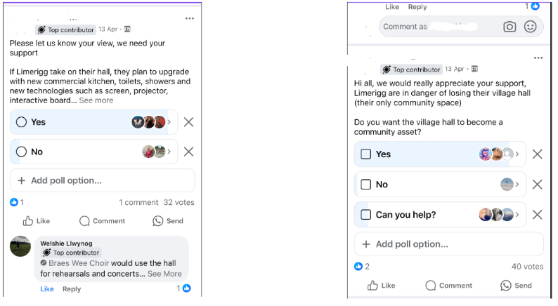

To gauge the level of demand, we recently carried out another community survey at a local event within the hall (appendices). Out of the 60 respondents from the surrounding area on the day, 100% of people strongly agreed that it was imperative that the Limerigg Village Hall stayed open; 100% of respondents strongly agreed that it would be detrimental to the local community of Limerigg and surrounding area, if the hall was not available for people to come together to reduce isolation, improve wellbeing, and encourage a cohesive community spirit; 98% of respondents strongly agreed that they would be happy to attend or organise events/classes/celebrations/etc, in Limerigg Village Hall.

Some of the feedback:

‘This is the heart of the community’

‘The Village Hall is an integral part of village life and a meeting place for all. Was used as a evacuation point during forest fire’

‘We don’t have much in the village as it is and it’s the only place for people to gather as a village and socialise’

‘We feel it is very important to all the village community and surrounding area to have this centre’

‘It brings all together’

‘The hall is so important for the community to come together’

‘It brings people from the village together that probably wouldn’t get together otherwise’

‘Great hall and must be kept open for the community’

‘Thank goodness we had the hall last summer when local homes were evacuated due to the wildfire!’

‘We need this building’

‘Crucial for small village communities’

‘We are losing things that make a community and this place would be one if it shut’

1. **Funding**
   1. Please outline how you propose to fund the price or rent you are prepared to pay for the land, and your proposed use of the land.

*You should show your calculations of the costs associated with the transfer of the land or building and your future use of it, including any redevelopment, ongoing maintenance and the costs of your activities. All proposed income and investment should be identified, including volunteering and donations. If you intend to apply for grants or loans you should demonstrate that your proposals are eligible for the relevant scheme, according to the guidance available for applicants.*

We plan to pay £1 for the purchase of the hall.

We are willing to pay for our share of the legal expenses and costs that will arise from this Community Asset Transfer request.



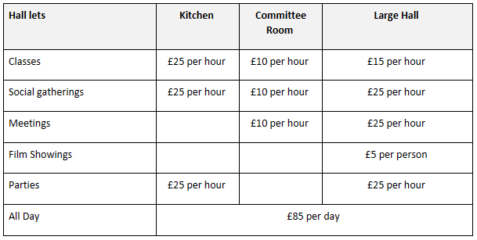

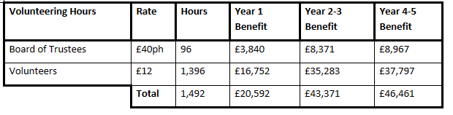

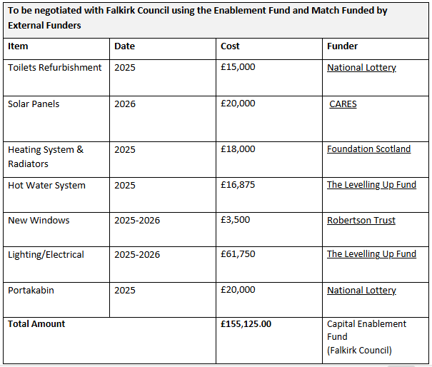

As the above table illustrates, we plan to access Falkirk Council’s enablement fund.

We are applying for £155,125.00 to carry out significant capital improvements to the property in terms of replacing heating; roofing; electrical works; windows; and a hot water system; which will transform our energy efficiency and ensure the projects viability going forward.   
This represents the full cost as provided by professional contractors (quotes have been submitted as part of our CAT application).   
However, we will continue to research and apply for 3rd-party match funding to go towards funding these works. If we are successful, this would reduce the amount of Enablement funding required and we would inform the Council promptly to allow funds to be reallocated in a timely manner.

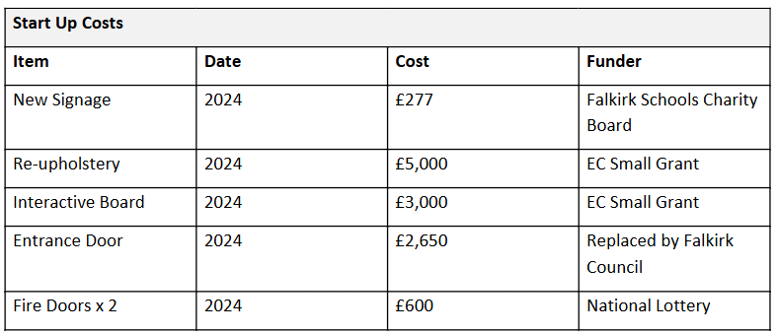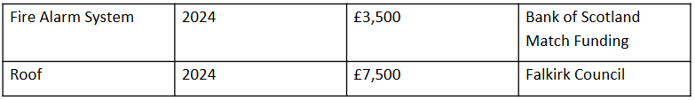

Once we take on ownership the building, we will look to refurbish the toilets and the kitchen areas. We will look to secure funding to Install showers, fire doors, update our heating and electrical systems. We will look to extend our usable storage space, by securing funding to purchase a new Portakabin to replace the current dilapidated unit.

We will endeavour to work with all our partners in the area, including local businesses; Forestry and Land Scotland; the Rambler's Association; Paths for All; the local Scouts associations; and other local authority services.

**Signature**

Two office-bearers (board members, charity trustees or committee members) of the community transfer body must sign the form. They must provide their full names and home addresses for the purposes of prevention and detection of fraud.

This form and supporting documents will be made available online for any interested person to read and comment on. Personal information will be redacted before the form is made available.

**We, the undersigned on behalf of the community transfer body as noted at section 1, make an asset transfer request as specified in this form.**

**We declare that the information provided in this form and any accompanying documents is accurate to the best of our knowledge.**

Name :   
[REDACTED]

Address:

Date:

Position:

Signature:

Name:

Address:

Date:

Position:

Signature:

**Checklist of accompanying documents**

To check that nothing is missed, please list any documents which you are submitting to accompany this form.

**Section 1 – you must attach your organisation’s constitution, articles of association or registered rules**

Title of document attached: Limerigg Action Group SCIO Constitution

**Section 2 – any maps, drawings or description of the land requested**

Documents attached: Please see all supporting documentation

**Section 3 – note of any terms and conditions that are to apply to the request**

Documents attached: Please see all supporting documentation

**Section 4 – about your proposals, their benefits, any restrictions on the land or potential negative consequences, and your organisation’s capacity to deliver.**

Documents attached: Please see all supporting documentation

**Section 5 – evidence of community support**

Documents attached: Please see all supporting documentation

**Section 6 – funding**

Documents attached: Please see all supporting documentation