KEYSAFE INFORMATION SHEET

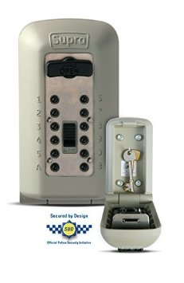 | 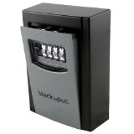 | 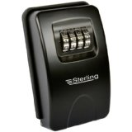 | 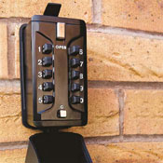 | 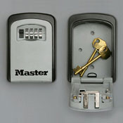

A keysafe is an outdoor box which can securely hold your household key(s).

It is installed into brick or concrete on the outside of your property and keys are accessed by a combination code known only to the householder and those who need to know e.g. family members and care staff. Having this installed provides vulnerable people with peace of mind knowing that assistance can be provided in an emergency or where they are unable to answer the door. Security will also be improved as the number of keyholders will be reduced.

Keysafes can be widely purchased online or in hardware stores locally. If purchasing online, please read any reviews which will help you decide which one is the best option for you. Most of these will hold 2 or 3 keys but please ensure it is big enough to accommodate yours.

Falkirk Council is unable to recommend any supplier; however, if the supplier is also fitting your keysafe, the installer should not set your code but should show you how to set the code yourself.

They can also be installed by yourself/family, or you can arrange for a tradesman to install but please be aware of the cost for this service before you agree to the installation.

It’s always best to check with your insurer before you buy and install a keysafe.

